ISI STEEL CO., LTD
PROMOTIONS & DEPOT DISCOUNT MANAGEMENT
Business & Software Requirements Document (BRD/SRS)
Covers: Database Schema & ERD | Approval Workflow | Mobile / Backend / Admin / Sales / Commercial

Field | Detail
Document Version | 1.0
Prepared For | ISI Steel Co., Ltd - Sales, Commercial & IT Departments
Feature | Promotions (Depot Sales Discount & Rebate Scheme)
Status | Draft for Review

1. Introduction

1.1 Purpose
This document defines the business requirements, data model (ERD), database schema, and end-to-end approval workflow for the Promotions feature. The feature digitizes the existing manual, spreadsheet-based process ("Depot Discount / Sales Discount request") used by ISI Steel to manage discount and rebate schemes offered to depots (customers/business partners) across regions such as Phnom Penh, Kampong Speu, Battambang (BMC), Pursat (PST), Kampong Cham (KCN) and Siem Reap (SRP).
The current process is run in Excel: a Sales Employee proposes a discount rate per product category (Pipe, K Pipe, Coil, Palm 50/70/100, Roofing Profile, PU Eco/Premium, CZD, ISI 295) for a given depot, either as a flat percentage, a tiered rate based on monthly purchase amount, or an immediate-payment discount. The request is then signed off by a Sales Support Supervisor, a Regional Sales Manager, a Consultant, and finally a Commercial Director. This document specifies how that process is replaced by a mobile app + backend system with full audit trail, controlled approvals, and automatic discount application on invoices.

1.2 Scope
In scope:
- Digital submission of depot discount/promotion requests from a mobile app used by Sales Employees.
- Multi-level approval workflow (Sales Support -> Regional Sales Manager -> Consultant -> Commercial Director).
- Support for three promotion types: On-Invoice Discount, Immediate-Payment Discount, and Volume-Tiered Rebate.
- Product-category-level and depot-level discount configuration.
- Automatic application of approved discounts to sales invoices.
- Notifications to Sales Employees on approval/rejection/return.
- Full audit log of every change and approval action.
- Admin console for master data (customers, product categories, teams, cost centers) and monitoring.
Out of scope:
- Core invoicing / ERP (SAP) financial postings - the system integrates with, but does not replace, the existing invoicing system.
- Payroll or sales-commission calculation.
- Pricing master (base list price) management.

2. Actors & Roles
Role | Platform | Responsibility
Sales Employee | Mobile App | Creates and submits a promotion/discount request for an assigned depot; tracks status; receives notifications.
Sales Support Supervisor (Admin) | Admin / Web Console | First-level review: validates request completeness and master-data mapping ("Prepared By").
Regional Sales Manager | Web / Mobile | Second-level review: validates business justification against sales targets ("Verified By").
Consultant | Web | Third-level review: evaluates commercial/margin impact ("Approved By").
Commercial Director | Web | Final approval authority; activates the promotion for use ("Approved By").
System Admin | Admin / Web Console | Maintains master data: customers, product categories, teams, cost centers, roles, and workflow templates.
Backend System | API / Services | Validates, stores, routes approvals, applies discount engine to invoices, sends notifications, writes audit log.

3. End-to-End Workflow
The diagram below shows the process flow across the five system actors: Mobile App, Backend/API, Admin, Sales, and Commercial.
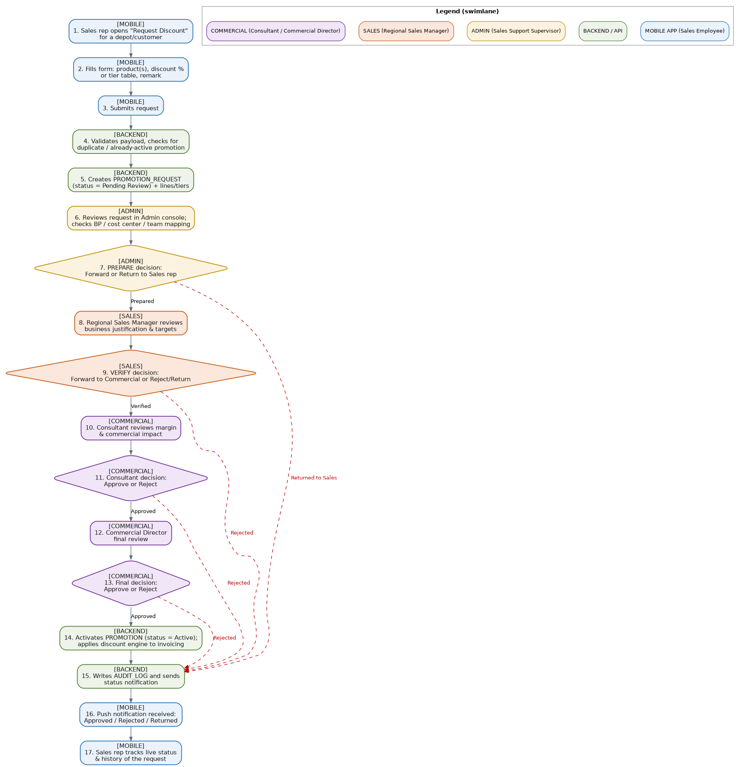

3.1 Step-by-step description
Steps | Actor | Description
1-3 | Mobile App | Sales Employee opens "Request Discount" for a depot, fills in the requested product(s), discount % or tier table, and remark, then submits.
4-5 | Backend | Validates the payload (duplicate/active-promotion checks) and creates a PROMOTION_REQUEST record with status Pending Review, plus its request lines and tiers.
6-7 | Admin (Sales Support Supervisor) | Reviews the request in the admin console, checks BP/cost-center/team mapping, and either forwards it ("Prepared") or returns it to the Sales Employee for correction.
8-9 | Sales (Regional Sales Manager) | Reviews business justification and monthly targets, then Verifies (forwards to Commercial) or Rejects/Returns the request.
10-13 | Commercial (Consultant -> Commercial Director) | Consultant reviews margin/commercial impact and approves or rejects; Commercial Director performs the final review and gives the final Approve/Reject decision.
14-15 | Backend | On final approval, activates the PROMOTION (status = Active) and the discount engine begins applying it to new invoices; writes an audit-log entry and sends a status notification at every step.
16-17 | Mobile App | Sales Employee receives a push notification of the outcome and can track live status and full history of the request.

4. Functional Requirements
ID | Requirement
FR-01 | The mobile app shall allow a Sales Employee to create a promotion request for any depot assigned to them.
FR-02 | A request shall support one or more product categories, each with its own promotion type (On-Invoice / Payment-Term / Volume-Tier).
FR-03 | For Volume-Tier promotion type, the system shall allow entry of multiple amount-based tiers (e.g. <$2,000: 1.5%, <$3,000: 3%).
FR-04 | The system shall prevent submission of a request with overlapping/duplicate active tiers for the same product and depot.
FR-05 | Every request shall pass through a 4-step sequential approval: Sales Support -> Regional Sales Manager -> Consultant -> Commercial Director.
FR-06 | Any approver may Reject or Return a request with a mandatory comment; a returned request goes back to the originating Sales Employee for edits and re-submission.
FR-07 | The system shall notify the Sales Employee in real time (push notification) on every status change of their request.
FR-08 | Upon final approval, the system shall automatically activate the corresponding PROMOTION record and make it available to the invoicing/discount engine.
FR-09 | The discount engine shall automatically apply the correct discount (flat % or tiered %) to eligible invoice lines for the depot and product category.
FR-10 | The system shall record which specific approved request/promotion produced each discount applied on an invoice, for traceability.
FR-11 | The Admin console shall allow authorized users to maintain customers, product categories, teams, cost centers, and roles.
FR-12 | The system shall maintain a complete, immutable audit log of every create/update/approve/reject/return action.
FR-13 | Users shall be able to filter/search requests by depot, status, sales employee, region (cost center), and date range.
FR-14 | The system shall support a promotion validity period (start date and optional end date); expired promotions no longer apply to new invoices.
FR-15 | The system shall enforce role-based access control so each actor can only perform actions permitted for their role.

5. Non-Functional Requirements
Category | Requirement
Performance | Discount calculation on invoice creation shall complete in under 500ms per invoice.
Availability | Backend API shall target 99.5% uptime; mobile app shall support offline draft creation with sync on reconnect.
Security | All API traffic over TLS; role-based authorization on every endpoint; approver actions require re-authentication for high-value discounts.
Auditability | Every state transition of a request or promotion must be recorded in AUDIT_LOG with before/after values.
Scalability | Schema must support 5,000+ depots and 50,000+ invoices/month without redesign.
Localization | Mobile app and notifications shall support Khmer and English.
Usability | Mobile submission form shall be completable in under 2 minutes for a standard flat-rate request.

6. Data Model (ERD)
The entity-relationship diagram below models the full Promotions feature: master data (customer/depot, product category, team, cost center, roles/users), promotion definition, the request and its approval trail, and how approved promotions are applied to invoices.
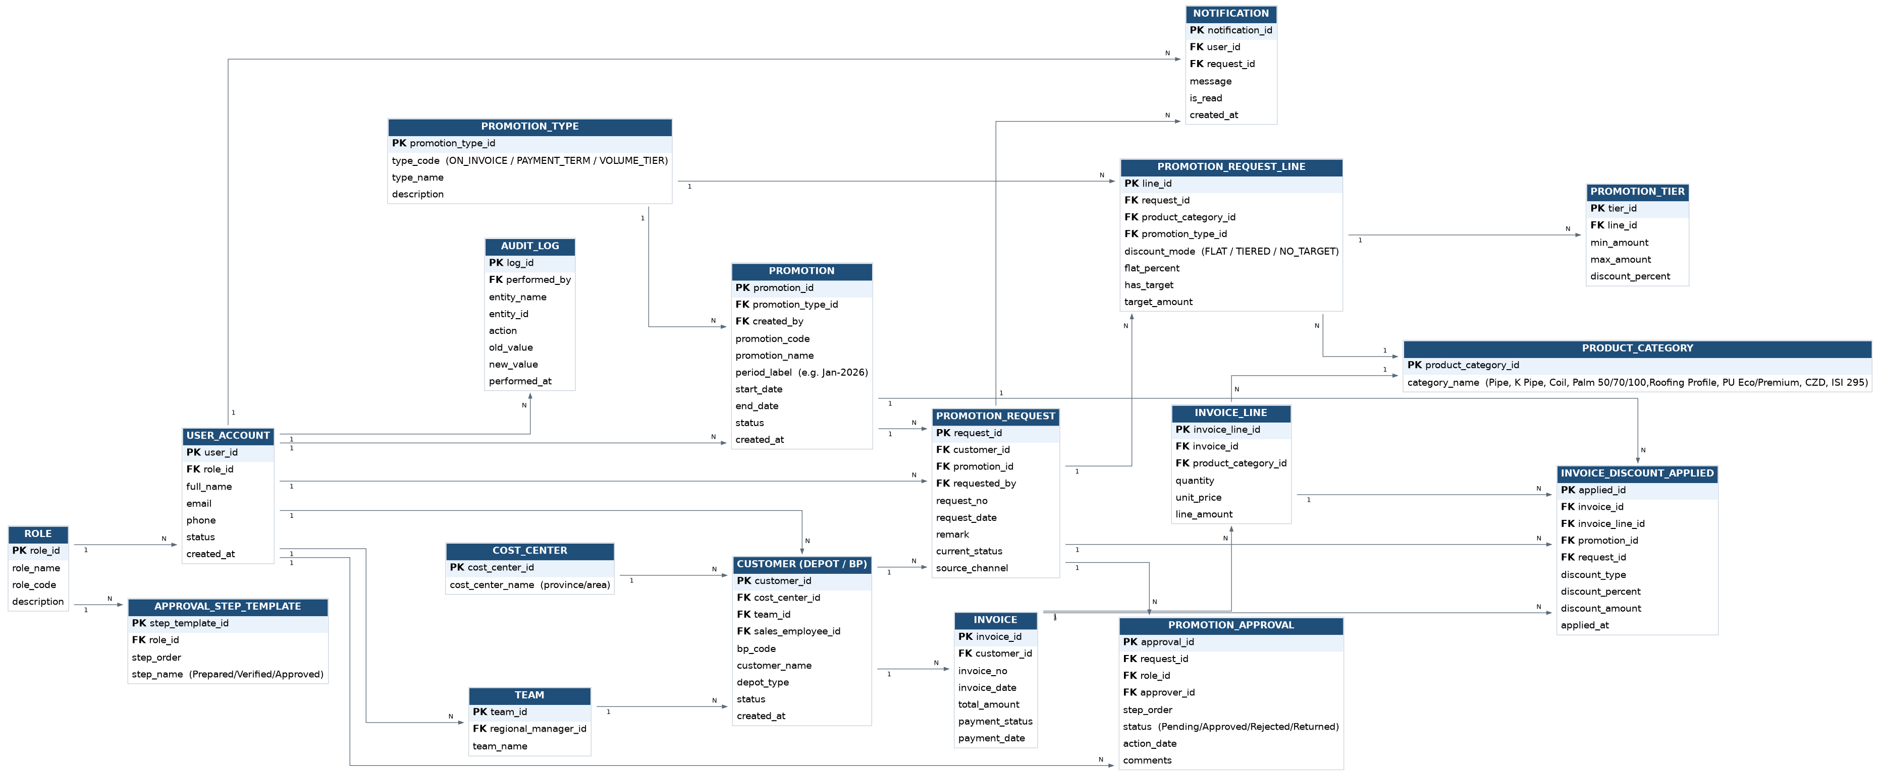

6.1 Entity summary
Entity | Description
ROLE | System roles: Sales Employee, Sales Support Supervisor, Regional Sales Manager, Consultant, Commercial Director, Admin.
USER_ACCOUNT | All system users (employees), linked to a ROLE.
TEAM | Sales team, linked to its Regional Sales Manager.
COST_CENTER | Region / province (e.g. Phnom Penh, Kampong Speu).
CUSTOMER (Depot/BP) | The depot/business partner that receives discounts; linked to cost center, team, and assigned sales employee.
PRODUCT_CATEGORY | Product lines eligible for discount (Pipe, K Pipe, Coil, Palm 50/70/100, Roofing Profile, PU Eco/Premium, CZD, ISI 295).
PROMOTION_TYPE | On-Invoice Discount / Immediate-Payment Discount / Volume-Tiered Rebate.
PROMOTION | The approved, active discount scheme with validity period and status.
PROMOTION_REQUEST | A submission from a Sales Employee for a specific depot; carries the overall approval status.
PROMOTION_REQUEST_LINE | One product-category line within a request, with its discount mode (flat / tiered).
PROMOTION_TIER | The amount-based tier breakdown for a tiered request line.
APPROVAL_STEP_TEMPLATE | The standard 4-step approval sequence and the role responsible for each step.
PROMOTION_APPROVAL | Instance of each approval step for a specific request, with approver, status, date and comments.
INVOICE / INVOICE_LINE | Sales invoice and its line items, to which discounts are applied.
INVOICE_DISCOUNT_APPLIED | The actual discount amount applied to an invoice/line, traceable back to the approving PROMOTION and PROMOTION_REQUEST.
NOTIFICATION | Push/in-app notifications sent to users about request status changes.
AUDIT_LOG | Immutable log of every create/update/approve/reject/return action across the feature.

7. Database Design (Key Tables)
Full DDL is provided in the accompanying file promotions_schema.sql (PostgreSQL). Key tables are summarized below; PK = Primary Key, FK = Foreign Key.

7.1 customer (Depot / Business Partner)
Column | Type | Key | Notes
customer_id | SERIAL | PK
bp_code | VARCHAR(30) |  | SAP BP code, unique
customer_name | VARCHAR(255)
depot_type | VARCHAR(30) |  | GENERAL_DEPOT / PARTNER_DEPOT / OUT_OF_LIST
cost_center_id | INT | FK | -> cost_center
team_id | INT | FK | -> team
sales_employee_id | INT | FK | -> user_account
status | VARCHAR(20) |  | ACTIVE / INACTIVE

7.2 promotion_request
Column | Type | Key | Notes
request_id | SERIAL | PK
request_no | VARCHAR(30) |  | unique human-readable number
customer_id | INT | FK | -> customer
promotion_id | INT | FK | -> promotion (set once approved)
requested_by | INT | FK | -> user_account (Sales Employee)
current_status | VARCHAR(30) |  | PENDING_REVIEW / PREPARED / VERIFIED / CONSULTANT_APPROVED / APPROVED / REJECTED / RETURNED
source_channel | VARCHAR(20) |  | MOBILE_APP / WEB / ADMIN

7.3 promotion_request_line & promotion_tier
Column | Type | Key | Notes
line_id | SERIAL | PK | promotion_request_line
request_id | INT | FK | -> promotion_request
product_category_id | INT | FK | -> product_category
discount_mode | VARCHAR(20) |  | FLAT_PERCENT / TIERED / NO_TARGET
flat_percent | NUMERIC(6,4) |  | e.g. 0.05 = 5%
tier_id | SERIAL | PK | promotion_tier
min_amount / max_amount | NUMERIC(14,2) |  | tier boundary in USD
discount_percent | NUMERIC(6,4) |  | rate for that tier

7.4 promotion_approval
Column | Type | Key | Notes
approval_id | SERIAL | PK
request_id | INT | FK | -> promotion_request
step_order | INT |  | 1=Sales Support, 2=RSM, 3=Consultant, 4=Commercial Director
role_id | INT | FK | -> role
approver_id | INT | FK | -> user_account, null until acted
status | VARCHAR(20) |  | PENDING / APPROVED / REJECTED / RETURNED
action_date | TIMESTAMP
comments | TEXT

7.5 invoice_discount_applied
Column | Type | Key | Notes
applied_id | SERIAL | PK
invoice_id | INT | FK | -> invoice
invoice_line_id | INT | FK | -> invoice_line (nullable)
promotion_id | INT | FK | -> promotion
request_id | INT | FK | -> promotion_request
discount_type | VARCHAR(20) |  | ON_INVOICE / PAYMENT_TERM
discount_amount | NUMERIC(14,2) |  | actual $ amount deducted

8. Approval Matrix
Step | Role | Action Label | Possible Outcomes
1 | Sales Support Supervisor | Prepared By | Forward to Step 2 / Return to Sales Employee
2 | Regional Sales Manager | Verified By | Forward to Step 3 / Reject / Return
3 | Consultant | Approved By | Forward to Step 4 / Reject
4 | Commercial Director | Approved By | Final Approve (activates promotion) / Reject

9. Assumptions & Constraints
- Business Partner (BP) codes are sourced from the existing ERP (SAP) and kept in sync via a nightly master-data feed.
- One depot can have at most one active promotion per product category at a time; a new approved request supersedes the previous one.
- "No target" discount lines (e.g. 12% No target) are modeled as discount_mode = NO_TARGET with flat_percent set and has_target = false.
- Damaged/scrap goods ("ដែកអេតចាយ") are excluded from any volume-target calculation, per existing business rule; this exclusion is enforced in the invoicing/discount engine, not in this schema.
- Mobile app users are Sales Employees only; all approval steps happen on the Admin/Web console (approvers may also view status on mobile).

10. Acceptance Criteria
- A Sales Employee can submit a multi-product discount request from the mobile app in under 2 minutes.
- A request cannot skip an approval step; each of the 4 steps is recorded with approver, timestamp, and status.
- A rejected or returned request notifies the Sales Employee within 1 minute (push notification).
- An approved promotion is automatically applied to the next matching invoice without manual intervention.
- Every action on a request is visible in the audit log with old/new values.
- Reports can reconstruct, for any invoice, exactly which approved request/promotion produced its discount.

11. Appendix
Accompanying files:
- promotions_schema.sql - full PostgreSQL DDL for all tables, indexes, and seed reference data.
- erd.png - entity-relationship diagram (also embedded in Section 6).
- workflow.png - end-to-end approval workflow diagram (also embedded in Section 3).

