Subject research proposal – Pham Hong Duyen Khanh

Spring – 2023

**License Plate Recognition**

**Abstraction**

To be able to extract license plates of vehicles passing a certain location using image processing algorithms without installing additional devices such as GPS or radio frequency recognition. The license plate recognition (LPR) system uses specialized cameras that will take pictures from each passing vehicle and forward the images to a computer for processing. Python Tensorflow Object Detection to be able to detect license plates using image data. Once those panels have been discovered, you'll be able to apply optical character recognition (OCR) to extract text from each and every plate using PyTorch and EachOCR. The resulting data is applied for comparison with records on the database. This system can also be used for security and traffic control.

1. **Introduction**
   1. **Background and context**

The license plate recognition (LPR) system is an important area of research interest in image processing and monitoring systems. With the advent of high-tech cameras, license plate recognition systems have a wide range of applications for traffic management applications and especially in parking lots. LPR systems have many applications such as border control, stolen vehicle identification, automated parking attendants, red light cameras, gas station monitoring, speed enforcement, security.

* 1. **Project solution overview**

The LPR system works in three steps:

* Detect and take a picture of the vehicle.
* Detect and extract the license plate in the image.
* Uses image segmentation: for individual characters recognition and optical character recognition (OCR) with the help of a database stored for each alphanumeric character.

1. **Project design and method**
   1. **Project material**

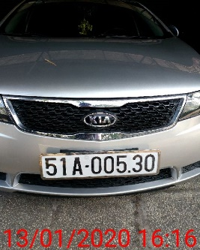 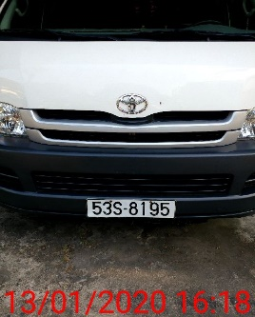 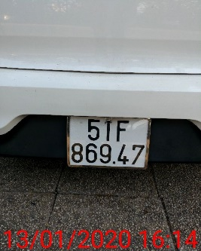 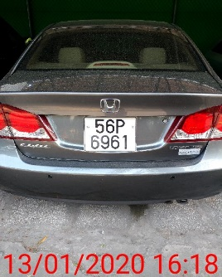 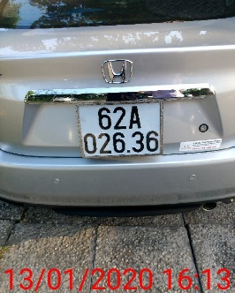

We use the data is the Vietnamese license plate on thigiacmaytinh for this project. A set of photos of car license plates, including long plates, square plates and new yellow plates.

* 1. **Project method**

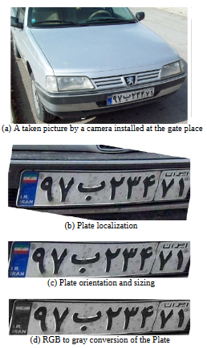The software uses nine algorithms means nine modules for identifying a license and number plate follows:

1. Plate localization: this algorithm is in charge of locating and identifying the plate in the image. It is seen in Fig.(b)
2. Plate orientation and sizing: This method corrects the plate's skew and modifies the dimensions to the desired size, as seen in Fig.(c).
3. Conversion: The picture may be converted using a variety of image processing approaches. For example, to make image processing simpler, we transformed the image from red, green, and blue (RGB) layers to a grayscale layer, as shown in Fig.(d)
4. Normalization: This procedure modifies the brightness and contrast of the image seen in Fig.(e)
5. 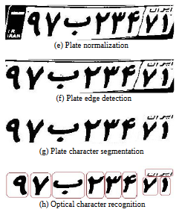Edge detection is used to improve the visual contrast between the plate backing and the lettering. The visual noise in the image may also be reduced using a median filter. As seen in Fig.(f), a pointless picture portion resembling the left side of Fig.(e) has been removed.
6. Character segmentation: this algorithm finds the individual characters on the plate and segments them for extra enhancement and also additional lines are deleted as shown in Fig.(g).
7. Optical character recognition is the process of electronically converting printed or imaged text into machine-encoded text, as seen in Fig.(h).
8. Syntactical and geometrical analysis: it compares characters and placements to rules particular to a certain nation.
9. The averaging of the recognized value across several fields or pictures to create a more dependable or certain outcome. especially given that every one picture might have a bright flash, be partially veiled, or have another transient impact
   1. **Project Schedule**

|  |  |  |  |
| --- | --- | --- | --- |
| **Weeks** | **Project phase** | **Objectives** | **Timeline** |
| 1 (02-08/01) | **Idea and planning** | Prepare knowledge | 02/01 - 08/01 |
| Choose topic | 06/01 - 08/01 |
| Create timeline | 06/01 - 08/01 |
| 2 (09-15/01) | **Collecting material** | Finding dataset | 09/01 - 10/01 |
| Create proposal | 11/01 - 15/01 |
|  |  |
| 3 (30/01-05/02) | **Build and Training Model** | Model license plate recognition (LPR) | 30/01 - 05/02 |
|  |  |
|  |  |
| 4 (06-12/02) | **Test and Fine-tuning Model** | Test and fine-tuning LPR model | 06/02 - 12/02 |
|  |  |
|  |  |
| 5 (13-19/02) | **Build and Training Model** | Test and fine-tuning lane detection model | 13/02 - 19/02 |
| Finding traffic sign detection resource | 13/02 - 19/02 |
|  |  |
| 6 (20-26/02) | **Change method** | Test and tuning traffic sign detection model | 20/02 - 26/02 |
| Buiding direction control model | 20/02 - 26/02 |
|  |  |
| 7 (27/02-05/03) | **Test and Enhance data** | Run | 27/02 - 05/03 |
| Check model another enviroment | 27/02 - 05/03 |
| Test and increase dataset to avoid overfit | 27/02 - 05/03 |
| 8 (06-12/03) | **Completing report** | Learn reputable papers to gain experience | 06/03 - 12/03 |
| Double check performance and algorithm | 06/03 - 12/03 |
| Write a complete report | 06/03 - 12/03 |
| 9 (13-19/03) | **Research and Development** | Learning advantage sign | 13/03 - 19/03 |
| Improve processing performance | 13/03 - 19/03 |
| Fine-tuning report if have improving | 13/03 - 19/03 |
| 10 (20-26/03) | **Run Project and  Increase data** | Recognize signs of many cases of error | 20/03 - 26/03 |
| Combine LPR with traffic signs | 20/03 - 26/03 |
|  |  |