 | Name: | Srirupa Dey
 | Role: | Salesforce Developer
 | Date of Birth: | 9th August,1997
 | Email: | srirupa.dey@capgemini.com
 | Location: | Kolkata

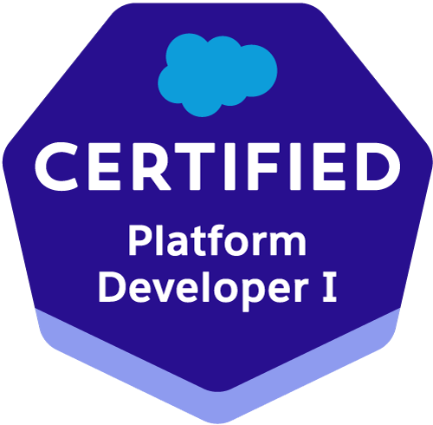
SUMMARY

- 1.5 years of experience working in Salesforce Development and Admin including Lightning.
- Hands on experience in Lightning Web Components, Flexi pages, Lightning App Builder.
- Hands on experience in developing Apex Triggers, Apex Classes, Workflows, Validation Rules, Email templates, Sharing Settings and necessary competencies to deliver the maximum value.
- Knowledge of coding in C++, Java and Database Management System.
- Good business and application analysis skills with good communication and interpersonal skills.
- Ability to adapt fast challenging skills and work.
- Good analytical skills combined with experience in coding, Team Management and Development.

EDUCATION AND CREDENTIALS

- Master of Computer Application(MCA) from Jadavpur University,Kolkata
- Bachelor of Computer Application(BCA) from NSHM College of Management & Tech.,Durgapur

TECHNICAL PROFICIENCIES
Technologies | Salesforce
Methodologies & Frameworks | Agile
Applications / IDE | Eclipse, Visual Studio Code, Salesforce Lightning Application
Project & Case Study | SF Baptist, Use Case (Apex, VF, LWC) -1(Rockford Solutions Sales Application)  Property Booking App

PROFESSIONAL EXPERIENCE
SF Baptist Feb 2023-Sep 23
Role: Salesforce Junior Developer

Project Description
Baptist Development team is responsible for development and enhancement of OneBaptistHealth application for Sustainment and Supply Chain Management. This Application is used by Baptist Health Group to help their customers and patients in the best way possible.

Platforms: Salesforce Sandbox

Responsibilities:

- designing the solution.
- Requirement gathering, planning & code as per requirement.
- Creating and managing Custom Objects, Custom Fields and Validation rules.
- Configuring Dependencies, Page Layouts, Record Types and Search Layouts.
- Creating Tabs, List Views and Email Templates.
- Developing Apex Classes, Triggers and Test classes.
- Enforcing security with the help of Organization Wide Defaults, profiles and opening access to the required users with the help of sharing rules, Permission sets.
- UAT validations
- Code reviews.

Achievements:
OneBaptistHealth Application is designed to analyze and manage Baptist Health customer interactions and data throughout the customer lifecycle. Enhancement and maintenance as per requirements improve business outcomes.

_PROJECTS________________________________________________________________________
Use Case (Apex, VF, LWC)-1(Rockford Solutions Sales Application) Sep 2022 – Oct2022
Role: Salesforce Developer
Project Description
A sales User can see a custom page with Tasks List for the day and able to create a new Task. Triggers, flows and validation rules were used. For creating New Task, LDS was used. For displaying task list, hooks were used along with pagination. A Search mechanism was also created to search a specific task.
Platforms: Salesforce Development Edition
Responsibilities:

- Architecting and designing the solution
- Profile and Security configuration
- Code and Deployment
- Requirement gathering, planning & execution
Achievements:
Rockford Solutions Sales Application to provide a channel for selling products. As part of their day-to-day activity, a Sales User can see a custom page with Tasks list for the day and able to create a new Task.

Project Name: Property Booking App |  | Oct 2022 – Nov 2022
Role: Salesforce Developer
Project Description
Property Booking Application is a platform for customers to purchase built property online and negotiate on the final rate. Customers can add their details and send approval request for negotiated price. Once approved, quotation is generated and send to the customer.
Platforms: Salesforce Development Edition
Responsibilities:
- Architecting and designing the solution
- Profile and Security configuration
- Code and Deployment
- Requirement gathering, planning & execution
Achievements:
Property Booking application facilitates customers to choose from a wide range of built properties online. They can also negotiate on the final rate and buy any property they want.

Trailhead & Badges

Badges – 157 Points-184,950
Admin Super Set
App Builder Super Set
Developer Super Set

