M. A. H. Nerenberg, T. M. Haridasan, J. Govindarajan, and P. W. M. Jacobs, *J. Phys. Chem. Solids* **41**, 1217 (1980).

T. M. Haridasan, J. Govindarajan, M. A. Nerenberg, and P. W. M. Jacobs, *Phys. Rev. B* **20**, 3462, 3474 (1979).

Calcium Fluorite

Yttrium and sodium doped CaF2 crystals.

<http://jphys.journaldephysique.org/articles/jphys/abs/1965/11/jphys_1965__26_11_645_0/jphys_1965__26_11_645_0.html>

Ceria Vacancies

Ceria has substantial nonstoichiometry dominated by defect chemistry with removal of oxygen atoms from the oxygen sublattice

$$O_{O}+2{Ce}_{Ce}→V_{O}^{..}+2{Ce}_{Ce}^{'}+{\frac{1}{2}O}_{2}(g)$$

$V_{O}^{..}$ is a oxygen vacancy and ${Ce}_{Ce}^{'}$ is a ${Ce}^{3+}$ ion on a ${Ce}^{4+}$ site

[21] B. C. H. Steele and J. M. Floyd, Proceedings of the British Ceramic Society 19, 55 (1971).

[22] J. Faber, M. A. Seitz, and M. H. Mueller, J. Phys. Chem. Solids 37, 903 (1976).

[23] M. Mogensen, N. M. Sammes, and G. A. Tompsett, Solid State Ionics 129, 63 (2000).

[24] S. R. Bishop, K. L. Duncan, and E. D. Wachsman, Acta Mater.57, 3596 (2009).

Uranium Interstitials

UO2 is the primary nuclear fuel in light nuclear reactors. Hyperstoichiometric UO2

Defect-Induced Raman Spectra in Fluorite Structures

The general problem of the effects of impurities on the vibrational, electric, and magnetic properties of crystalline solids. One aspect of this problem is random disordered systems.

Ceria are isostructural with Urania (UO2) and plutonia (PuO2) which are the primary nuclear fuel materials of interest, as well as Thoria (ThO2) which is of interest for a thorium-based fuel cycle. Ceria is most often used as a non-radioactive surrogate for these actinide dioxide materials. All these oxides display a broad range of sub-stoichiometry leading to an intrinsic disorder due to large oxygen vacancy concentrations[15,16]

[Notes from Norwick]

The simplest point defects come from removing an atom, substituting an atom of a different species, bring an extra atom into a position not a normal lattice site. (these are a vacancy, substitution, and an interstitial). Composite defects or defect complexes can be created by combining elementary point defects into composite defects (aka defect complexes).

Energy of formation of the defect (enthalpy of formation)

Vibrational entropy ( $∆s_{d})$ of the defect, which is the change in entropy of the lattice when one defect is inserted in a specific location (excludes configurational entropy). $∆s_{d}$ is positive for open defects such as a vacancy, and negative for a defect which crowds the surrounding atoms.

[end norwick]

**Calculation of Enthalpy of Formation**

Fluorite Systems

The fluorite structure belongs to the space group, $O_{h}^{5}$, the Raman tensor transforms as the irreducible representation $A_{1g}+E_{g}+T_{2g}.$

Compounds with the fluorite structure are known to be capable of accommodating a large excess of anions (ions with net negative charge).[1]

Y doped CaF2 structures[1].

Y doped CeO2 structures[2].

Crystallography

Massa/Gould, Crystal Structure Determination

Giacovazzo, Fundamentals of Crystallography

Bragg, The Crystalline State

BaF2

CaF2

**Different Point Defects**

* Vacancy defects. Lattice sites which would be occupied in a perfect crystal, but are vacant.
* Interstitial defects. Atoms that occupy a site in the crystal structure at which there is usually not an atom.
* Schottky defect. A pair of vacancies in an ionic solid.
* Frenkel defect. A pair of a vacancy and an interstitial.
* Substitutional defect (isovalent vs aliovalent)
* Antisite defect. Given an ordered alloy or compound (AB), with two sublattice A and B. An anti-site defect is when an A atom occupies a B site, and B atom occupies an A site.
* Split interstitial. Two atoms effectively share an atomic site.

**Green’s Functions Methods**

A review of Green’s function methods for isolated defect and random disorder problems are briefly reviewed in Lacina and Pershan[2] where it can be shown how the phonon optical properties can be expressed using this formalism. These techniques are useful for qualitative and quantitative understanding of impurity effects, although they usually involve cumbersome computational difficulties for physically realistic models of the impurity and the host lattice.

Review article on the effects of point defects and disorder on lattice vibrational properties by Maradudin.[3] Get from Florida Library.

## Characterization of Point Defects by Analysis of Eigenvectors

Since Raman scattering can yield important information about the nature of the solid on the scale of the order of a few lattice constants, it can be sued to study microscopic nature of structural and topological disorder.

The purpose of this section is elucidate the relationship between disorder and line shape (linewidth and asymmetry) of allowed modes.

Point defects destroy translational invariance, an effect that manifests itself as a breakdown of the usual q=0 Raman selection rule , thus leading to broadening and asymmetry of the Raman line shape.

An ideal crystal has translational symmetry, the spatial correlation function of the phonon is infinite in extent and heance the phonon eigenstates are plane waves. This leads to the usual q=0 momentum selection rules of Raman scattering. However, point defects introduces.



[Parayanthal, Pollak, “Raman Scattering in Alloy Semiconductors: “Spatial Correlation” Model]

In an “ideal” crystal

## Analysis of O2- vacancies

The O2- vacancy can be thought of as a combination of two defect complexes. Letting Ov represent an oxygen vacancy, Ov coordinates with the metal ion sub-lattice creating the M4Ov-type complex as well as the oxygen ion sub-lattice to create the O6Ov-type complex.

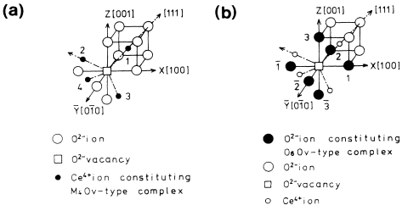

Figure . [4] The defect spaces of an O2- vacancy in CeO2 (a) M4Ov defect (b) O6Ov defect

**M4Ov-type complex** where Ov is an O2- vacancy. The defect space consists of an O2-vacancy and surrounding four nearest-neighbor metal ions. SEE FIGURE 1(A). This complex has 12 degrees of freedom and possesses Td symmetry, vibrational modes of this complex are given by the group operation of the point group Td as follows $Γ=A_{1}+E+T_{1}+2T_{2}$

All irreducible components, seen in the figure below, the calculated results only appear in the low-frequency region compared with the observed spectra. This is considered that the projection of high-frequency components due to the vibration of O2- ion in the Brillouin zone are lost because the used defect space (M4Ov-type complex) consists of only metal ions with heavy mass neglecting the O2- ions with light mass.

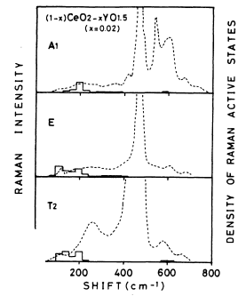

Figure . [4] The frequency distributions of the defect-induced Raman spectra which are the imaginary part of A1, E, T2 symmetry Green’s functions calculated using mode vectors of M4Ov-type defect space.

Unnormalized mode vectors for an M4Ov-type complex are shown in the table below

Table [4] Unnormalized mode vectors for an M4Ov-type complex given by decomposition using group analysis

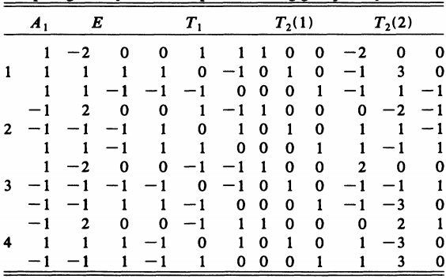

**O6Ov-type complex** where the defect space consists of an O2- vacancy and surrounding nearest neighbor O2i ions. SEE FIGURE 1(B). Since the O6Ov-type complex has 18 degrees of freedom and possesses Oh symmetry, vibrational modes of the complex are given by the group operation of the point group $O_{h}$ as follows: $Γ=A_{1g}+E_{g}+T_{1g}+T_{2g}+2T_{1u}+T_{u.}$ In these modes, Raman active modes are $A_{1g}$, $E_{g}$, and $T_{2g}.$

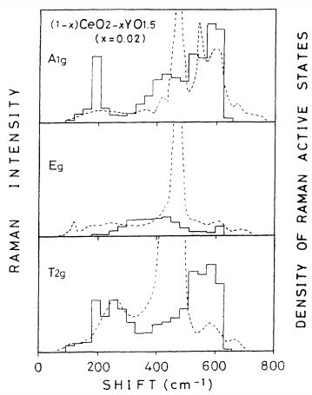

Figure . [4] The frequency distributions of the defect-induced Raman spectra which are the imaginary part of A1g, Eg, T2g symmetry Green’s functions calculated using mode vectors of O6Ov-type defect space. Broken curves are the irreducible components obtained using the observed polarized Raman Spectra

UO2 can accommodate large of amounts of interstitial oxygen. It can form hyperstoimetric UO2+x or other higher oxides of uranium such as triuranium octoxide or uranium(IV,V) oxide (U4O9) with accompanying disorder only in the anion sublattice; the cation sublattice remains mostly unaffected.

Use of raman

Characterize defects and oxygen stoichiometry in unirradiated uranium oxides[6]

Provide supportive structural information about the surface[7][8]

Study phase transitions due to oxidation[9]

Investigate phonon behavior at high temperature[10]

Identification of corrosion products formed on UO2[11]

Ion-beam, irradiation-induced damage in UO2[12]

Plutonium dioxide and (U1-yPuy)O2 fuels

Raman Spectroscopy, Thorium dioxide, Uranium dioxide[5]

The results of Raman spectroscopic investigations carried out on ThO2–UO2 fuels and SIMFUELs based on ThO2–UO2 for composition analysis, estimation of extent of damage and oxygen stoichiometry.

The presence of defects distorts the translational symmetry and relaxes the selection rules, making several normally dipole-forbidden optical transitions observable.

A weak feature observed in the Raman spectra of UO2 around 575 cm-1, assigned to the IR active F_1u longitudinal optic (1LO) mode, appears to be due to the breakdown of selection rules as a result of presence of defects. [4, 6]

A broad band observed in UO2 around 1150 cm1 , a band that was initially assigned to an electronic crystal field transition, is now attributed to the second-order longitudinal optic (2LO) phonon based on the similarity of 1150 cm1 mode with 575 cm1 in terms of resonance profile, pressure dependence of intensity, and frequency.[1] How do we calculate resonance Raman using ab-initio.

UO2,

ZrO2 cannot be stabilized atlow dopant concentrations

CaF2,

CeO2

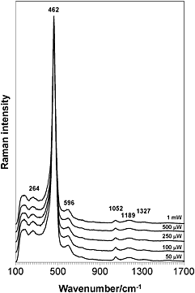

Influence of laser on Raman spectrum of pristine CeO2 achieved in ambient air with exciting line at 514.5 nm.[Daniel, J Raman Spec., 2012] Main peak at 462 attributed to triply degenerate F2g mode (symmetric breathing mode of O2 atoms around cerium atoms). Since the Raman line of fluorite-structured oxides is attributed to the symmetrical vibration of the oxygen ions.

Broadens in nanocrystalline CeO2 because of confinement effects and the presence of defects [Kosaki et al., Solid State Ionics, 2002] The correlation length, L should be related to the short-range order parameter and can be changed with material non-stoichiometry.

[Daniel, J Raman Spec., 2-12] Characterize $O_{2}^{-}$ and $O_{2}^{2-}$ species.

[Kosacki, Suzuki, Anderson, Colomban, “Raman Scattering and lattice defects in nanocrystalline CeO2 thin films, Solid State Ionics, 249, 1-2, July 2002, 99-105.]

Information regarding lattice disorder can be obtained from the analysis of the shape of the Raman line, which can be performed using a spatial correlation model.

Oxides having a florite-type structure, when doped with aliovalent cations, become good O2- conductors at elevated temperatures. CeO2 solid electrolyte for oxygen sensors, fuel cells.

1st order Raman scattering pure CeO2 (Keramidas and White).

2nd order Raman scattering in CeO2 (Kourouklis, Jayaraman, and Espinosa)

Polarized raman-scattering spectra from oriented crystals of CeO2 and second-order Raman features are analyzed on the basis of selection rules[6].

Defect induced Raman spectra of doped CeO2[4] with Yttria. Temperature and dopant dependencies of Raman spectra strongly suggest that many structures in the Raman spectra of yttria doped CeO2 are induced by the defect space including an O2 vacancy.

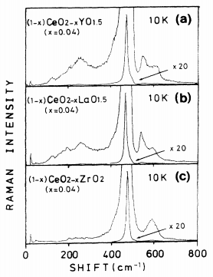

Figure . [4] Dopant-type dependence of Raman-scattering spectra for doped CeO2. (a) Y doped CeO2. (b) La doped CeO2. (c) Zr doped CeO2.

Defect-induced Raman spectra. From the figure above, the defect-induced peak around 540 cm-1 and below 400 cm-1 are attributed to the defect spaces indicating an O2- vacancy. We analyze the data assuming that the defect induced Raman spectra in (1-x)CeO2-xYO1.5 (x=0.02) are mainly attributed to the defect space including an O2- vacancy.

In Y3+ doped CeO2 and La3+-doped CeO2, the O2-vacancies are introduced as defects as well as dopant cations to keep charge neutrality.

In Zr4+-doped CeO2 only the dopant cations are introduced without the O2-vacancies.

Lattice Dynamics of CeO2

Short-range force-constant matrix

, ThO2

Anti-Fluorite Structure

Raman-active mode T2g

Li2O, Na2O, K2O

# Computational Methods

Umari and Pasquarello describe a technique where both IR and Raman spectra are calculated from first principals for an amorphous silicate system[7] which uses results from the modern theory of polarization to treat finite electric fields.[8] This method gives derivatives with respect to the electrical field equivalent to perturbational methods[8, 9] but only requires the addition of a term to the ground energy functional[7]:

$$E^{ℇ}\left[\left\{ψ\right\}\right]=E^{0}\left[\left\{ψ\right\}\right]-Ωℇ(P^{\text{el}}\left[\left\{ψ\right\}\right]+P^{\text{ion}})$$

$E^{0}\left[\left\{ψ\right\}\right]$ is the energy functional in the absence of an electric field, $P^{\text{el}}\left[\left\{ψ\right\}\right]$ is the electronic polarization and $P^{\text{ion}}$ is the ionic polarization.

This approach is attractive for several reasons. First, by defining the polarizability tensor as derivatives of atomic forces with respect to finite electric fields approximations for the Raman spectra can be calculated using density functional theory (DFT) software such as VASP.

With this approach, dielectric susceptibilities, can be calculated by taking finite differences of the polarization of the system subject to an electric field[7].

$$χ_{ij}=\frac{∂^{2}E}{∂ℇ_{i}∂ℇ_{i}}≅\frac{ΔP_{i}^{el}}{Δℇ_{i}}$$

Born effective charge tensors are defined as induced polarization along the direction $I$ by a unitary displacement of the Ith atom in the direction $j$ [10]:

$$Z_{I,ij}^{*}=Ω\frac{∂P_{i}^{el}}{∂r_{Ij}}=\frac{∂^{2}E}{∂ℇ_{i}∂r_{Ij}}=-\frac{∂F_{Ij}}{∂ℇ_{i}}$$

Using finite electric field DFT calculations, we can calculate the Born effective charge tensors by taking finite difference of atomic forces with respect to the electric field.

For a Raman scattering process, an incoming photon of frequency $ω_{L}$ and polarization $e_{L}$ is scattered to an outgoing photon of frequency $ω_{s}$ and polarization $e_{s}$. This either creates on annihilates a phonon of frequency $ω_{n}$ by Stokes or anti-Stokes processes, respectively. We consider the nonresonant Raman scattering process[7, 11, 12].

$$\frac{dσ(ω)}{dΩ}∼\sum_{n}{{\left|e_{s}{∙α}^{n}∙e_{L}\right|}^{2}δ(ω-ω_{n})}$$

Calculation of Raman tensors alpha[7, 12] is defined the formula:

$$α_{ij}^{n}=\sqrt{Ω}\sum_{Ik}{\frac{{∂χ}_{ij}}{∂r_{Ik}}u_{Ik}^{n}}$$

Third rank tensors which are derivatives of the dielectric susceptibility tensor with respect to ionic displacements can be alternatively calculated by second derivatives of the atomic forces with respect to changes in the finite electric field.

$$\frac{{∂χ}_{ij}}{∂r_{Ik}}=\frac{∂^{2}P_{i}^{\text{el}}}{∂r_{Ik}∂ℇ_{j}}=\frac{1}{Ω}\frac{∂^{3}E_{\text{tot}}}{∂r_{Ik}∂ℇ_{i}∂ℇ_{j}}=-\frac{1}{Ω}\frac{∂^{2}F_{Ik}}{∂ℇ_{i}∂ℇ_{j}}$$

Density functional theory (DFT) has two foundational principles outlined in the seminal papers containing the Hohenberg-Kohn theorems[13] and Kohn-Sham equations[14]. This section provides an overview of the DFT machinery required for this proposal. A more thorough and theoretical treatment can be found in Parr and Yang[15].

All discussions of DFT will assume the use of code VASP[16, 17]. In the proposed work, the projected augmented plane wave (PAW)[18, 19] to describe the interactions between the core and valence electrons. The exchange-correlation functional is treated with the LDA functional. The present study employs the VASP code with a cutoff for the plane wave basis set tabulated below, the LDA exchange-correlation functional and a 2x2x2 supercell containing 96 lattice sites and a 1x1x1 k-point grid.

DFT often fails to describe systems with localized d and f-elections due to approximations to the exchange-correlation energy (e.g. LDA and GGA) having the consequence of an erroneous electron self-interaction; this causes repulsion which favors electron delocalization. To correctly characterize the localization of the Fe d-electrons, the DFT+U approach of Dudarev[20], will be used for all calculations, with all +U parameters originating from previous studies which have used this method. The Hubbard DFT+U method is applied to the f-electrons of the U species in UO2 (U = 4.50 eV and J= 0.51 eV), with occupancy control to ensure that lowest energy configuration is identified [Dorado,Amandon,Freyss-2009].

# Methodology

Defect Structures

Simple interstitial at the ½, ½, ½ site, anion vacancy, and a Frenkel defect

**Possible locations of Anion Accomodation**

Middleburgh describes mechanisms for excess anion accommodation[21].

* Simple interstitial at the ½, ½, ½ site.
* Split interstitial orientated in the <100> direction
* Split interstitial orientated in the <110> direction
* <111> peroxide
* <110> peroxide
* <100> peroxide

The stoichiometry changes to MO2.03125.

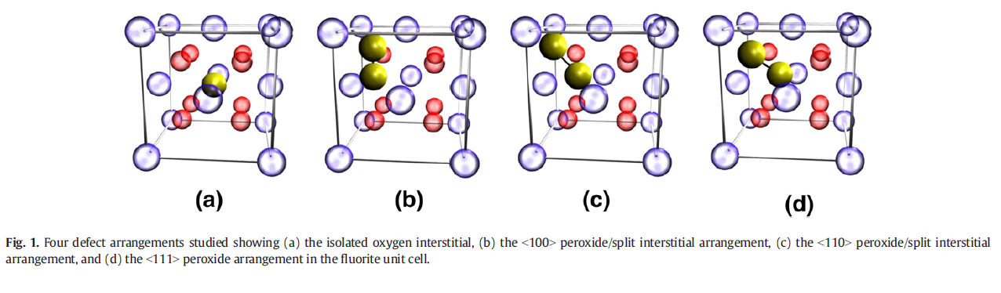

Li2O (lithia)

Mg2Si

[1] A. Cheetham, B. Fender, and M. Cooper, "Defect structure of calcium fluoride containing excess anions I. Bragg scattering," *Journal of Physics C: Solid State Physics,* vol. 4, p. 3107, 1971.

[2] W. B. Lacina and P. S. Pershan, "Phonon Optical Properties of ${\mathrm{Ca}}_{1-x}{\mathrm{Sr}}_{x}{\mathrm{F}}_{2}$," *Physical Review B,* vol. 1, pp. 1765-1786, 02/15/ 1970.

[3] A. Maradudin, "Theoretical and Experimental Aspects of the Effects of Point Defects and Disorder on the Vibrations of Crystals—1," *Solid state physics,* vol. 18, pp. 273-420, 1966.

[4] A. Nakajima, A. Yoshihara, and M. Ishigame, "Defect-induced Raman spectra in doped CeO 2," *Physical Review B,* vol. 50, p. 13297, 1994.

[5] R. Rao, R. Bhagat, N. P. Salke, and A. Kumar, "Raman Spectroscopic Investigation of Thorium Dioxide-Uranium Dioxide (ThO 2-UO 2) Fuel Materials," *Applied spectroscopy,* vol. 68, pp. 44-48, 2014.

[6] W. Weber, K. Hass, and J. McBride, "Raman study of CeO 2: second-order scattering, lattice dynamics, and particle-size effects," *Physical Review B,* vol. 48, p. 178, 1993.

[7] P. Umari and A. Pasquarello, "Infrared and Raman spectra of disordered materials from first principles," *Diamond and related materials,* vol. 14, pp. 1255-1261, 2005.

[8] P. Umari and A. Pasquarello, "Ab initio molecular dynamics in a finite homogeneous electric field," *Physical review letters,* vol. 89, p. 157602, 2002.

[9] R. Nunes and X. Gonze, "Berry-phase treatment of the homogeneous electric field perturbation in insulators," *Physical Review B,* vol. 63, p. 155107, 2001.

[10] R. Resta, "Macroscopic polarization in crystalline dielectrics: the geometric phase approach," *Reviews of modern physics,* vol. 66, p. 899, 1994.

[11] P. Brüesch, *Phonons: Theory and Experiments II*. Berlin: Springer-Verlag, 1986.

[12] M. Cardona and G. Guenzerodt, *Light scattering in solids II*. Berlin: Springer-Verlag, 1982.

[13] P. Hohenberg and W. Kohn, "Inhomogeneous electron gas," *Physical review,* vol. 136, p. B864, 1964.

[14] W. Kohn and L. J. Sham, "Self-consistent equations including exchange and correlation effects," *Physical Review,* vol. 140, p. A1133, 1965.

[15] R. G. Parr and R. G. P. W. Yang, *Density-functional theory of atoms and molecules*: Oxford university press, 1989.

[16] G. Kresse and J. Furthmüller, "Efficiency of ab-initio total energy calculations for metals and semiconductors using a plane-wave basis set," *Computational Materials Science,* vol. 6, pp. 15-50, 1996.

[17] G. Kresse and J. Hafner, "Ab initio molecular dynamics for liquid metals," *Physical Review B,* vol. 47, p. 558, 1993.

[18] P. E. Blöchl, "Projector augmented-wave method," *Physical Review B,* vol. 50, p. 17953, 1994.

[19] G. Kresse and D. Joubert, "From ultrasoft pseudopotentials to the projector augmented-wave method," *Physical Review B,* vol. 59, p. 1758, 1999.

[20] S. Dudarev, G. Botton, S. Savrasov, C. Humphreys, and A. Sutton, "Electron-energy-loss spectra and the structural stability of nickel oxide: An LSDA+ U study," *Physical Review B,* vol. 57, p. 1505, 1998.

[21] S. Middleburgh, G. Lumpkin, and R. Grimes, "Accommodation of excess oxygen in fluorite dioxides," *Solid State Ionics,* vol. 253, pp. 119-122, 2013.