First principles calculation of Raman spectra of fluorite systems with anion defects: CaF2, CeO2, and UO2

By Eugene Ragasa, Alex Chernitnovsky, and Simon Phillpot

# Abstract

# Introduction

Raman spectroscopy provides an in situ mechanism for the non-destructive characterization of materials. When electromagnetic radiation interacts with the polarizable electron density, the change in the electric dipole-electric polarizability with respect to the phonon vibrational mode associated with a specific frequency is required for Raman phenomena. However, a detailed understanding of the vibrational spectra can only be achieved through accurate theoretical modelling.

Raman spectroscopy is used commonly used in conjunction infrared (IR) spectroscopy, since vibrational information is specific to the chemical bonds and crystalline symmetry. While vibrational spectroscopy’s sensitive to point defect make this technique particularly useful, the broken translation symmetry of structures with point defect make it difficult to resolve changes in Raman spectra to specific structures.

Materials with fluorite structures are important materials in both technical applications and science studies. Compounds with the fluorite structure are known to be capable of accommodating a large excess of anions (ions with net negative charge),[1] due to the stability of the cation sub lattice which maintains long-range order while doped with large numbers of impurities. This study calculates the Raman spectra of three fluorite structures of increasing electronic structure complexity: fluorite (CaF2­), ceria (CeO2), and urania (UO2).

Oxides having a fluorite-type structure, when doped with aliovalent cations, become good oxygen- conductors at elevated temperatures. CeO2 solid electrolyte for oxygen sensors, fuel cells. Ceria is of interest as a solid fuel cell electrolyte and catalyst applications, but also because it is isostructural with nuclear fuels of interest, such as urania (UO2), plutonia (PuO2), and thoria (ThO2). The prior two materials are primary nuclear fuels in operating reactors, while the latter is of interest for a thorium-based fuel cycle.

# Computational Methods

This study calculates the Raman tensor by calculating the finite differences of the polarization of a system subject to various finite electric fields and coupling them with phonon vibrational modes. Interatomic forces are calculated in VASP using the PAW formalism with the appropriate LDA/GGA functionals. For CeO2 and UO2, DFT+U are required to provide the necessary corrections to point defect calculations. Occupation matrix control is required to account for localized f electrons in both CeO2 and UO2.

## Calculation of Raman spectra

Umari and Pasquarello describe a technique where both IR and Raman spectra are calculated from first principals for an amorphous silicate system[2] which uses results from the modern theory of polarization to treat finite electric fields.[3] This method gives derivatives with respect to the electrical field equivalent to perturbational methods[3, 4] but only requires the addition of a term to the ground energy functional[2]:

$$E^{ℇ}\left[\left\{ψ\right\}\right]=E^{0}\left[\left\{ψ\right\}\right]-Ωℇ(P^{\text{el}}\left[\left\{ψ\right\}\right]+P^{\text{ion}})$$

$E^{0}\left[\left\{ψ\right\}\right]$ is the energy functional in the absence of an electric field, $P^{\text{el}}\left[\left\{ψ\right\}\right]$ is the electronic polarization and $P^{\text{ion}}$ is the ionic polarization.

This approach is attractive for several reasons. First, by defining the polarizability tensor as derivatives of atomic forces with respect to finite electric fields approximations for the Raman spectra can be calculated using density functional theory (DFT) software such as VASP.

With this approach, dielectric susceptibilities, can be calculated by taking finite differences of the polarization of the system subject to an electric field[2].

$$χ_{ij}=\frac{∂^{2}E}{∂ℇ_{i}∂ℇ_{i}}≅\frac{ΔP_{i}^{el}}{Δℇ_{i}}$$

Born effective charge tensors are defined as induced polarization along the direction $I$ by a unitary displacement of the Ith atom in the direction $j$ [5]:

$$Z_{I,ij}^{*}=Ω\frac{∂P_{i}^{el}}{∂r_{Ij}}=\frac{∂^{2}E}{∂ℇ_{i}∂r_{Ij}}=-\frac{∂F_{Ij}}{∂ℇ_{i}}$$

Using finite electric field DFT calculations, we can calculate the Born effective charge tensors by taking finite difference of atomic forces with respect to the electric field.

For a Raman scattering process, an incoming photon of frequency $ω_{L}$ and polarization $e_{L}$ is scattered to an outgoing photon of frequency $ω_{s}$ and polarization $e_{s}$. This either creates on annihilates a phonon of frequency $ω_{n}$ by Stokes or anti-Stokes processes, respectively. We consider the nonresonant Raman scattering process[2, 6, 7].

$$\frac{dσ(ω)}{dΩ}∼\sum_{n}{{\left|e_{s}{∙α}^{n}∙e_{L}\right|}^{2}δ(ω-ω_{n})}$$

Calculation of Raman tensors alpha[2, 7] is defined the formula:

$$α_{ij}^{n}=\sqrt{Ω}\sum_{Ik}{\frac{{∂χ}_{ij}}{∂r_{Ik}}u_{Ik}^{n}}$$

Third rank tensors which are derivatives of the dielectric susceptibility tensor with respect to ionic displacements can be alternatively calculated by second derivatives of the atomic forces with respect to changes in the finite electric field.

$$\frac{{∂χ}_{ij}}{∂r_{Ik}}=\frac{∂^{2}P_{i}^{\text{el}}}{∂r_{Ik}∂ℇ_{j}}=\frac{1}{Ω}\frac{∂^{3}E_{\text{tot}}}{∂r_{Ik}∂ℇ_{i}∂ℇ_{j}}=-\frac{1}{Ω}\frac{∂^{2}F_{Ik}}{∂ℇ_{i}∂ℇ_{j}}$$

Lattice dynamics provides an analytical solution of the equations of motion resulting in a vibrational system where atoms are displaced from their equilibrium positions. A rigorous development of the theory of lattice dynamics is described in the seminal book on the subject by Born and Huang[8]. For the proposed work, relevant key results are distilled from the mathematical machinery.

An atomic system can be represented by the atomic masses of the systems combined with an interatomic potential that describes the forces between the atoms are captured in a dynamical matrix.

$$D_{Ii,Jj}=\frac{1}{\sqrt{M_{I}M_{J}}}\frac{∂E_{\text{tot}}}{∂r_{Ii}∂r_{Jj}}$$

To calculate the dynamical matrix, either by numerical derivatives using finite displacements of individual atoms. The eigenvalues, $ω_{n}$, and eigenvectors, $u_{Ii}^{n}=\frac{1}{\sqrt{M_{I}}}v_{Ii}^{n}$, of this matrix represent the frequencies and vibrational modes associated with the material. Since these modes are linearly independent and form an orthonormal basis set, the state of any vibrational system can be represented by a linear combination of its modes.

## Calculation Parameters

A 2x2x2 supercell of CaF2 (, is relaxed in the ideal crystal, with a single fluorine atom either being removed or added to create the anion vacancy and interstitial structures, respectively. Density functional calculations used the plane-wave based Vienna *ab initio* program package (VASP). The electron wave functions are described using the projector augmented wave (PAW) method. Plane waves have been included up to the energy cutoff of 650 eV. Only a single *k*-point (the $Γ$- point) was used to sample the Brillouin zone. The projector augmented wave (PAW) method was used to represent the interaction between the valence electrons and the atomic cores. Gaussian smoothing with a width of sigma=0.02 was applied. The total energy threshold defining the self-consistency of the electron density was set to 10-8 eV. Relaxation of forces was conducted to 10-4eV/A.

To calculate the phonons at the $Γ$- point, the Hessian matrix from which the vibrational frequencies of a system are derived are also calculated at the $Γ$- point by taking central differences with respect atomic displacements of 0.015 Å.

For the finite electric field calculations, the second derivatives of the atomic forces with respect to changes in the finite electric field were calculated by varying the applied electric field to calculate by central differences. A total of twenty-four finite electric fields were applied to each structure, where $\left[E_{i},E_{j},E_{k}\right]$ = $\left[mΔE,nΔE,pΔE\right]$, for $m,n,p ϵ\left\{-2,1,0,1,2\right\}$ and $ΔE=1$ meV/Å. The total energy threshold for self-consistency of electron density was set to 10-10 eV when a finite electric field is applied to the structure. A python code was developed to extract vibrational modes, calculate the Raman tensors, and calculate the Raman intensities.

The energy functional in DFT+U is given by

$$E_{DFT+U}=E_{DFT+U}+E_{Hub}-E_{dc}$$

where $E_{DFT}$ is the LDA or GGA contribution to the energy, $E_{Hub}$ is the electron-electron interaction from the Hubbard term. Since part of this interaction is already taken into account in $E_{DFT}$, a double counting correction in $E_{dc}$ is necessary. The last two terms depend on the occupation matrix of the correlated orbitals. The Hubbard parameter U, which reflects the strength of the on-site Coulomb interaction, and the parameter J, which adjusts the strength of the exchange interaction. For CeO­2, Ueff=5.0 eV was determined for LDA+U calculations.[9]

## Models

For ideal crystalline CaF2, a Raman signature is calculated using the primitive cell.

The removal of one F atom leads to a Ca32F65  For defect structures, a 2x2x2 supercell used.

o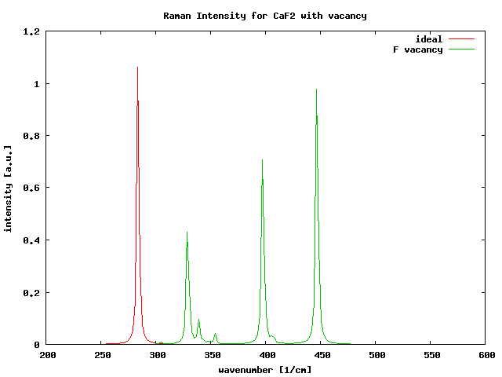/

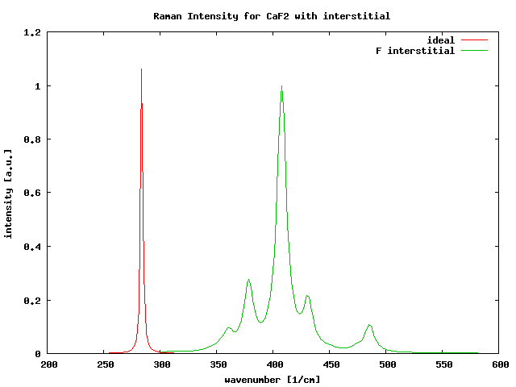

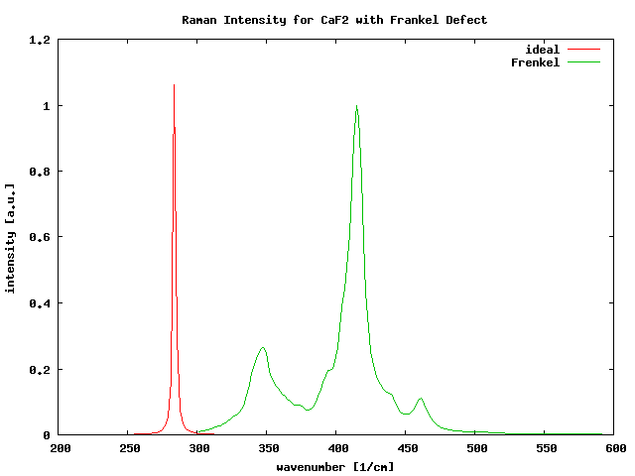

Vi

For both $\text{Ca}{\text{F}}_{\text{2}}$, $\text{Ce}O_{2}$

Calcium Floride

<http://webdoc.sub.gwdg.de/ebook/diss/2003/fu-berlin/1999/24/ch_2.pdf>

Pure cerium oxide has two stable stoichiometry: the CeO2 (Fm3m) and Ce2O3 ($P\overline{3}m1$) which represent the oxidation and reduction extremes in which all the Ce ions are nominally in the 4+ and 3+ oxidation states respectively. In the former, all valence states are empty, while in the latter one electron per cation occupies the Ce 4f-like band. In terms of electronic structure, partially reduced ceria CeO2-x is an intermediate case. The presence of compensating electrons into the empty 4f states of neighboring Ce atoms, thus driving the Ce(IV) to Ce(III) reduction. Electronic correlation due to the strong localization of these states in reduced cerias have the effect of splitting the Ce-4f band upon occupation, resulting in a fully occupied gap state experimentally detected to be 1.2 – 1.5 eV above the top of the valence band.[10]

For CeO2,

In principle, the computational description of the insulating CeO2 with conventional density functional theory is more or less straightforward due to the unoccupied Ce (4*f*) state. However Ce2(III)O3 has been known to be a notorious problem case for electronic structure calculation. From the recently published work it is evident now that calculations using the standard LDA or GGA give the wrong metallic ground state for Ce2O3. An accurate descrioption demands a modification of the usually employed DFT approaches to account for the strong localization of the Ce *f* electron in the formal Ce oxidation state III.

For UO2,

Monkhorst-Pack k-point mesh with the use of a 6x6x6 k-point grid is sufficient to get results converged to less than 0.1 meV per atom in a 6-atom supercell. A 600eV cut-off energy is large enough to get results converged to 0.3 meV.[Dorado 2009]

Values for U and J parameters are chosen equal to U = 4.50 eV and J = 0.51 eV. These values are close to those determined by Kotani[] and Dorado[].

## Ground State and Metastable States

A thorough review of DFT+U leading to issues of finding the ground state configuration amongst metastable phases is provided by Dorado[11]

Correlated orbitals in UO2 have roughly the same energy. This results in fractional occupancies of the f orbitals, and hence a metallic character. On the contrary, the DFT+U approximation localizes electrons on specific orbitals, leading to an insulating character. The price to pay for this localization in DFT+U is the occurrence of metastable states[12-15] that correspond with the different ways of filling the orbitals: in UO2, the metastable states correspond to the filling of the 5f orbitals by the two 5f electrons of the U4+ ions.

The number of metastable states is directly related to the orbital degeneracies. In paramagnetic UO2, the point group symmetry of the uranium site is Oh and the crystal field lifts the seven 5f orbital degeneracies into a 3-1-3 configuration (sorted by increasing energy). The introduction of anti-ferromagnetic order then changes the point group symmetry of the uranium site to D4h which in then lifts the degeneracies into a 2-1-1-2-1 configuration.

Dorado studies the ground state and metastable states in UO2 (1k antiferromagnetic order), Dorado inferred that the ground state is obtained by putting the two 5f electrons into the two lowest two-fold degenerate orbitals whereas the first metastable state is obtained by filling the two higher two-fold degenerate orbitals.

Discrepancies stem from the presence of metastable states in UO2[16]: in all studies in which no control has been done on electronic occupancies, the calculation of the perfect crystal always reached the first metastable state, located 12 meV/UO2 above the ground state.

**Occupation Matrices**

Occupation matrix control scheme[17-19] uses occupation matrices (which represent how the correlated electrons occupy the correlated orbitals) to precondition the convergence of the system toward the ground state. The ground state must first be found by imposing all possible initial occupation matrices (hence all possible initial electronic occupancies) and by comparing the corresponding total energies, the lowest being that of the ground state. Once the ground state is found, the associated electronic configuration is imposed at the beginning of all subsequent calculations in order to ensure the calculation does not “jump” out of the ground state configuration.

In order to determine the ground state, Dorado[17] imposed different occupation matrices at the beginning of each calculation. Each occupation matrix corresponds to a particular filling of the U (5f) levels. As a first step, only the diagonal occupation matrices are imposed. There are $C_{2}^{7}=21$ different ways of filling the seven 5f levels with two elections. Each of the 21 ways is called an electronic configuration. Since there are several degenerate f levels, some of the electronic configurations are identical by symmetry. The imposed occupation matrices are defined by two quantum numbers $m_{i}$ and $m_{j}$, corresponding to the orbitals which are filled. The basis of real harmonics.

In each calculation, we impose one particular diagonal occupation matrix using the first 10 steps of the first self-consistent cycle. This constraint is then lifted and the calculation is left to converge on it’s own.

# Results and Discussion

## Atomic and Electronic Structure

The fluorite structure belongs to the space group, $O_{h}^{5}$. The cation sublattice is arranged in a BCC arrangement, while the the Raman tensor transforms as the irreducible representation $A_{1g}+E_{g}+T_{2g}.$

Ceria-based substances take an active role in the catalytic reaction by controlling the oxygen partial pressure at the reaction sites, acting effectively as oxygen reservoirs. There is ample evidence that this property is controlled by the chemistry of oxygen vacancies which hare neutralized by the valance change Ce4+ -> Ce3+. Our current understanding of the phenomena relies on the quasidegeneracy of different ionic configurations in which a highly localized 4f-electron state is occupied or empty.

Ceria has substantial nonstoichiometry dominated by defect chemistry with removal of oxygen atoms from the oxygen sublattice.

$$O_{O}+2{Ce}_{Ce}→V_{O}^{..}+2{Ce}_{Ce}^{'}+{\frac{1}{2}O}_{2}(g)$$

$V_{O}^{..}$ is a oxygen vacancy and ${Ce}_{Ce}^{'}$ is a ${Ce}^{3+}$ ion on a ${Ce}^{4+}$ site

**GET REFERENCE: Steele, B. C. H., and J. M. Floyd. *OXYGEN SELF-DIFFUSION AND ELECTRICAL TRANSPORT PROPERTIES OF NONSTOICHIOMETRIC CERIA AND CERIA SOLID SOLUTIONS*. Imperial Coll. of Science and Tech., London, 1971.**

[21] B. C. H. Steele and J. M. Floyd, Proceedings of the British Ceramic Society 19, 55 (1971).

[22] SC

[23] M. Mogensen, N. M. Sammes, and G. A. Tompsett, Solid State Ionics 129, 63 (2000).

[24] S. R. Bishop, K. L. Duncan, and E. D. Wachsman, Acta Mater.57, 3596 (2009).

PEAD. /prb/pdf/10.1103/PhysRevB.63.155107

On fluorite structrues.

Keramidas, Vassilis G., and William B. White. "Raman spectra of oxides with the fluorite structure." *The Journal of Chemical Physics* 59.3 (1973): 1561-1562.

Michel, D., and R. Collongues. "Study by Raman spectroscopy of order‐disorder phenomena occurring in ome binary oxides with fluorite‐related structures." *Journal of Raman Spectroscopy* 5.2 (1976): 163-180.

CeO2

Weber, W. H., K. C. Hass, and J. R. McBride. "Raman study of CeO 2: second-order scattering, lattice dynamics, and particle-size effects." *Physical Review B* 48.1 (1993): 178.

First-principles, L. D. A. "U and GGA+ U study of cerium oxides: Dependence on the effective U parameter Loschen, Christoph; Carrasco, Javier; Neyman, Konstantin M.; Illas, Francesc." *Physical Review B: Condensed Matter and Materials Physics* 75.3 (2007): 035115.

UO2

Bierlein, T. K., and B. Mastel. "Damage in UO2 films and particles during reactor irradiation." *Journal of Applied Physics* 31.12 (1960): 2314-2315.

Desgranges, Lionel, et al. "Raman spectrum of U4O9: a new interpretation of damage lines in UO2." *Journal of Raman Spectroscopy* 43.3 (2012): 455-458.

Guimbretière, G., et al. "In situ Raman monitoring of He2+ irradiation induced damage in a UO2 ceramic." *Applied Physics Letters* 103.4 (2013): 041904.

Dorado, B., et al. "Advances in first-principles modelling of point defects in UO2: f electron correlations and the issue of local energy minima." *Journal of Physics: Condensed Matter* 25.33 (2013): 333201.

[1] A. Cheetham, B. Fender, and M. Cooper, "Defect structure of calcium fluoride containing excess anions I. Bragg scattering," *Journal of Physics C: Solid State Physics,* vol. 4, p. 3107, 1971.

[2] P. Umari and A. Pasquarello, "Infrared and Raman spectra of disordered materials from first principles," *Diamond and related materials,* vol. 14, pp. 1255-1261, 2005.

[3] P. Umari and A. Pasquarello, "Ab initio molecular dynamics in a finite homogeneous electric field," *Physical review letters,* vol. 89, p. 157602, 2002.

[4] R. Nunes and X. Gonze, "Berry-phase treatment of the homogeneous electric field perturbation in insulators," *Physical Review B,* vol. 63, p. 155107, 2001.

[5] R. Resta, "Macroscopic polarization in crystalline dielectrics: the geometric phase approach," *Reviews of modern physics,* vol. 66, p. 899, 1994.

[6] P. Brüesch, *Phonons: Theory and Experiments II*. Berlin: Springer-Verlag, 1986.

[7] M. Cardona and G. Guenzerodt, *Light scattering in solids II*. Berlin: Springer-Verlag, 1982.

[8] M. Born and K. Huang, *Dynamical Theory Of Crystal Lattices*. New York: Oxford University Press, 1954.

[9] C. Loschen, J. Carrasco, K. M. Neyman, and F. Illas, "First-principles LDA+ U and GGA+ U study of cerium oxides: Dependence on the effective U parameter," *Physical Review B,* vol. 75, p. 035115, 2007.

[10] S. Fabris, S. de Gironcoli, S. Baroni, G. Vicario, and G. Balducci, "Taming multiple valency with density functionals: A case study of defective ceria," *Physical Review B,* vol. 71, p. 041102, 2005.

[11] B. Dorado, M. Freyss, B. Amadon, M. Bertolus, G. Jomard, and P. Garcia, "Advances in first-principles modelling of point defects in UO2: f electron correlations and the issue of local energy minima," *Journal of Physics: Condensed Matter,* vol. 25, p. 333201, 2013.

[12] A. Shick, W. Pickett, and A. Liechtenstein, "Ground and metastable states in γ-Ce from correlated band theory," *Journal of Electron Spectroscopy and Related Phenomena,* vol. 114, pp. 753-758, 2001.

[13] K. N. Kudin, G. E. Scuseria, and R. L. Martin, "Hybrid Density-Functional Theory and the Insulating Gap of U O 2," *Physical review letters,* vol. 89, p. 266402, 2002.

[14] I. D. Prodan, G. E. Scuseria, and R. L. Martin, "Assessment of metageneralized gradient approximation and screened Coulomb hybrid density functionals on bulk actinide oxides," *Physical Review B,* vol. 73, p. 045104, 2006.

[15] P. Larson, W. R. Lambrecht, A. Chantis, and M. van Schilfgaarde, "Electronic structure of rare-earth nitrides using the LSDA+ U approach: Importance of allowing 4 f orbitals to break the cubic crystal symmetry," *Physical Review B,* vol. 75, p. 045114, 2007.

[16] F. Jollet, G. Jomard, B. Amadon, J. Crocombette, and D. Torumba, "Hybrid functional for correlated electrons in the projector augmented-wave formalism: Study of multiple minima for actinide oxides," *Physical Review B,* vol. 80, p. 235109, 2009.

[17] B. Dorado, B. Amadon, M. Freyss, and M. Bertolus, "DFT+ U calculations of the ground state and metastable states of uranium dioxide," *Physical Review B,* vol. 79, p. 235125, 2009.

[18] B. Amadon, F. Jollet, and M. Torrent, "γ and β cerium: LDA+ U calculations of ground-state parameters," *Physical Review B,* vol. 77, p. 155104, 2008.

[19] G. Jomard, B. Amadon, F. Bottin, and M. Torrent, "Structural, thermodynamic, and electronic properties of plutonium oxides from first principles," *Physical Review B,* vol. 78, p. 075125, 2008.