Silk Value Digital Platform – Architecture & PRD Handover
This document is prepared for solution architects and development partners. It consolidates the end-to-end business flow, digital system architecture, and PRD structure for the Silk Value procurement, traceability, and payment platform. Single app whould integrate all activities with limited access to each stakeholders.

1. End-to-End Digital Flow (Business + System)
The following flowchart represents the complete operational and digital lifecycle from reeler onboarding to finished goods traceability.

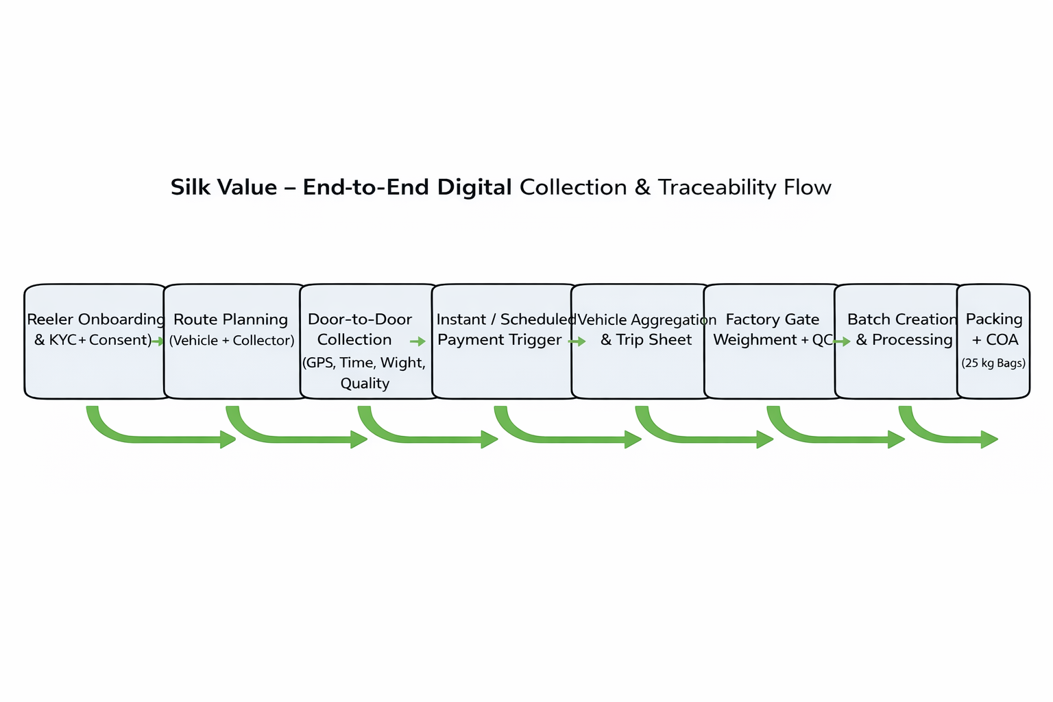

2. One-Pager System Architecture
This architecture diagram illustrates how mobile applications, backend services, data layers, and integrations work together to deliver traceability, payments, and analytics.
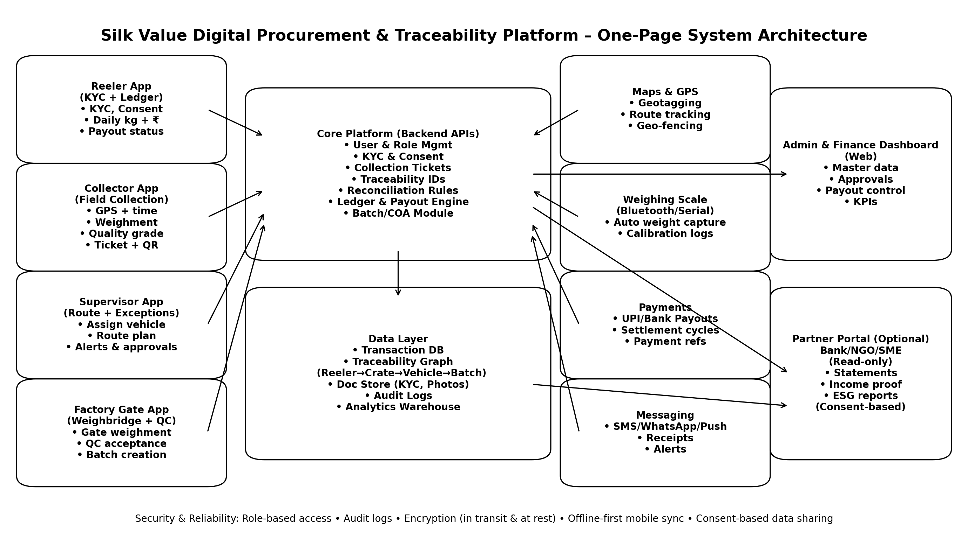

1️⃣ END-TO-END FLOW CHART
Silk Value Digital Collection, Traceability & Payment Platform
You can use this as-is in DPR / PPT / PRD.

A) HIGH-LEVEL FLOW (Business + Tech Combined)
Reeler Onboarding & KYC
↓
Reeler Geo-Tagging & Cluster Mapping
↓
Daily Route Planning (Vehicle + Collector Assigned)
↓
Door-to-Door Collection Event
(GPS + Time + Weight + Quality)
↓
Instant / Scheduled Payment Trigger
↓
Vehicle-Level Aggregation
↓
Factory Gate Cross Weighment
↓
Gate QC Acceptance / Rejection
↓
Final Payment Settlement
↓
Batch Creation & Processing Traceability
↓
Packing + COA Generation
↓
Customer Dispatch & Traceability
↓
Analytics, Reports & Bank/NGO Integration ( future)

B) DETAILED FLOW (Operational Accuracy)
[ REELER APP ]
Reeler Registration
→ KYC Upload (Aadhaar/PAN/Bank)
→ Approval by Admin
→ Reeler ID + QR Generated
→ Reeler Dashboard Active
[ COLLECTION PLANNING ]
Admin/Supervisor
→ Map Reelers by Cluster
→ Assign Vehicle + Collector
→ Generate Route Plan
→ Push Schedule to Collector App
[ FIELD COLLECTION – COLLECTOR APP ]
Collector Starts Route
→ GPS + Time Auto Logged
→ Select Reeler / Scan QR
→ Weigh Pupae (Bluetooth / Manual)
→ Enter Crate Count
→ Quick Quality Grade
→ Photo (Optional)
→ Collection Ticket Generated
→ Payment Triggered (Instant / Weekly)
→ Reeler Receives Notification
[ VEHICLE TRACEABILITY ]
Vehicle ID + Collector ID
→ Linked to All Collection Tickets
→ Trip Sheet Auto Generated
→ Expected Gate Weight Calculated
[ FACTORY GATE ]
Vehicle Check-In
→ Gate Weighment
→ Compare with Field Weight
→ QC Check (Accept / Reject / Deduction)
→ Final Accepted Qty per Reeler
→ Ledger Updated
[ PAYMENTS ]
Finance Approval (Auto / Manual)
→ Bank / UPI Payout
→ Payment Confirmation
→ Reeler Ledger Updated
[ PROCESSING & TRACEABILITY ]
Batch ID Created
→ Link All Reeler Tickets
→ Drying + QC Results Logged
→ Packing (25 kg bags)
→ COA Generated
[ DISPATCH ]
Sales Order Linked
→ Batch Selected

[ ANALYTICS & REPORTING ]
Admin Dashboard
→ Reeler Income Reports
→ Collection Efficiency
→ Quality Trends
→ ESG Impact Metrics
→ Bank / NGO Reports (Consent-based)

2️⃣ PRD (PRODUCT REQUIREMENTS DOCUMENT) – STRUCTURE
“PRD – Silk Value Digital Procurement & Traceability Platform”

1. Document Overview
- Product Name
- Version
- Prepared by
- Date
- Stakeholders

2. Problem Statement
- Unorganised pupae collection
- No traceability
- Payment delays
- No formal income proof for reelers
- No data layer for banks/NGOs

3. Product Vision & Objectives
Vision:
Create India’s first traceable, payment-enabled sericulture by-product platform that converts waste into value while uplifting reelers.
Objectives:
- 100% traceability from reeler to finished goods
- Same-day or defined-cycle payments
- Bank-ready transaction history for reelers
- Scalable cluster-based model

4. User Personas
- Reeler
- Collection Agent
- Supervisor
- Factory QC Operator
- Finance/Admin
- External Partner (Bank/NGO – Read Only)

5. User Roles & Permissions
Role | Permissions
Reeler | View own data, earnings
Collector | Collect, weigh, submit
Supervisor | Route, approve, monitor
QC Operator | Gate QC, accept/reject
Admin | Full control

6. Functional Requirements (Core Modules)
6.1 Reeler Onboarding & KYC
- Mandatory KYC
- Geo-tagging
- Consent capture
- Reeler ID & QR
6.2 Route & Collection Management
- Cluster mapping
- Vehicle assignment
- GPS tracking
- Time stamping
6.3 Collection Ticket System
- Weight capture
- Quality grade
- Photo proof
- Digital receipt
6.4 Weighment Reconciliation
- Field vs Gate comparison
- Variance rules
- Auto alerts
6.5 Payments & Ledger
- Instant / weekly payout
- Reeler ledger
- Downloadable statements
6.6 Processing & Batch Traceability
- Batch ID creation
- QC parameter logging
- COA generation
6.7 Analytics & Reporting
- Reeler income reports
- Cluster productivity
- ESG impact dashboards

7. Non-Functional Requirements
- Offline-first app
- Data encryption
- Audit logs
- Role-based access
- Scalability (multi-state)

8. Integrations
- Weighing scale (Bluetooth)
- Payment gateway
- GPS/Maps
- Accounting software (future)
- Bank APIs (future)

9. Compliance & Data Governance
- Consent-based data sharing
- KYC compliance
- Audit trail retention
- Data privacy safeguards

10. MVP Scope (Phase 1)
Must Have
- Reeler onboarding
- Collection ticket
- Payments
- Gate verification
- Dashboard
Nice to Have
- COA automation
- Bank reporting
- NGO dashboards

11. Phase-wise Roadmap
Phase | Features
Phase 1 | Collection + Payment
Phase 2 | QC + Batch + COA
Phase 3 | Bank/NGO integration
Phase 4 | Credit scoring

12. KPIs & Success Metrics
- % reelers KYC completed
- Avg payment time
- Weight mismatch %
- Reeler income growth
- Adoption per cluster

13. Risks & Mitigation
- Network issues → Offline sync
- Manipulation → Dual weighment
- Adoption resistance → Training & incentives

14. Appendices
- Flow diagrams
- Screen wireframes (future)
- Data fields list

