**Report**

Major Steps in Genetic Algorithm:

Parent Selection

Recombination

Mutation

Survivor Selection

**Parent Selection:**

From a randomly generated sample of population the parents are selected based on their fitness value. Individuals with high fitness are preferred over individuals with low fitness. The fitness criterion is that individuals with maximum fitness are always selected first according to their expected number of count and then the individuals with lower expected count than maximum are selected till the population size is reached. The selection method used can also be called as selection of the fittest individual.

**Recombination:**

The recombination method is one-point recombination. A recombination point is generated randomly and then a random number is generated. If the random number is greater than the recombination probability, then recombination takes place otherwise recombination does not take place. Solutions with high recombination probability converges rapidly than those with low probability. The first plot is with low crossover probability while the other is with high cross over probability. Low cross-over probability grants uniformity in solutions while high cross-over probability grants local non-uniformities in fitness of individuals. These plots are generated while keeping the mutation probability as constant.

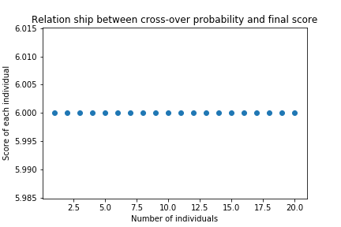

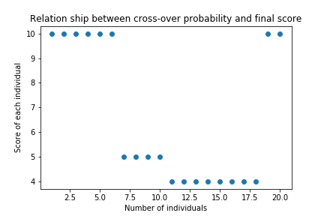

**Mutation:**

The mutation method used is points mutation. A random mutation point is generated than a random number is generated. If the random number is greater than the mutation probability than bit is flip on or off depending on the previous bit. If it is 1 then it is turned to 0 and vice versa. A high mutation probability causes data to become non-uniform and its variance increases as a result.

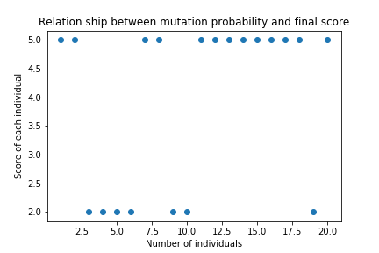

While a low mutation probability ensures uniformity in result.

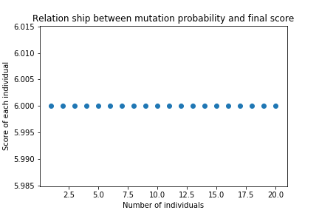

**Survivor Selection:**

The resulting off-spring is screened through the fittest selection criterial so that only the fittest solutions survives. The yellow dots showed the individuals after first generation while the blue dots showed their parents i.e. the first generation.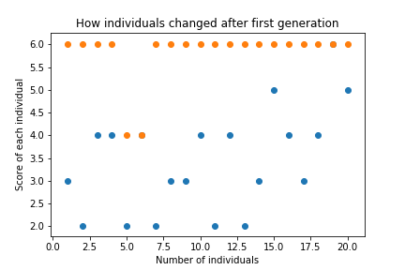

**Results:**

After enough number of generations, the desired solution can be obtained since we are always selecting the fittest individuals.