Question 1:

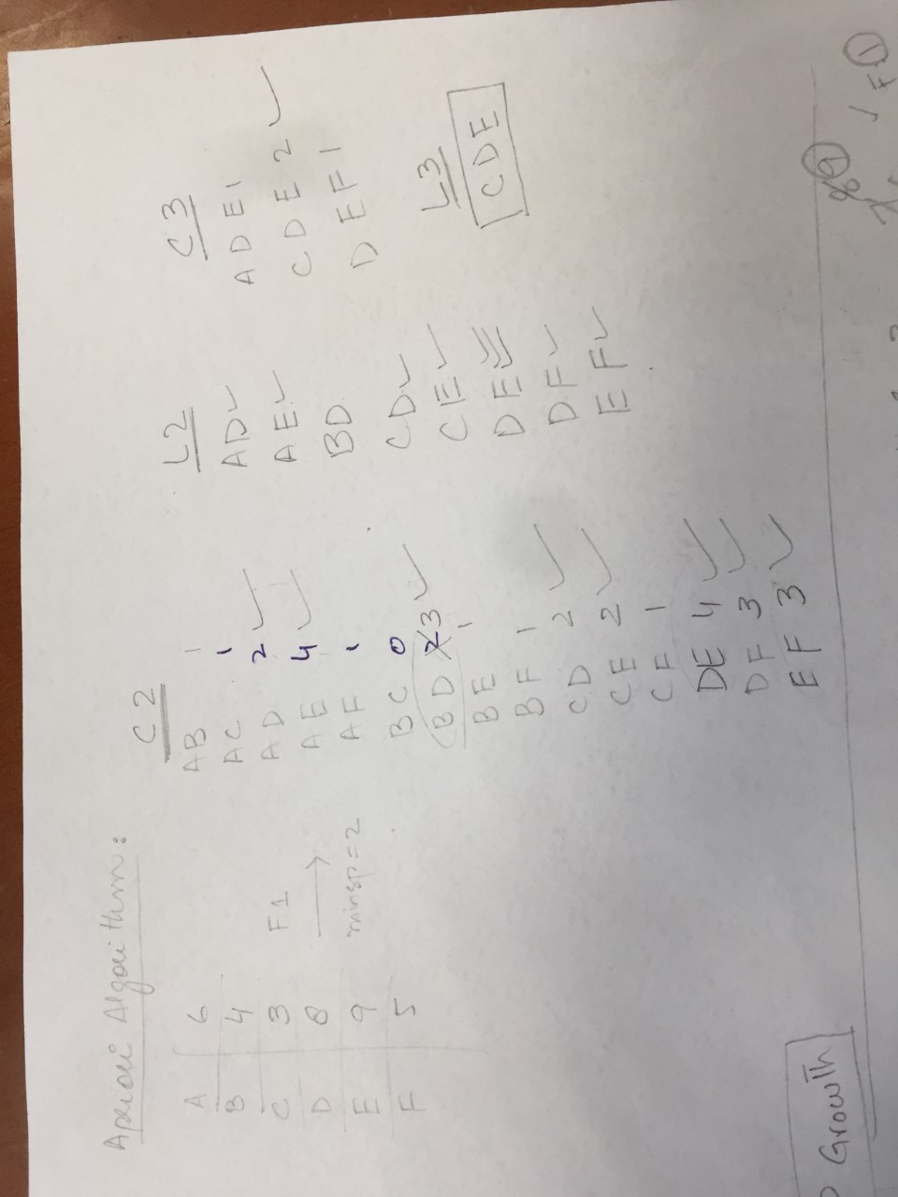

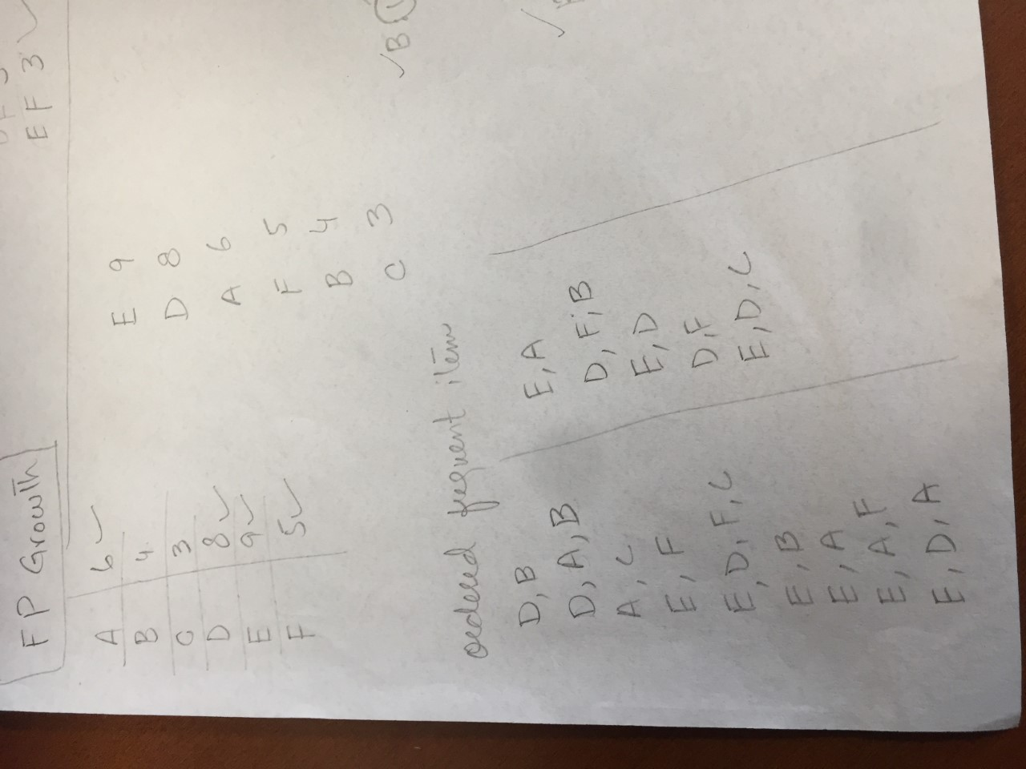

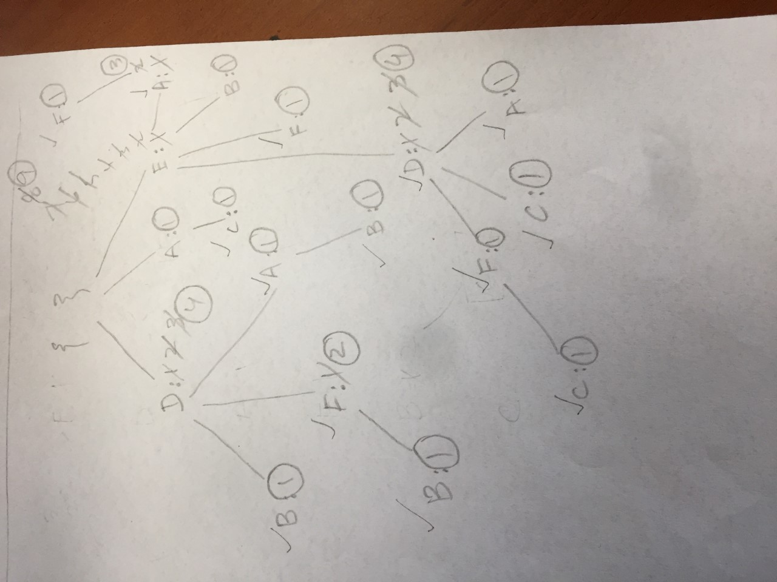

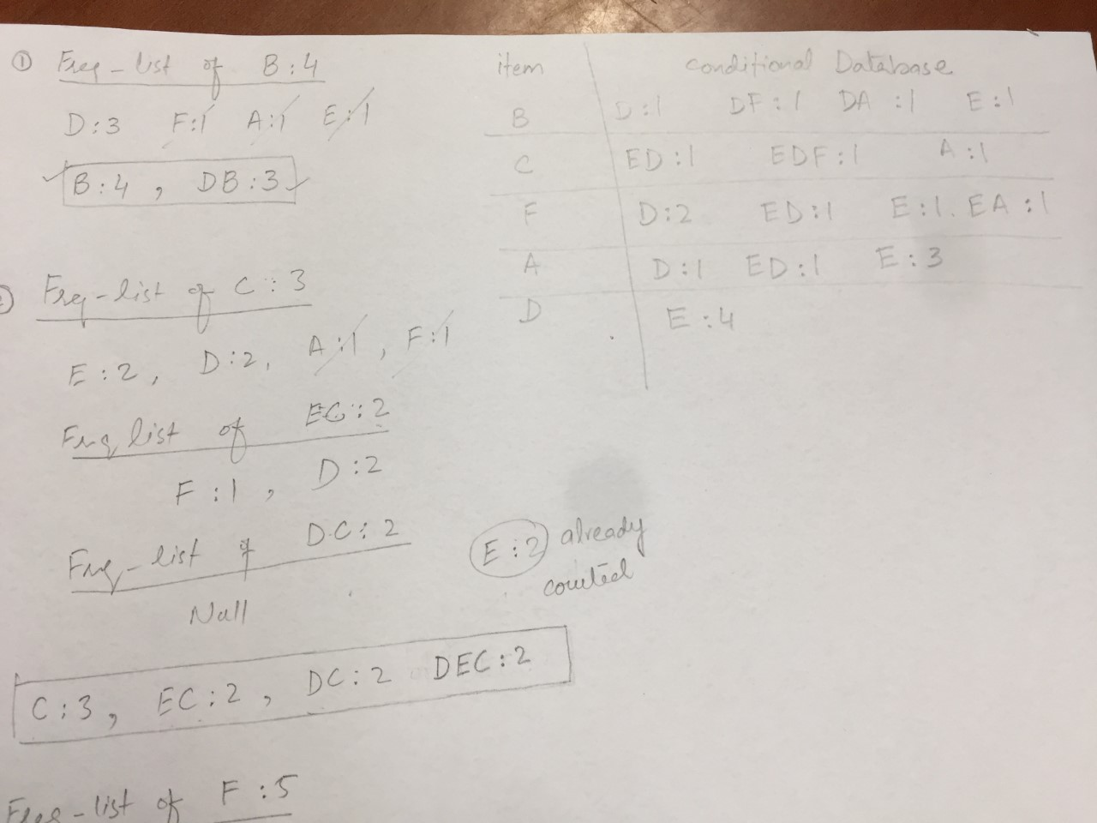

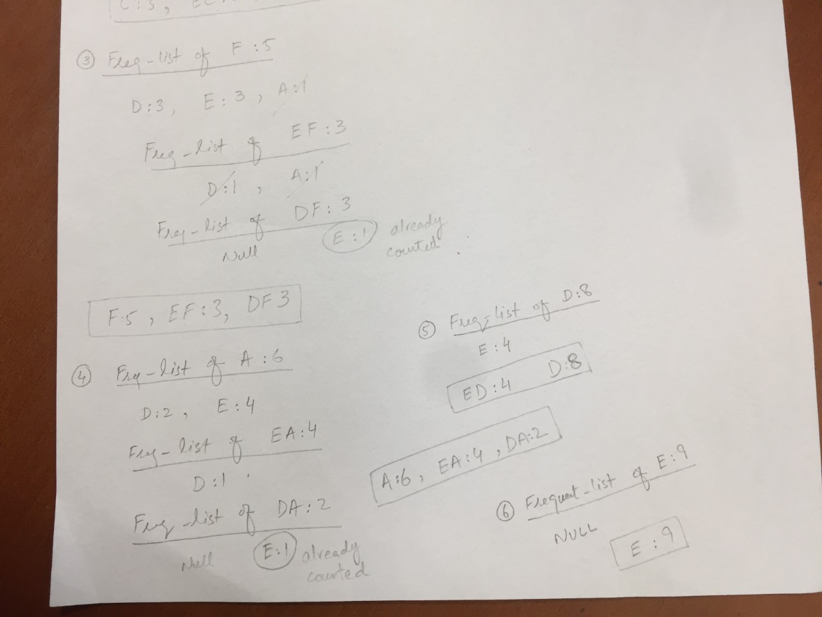

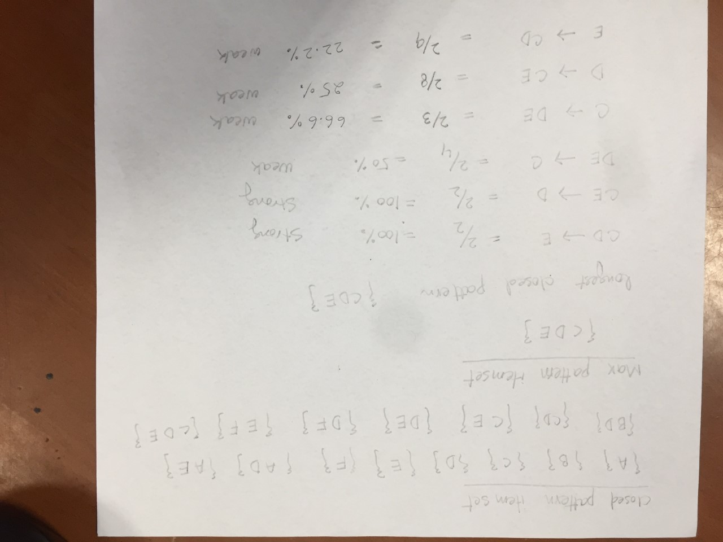

Question 2:

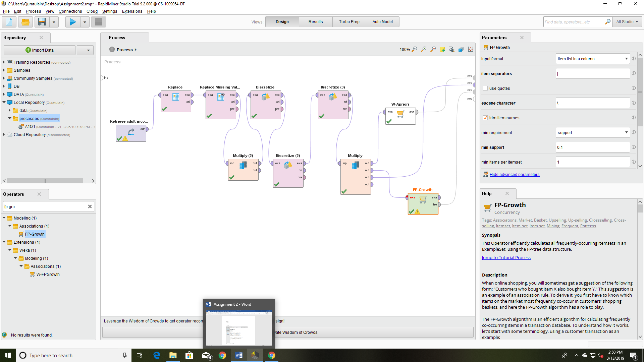

Default Parameters:

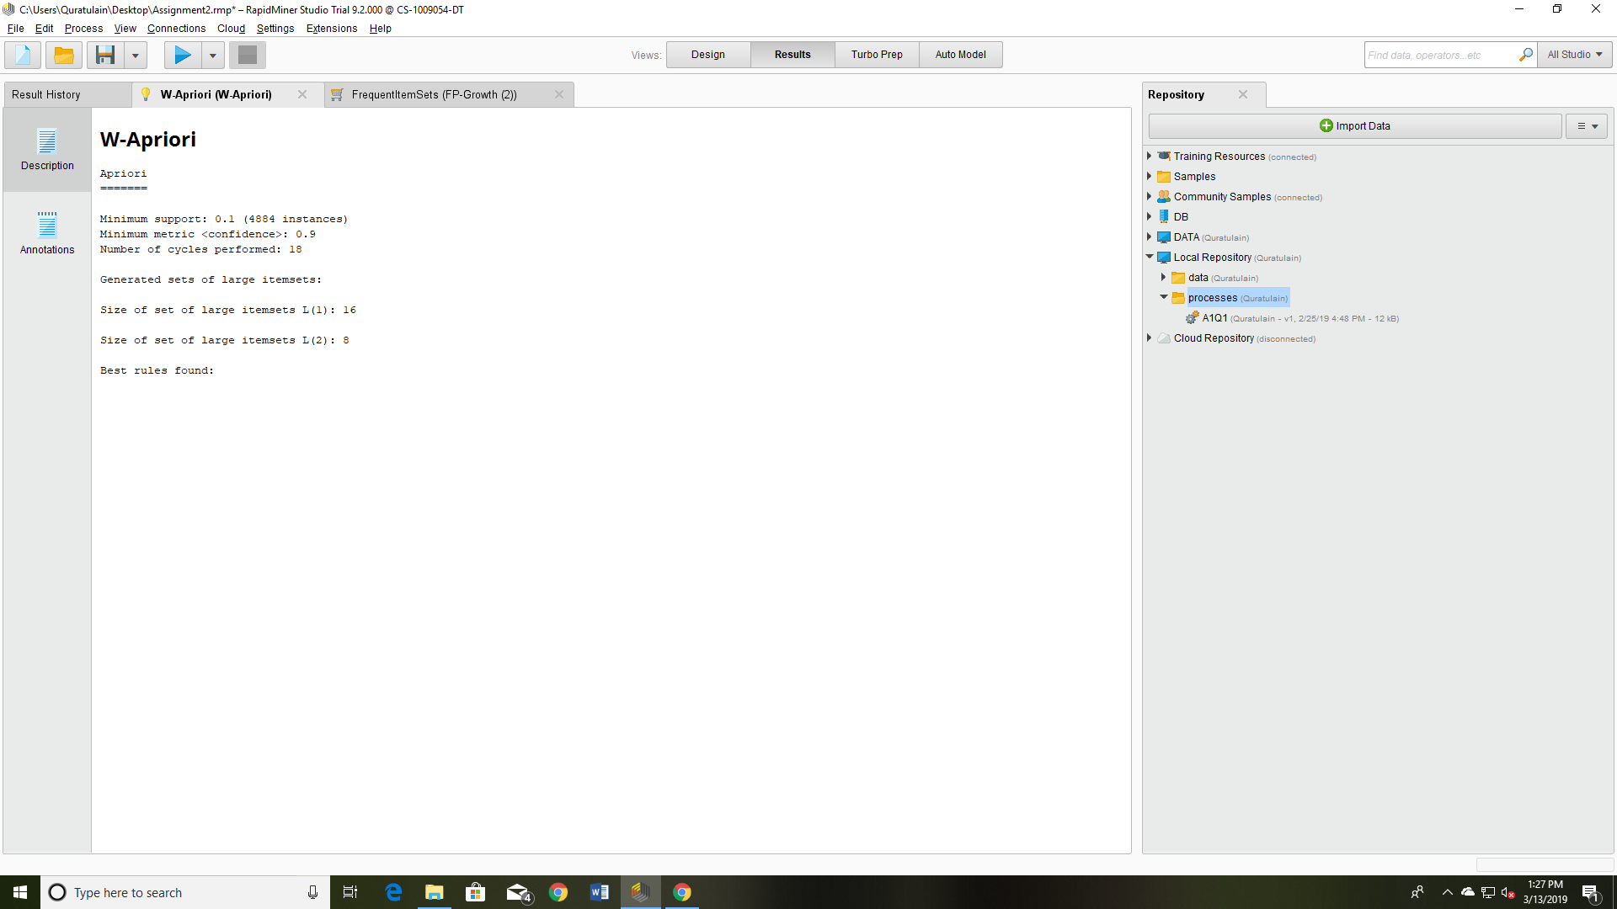

Minimum support = 0.7, rules =50

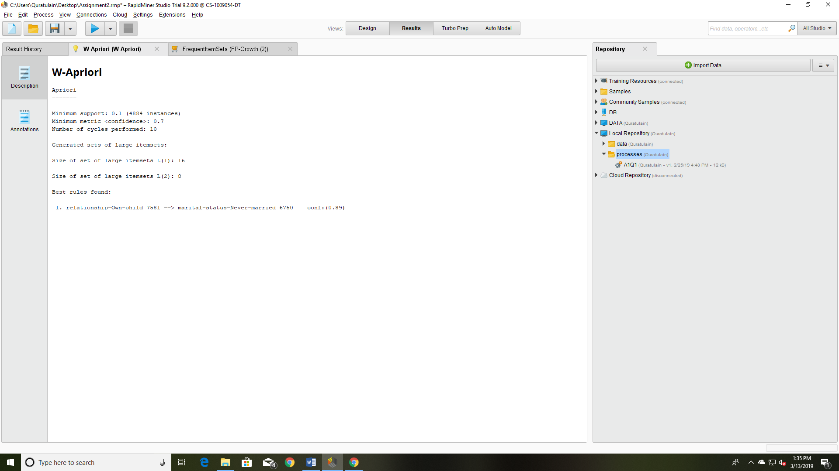

Minimum support = 0.05

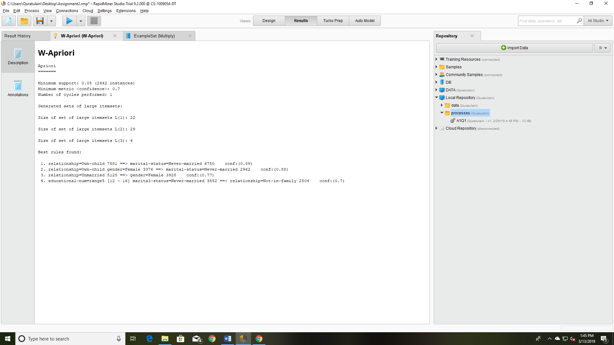

FP-Growth:

Code file is attached to get the frequent item set list.

Default:

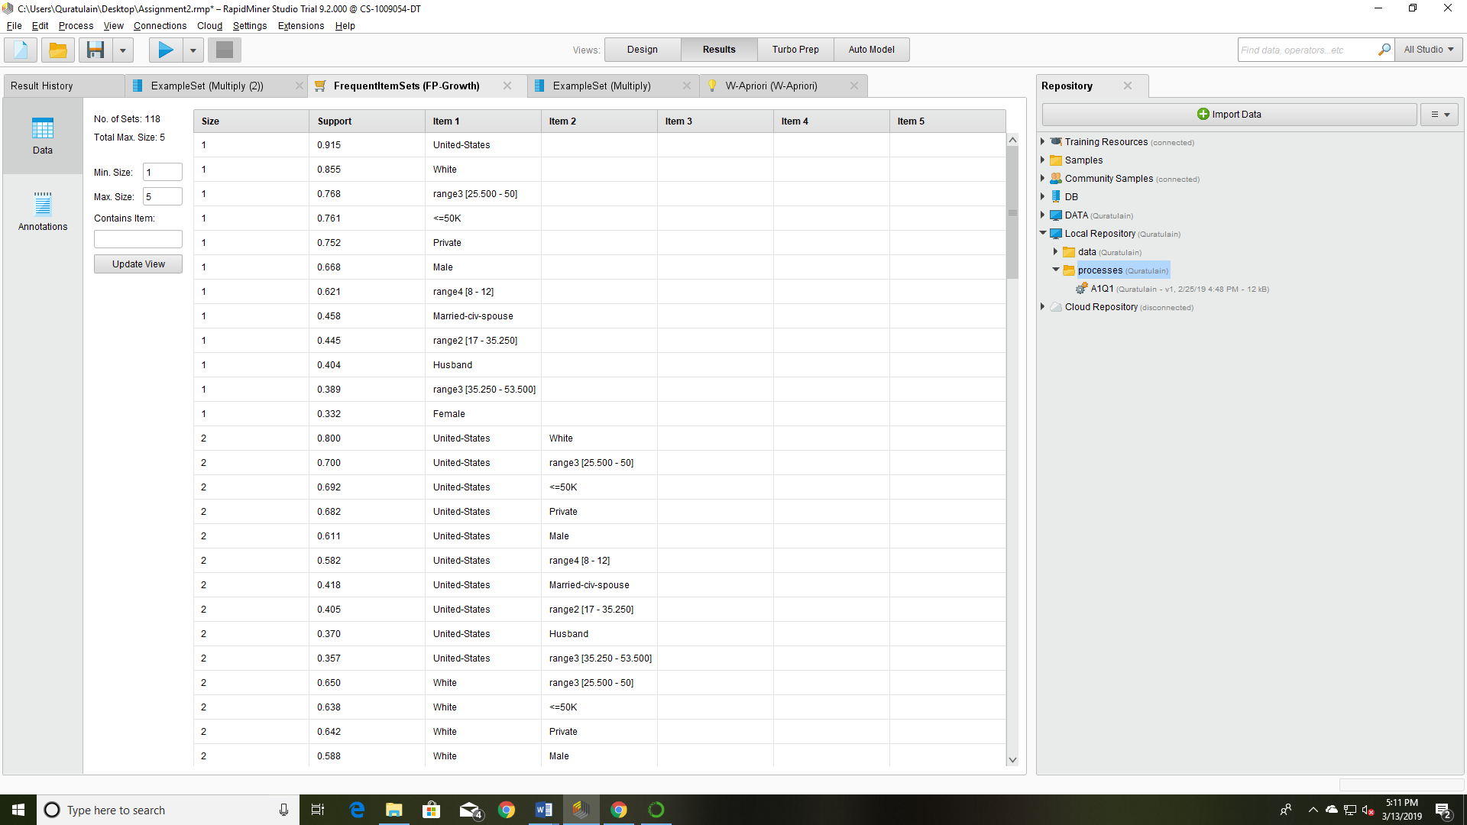

Minimum Support=0.1

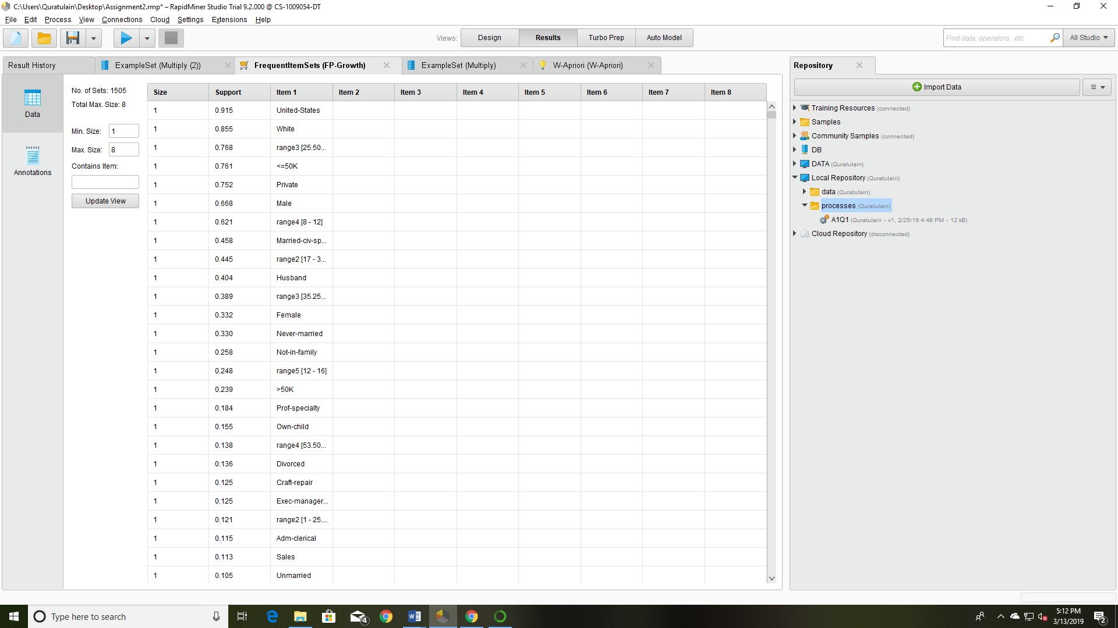

Unchecked, Minimum Support=0.1

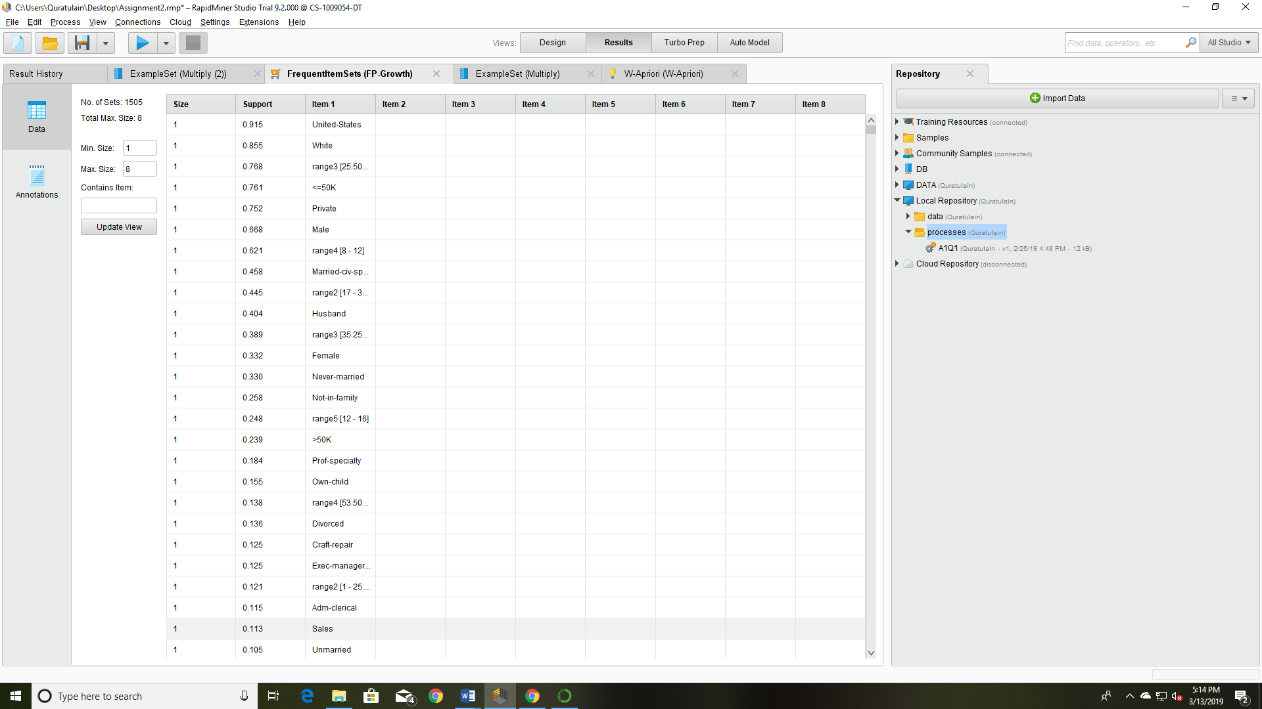

Only rule is generated

Minimum support: 0.1 (4884 instances)

Minimum metric <confidence>: 0.7

Number of cycles performed: 1

Generated sets of large itemsets:

Size of set of large itemsets L(1): 16

Size of set of large itemsets L(2): 8

Best rules found:

1. relationship=Own-child 7581 ==> marital-status=Never-married 6750 conf:(0.89)

Four rules generated,

Minimum support: 0.05 (2442 instances)

Minimum metric <confidence>: 0.7

Number of cycles performed: 1

Generated sets of large itemsets:

Size of set of large itemsets L(1): 22

Size of set of large itemsets L(2): 29

Size of set of large itemsets L(3): 4

Best rules found:

1. relationship=Own-child 7581 ==> marital-status=Never-married 6750 conf:(0.89)

2. relationship=Own-child gender=Female 3376 ==> marital-status=Never-married 2962 conf:(0.88)

3. relationship=Unmarried 5125 ==> gender=Female 3928 conf:(0.77)

4. educational-num=range5 [12 - 16] marital-status=Never-married 3552 ==> relationship=Not-in-family 2504 conf:(0.7)

Observations:

Age Vs Income

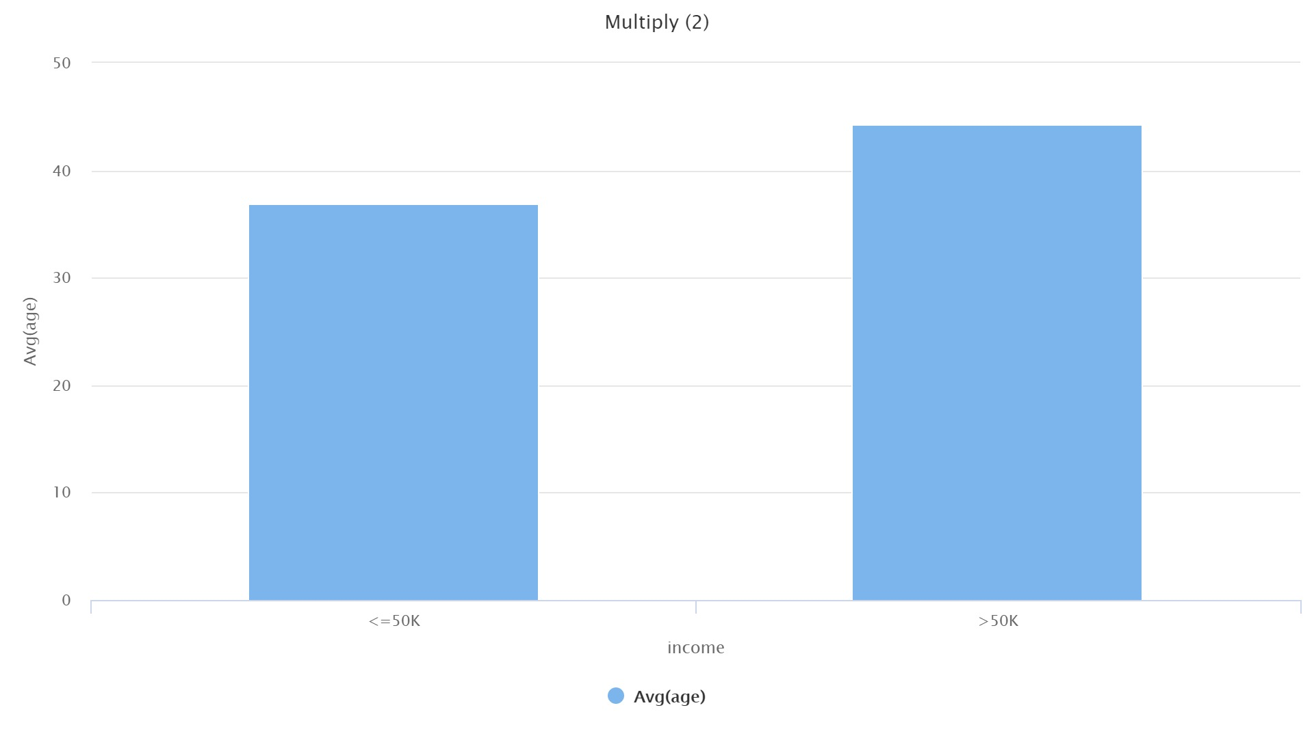

Educational years VS Income

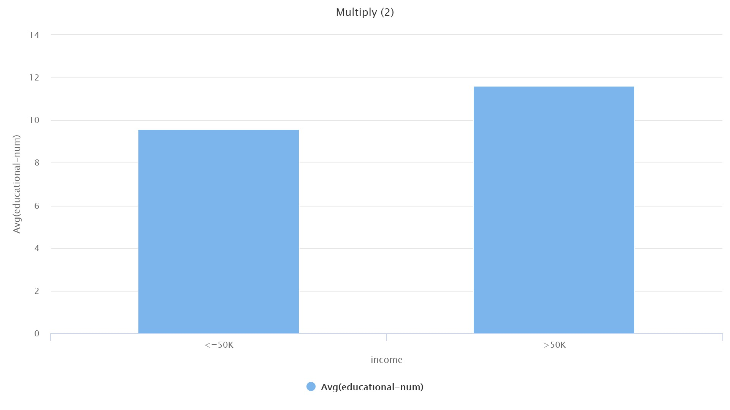

Age vs Gender

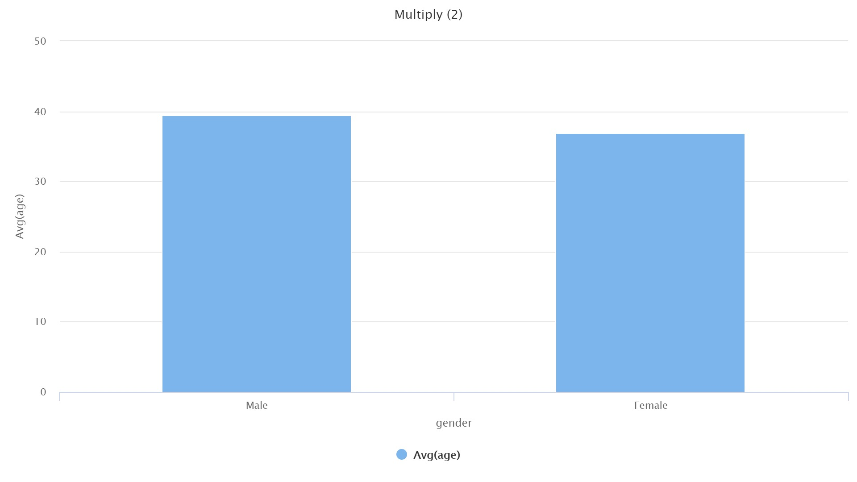

Educational years Vs Gender

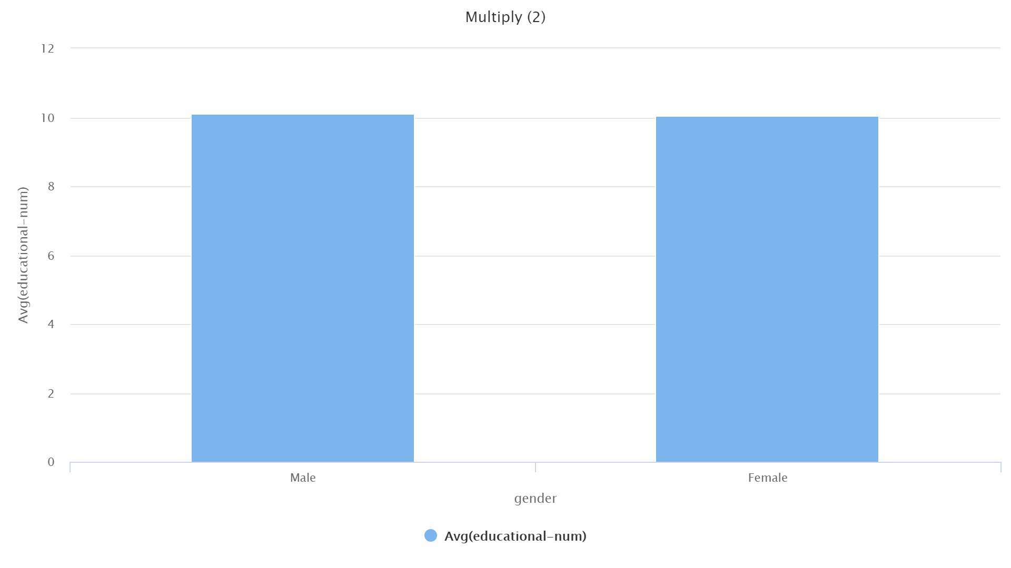

Question 3:

See the appendix for Bin values:

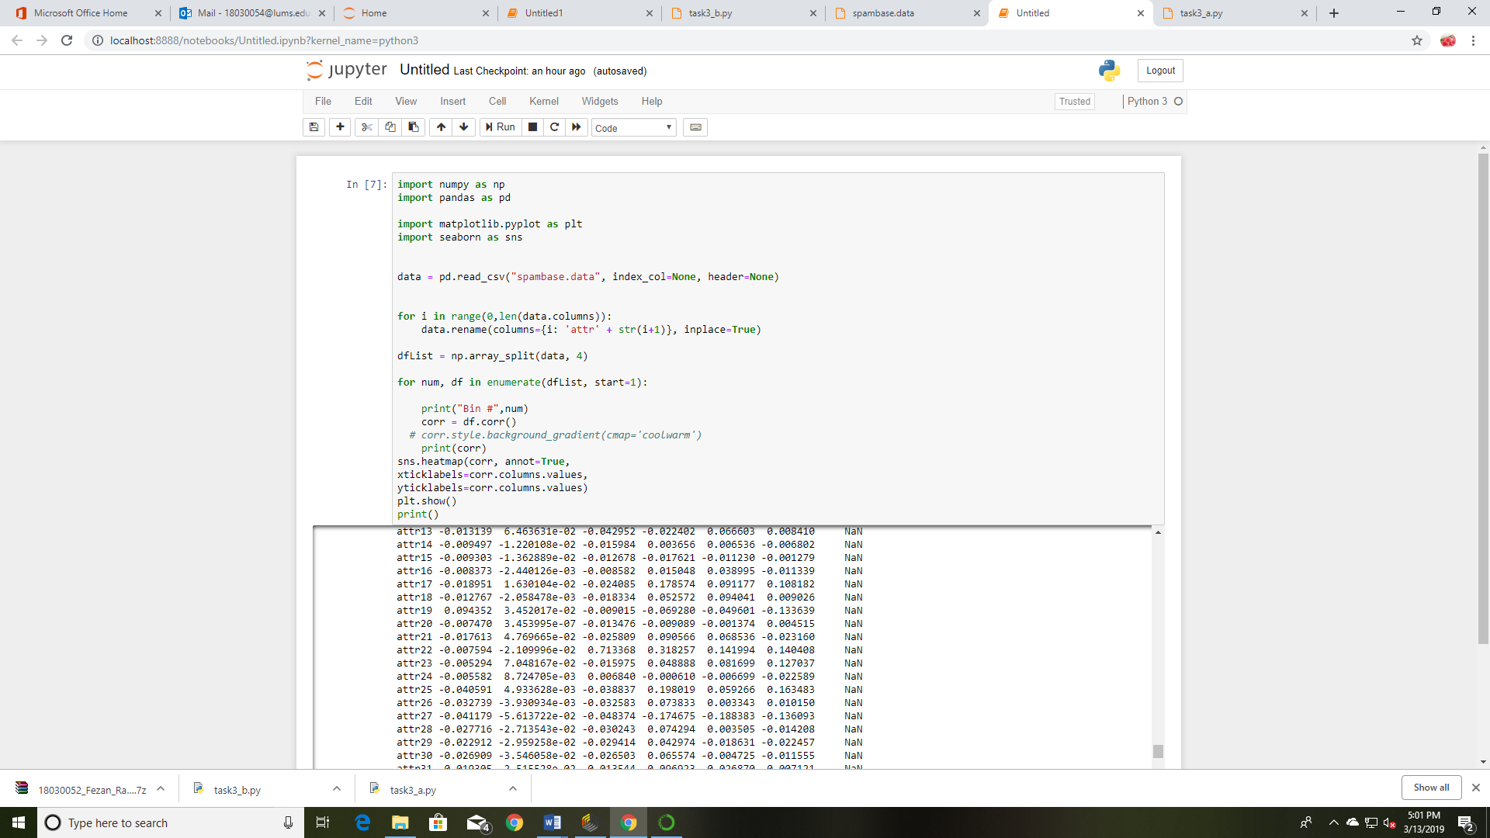

[58 rows x 58 columns]

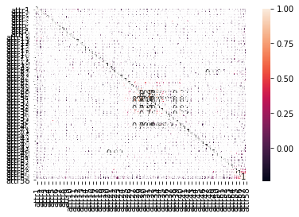

**Dimensionality reduction** is the process of reducing the number of random variables under consideration by obtaining a set of principal variables. It can be divided into selection and [feature extraction](https://en.wikipedia.org/wiki/Feature_extraction) process.

The methods used for dimensionality reduction:

* Discrete Cosine Transform
* Discrete Fourier Transform
* Convolutional Neural Network Auto encoders
* Principal component analysis

We use covariance to find/ identify the principal component in PCA.

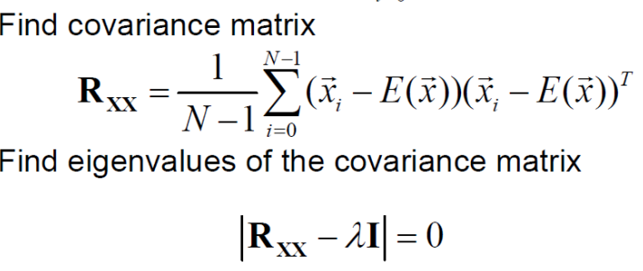



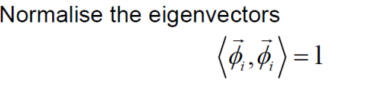

For simple correlation analysis

From results of corr matrix, I am getting attribute correlations values which are lowest for all values.

I found that out correlation of Var 10, var 25, var 21 was less 0.1 with all the other variables. So, I would discard them for further analysis .

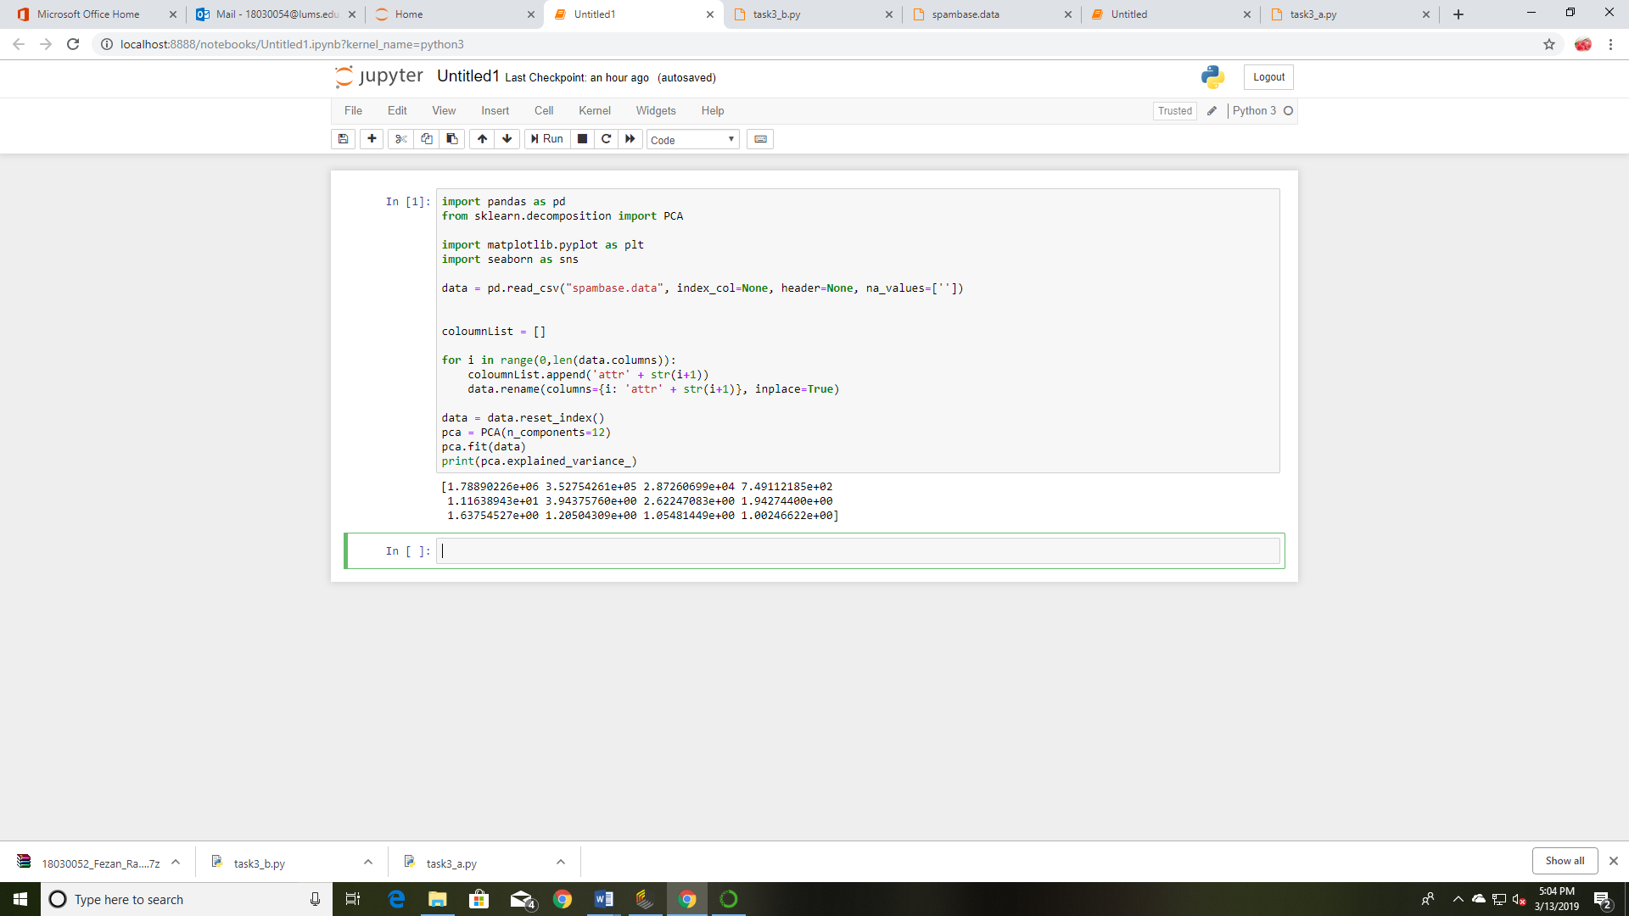

Appendix:

Bin # 1

attr1 attr2 attr3 attr4 attr5 attr6 attr7 \

attr1 1.000000 -0.016703 0.086017 0.027809 -0.001538 0.013705 -0.044496

attr2 -0.016703 1.000000 0.119805 -0.031343 0.006223 -0.015271 0.131200

attr3 0.086017 0.119805 1.000000 -0.059759 0.049966 0.034374 -0.065410

attr4 0.027809 -0.031343 -0.059759 1.000000 -0.005708 -0.031809 -0.000430

attr5 -0.001538 0.006223 0.049966 -0.005708 1.000000 -0.002105 0.110412

attr6 0.013705 -0.015271 0.034374 -0.031809 -0.002105 1.000000 -0.026817

attr7 -0.044496 0.131200 -0.065410 -0.000430 0.110412 -0.026817 1.000000

attr8 -0.038159 0.000590 -0.050805 0.006044 -0.010103 0.085963 -0.034645

attr9 0.176739 0.054602 0.067063 -0.013718 -0.047744 0.099728 -0.031348

attr10 0.105858 0.303227 0.084665 -0.023128 0.016452 -0.031202 0.043153

attr11 0.012338 0.063401 -0.000330 -0.034922 -0.049124 0.036350 0.099780

attr12 0.159070 0.231304 0.131390 -0.051993 0.057356 0.073842 -0.007237

attr13 0.119081 0.026722 -0.048002 -0.030265 -0.029321 0.078899 -0.057905

attr14 0.110905 0.100769 -0.044573 0.031100 -0.020982 -0.063988 -0.057939

attr15 -0.003905 0.061898 0.119950 -0.019953 0.040163 0.163594 -0.034133

attr16 0.076607 0.065260 0.048483 -0.002098 0.081242 -0.070393 0.122914

attr17 0.087564 -0.003964 -0.029536 -0.006845 0.096441 0.019303 0.133667

attr18 -0.068601 0.249963 0.051300 -0.000016 0.034661 -0.013810 0.056764

attr19 0.173034 0.044405 0.010588 -0.061868 0.067194 0.055906 0.026223

attr20 -0.022149 -0.062238 -0.010990 -0.016826 -0.025056 0.030636 -0.016802

attr21 0.079800 0.089321 0.178601 -0.032311 0.028146 0.034327 -0.013414

attr22 -0.067932 -0.075782 -0.103350 0.038216 -0.072019 -0.017024 -0.041686

attr23 0.156606 -0.101332 0.036510 -0.037693 -0.024387 0.176602 -0.076180

attr24 0.198732 -0.005416 0.018059 0.056903 -0.094295 0.056352 -0.036411

attr25 -0.042878 -0.043340 -0.038109 -0.010398 -0.000676 -0.054222 -0.033408

attr26 -0.045326 -0.032478 -0.067228 -0.008581 0.030597 -0.035742 -0.006338

attr27 -0.025113 0.068925 -0.016436 -0.004153 -0.037695 0.043606 -0.025694

attr28 -0.016861 -0.009183 -0.028755 -0.002803 -0.021652 -0.018634 -0.017062

attr29 -0.022716 -0.024728 -0.005071 -0.005927 -0.018594 -0.034539 -0.036665

attr30 -0.022910 -0.023094 -0.027075 -0.003789 -0.017572 0.016576 -0.023440

attr31 -0.018626 0.060510 -0.020689 -0.003080 0.006592 -0.001942 -0.019057

attr32 -0.014301 0.075588 0.033480 -0.002365 -0.021467 -0.016273 -0.014632

attr33 -0.024656 0.007042 0.023957 -0.008045 0.019625 -0.029597 -0.037299

attr34 0.007570 -0.020959 0.000060 -0.001947 -0.008092 -0.019685 -0.031027

attr35 0.016796 -0.004137 0.003582 0.070394 0.021401 -0.034181 -0.000994

attr36 -0.023763 -0.039713 -0.084965 -0.013772 0.025184 0.026445 -0.019702

attr37 -0.030906 0.070907 -0.052498 -0.012926 -0.027609 -0.040058 0.029366

attr38 -0.003771 -0.023843 -0.010948 -0.005550 -0.034724 -0.053722 -0.027368

attr39 0.002534 -0.037897 0.076361 -0.009901 0.022257 -0.053898 -0.007013

attr40 -0.042558 -0.014502 0.066548 -0.013227 0.008630 -0.023441 0.025076

attr41 NaN NaN NaN NaN NaN NaN NaN

attr42 -0.025649 -0.022717 -0.025930 -0.006533 -0.021011 0.021917 0.012414

attr43 -0.033215 -0.037112 0.033059 -0.011847 0.025727 0.109894 -0.008312

attr44 -0.033981 0.003769 -0.040140 -0.007121 -0.009969 0.010453 -0.035407

attr45 -0.073309 -0.033718 -0.025934 -0.034342 -0.009238 -0.063837 0.013504

attr46 -0.006391 -0.009028 -0.011919 -0.004077 0.031606 0.047311 -0.020165

attr47 -0.004109 -0.002047 0.002944 -0.004260 -0.025443 -0.019783 -0.005764

attr48 0.176191 -0.024284 -0.002502 0.069245 0.045967 -0.010144 -0.012167

attr49 -0.050399 -0.027008 -0.087421 0.023116 -0.003009 -0.025511 -0.030507

attr50 -0.024777 0.031116 0.017877 -0.014200 0.012509 0.102718 -0.072737

attr51 -0.042451 -0.020451 -0.032308 -0.013176 -0.017481 0.109129 -0.032365

attr52 0.059458 0.054441 0.127549 -0.028137 -0.081061 -0.007688 -0.076849

attr53 0.136319 0.050165 0.054888 -0.014572 -0.046213 0.039286 -0.061199

attr54 -0.029833 0.005705 -0.002102 -0.003257 -0.050203 0.050999 0.032886

attr55 0.062085 0.047175 0.171147 -0.002031 0.048321 -0.057403 -0.005213

attr56 0.104972 0.139695 0.221832 0.020759 0.030374 0.051667 -0.023693

attr57 0.100131 0.061549 0.053916 0.018525 -0.071402 0.026332 -0.127195

attr58 NaN NaN NaN NaN NaN NaN NaN

attr8 attr9 attr10 ... attr49 attr50 attr51 \

attr1 -0.038159 0.176739 0.105858 ... -0.050399 -0.024777 -0.042451

attr2 0.000590 0.054602 0.303227 ... -0.027008 0.031116 -0.020451

attr3 -0.050805 0.067063 0.084665 ... -0.087421 0.017877 -0.032308

attr4 0.006044 -0.013718 -0.023128 ... 0.023116 -0.014200 -0.013176

attr5 -0.010103 -0.047744 0.016452 ... -0.003009 0.012509 -0.017481

attr6 0.085963 0.099728 -0.031202 ... -0.025511 0.102718 0.109129

attr7 -0.034645 -0.031348 0.043153 ... -0.030507 -0.072737 -0.032365

attr8 1.000000 0.117128 0.151316 ... -0.039608 0.003715 -0.025738

attr9 0.117128 1.000000 0.201137 ... -0.018071 0.024595 0.113153

attr10 0.151316 0.201137 1.000000 ... -0.004213 0.033539 0.045765

attr11 0.169499 0.101349 0.198785 ... -0.048373 -0.045876 0.019064

attr12 0.031555 0.065416 0.198525 ... -0.029171 -0.048505 -0.033638

attr13 0.040326 -0.008503 0.073043 ... -0.022010 -0.064097 -0.047264

attr14 0.007685 0.107427 0.087622 ... -0.041121 -0.005275 -0.008926

attr15 0.032782 0.172815 0.123070 ... -0.037036 0.089297 -0.035948

attr16 -0.043475 -0.072515 0.025943 ... -0.005144 0.040514 -0.034802

attr17 0.251795 0.147750 0.158584 ... -0.054177 -0.033357 -0.058105

attr18 -0.009106 0.004433 -0.024099 ... -0.057055 -0.041613 0.018991

attr19 -0.036804 -0.067217 0.078095 ... -0.097241 -0.210431 -0.022795

attr20 0.079581 0.088971 -0.000520 ... -0.026068 -0.047793 -0.005241

attr21 0.105376 0.081063 0.089583 ... -0.104492 -0.094179 -0.039476

attr22 -0.046943 -0.061984 -0.036353 ... 0.190964 -0.083168 0.046791

attr23 0.083951 0.011925 0.031721 ... -0.018237 0.035379 0.124816

attr24 -0.008432 0.097457 0.048729 ... -0.018546 -0.074273 -0.013722

attr25 -0.046768 0.007640 0.034203 ... 0.056538 -0.001593 0.013500

attr26 -0.040060 -0.023253 0.058755 ... 0.085730 0.010463 0.016736

attr27 -0.011118 0.108190 0.001862 ... -0.011053 -0.023880 -0.008525

attr28 -0.015513 -0.012463 -0.015811 ... -0.007588 0.241534 0.002102

attr29 -0.031806 0.082331 -0.034988 ... 0.001070 -0.004079 -0.012165

attr30 -0.020516 -0.018019 -0.025889 ... 0.055493 0.038562 0.016571

attr31 -0.003173 -0.018192 0.011471 ... -0.008198 -0.006342 0.092757

attr32 -0.012869 -0.013968 -0.016315 ... 0.017904 0.023720 -0.004855

attr33 -0.018183 -0.034121 -0.034545 ... -0.020377 0.080189 -0.018595

attr34 -0.029463 0.020171 0.009744 ... -0.014412 0.007055 -0.008125

attr35 -0.024458 0.071187 0.006853 ... -0.022347 -0.021024 0.084851

attr36 -0.005227 -0.050971 -0.025252 ... -0.003134 0.028217 0.058209

attr37 0.000266 -0.010127 0.014607 ... 0.190688 0.260295 0.060126

attr38 -0.013451 0.176398 -0.014758 ... -0.008913 0.033049 -0.016450

attr39 -0.010862 0.010968 -0.023949 ... -0.006987 0.152394 0.020218

attr40 0.077064 -0.015563 0.031645 ... -0.042514 -0.000643 -0.033733

attr41 NaN NaN NaN ... NaN NaN NaN

attr42 0.007326 0.040350 -0.007095 ... -0.008996 0.009211 -0.003218

attr43 -0.046030 0.130327 -0.016602 ... -0.022462 0.007271 -0.016399

attr44 -0.027214 -0.010841 -0.021164 ... 0.014065 -0.034610 -0.006645

attr45 0.022336 -0.141856 -0.093969 ... -0.046943 0.089287 -0.026312

attr46 -0.018373 0.026782 0.008653 ... -0.017285 0.014171 -0.013834

attr47 -0.011867 0.040252 0.024319 ... -0.010985 0.065421 -0.008744

attr48 -0.028710 -0.020919 -0.024402 ... -0.011649 0.000671 -0.010831

attr49 -0.039608 -0.018071 -0.004213 ... 1.000000 0.094297 0.095308

attr50 0.003715 0.024595 0.033539 ... 0.094297 1.000000 0.046023

attr51 -0.025738 0.113153 0.045765 ... 0.095308 0.046023 1.000000

attr52 -0.028227 0.005265 0.068377 ... 0.241427 0.028333 -0.017692

attr53 -0.014016 0.159388 0.073274 ... 0.073888 0.070044 -0.002994

attr54 -0.032687 -0.025784 -0.019534 ... 0.076077 -0.035580 -0.004829

attr55 -0.019805 0.127026 0.119875 ... -0.017128 -0.053873 -0.009654

attr56 -0.006863 0.262623 0.259657 ... 0.043599 -0.030705 0.006576

attr57 -0.027719 0.261872 0.156079 ... 0.169262 -0.036118 0.056309

attr58 NaN NaN NaN ... NaN NaN NaN

attr52 attr53 attr54 attr55 attr56 attr57 attr58

attr1 0.059458 0.136319 -0.029833 0.062085 0.104972 0.100131 NaN

attr2 0.054441 0.050165 0.005705 0.047175 0.139695 0.061549 NaN

attr3 0.127549 0.054888 -0.002102 0.171147 0.221832 0.053916 NaN

attr4 -0.028137 -0.014572 -0.003257 -0.002031 0.020759 0.018525 NaN

attr5 -0.081061 -0.046213 -0.050203 0.048321 0.030374 -0.071402 NaN

attr6 -0.007688 0.039286 0.050999 -0.057403 0.051667 0.026332 NaN

attr7 -0.076849 -0.061199 0.032886 -0.005213 -0.023693 -0.127195 NaN

attr8 -0.028227 -0.014016 -0.032687 -0.019805 -0.006863 -0.027719 NaN

attr9 0.005265 0.159388 -0.025784 0.127026 0.262623 0.261872 NaN

attr10 0.068377 0.073274 -0.019534 0.119875 0.259657 0.156079 NaN

attr11 -0.057977 -0.008061 -0.017244 -0.019199 0.055327 0.082938 NaN

attr12 0.054293 0.055556 -0.048616 -0.031059 0.071427 0.039529 NaN

attr13 0.005372 0.282710 -0.035175 -0.045048 0.026199 0.123498 NaN

attr14 -0.041438 0.154319 -0.002742 -0.009457 0.142081 0.272738 NaN

attr15 -0.048369 0.117614 -0.020980 -0.006425 0.250478 0.131371 NaN

attr16 0.061870 -0.063685 0.013785 -0.021187 -0.041268 -0.096252 NaN

attr17 0.046714 0.034078 -0.022616 -0.007589 -0.004324 -0.033732 NaN

attr18 -0.038159 0.006750 -0.032965 -0.051930 0.012336 -0.012603 NaN

attr19 0.066835 -0.001902 -0.032041 -0.124246 -0.122835 -0.090396 NaN

attr20 0.012374 -0.025903 0.007196 0.055407 0.083100 0.034134 NaN

attr21 -0.021609 0.065989 -0.048325 -0.023130 0.011832 -0.084943 NaN

attr22 -0.065036 -0.053213 0.265928 -0.003823 0.003449 0.121388 NaN

attr23 -0.043734 0.273255 0.022913 -0.045451 0.054086 0.091173 NaN

attr24 -0.049359 0.071090 -0.023440 -0.020787 0.007721 0.048521 NaN

attr25 -0.027044 -0.017007 -0.003897 0.113703 0.054932 0.017881 NaN

attr26 -0.025999 -0.037048 0.010929 -0.013548 -0.036192 -0.007172 NaN

attr27 -0.003514 -0.020952 -0.008072 -0.006897 -0.017898 -0.021472 NaN

attr28 -0.023301 -0.012142 -0.005382 0.005821 -0.006613 -0.013978 NaN

attr29 -0.043945 -0.023204 -0.010229 -0.008726 -0.003056 0.072733 NaN

attr30 -0.033412 -0.017554 -0.004718 -0.006971 -0.018325 -0.016254 NaN

attr31 -0.026000 -0.008241 -0.005987 -0.004952 -0.014516 -0.012197 NaN

attr32 -0.009593 -0.016590 -0.004597 -0.003459 -0.008254 0.000504 NaN

attr33 -0.076973 -0.042576 0.012157 -0.017777 -0.030373 -0.019112 NaN

attr34 0.000745 0.093978 -0.000776 0.320759 0.185508 0.137536 NaN

attr35 0.008327 -0.009968 -0.008639 -0.012292 -0.015458 0.002323 NaN

attr36 -0.062473 -0.034668 -0.004128 -0.019897 -0.022575 -0.019363 NaN

attr37 0.052859 -0.027260 -0.005401 -0.007236 -0.019703 -0.027144 NaN

attr38 -0.036724 -0.017139 0.001480 -0.013141 -0.003636 -0.005658 NaN

attr39 -0.030189 0.016687 -0.010685 -0.011712 -0.015649 -0.007414 NaN

attr40 -0.029663 0.092909 -0.029368 -0.016970 0.021819 -0.007036 NaN

attr41 NaN NaN NaN NaN NaN NaN NaN

attr42 -0.043431 -0.003498 -0.010848 -0.009541 -0.008257 0.040745 NaN

attr43 -0.043390 -0.033375 -0.020999 -0.014558 0.158565 0.082802 NaN

attr44 0.036105 -0.032812 0.000647 -0.011613 0.005153 0.001971 NaN

attr45 -0.022304 0.029521 -0.040037 -0.046687 -0.080525 -0.117070 NaN

attr46 -0.026365 -0.022711 0.000462 -0.009495 0.043472 0.011794 NaN

attr47 -0.022133 -0.017615 -0.006534 -0.007052 -0.013768 0.005965 NaN

attr48 -0.012338 -0.022795 -0.010008 0.038562 0.037744 0.019224 NaN

attr49 0.241427 0.073888 0.076077 -0.017128 0.043599 0.169262 NaN

attr50 0.028333 0.070044 -0.035580 -0.053873 -0.030705 -0.036118 NaN

attr51 -0.017692 -0.002994 -0.004829 -0.009654 0.006576 0.056309 NaN

attr52 1.000000 0.103017 -0.016240 0.060200 0.074285 -0.024683 NaN

attr53 0.103017 1.000000 -0.011494 0.057467 0.092967 0.152175 NaN

attr54 -0.016240 -0.011494 1.000000 -0.009490 -0.014117 0.018080 NaN

attr55 0.060200 0.057467 -0.009490 1.000000 0.679592 0.164114 NaN

attr56 0.074285 0.092967 -0.014117 0.679592 1.000000 0.512733 NaN

attr57 -0.024683 0.152175 0.018080 0.164114 0.512733 1.000000 NaN

attr58 NaN NaN NaN NaN NaN NaN NaN

[58 rows x 58 columns]

Bin # 2

attr1 attr2 attr3 attr4 attr5 attr6 attr7 \

attr1 1.000000 0.151903 0.075939 -0.018954 0.012521 0.085922 -0.027189

attr2 0.151903 1.000000 0.024674 -0.017159 0.088495 0.012807 0.107120

attr3 0.075939 0.024674 1.000000 -0.022863 0.034567 0.128933 0.041539

attr4 -0.018954 -0.017159 -0.022863 1.000000 -0.024636 -0.018889 0.011317

attr5 0.012521 0.088495 0.034567 -0.024636 1.000000 0.038321 0.153572

attr6 0.085922 0.012807 0.128933 -0.018889 0.038321 1.000000 0.049616

attr7 -0.027189 0.107120 0.041539 0.011317 0.153572 0.049616 1.000000

attr8 -0.011339 -0.005301 0.005907 -0.004767 -0.001134 0.031261 -0.016445

attr9 0.099066 0.159144 0.150478 -0.018959 -0.000901 0.142694 0.028477

attr10 0.044402 0.165219 0.019079 -0.005157 0.033443 0.015185 0.028039

attr11 0.107279 0.117609 0.079251 -0.017612 0.160689 0.029799 0.191021

attr12 0.112270 0.014295 0.085354 -0.011128 0.143398 0.023809 0.003994

attr13 0.117662 0.054333 0.119608 -0.014831 0.055804 0.083811 0.040971

attr14 0.073081 -0.002730 -0.018133 -0.011650 -0.028589 -0.016837 -0.063858

attr15 0.043839 0.119888 0.150821 0.022471 0.021916 0.219579 0.047526

attr16 0.067585 0.077549 0.061332 -0.010427 0.054770 0.014063 0.031611

attr17 0.058951 0.039140 0.041223 -0.016994 0.208264 0.045043 0.142781

attr18 0.192647 0.346761 0.142251 0.033606 0.042855 0.138603 0.123427

attr19 0.199762 0.083312 0.192563 0.005869 0.257886 0.110722 0.151297

attr20 0.043713 0.000037 0.026716 -0.009124 0.015710 0.043825 0.023886

attr21 0.214167 0.181403 0.144783 0.017216 0.211693 0.072599 0.117107

attr22 -0.019763 -0.003151 -0.039166 -0.004884 -0.016913 0.006862 -0.012272

attr23 0.141320 0.060314 0.213258 0.064974 0.067486 0.253405 0.067753

attr24 0.358613 0.185500 0.030181 -0.011993 -0.009001 0.025439 -0.013701

attr25 -0.083051 -0.071061 -0.088160 -0.016065 -0.142120 -0.117608 -0.112234

attr26 -0.056573 -0.083806 -0.050027 -0.014337 -0.126526 -0.113526 -0.100901

attr27 -0.056685 -0.035675 -0.080778 -0.008031 -0.078174 -0.063796 -0.056707

attr28 -0.055851 -0.049574 -0.038425 -0.011536 -0.099045 -0.094145 -0.081406

attr29 -0.042743 -0.054375 -0.063438 -0.008161 -0.021452 -0.064721 -0.057972

attr30 -0.059023 -0.058696 0.007920 -0.010913 -0.086480 -0.053711 -0.077358

attr31 -0.045124 -0.053067 -0.012652 -0.008853 -0.075389 -0.072858 -0.061572

attr32 -0.027330 -0.023915 -0.057688 -0.006560 -0.040075 -0.055170 -0.045663

attr33 -0.079567 -0.039450 -0.100555 -0.011366 -0.072506 -0.026886 -0.051471

attr34 -0.007379 -0.030863 -0.056271 -0.006867 -0.043833 -0.057751 -0.047052

attr35 -0.054549 -0.054950 -0.029878 -0.011496 -0.094082 -0.088575 -0.074339

attr36 -0.064036 -0.052593 -0.032990 0.007638 -0.091589 -0.086735 -0.075692

attr37 -0.060855 -0.047084 -0.022136 0.013228 -0.075055 -0.062175 -0.063376

attr38 -0.026027 0.002607 -0.024146 -0.004489 -0.011219 -0.036913 -0.011199

attr39 -0.039834 -0.043821 -0.028448 0.010167 -0.072069 -0.064924 -0.061974

attr40 -0.036309 -0.016660 -0.037597 -0.010114 -0.009862 -0.013368 -0.033988

attr41 -0.010795 -0.028437 -0.049983 -0.004324 -0.050795 -0.031297 -0.030381

attr42 -0.032638 -0.038309 -0.065412 -0.009432 0.107562 -0.078305 -0.066517

attr43 -0.047742 -0.030340 -0.047566 -0.010026 -0.070908 -0.036130 -0.058924

attr44 -0.026474 -0.043699 -0.066816 -0.006296 0.032472 -0.049103 -0.035526

attr45 -0.015599 -0.032332 -0.055305 -0.007121 0.009640 -0.064432 -0.041646

attr46 -0.050842 -0.023608 -0.069616 -0.007027 -0.056683 -0.042655 -0.046235

attr47 0.043180 -0.019341 -0.022022 -0.003240 -0.033854 -0.016871 -0.018270

attr48 -0.036353 -0.028992 -0.041965 -0.007260 -0.049133 -0.055273 -0.048632

attr49 -0.034795 -0.008542 -0.019911 -0.002968 -0.068809 -0.025825 -0.062065

attr50 -0.036428 -0.034347 -0.036680 -0.013319 -0.066537 -0.036784 -0.041986

attr51 -0.056656 -0.029409 -0.066037 -0.011687 -0.052536 -0.049787 -0.038831

attr52 0.115004 0.089266 0.205675 -0.016046 0.041898 0.143179 0.086063

attr53 0.139640 0.054745 0.082514 0.011271 0.001875 0.106339 0.029613

attr54 -0.012055 0.068715 -0.012101 -0.004087 0.027724 -0.007443 0.047752

attr55 0.014871 0.080620 0.010045 0.003226 0.050199 0.004546 0.083281

attr56 0.029987 0.048812 0.047465 0.005542 0.014173 0.085251 0.027110

attr57 0.115274 0.055806 0.064930 0.000138 -0.040949 0.083165 -0.041202

attr58 0.119156 0.182257 0.197281 0.040691 0.248581 0.238457 0.266938

attr8 attr9 attr10 ... attr49 attr50 attr51 \

attr1 -0.011339 0.099066 0.044402 ... -0.034795 -0.036428 -0.056656

attr2 -0.005301 0.159144 0.165219 ... -0.008542 -0.034347 -0.029409

attr3 0.005907 0.150478 0.019079 ... -0.019911 -0.036680 -0.066037

attr4 -0.004767 -0.018959 -0.005157 ... -0.002968 -0.013319 -0.011687

attr5 -0.001134 -0.000901 0.033443 ... -0.068809 -0.066537 -0.052536

attr6 0.031261 0.142694 0.015185 ... -0.025825 -0.036784 -0.049787

attr7 -0.016445 0.028477 0.028039 ... -0.062065 -0.041986 -0.038831

attr8 1.000000 0.083230 0.040084 ... -0.043432 -0.036459 -0.031510

attr9 0.083230 1.000000 0.210092 ... -0.044145 -0.047134 0.028896

attr10 0.040084 0.210092 1.000000 ... 0.063420 -0.015231 0.049231

attr11 0.104695 0.173635 0.182934 ... -0.064707 -0.056611 -0.056102

attr12 -0.014195 0.081912 0.070261 ... -0.008307 -0.037204 -0.073183

attr13 0.003124 0.075028 0.080038 ... -0.024506 -0.036089 -0.055120

attr14 -0.005095 0.106989 0.000077 ... -0.025866 -0.016802 -0.008994

attr15 0.062184 0.358561 0.286801 ... -0.029491 -0.018954 0.024729

attr16 0.075096 -0.024404 -0.011417 ... -0.038933 -0.056278 -0.064829

attr17 0.154255 0.077265 0.049502 ... -0.029080 -0.024083 -0.068440

attr18 0.027432 0.163129 0.070955 ... -0.066982 -0.029245 -0.008741

attr19 0.055001 0.124645 0.114129 ... -0.062055 -0.123923 -0.104504

attr20 0.123148 0.144033 0.052921 ... -0.039668 0.007271 -0.028412

attr21 0.233497 0.175446 0.119546 ... -0.066587 -0.096450 -0.068247

attr22 -0.022441 -0.012486 0.003975 ... 0.053493 -0.032968 0.000992

attr23 0.015753 0.181537 0.198159 ... -0.034462 -0.054352 -0.029669

attr24 0.020236 0.087274 0.080810 ... -0.026958 -0.045958 -0.042005

attr25 -0.076221 -0.106248 -0.085262 ... 0.174842 0.107579 0.118128

attr26 -0.078752 -0.089017 -0.030301 ... 0.029563 0.091121 0.141318

attr27 -0.046287 -0.052771 -0.064330 ... 0.021461 -0.018637 0.009960

attr28 -0.065134 -0.075932 0.001282 ... -0.028268 0.230492 0.001508

attr29 -0.045410 -0.066070 -0.061394 ... -0.022900 0.087330 0.036457

attr30 -0.055326 -0.080422 -0.045845 ... 0.000996 0.131480 0.023997

attr31 -0.049873 -0.069078 -0.051969 ... -0.017157 0.126792 0.035085

attr32 -0.037746 -0.049129 -0.031360 ... 0.005046 0.178541 0.058095

attr33 -0.056576 -0.044833 0.020508 ... -0.010227 0.053853 0.106730

attr34 -0.039531 -0.050810 -0.030329 ... 0.002250 0.174371 0.056625

attr35 -0.054083 -0.065250 -0.023915 ... -0.029088 0.114886 0.017994

attr36 -0.044910 -0.092022 -0.065891 ... -0.024400 0.129501 0.008811

attr37 -0.019955 -0.046474 -0.018092 ... 0.030079 0.052887 0.143924

attr38 -0.017115 0.050232 -0.007790 ... -0.015922 -0.013172 -0.009835

attr39 -0.047992 -0.054956 -0.062384 ... 0.008522 0.022939 0.049060

attr40 0.004567 -0.007333 0.009504 ... -0.006175 0.155386 0.061788

attr41 -0.022886 -0.036208 -0.018037 ... -0.013565 -0.015202 -0.003008

attr42 -0.052719 -0.055090 -0.082987 ... -0.007065 0.002720 -0.007848

attr43 -0.005579 -0.044359 0.019671 ... 0.038862 0.049151 0.236205

attr44 -0.031974 -0.050007 -0.045540 ... -0.004057 -0.029853 -0.015447

attr45 0.181634 -0.066417 -0.050588 ... -0.012753 0.012184 0.011628

attr46 -0.031487 -0.048803 -0.032842 ... -0.006709 0.006611 -0.010971

attr47 -0.017217 0.002073 -0.023790 ... -0.012107 0.002903 0.005450

attr48 -0.029262 -0.053508 -0.043926 ... -0.003011 0.022138 -0.030377

attr49 -0.043432 -0.044145 0.063420 ... 1.000000 0.264795 0.036913

attr50 -0.036459 -0.047134 -0.015231 ... 0.264795 1.000000 0.029491

attr51 -0.031510 0.028896 0.049231 ... 0.036913 0.029491 1.000000

attr52 0.034679 0.035124 0.035816 ... 0.203952 -0.011284 -0.077779

attr53 0.021656 0.080758 0.081007 ... 0.095728 0.107743 -0.042822

attr54 -0.010768 -0.002721 0.028159 ... 0.006798 0.079794 -0.004117

attr55 0.025185 0.123679 0.068336 ... 0.102970 0.386461 -0.018741

attr56 0.012396 0.130655 0.044508 ... 0.187902 0.705822 -0.024092

attr57 0.017003 0.198900 0.078475 ... 0.098248 0.265354 0.005490

attr58 0.182376 0.211293 0.198323 ... -0.031405 -0.055468 -0.140743

attr52 attr53 attr54 attr55 attr56 attr57 attr58

attr1 0.115004 0.139640 -0.012055 0.014871 0.029987 0.115274 0.119156

attr2 0.089266 0.054745 0.068715 0.080620 0.048812 0.055806 0.182257

attr3 0.205675 0.082514 -0.012101 0.010045 0.047465 0.064930 0.197281

attr4 -0.016046 0.011271 -0.004087 0.003226 0.005542 0.000138 0.040691

attr5 0.041898 0.001875 0.027724 0.050199 0.014173 -0.040949 0.248581

attr6 0.143179 0.106339 -0.007443 0.004546 0.085251 0.083165 0.238457

attr7 0.086063 0.029613 0.047752 0.083281 0.027110 -0.041202 0.266938

attr8 0.034679 0.021656 -0.010768 0.025185 0.012396 0.017003 0.182376

attr9 0.035124 0.080758 -0.002721 0.123679 0.130655 0.198900 0.211293

attr10 0.035816 0.081007 0.028159 0.068336 0.044508 0.078475 0.198323

attr11 0.018802 0.046685 -0.002868 0.148386 0.064711 0.102380 0.255785

attr12 0.009095 0.011793 -0.033125 0.004419 0.012803 0.042607 0.004474

attr13 0.104199 0.215224 -0.010678 0.011440 0.035464 0.126956 0.181011

attr14 -0.018249 0.080688 0.020079 0.015586 0.039918 0.271807 0.081009

attr15 0.013361 0.065251 -0.012362 0.038394 0.168027 0.137738 0.183748

attr16 0.202133 0.033175 0.053948 0.022553 -0.004515 -0.023258 0.280923

attr17 0.086933 0.047729 -0.006244 0.126336 0.034281 0.035196 0.221390

attr18 0.064617 0.034685 0.055113 0.025688 0.071706 0.033619 0.180825

attr19 0.262578 0.115149 0.014830 0.001061 0.005716 0.042662 0.425110

attr20 0.052419 0.008980 -0.010553 0.043532 0.072442 0.058808 0.181025

attr21 0.140559 0.079374 -0.009142 0.112993 0.039065 0.045237 0.378425

attr22 0.004693 -0.020028 0.138978 0.105832 0.020777 0.067431 0.094063

attr23 0.108445 0.258979 -0.008083 0.065600 0.096194 0.149146 0.289015

attr24 0.114399 0.070419 -0.001855 0.008028 0.018095 0.065331 0.214312

attr25 -0.137487 -0.101360 -0.026564 -0.048983 -0.051825 -0.073623 -0.389870

attr26 -0.105967 -0.090781 -0.020176 -0.047916 -0.048004 -0.079467 -0.344274

attr27 -0.074923 -0.052745 -0.012552 -0.027764 -0.031690 -0.071449 -0.197083

attr28 -0.100123 -0.073592 -0.016616 -0.024629 -0.036938 -0.080556 -0.216680

attr29 -0.084766 -0.053520 0.001155 -0.032220 -0.032925 -0.066207 -0.197747

attr30 -0.084292 -0.070999 -0.021216 -0.013110 -0.029452 -0.068509 -0.238071

attr31 -0.075836 -0.057465 0.002188 -0.031624 -0.032018 -0.060114 -0.215625

attr32 -0.064656 -0.042567 -0.013509 -0.021226 -0.024206 -0.047473 -0.157997

attr33 -0.097504 -0.066798 0.001754 -0.031771 -0.032888 -0.022722 -0.198204

attr34 -0.049179 -0.042732 -0.013559 -0.021606 -0.024353 -0.049127 -0.155809

attr35 -0.086607 -0.059558 -0.004954 -0.024719 -0.029743 -0.058135 -0.258095

attr36 -0.092452 -0.059258 0.048755 -0.043423 -0.038794 -0.056914 -0.181834

attr37 -0.117146 -0.058433 -0.026704 0.019476 -0.027540 -0.031233 -0.245047

attr38 0.004848 0.000681 -0.001812 0.001993 0.002637 0.002066 0.034092

attr39 -0.046379 -0.050893 -0.006429 -0.018148 -0.026399 -0.050528 -0.173876

attr40 -0.032480 -0.029980 -0.018761 -0.014558 -0.016175 -0.035432 -0.088045

attr41 -0.040022 -0.029013 -0.009133 -0.004866 -0.016720 -0.033106 -0.105889

attr42 -0.087710 -0.062685 -0.003043 -0.036235 -0.026536 -0.050451 -0.223252

attr43 -0.086508 -0.058054 -0.017700 -0.032272 -0.015782 -0.043789 -0.197859

attr44 -0.058375 -0.038391 0.012719 -0.027012 -0.022592 -0.041753 -0.132678

attr45 -0.039223 -0.038344 -0.021818 -0.036568 -0.036392 -0.071721 -0.096066

attr46 -0.066995 -0.042491 -0.011812 -0.013829 -0.020108 -0.034713 -0.099096

attr47 -0.026555 -0.016986 0.003513 -0.010956 -0.006616 0.017040 -0.053753

attr48 -0.060507 -0.045549 0.000480 -0.022773 -0.016970 0.018982 -0.153389

attr49 0.203952 0.095728 0.006798 0.102970 0.187902 0.098248 -0.031405

attr50 -0.011284 0.107743 0.079794 0.386461 0.705822 0.265354 -0.055468

attr51 -0.077779 -0.042822 -0.004117 -0.018741 -0.024092 0.005490 -0.140743

attr52 1.000000 0.210661 0.052741 0.074232 0.069137 0.030041 0.337183

attr53 0.210661 1.000000 0.004956 0.108462 0.165449 0.168651 0.254233

attr54 0.052741 0.004956 1.000000 0.078830 0.093443 0.050642 0.053285

attr55 0.074232 0.108462 0.078830 1.000000 0.670858 0.280637 0.119396

attr56 0.069137 0.165449 0.093443 0.670858 1.000000 0.462045 0.127336

attr57 0.030041 0.168651 0.050642 0.280637 0.462045 1.000000 0.171911

attr58 0.337183 0.254233 0.053285 0.119396 0.127336 0.171911 1.000000

[58 rows x 58 columns]

Bin # 3

attr1 attr2 attr3 attr4 attr5 attr6 attr7 \

attr1 1.000000 -0.047585 0.029326 0.005692 -0.014084 0.058314 -0.014515

attr2 -0.047585 1.000000 -0.069045 -0.012006 -0.049015 -0.042471 -0.019727

attr3 0.029326 -0.069045 1.000000 0.025032 0.047191 0.078595 -0.027502

attr4 0.005692 -0.012006 0.025032 1.000000 0.022709 0.057157 -0.006222

attr5 -0.014084 -0.049015 0.047191 0.022709 1.000000 0.023479 -0.013542

attr6 0.058314 -0.042471 0.078595 0.057157 0.023479 1.000000 -0.001882

attr7 -0.014515 -0.019727 -0.027502 -0.006222 -0.013542 -0.001882 1.000000

attr8 -0.033360 -0.036266 -0.005415 -0.006249 -0.018819 0.048686 0.380556

attr9 0.003657 -0.031384 0.010504 0.001738 -0.022926 0.007755 -0.018121

attr10 -0.024156 -0.034411 -0.033506 -0.012353 -0.005607 0.000922 0.045218

attr11 0.494692 -0.028227 -0.008713 0.004542 -0.008403 -0.014688 0.003214

attr12 0.060052 -0.096816 0.070316 -0.009257 0.049185 0.001644 -0.017639

attr13 -0.009193 -0.032143 -0.006178 0.020332 0.002619 0.003224 -0.019372

attr14 -0.018747 -0.023409 0.000445 -0.004868 0.020342 -0.010212 -0.013601

attr15 -0.022443 -0.014310 0.045629 -0.005745 0.002537 0.009482 -0.009187

attr16 -0.009371 -0.021722 -0.006121 0.001025 -0.004929 -0.018820 0.044293

attr17 -0.020633 -0.048111 -0.035946 0.004818 -0.018230 0.009045 0.035634

attr18 -0.038072 -0.026508 0.209957 0.021003 0.034309 0.035386 0.079552

attr19 0.044554 -0.100668 0.052612 -0.021521 0.010201 -0.002681 0.040521

attr20 0.010935 -0.015939 0.017000 -0.005240 -0.001175 0.023156 0.037329

attr21 0.310640 -0.052206 0.045388 -0.021988 -0.003546 -0.020395 0.009028

attr22 -0.007210 -0.003400 0.008247 -0.001737 -0.000167 0.015542 -0.003118

attr23 0.039702 -0.022048 -0.021779 0.005981 -0.018310 -0.006853 -0.006077

attr24 0.074222 -0.015652 -0.015327 -0.004806 0.009706 -0.003497 0.032285

attr25 -0.058606 -0.086216 -0.047126 0.000164 -0.011484 -0.023460 -0.013228

attr26 -0.058088 -0.080232 -0.015197 0.018593 -0.049145 -0.042757 -0.006969

attr27 -0.057085 -0.049614 -0.069995 -0.017099 -0.053445 -0.032785 -0.027165

attr28 -0.048892 -0.057841 -0.000488 0.041738 -0.028948 -0.019630 -0.033742

attr29 -0.035761 -0.040481 -0.034970 -0.011007 0.128531 -0.026948 -0.023502

attr30 -0.043905 -0.054005 0.013478 -0.008959 -0.021350 0.004767 0.025976

attr31 -0.034065 -0.034182 -0.020248 -0.012482 -0.019617 -0.014046 -0.021204

attr32 -0.020918 -0.015162 -0.051688 -0.012158 0.005955 0.019528 -0.020431

attr33 -0.022424 -0.048181 -0.041346 -0.013729 0.002189 0.013755 -0.010652

attr34 -0.020995 -0.015285 -0.051786 -0.011500 0.006111 0.019348 -0.020514

attr35 -0.054165 -0.052846 -0.022480 -0.001713 -0.030341 -0.018464 -0.023432

attr36 -0.050506 -0.054841 0.011198 -0.008401 -0.021976 -0.008760 0.004759

attr37 -0.038093 -0.054931 -0.043273 0.053316 -0.055139 0.009118 -0.008984

attr38 -0.004330 -0.012689 -0.008827 -0.003228 -0.007309 -0.009697 -0.006583

attr39 -0.018997 -0.045070 0.017073 0.005213 -0.039496 -0.031953 -0.020065

attr40 -0.038797 -0.032172 -0.061415 -0.012507 -0.022395 -0.020848 -0.020249

attr41 -0.030057 -0.029264 -0.022076 -0.010040 -0.038919 -0.017107 0.000415

attr42 -0.020117 -0.043813 -0.002030 -0.013010 0.150371 -0.032672 -0.022148

attr43 0.023736 -0.015387 -0.037346 0.017290 -0.042154 -0.018049 -0.018746

attr44 -0.017329 -0.042312 -0.046840 -0.004827 0.063299 0.030149 -0.017238

attr45 -0.038680 -0.045040 -0.046296 -0.010065 -0.005277 -0.023305 -0.023525

attr46 -0.033499 -0.026584 -0.025625 -0.010196 -0.041792 -0.020486 -0.018117

attr47 -0.016140 -0.018681 0.101391 -0.005847 -0.028502 -0.021636 -0.009506

attr48 -0.005337 -0.028976 0.000157 -0.004003 -0.021856 -0.007448 -0.016271

attr49 0.006920 -0.050612 -0.007306 -0.003590 -0.023104 0.101109 -0.003375

attr50 -0.005251 -0.119912 0.057248 0.000889 -0.032092 0.037424 0.032271

attr51 -0.029732 -0.028815 -0.047514 0.003729 -0.034158 -0.028677 -0.009829

attr52 0.015687 -0.052832 0.027342 0.001102 0.007417 -0.006066 0.081014

attr53 -0.016378 -0.027952 -0.013328 -0.001694 -0.003224 0.012296 0.234470

attr54 -0.017523 -0.011788 -0.028072 -0.004835 -0.021572 -0.015693 -0.007808

attr55 0.035574 -0.046042 -0.068020 0.002195 -0.048625 -0.034501 0.097622

attr56 0.009823 -0.076115 -0.034629 0.006249 -0.026204 0.011416 0.056869

attr57 -0.017565 -0.079402 -0.019448 0.038325 -0.046168 0.033664 -0.009976

attr58 NaN NaN NaN NaN NaN NaN NaN

attr8 attr9 attr10 ... attr49 attr50 attr51 \

attr1 -0.033360 0.003657 -0.024156 ... 0.006920 -0.005251 -0.029732

attr2 -0.036266 -0.031384 -0.034411 ... -0.050612 -0.119912 -0.028815

attr3 -0.005415 0.010504 -0.033506 ... -0.007306 0.057248 -0.047514

attr4 -0.006249 0.001738 -0.012353 ... -0.003590 0.000889 0.003729

attr5 -0.018819 -0.022926 -0.005607 ... -0.023104 -0.032092 -0.034158

attr6 0.048686 0.007755 0.000922 ... 0.101109 0.037424 -0.028677

attr7 0.380556 -0.018121 0.045218 ... -0.003375 0.032271 -0.009829

attr8 1.000000 0.015570 0.107109 ... 0.009495 0.029902 -0.014859

attr9 0.015570 1.000000 -0.004161 ... 0.108402 -0.018472 0.001368

attr10 0.107109 -0.004161 1.000000 ... -0.021894 0.032764 0.011042

attr11 0.013885 0.023457 -0.006004 ... -0.019029 -0.070258 -0.022416

attr12 -0.004047 -0.036834 0.034888 ... -0.032978 -0.035554 -0.063157

attr13 0.010842 -0.027772 -0.007800 ... -0.033262 -0.055920 -0.017364

attr14 -0.003631 -0.001800 -0.002933 ... -0.020159 -0.001386 -0.016813

attr15 0.125669 -0.012352 0.095969 ... 0.067268 0.014034 0.037339

attr16 0.000174 -0.006421 0.001685 ... 0.001095 -0.032041 -0.014584

attr17 0.076966 0.208141 -0.017030 ... -0.012445 -0.037209 -0.025833

attr18 0.004060 0.003177 -0.004427 ... -0.004705 -0.050022 -0.028073

attr19 -0.034935 -0.018586 -0.003121 ... -0.072760 -0.092556 -0.047493

attr20 0.116654 0.062002 0.015628 ... -0.002705 0.005211 -0.011825

attr21 0.015074 0.090814 0.002685 ... -0.045650 -0.059702 -0.025369

attr22 -0.006361 -0.005834 -0.006679 ... -0.003535 0.009594 -0.004683

attr23 0.008867 0.021267 -0.020910 ... -0.010178 0.098309 -0.017261

attr24 0.013329 -0.003131 -0.003576 ... 0.099829 0.017640 -0.011240

attr25 0.021752 -0.023857 0.024817 ... 0.016982 0.113369 -0.012625

attr26 0.092674 0.016798 0.029296 ... 0.031965 0.198811 0.006496

attr27 -0.044703 -0.040655 -0.035252 ... -0.042983 0.034555 -0.026154

attr28 -0.044240 -0.034721 0.055516 ... -0.070720 0.444862 -0.001391

attr29 -0.022418 -0.025842 -0.022259 ... -0.048289 0.192416 -0.009132

attr30 -0.015811 0.014130 0.067278 ... -0.068445 0.309439 -0.013575

attr31 -0.020932 -0.013581 -0.016783 ... -0.044675 0.309443 -0.006243

attr32 -0.023989 -0.007849 -0.005047 ... -0.039270 0.448418 0.002671

attr33 -0.034285 0.031128 -0.039613 ... 0.002632 0.023842 -0.017606

attr34 -0.024161 -0.007918 -0.004980 ... -0.039067 0.448758 0.002671

attr35 -0.004585 -0.028550 -0.003807 ... -0.067543 0.367421 0.004023

attr36 -0.019494 -0.020818 0.015559 ... -0.053989 0.384039 -0.017631

attr37 -0.003134 0.015650 0.035221 ... 0.208567 0.094015 0.053572

attr38 -0.001265 -0.010650 -0.013728 ... -0.017260 -0.011865 -0.007725

attr39 -0.030673 -0.027631 -0.010297 ... 0.168629 0.151407 0.043501

attr40 -0.022322 0.013705 0.003151 ... -0.046044 0.400193 0.004653

attr41 -0.033338 -0.025416 -0.022493 ... 0.391212 0.031035 0.047575

attr42 -0.043573 -0.040217 -0.043434 ... -0.020954 -0.054083 -0.017537

attr43 -0.050982 -0.039625 0.048714 ... 0.049694 0.068758 0.099252

attr44 -0.030624 -0.030700 -0.001951 ... -0.012116 0.045980 -0.020001

attr45 -0.040529 -0.047652 -0.038121 ... -0.046056 -0.047203 0.021426

attr46 -0.027360 -0.027391 -0.030574 ... 0.263107 0.018701 0.019342

attr47 0.038794 0.008912 -0.011865 ... 0.018941 -0.033828 -0.011982

attr48 0.007247 -0.002662 -0.019790 ... 0.005136 -0.049139 -0.013899

attr49 0.009495 0.108402 -0.021894 ... 1.000000 0.137064 0.012754

attr50 0.029902 -0.018472 0.032764 ... 0.137064 1.000000 -0.001303

attr51 -0.014859 0.001368 0.011042 ... 0.012754 -0.001303 1.000000

attr52 -0.016460 -0.032373 0.023035 ... -0.043533 -0.050218 -0.024221

attr53 0.184802 0.062259 -0.011757 ... -0.013226 0.040230 -0.018970

attr54 -0.016335 -0.010660 0.139925 ... -0.023210 -0.035917 -0.008018

attr55 0.025340 0.029776 0.192757 ... 0.011016 0.071798 0.015267

attr56 0.042014 0.087609 0.041975 ... 0.055968 0.039796 -0.002047

attr57 0.040412 0.160702 -0.014333 ... 0.170058 0.034373 0.019322

attr58 NaN NaN NaN ... NaN NaN NaN

attr52 attr53 attr54 attr55 attr56 attr57 attr58

attr1 0.015687 -0.016378 -0.017523 0.035574 0.009823 -0.017565 NaN

attr2 -0.052832 -0.027952 -0.011788 -0.046042 -0.076115 -0.079402 NaN

attr3 0.027342 -0.013328 -0.028072 -0.068020 -0.034629 -0.019448 NaN

attr4 0.001102 -0.001694 -0.004835 0.002195 0.006249 0.038325 NaN

attr5 0.007417 -0.003224 -0.021572 -0.048625 -0.026204 -0.046168 NaN

attr6 -0.006066 0.012296 -0.015693 -0.034501 0.011416 0.033664 NaN

attr7 0.081014 0.234470 -0.007808 0.097622 0.056869 -0.009976 NaN

attr8 -0.016460 0.184802 -0.016335 0.025340 0.042014 0.040412 NaN

attr9 -0.032373 0.062259 -0.010660 0.029776 0.087609 0.160702 NaN

attr10 0.023035 -0.011757 0.139925 0.192757 0.041975 -0.014333 NaN

attr11 0.016844 0.026744 -0.011097 0.108200 0.070283 0.007170 NaN

attr12 0.148753 -0.051328 -0.035406 0.002133 -0.001226 -0.036936 NaN

attr13 -0.012465 -0.007775 -0.016350 -0.056682 -0.032811 -0.024449 NaN

attr14 -0.032486 0.001448 -0.006929 0.033036 0.039339 0.006940 NaN

attr15 -0.031738 -0.001977 -0.007610 0.006513 0.002794 -0.006015 NaN

attr16 0.042297 0.007132 -0.008952 -0.006406 -0.008724 -0.019723 NaN

attr17 0.031916 0.044221 -0.013086 0.121388 0.162338 0.102687 NaN

attr18 0.021790 -0.009699 -0.016650 -0.011423 0.007583 -0.027601 NaN

attr19 0.109442 -0.020121 -0.037335 -0.027364 -0.065709 -0.131740 NaN

attr20 0.094038 0.048232 -0.006118 0.025508 0.089016 0.081268 NaN

attr21 0.002627 0.016424 -0.020425 0.067691 0.035876 -0.045082 NaN

attr22 -0.010092 -0.004500 -0.002423 -0.003813 -0.007156 0.016375 NaN

attr23 0.016508 0.094343 -0.008785 -0.002465 0.011994 0.025283 NaN

attr24 0.067021 0.024824 -0.006422 0.006581 0.066987 0.005380 NaN

attr25 -0.082824 -0.016658 0.252931 0.087782 0.009500 0.002396 NaN

attr26 -0.056246 -0.026239 -0.018747 0.044051 0.000720 -0.007232 NaN

attr27 -0.024330 -0.034915 -0.018215 -0.071141 -0.104698 -0.108879 NaN

attr28 -0.038380 0.007107 0.005322 0.058102 -0.010950 -0.068895 NaN

attr29 0.054271 -0.032225 0.018553 -0.007617 -0.052852 -0.062855 NaN

attr30 -0.047858 -0.030028 0.316156 0.011542 -0.038776 -0.067926 NaN

attr31 -0.037966 -0.027721 0.011105 0.082489 0.009208 -0.042296 NaN

attr32 -0.022597 -0.030418 -0.004918 0.038274 -0.026365 -0.053919 NaN

attr33 -0.026547 -0.027196 -0.017594 -0.020200 0.035635 0.110760 NaN

attr34 -0.022785 -0.016040 -0.004961 0.041317 -0.019478 -0.052849 NaN

attr35 -0.003684 -0.005205 -0.010306 0.070705 0.009633 -0.037132 NaN

attr36 -0.038330 -0.042546 -0.015528 0.031299 -0.031815 -0.037412 NaN

attr37 -0.014593 -0.023530 -0.020233 0.026014 0.067315 0.108432 NaN

attr38 -0.020219 -0.008388 -0.002325 -0.024404 -0.025929 -0.015929 NaN

attr39 0.033909 -0.015636 -0.015105 0.001434 -0.012187 -0.053955 NaN

attr40 -0.051366 -0.030770 0.003837 0.192436 0.101843 -0.034633 NaN

attr41 -0.042931 -0.024891 -0.011748 0.004949 -0.018674 0.003094 NaN

attr42 0.071973 0.016241 0.005154 -0.067265 -0.080395 -0.071228 NaN

attr43 0.003195 -0.039705 -0.005073 -0.027144 -0.030664 -0.043466 NaN

attr44 -0.028487 -0.028971 0.011808 -0.036558 -0.050878 -0.046188 NaN

attr45 0.102244 -0.033059 -0.020111 -0.070740 -0.097067 -0.107682 NaN

attr46 -0.039176 -0.020346 -0.012028 -0.007386 -0.021656 0.013540 NaN

attr47 -0.007066 -0.014657 0.003506 -0.008195 0.003229 0.020816 NaN

attr48 -0.008549 -0.016330 -0.010927 -0.018655 -0.003626 0.009253 NaN

attr49 -0.043533 -0.013226 -0.023210 0.011016 0.055968 0.170058 NaN

attr50 -0.050218 0.040230 -0.035917 0.071798 0.039796 0.034373 NaN

attr51 -0.024221 -0.018970 -0.008018 0.015267 -0.002047 0.019322 NaN

attr52 1.000000 -0.000729 -0.012667 0.009513 0.013113 -0.068182 NaN

attr53 -0.000729 1.000000 -0.009376 0.155042 0.324425 0.089188 NaN

attr54 -0.012667 -0.009376 1.000000 0.016261 -0.008845 -0.016674 NaN

attr55 0.009513 0.155042 0.016261 1.000000 0.613013 0.152835 NaN

attr56 0.013113 0.324425 -0.008845 0.613013 1.000000 0.455355 NaN

attr57 -0.068182 0.089188 -0.016674 0.152835 0.455355 1.000000 NaN

attr58 NaN NaN NaN NaN NaN NaN NaN

[58 rows x 58 columns]

Bin # 4

attr1 attr2 attr3 attr4 attr5 attr6 attr7 \

attr1 1.000000 0.016043 0.004111 -0.006832 0.005264 0.014158 0.001048

attr2 0.016043 1.000000 0.013844 -0.004686 0.009747 0.000554 0.009502

attr3 0.004111 0.013844 1.000000 -0.012491 0.046884 -0.001515 -0.011289

attr4 -0.006832 -0.004686 -0.012491 1.000000 0.046261 -0.006204 -0.002413

attr5 0.005264 0.009747 0.046884 0.046261 1.000000 0.009730 0.013702

attr6 0.014158 0.000554 -0.001515 -0.006204 0.009730 1.000000 0.010720

attr7 0.001048 0.009502 -0.011289 -0.002413 0.013702 0.010720 1.000000

attr8 -0.024024 0.016075 -0.021883 0.024227 -0.000609 0.023552 0.005153

attr9 0.010527 -0.024445 -0.032013 -0.005120 -0.009330 0.006591 -0.014194

attr10 0.001272 0.397810 0.006692 0.020747 0.017275 -0.010227 0.021849

attr11 0.225725 -0.012063 -0.019437 -0.004135 0.026881 -0.012190 0.057511

attr12 0.122183 0.024061 0.072910 0.026691 0.020182 -0.047590 -0.019764

attr13 -0.034629 -0.043727 0.061312 -0.008879 0.031927 0.043366 -0.024613

attr14 -0.021518 -0.012741 0.066298 -0.002900 -0.022358 0.105658 -0.001129

attr15 0.004633 0.011028 0.064249 -0.002303 -0.005785 0.006321 -0.006385

attr16 -0.013393 0.005045 -0.003723 -0.003897 0.008459 -0.007242 -0.000232

attr17 0.085674 -0.009230 -0.001198 -0.004893 0.035766 -0.020461 0.017112

attr18 -0.000187 0.084839 -0.000867 -0.007843 -0.022752 0.002631 0.064132

attr19 0.038609 0.073846 0.155660 -0.010226 -0.068401 0.037961 0.020490

attr20 0.002767 -0.010797 -0.006018 -0.002465 0.089306 -0.005079 0.008223

attr21 0.115753 0.055162 0.043172 0.025300 0.067332 0.067579 0.082006

attr22 -0.013062 0.083533 -0.022536 -0.003405 -0.018884 -0.015172 -0.009440

attr23 -0.001913 -0.008007 0.005741 -0.003625 0.042462 0.017126 0.025169

attr24 -0.017147 -0.005371 -0.009233 -0.002300 -0.016758 -0.012994 -0.006377

attr25 -0.048408 -0.027795 -0.064886 -0.010553 -0.002605 -0.028427 -0.022285

attr26 -0.034577 -0.020130 -0.040944 -0.008395 0.010434 -0.042985 -0.020305

attr27 -0.060822 -0.048733 -0.127390 -0.009387 -0.072056 -0.053969 -0.023533

attr28 -0.019682 -0.036118 -0.064820 0.030730 -0.005975 -0.030951 -0.009604

attr29 -0.035673 -0.024207 -0.055005 -0.005675 -0.003329 -0.021455 -0.013384

attr30 -0.033081 -0.030631 -0.048290 -0.006695 0.002866 -0.027935 -0.016451

attr31 -0.027281 -0.021950 -0.048403 -0.004869 -0.012031 -0.026104 -0.010664

attr32 -0.028208 -0.021048 -0.053207 -0.004360 -0.013879 -0.028473 0.013832

attr33 -0.025980 -0.019796 -0.024116 -0.004866 -0.005065 -0.027351 0.029972

attr34 -0.028048 -0.023161 -0.052914 -0.004340 -0.013688 -0.028328 0.013893

attr35 -0.021124 -0.021946 -0.046014 -0.004531 -0.002519 -0.019451 -0.011163

attr36 -0.036220 -0.027133 -0.055975 0.014112 -0.014213 -0.029745 -0.010377

attr37 -0.042684 -0.039608 -0.061181 -0.010965 -0.026396 -0.026973 -0.014065

attr38 -0.001648 -0.012639 0.103406 -0.002350 0.462301 -0.011394 -0.006514

attr39 0.033574 0.020481 -0.000118 -0.005355 0.013870 -0.014661 -0.011543

attr40 -0.019015 0.000199 -0.053471 -0.004612 -0.013255 -0.028517 -0.009981

attr41 0.042149 -0.015938 0.021518 -0.005068 -0.024400 -0.003516 -0.014050

attr42 -0.000888 -0.025200 0.119408 -0.005894 0.287284 -0.035802 -0.016338

attr43 -0.021487 -0.023393 -0.011453 -0.005571 0.001550 -0.009789 -0.003235

attr44 -0.009662 -0.014613 -0.037470 -0.003767 0.031256 -0.016467 -0.010444

attr45 -0.005601 0.073658 -0.009706 -0.010622 -0.032548 -0.020734 -0.024996

attr46 -0.012374 -0.021879 -0.044225 -0.009833 -0.071486 -0.002443 -0.020653

attr47 0.001323 -0.011740 -0.000666 -0.002211 0.008949 0.029616 -0.006130

attr48 -0.020402 -0.018066 -0.023562 -0.003558 -0.016535 -0.022320 -0.009863

attr49 -0.023989 0.059011 -0.028512 -0.004975 -0.013343 -0.017881 -0.010885

attr50 0.014633 -0.018093 -0.015523 -0.011073 -0.013192 0.012578 -0.012855

attr51 -0.014409 -0.024140 0.043420 -0.005018 0.047094 -0.019992 0.032825

attr52 -0.004974 -0.008969 0.009406 -0.002331 -0.015057 -0.013277 -0.008962

attr53 -0.036363 -0.018053 -0.022729 -0.005393 -0.006571 -0.019764 0.021462

attr54 0.019308 0.050402 -0.023825 -0.004797 -0.000825 -0.019859 -0.000535

attr55 -0.001671 0.048211 -0.008322 0.032966 -0.042215 -0.035824 -0.001226

attr56 -0.023009 0.062335 0.059364 0.032291 -0.041998 0.005117 0.012137

attr57 -0.015261 -0.000188 0.000060 0.015635 -0.022227 -0.010869 0.008212

attr58 NaN NaN NaN NaN NaN NaN NaN

attr8 attr9 attr10 ... attr49 attr50 attr51 \

attr1 -0.024024 0.010527 0.001272 ... -0.023989 0.014633 -0.014409

attr2 0.016075 -0.024445 0.397810 ... 0.059011 -0.018093 -0.024140

attr3 -0.021883 -0.032013 0.006692 ... -0.028512 -0.015523 0.043420

attr4 0.024227 -0.005120 0.020747 ... -0.004975 -0.011073 -0.005018

attr5 -0.000609 -0.009330 0.017275 ... -0.013343 -0.013192 0.047094

attr6 0.023552 0.006591 -0.010227 ... -0.017881 0.012578 -0.019992

attr7 0.005153 -0.014194 0.021849 ... -0.010885 -0.012855 0.032825

attr8 1.000000 -0.019313 0.007663 ... -0.015391 -0.031132 0.007216

attr9 -0.019313 1.000000 -0.034906 ... -0.007756 0.011375 0.007133

attr10 0.007663 -0.034906 1.000000 ... 0.027571 0.018687 -0.018176

attr11 -0.004332 0.029123 0.023493 ... -0.010458 0.005657 -0.014692

attr12 -0.030562 0.008334 0.038320 ... -0.036108 -0.025511 -0.006021

attr13 -0.029484 0.009244 -0.011189 ... -0.025170 -0.045115 -0.006948

attr14 0.023156 -0.013988 -0.018580 ... -0.013040 0.011352 -0.012403

attr15 0.003355 0.036967 0.080085 ... -0.011724 0.000853 -0.008756

attr16 0.001006 -0.000561 -0.000175 ... -0.019381 -0.033145 0.008104

attr17 0.157835 -0.019050 -0.033150 ... -0.018960 0.011729 0.005264

attr18 -0.003179 0.038336 0.011868 ... -0.037221 0.016000 -0.011810

attr19 -0.074692 -0.051599 0.119580 ... -0.031419 -0.089834 -0.058692

attr20 -0.009868 0.015815 -0.008352 ... -0.012150 -0.023767 0.050319

attr21 -0.031605 0.003651 0.074905 ... -0.040143 -0.002777 -0.024284

attr22 -0.014279 -0.017190 0.049946 ... 0.915716 -0.050647 -0.018353

attr23 -0.000083 0.032358 -0.012667 ... -0.011651 -0.014761 -0.013510

attr24 -0.006220 -0.012485 -0.017534 ... -0.011625 0.041648 -0.004727

attr25 0.002933 -0.022188 -0.020222 ... -0.002623 0.187271 0.085460

attr26 0.002216 0.003883 0.000536 ... -0.001793 0.127660 0.121374

attr27 -0.038398 -0.049279 -0.076355 ... -0.050565 -0.108967 -0.044022

attr28 0.004648 -0.024152 0.053970 ... -0.032581 0.291234 0.125298

attr29 -0.014145 -0.019135 0.043059 ... -0.025858 0.255605 -0.007954

attr30 -0.004854 -0.033126 0.029162 ... -0.029071 0.249609 -0.005437

attr31 -0.013404 -0.025475 0.013945 ... -0.020737 0.324251 0.008183

attr32 -0.018284 -0.024440 0.011711 ... -0.012819 0.334668 -0.004734

attr33 -0.016831 0.034822 -0.041295 ... -0.015349 -0.001536 0.359455

attr34 -0.018199 -0.024321 0.011913 ... -0.012700 0.334674 -0.004613

attr35 -0.002651 -0.013795 -0.010569 ... -0.020668 0.161294 0.077317

attr36 0.005132 -0.024573 0.018274 ... -0.020721 0.254924 -0.006231

attr37 0.060933 0.013176 -0.002989 ... 0.009811 0.114631 0.054486

attr38 -0.009342 -0.010410 -0.021481 ... 0.008844 -0.020364 0.014726

attr39 0.013327 -0.016039 0.031143 ... 0.010809 0.132410 0.019241

attr40 -0.017950 -0.020612 0.015405 ... -0.020161 0.321036 0.003252

attr41 0.123408 -0.015067 -0.019471 ... -0.002600 0.032099 0.028103

attr42 -0.023585 -0.033417 -0.036756 ... -0.015485 -0.024064 0.081919

attr43 0.113099 -0.013344 0.042689 ... 0.002955 0.038881 0.086512

attr44 -0.014838 -0.008138 -0.022498 ... -0.014983 -0.027056 -0.015937

attr45 -0.020741 -0.042417 0.030587 ... -0.044085 0.002351 -0.027906

attr46 -0.009479 -0.042695 -0.009558 ... -0.033704 0.009728 -0.028142

attr47 -0.009091 0.093507 -0.013315 ... -0.001504 0.014313 -0.004617

attr48 -0.013597 -0.018746 0.010792 ... -0.010868 -0.019459 -0.004743

attr49 -0.015391 -0.007756 0.027571 ... 1.000000 -0.037941 -0.000360

attr50 -0.031132 0.011375 0.018687 ... -0.037941 1.000000 0.040547

attr51 0.007216 0.007133 -0.018176 ... -0.000360 0.040547 1.000000

attr52 -0.015026 -0.011380 -0.015859 ... -0.012318 -0.024929 -0.019784

attr53 -0.006204 -0.004819 0.001162 ... -0.011760 0.000435 -0.015564

attr54 -0.019177 -0.020995 0.018286 ... 0.686616 -0.009663 -0.016079

attr55 -0.012858 0.043241 0.083318 ... 0.327987 0.078383 0.050830

attr56 0.001557 0.099723 0.081361 ... 0.157456 0.034737 0.017602

attr57 0.013087 0.149523 -0.016125 ... 0.142178 0.089126 0.018819

attr58 NaN NaN NaN ... NaN NaN NaN

attr52 attr53 attr54 attr55 attr56 attr57 attr58

attr1 -0.004974 -3.636267e-02 0.019308 -0.001671 -0.023009 -0.015261 NaN

attr2 -0.008969 -1.805270e-02 0.050402 0.048211 0.062335 -0.000188 NaN

attr3 0.009406 -2.272948e-02 -0.023825 -0.008322 0.059364 0.000060 NaN

attr4 -0.002331 -5.392569e-03 -0.004797 0.032966 0.032291 0.015635 NaN

attr5 -0.015057 -6.570776e-03 -0.000825 -0.042215 -0.041998 -0.022227 NaN

attr6 -0.013277 -1.976419e-02 -0.019859 -0.035824 0.005117 -0.010869 NaN

attr7 -0.008962 2.146160e-02 -0.000535 -0.001226 0.012137 0.008212 NaN

attr8 -0.015026 -6.204431e-03 -0.019177 -0.012858 0.001557 0.013087 NaN

attr9 -0.011380 -4.818640e-03 -0.020995 0.043241 0.099723 0.149523 NaN

attr10 -0.015859 1.161862e-03 0.018286 0.083318 0.081361 -0.016125 NaN

attr11 -0.008212 3.357885e-02 -0.021745 0.099210 0.066944 0.046443 NaN

attr12 -0.016519 5.178887e-02 -0.038729 0.029515 0.028930 0.018416 NaN

attr13 -0.013139 6.463631e-02 -0.042952 -0.022402 0.066603 0.008410 NaN

attr14 -0.009497 -1.220108e-02 -0.015984 0.003656 0.006536 -0.006802 NaN

attr15 -0.009303 -1.362889e-02 -0.012678 -0.017621 -0.011230 -0.001279 NaN

attr16 -0.008373 -2.440126e-03 -0.008582 0.015048 0.038995 -0.011339 NaN

attr17 -0.018951 1.630104e-02 -0.024085 0.178574 0.091177 0.108182 NaN

attr18 -0.012767 -2.058478e-03 -0.018334 0.052572 0.094041 0.009026 NaN

attr19 0.094352 3.452017e-02 -0.009015 -0.069280 -0.049601 -0.133639 NaN

attr20 -0.007470 3.453995e-07 -0.013476 -0.009089 -0.001374 0.004515 NaN

attr21 -0.017613 4.769665e-02 -0.025809 0.090566 0.068536 -0.023160 NaN

attr22 -0.007594 -2.109996e-02 0.713368 0.318257 0.141994 0.140408 NaN

attr23 -0.005294 7.048167e-02 -0.015975 0.048888 0.081699 0.127037 NaN

attr24 -0.005582 8.724705e-03 0.006840 -0.000610 -0.006699 -0.022589 NaN

attr25 -0.040591 4.933628e-03 -0.038837 0.198019 0.059266 0.163483 NaN

attr26 -0.032739 -3.930934e-03 -0.032583 0.073833 0.003343 0.010150 NaN

attr27 -0.041179 -5.613722e-02 -0.048374 -0.174675 -0.188383 -0.136093 NaN

attr28 -0.027716 -2.713543e-02 -0.030243 0.074294 0.003505 -0.014208 NaN

attr29 -0.022912 -2.959258e-02 -0.029414 0.042974 -0.018631 -0.022457 NaN

attr30 -0.026909 -3.546058e-02 -0.026503 0.065574 -0.004725 -0.011555 NaN

attr31 -0.019305 -2.515528e-02 -0.013544 0.096923 0.026870 -0.007121 NaN

attr32 -0.018120 -2.590041e-02 -0.020647 0.084101 -0.014839 -0.022430 NaN

attr33 -0.019554 -1.498202e-02 -0.022095 -0.002473 0.024746 0.084972 NaN

attr34 -0.018087 -2.636589e-02 -0.020534 0.084084 -0.014927 -0.022489 NaN

attr35 -0.018141 -1.909739e-02 -0.018438 0.045824 -0.003821 -0.015953 NaN

attr36 -0.025723 -2.603595e-02 -0.011267 0.037550 -0.001621 0.014338 NaN

attr37 -0.019300 5.041339e-03 -0.019406 0.104710 0.113969 0.173930 NaN

attr38 -0.010505 -8.459725e-03 -0.006190 -0.032017 -0.021359 -0.007683 NaN

attr39 0.005322 -2.605189e-02 -0.000555 0.024569 -0.002143 -0.026577 NaN

attr40 -0.018228 -2.447988e-02 -0.023074 0.161236 0.074292 -0.004552 NaN

attr41 0.009014 -2.300597e-02 -0.027917 0.038630 -0.016485 0.019663 NaN

attr42 -0.015883 2.745987e-03 -0.005170 -0.034691 -0.050656 -0.052835 NaN

attr43 -0.017138 -1.754674e-02 -0.022448 -0.007806 -0.004095 0.004364 NaN

attr44 -0.012813 -1.188929e-02 -0.017768 -0.035543 -0.044315 -0.035643 NaN

attr45 0.175912 -3.601579e-03 -0.033142 -0.081998 -0.096920 -0.099951 NaN

attr46 0.006242 1.820054e-02 0.001803 0.022014 0.026893 -0.007470 NaN

attr47 -0.005841 7.611894e-03 -0.012090 -0.005315 -0.007325 0.012508 NaN

attr48 -0.007838 -2.151316e-03 -0.018359 -0.001434 0.003196 0.018096 NaN

attr49 -0.012318 -1.175993e-02 0.686616 0.327987 0.157456 0.142178 NaN

attr50 -0.024929 4.345344e-04 -0.009663 0.078383 0.034737 0.089126 NaN

attr51 -0.019784 -1.556403e-02 -0.016079 0.050830 0.017602 0.018819 NaN

attr52 1.000000 -6.082203e-03 -0.012664 0.072131 -0.013222 -0.037824 NaN

attr53 -0.006082 1.000000e+00 -0.008818 0.013743 0.011503 0.031215 NaN

attr54 -0.012664 -8.818163e-03 1.000000 0.270092 0.141564 0.114155 NaN

attr55 0.072131 1.374300e-02 0.270092 1.000000 0.697807 0.303942 NaN

attr56 -0.013222 1.150348e-02 0.141564 0.697807 1.000000 0.443939 NaN

attr57 -0.037824 3.121513e-02 0.114155 0.303942 0.443939 1.000000 NaN

attr58 NaN NaN NaN NaN NaN NaN NaN