# **Post-Lab Report**

# **1.Introduction:**

A greenhouse is a structure with walls and roof made chiefly of transparent material, such as glass, in which plants requiring regulated climatic conditions are grown. These structures range in size from small sheds to industrial-sized buildings. A miniature greenhouse is known as a cold frame. The interior of a greenhouse exposed to sunlight becomes significantly warmer than the external temperature, protecting its contents in cold weather. In this project we aim to develop an IOT based solution to measure temperature, humidity and light intensity and raise an alarm if value of the mentioned parameters exceeds a certain threshold.

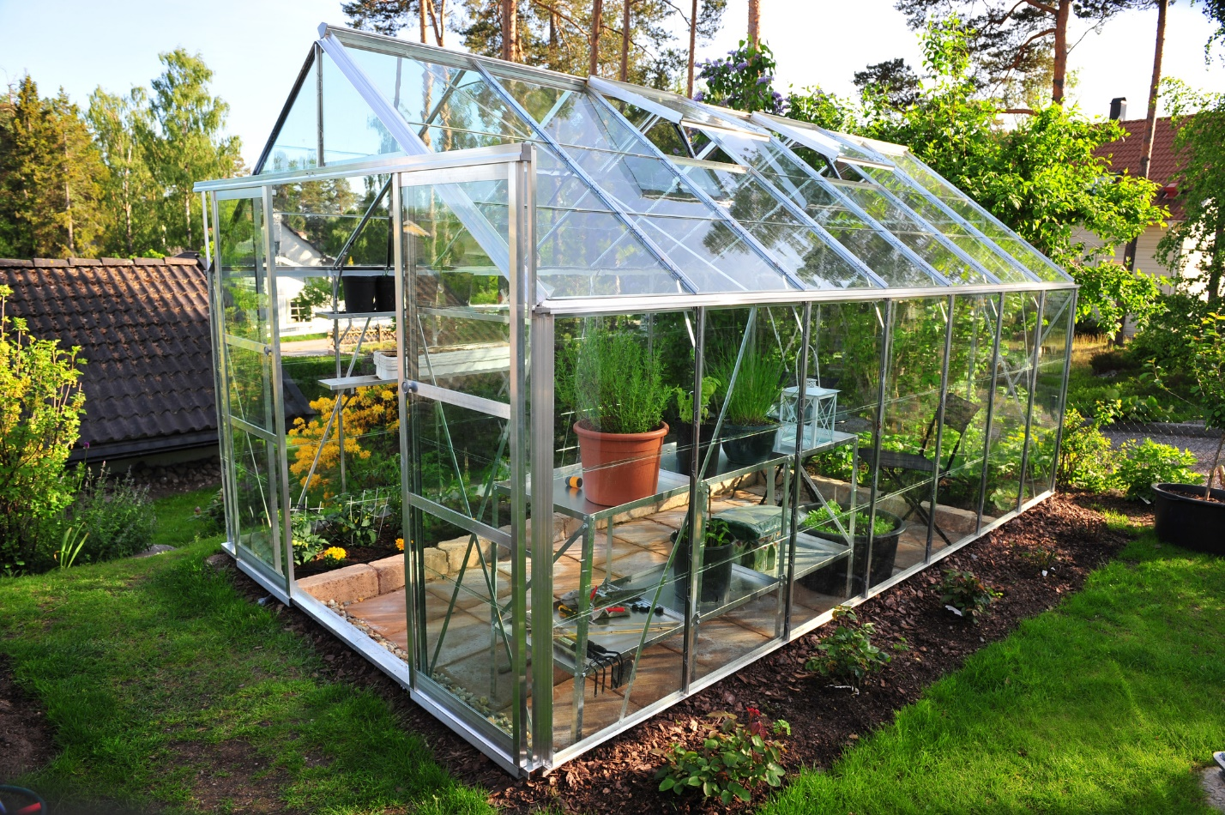

Figure . A greenhouse

# **2.Task:**

Our task is to monitor the following:

1. Average Temperature on 2,5 and 10s sensing interval.
2. Average Humidity on 2,5 and 10s sensing interval.
3. Average Light intensity on 2,5 and 10s sensing interval

A red LED is to be turned on whose turning on condition is described in the next section.

# **3.Condition to Turn Red Led On:**

The red led will be turned on when any one of the following conditions is met:

1. Average of temperature is greater than 24 degree Celsius.
2. Average of Humidity is greater than 70%.
3. Average of Light Intensity is greater than 100

# **4.Sensor Output to physical value conversion:**

The sensor output is converted into physical values which are described in the following three sections:

# Temperature Conversion:

The following formulae are used to convert sensor output to physical temperature values:

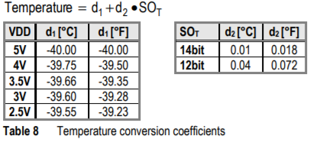

In the code, I used 4V degree Celsius value for d1 i.e. -39.75- and 14-bit degree Celsius value for d2 i.e. 0.01 and used the above-mentioned formulae for conversion.

# Humidity Conversion:

The following formulae are used to convert sensor output to physical pressure percentage:

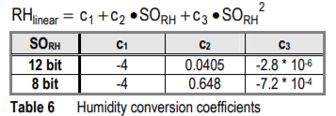

To calculate RHLinear, I used 12-bit values for the constant c1, c2 and c3 i.e. -4,0.405 and .

Then I used the following formulae to calculate the RHtrue values:

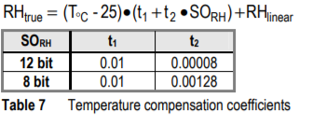

I again used 12-bit values for the constants t1 and t2 i.e. 0.01 and 0.00008 respectively.

# Light Conversion:

For Light conversion of SOL to physical value the following formulae is being used:

# **5.Sensing Results:**

For results, graphs and plotting purposes, I took the first 10 averages generated by the 2,5 and 10s sensing intervals. First average will be generated after 20,50 and 100s for 2,5 and 10s as average is being calculated using 10 data points and then next 10 data points and so on.

# Sensing Result for 2s Interval:

The following are the plots generated by the averages of temperature, humidity and light:

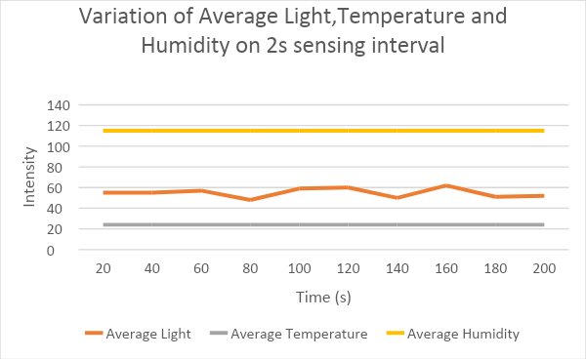

**Figure 1.**

As seen in the above figure the average temperature and humidity remains constant as both sensors are outputting the same values however in the case of average light intensity first the average increases slightly till 60s and then it decreases in 60s-80s interval and then again increases(80s-120s) and decreases(120s-140s) and then increases(140s-160s) and then decreases(160s-200s). We can say that average light intensity is periodically increasing and decreasing.

A side by side intensity conversion plot is also shown in the following figure:

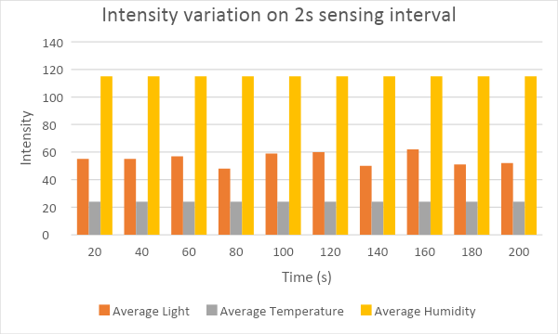

**Figure 2.**

# Sensing Result for 5s sensing interval:

The following are the plots generated by the averages of temperature, humidity and light:

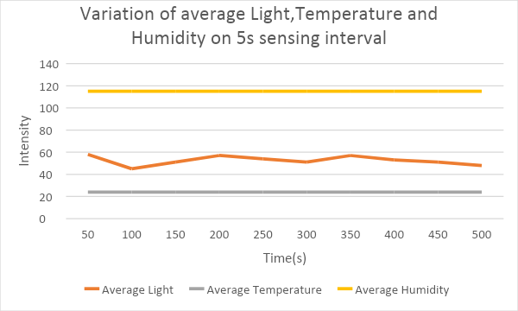

**Figure 3.**

As seen in the above figure the average temperature and humidity remains constant as both sensors are outputting the same values however in the case of average light intensity first the average decreases slightly till 100s and then it increases in 100s-200s interval and then again decreases(200s-300s) and increases (300ss-350s) and then decreases(350s-500s). We can say that average light intensity is periodically increasing and decreasing.

The above graph is smoother than the graph in the 2s sensing interval.

A side by side intensity conversion plot is also shown in the following figure: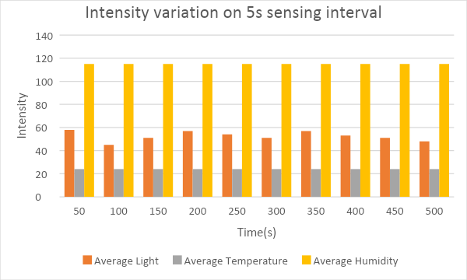

**Figure 4.**

# Sensing Result for 10s sensing interval:

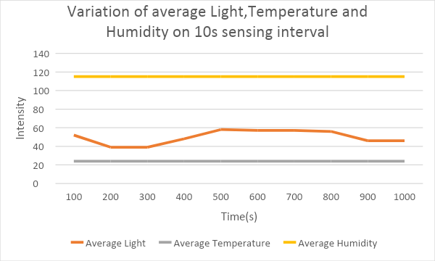

As seen in the above figure the average temperature and humidity remains constant as both sensors are outputting the same values however in the case of average light intensity first the average decreases slightly till 200s and then it stays constant in 200s-300s interval and then increases(300s-500s) and slightly decreases (500s-800s) and then decreases(800s-900s) and then become constant(900s-1000s). We can say that average light intensity is periodically increasing and decreasing.

The above graph is smoother than the graph in the 2s and 5s sensing interval. Moreover there are intervals where the average light intensity remains constant.

A side by side intensity conversion plot is also shown in the following figure:

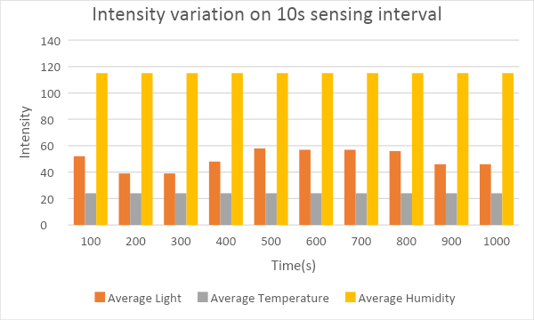

# **6. Analysis:**

The following sections are the result of the analysis of the programs by running it on sensing intervals:

# Energy Consumption:

The following are the observations regarding the energy consumption observed by running on different sensing intervals:

As we increase the sensing interval, the power consumption decreases because the sensors need to be turned on after longer intervals rather than smaller ones.

As we decrease the sensing interval, the power consumption of sensors will increase because the sensors need to be turned on smaller intervals rather than longer ones.

# Processing:

The following are the observations regarding processing by running on different sensing intervals:

More processing is required for smaller sensing intervals since we will be collecting values more frequently on smaller sensing intervals.

Less processing is required for longer sensing intervals since we will be collecting values after long sensing intervals.

# Rapid Light Intensity:

The following are the observations regarding light intensity:

Light intensity changes more rapidly than humidity and temperature which can be quite problematic because mean is highly influenced by an outlier so at times alarms will be even raised when most of the values are low but a single high value causes the alarm to go on.

# Average or Median:

The following are the observations regarding sensing interval:

* + 1. As we know that average is highly influenced by outliers a more sensible option should be to calculate median but that will require more processing.

# Communication:

The following is the observation regarding the communication happening:

* + 1. More communication is required for smaller sensing intervals between sensor and the micro-processor as we are taking more readings
    2. Less communication is required for larger sensing intervals as we are taking less readings.

# Sensing Interval:

The following is the observation regarding the sensing interval:

* + 1. Longer sensing interval reduces computational overheads whereas smaller intervals give more accurate results. Therefore, sensing interval should be carefully selected it should not be too long nor should be too short.