NDESS Modernization Strategy
Table of Contents

NDESS Modernization Strategy
Migrating from NDESS 2.0 (ASP.NET WebForms) to the NDESS API (Modular Monolith Â· VSA Â· .NET)
Audience | Management, technical leads, senior developers
Companion document | NDESS API â€” Architecture Document (describes what we are building; this document describes how we get there)
Team size assumed | 6 developers, who must also keep NDESS 2.0 running
Status | Draft for review

About this document
This is a planning and governance document, not a technical manual. It answers the questions management and leads will ask over the next several years:
- What is our migration strategy, and why this one?
- What decisions will we face, and how do we make them consistently?
- What risks should we expect, and what do we do when they materialize?
- How does day-to-day development change?
- How do we keep the business running while we do this?
Every recommendation in this document was filtered through one constraint: we are six developers, not sixty. Anything that assumes a platform team, a DBA team, a QA department, or a release manager has been rejected, no matter how good it looks in a conference talk. Where an "enterprise" practice was the obvious answer, we name it, explain why it doesn't fit us, and give the six-person version instead.

1. Migration Roadmap

1.1 Why we are modernizing
Be honest about the motivation, because it determines what "success" means.
- WebForms is a dead end. ASP.NET WebForms does not exist on modern .NET. It is tied to .NET Framework 4.8, which receives security patches only â€” no new features, no performance work, ever. Every year we stay, the gap between what we run and what the ecosystem supports widens.
- The talent problem is real and getting worse. Hiring developers who know (or will accept working in) WebForms is already hard. In five years it will be a specialist skill we pay a premium for. Our existing team's skills also stagnate while they maintain it.
- The codebase resists change. Business rules are spread across code-behind files, shared libraries, and stored procedures. The same rule often exists in two or three places. Estimating a change is guesswork; testing it is manual; a fix in one screen breaks another.
- We cannot test what matters. Business rules entangled with Page_Load and Session cannot be unit-tested. Our safety net is manual regression testing, which means we either ship slowly or ship risk.
What we are not doing: chasing fashion. The target architecture (a modular monolith, one deployable, SQL Server, plain SQL) was deliberately chosen to be boring and operable by a small team. We are modernizing the parts that hurt â€” the UI framework, the tangled logic, the untestability â€” and keeping the parts that work (SQL Server, stored procedures for data access, IIS, one database).
ðŸ”‘ Success is not "WebForms is gone." Success is: every business capability we migrate becomes cheaper to change, safer to change, and testable â€” and the business never notices the transition happening. If we migrate a module and it's just the same mud in a newer framework, we failed on that module.

1.2 Rewrite vs. incremental migration
This is the first and most consequential decision, so it gets a full comparison.

Option A â€” Big-bang rewrite
Build the entire new system in parallel, then cut everyone over on a chosen weekend.
Advantages | Clean slate; no coexistence plumbing; no dual maintenance of the architecture (though dual maintenance of features is unavoidable â€” see risks); one migration event to plan instead of dozens.
Disadvantages | No business value delivered until the very end. The old system doesn't stand still â€” every feature and fix applied to WebForms during the (multi-year) rewrite must be re-implemented in the new system, so the finish line moves as you run toward it. The final cutover is an all-or-nothing bet on a system that has never carried production load.
Risk profile | One enormous risk event at the end. Industry experience with ERP rewrites is grim: they routinely run 2â€“3Ã— over schedule, and the cutover weekend discovers years of accumulated assumptions at once. For a 6-person team, a rewrite means 4â€“5 people disappear from support for years, or the rewrite proceeds at a crawl â€” usually both.
When it's right | Small systems (weeks or months of work, not years), or systems being retired rather than evolved.

Option B â€” Incremental migration (strangler fig)
Build the new system module by module around the old one. Each migrated module goes to production and takes over its slice of the business. WebForms shrinks; the API grows; eventually WebForms is an empty shell and is turned off.
Advantages | Value ships early and continuously â€” the first migrated module is in production within months, not years. Risk is spread across many small cutover events, each individually rollback-able. The team learns on low-stakes modules before touching critical ones. Support and migration work can flex against each other month by month. The business sees progress, which protects the project's funding and credibility.
Disadvantages | Coexistence has a real cost: two systems run side by side for years, an integration seam must be built and maintained, and some work is done twice (a screen exists in WebForms while its logic moves to the API). Total elapsed time is longer than an idealized rewrite (but not longer than a real one).
Risk profile | Many small risks instead of one huge one. The worst realistic failure is "we stall halfway" â€” mitigated by governance (Â§1.10) and by choosing module boundaries that leave the system coherent at every intermediate state.
When it's right | Exactly our situation: a live ERP, a small team, a multi-year horizon, and zero tolerance for a failed cutover.

âœ… Recommendation: incremental migration (strangler fig)
The deciding argument for a six-person team: a rewrite requires us to be two teams, and we are barely one. Incremental migration lets the same six people do support and migration as one flow of work, shifting the balance week by week (Â§1.9). Every intermediate state is a working, shippable system.
ðŸ–¼ï¸ Suggested public image â€” the Strangler Fig pattern. Rather than drawing our own, include Martin Fowler's well-known illustration of the pattern (new system growing around the old until the old is hollowed out).
- What it should show: three stages â€” old system intact â†’ new system intercepting some functionality while the old handles the rest â†’ old system decommissioned.
- Search keywords: strangler fig pattern martin fowler legacy migration diagram
- Ideal type: simple 3-stage conceptual diagram (often drawn as boxes with a routing faÃ§ade, or as the literal fig-tree metaphor).
- Selection notes: pick one that shows coexistence (both systems live simultaneously), not just before/after. Avoid microservices-specific versions with service meshes and API gateways â€” ours is a monolith-to-monolith migration.

1.3 Expected duration
Plan for 3 to 4 years end to end, and say so out loud from day one.
The math that produces that number: assume the ERP decomposes into roughly 8â€“12 modules (Â§1.5). With six developers spending, on average, 60% of capacity on migration (Â§1.9), we have ~3.5 developer-equivalents on migration. A mid-sized module â€” domain model, features, SQL, WebForms integration, testing, parallel-run, cutover â€” is realistically 2â€“4 months of focused work for a pair of developers. Modules can overlap somewhat, but coordination and the shared SQL estate limit parallelism for a team this size to about two module streams at once. That yields roughly 3â€“4 modules per year, hence 3â€“4 years â€” before adding the inevitable quarter lost to a major support fire or a big customer commitment.
Two rules about this number:
- Do not promise a completion date to the business. Promise a cadence: "a module reaches production every N months, here's the current order, here's what shipped last quarter." Cadence is verifiable and survives re-prioritization; a 2029 end-date is fiction the day it's written.
- Re-estimate after the pilot. The first module (Phase 2 below) exists partly to calibrate this estimate with real data. Expect the pilot to take twice as long as the modules that follow it â€” it pays for the seam, the pipeline, and the learning.

1.4 Migration phases
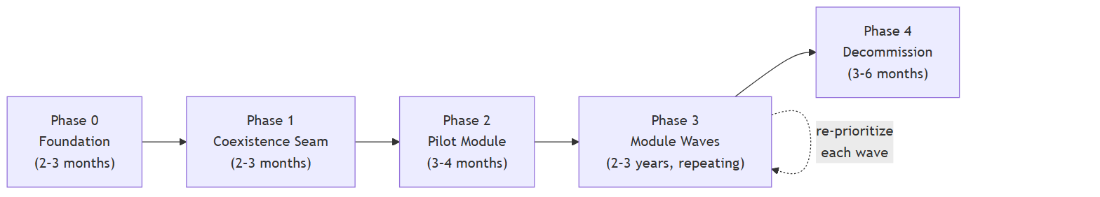{ width=6.3in }

Phase 0 â€” Foundation (â‰ˆ 2â€“3 months, part-time alongside support)
Objective: everything a migrated module will need on day one exists before the first module starts.
- Solution skeleton for the NDESS API per the architecture document (host, Shared building blocks, mediator, module template).
- CI pipeline: every push builds the whole solution and runs all tests (Â§2.3).
- A Test environment that mirrors production shape (Â§3.2).
- Structured logging in place for the API from the first request (Â§3.4).
- The module inventory and first prioritization pass (Â§1.5â€“1.6) â€” a one-page list, not a 40-page study.
- Team training: the architecture document is read and discussed by all six developers; the patterns (slices, handlers, domain rules, the "where logic lives" table) are agreed before code exists to argue about.
Success criteria (gate to Phase 1): solution builds and deploys to Test via the pipeline; a trivial health-check endpoint is reachable in Test; the module inventory exists and management has seen it.
Risks: the classic one is gold-plating the foundation ("just one more building blockâ€¦"). Mitigation: Phase 0 is time-boxed. Anything not needed by the pilot module is deferred until a module needs it.

Phase 1 â€” Coexistence seam (â‰ˆ 2â€“3 months, overlaps Phase 0)
Objective: WebForms can call the API securely, and both systems share identity, before any business logic moves.
- Authentication bridge: a WebForms user gets an API token at login (Â§4.5). Roles map one-to-one.
- The WebFormsâ†’API calling convention: one small, shared HTTP client wrapper in the WebForms codebase (typed methods, token attach, timeout, error translation) so every future integration point looks the same.
- Correlation: a request that starts in WebForms and continues into the API carries one correlation ID visible in both logs (Â§4.6).
- Prove it end-to-end with something harmless: one WebForms page displays one read-only value fetched from the API in production.
Success criteria: that read-only call runs in production for two weeks without incident; logs on both sides correlate; token expiry/renewal works for a full workday session.
Rollback: trivial by design â€” the API call is additive; removing it restores the status quo. This is deliberate: prove the seam where failure is embarrassing, not damaging.

Phase 2 â€” Pilot module (â‰ˆ 3â€“4 months)
Objective: one real module in production, end to end, and a calibrated estimate for the rest.
Choose the pilot deliberately (Â§1.6): meaningful enough to prove the approach (real writes, real rules, real users), small enough to abandon without trauma, and with few dependencies on other modules. A self-contained master-data or reference module (e.g., customer maintenance, item catalog) is the classic choice; the highest-value, highest-risk module (usually order processing) is explicitly the wrong pilot.
The pilot also forces every coexistence decision to be made concretely: how the WebForms screen delegates to the API, how a bug in the module is triaged (Â§1.8), how cutover and rollback actually work. Write these down as they're decided â€” they become the playbook for every subsequent module.
Success criteria: the module is the system of record in production (WebForms no longer writes its tables directly); it has survived one month of real use; its business rules are covered by unit tests; the team has re-estimated Phase 3 using actuals; the migration playbook exists as a checklist.
Risks & mitigation: the pilot revealing that the seam or the architecture doesn't work is not a failure of the pilot â€” it's the pilot doing its job cheaply. Budget one explicit "stop and fix the approach" checkpoint at the pilot's midpoint.
Rollback: the WebForms code path for the module is disabled, not deleted, until the success criteria are met. Rollback = re-enable it and stop routing to the API (see the cutover pattern in Â§4.7).

Phase 3 â€” Module waves (the long middle: â‰ˆ 2â€“3 years)
Objective: repeat the pilot's playbook, one or two modules in flight at a time, until WebForms holds nothing but glue.
Each wave is the same loop:
- Confirm priority (Â§1.6 â€” re-scored each wave, not set in stone years ahead).
- Define the module's boundary and contract (Â§1.5): which tables it owns, which screens it replaces, what it must expose to modules not yet migrated.
- Build the module in the API; integrate WebForms as a thin caller (Â§4).
- Parallel-run / verify in Test with production-shaped data.
- Cut over (WebForms stops writing the module's tables; the API is the system of record).
- Stabilize (2â€“4 weeks with rollback still available), then delete the superseded WebForms logic.
- Retrospect: update the playbook, re-estimate, re-prioritize.
Success criteria per wave: same as the pilot's, plus: no regression in the modules already migrated (the CI test suite is the evidence).
Risks & mitigation:
Risk | Mitigation
Stall: support work swallows migration for months | Capacity rule and monthly review (Â§1.9â€“1.10) make the stall visible in week 2, not month 6.
The half-migrated state confuses developers ("where does this rule live now?") | One page in the repo â€” the module ledger â€” lists every module, its migration status, and its current system of record. Kept current at every cutover. It is the first thing checked when triaging any bug (Â§1.8).
A module's boundary turns out wrong mid-migration | Acceptable and expected once or twice. Boundaries are cheapest to fix inside a monolith â€” merging or splitting modules is a refactor, not a re-platforming. Do it, update the ledger, move on.
Key-person risk (only one dev understands module X) | Every module is migrated by a pair, never a single developer, and the pair rotates between waves.
Rollback: per module, per the cutover pattern (Â§4.7). There is no whole-program rollback in Phase 3 and none is needed â€” every completed module is simply the new normal.

Phase 4 â€” Decommission (â‰ˆ 3â€“6 months)
Objective: turn WebForms off and harvest the payoff.
By now WebForms is a shell of navigation and a few rarely-used screens. Migrate or consciously retire the long tail (some screens will turn out to have zero users â€” check IIS logs before migrating anything), move any remaining cron-style jobs, then remove the WebForms site, its server dependencies, and its build from the pipeline. Archive the repo history; don't delete it.
Success criteria: WebForms site returns HTTP 410/redirect for one full business cycle (including month-end and year-end closing!) with no one asking for it back.

1.5 Identifying modules

What a module is (and is not)
A module is a business capability: a cohesive area of the business with its own vocabulary, its own rules, and â€” critically â€” its own data. Sales orders, Inventory, Purchasing, Billing, Customer management are modules. Reports, Validation, Data access, Utilities are not modules â€” they are technical groupings, and organizing the migration around them recreates exactly the layered tangle we are escaping. A "Reports module" would depend on every other module's data forever; a Sales module that owns its own sales reports depends on nothing new.
ðŸ’¡ The practical test: could you explain the module's job to the department head who uses it, in one sentence, without naming a technology? "Inventory tracks what we have and reserves stock for orders" â€” module. "The stored procedure layer" â€” not a module.

How boundaries are determined
Use these heuristics, in roughly this order of weight:
- Data that changes together belongs together. Look at the write side: which tables are updated in the same transaction, by the same screens, under the same rules? A sales order header and its lines are inseparable. An order and the customer's credit limit check touch each other but change independently â€” that's a boundary with a contract across it, not one module.
- Follow the org chart, loosely. Departments are a decent first draft of capabilities: the people who use sales screens rarely use payroll screens. Where one department's process crosses into another's data, you've found a place that needs an explicit contract rather than a shared table.
- Vocabulary shifts mark boundaries. When the same word means different things ("item" to sales is a sellable product with a price; "item" to warehousing is a bin location and a reorder point), you're looking at two modules that happen to share a noun.
- A screen inventory is the cheapest map. List every WebForms page, group by the capability it serves, and note which tables each reads and writes. In an afternoon of grepping this produces both the candidate module list and the dependency picture below. Expect 8â€“12 modules for a typical ERP; if you get 30, you're listing features; if you get 3, you're listing departments' names rather than their distinct capabilities.

When functionality belongs together
Put two features in the same module when they share invariants â€” rules that must hold across both at the same moment (an order's total must equal the sum of its lines: same module). Keep them apart when they merely share data flow â€” one produces what the other consumes later (an approved order eventually becomes an invoice: two modules, connected by a contract or an event). Shared reference data (units of measure, currency) is neither â€” it goes in Shared, owned by no module.
When genuinely unsure, start bigger. Merging two modules that were split too finely means unwinding contracts; splitting one that grew too big is a folder refactor inside the monolith. Coarse and correct beats fine and wrong.

How dependencies affect migration
Build the dependency picture from the screen/table inventory, then use it two ways:
- Order of migration: prefer to migrate leaves first â€” modules that others depend on lightly or not at all. Migrating a heavily-depended-on module early means every dependent interaction crosses the WebForms/API seam, which is the most expensive place for an interaction to live.
- Seam design: every dependency arrow that crosses the migrated/unmigrated line must become either a synchronous contract or "WebForms still reads those tables directly, read-only, temporarily" (Â§4.3). Count those arrows before committing to a module's migration â€” they are usually the real cost, more than the module's own logic.
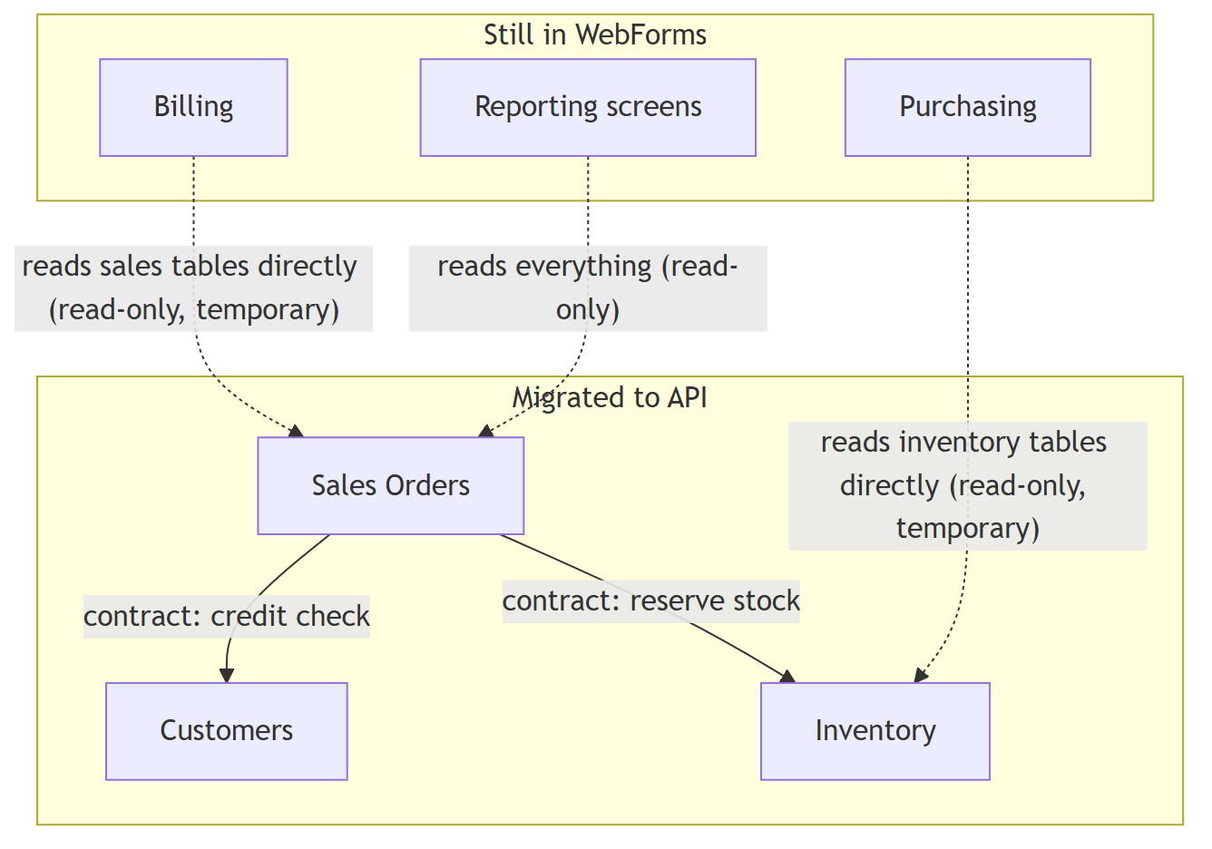{ width=6.3in }
Solid arrows are clean contracts inside the API. Dotted arrows are the temporary, tolerated, read-only exceptions the module ledger tracks â€” each one is a debt with a planned retirement date.

1.6 Determining migration priorities

The factors
Factor | Pushes a module earlier whenâ€¦ | Pushes it later whenâ€¦
Business value | Improving it unlocks revenue or major efficiency | It's a commodity function nobody differentiates on
Frequency of change | We modify it constantly (every change is cheaper post-migration) | It hasn't changed in two years
Number of users / frequency of use | Many daily users feel every improvement | Three people use it quarterly
Technical debt & maintenance cost | It consumes disproportionate support hours | It's ugly but quiet
Production issues | Recurring incidents trace to its design | It just works
Complexity | Low â€” a confidence-builder | Very high â€” do it once the playbook is proven
Future roadmap | Big enhancements are queued for it (build them once, in the new system) | Nothing is planned
Dependencies | Few; it's a leaf | Many modules depend on it, or it depends on many
Business criticality | Moderate criticality is the sweet spot early | The company dies if it breaks for an hour â€” migrate mid-program, when the playbook is boring
The pattern behind the table: early modules should maximize learning per unit of risk; middle modules should maximize value; late modules are whatever is left. Note that "most critical" is deliberately not "first" â€” the pilot is where mistakes happen, so it must be somewhere mistakes are survivable.

Keep the mechanics lightweight
Score each module 1â€“5 on four axes only â€” value of migrating (change frequency + support pain + roadmap), risk of migrating (criticality + complexity), dependency friction (arrows that would cross the seam), and size. Sort by value, adjusted down by risk and friction. This takes the tech lead and seniors one afternoon per re-scoring. Resist the urge to build a weighted 14-factor spreadsheet; the scores are conversation-starters for the governance review (Â§1.10), not an algorithm that replaces judgment.
Re-score at every wave boundary. Priorities set once at the start of a 3-year program are wrong by month six.

1.7 Decision scenarios
These are the situations that will occur. Deciding the policy now, calmly, beats improvising under pressure. Each scenario ends with a recommendation, but the governance review (Â§1.10) may override any of them with reasons recorded.

Scenario 1 â€” A module has many bugs. Migrate immediately or stabilize first?
Options: (a) stabilize in WebForms first, then migrate; (b) migrate now and fix the bugs only in the new implementation; (c) do both in parallel.
Trade-offs: Stabilizing first (a) spends effort on code that is scheduled for deletion â€” pure waste if the migration follows soon. Migrating now (b) means the business lives with the bugs until cutover, and a buggy module is often buggy because its requirements are poorly understood, which is the worst possible state in which to re-implement it. Parallel (c) doubles the work and guarantees the two implementations drift.
Risks: the hidden trap in (b): bugs are sometimes load-bearing. Users and downstream reports may have workflows built around the wrong behavior. Migrating "the fixed version" without warning is itself a production incident.
âœ… Recommended: triage the bugs first. Data-corrupting or money-losing bugs get fixed in WebForms now regardless of migration plans â€” that's support, not strategy. Everything else: pull the module earlier in the queue (high support pain is a top prioritization signal, Â§1.6) and fix the remainder only in the new implementation, with each intentional behavior change listed in the cutover notes so the business signs off on it. Don't stabilize-then-migrate: it pays for the same understanding twice.

Scenario 2 â€” A stable module rarely changes. Migrate early or late?
Options: (a) early, because it's easy; (b) late, because it's not urgent; (c) never â€” leave it until Phase 4 forces the question.
Trade-offs: Early (a) produces motion without value â€” you spend a wave on something that was costing nothing, while painful modules keep burning support hours. Late (b) defers cost to when the team is fastest. The exception: a small, stable, self-contained module can be an ideal pilot, where the goal is learning, not value.
âœ… Recommended: late â€” with the pilot exception above. Stable modules score near zero on value-of-migrating. Migrate them in the closing waves when the playbook makes them cheap, or discover in Phase 4 that nobody uses them and retire them instead. "It would be easy" is not a reason to spend a wave.

Scenario 3 â€” A module is under active development when migration begins
Options: (a) freeze new development until it's migrated; (b) keep developing in WebForms and migrate later; (c) migrate it now, precisely because it's active, and build the new features in the API only.
Trade-offs: A freeze (a) is usually a business non-starter and creates pressure to rush the migration. Continuing in WebForms (b) grows the very code you'll have to re-implement â€” every sprint adds to the migration bill. Migrating now (c) means the new features are built once, in the right place, but the business must accept that during the migration window (2â€“4 months) feature delivery on that module slows.
âœ… Recommended: (c), scheduled at the next wave boundary â€” active development is one of the strongest "migrate early" signals (Â§1.6: future roadmap, change frequency). Between now and that wave: small changes proceed in WebForms; anything large is negotiated â€” either deferred 2â€“3 months to be built natively in the API, or, if truly undeferrable, built in WebForms with the explicit understanding that it re-adds to the migration scope. Make that cost visible to whoever is asking, in hours, and let them choose.

Scenario 4 â€” A critical production bug appears in a module scheduled for (or mid-) migration
Options: (a) fix in WebForms only; (b) fix in the new module only and accelerate its cutover; (c) fix in both.
Trade-offs: WebForms is the system of record until cutover, so (a) is mandatory for the users' sake â€” the only question is what else. Accelerating a cutover to dodge a legacy fix (b) is cutting over under pressure, which is how bad cutovers happen. Fixing in both (c) costs double but is cheap insurance when the new implementation already exists.
âœ… Recommended: fix WebForms now, always â€” production reality outranks migration aesthetics. Then: if the new module's equivalent logic is already written, port the fix immediately while context is fresh (and write the unit test there â€” the test is the durable part, Â§1.8). If the module is merely scheduled, just record the bug and its fix in the module's migration notes so the re-implementation includes it. Never accelerate a cutover to avoid a legacy fix.

Scenario 5 â€” A module is 30% migrated when new feature requests arrive
Options: (a) build the feature in WebForms; (b) build it in the API and cut that slice over early; (c) pause the feature until migration completes; (d) build in both.
Trade-offs: (a) grows the remaining 70%. (b) is attractive when the feature falls inside the 30% â€” vertical slices make "this one workflow is served by the API while the rest stays in WebForms" a normal state, not a hack. (c) is honest but often commercially impossible. (d) is waste with extra steps.
âœ… Recommended: decide by where the feature lands. Inside the migrated 30% â†’ build in the API only (b); the feature becomes extra validation of the new module. Inside the unmigrated 70% â†’ small features go into WebForms (a) and onto the re-implementation list; large features justify resequencing the migration so their slice moves next, then building them cleanly in the API. Never (d).

Scenario 6 â€” A customer requests enhancements to an old (not-yet-scheduled) module
Options: (a) build in WebForms as normal; (b) use the request as the trigger to migrate the module first; (c) decline/defer.
Trade-offs: This is Scenario 3's little sibling, and the answer scales with the size of the ask. A small enhancement doesn't justify dragging a module up the queue â€” (b) turns a two-week request into a three-month project and the customer hears "no" dressed up as architecture. But a large enhancement to an unmigrated module is the worst kind of new debt.
âœ… Recommended: small â†’ (a), build in WebForms, log it on the module's re-implementation list. Large â†’ (b), present the trade to the customer/management honestly: "built on the old system: X weeks now, re-paid later; migrate-then-build: Y weeks, permanent." Let the money decide with full information. The one thing forbidden is doing (b) silently â€” resequencing the roadmap is a governance decision (Â§1.10).

Scenario 7 â€” A module has significant technical debt but low business value
Options: (a) migrate it anyway ("finish the job"); (b) migrate a simplified version â€” port what's used, drop what isn't; (c) retire it; (d) leave it in WebForms until Phase 4 forces a decision.
Trade-offs: (a) faithfully re-implements complexity nobody benefits from. (c) is the highest-value outcome when usage data supports it, but someone must own saying so to its three users. (b) is the usual sweet spot â€” usage logs typically show that half of an old module's features have no users.
âœ… Recommended: defer to late in the program (d), then (b) or (c) based on evidence. Before migrating any low-value module, pull 90 days of IIS/usage logs. Migrate what's actually used, in simplified form; formally retire the rest with a sign-off from the business owner. Technical debt in a module nobody changes is not actually costing anything â€” it only matters if it's generating support load (in which case it isn't low-value; re-score it).

Scenario 8 â€” A module depends heavily on several other modules
Options: (a) migrate it first so others can build on it; (b) migrate it last, after its dependencies; (c) migrate the cluster together as one oversized wave.
Trade-offs: Note the direction of the arrows matters. A module depended on by many others (e.g., Customers) migrated early means many seam-crossings â€” but they're mostly reads, which are the cheap kind (Â§4.3). A module that depends on many others (e.g., Billing, which needs orders, customers, and inventory) migrated early would need every one of those dependencies faked or bridged across the seam â€” the expensive kind. (c) removes the seam problem but creates a mini-big-bang, with a multi-month wave and a scary cutover.
âœ… Recommended: widely-depended-on foundational modules (many inbound reads) go early; heavily- dependent orchestrating modules (many outbound needs) go late (b). In practice this yields a natural order: master data first (customers, items), transactional cores mid-program (orders, inventory), cross-cutting orchestrators last (billing, reporting). Reserve (c) for genuinely inseparable pairs, and even then cut over in stages behind the scenes.

Scenario 9 â€” A module has already been partially modernized
(Say an earlier effort moved some of its logic into the existing ASP.NET API or a shared library.)
Options: (a) treat the partial work as done and build around it; (b) treat it as legacy input and re-implement to the target architecture; (c) leave the module for later because it's "already sort of fine."
Trade-offs: The partial work is usually better input than raw WebForms â€” requirements were recently re-understood, and there may be tests. But "modernized" rarely means "matches the module/VSA/domain-rules architecture"; grandfathering it in (a) creates a permanent architectural exception that every future developer must learn about. (c) wastes the fact that this module is probably the cheapest to finish.
âœ… Recommended: (b), with salvage. The module enters the same pipeline as any other, and the finish line is the same: conforms to the architecture document, listed in the ledger, rules unit-tested. But mine the partial work deliberately â€” port its tests, reuse its requirement decisions, and often its SQL. Because its analysis is fresh, such a module is frequently a good early pick: real value, reduced discovery cost. What it must not become is a permanent "special" module that follows different rules.

1.8 Bug fixing and dual maintenance
The standing question for years will be: a bug is reported â€” where does the fix go? One rule decides it:
ðŸ”‘ Fix the system of record. Every module has exactly one system of record at any moment (it's in the module ledger). That is where the fix goes. Everything else is an exception to be justified.
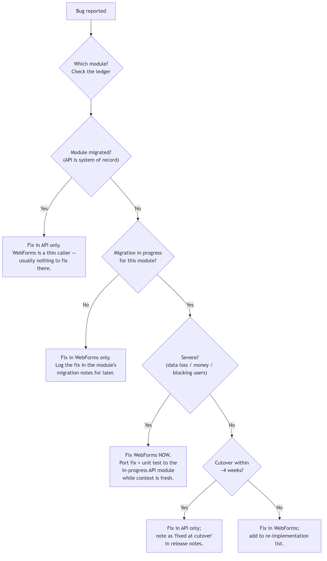{ width=4.9in }
In words:
- Bugs in migrated modules â€” fixed in the API only. This is the payoff: one place, unit test, done.
- Bugs in untouched modules â€” fixed in WebForms only, and logged against the module for its eventual migration. No preemptive fixing in a new system that doesn't exist yet.
- Bugs in in-flight modules â€” the only genuinely dual territory. Severity decides: severe bugs are fixed in WebForms immediately (users can't wait for a cutover) and ported to the in-progress module the same week â€” the port costs minutes while context is fresh and days if deferred. Minor bugs near cutover can wait and be fixed once, in the new module.
- Pause the migration? Only when severe production issues exceed the support capacity (Â§1.9) for more than ~2 consecutive weeks â€” then the wave formally pauses (a governance decision, recorded) rather than silently starving. A paused wave with a stated resume condition beats a zombie wave everyone has quietly abandoned.
Minimizing duplicate work. Three habits do most of the work: (1) keep in-flight windows short â€” dual-maintenance cost is proportional to how long a module stays half-migrated, which is why waves migrate whole modules in 2â€“4 months rather than trickling forever; (2) when a fix must exist in both systems, write the unit test in the new system first â€” the WebForms fix is disposable, the test is permanent; (3) never build the same new feature twice â€” Scenarios 3, 5, and 6 above exist precisely to prevent it.

1.9 Balancing support and migration capacity
Do not split the team into a "legacy team" and a "migration team." With six people that creates two three-person teams, each too small to absorb an absence, and it turns support into a punishment posting that the unlucky pair will resent within a quarter.
Instead, one team, one backlog, two kinds of work, governed by a capacity rule:
- Default: ~60% migration / ~40% support-and-BAU, reviewed monthly. In a calm month migration takes more; in a fire month it takes less. The number is a dial, not a law â€” what's mandatory is looking at the dial monthly so drift is a decision, not an accident.
- A rotating support duty (1â€“2 developers per sprint) fields incoming issues and small WebForms changes, shielding the module pair(s) from interruption. Rotation spreads legacy knowledge and API knowledge across all six people â€” this is also the succession plan.
- Module work is done in pairs (Â§1.4, Phase 3 risks). Two pairs on modules + support duty + lead coordination is exactly six people. That's the honest arithmetic of this team size, and it's why "3â€“4 modules a year" is the cadence and not more.

1.10 Governance
Governance for six developers means a few named decisions with named owners and a written trail â€” not committees.
Decision | Owner | Input from
Module boundaries, technical readiness to start a module | Tech lead | Senior developers
A module is ready to cut over (checklist met: tests, parallel-run, rollback plan, business sign-off) | Tech lead recommends, business owner of that module approves | The pair who built it
Production deployment approval | Tech lead (routine) / business owner (cutovers) | â€”
Migration order and re-prioritization | Monthly review (below) | Scores from Â§1.6, support data
Pausing/resuming a wave; changing the capacity dial | Monthly review, recorded | â€”
The monthly review is the entire ceremony: one hour, tech lead + management sponsor + (rotating) one developer. Standing agenda: the module ledger (what changed state), the capacity dial (actuals vs. the 60/40 intent), support-load trend, the next wave's candidate and its score, and any scenario-type decisions taken since last time (Scenarios 1â€“9) with their reasoning. Output is a half-page note in the repo. That note trail is the roadmap's evolution â€” anyone can reconstruct why the plan changed, which is what protects the program when people change roles.
Progress reporting to the wider business is the cadence statement from Â§1.3: modules shipped, module in flight, what's next â€” one slide, quarterly. Resist percentage-complete numbers; "7 of 11 modules live" is honest, "68% done" is not.

2. DevOps Strategy

2.1 Monorepo vs. multiple repositories
Current state: one repository containing WebForms, the ASP.NET API, SQL stored procedures, shared libraries, and supporting projects.
Aspect | Monorepo (status quo) | Multi-repo (split by system)
Cross-system changes (the defining workload of a migration: one change touches WebForms + API + SQL) | One branch, one PR, one review, atomic merge | 2â€“3 coordinated PRs, ordering rules, "merge mine first"
Visibility | Every developer sees the whole system; the module ledger, playbook, and code live together | Knowledge fragments; discovering "what calls this proc" requires cross-repo search
CI/CD | One pipeline definition; needs path filters to avoid rebuilding everything on every push | Small fast pipelines per repo; but shared-library changes trigger cascading version bumps
Versioning | Everything at HEAD is compatible by construction; no internal package versioning | Shared libraries become NuGet packages with versions, feeds, and upgrade PRs â€” a part-time job
Release management | Release = "deploy these artifacts from this commit"; one tag describes prod | Release = a compatibility matrix of repo versions
Access control / blast radius | Weaker isolation (any dev can touch anything â€” for six trusted devs, a non-issue) | Strong isolation (matters for large orgs, vendors, open-sourcing)
Repo hygiene | Can grow messy without folder discipline | Clean-slate feeling per repo
âœ… Recommendation: keep the monorepo. For a six-person team doing a migration, the multi-repo model's costs land exactly on our critical path (coordinated changes, shared-library versioning) while its benefits (team isolation, independent release trains) solve problems we don't have. The one real monorepo cost â€” pipelines rebuilding too much â€” is solved with path-filtered triggers, which is an afternoon's work.
Do impose folder discipline so the monorepo stays navigable:
/legacy/ NDESS 2.0 WebForms + its supporting projects (frozen shape; shrinks over time)
/src/ NDESS API â€” host + modules, per the architecture document
/database/ SQL: schema + stored procedures, one folder per module schema, migration scripts
/shared-legacy/ Existing shared libraries still referenced by WebForms
/docs/ Architecture doc, this strategy, the module ledger, playbook, review notes
Moving existing code into /legacy/ is a one-time, mechanical, high-value cleanup: it makes "old vs. new" visible in every PR's file paths, and it lets CI path-filter cheaply.

2.2 Branch and pull request strategy
Branching: short-lived feature branches off main, merged via PR, main always deployable. (Trunk-based development with PR gates, in the common usage of the term.) No develop branch, no long-lived release branches, no GitFlow â€” those exist to coordinate many parallel teams and scheduled release trains; for six people they add merge ceremony and delay integration with no offsetting benefit.
Rules that matter more than the branching model:
- Branches live days, not weeks. A module migration is many small PRs behind the coexistence seam (the module isn't "routed to" until cutover), not one three-month branch. A three-month branch is where migrations go to die.
- One approving review per PR, any of the other five developers. Not two reviewers â€” the arithmetic of six people doesn't support it, and one engaged review beats two rubber stamps. The tech lead reviews anything touching Shared, the seam, or module contracts.
- CI must be green to merge. Non-negotiable from Phase 0 onward; it's the regression net that lets a small team move without a QA department.
- Releases are tags on main, and hotfixes are just normal PRs (plus, rarely, a cherry-pick onto the last release tag if main has unreleased work â€” with a deploy cadence of days, that stays rare).

2.3 CI/CD implications and build complexity
- One pipeline, path-filtered: changes under /src build/test/package the API; under /legacy build the WebForms projects; under /database validate and package SQL migration scripts; /shared-legacy triggers both app builds. Full solution build nightly as a drift check.
- Artifacts, not builds-on-the-server: every merged PR produces versioned, deployable packages (API zip, WebForms zip, SQL script bundle) even while deployment itself is still a manual click (Â§3.6). This costs little now and is the prerequisite for everything later.
- Tests in the pipeline from day one: unit tests always; the integration tests against a real SQL Server on the nightly build if they're too slow per-PR.

2.4 Versioning and release management
Keep it minimal: the repo commit is the version. Artifacts are stamped YYYY.MM.DD.build+sha. Because the monorepo means everything at one commit is mutually compatible, "what's in production?" is answered by one tag per environment. No semantic versioning of internal libraries, no NuGet feed for our own code â€” those are multi-repo taxes we've opted out of. A CHANGELOG-style release note (five bullets, written by the deploying developer) accompanies each production deploy; cutover deploys additionally get the module's cutover checklist (Â§4.7).

2.5 Secret management
- No secrets in the repo. Ever. Connection strings, JWT signing keys, and API keys live outside source control from Phase 0 â€” this is the cheapest security win available and it must predate the first deployment.
- Six-person-appropriate mechanism: environment-level configuration on the servers (IIS environment variables / appsettings.Production.json deployed separately from the artifact, readable only by the app-pool identity), with the production values held in a team password manager as the source of truth. If the org later adopts Azure, Key Vault slots into the same seam; don't build toward it before then.
- The JWT signing key and DB credentials get a rotation note (where used, how to rotate, last rotated) in /docs. Rotation you can't do calmly is rotation you won't do at all.

2.6 Database deployment
Today the database changes by "run this script in prod." That's the single most dangerous habit to outgrow, because both WebForms and the API share the one SQL Server database â€” a bad schema change breaks everything at once.
âœ… Recommendation: versioned, ordered migration scripts in /database, applied by a runner (DbUp or plain sqlcmd over an ordered folder â€” either is fine; the discipline matters, not the tool):
- Every schema/proc change is a numbered script in the repo, code-reviewed like code, applied in order, recorded in a journal table. The same scripts run in Test first, always. "What's in prod?" becomes a query, not a memory.
- Additive-first rule during coexistence: while both systems share tables, schema changes are backward compatible by default â€” add columns/procs, don't rename or drop until both systems have moved off (rename = add new + migrate + drop later, three deploys). This is what keeps DB deploys from requiring synchronized WebForms + API releases.
- New-module schemas follow the architecture document's schema-per-module convention, which conveniently also makes ownership visible in the migration scripts' paths.
- The runner fans out across every company database (Â§3.7): each ordered script is applied to all company DBs, the applied version is journaled per database, and the run halts with a report if any database has drifted â€” so "all companies are on the same schema version" is a fact you can query, not assume.

2.7 Work item management
The question underneath all the sub-questions: what granularity of tracking pays for itself for six people? The answer: track by business outcome, decompose by conversation, not by system layer.
- One business feature (or bug) = one work item, regardless of how many systems it touches. "Sales order approval threshold" is one item even though it means an API handler, a WebForms screen change, and a stored procedure. The item is what management, the customer, and the ledger care about.
- Do not create separate frontend / backend / database work items for the same feature. That's Conway's law as ceremony: it triples the items, invents dependencies between them, and produces boards that say "database: done, frontend: blocked" â€” a status no stakeholder can use. If a feature is big enough to need decomposition, use child tasks under the one item (or, honestly, a checklist in the item's description) â€” the tasks are for the pair working it, not for reporting.
- Module migrations get one epic per module ("Migrate Inventory"), containing the feature-slice items and the standing checklist from the playbook (seam, parallel-run, cutover, ledger update, deletion). The epic's state is the module ledger entry's source.
- Reduce overhead by capping the taxonomy: epics (modules / large initiatives) â†’ items (features, bugs) â†’ optional tasks. Three levels, one board, columns = the real workflow states. No story points unless the team wants them for its own forecasting; the monthly review (Â§1.10) needs the module ledger and the capacity dial, neither of which requires estimation ceremony. A work item that takes longer to administer than to read is overhead; delete the field, not the discipline.

3. Infrastructure Strategy

3.1 Hosting: WebForms and the API side by side on IIS
No infrastructure revolution is needed or wanted â€” the migration's hosting story is deliberately dull:
- NDESS 2.0 WebForms stays exactly where it is: an IIS site on .NET Framework 4.8, its own app pool. Don't touch its hosting during the migration; every change to it is risk spent on a shrinking asset.
- The NDESS API is a separate IIS site (or sub-application), separate app pool, running on modern .NET via the ASP.NET Core Hosting Bundle on the same servers initially. Separate pools mean a crash or recycle in one never takes down the other, and each can be deployed independently â€” which is the whole point of coexistence.
- Both talk to the same SQL Server. The database is the one truly shared piece of infrastructure and the reason database deployment discipline (Â§2.6) outranks every other infra improvement.
- Scale-out later (a second web server behind a load balancer) is available if ever needed, but don't build it speculatively; the API is one deployable and SQL Server is the bottleneck that matters.
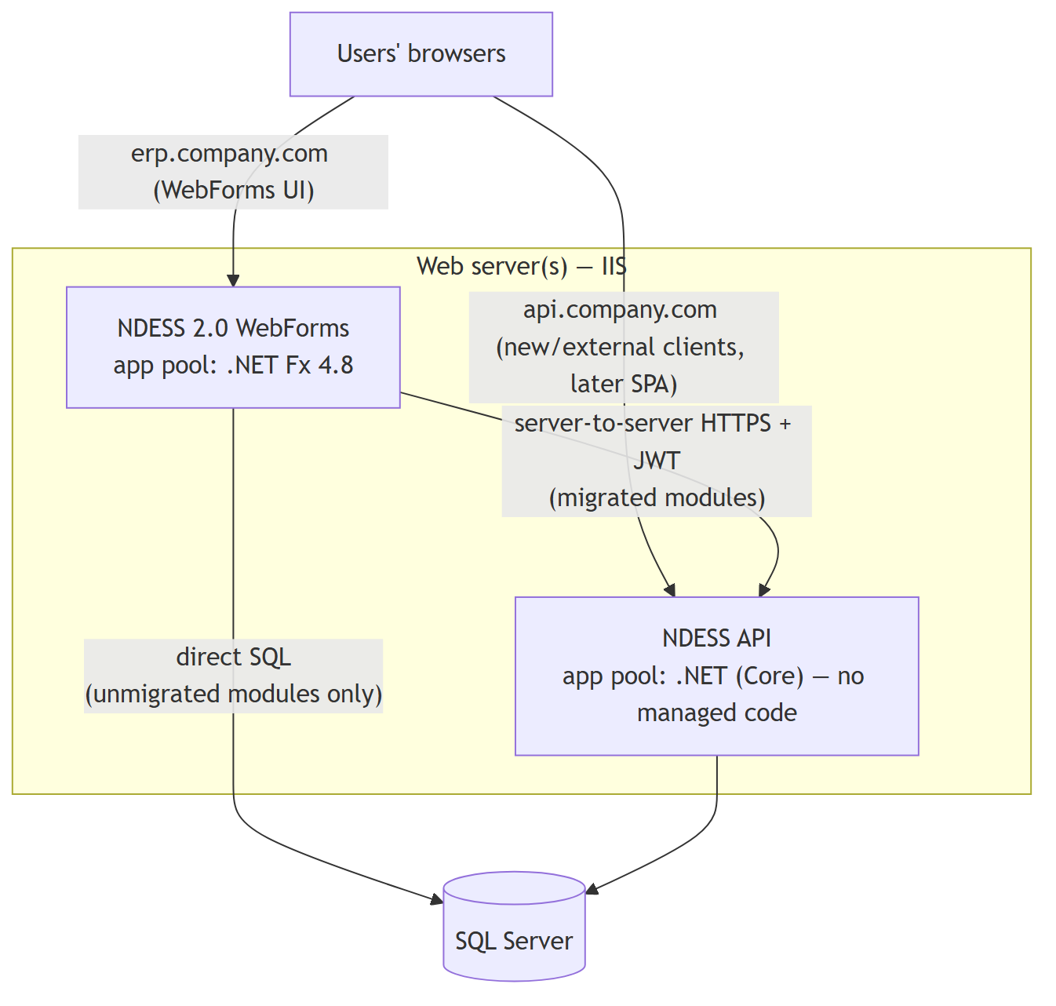{ width=6.3in }

3.2 Environment strategy
Three environments, no more:
Environment | Purpose | Data
Dev (developer machines + shared Dev SQL) | Daily work; each dev runs both apps locally against Dev SQL or LocalDB | Synthetic + small anonymized set
Test / UAT (one server, mirrors prod shape: IIS + both sites + SQL) | The gate: every artifact and every DB script goes here first; parallel-runs and business sign-off for cutovers happen here | Refreshed copy of production, anonymized, on a schedule (monthly, and on demand before a cutover) â€” realistic data is what makes parallel-runs meaningful
Production | The business | The business's
No separate staging, no per-developer cloud environments, no ephemeral environments â€” those are enterprise answers to contention problems six people don't have. The one non-negotiable property is that Test is shaped like production (same IIS layout, same auth, same DB version), because the coexistence seam is exactly the kind of thing that "works on my machine" and fails only in the real topology.

3.3 Domains and SSL
- Domain strategy: keep the users' existing URL for WebForms untouched (erp.company.com or its internal equivalent) â€” users should never re-bookmark anything because of the migration. Give the API its own hostname (api.company.com / ndess-api.internal) from day one, even while its only caller is WebForms server-side â€” retro-fitting a hostname later, once external clients or a SPA exist, is far messier than reserving it now. Test mirrors with a -test or test. prefix.
- SSL everywhere, including WebFormsâ†’API traffic on the same box, including Test. Terminate TLS at IIS. Use the organization's certificate process if one exists; otherwise a wildcard cert or free ACME certificates via win-acme (which also solves renewal â€” expired-cert outages are a self-inflicted wound with a scheduled date). The JWTs crossing the seam are bearer credentials; plaintext HTTP anywhere on their path is a real vulnerability, not a formality.

3.4 Logging and monitoring
The migration doubles the number of systems involved in a user action, so observability stops being a nicety:
- API: structured logging from the first endpoint (Serilog is the de-facto standard) â€” JSON logs with a correlation ID on every request. The mediator pipeline is the natural single place to log every command/query, its duration, and its outcome; that one pipeline behavior gives more diagnostic power than any tool purchase.
- WebForms: don't retrofit a logging framework across the legacy codebase â€” that's large, risky, and temporary. Instrument only the seam: the shared HTTP client wrapper (Â§4.2) logs every API call with the same correlation ID it sends. One user action then traces WebForms â†’ API â†’ SQL in one query.
- Aggregation: ship both logs to one place a developer can actually search. A single Seq (or equivalent) instance on the Test/utility server is the right size for this team â€” no cluster, no license drama, an afternoon's setup. Grepping flat files across two apps on N servers is where on-call evenings go to die.
- Monitoring, minimum viable: an uptime check hitting a WebForms page and the API /health endpoint every minute with email/Teams alerting; disk/CPU alerts on the servers; a SQL job watching for failed backup jobs. Dashboards, APM suites, and SLO tooling are later-if-ever; alerting that reaches a human is the part that can't wait.

3.5 Backup and disaster recovery
- SQL Server is the asset: full nightly + transaction-log backups at 15-minute intervals, copied off the DB server, with a restore actually rehearsed â€” an untested backup is a hope, not a plan. The quarterly Test-environment data refresh (Â§3.2) is conveniently also that rehearsal: refresh Test by restoring the production backup, and you've tested your DR restore path four times a year for free.
- Application servers are rebuildable, not backed up: keep a checked-in setup document (IIS features, hosting bundle, sites, app pools, cert locations, environment variables) sufficient for a developer to stand up a replacement web server in half a day using the versioned artifacts (Â§2.3). For a system whose state lives entirely in SQL Server, that document plus the DB backups is the DR plan.
- Write down the honest RPO/RTO this yields (â‰ˆ15 min data loss / â‰ˆhalf-day rebuild) and get management to sign it. If the business needs better, that's a funded infrastructure decision (standby server, log shipping) â€” not something six developers should improvise.

3.6 Deployment: manual â†’ semi-automated â†’ fully automated
 | Manual | Semi-automated | Fully automated CI/CD
What it looks like | RDP to server, copy files, run SQL by hand | Pipeline builds versioned artifacts; deployment is a one-click, scripted, human-approved run per environment | Merge to main deploys to Test automatically; production deploys on approval or automatically
Advantages | No setup cost; total control | Repeatable, logged, reversible (redeploy previous artifact); human judgment kept at the risky moment | Fastest feedback; deploys become non-events; enables frequent small releases
Disadvantages | Error-prone, undocumented, person-dependent, slow, frightening â€” fear of deploying quietly throttles the whole migration | Still needs a human to click; scripts must be maintained | Highest setup cost; demands mature tests, migrations, monitoring, rollback â€” automation without those just ships mistakes faster
Cost / complexity | Free now, expensive forever | Days of scripting + the artifact pipeline (Â§2.3) | Weeks, plus ongoing pipeline care
Team readiness needed | None | Low â€” this is achievable in Phase 0â€“1 | High â€” realistic for the API mid-program; never worth building for WebForms
âœ… Recommendation: get to semi-automated in Phase 0â€“1 and treat it as the program's standard. The deploy script (stop pool â†’ backup current â†’ unzip artifact â†’ apply DB migrations â†’ start â†’ smoke-test) is small, and it converts deployment from a feared craft into a boring procedure â€” which matters enormously for a migration whose whole rhythm is "many small cutovers." Adopt full automation for the API only, mid-program, once the prerequisites below hold; leave WebForms semi-automated until it's deleted.
Prerequisites before automated production deploys (each one is a thing that replaces the human who used to catch the problem):
- Versioned artifacts + journaled DB migrations (Â§2.3, Â§2.6) â€” deploys must be reconstructible.
- A trusted test suite gating merge â€” green must actually mean "safe."
- Health endpoint + alerting (Â§3.4) â€” the pipeline (and the team) must know within minutes if a deploy is bad.
- A rehearsed rollback: redeploy previous artifact + backward-compatible DB rule (Â§2.6) so rollback never needs a DB downgrade.
- Several months of uneventful semi-automated deploys â€” the social proof that the mechanics are boring.

3.7 Multi-company data: choosing the connection string per company
NDESS serves multiple companies, each with its own database, so the API must connect to the right company's database on every request. Treat this as a first-class capability, not a configuration afterthought: get it wrong and you get a cross-company data leak â€” the single worst class of ERP bug, and one that erodes customer trust permanently. Three isolation models are possible; the choice sets the tone for the whole data layer.
Model | How companies are separated | Isolation | Ops cost
A. Database-per-company (current model) | Each company is its own database with an identical schema; the API selects the connection string per request | Strongest â€” a query physically cannot see another company's rows | N databases to migrate and back up
B. Shared DB + CompanyId column | One database; every table carries a company discriminator; every query filters on it | Weakest â€” one missing WHERE CompanyId= leaks data across companies, forever, on every read and write | One DB to deploy/back up
C. Schema-per-company | One database, one schema per company | Middle | Most of A's migration fan-out without A's clean per-company backup/move
âœ… Recommendation: keep database-per-company (Model A). It matches what NDESS already does â€” so the migration doesn't disturb the data topology â€” and, decisively for a six-person team, it makes "which company's data is this?" a physical fact (the database you're connected to) rather than a discipline every developer must uphold on every query for years. It also gives per-company backup, restore, and "move this company to another server" for free. Model B's single-WHERE-clause failure mode is exactly the kind of latent, silent, catastrophic bug a small team cannot afford to police by hand.
The design that keeps Model A manageable â€” and the one insight worth carrying to the whole team:
ðŸ”‘ Resolve the connection once, centrally, from a trusted identity â€” never per handler, never from a value the client supplied. The multi-company capability lives in exactly one seam, so it cannot be gotten wrong feature by feature.
- Company travels in the JWT. The authenticated user's company is a claim stamped at login (Â§4.5), signed, and therefore un-spoofable. It is not a header or query parameter the browser can set.
- One company catalog maps company code â†’ connection string. It lives in a single well-known place (a small central/master database, or protected config), is the only thing that knows the topology, and is the one place a company is onboarded or moved to a new server.
- The connection factory becomes company-aware. The factory.Create() that every handler already calls (per the architecture document) reads the current user's company claim and returns a connection to that company's database. Handlers, repositories, validators, and SQL are unchanged â€” they neither know nor care that the system is multi-company. The capability is a property of the factory plus a current-company accessor, and nowhere else.
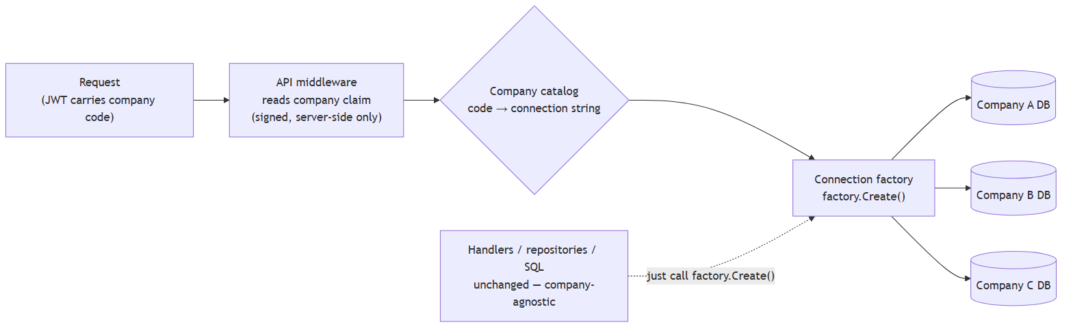{ width=6.3in }
Risks and mitigations specific to this feature:
Risk | Mitigation
Cross-company data leak (catastrophic) | Resolve company only from the signed JWT claim, server-side. Forbid any code path that derives the database from a header, query string, or request body. Add a standing integration test: a user of Company A cannot read or write Company B's data. This is the one rule enforced mechanically, not by convention.
Migration fan-out | Every schema change now touches N databases. The DB deployment runner (Â§2.6) iterates the catalog, applies each ordered script to every company DB, records the version per DB, and halts with a report if any database diverges. Budget "this migration touches N databases" into every wave's cutover.
Secret sprawl | N connection strings/credentials managed per Â§2.5 (secret store keyed by company code), not scattered. A central database catalog may hold them if that database is itself access-controlled; a file catalog must not hold plaintext credentials.
Connection-pool fragmentation | Each distinct connection string is its own ADO.NET pool. Dozens of companies is a non-issue; hundreds warrants a look. Flag it; don't pre-optimize.
Coexistence angle (ties to Â§4): WebForms already selects a company today (via session/login). During the migration the company identity must cross the seam so the API connects to the same database WebForms is using for that user â€” which is why company goes in the JWT (Â§4.5) and both systems read the same catalog. WebForms and the API resolving one company to two different connection strings is a data-integrity incident waiting to happen; the shared catalog is what prevents it.

4. WebForms and API Coexistence

4.1 The one rule that governs coexistence
ðŸ”‘ Ownership is per module, binary, and recorded. For every module, exactly one system owns its writes and business rules at any moment â€” before cutover it's WebForms, after cutover it's the API. There is no state in which both systems apply business rules to the same data. The module ledger (Â§1.4) is the authoritative record, and every rule below is a consequence of this one.
This is what makes coexistence tractable: the dangerous versions of every coexistence question ("which validation runs?", "who fixed this bug?", "why do the two screens disagree?") all stem from shared ownership. Refuse shared ownership and the rest becomes bookkeeping.

4.2 How WebForms communicates with the API
Server-to-server HTTP calls from WebForms code-behind to the API, through the one shared client wrapper built in Phase 1 (Â§1.4):
- The wrapper owns: base URL from config, JWT attachment (Â§4.5), timeouts (short â€” 10s default; the API is on the same network), the correlation ID header, deserialization, and the translation of API errors into the exception/message shape WebForms pages already know how to display (Â§4.6). Individual pages never build raw HttpClient calls â€” one convention, one place to fix things.
- Not chosen â€” direct assembly reference (WebForms referencing API module DLLs in-process): it's faster and skips HTTP, but it welds the two deployments together (every API change forces a WebForms redeploy), drags modern-.NET dependencies into a Framework 4.8 process (frequently impossible outright), and hides the seam we're trying to make explicit. Rejected.
- Not chosen â€” integration via database (shared tables/triggers as the message channel): recreates the tangle we're escaping, invisibly. Rejected.
- Browser-side calls (JavaScript from WebForms pages to the API) are a legitimate later option for specific interactive screens, but the default is server-side: it keeps auth simple (Â§4.5) and avoids CORS and token-in-browser questions until a real SPA raises them properly.

4.3 Does WebForms keep direct SQL Server access?
Yes â€” scoped, shrinking, and rule-bound:
Data belongs toâ€¦ | WebForms reads | WebForms writes
Unmigrated module | âœ… Direct SQL, as today | âœ… Direct SQL, as today
Migrated module | âš ï¸ Tolerated read-only, temporarily (see below) | ðŸš« Never. Writes go through the API, no exceptions
The write rule is absolute because a direct write bypasses the migrated module's domain rules â€” the credit check, the status transition guard, the stock reservation â€” silently corrupting exactly the invariants the migration exists to enforce. Enforce it mechanically, not just socially: after each cutover, revoke UPDATE/INSERT/DELETE on the module's schema from the WebForms application's SQL login (schema-per-module makes this a one-line DENY). A permission error in Test is how you want to discover a missed write path.
The read tolerance is pragmatic: dozens of legacy screens and reports read, say, order data with plain SELECTs, and converting them all to API calls at cutover would balloon every wave for little benefit â€” reads through stale-ish SQL are exactly as consistent as they were yesterday. But each tolerated read is logged in the module ledger with a retirement plan (converted opportunistically, or simply deleted with the screen in Phase 4). New development never adds one.

4.4 Which business logic lives where
Follows entirely from ownership (Â§4.1):
- Unmigrated modules: logic stays in WebForms, untouched. No preemptive cleanup, no "while we're in here" extraction of rules into shared libraries â€” half-refactored legacy is the worst of both worlds, and that effort belongs to the module's real migration.
- Migrated modules: every business rule lives in the API's domain layer (per the architecture document), and the WebForms screen that survives becomes a thin caller â€” it renders, collects input, calls the API, displays results and errors. Its code-behind contains no validation beyond basic input shape, no calculation, no status logic. If a migrated module's WebForms page still contains a business if, that's a defect with the same severity the architecture document assigns to business logic in an endpoint.
- The gray zone is UI behavior (which fields are visible for a role, client-side convenience checks that improve UX). These may stay in WebForms â€” but they must be duplications for convenience of rules the API enforces authoritatively, never the only enforcement. The test: if the WebForms copy were deleted, the system stays correct and merely gets less friendly.

4.5 Authentication and authorization across the seam
- One identity, one user store. Users keep logging in through the WebForms login they know. At login, the WebForms server additionally authenticates against the API's token endpoint (same credentials, same user store) and holds the resulting JWT (+ refresh token) server-side in the user's session â€” never sent to the browser. Every API call the wrapper makes carries the user's token, so the API applies its own role checks per request.
- The user's company travels in that token as a claim (Â§3.7). It is the API's un-spoofable answer to "whose database do I connect to?", and it is the same value WebForms uses to pick the company today â€” set once at login, read by both systems from the shared company catalog, so the two never disagree.
- Do not use a single service account for WebFormsâ†’API traffic. It's simpler for a week, and then the API can't tell users apart: per-user authorization ("your own customers only"), audit trails, and rate-sane logging all die. The API would inherit WebForms' security model instead of imposing its own â€” backwards.
- Roles map one-to-one between the WebForms role system and the API's role claims (SalesRep, SalesManager, Admin â€” the literal strings, agreed once in Phase 1, treated as a contract; a paraphrased role name is a silent authorization bug).
- Authorization is enforced by the API regardless of caller. WebForms may hide a button from a non-manager, but the API's endpoint/domain checks are the enforcement â€” WebForms is just another client, with no special trust beyond its user's token. This is also what makes future clients (SPA, mobile, customer portal) free: the API's security story was never "only WebForms can reach me."
- Token lifetime plumbing (short access token, refresh-before-expiry) lives inside the shared wrapper, so a WebForms session spanning a workday never surfaces a token error to a user or a page author.

4.6 Error handling, logging, and performance across the seam
- Error contract: the API returns structured errors (validation problems vs. domain-rule violations vs. faults). The wrapper translates them into the message pattern WebForms pages already use â€” a domain rejection ("credit limit exceeded") must read to the user exactly as native messages always have. Users should be unable to tell which system declined them. Faults (timeouts, 5xx) surface as the generic error page plus the correlation ID displayed to the user ("quote this code to support") â€” that ID turns "it was broken this morning" into a findable log line.
- Logging: the correlation ID is generated at the WebForms entry point, sent on every API call, logged on both sides, and searchable in one place (Â§3.4). This is the single highest-value piece of coexistence plumbing; build it in Phase 1, not after the first cross-system incident.
- Performance: an in-datacenter HTTP hop is ~1â€“5 ms â€” irrelevant next to the SQL it fronts, except when a page loops: a WebForms grid calling the API once per row turns 2 ms into 2 seconds. The rule is one page action â‰ˆ one API call; where a legacy page can't reasonably comply, that's what the tolerated read-only SQL path (Â§4.3) is for. Watch the wrapper's duration logs (Â§3.4) after each cutover â€” chatty pages announce themselves immediately.

4.7 Deployment and cutover mechanics
Coexistence changes what a deployment is: most weeks it's just the API (new module work, invisible to users). The choreography that matters is cutover, and it follows the same pattern every wave:
- Deploy ahead: the API version containing the module goes to production before cutover, dark â€” endpoints live, nothing routed to them. DB migrations are already applied (additive, Â§2.6).
- Switch: a WebForms release flips the module's screens from direct-SQL to API calls behind a config toggle â€” one setting, flippable without a redeploy.
- Watch: the stabilization window (2â€“4 weeks) with seam logs and support channel on alert.
- Roll back if needed: flip the toggle back. Because the module's schema didn't break compatibility, WebForms' old code path still works. This is the rollback story for the entire program, and it's why cutovers can be calm: the exit is tested and one config value away.
- Seal: after the window â€” revoke WebForms' write permissions on the schema (Â§4.3), delete the old WebForms code path and the toggle, update the ledger. Rollback expires deliberately, not by decay; an eternal toggle is dual maintenance in disguise.

4.8 Avoiding duplicate business logic â€” while the business keeps running
The strategies, gathered from the sections above into one place, in priority order:
- Binary per-module ownership (Â§4.1) â€” duplication of authority is forbidden outright; at no point do two systems both enforce rules for one module.
- Whole modules move, and move fast (Â§1.4, Â§1.8) â€” the duplicated-effort window is the in-flight window, so waves are 2â€“4 focused months, one or two in flight, never a slow smear across the estate.
- Thin-caller discipline (Â§4.4) â€” after cutover the WebForms remnant cannot duplicate logic because it has no logic; UI-convenience duplication is allowed only where deleting it leaves the system correct.
- Mechanical enforcement (Â§4.3) â€” revoked write permissions make bypassing the API's rules an error, not a temptation.
- New work lands once, in the right place (Scenarios 3, 5, 6) â€” features for migrated or in-flight slices are built only in the API; features for unmigrated modules are built in WebForms and logged for re-implementation, a cost made visible to whoever requests it.
- Tests are the durable copy (Â§1.8) â€” whenever a fix must temporarily exist in both systems, the unit test written in the API is the permanent artifact; the WebForms fix is scaffolding that burns down with the module.
Business continuity is the product of the same choices: users keep their URLs, their login, and their screens; every cutover is reversible for weeks; the system of record is never ambiguous; and the loudest possible outcome of the whole program is that nobody outside the team notices anything except that change requests started coming back faster.

Maintained in the repository under /docs conventions (Â§2.1). Review at the monthly governance meeting; material changes to strategy are recorded in the meeting notes with reasoning, per Â§1.10.

