NDESS Modernization Strategy

1. Executive Summary
NDESS Modernization gradually transitions the ERP from ASP.NET WebForms to a modern, API-driven architecture — improving maintainability, scalability, and support for future applications without interrupting business operations.
The migration is incremental. Existing modules keep running in WebForms while new and migrated functionality is built on the API, so the two run side by side. This keeps risk low and lets business improvements ship continuously.
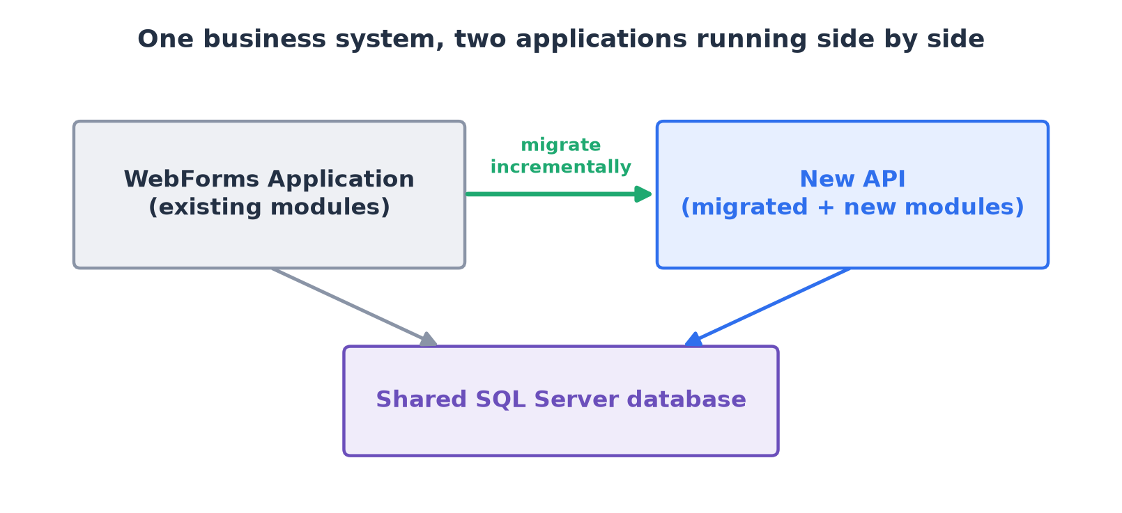
This document covers the migration roadmap, DevOps strategy, infrastructure, and how the WebForms application and the API coexist.

2. Migration Roadmap
Modules move to the API one at a time, chosen by business priority, readiness, and available resources. WebForms stays fully operational throughout, so there is no large-scale, all-at-once replacement.
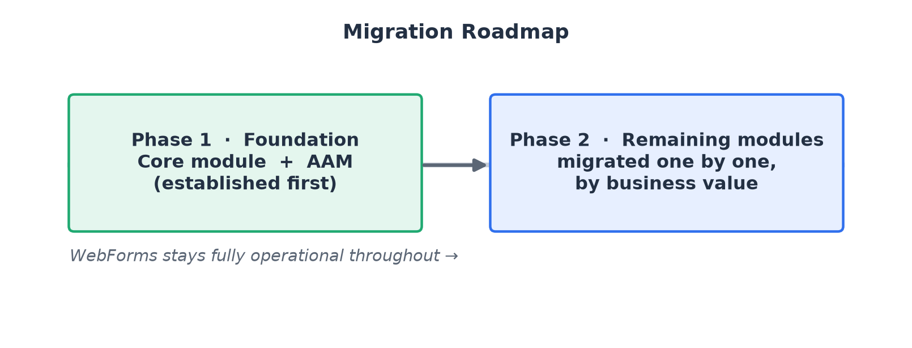

2.1 Phase 1 – Core Module and Approval Authority Matrix (AAM)
Phase 1 delivers two foundational modules — the Core module and the Approval Authority Matrix (AAM). Future API modules reference and integrate with these instead of re-implementing the same functionality, giving the rest of the migration a consistent foundation.
Core and AAM also demonstrate the intended Modular Monolith. Although closely related, they remain separate modules — each owning its responsibilities and boundaries and communicating through well-defined interfaces. This is the pattern every later module follows.
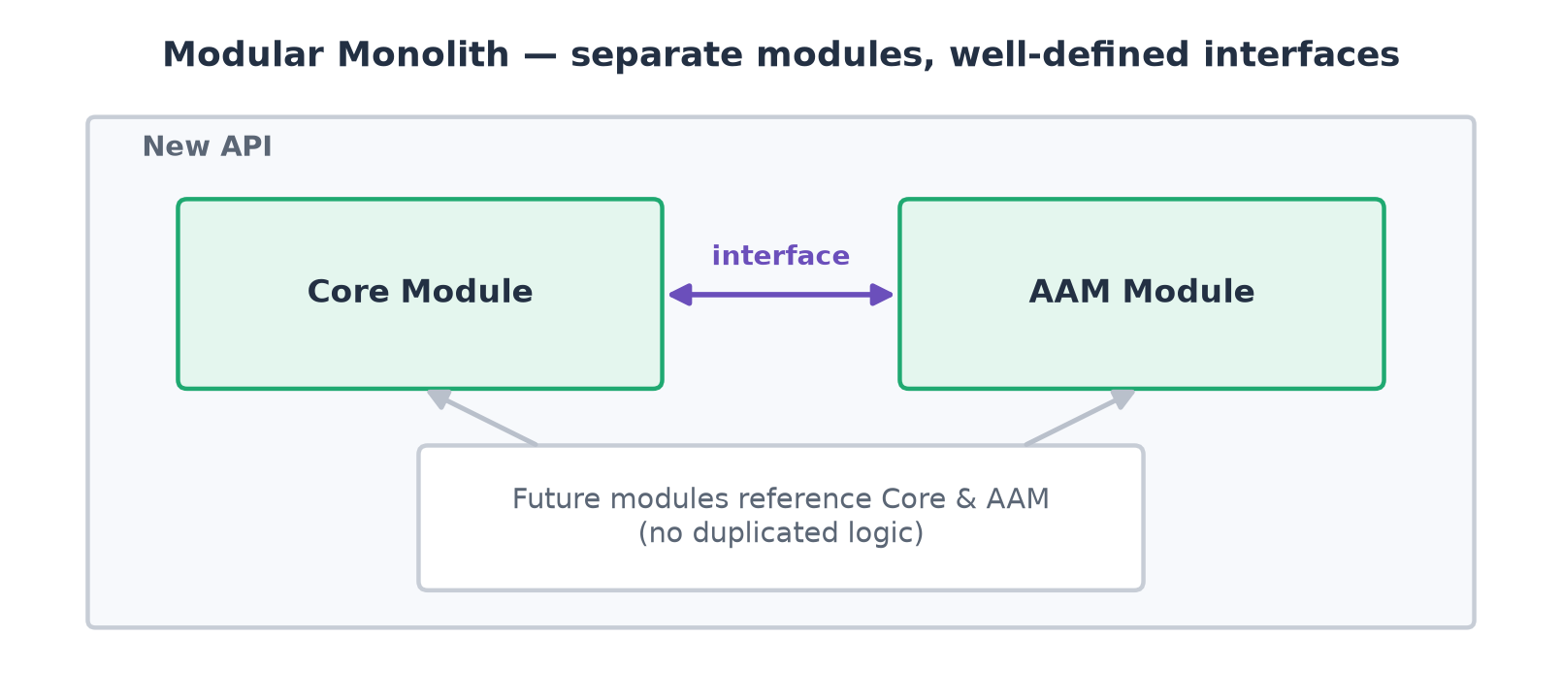

2.2 Phase 2 – Remaining Modules
With the foundation in place, the remaining modules move to the API over time. The goal is to expand by business value, not to migrate everything at once. Migration need not follow the WebForms menu structure — each module is evaluated independently, so priorities can adapt as business needs evolve.
Migration Decision Framework
There is no fixed order. Weigh each module against these considerations — no single factor decides; balance business value, technical complexity, risk, and available resources.
Consideration | Description
Business Priority | Does the module support a critical business process?
Upcoming Enhancements | Are major changes or new features already planned?
Production Support | Does the module frequently require maintenance or bug fixes?
Technical Debt | Is the module becoming difficult to maintain?
Dependencies | Does it rely on modules that have not yet been migrated?
Development Effort | Can the team realistically complete the migration within the roadmap?

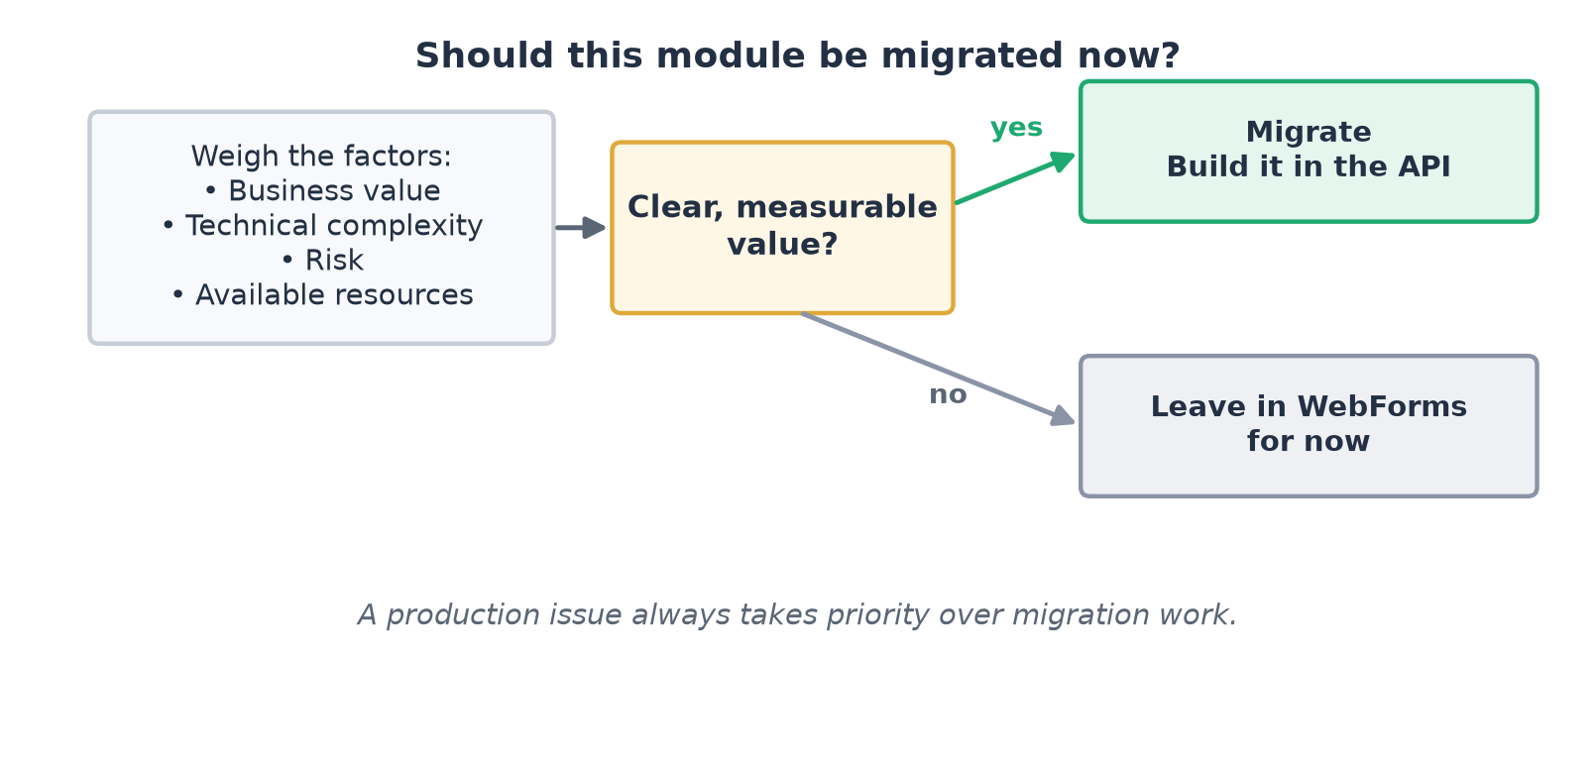
Common Decision Scenarios
Migrate for measurable value, not simply because a module exists.
Scenario | Recommended Approach
A module requires significant new enhancements. | Prioritize migration so future development occurs in the API instead of WebForms.
A module frequently receives bug fixes or support requests. | Evaluate whether migrating would reduce long-term maintenance effort.
A critical production issue occurs. | Resolve the production issue first before continuing migration activities.
A stable module rarely changes. | Leave it in WebForms until there is a clear business reason to migrate.
A module has many dependencies on other modules. | Migrate its dependencies first, or migrate them together if appropriate.

Defining Module Scope
A module should represent a complete business capability — not a collection of related screens or database tables. Each module owns its business rules and exposes only what other modules need. This gives clear ownership, low coupling, and lets each module be migrated, maintained, and enhanced independently.

2.3 Multi-Company Support (Shared API)
A single API and a single codebase can serve more than one company — for example a sister company — without standing up a separate system. Each request carries an API key that identifies the company; the API resolves that key and connects to that company's own database.
Every company keeps its data in a separate database, so records never mix and each company's data stays fully isolated. Onboarding a new company is a configuration step — issue an API key and point it at a database — with no code changes.
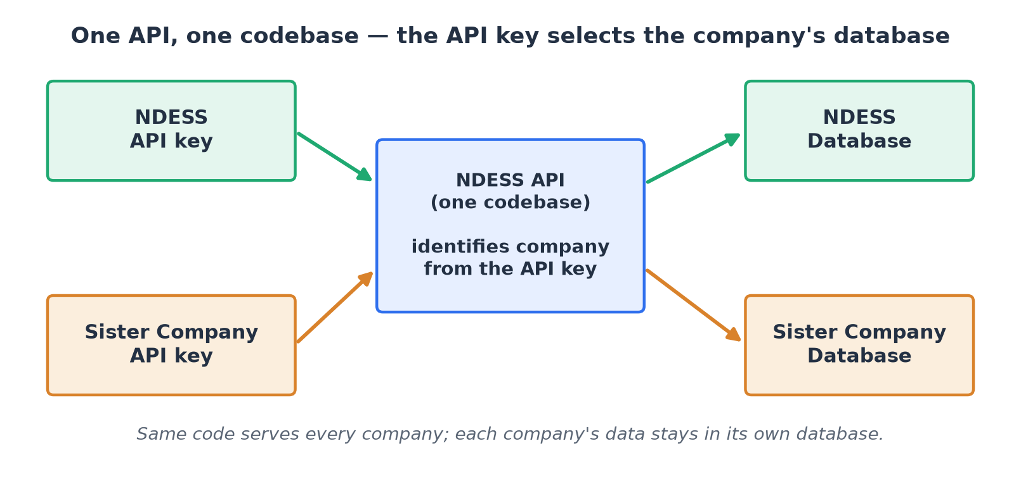
- One codebase to build, test, and maintain for all companies.
- Strong isolation — a separate database per company, selected by the API key.
- New companies are added by configuration, not by forking or redeploying the code.
The API key identifies the company, so it is a credential — it must be kept secret and be revocable, the same as any other access key.

3. DevOps Strategy
The modernization introduces new projects, technologies, and deployment processes. The team should adopt practices that support collaboration while keeping administrative overhead low.

3.1 Repository Strategy
The source code currently lives in a single repository holding the WebForms application, API, database scripts, and supporting projects. As modernization progresses, the team should evaluate whether this structure still fits.
Monorepo | Multiple Repositories
Single source of truth for the entire solution. | Clear separation between applications and services.
Easier coordination when a feature spans projects. | Independent versioning and release cycles.
Simpler work item and pull request management. | More repositories to maintain and coordinate.
Reduced administrative overhead for a small team. | May need multiple PRs and work items for one feature.

4. Infrastructure Strategy
The infrastructure strategy defines how the WebForms application and the API are hosted, configured, and maintained during the migration. Both run simultaneously to keep business operations uninterrupted.

4.1 Hosting Strategy
Host both applications as separate IIS Applications on the same IIS server. Each is deployed and maintained independently while operating as one business solution. This is the recommended approach given the current team size and workload — provided the server has sufficient CPU, memory, storage, and network capacity.
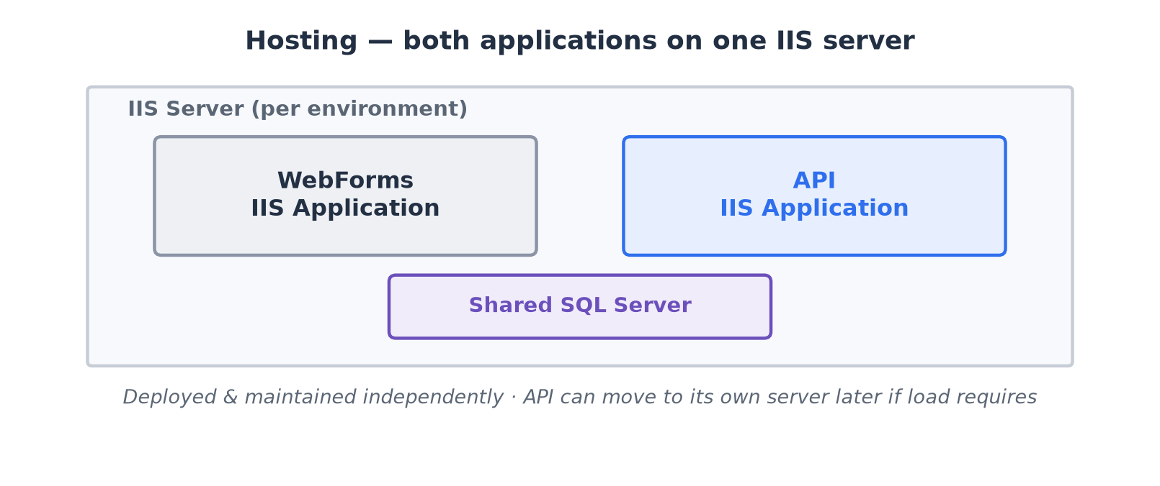
If server resources become insufficient, the API can move to a dedicated IIS server with no significant architectural change. That decision should follow capacity and performance needs — not be part of the initial deployment.
Environment Hosting
Each environment maintains its own deployment of both applications.
Environment | WebForms | API | Protocol
Development | IIS Application | IIS Application | HTTP/HTTPS
QA | IIS Application | IIS Application | HTTP/HTTPS
UAT | IIS Application | IIS Application | HTTP/HTTPS
Production | IIS Application | IIS Application | HTTPS

4.2 Configuration Management
The API uses environment variables instead of the Windows Registry for environment-specific configuration — so developers no longer create or maintain Registry entries locally. Local development uses appsettings.json (the modern equivalent of web.config); on deployment, the server's environment variables override those values.
Windows Registry | Environment Variables
Windows-specific configuration. | Cross-platform, supported natively by modern .NET.
Manual updates on each developer and server machine. | appsettings.json locally; environment variables on servers.
Requires custom code to read and manage values. | Built-in .NET configuration provider, no custom code.
Harder to automate in CI/CD pipelines. | Integrates naturally with CI/CD and deployment automation.
Less visible and harder to audit. | Centralized and easier to manage across environments.
Common in legacy applications. | Recommended for modern application development.

4.3 Backup and Disaster Recovery
Throughout modernization, the primary backup is source control. All application code, database scripts, and migration changes are committed to the central repository, providing a complete history of every change made during the project.

