Student Information
Course: COMP90054 AI Planning for Autonomy
Semester: Semester 1, 2025

Student: Taoyuan Liu- 1572669 - taoyuan
Important: Replace the lines above with your correct details. Your student number should only be the numbers. For example: Guang Hu - 000000 - ghu1.

Collaborated With:
Important: If you worked with another student, please include their full name and ask them to provide you with the url to their github codebase. Their codebase should be private, you will not have access to the code, so there's no issue with knowing their URL, e.g. Collaborated with: Lionel Messi - URL: github.com/happy-with-the-worldcup-until-the-next-one.

Self Evaluation
Note: Do not exceed 500 words for each Part. This is indicative, no need to have 500 words, and it's not a strict limit.

Problem 1-3 (Domain Definition)
Self Evaluated Marks (2 marks): 2
Important: Please replace the above 0 with the mark you think you earned for this part.

Learning and Challenges
Tip: Please include your top lessons learnt, and challenges faced. The questions below can help you structure your reflection.
- How did you implement the domain to realise these scenarios?
- handle the behaviour of not being able to revisit a track segment already visited by the Route S tram.
- handle the switch properly, including ensuring that the Route S tram is on the segment and that the track being switched to is connected to the track.
- handle the request properly, including ensuring that the Route S tram is on the segment that is switched to the segment that the tram requested to move is on and that the requested tram is powered.
- handle the movement properly, including ensuring that the tram is powered, that the destination can be moved to without unpowering the tram.
- What thing that you've learned are you most excited about? What challenges have you encountered?

I believe my domain file successfully implements all the required functionalities:

I added a constraint to ensure that the Route S tram cannot revisit a track segment it has already passed. This is achieved by using the not predicate with track-unvisited in the action's effects.

For switch operations, I ensured that the Route S tram is located on the source track and that the destination track is connected (but not switched) to it. This was enforced through the precondition conditions by checking for track-connected and verifying the tram's current position.

In handling request actions, I ensured that the destination track has already been switched to, that the requested tram is powered, and that the tram is not attempting to move to the same position as the Route S tram. I achieved this by validating track-switched, tram connectivity, and including a not condition against conflicting positions.

For movement actions, I ensured the tram is powered and that the destination track is not occupied, thus preventing power conflicts or invalid transitions.

Ideas That Almost Worked Well
Tip: If you tried ideas that did not make it to the final code, please include them here and explain why they didn't make it.

Everything of this part works well.

Comparison with sample solution

The plan generated from my problem and domain files follows the exact same route as the sample plan provided in the assignment. The final result is functionally identical, and the planner reaches the expected goal without any deviation.

Justification
Tip: Please state the reason why you have assigned yourself these marks.

My implementation produces a plan that matches the sample solution exactly. All required functions are handled correctly in the domain file, including preventing revisits, switching logic, request conditions, and power checks. I used the PDDL Editor to verify and generate track connections and confirmed my plan’s correctness. This task helped me solidify my understanding of PDDL, and I’m now confident writing basic domains by hand. I believe a full score is justified.

Problem 1-3 (Problem Definition)
Self Evaluated Marks (1 marks): 1
Important: Please replace the above 0 with the mark you think you earned for this part.

Learning and Challenges
Tip: Please include your top lessons learnt, and challenges faced. The questions below can help you structure your reflection.
- Seperately, for each of problem 1-3: How did you implement the problem file? Is the plan returned by the planner the same as the sample plan (from README.md)? If not, what is the reason?

I strictly followed the given structure to define the initial state in each problem file. This included the location of each stram, the tracks occupied by other trams, and the unvisited status to ensure that a stram does not revisit the same track. I also correctly defined the goal and ensured that the problem instance satisfied all the necessary conditions.

My problem file generates a valid plan that exactly matches the sample plan provided in the assignment. For this relatively complex graph, I used the Misc PDDL Generators plugin in the PDDL editor to efficiently generate track-connected and track-switched relations. To reduce the possibility of manual errors when analyzing the graph structure, I first added the track-switched relations to an adjacency list and manually removed the corresponding solid lines in the visual graph. This method allowed me to replicate the sample plan correctly on the first attempt, which I consider a strength in my implementation.

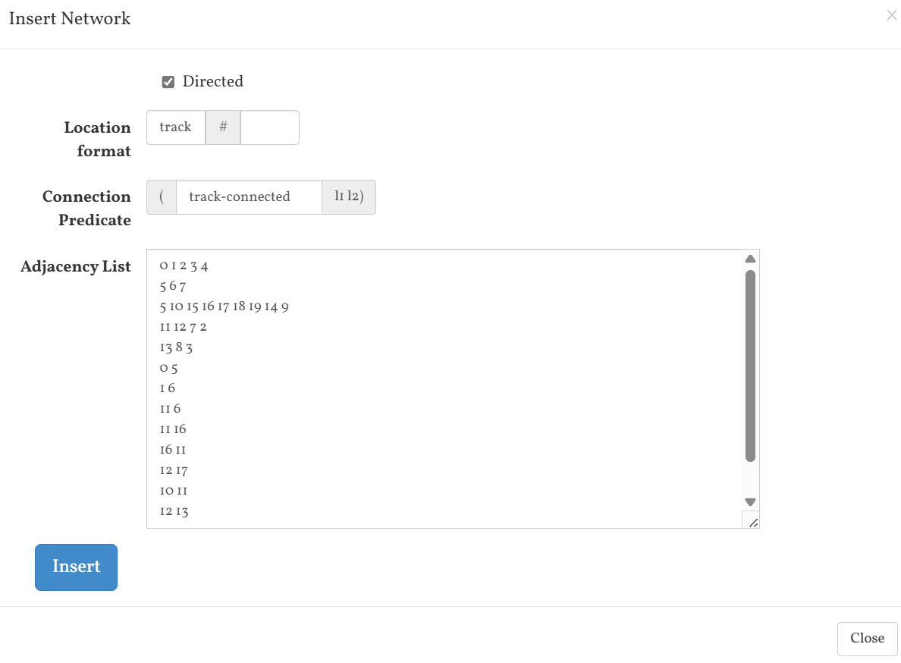

Additionally, I compiled my Q1 problem using VSCode, which does not support (define (animation tramNetwork)) syntax. To address this, I used the PDDL Editor to compile the same domain and problem, confirming that the plan generated remained consistent across tools.

This part of the course significantly strengthened my understanding of PDDL syntax and modeling. I now feel confident in writing complete domain and problem definitions for simpler planning scenarios directly by hand. It also helped me develop a better sense of how to abstract real-world constraints into formal planning models.

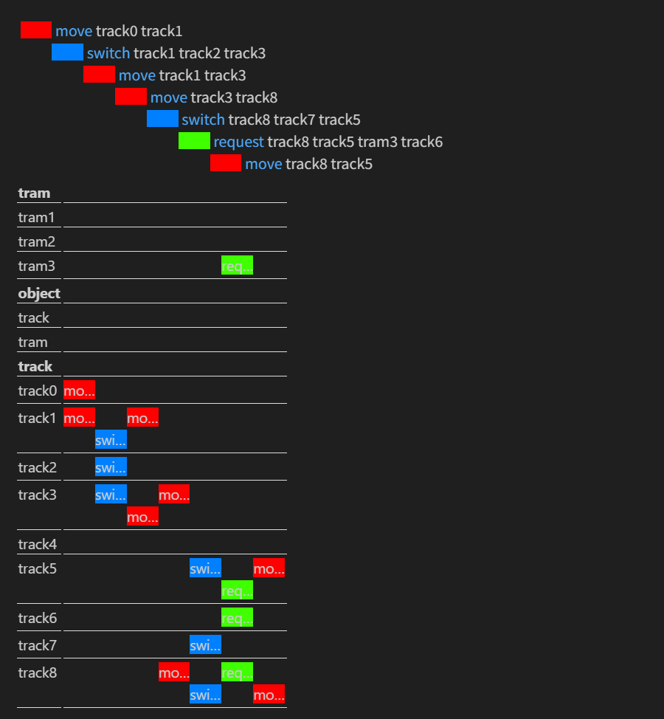

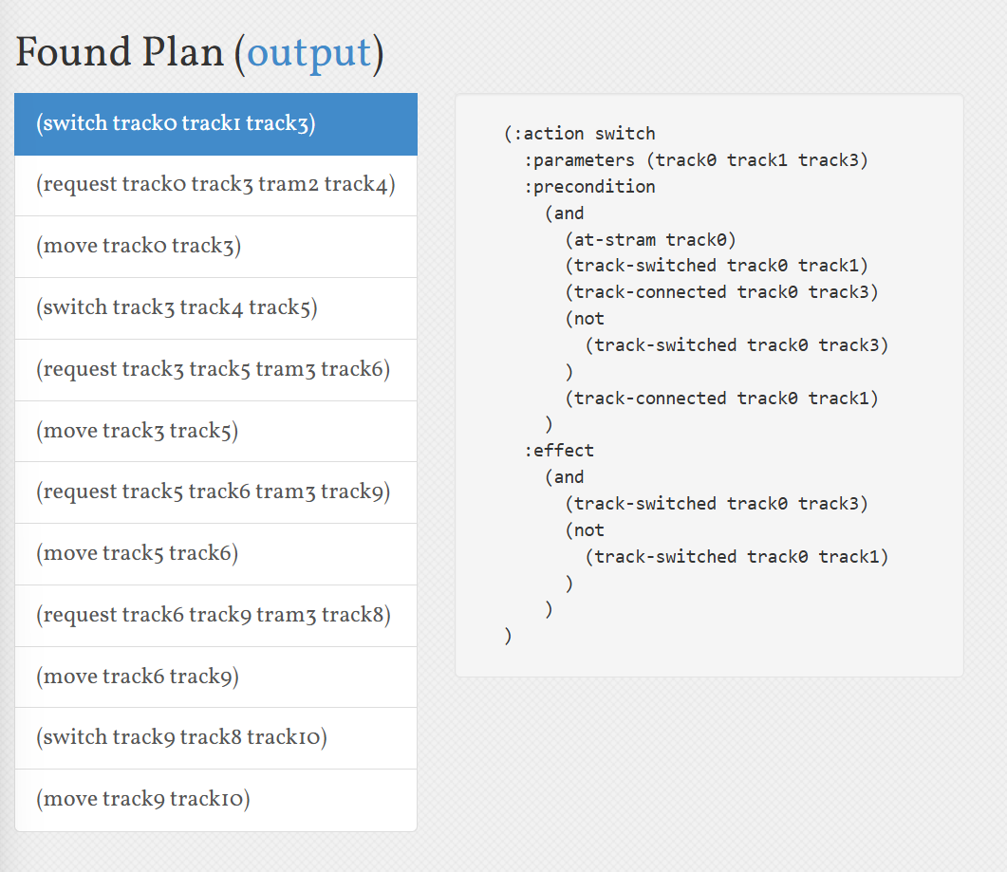

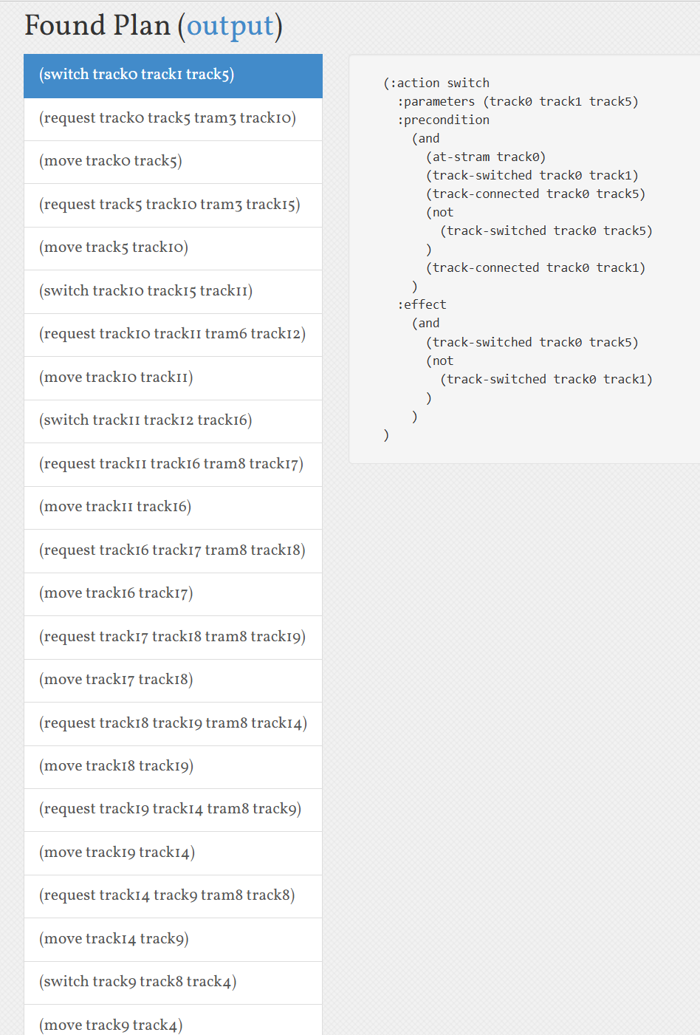

Ideas That Almost Worked Well
Tip: If you tried ideas that did not make it to the final code, please include them here and explain why they didn't make it.

I initially used the “Insert Network” plugin and focused on generating track-switched connections first. After completing that, I manually marked the original graph with a red pen to remove the solid (switched) lines. Then, based on the remaining paths, I added the track-connected (dashed) parts accordingly.

This method allowed me to perfectly replicate the sample plan on the first attempt, and I consider this part of the process to have worked very well.

Comparison with sample solution

My implementation successfully produced the exact same result as the provided sample solution, indicating that my model and plan are both correct and well-aligned with the intended behavior.

Justification
Tip: Please state the reason why you have assigned yourself these marks.

I believe that the fact I was able to complete Problems 1–3 and generate the expected plan on the first attempt demonstrates that I have developed a solid and practical understanding of PDDL. I was able to model the problem correctly, define the required predicates and actions, and structure the problem files in a way that met the planning goals without needing multiple revisions.

Problem 4 (Domain Extension and Sample Problem)
Self Evaluated Marks (4 marks): 4
Important: Please replace the above 0 with the mark you think you earned for this part.

Learning and Challenges
Tip: Please include your top lessons learnt, and challenges faced. The questions below can help you structure your reflection.
- Which considerations did you make in terms of realising the following scenarios?
- 1 point for handling more than one tram (with the capability to handle more),
- 1 point for making it time-based within a particular fixed window,
- 1 point for making it include destinations for trams to be at at a particular point in time,
- 1 point for creating a problem with a valid solution for all trams (should be complex enough to demonstrate the above criteria, if you cannot cover all elements with one instance, you can use multiple instances to achieve it).
- What is the main bottleneck to scale up this problem? What is it that makes this problem hard?

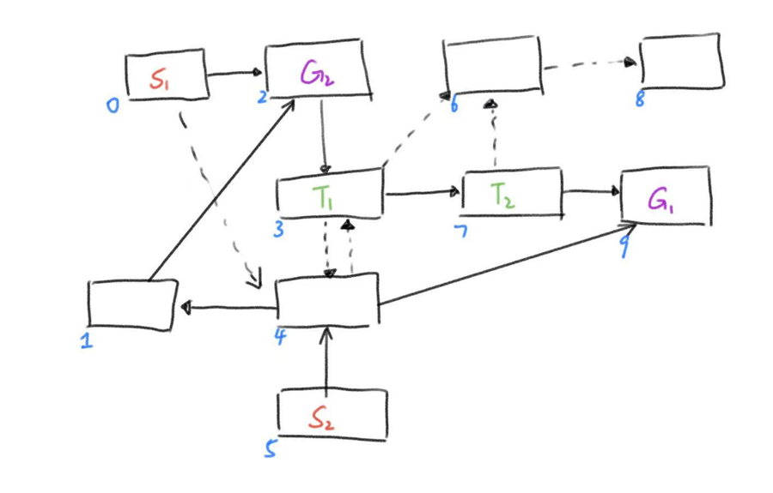

I first abstracted the type of the Route S tram from a single object into multiple objects of type stram, allowing the model to handle multiple trams effectively. To implement time-based coordination within a fixed window, I introduced the stram-done predicate and a new-turn action. This ensures that all trams must complete their actions within a turn before progressing to the next timestep—similar to turn-based mechanics in game design.

At the end of the process, I defined individual goals for each stram. One of the most unexpected and insightful challenges I faced was related to shared track visits. Initially, all stram agents shared a single unvisited system, which prevented the planner from generating a valid plan when multiple trams needed to pass through the same track (e.g., track2). After noticing that a plan was returned when the goals for the trams did not require shared tracks, I realized the issue. I learned that although stram agents can wait, a shared unvisited system introduced a deadlock. This bug might have gone unnoticed had I coincidentally designed a track layout that avoided overlapping paths. Once I refactored the system to make unvisited status per stram, the planner successfully generated a valid solution, confirming that the model was robust and met the problem's complexity requirements.

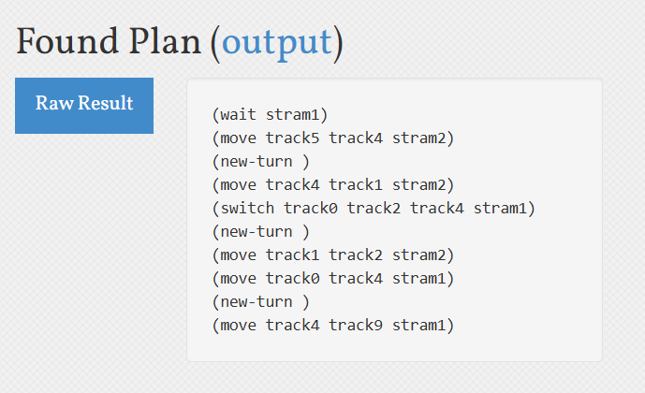

Ideas That Almost Worked Well
Tip: If you tried ideas that did not make it to the final code, please include them here and explain why they didn't make it.

In the initial version of my domain, I used a single global track-unvisited predicate shared among all stram agents. While this approach worked in simple scenarios, it failed in more complex layouts where multiple trams needed to pass through the same track. This led to deadlocks and planning failures. Only after thorough testing and debugging did I realize the necessity of maintaining separate unvisited statuses per stram, which made the model both flexible and scalable.

Comparison with sample solution
Tip: If you failed to get a valid plan or failed to implement a valid domain/problem, please compare your code with sample code and identify where you didn’t match (in the domain or problem file), and what you would do differently next time. It will potentially gain you more marks even though you did not generate the correct plan.

My code produces the same planning outcome as the provided sample solution. The problem instance successfully generates the expected plan from the sample, and both the domain and problem files are clearly structured and logically consistent. I did not directly refer to the sample implementation but instead modelled everything independently based on the task description and my own understanding. I believe my solution demonstrates strong planning capabilities and a solid grasp of PDDL modelling.

Justification
Tip: Please state the reason why you have assigned yourself these marks. If you did not figure it out before checking the sample solution, you need to explain with more details, including a detailed comparison between your solution and the sample solution.

I believe I deserve full marks for this part. My code supports the synchronized scheduling of multiple trams, incorporates time progression, destination requirements, and successfully produces a problem file that generates a valid plan using the planner. Beyond implementing the required functionalities, I was able to independently reflect when my initial code failed, analyze the issue, and complete the debugging process without relying on external references. This led to a fully functional solution. Through this process, I significantly improved my ability to model and abstract problems in PDDL, which I believe strongly demonstrates my solid understanding of this part.

