Platform Process Guide
Applicant provider and admin walkthrough with account labelled screenshots
Profile verification update November 5 2026. Academic results now saves with academic evidence review. Step 2 is only the final profile outcome. Updated review screenshots use platform.reviews; manager oversight uses platform.manager. No review decisions were submitted during capture.
Provider verification update November 5 2026. Organization proof now has individual document reviews before final account verification. These updated screenshots are local platform captures using platform.reviews and dalisay; no demo business decisions were submitted.
Prepared for personal demonstration use on November 3 2026. Screenshots were captured from findscholarship.online using the account named on each page, except the public registration form. No application decisions, case notices, payments or other business actions were submitted while capturing them.
Each process explains who acts, what the screenshot shows, and which role receives the next handoff. A queue screenshot shows where to perform the process, not evidence that every possible outcome has already occurred. Some prepared records intentionally await a tester decision. Manager, representative and superadmin views appear last.

Process index
1. Registration and sign in
2. Applicant profile and supporting evidence
3. Admin applicant verification
4. Provider organization profile
5. Admin provider verification
6. Program creation and publication
7. Admin program review
8. Scholarship discovery and preparation
9. Reusable applicant documents
10. Submitted application and next action
11. Provider screening and document review
12. Formal application verification
13. Examination and interview scheduling
14. Applicant examination schedule
15. Applicant interview schedule
16. Recording conducted stage results
17. Final scholarship decision
18. Applicant acceptance of the agreement
19. Recipient support and agreement tracking
20. Applicant monitoring and check in submission
21. Provider monitoring evidence review
22. Admin monitoring oversight
23. Renewal completion and support decisions
24. Planning the first or one time benefit release
25. Recording actual benefit distribution
26. Applicant receipt and delivery reports
27. Recipient withdrawal requests
28. Agreement concerns before conclusions
29. Provider delivery investigation and correction
30. Independent review appeals and privacy
31. Provider support and platform reports
32. Admin support case handling
33. Provider staff and program assignment
34. Admin account management
35. Provider paid services and requests
36. Admin service intake delivery and closeout
37. Admin finance and payment records
38. Admin audit history and exports
39. Provider manager overview and combined workspaces
40. Organization representative view
41. Portal manager overview
42. Superadmin governance view

1 Registration and sign in
Signed in account: Not signed in
Page shown: Registration form before sign in
A new applicant or provider starts at registration, selects the appropriate account type and supplies the requested identity and contact information. Follow the email verification instructions before continuing. An existing demo account instead signs in using its username or email. The middle initial is optional.
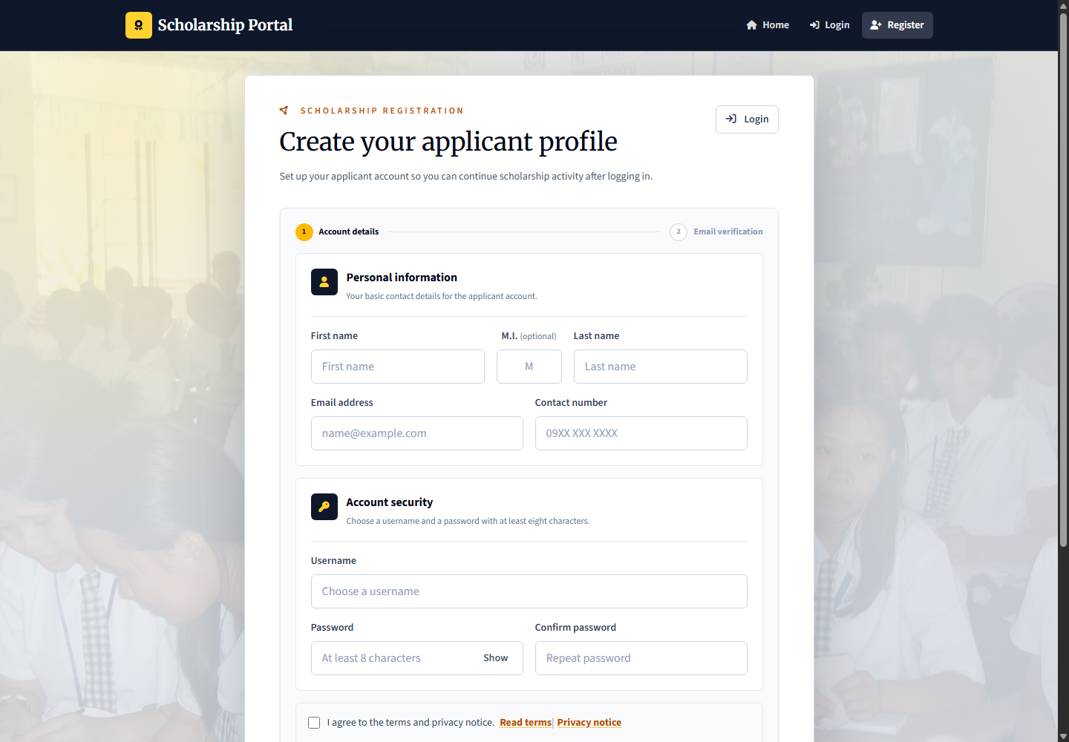
Applicant: registers and completes profile evidence. Provider: registers the organization and submits its verification information. Admin: operational accounts are managed through the authorized admin account workflow; provider and applicant verification are handled by platform.reviews. No new account was registered for this screenshot.

2 Applicant profile and supporting evidence
Signed in account: learner.profile
Page shown: Applicant profile and supporting evidence
The applicant maintains identity, contact, education, household, and location details. Section edit modals keep the applicant on their record. Upload documents that support the profile rather than merely filling the text fields.
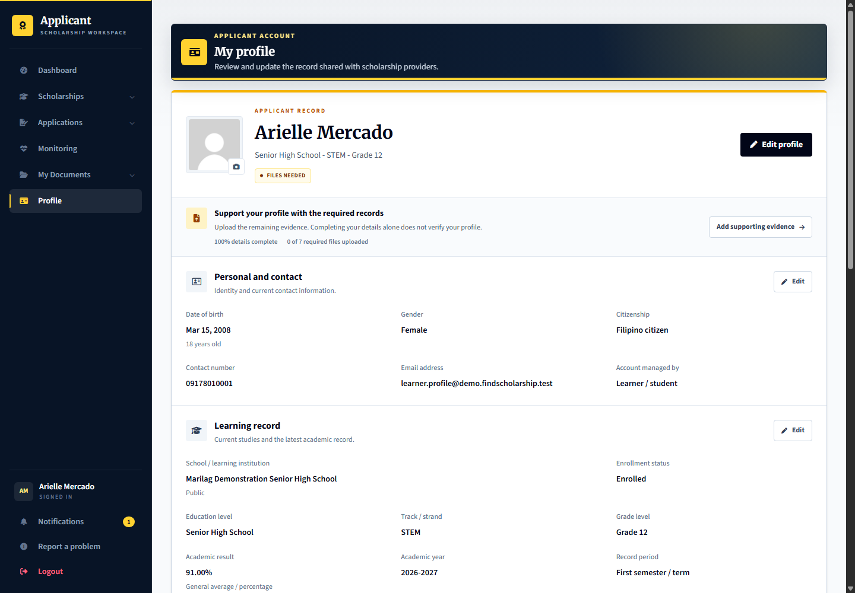
Applicant: complete the record and evidence. Provider: later sees the submitted applicant record and which information is self-declared. Admin: the review officer verifies the profile evidence before the applicant can apply.

3 Admin applicant verification
Signed in account: platform.reviews
Page shown: Admin applicant verification
The review officer checks supporting files first. In the academic record review, Academic results contains the grading scale and verified result; accepting that document saves any correction. Step 2 then records only the overall profile outcome and review note. Accepting evidence does not verify the whole profile or select an applicant for a scholarship. Use learner.verification for this queue and platform.reviews to review it.
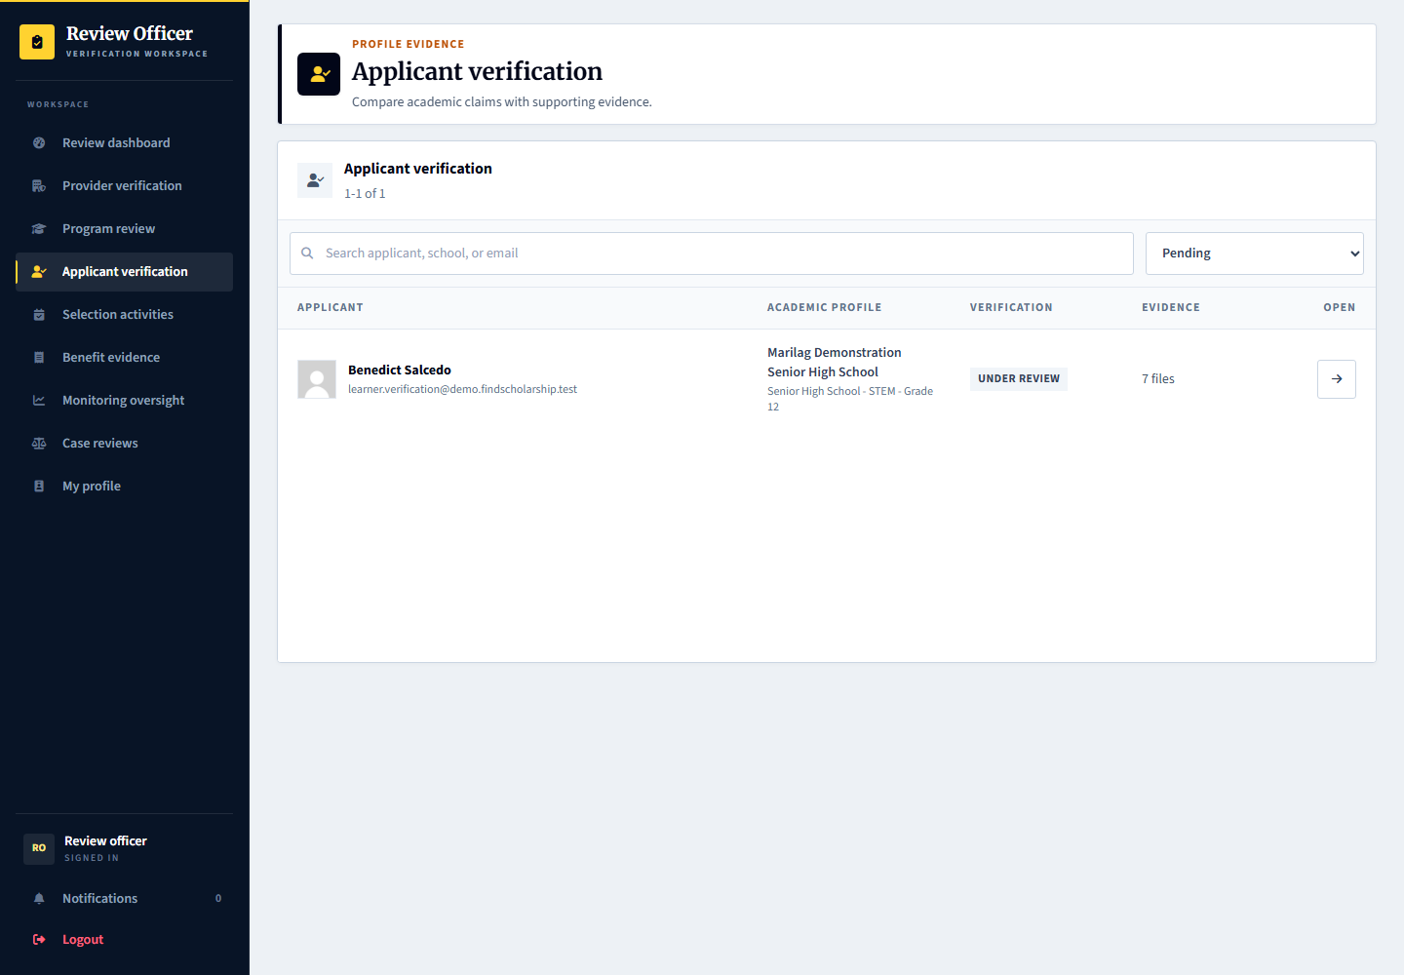
Applicant: learner.verification supplies or corrects evidence. Provider: cannot replace platform profile verification with a scholarship decision. Admin: platform.reviews performs verification; superadmin is not the normal operational reviewer.

4 Provider organization profile
Signed in account: marilag.profile
Page shown: Provider organization profile
The organization profile manager maintains the provider information shown to applicants, including identity, public description, branding, contact information, and location. A provider preview shows the applicant-facing presentation.
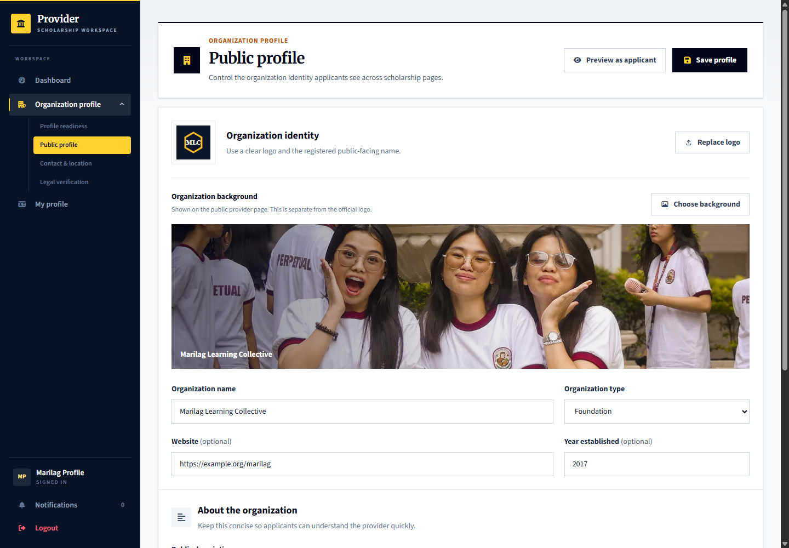
Applicant: discovers and evaluates providers. Provider: marilag.profile maintains the organization record and evidence. Admin: platform.reviews checks registration evidence and organization verification.

5 Admin provider verification
Signed in account: platform.reviews
Page shown: Admin provider verification
Use platform.reviews to review the Dalisay organization. Step 1 reviews each current proof separately: open Review, inspect the file beside the organization details, then Accept document with the comparison acknowledgement or Request replacement with a clear reason. Step 2 records the final provider account decision only after every current file is accepted. Verification does not approve the provider's scholarships.
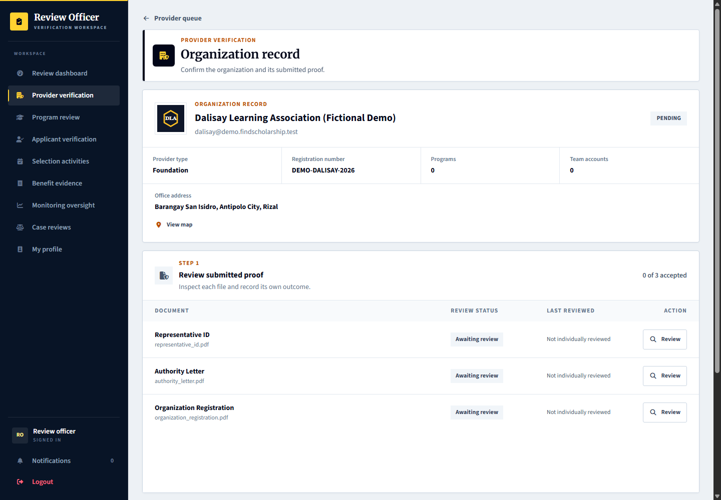
Applicant: sees the provider trust state. Provider: sees individual file outcomes and corrective notes, and uses Replace document to submit new proof. Admin: records each document review and then a separate account outcome; the final account decision never overwrites file outcomes or notes.

6 Program creation and publication
Signed in account: marilag.programs
Page shown: Program creation and publication
The program coordinator prepares scholarship details, benefits, eligibility rules, requirements, selection stages, dates, applicant limits, and branding. Drafts and requested changes stay separate from published programs. The staged editor validates each step.
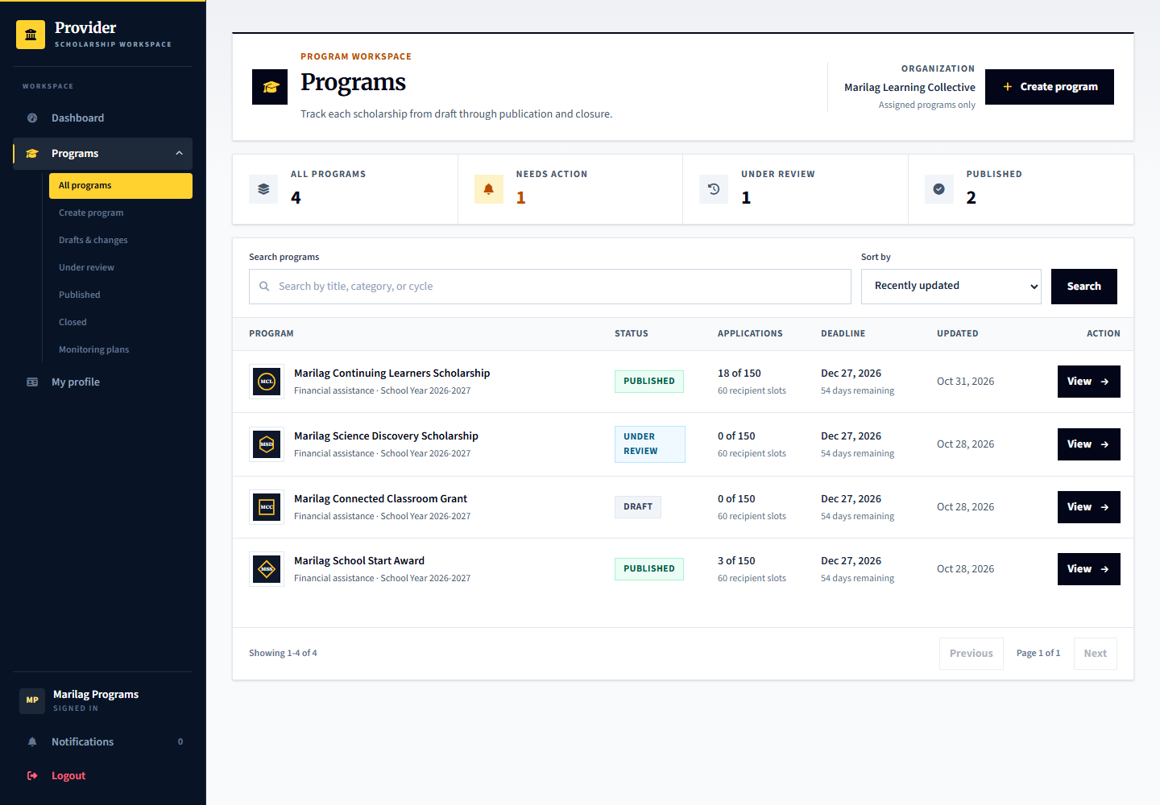
Applicant: sees published scholarships, not private drafts. Provider: marilag.programs prepares and submits programs. Admin: platform.reviews checks publication submissions; it does not make the provider final applicant selection.

7 Admin program review
Signed in account: platform.reviews
Page shown: Admin program review
The program review queue separates publication checks from organization verification and applicant verification. The officer examines the program information and requests changes or records the publication review decision.
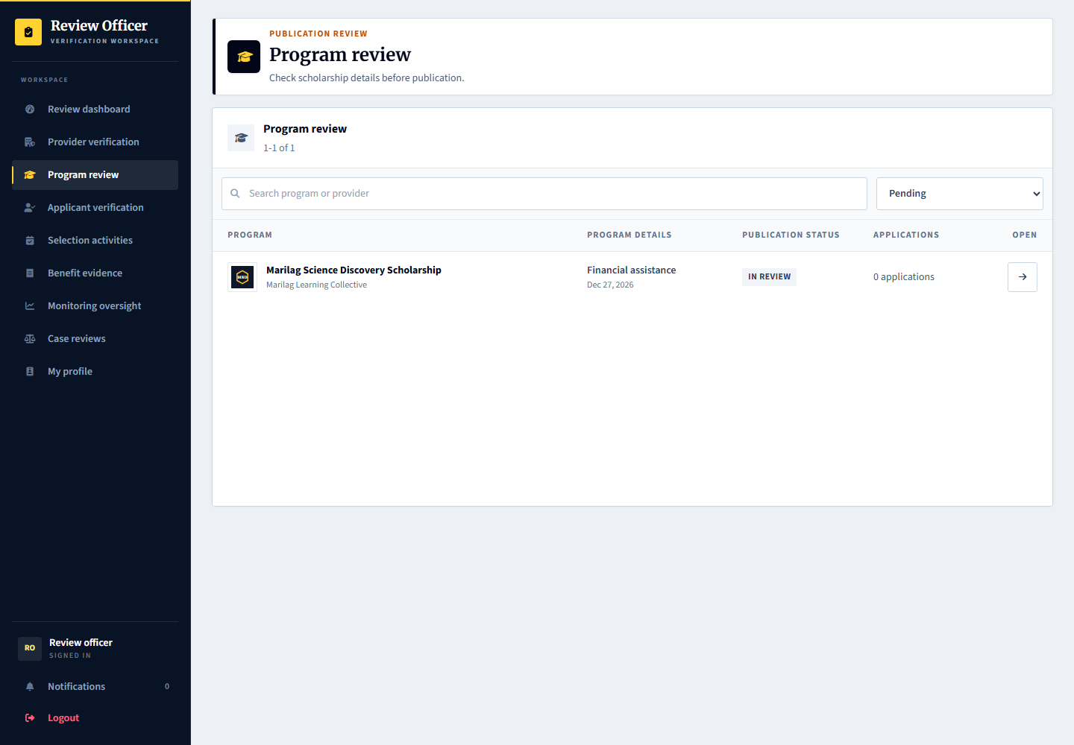
Applicant: can discover approved published programs. Provider: answers requested changes. Admin: verifies the submission through the program review workspace.

8 Scholarship discovery and preparation
Signed in account: learner.apply
Page shown: Scholarship discovery and preparation
The applicant finds a scholarship and opens its details to understand benefits, eligibility, documents, application instructions, and selection stages. The provider page helps applicants identify a specific organization.
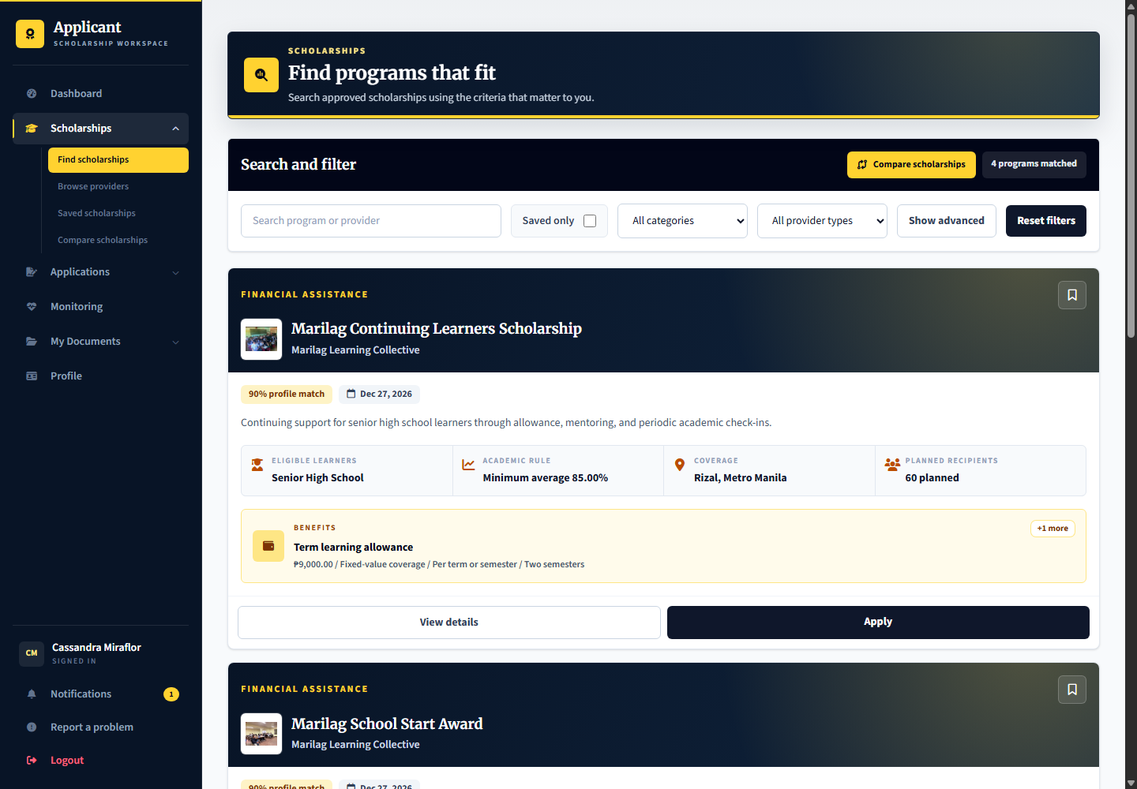
Applicant: learner.apply is ready to start a new application. Provider: supplies accurate program and organization content. Admin: oversees publication and trust checks, not the applicant choice of scholarship.

9 Reusable applicant documents
Signed in account: learner.apply
Page shown: Reusable applicant documents
My Documents holds reusable files for future applications. A saved document is not automatically an accepted application requirement; the applicant must choose appropriate current files during an application.
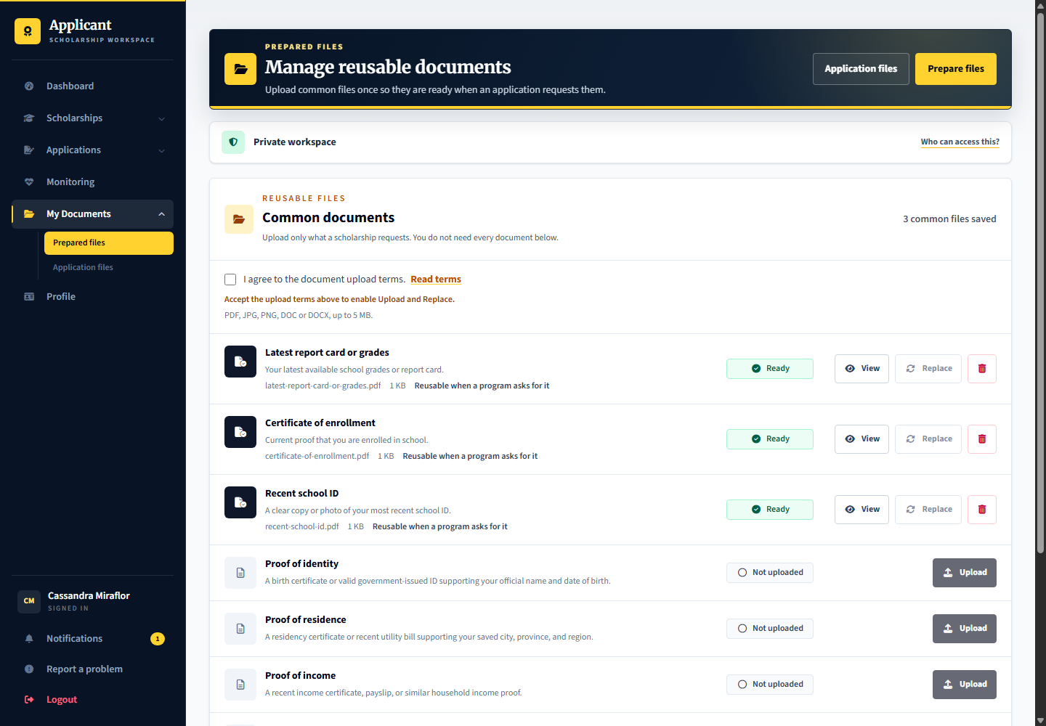
Applicant: uploads and manages documents. Provider: reviews files actually submitted to its program. Admin: profile evidence verification remains separate from a provider application document decision.

10 Submitted application and next action
Signed in account: learner.screening
Page shown: Submitted application and next action
The application details tell the applicant the current stage, what happens next, required submissions, schedule, decision, and history. learner.screening is waiting for the initial provider review.
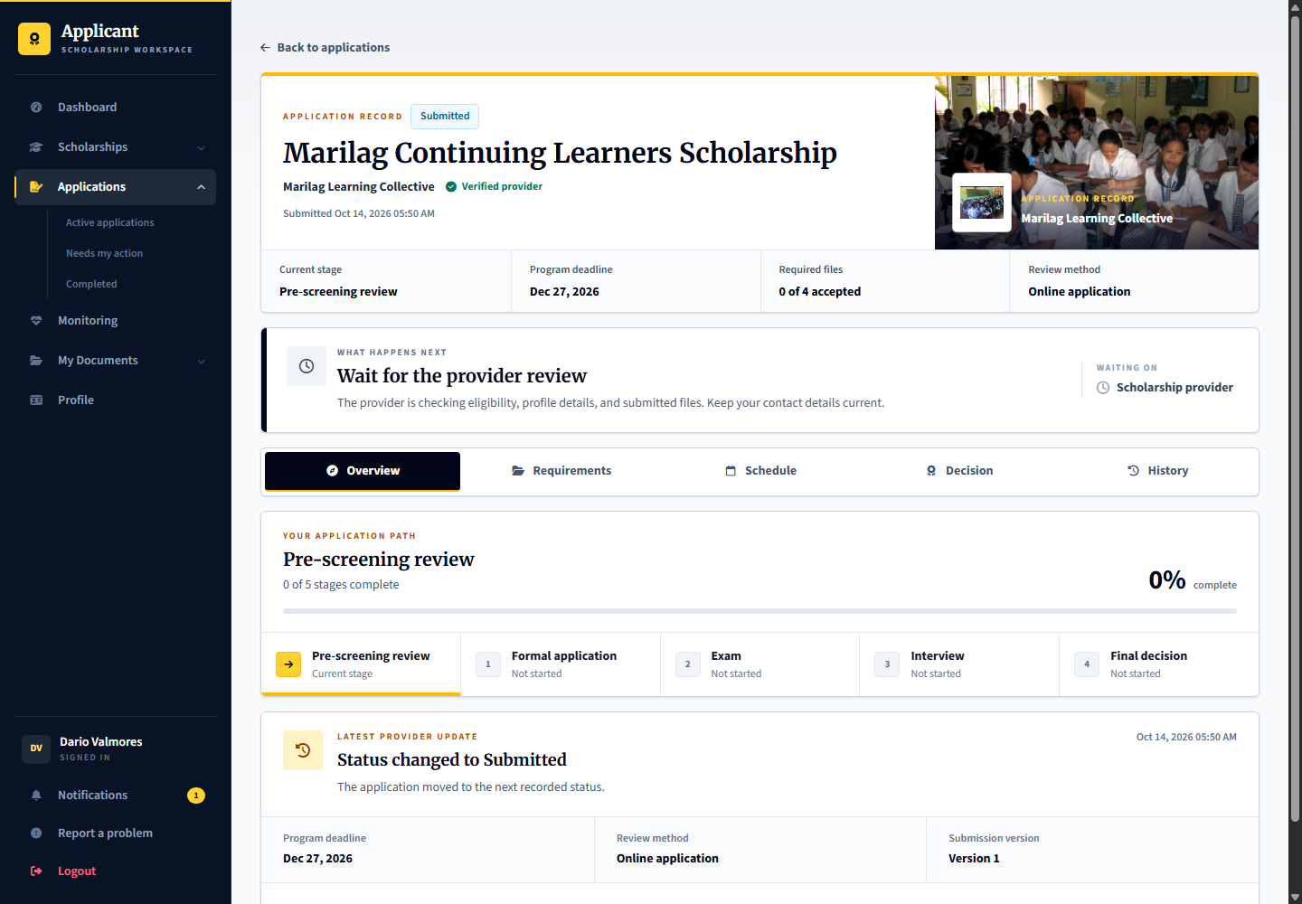
Applicant: follows the next-action guidance and answers correction requests. Provider: marilag.reviewer checks eligibility and submitted documents. Admin: handles platform verification or oversight, not routine scholarship screening.

11 Provider screening and document review
Signed in account: marilag.reviewer
Page shown: Provider screening and document review
The application reviewer works from the assigned queue instead of the manager overview. Review the applicant record, eligibility and document evidence before recording a screening result. Corrections should identify what the applicant must fix.
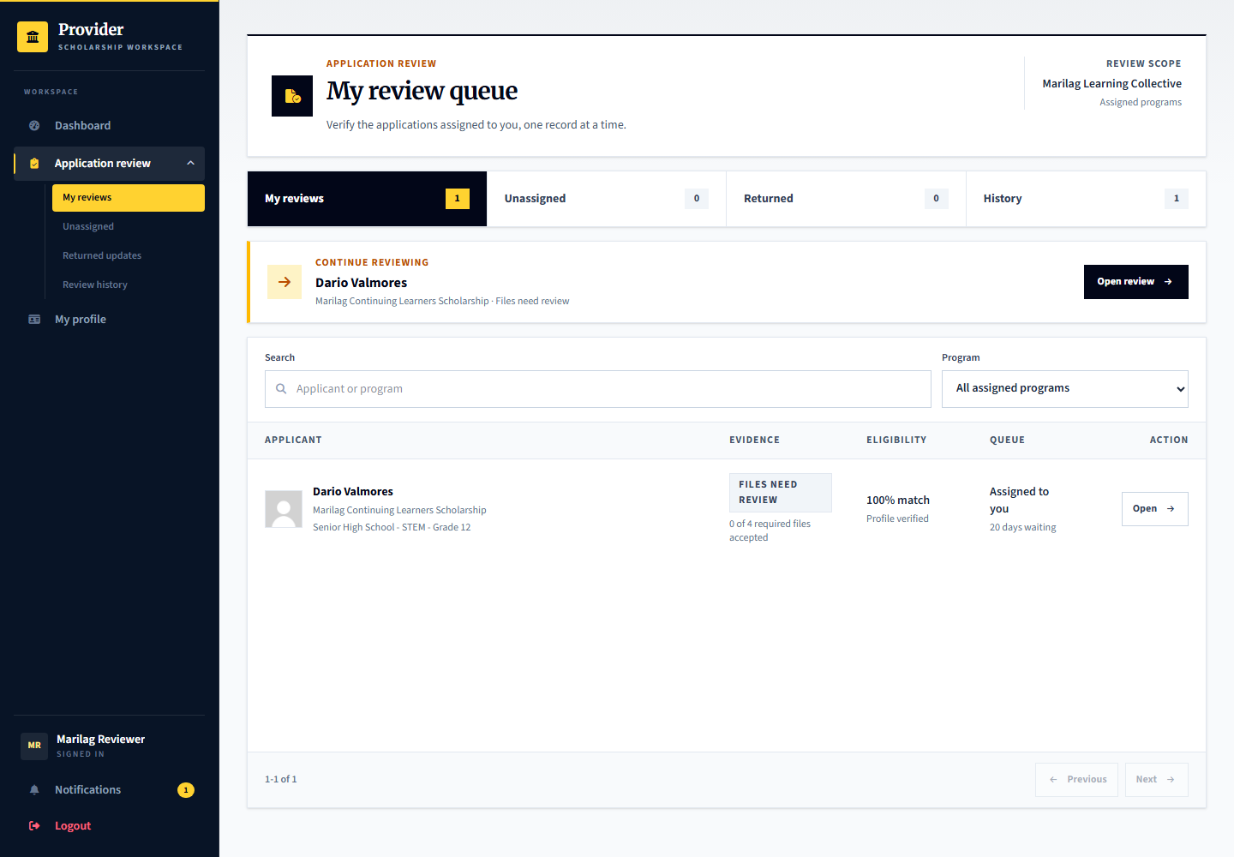
Applicant: learner.screening is the prepared screening record. Provider: marilag.reviewer performs the review. Admin: platform.reviews verifies profile evidence separately; passing screening does not itself award a scholarship.

12 Formal application verification
Signed in account: learner.formal
Page shown: Formal application verification
Formal application is a configured stage for providers that require a further official application or in-person verification. Applicants follow the published instructions and schedule where applicable. A separate session is not always mandatory for this stage.
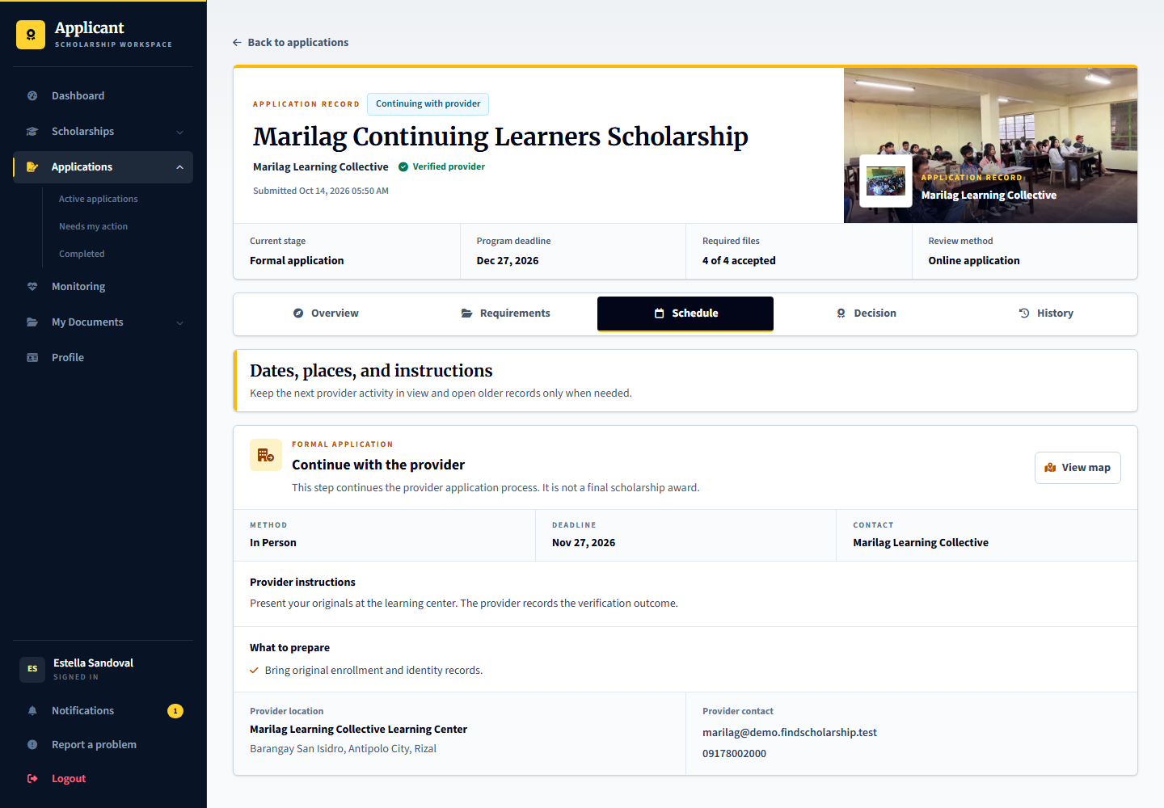
Applicant: learner.formal follows the formal instructions. Provider: marilag.selection records the verification, required proof and result according to the configured stage. Admin: can inspect selection activity evidence through oversight.

13 Examination and interview scheduling
Signed in account: marilag.selection
Page shown: Examination and interview scheduling
The selection officer assigns eligible applicants to sessions. Separate sessions support different dates or venues; online interviews use a meeting link. Session attendance or completion and an individual applicant result are different records.
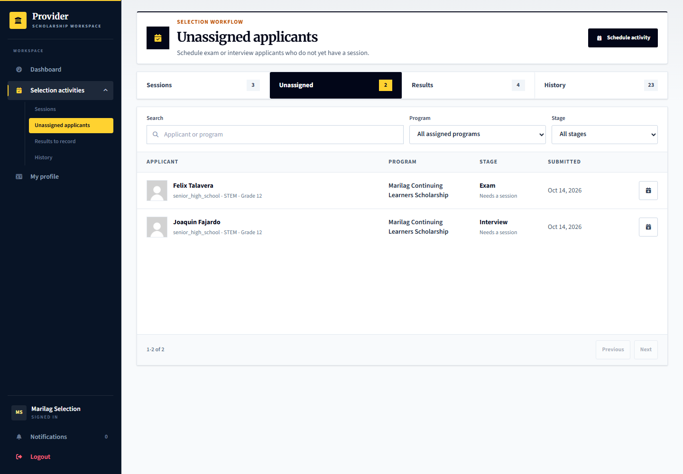
Applicant: learner.exam.assign or learner.interview.assign awaits assignment. Provider: marilag.selection manages sessions and outcomes. Admin: platform.reviews can inspect selection activity records and evidence.

14 Applicant examination schedule
Signed in account: learner.exam.confirm
Page shown: Applicant examination schedule
The applicant reads the assigned examination date, venue, instructions, and acknowledgement action. Other prepared accounts cover completing the conducted session and recording an individual examination result.
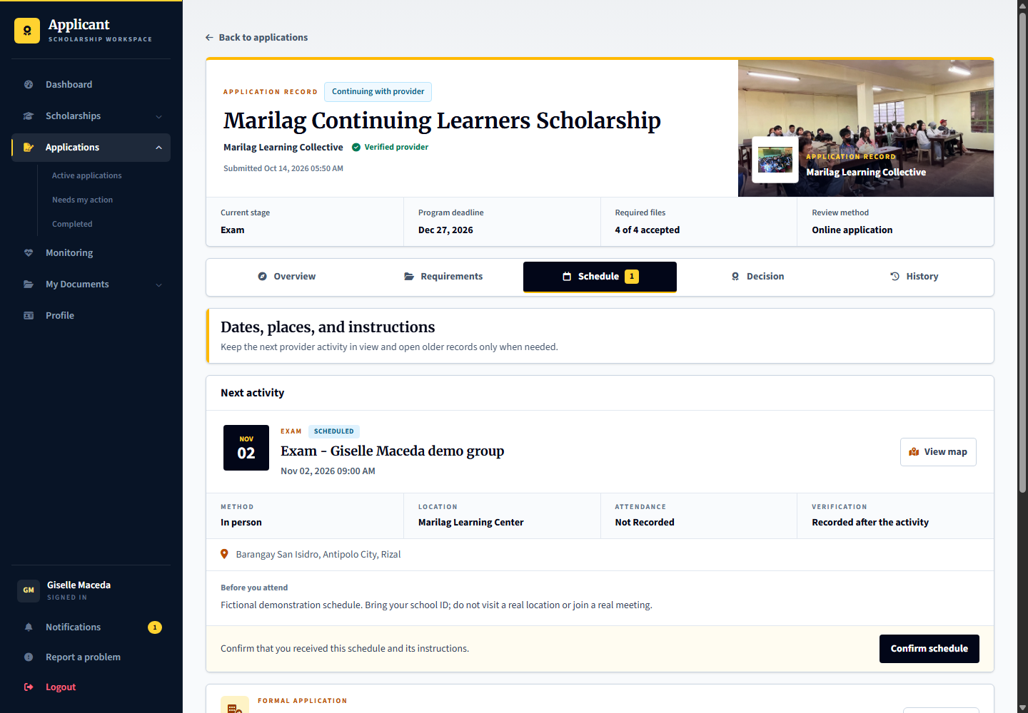
Applicant: learner.exam.confirm acknowledges the schedule. Provider: learner.exam.complete is the session-completion scenario and learner.exam.result awaits a result, both acted on by marilag.selection. Admin: provides oversight rather than taking the examination decision.

15 Applicant interview schedule
Signed in account: learner.interview.confirm
Page shown: Applicant interview schedule
The interview schedule tells the applicant when and how to attend, including the meeting link for an online interview. An applicant acknowledgement does not prove the interview took place.
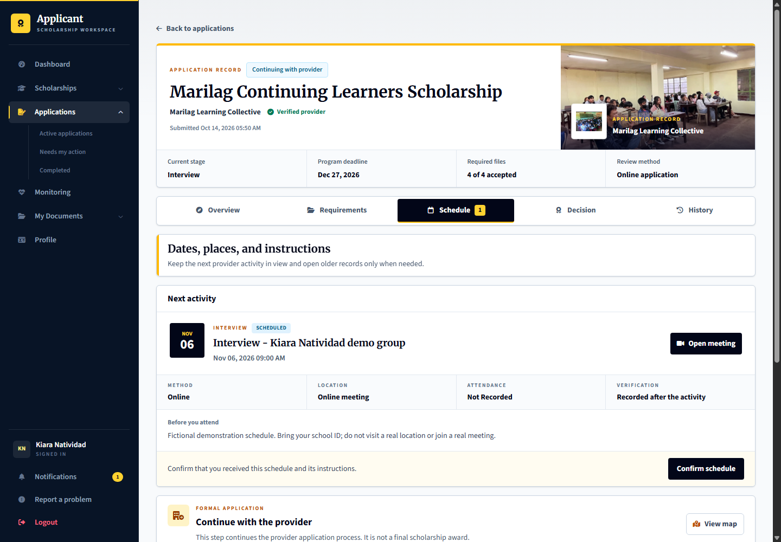
Applicant: learner.interview.confirm acknowledges its schedule. Provider: marilag.selection records attendance, stage proof and the interview result; learner.interview.result is ready for that result. Admin: can inspect supporting activity records.

16 Recording conducted stage results
Signed in account: marilag.selection
Page shown: Recording conducted stage results
The results workspace separates work ready for result recording from scheduling work. Complete the required conducted-session or stage verification and attach proof where required before recording an applicant result.
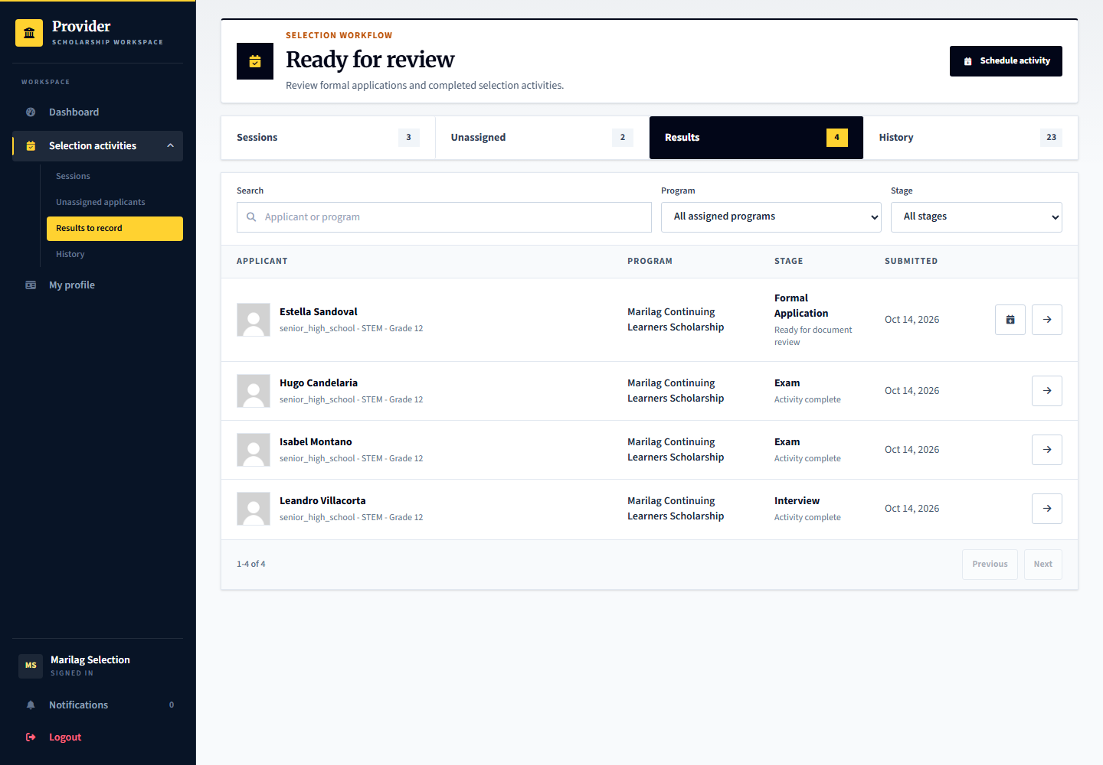
Applicant: sees the recorded result and next stage. Provider: records the evidence-based result and any permitted audited correction, rather than merely marking every applicant complete. Admin: oversight does not replace the provider stage result.

17 Final scholarship decision
Signed in account: marilag.decisions
Page shown: Final scholarship decision
The decision officer reviews applicants who have reached the final stage and records the final selection outcome and notes. Earlier exam or interview success is not a final scholarship award.
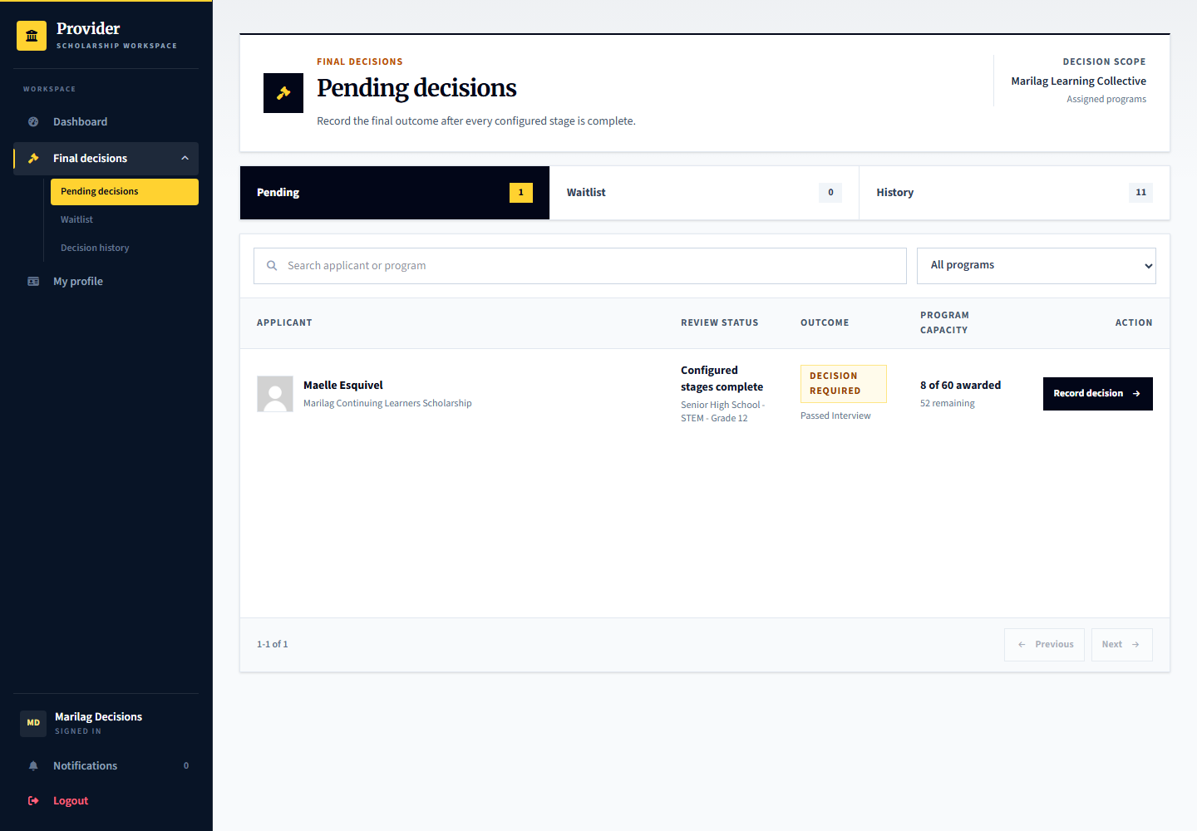
Applicant: learner.decision is ready for this tester-controlled decision. Provider: marilag.decisions records the final outcome. Admin: does not routinely select recipients for the provider.

18 Applicant acceptance of the agreement
Signed in account: learner.agreement
Page shown: Applicant acceptance of the agreement
The selected applicant reviews the actual recipient terms before accepting or declining. Acceptance creates a clear record of the obligations the applicant agreed to; later program edits must not silently replace those accepted terms.
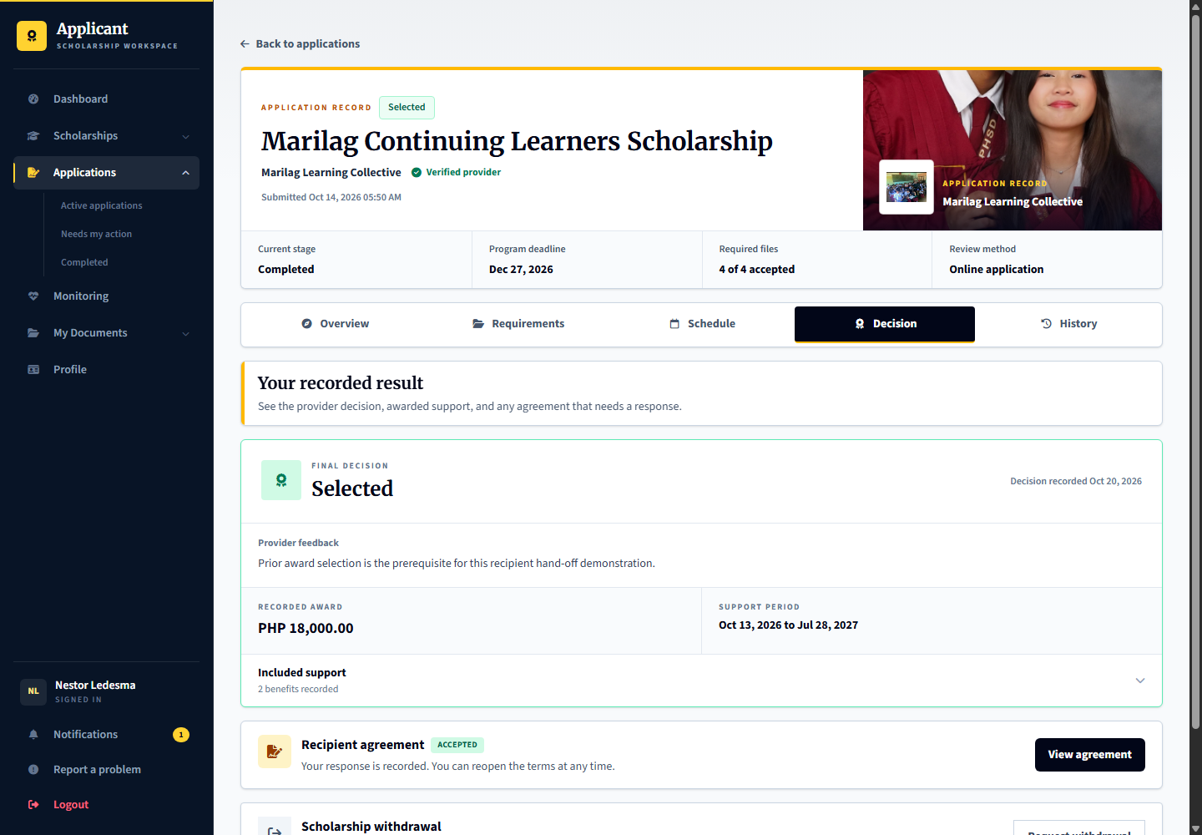
Applicant: learner.agreement is awaiting its agreement response. Provider: marilag.recipients tracks agreement responses. Admin: independent review later uses the accepted source, not an unrelated current program rule.

19 Recipient support and agreement tracking
Signed in account: marilag.recipients
Page shown: Recipient support and agreement tracking
The recipient officer tracks agreement responses and active scholarship support. Formal application, final selection, agreement acceptance and active support are separate process stages.
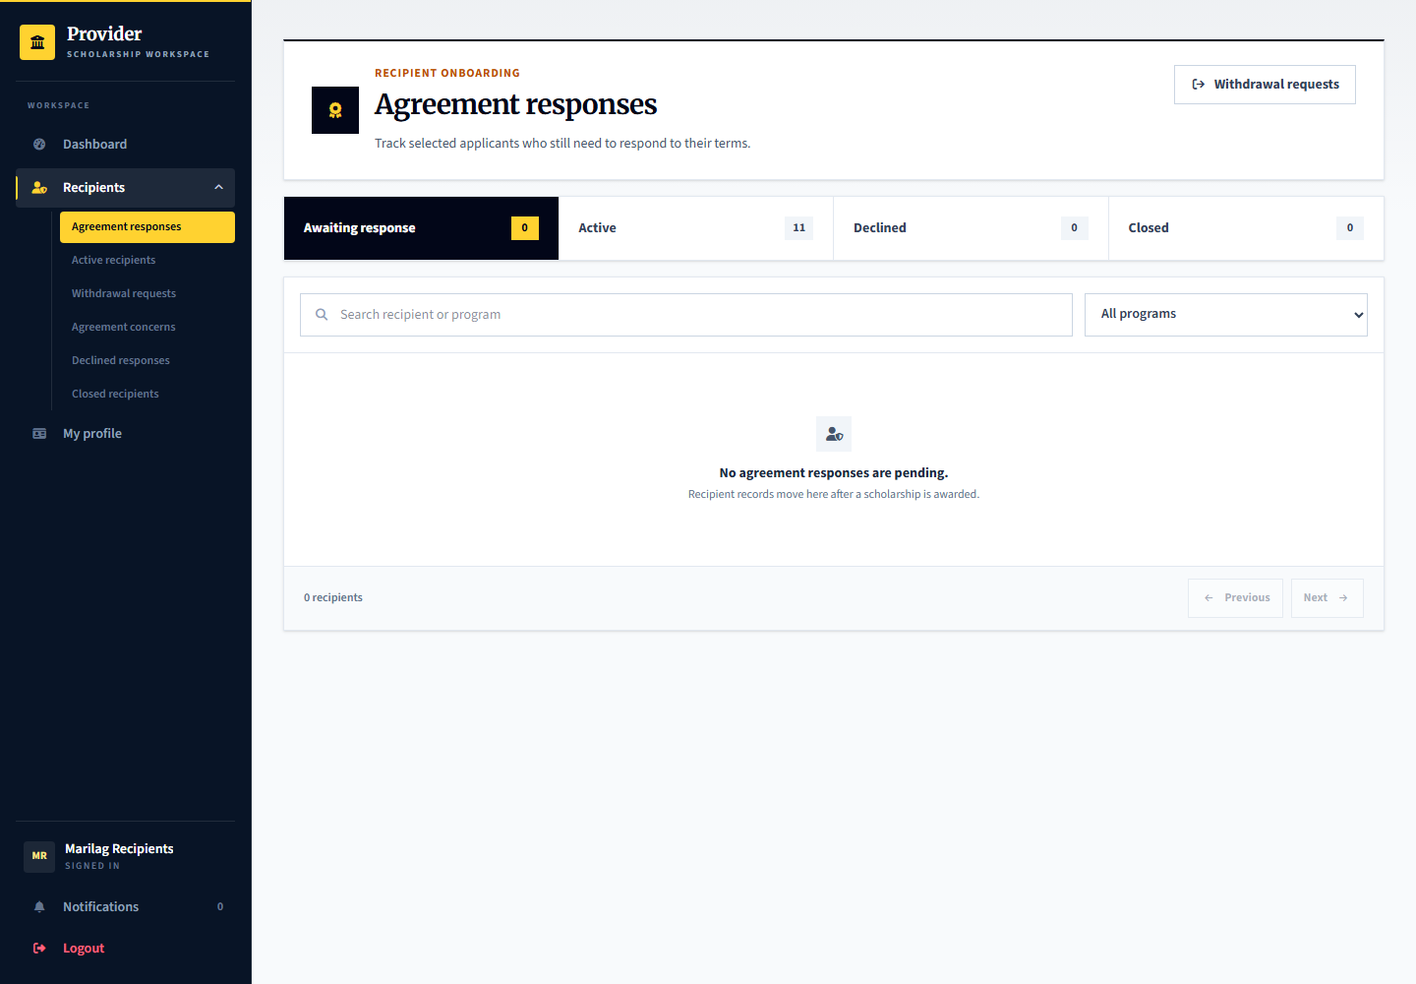
Applicant: responds to the agreement and follows accepted responsibilities. Provider: marilag.recipients manages the support record. Admin: handles independent cases or oversight when required.

20 Applicant monitoring and check in submission
Signed in account: learner.monitoring.upload
Page shown: Applicant monitoring and check in submission
The applicant opens the current check-in, reviews the requirements and deadline, and submits the requested records. Monitoring can cover more than grades when the plan includes enrollment or other agreed requirements.
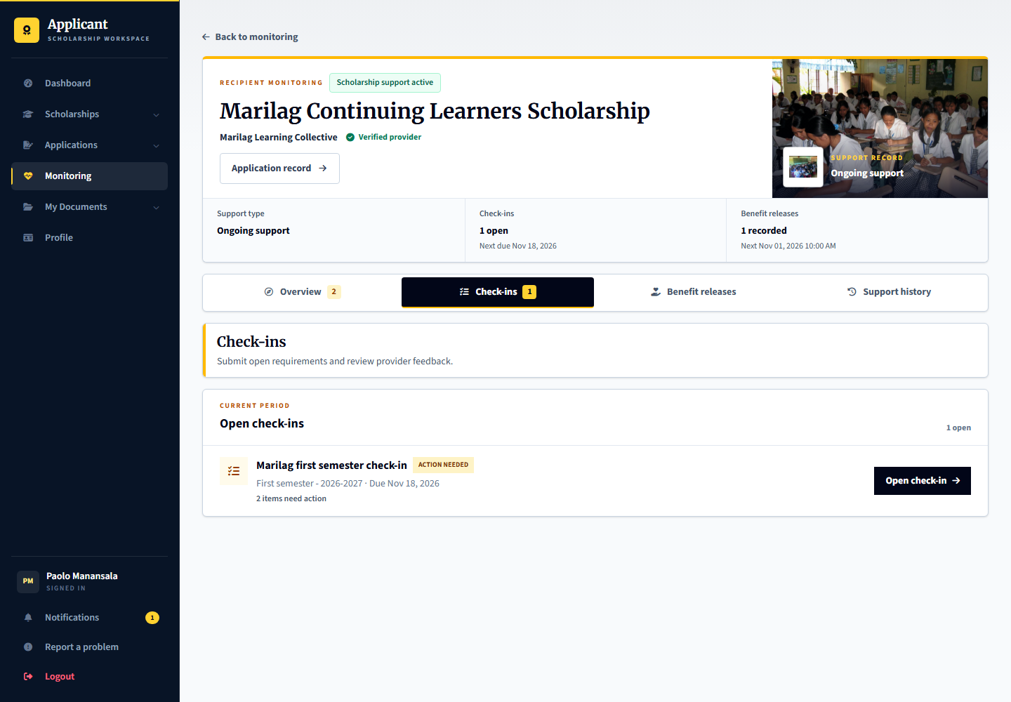
Applicant: learner.monitoring.upload prepares the submission. Provider: marilag.monitoring reviews evidence against the plan. Admin: oversees monitoring records without treating a missing document as an automatic misconduct finding.

21 Provider monitoring evidence review
Signed in account: marilag.monitoring
Page shown: Provider monitoring evidence review
The monitoring officer reviews submitted checklist items, records feedback or requests correction, and handles justified adjustments through the monitoring workflow. Closing a check-in is different from deciding the entire scholarship support outcome.
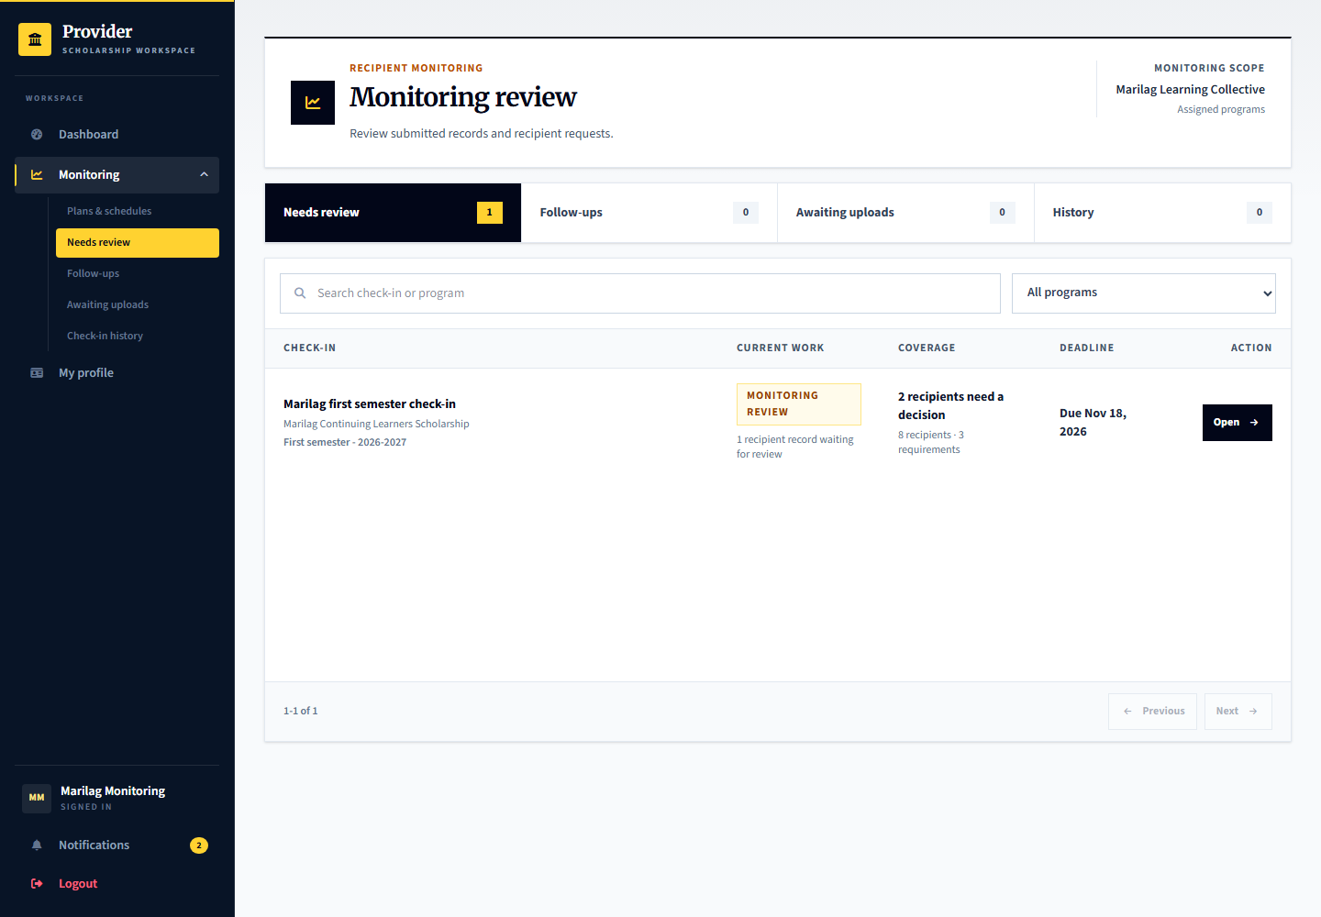
Applicant: learner.monitoring.review has submitted evidence for review. Provider: marilag.monitoring reviews it; learner.monitoring.close is ready for closing the reviewed case. Admin: platform.reviews can perform monitoring oversight.

22 Admin monitoring oversight
Signed in account: platform.reviews
Page shown: Admin monitoring oversight
The review officer can inspect monitoring records and supporting evidence through its own oversight workspace. This is separate from routine provider checklist review.
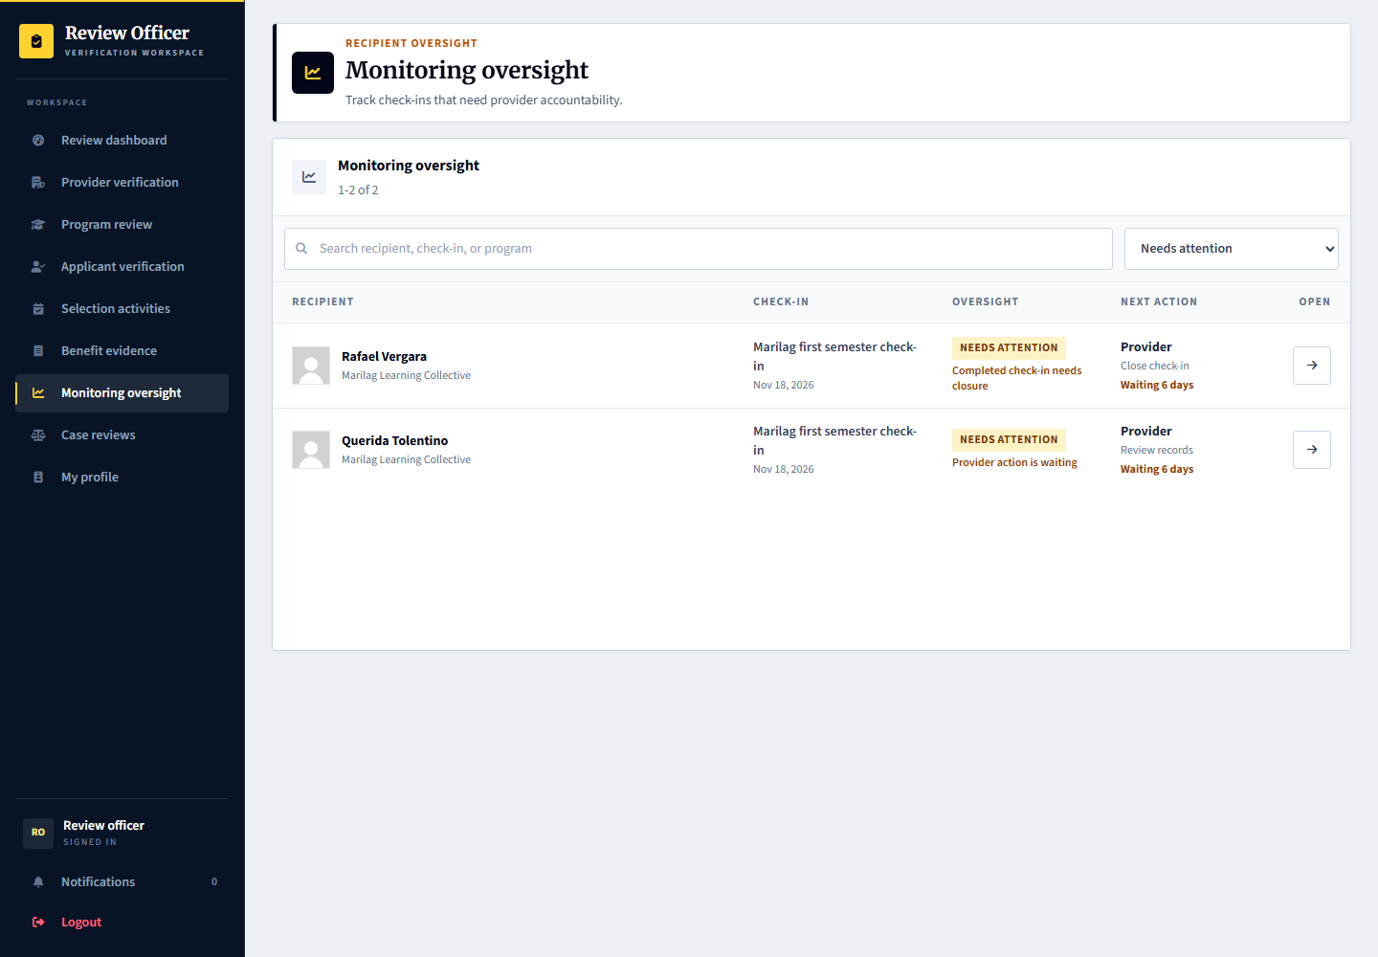
Applicant: supplies the requested evidence. Provider: performs the initial monitoring review and follow-up. Admin: records oversight through the permitted review tools, rather than silently replacing the provider records.

23 Renewal completion and support decisions
Signed in account: marilag.recipients
Page shown: Renewal completion and support decisions
The support record separates renewal, normal completion and ending support early. Sabina Ocampo has an accepted award ready for a tester-controlled support decision. Concern-related early termination is guarded by notice, response, independent review and the appeal opportunity.
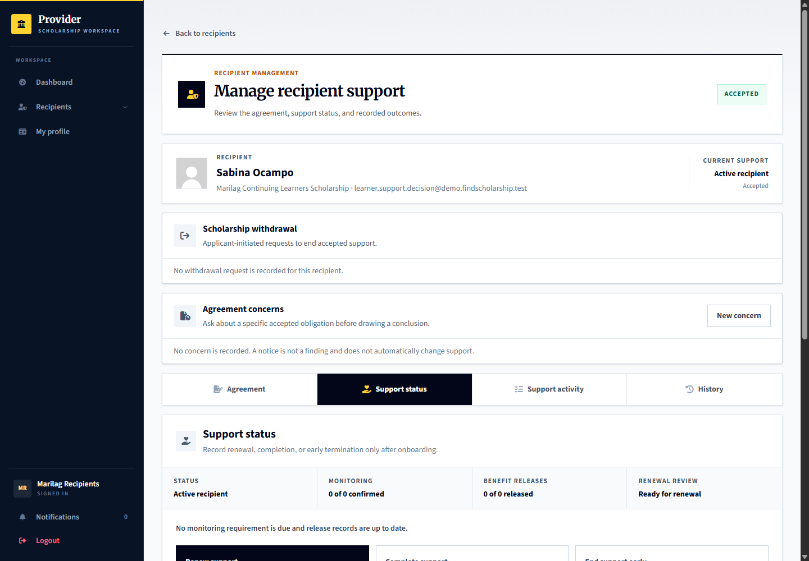
Applicant: learner.support.decision sees recorded notices and outcomes and may use the appropriate response route. Provider: marilag.recipients records a separate support decision. Admin: independently reviews escalated concerns and appeals; no automatic penalty is applied.

24 Planning the first or one time benefit release
Signed in account: marilag.releases
Page shown: Planning the first or one time benefit release
The benefit release officer can schedule the first distribution after the required agreement state without creating recurring monitoring merely to distribute a benefit. One-time awards can use no recurring monitoring policy.
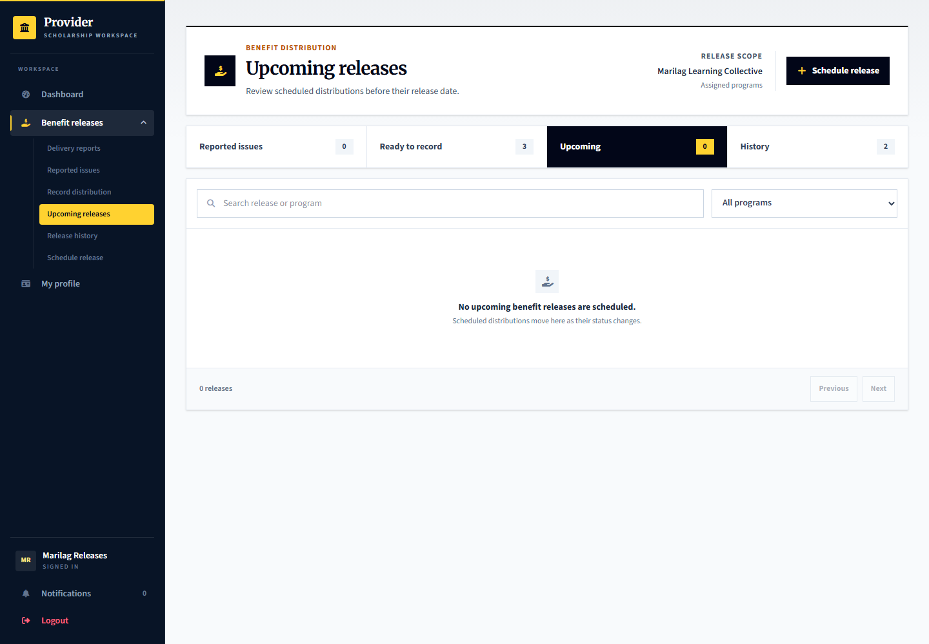
Applicant: learner.release.plan or learner.onetime.plan is ready for planning. Provider: marilag.releases schedules the benefit and instructions. Admin: checks benefit evidence or service payment records in the relevant separate workspace, not a fictitious scholarship transfer.

25 Recording actual benefit distribution
Signed in account: marilag.releases
Page shown: Recording actual benefit distribution
A published release schedule is a plan, not proof of delivery. The release officer records distribution per recipient and attaches the required delivery evidence. Mentoring or other non-cash benefits must also have clear delivery or participation instructions.
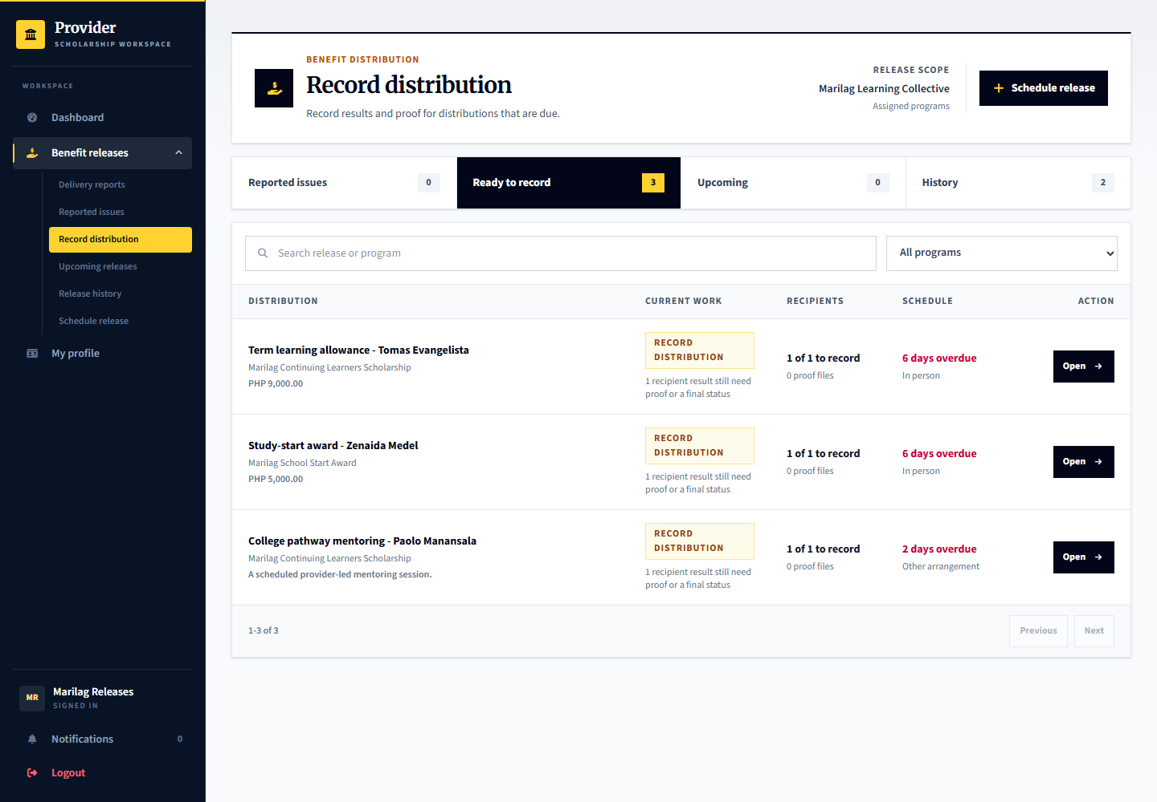
Applicant: learner.release.record and learner.onetime.record await provider distribution recording. Provider: marilag.releases records the distribution. Admin: can inspect benefit evidence; demo payment and benefit records do not prove real transfers.

26 Applicant receipt and delivery reports
Signed in account: learner.release.confirm
Page shown: Applicant receipt and delivery reports
The applicant reviews recorded benefits and confirms actual receipt or reports missing, partial, or unclear delivery. A provider statement or upload alone does not count as the applicant confirming receipt.
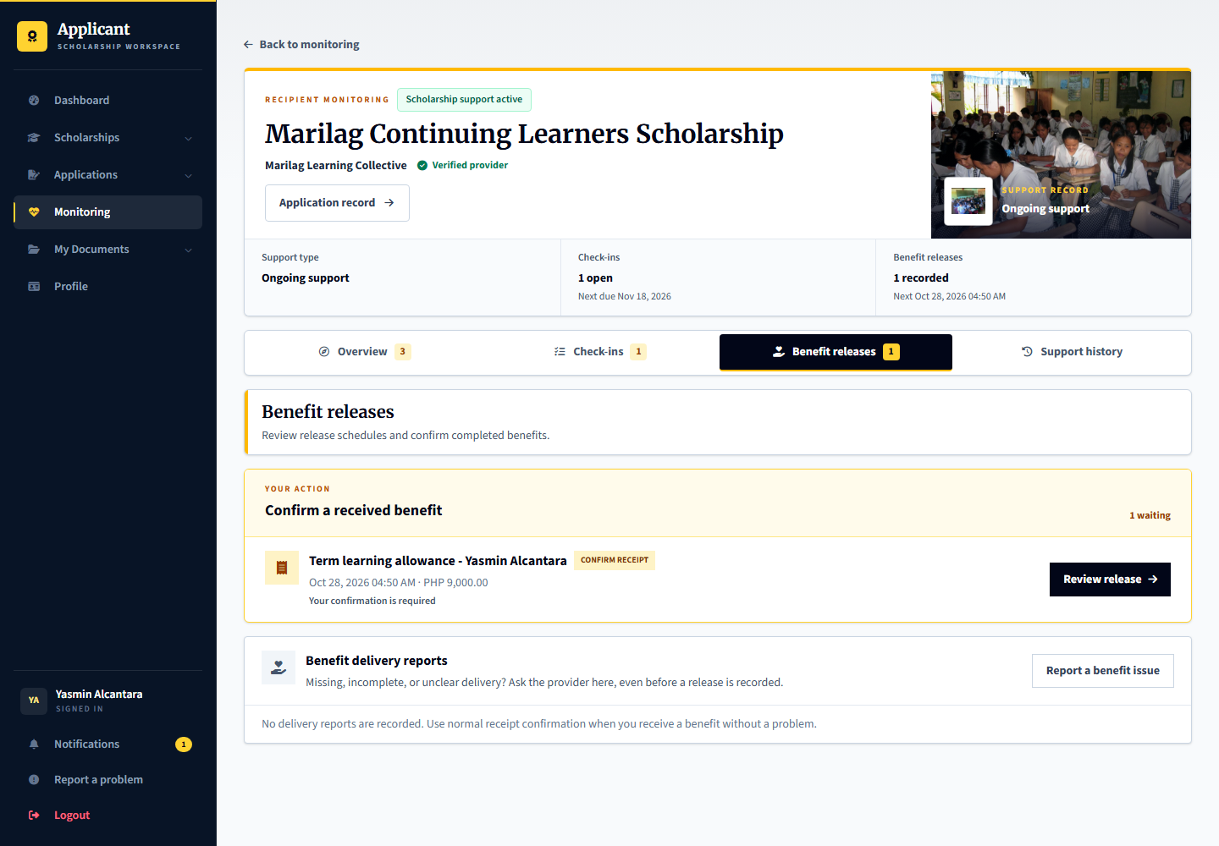
Applicant: learner.release.confirm is the recurring-support example and learner.onetime.confirm the one-time example. Provider: marilag.releases responds to delivery reports and supplies correction proof. Admin: can independently review escalated delivery cases but cannot substitute its finding for receipt confirmation.

27 Recipient withdrawal requests
Signed in account: learner.support.decision
Page shown: Recipient withdrawal section
An accepted recipient can request withdrawal with an explanation. A request does not immediately erase the agreement or decide every support consequence. It is separate from alleging misconduct and from withdrawing an application before award.
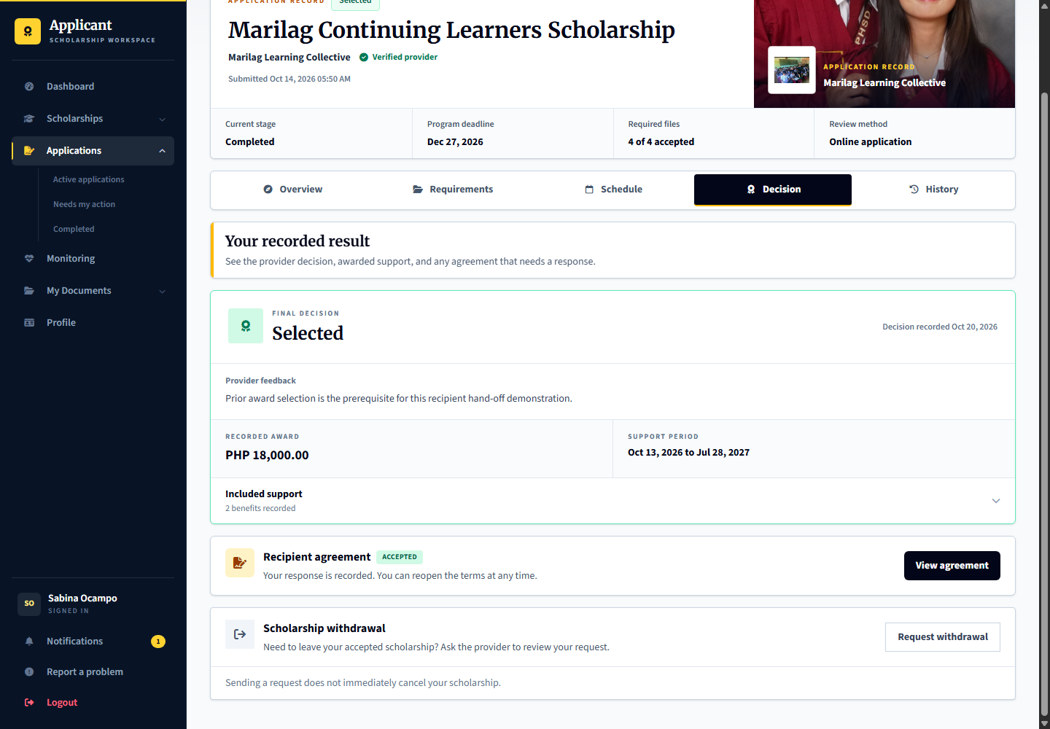
Applicant: learner.support.decision submits or cancels an eligible request. Provider: marilag.recipients reviews it in Withdrawal requests and records the outcome. Admin: handles any appropriate platform support or independent review rather than silently changing the provider decision.

28 Agreement concerns before conclusions
Signed in account: marilag.recipients
Page shown: Agreement concerns before conclusions
Agreement concerns begin as private drafts with a specific accepted obligation, factual explanation and proof. Sending the notice gives the applicant an opportunity to respond; a notice is not a confirmed breach. The live queue starts empty until a tester creates a case.
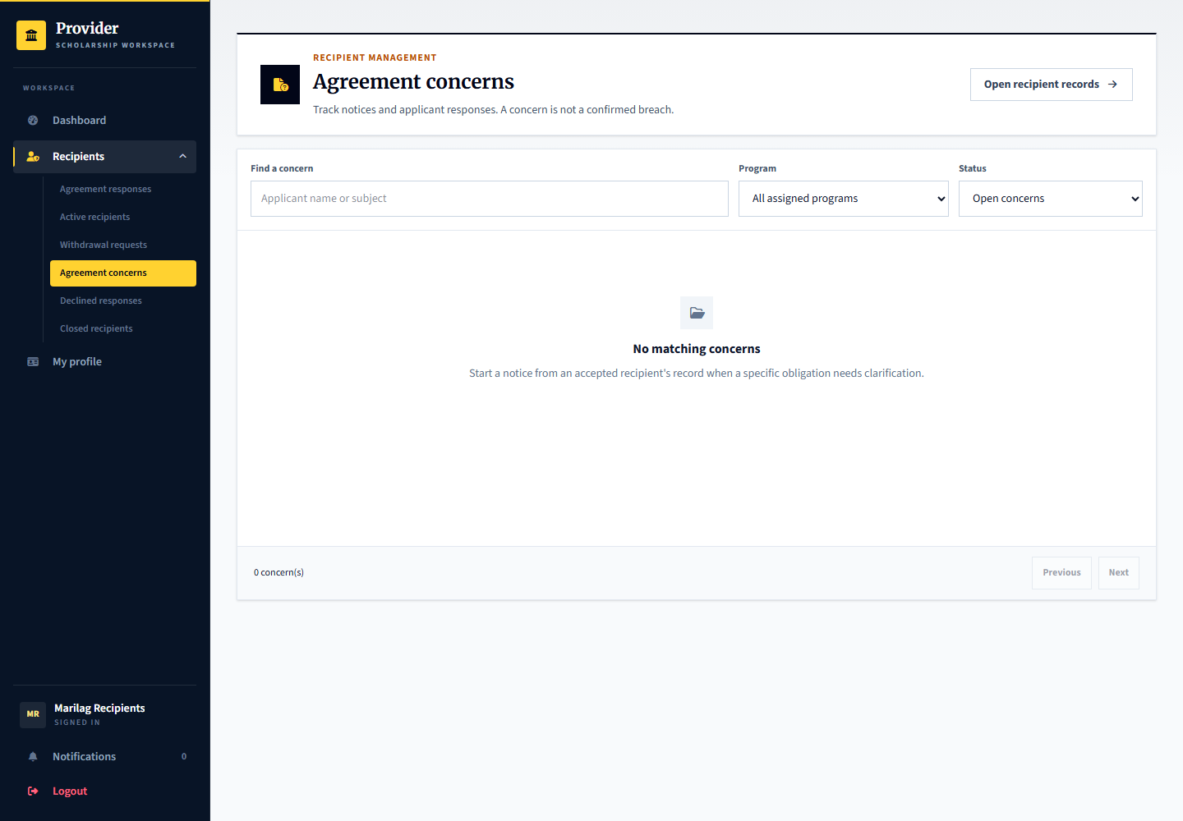
Applicant: learner.support.decision can respond to a concern created for Sabina. Provider: marilag.recipients prepares and issues notices. Admin: platform.reviews receives cases only when independently escalated. No cases were seeded merely to fill this page.

29 Provider delivery investigation and correction
Signed in account: marilag.releases
Page shown: Provider delivery investigation and correction
The release officer responds to missing-benefit reports, requests information or proposes a documented delivery correction. The report stays unresolved until the applicant confirms receipt or gives the appropriate response.
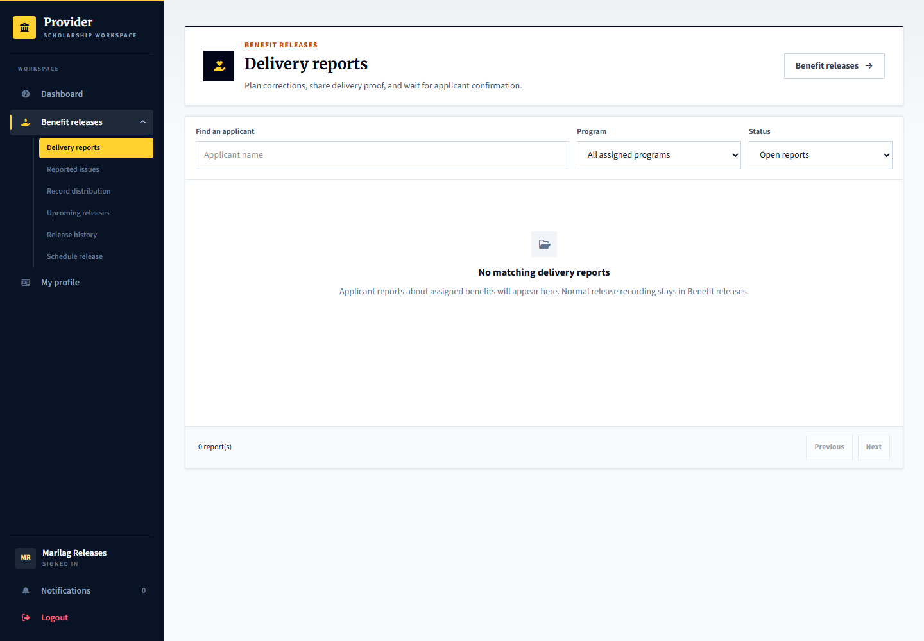
Applicant: learner.release.confirm can report an issue from its benefit page. Provider: marilag.releases investigates and supplies proof. Admin: may recommend follow-up on an escalated delivery review but cannot penalize the applicant for reporting a missing benefit.

30 Independent review appeals and privacy
Signed in account: platform.reviews
Page shown: Independent review appeals and privacy
The admin reviewer examines the accepted obligation or benefit, evidence, statements and response opportunity, then records a reasoned outcome. A different authorized reviewer must decide an appeal of the first reviewers outcome. Privacy and access details are collapsed inside an opened case.
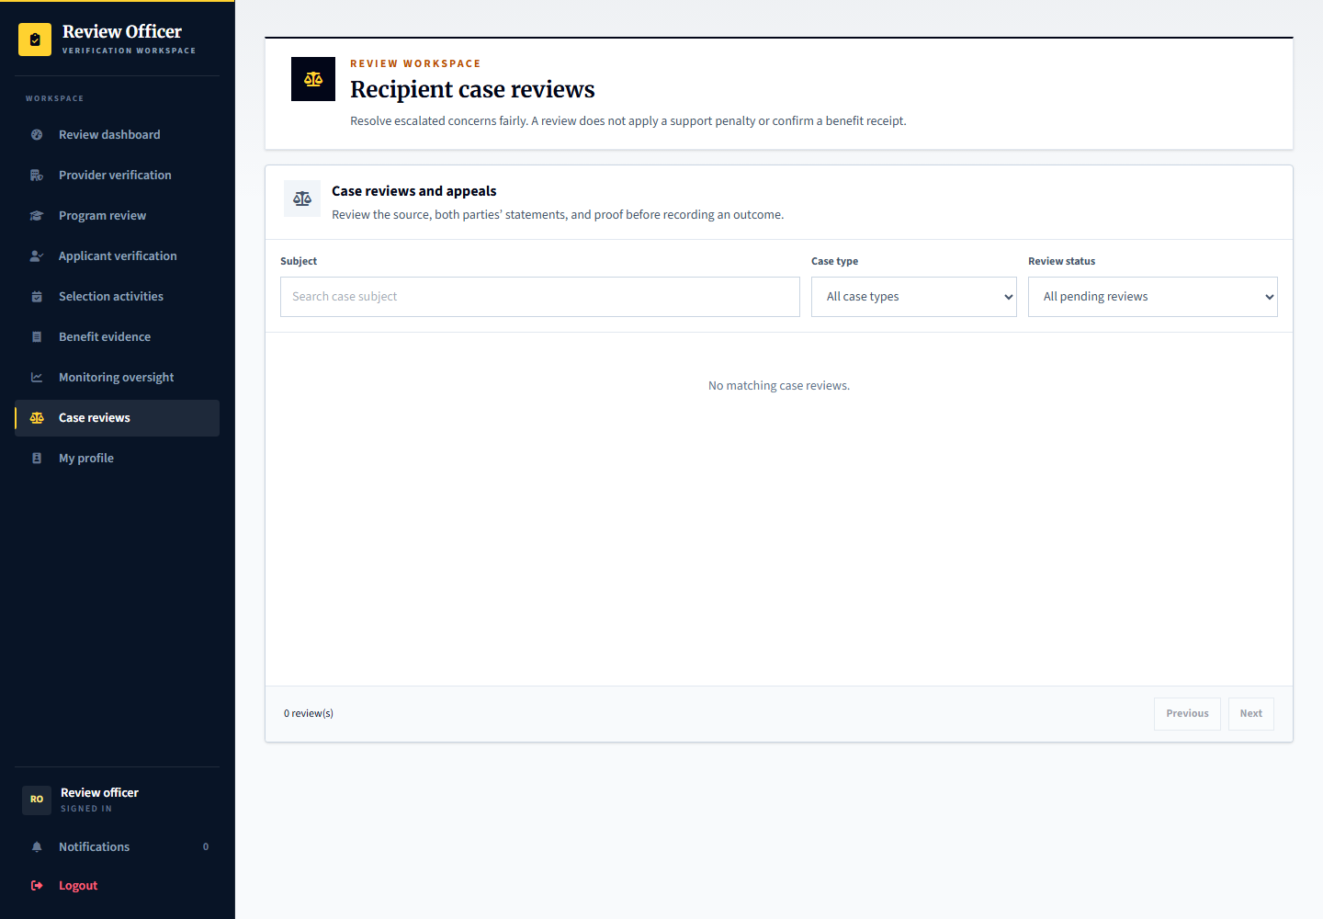
Applicant: may submit information and appeal. Provider: may request independent review but cannot decide its own appeal. Admin: platform.reviews handles the initial case and platform.manager can provide a different authorized reviewer. Cross-provider sharing stays disabled; no blacklist or automatic rejection is created.

31 Provider support and platform reports
Signed in account: marilag.support
Page shown: Provider support and platform reports
Provider support staff handle questions and track replies within their organization. Platform problems and privacy requests can be escalated through the platform support process rather than changing an applicant decision informally.
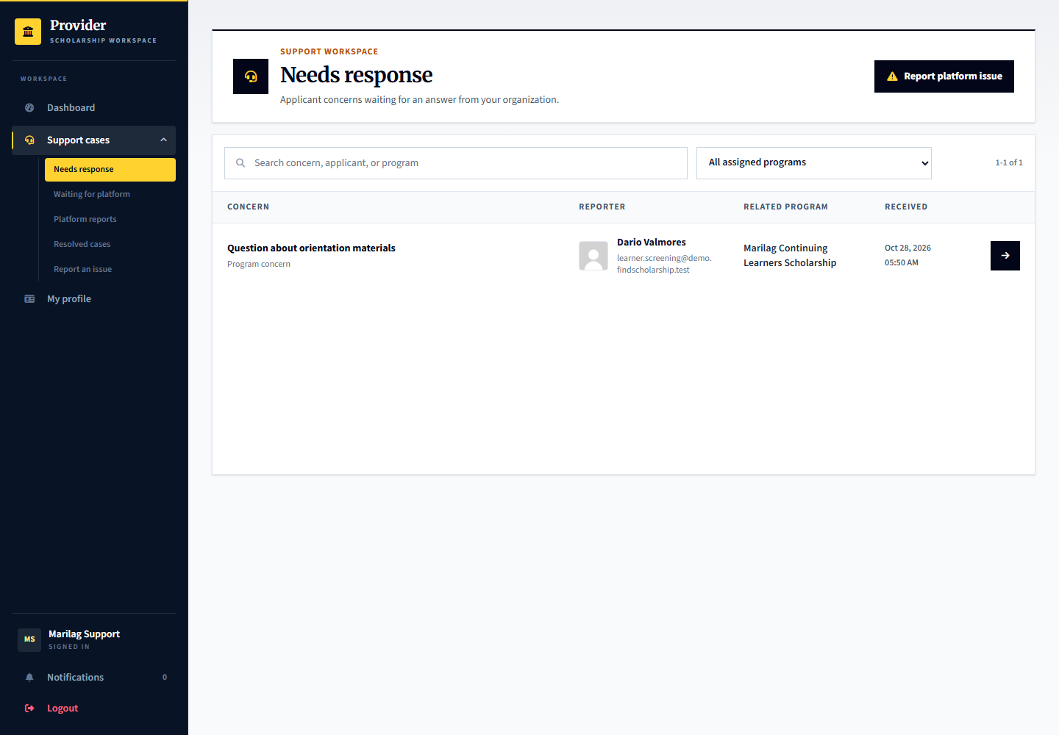
Applicant: uses its permitted help or problem-report entry points. Provider: marilag.support handles its inbox and platform escalations. Admin: platform.support handles platform-level support and privacy follow-up.

32 Admin support case handling
Signed in account: platform.support
Page shown: Admin support case handling
The support officer works from its own response queue and keeps case discussion and resolution recorded. A support reply is not a scholarship selection result, evidence approval or independent misconduct finding.
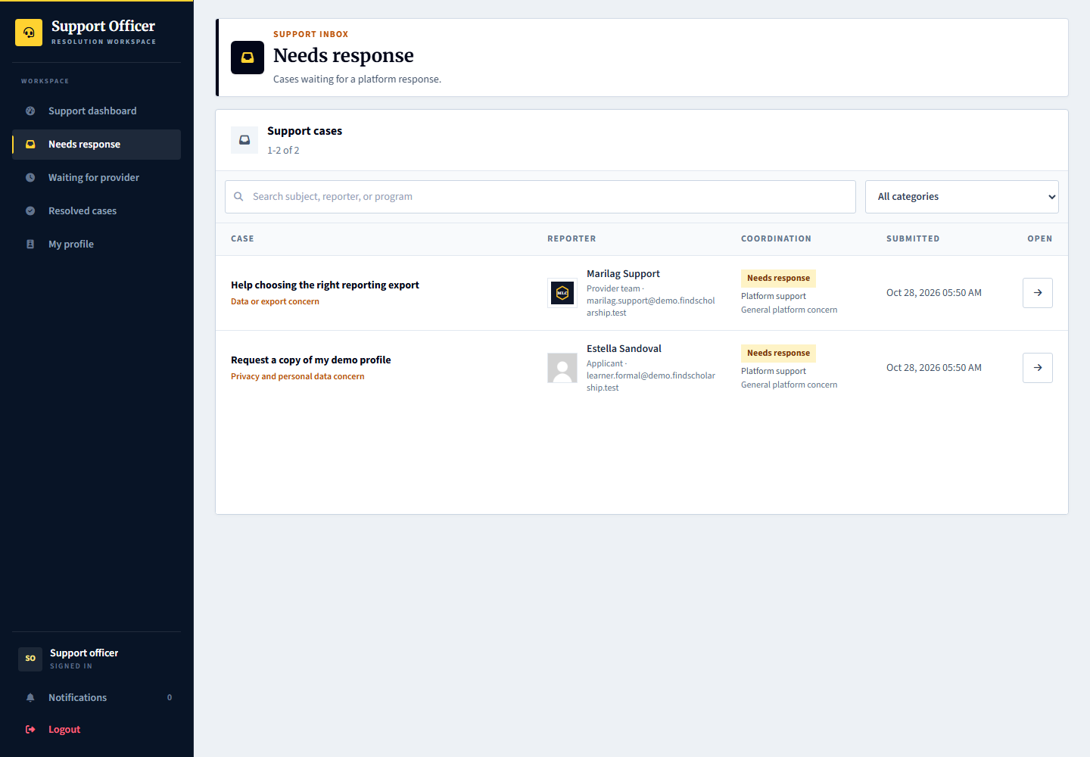
Applicant and provider: supply the relevant facts and respond to requests. Admin: platform.support routes and resolves platform issues using the support workspace.

33 Provider staff and program assignment
Signed in account: marilag.team
Page shown: Provider staff and program assignment
The team administrator manages staff access, role responsibilities and assigned scholarships. Limited program assignment prevents a staff member from automatically working on every program. Newly invited staff complete their first-login setup.
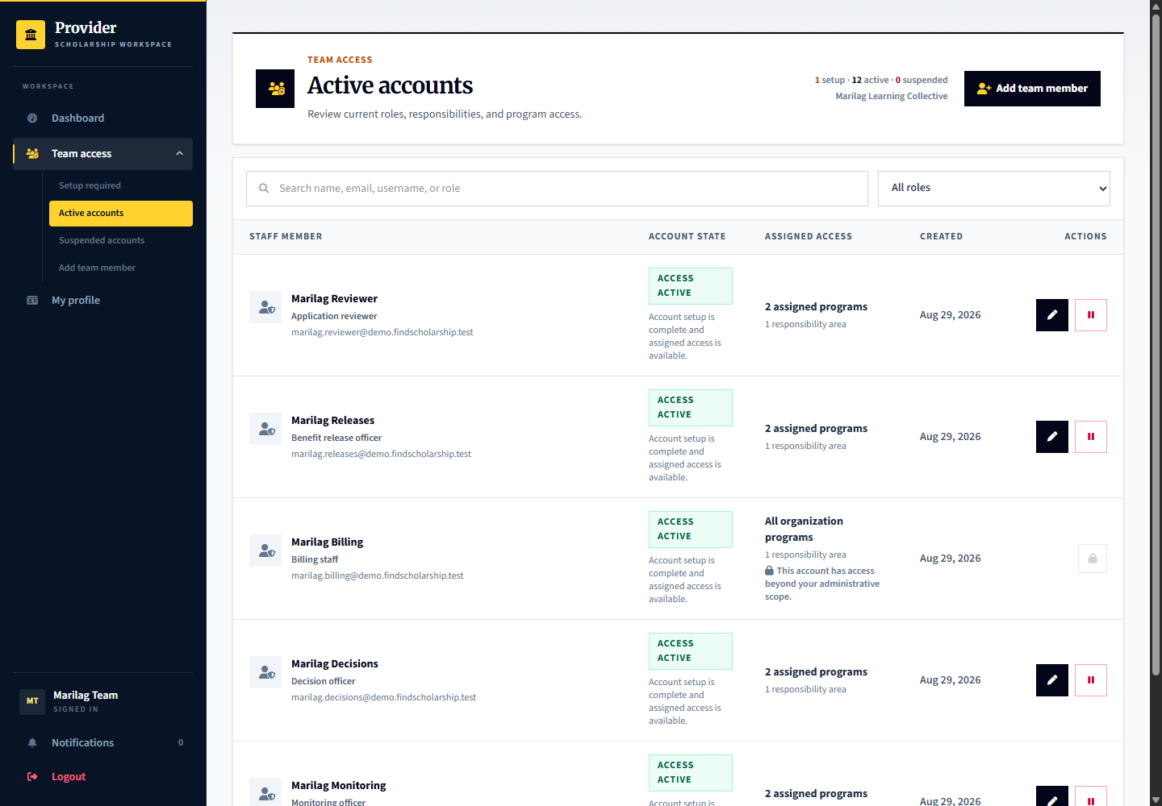
Applicant: has no staff-management access. Provider: marilag.team manages access; marilag.newstaff demonstrates first-login setup. Admin: platform.accounts manages platform account controls separately.

34 Admin account management
Signed in account: platform.accounts
Page shown: Admin account management
The account manager handles account access and managed-account administration in its own workspace. Account access changes should not be confused with profile or provider verification.
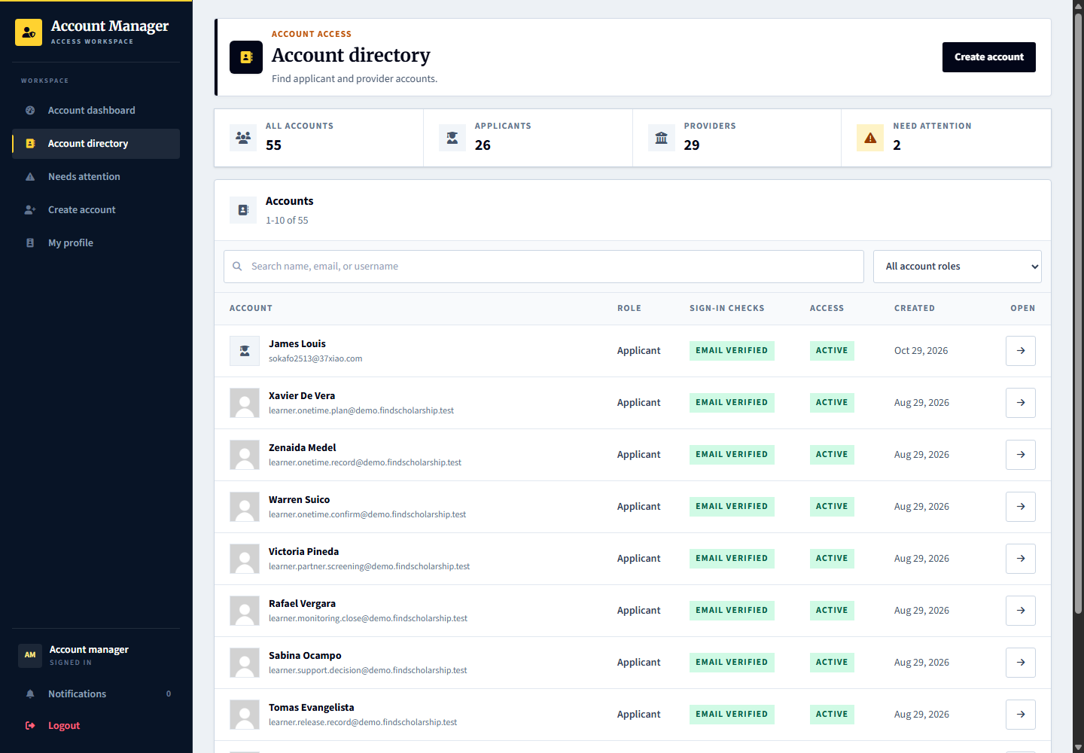
Applicant and provider: use their own profile and account settings. Admin: platform.accounts handles account controls, while platform.reviews performs verification and superadmin handles governance.

35 Provider paid services and requests
Signed in account: marilag.billing
Page shown: Optional support services
The provider billing role reviews available platform services, submits intake information, follows checkout and tracks delivery, files, meetings and acceptance. These are provider-to-platform services, not scholarship payments to applicants.
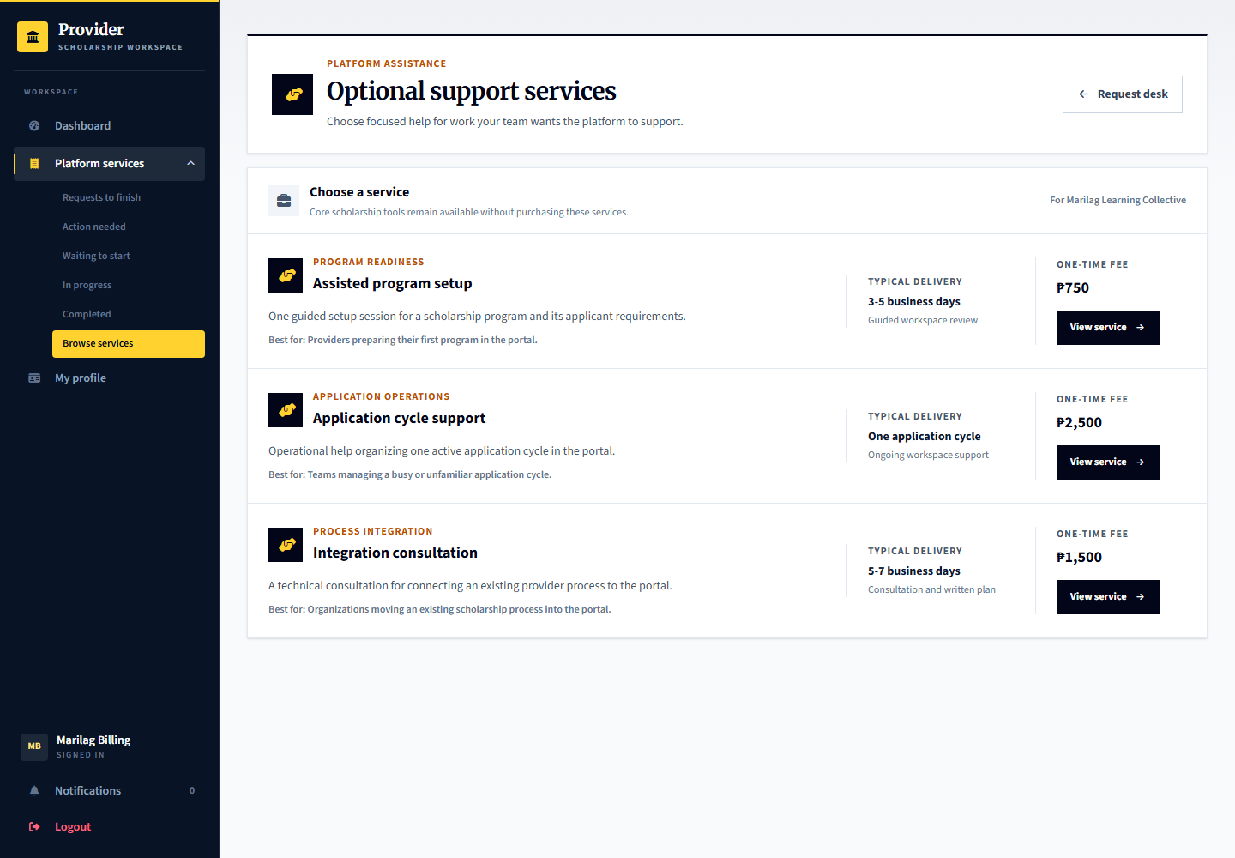
Applicant: is not the purchaser in this workflow. Provider: marilag.billing follows request, payment and delivery steps. Admin: platform.billing processes service delivery; platform.finance reviews financial records. Existing paid demo records are simulated.

36 Admin service intake delivery and closeout
Signed in account: platform.billing
Page shown: Service request dashboard
The billing officer handles the service queue, intake readiness, assignment, delivery work, files and meetings, then closeout or provider acceptance where required. Status changes must reflect the actual step rather than treating checkout as delivered work.
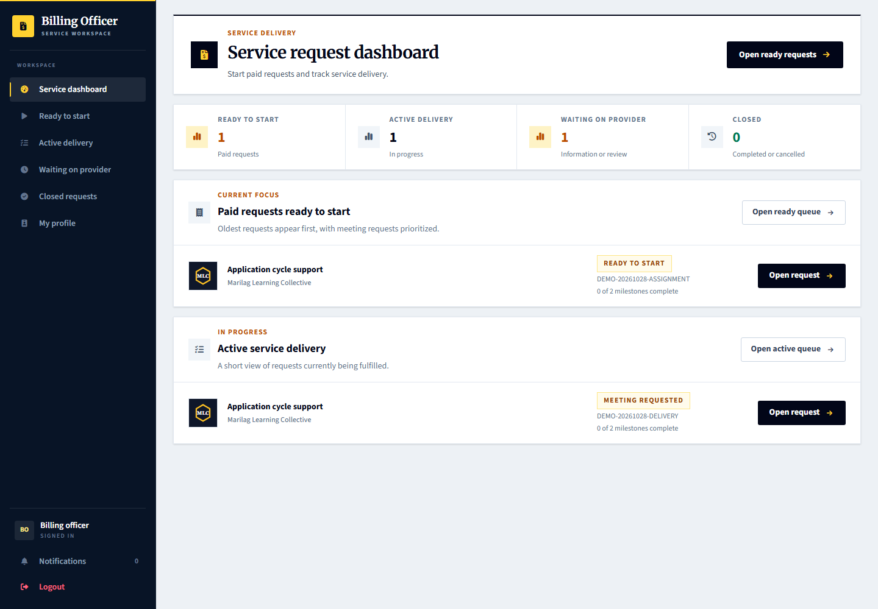
Provider: marilag.billing supplies intake information and reviews delivered work. Admin: platform.billing manages operational delivery. Applicant: no direct role in purchasing these provider services.

37 Admin finance and payment records
Signed in account: platform.finance
Page shown: Confirmed payments
The finance officer reviews payment records, receipts and exceptions in its own workspace. Payment status and service delivery status are separate. Demo paid records do not mean real money was transferred.
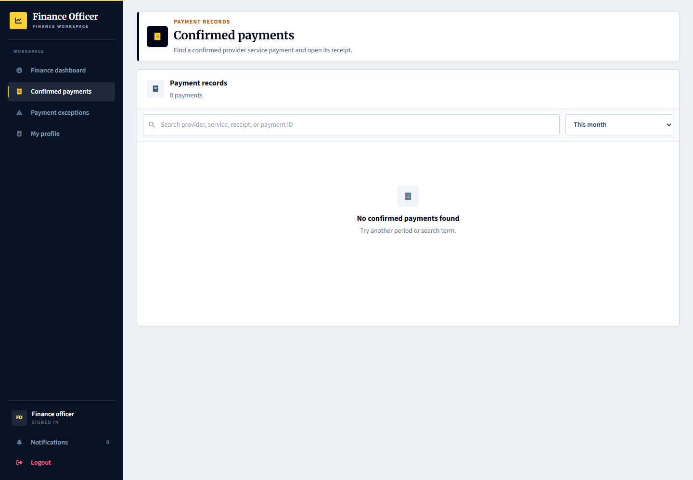
Provider: uses its billing workspace and payment or receipt links. Admin: platform.finance handles finance review; platform.billing handles the service work. Applicant scholarship benefits remain a separate workflow.

38 Admin audit history and exports
Signed in account: platform.records
Page shown: Activity records
The records officer inspects audit activity and permitted exports. Exports and activity records support traceability but are not authority to change scholarship decisions or share private accountability cases with other organizations.
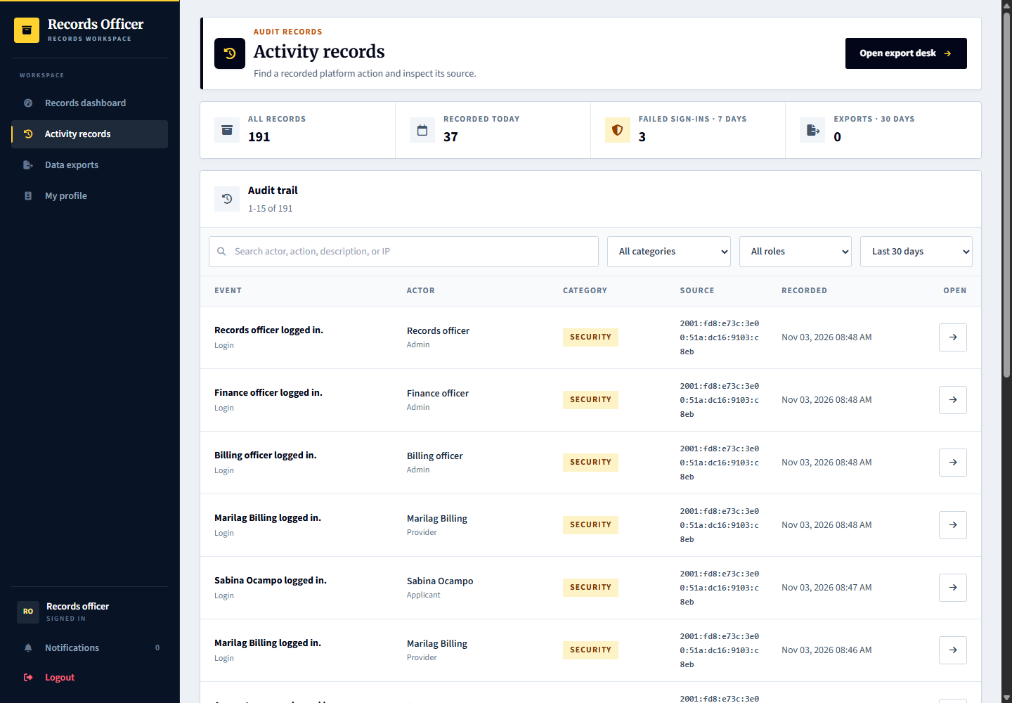
Applicant and provider: see only their permitted histories. Admin: platform.records reviews platform records and exports within its permission scope.

39 Provider manager overview and combined workspaces
Signed in account: marilag.manager
Page shown: Provider dashboard
The provider manager has a cross-workspace overview for its organization rather than a separate new scholarship process. It can move between permitted programs, reviews, selection, decisions, recipients, monitoring and releases. Program assignment and organization boundaries still apply.
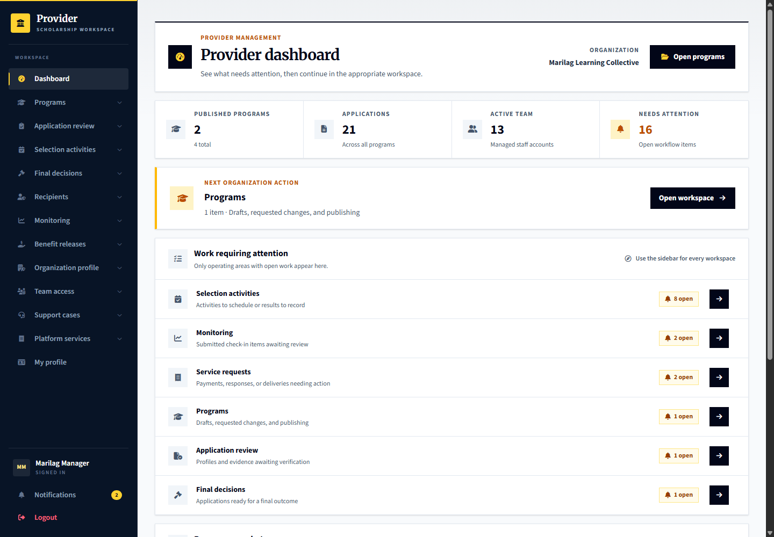
Comparison: operational staff see focused queues; the manager sees the broader organization picture. Having access to multiple workspaces does not remove evidence, notice, agreement, appeal or receipt-confirmation guards.

40 Organization representative view
Signed in account: marilag
Page shown: Provider dashboard
The organization representative is the organization owner account. Its visible navigation and actions follow the current role model; do not assume it is interchangeable with every specialist or the provider manager. Use the named operational account for the process being demonstrated.
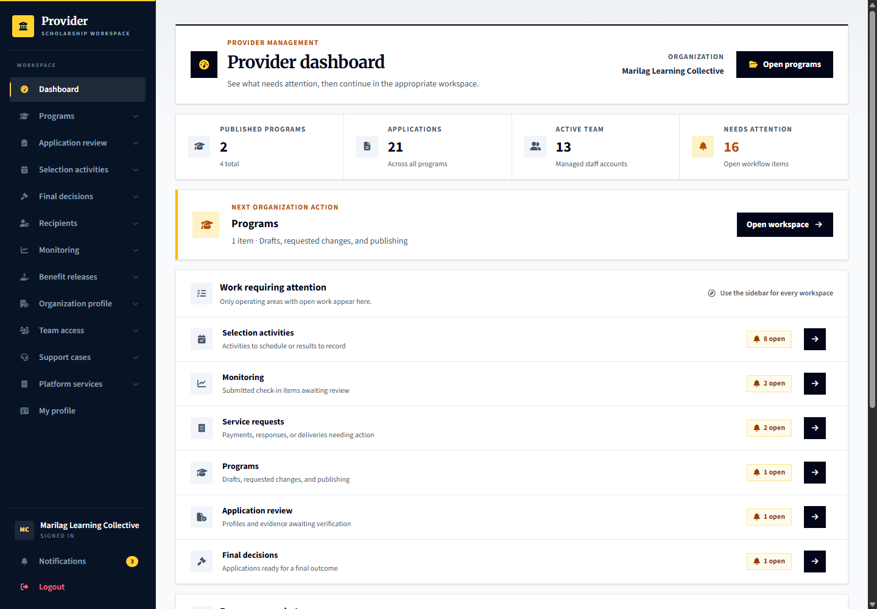
Comparison: the representative is shown here after the specialist workflows so organization ownership is not confused with the day-to-day duty of each role.

41 Portal manager overview
Signed in account: platform.manager
Page shown: Operations overview
The portal manager combines oversight across permitted admin service areas. Its overview helps locate work across accounts, reviews, support, billing, finance and records without treating all operational jobs as superadmin pages.
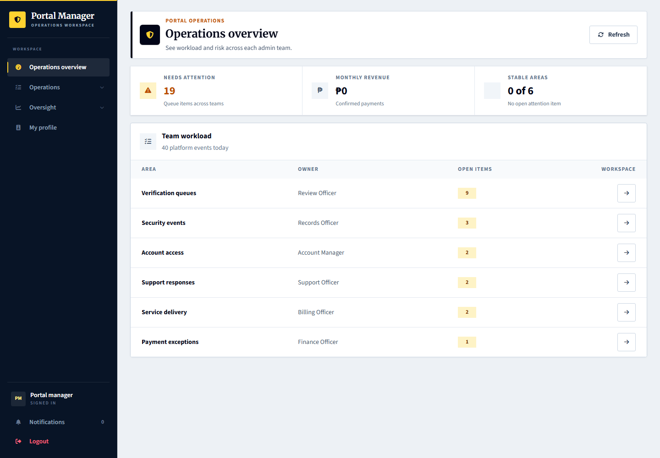
Comparison: specialists have focused workspaces. The manager has broader authorized navigation, but review independence still applies; it cannot decide an appeal of its own prior outcome.

42 Superadmin governance view
Signed in account: superadmin
Page shown: Governance overview
Superadmin focuses on platform governance, admin-team access, platform health and its own profile. It is not the routine account to use for applicant verification, provider screening, examination decisions or benefit distribution.
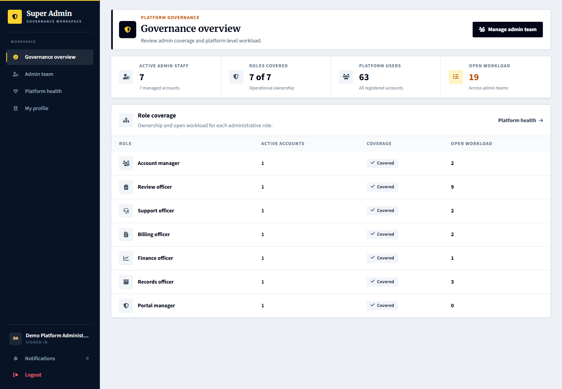
Comparison: demonstrate superadmin last. Use platform.accounts, platform.reviews, platform.support, platform.billing, platform.finance and platform.records for the corresponding operational process.

Demonstration boundaries
Shared demo credentials are unchanged. The demo data is fictional and applicants use neutral profile images. Do not use the demo credentials for a real launch. No financial transfer or successful external email delivery is implied by these screens.
A term-related early support termination requires its separate guarded decision and the appeal opportunity. Do not backdate records or change the clock to bypass it. Independent review and delivery receipt are separate actions. Cross-provider disclosure remains disabled.
Schedule definitions and cleanup command dry-runs were verified on hosting. The Hostinger hPanel scheduler invocation was not directly inspectable through SSH. Empty concern or appeal queues are intentional until the tester creates those cases.

