Platform Process Guide
Applicant provider and admin walkthrough with account labelled screenshots
Expanded edition: the pages following each process now show selected records, review dialogs and action forms with step-by-step instructions. The existing overview pages are retained. Record states can change as the tester proceeds. Locally staged case illustrations are explicitly labelled because those hosted queues are empty.
Profile verification update November 5 2026. Academic results now saves with academic evidence review. Step 2 is only the final profile outcome. Updated review screenshots use platform.reviews; manager oversight uses platform.manager. No review decisions were submitted during capture.
Provider verification update November 5 2026. Organization proof now has individual document reviews before final account verification. These updated screenshots are local platform captures using platform.reviews and dalisay; no demo business decisions were submitted.
Prepared for personal demonstration use on November 3 2026. Screenshots were captured from findscholarship.online using the account named on each page, except the public registration form. No application decisions, case notices, payments or other business actions were submitted while capturing them.
Each process explains who acts, what the screenshot shows, and which role receives the next handoff. A queue screenshot shows where to perform the process, not evidence that every possible outcome has already occurred. Some prepared records intentionally await a tester decision. Manager, representative and superadmin views appear last.

Process index
1. Registration and sign in
2. Applicant profile and supporting evidence
3. Admin applicant verification
4. Provider organization profile
5. Admin provider verification
6. Program creation and publication
7. Admin program review
8. Scholarship discovery and preparation
9. Reusable applicant documents
10. Submitted application and next action
11. Provider screening and document review
12. Formal application verification
13. Examination and interview scheduling
14. Applicant examination schedule
15. Applicant interview schedule
16. Recording conducted stage results
17. Final scholarship decision
18. Applicant acceptance of the agreement
19. Recipient support and agreement tracking
20. Applicant monitoring and check in submission
21. Provider monitoring evidence review
22. Admin monitoring oversight
23. Renewal completion and support decisions
24. Planning the first or one time benefit release
25. Recording actual benefit distribution
26. Applicant receipt and delivery reports
27. Recipient withdrawal requests
28. Agreement concerns before conclusions
29. Provider delivery investigation and correction
30. Independent review appeals and privacy
31. Provider support and platform reports
32. Admin support case handling
33. Provider staff and program assignment
34. Admin account management
35. Provider paid services and requests
36. Admin service intake delivery and closeout
37. Admin finance and payment records
38. Admin audit history and exports
39. Provider manager overview and combined workspaces
40. Organization representative view
41. Portal manager overview
42. Superadmin governance view

1 Registration and sign in
Signed in account: Not signed in
Page shown: Registration form before sign in
A new applicant or provider starts at registration, selects the appropriate account type and supplies the requested identity and contact information. Follow the email verification instructions before continuing. An existing demo account instead signs in using its username or email. The middle initial is optional.
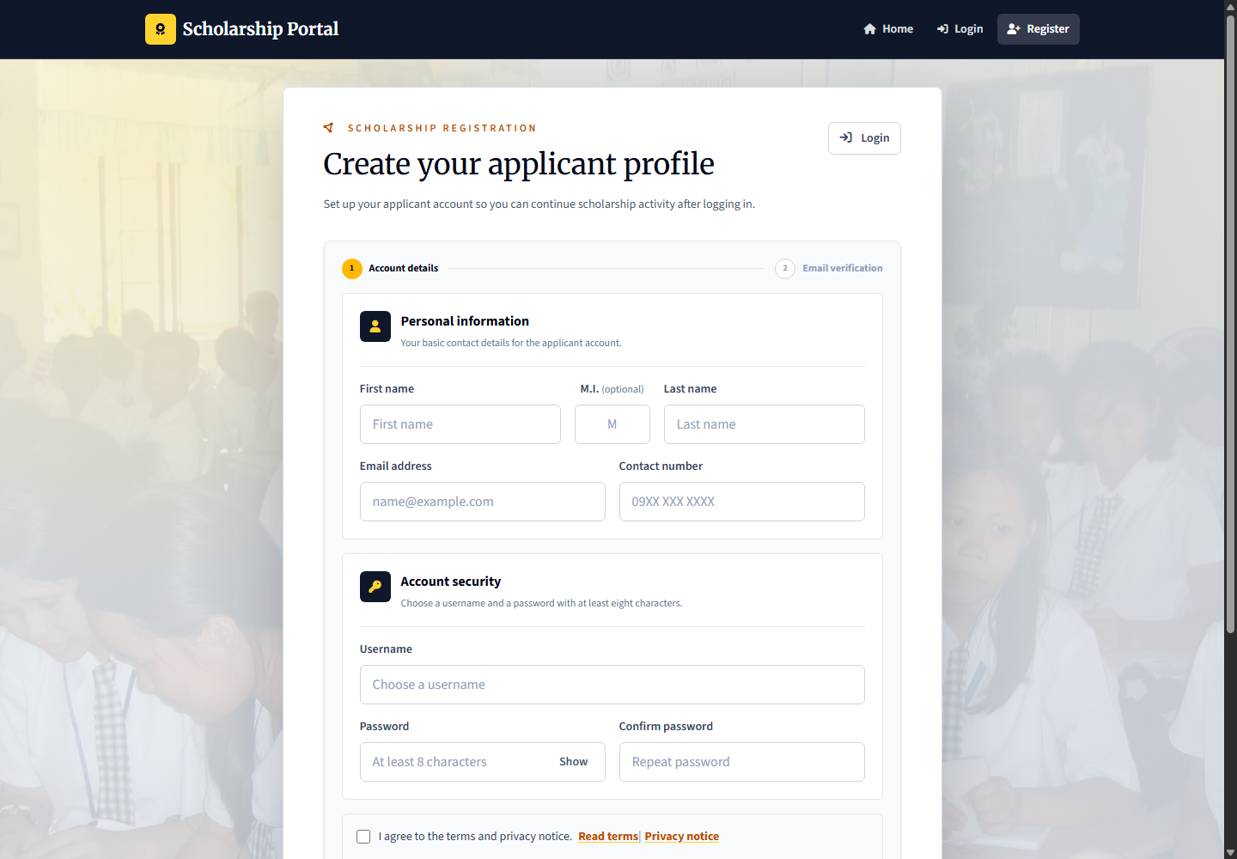
Applicant: registers and completes profile evidence. Provider: registers the organization and submits its verification information. Admin: operational accounts are managed through the authorized admin account workflow; provider and applicant verification are handled by platform.reviews. No new account was registered for this screenshot.

2 Applicant profile and supporting evidence
Signed in account: learner.profile
Page shown: Applicant profile and supporting evidence
The applicant maintains identity, contact, education, household, and location details. Section edit modals keep the applicant on their record. Upload documents that support the profile rather than merely filling the text fields.
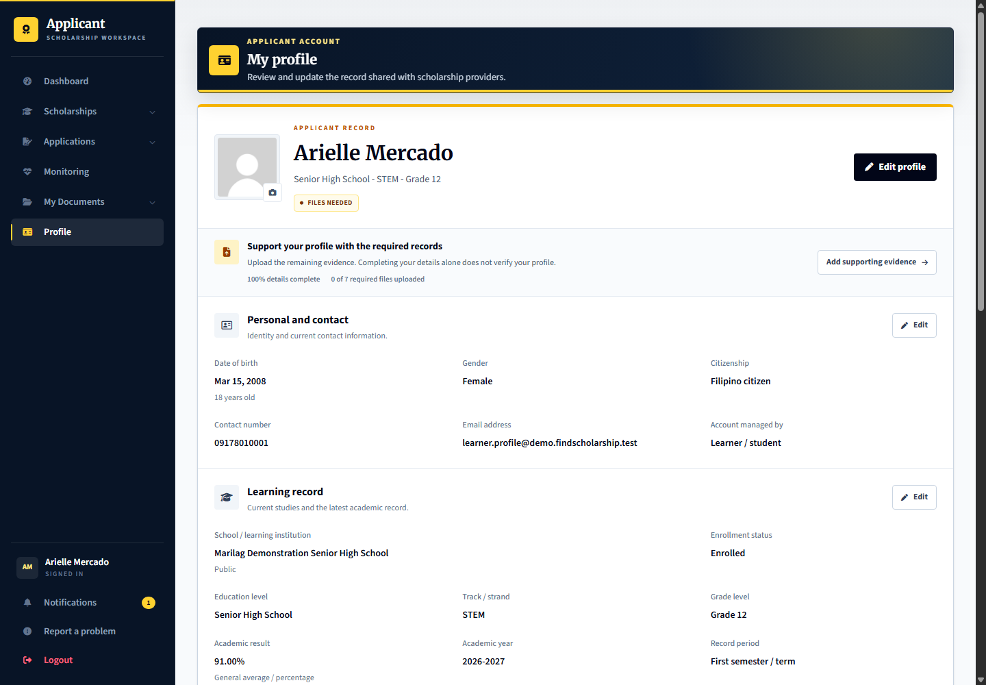
Applicant: complete the record and evidence. Provider: later sees the submitted applicant record and which information is self-declared. Admin: the review officer verifies the profile evidence before the applicant can apply.

Edit the applicant information in its modal
Signed in account: learner.profile
1. Choose Edit beside the personal information section.
2. Update only the details that need correction and check the required fields.
3. Review the changes before Save changes; Cancel leaves the record unchanged.
4. Photo changes can save immediately through the photo controls, so do not replace or remove a photo merely to demonstrate the form.
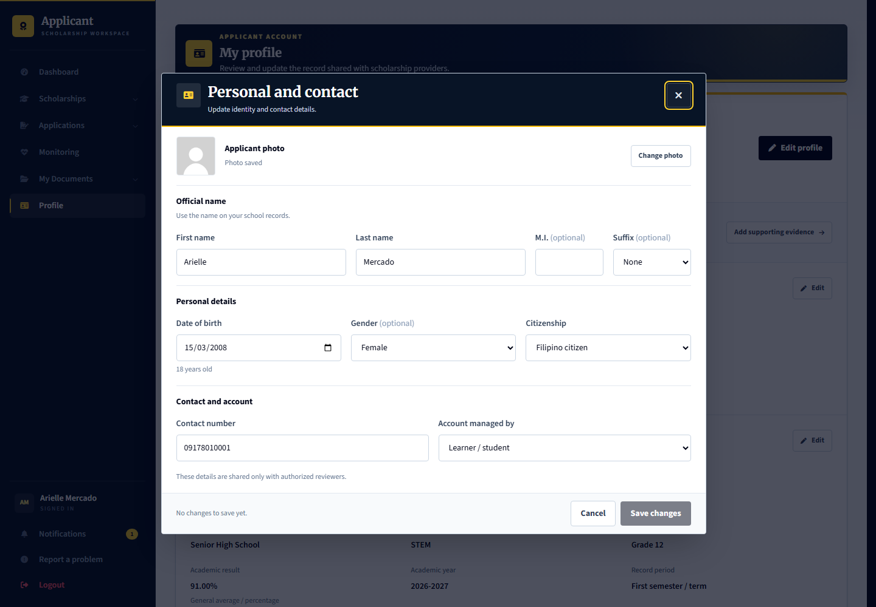
Capture only: no decision, response, upload or account change was submitted. Available actions depend on the role, current record state and completed prerequisites.

3 Admin applicant verification
Signed in account: platform.reviews
Page shown: Admin applicant verification
The review officer checks supporting files first. In the academic record review, Academic results contains the grading scale and verified result; accepting that document saves any correction. Step 2 then records only the overall profile outcome and review note. Accepting evidence does not verify the whole profile or select an applicant for a scholarship. Use learner.verification for this queue and platform.reviews to review it.
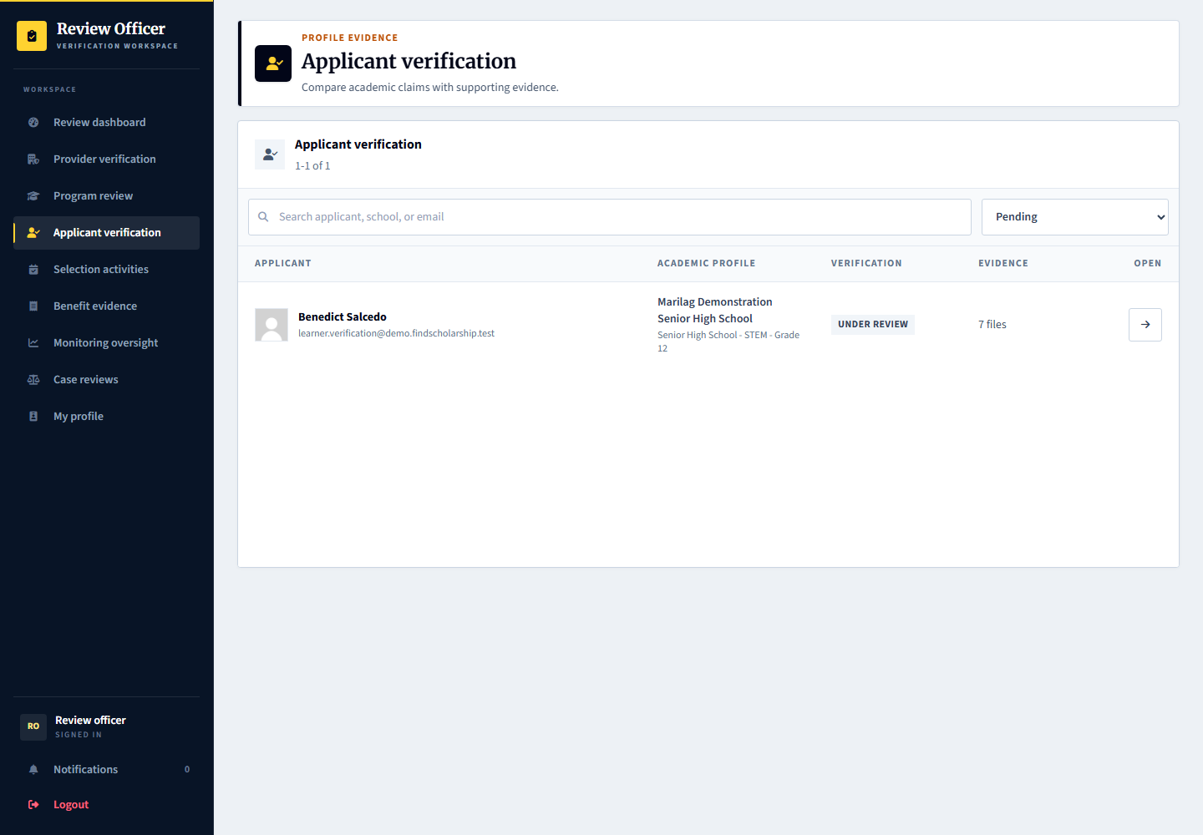
Applicant: learner.verification supplies or corrects evidence. Provider: cannot replace platform profile verification with a scholarship decision. Admin: platform.reviews performs verification; superadmin is not the normal operational reviewer.

Open the applicant verification record
Signed in account: platform.reviews
1. Select Benedict Salcedo from Applicant verification. Confirm the name and account before reviewing.
2. Read the applicant record and expand View complete applicant profile when more context is needed.
3. Go to Supporting evidence and compare each required document with the corresponding declared information.
4. Do not verify the whole profile merely because the applicant has uploaded files.
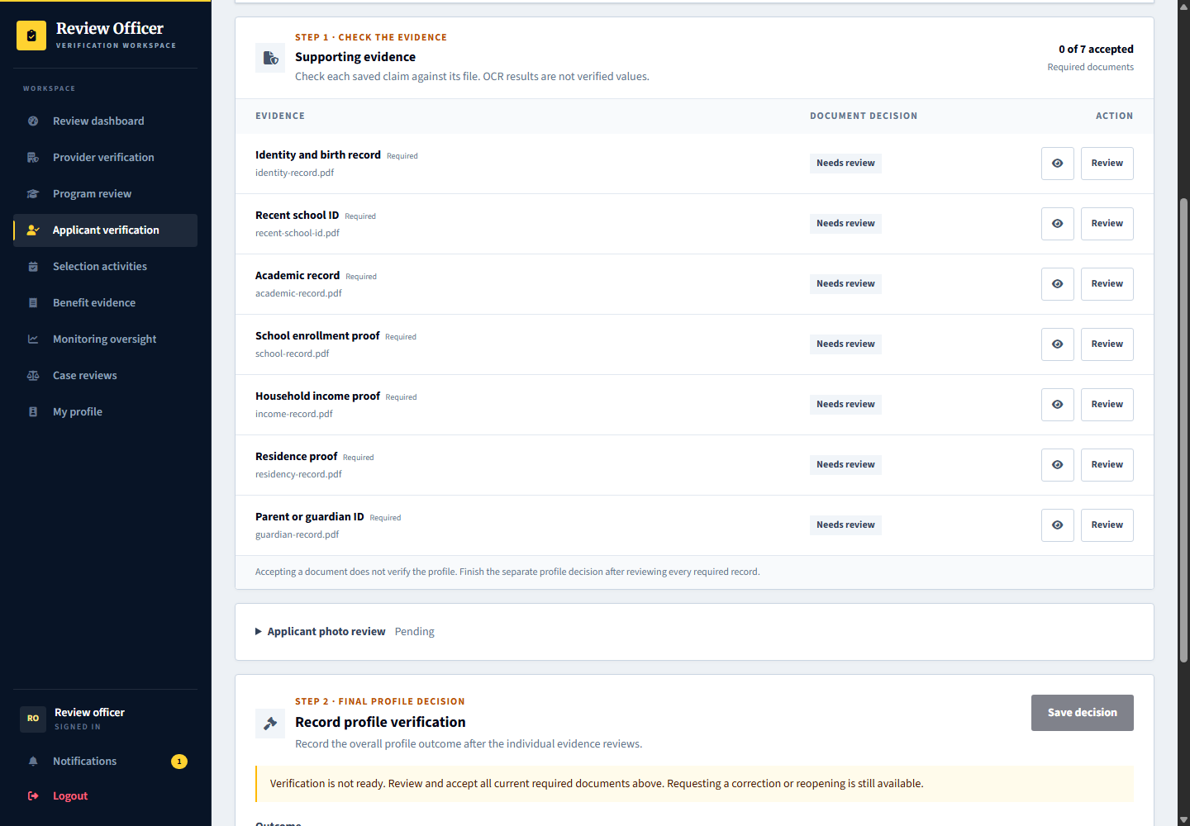
Capture only: no decision, response, upload or account change was submitted. Available actions depend on the role, current record state and completed prerequisites.

Review an individual supporting document
Signed in account: platform.reviews
1. Select Review beside a submitted document to open this evidence-review dialog.
2. Inspect the file and related self-declared profile details. OCR is only a suggestion; use the larger preview if needed.
3. For an academic record, choose Accept document and confirm or correct the grading scale and verified result in Academic results. For an unreadable or unsuitable file, request a replacement and explain why.
4. Acknowledge the comparison, then accept the document to save the academic result and evidence decision together. This leaves overall profile verification pending. The screenshot is an unsaved form.
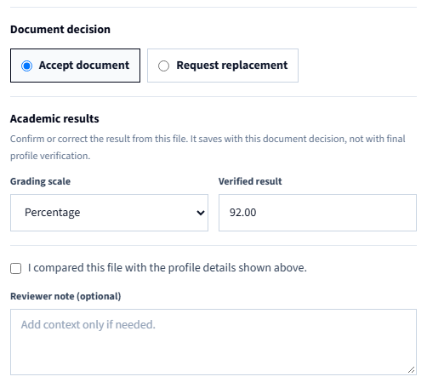
Capture only: no decision, response, upload or account change was submitted. Available actions depend on the role, current record state and completed prerequisites.

Record overall profile verification
Signed in account: platform.reviews
1. Return to the applicant record after reviewing the individual files and photo.
2. At Step 2 Final profile decision, confirm that all current required evidence is accepted. Grades were already reviewed in Academic results; there are no grading controls here.
3. Choose Verify profile, Request profile correction, or Keep under review for the profile as a whole. Add the final review note; correction and reopening require an explanation.
4. Save decision records only the overall profile outcome, not grades or a scholarship result. If a file changed, reload and review its current revision before verifying the profile.
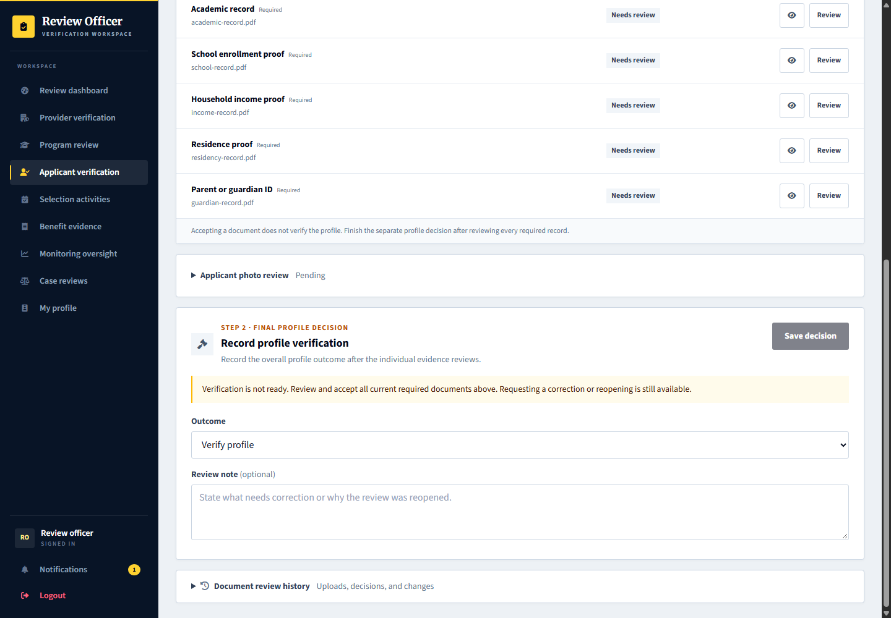
Capture only: no decision, response, upload or account change was submitted. Available actions depend on the role, current record state and completed prerequisites.

4 Provider organization profile
Signed in account: marilag.profile
Page shown: Provider organization profile
The organization profile manager maintains the provider information shown to applicants, including identity, public description, branding, contact information, and location. A provider preview shows the applicant-facing presentation.
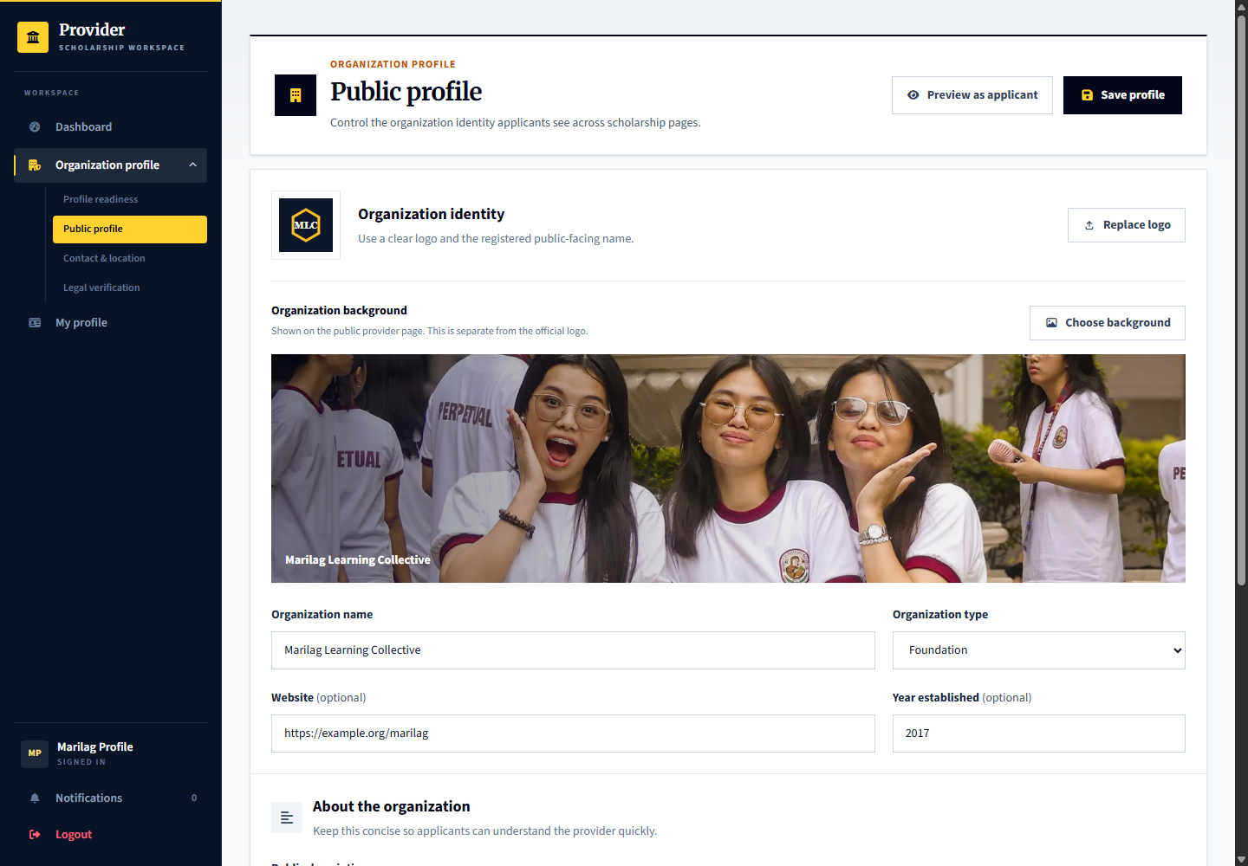
Applicant: discovers and evaluates providers. Provider: marilag.profile maintains the organization record and evidence. Admin: platform.reviews checks registration evidence and organization verification.

5 Admin provider verification
Signed in account: platform.reviews
Page shown: Admin provider verification
Use platform.reviews to review the Dalisay organization. Step 1 reviews each current proof separately: open Review, inspect the file beside the organization details, then Accept document with the comparison acknowledgement or Request replacement with a clear reason. Step 2 records the final provider account decision only after every current file is accepted. Verification does not approve the provider's scholarships.
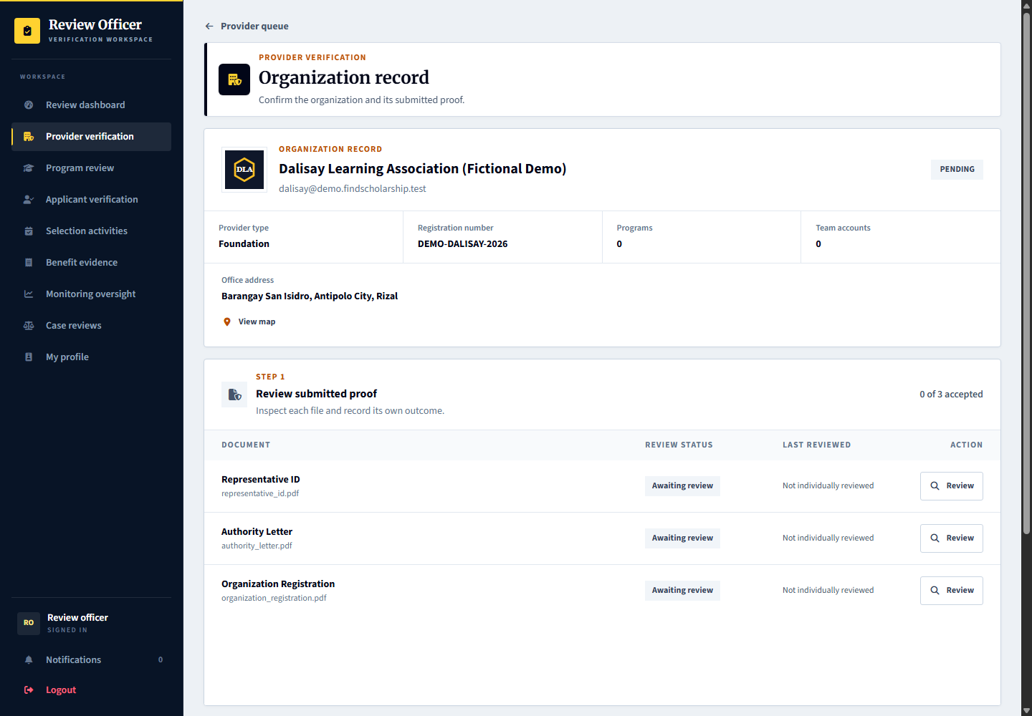
Applicant: sees the provider trust state. Provider: sees individual file outcomes and corrective notes, and uses Replace document to submit new proof. Admin: records each document review and then a separate account outcome; the final account decision never overwrites file outcomes or notes.

Review organization documents individually
Signed in account: platform.reviews
1. Sign in as platform.reviews. Open Provider verification and select Dalisay. Step 1 shows each file as Awaiting review, Accepted, or Needs replacement, with reviewer and date when available.
2. Choose Review on one file. Compare the submitted proof with the legal organization name, registration authority and number, and representative details. Download it if the format cannot be previewed.
3. Choose Accept document only after inspecting it and checking the comparison acknowledgement. Otherwise choose Request replacement and explain what must be corrected. Saving records the reviewer, time, note and file revision; it does not verify the account.
4. Repeat for every current file. Unreviewed files, unavailable files and replacement requests block final approval. If another reviewer or upload changes the file, reload instead of submitting an outdated review. The screenshot shows an unsaved form.
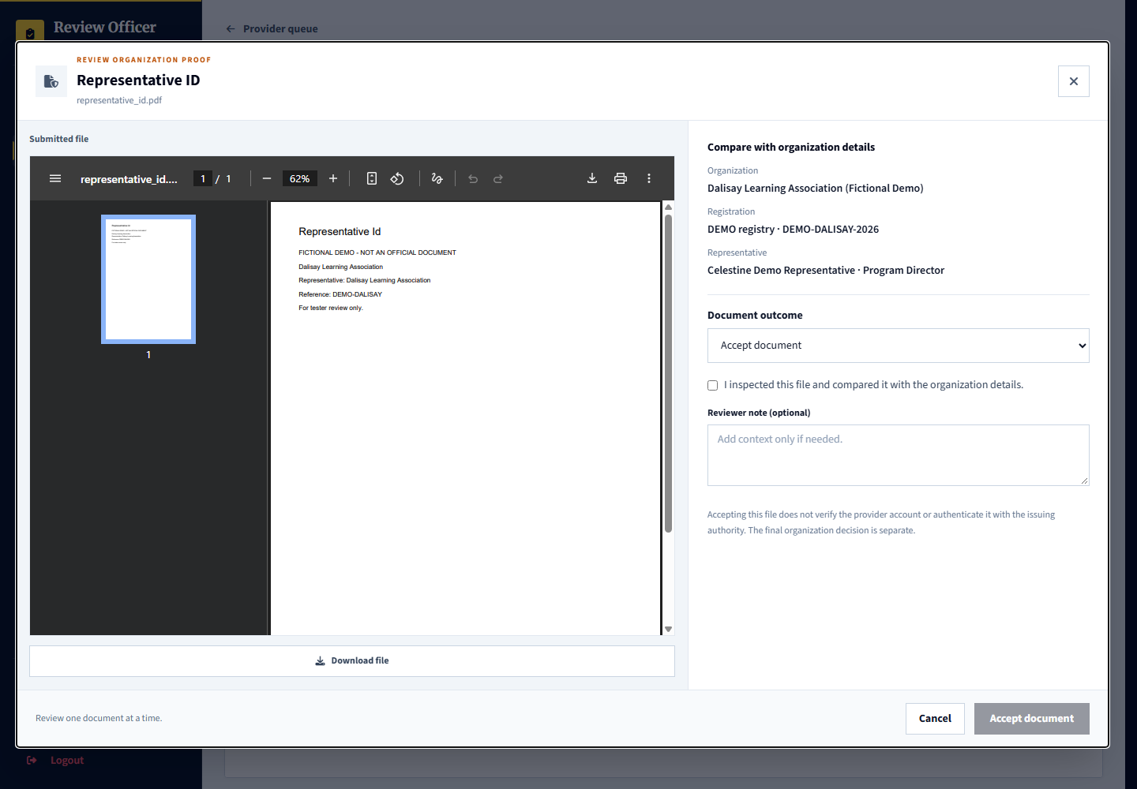
Capture only: no decision, response, upload or account change was submitted. Available actions depend on the role, current record state and completed prerequisites.

Record the final provider account decision
Signed in account: platform.reviews
1. In Step 2 Final provider account decision, confirm all current proof has been individually accepted. Uploading documents alone is insufficient.
2. Choose Approve, Reject, or Return to pending. Rejection requires a clear organization review note. File outcomes and their notes remain independent.
3. Save decision only when appropriate. If the organization or document set changed, reload and inspect the current record before deciding.
4. Organization verification is not scholarship publication or applicant selection. Existing approved demo accounts are not reset by this update; inherited historical file approvals do not count as individual reviews during a new verification.
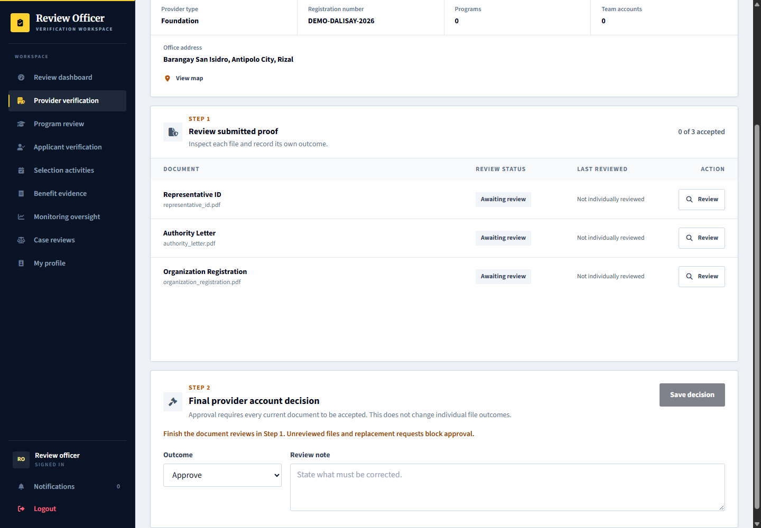
Local platform capture. No review decision or replacement upload was submitted for this screenshot.

Replace organization proof after a review
Signed in account: dalisay
1. Open Organization profile then Legal verification. Review the status and corrective note for the affected file.
2. Choose the Replace document icon on that row. The upload form identifies the file being replaced and selects its document type. Choose the new file and acknowledge the upload terms.
3. Upload proof replaces the old file with a new unreviewed record. The new file does not inherit acceptance. Other unchanged accepted files keep their own decisions.
4. New proof or relevant legal identity changes return approved accounts to review. Relevant organization changes invalidate prior file comparisons; a reviewer must inspect the current details and files again.
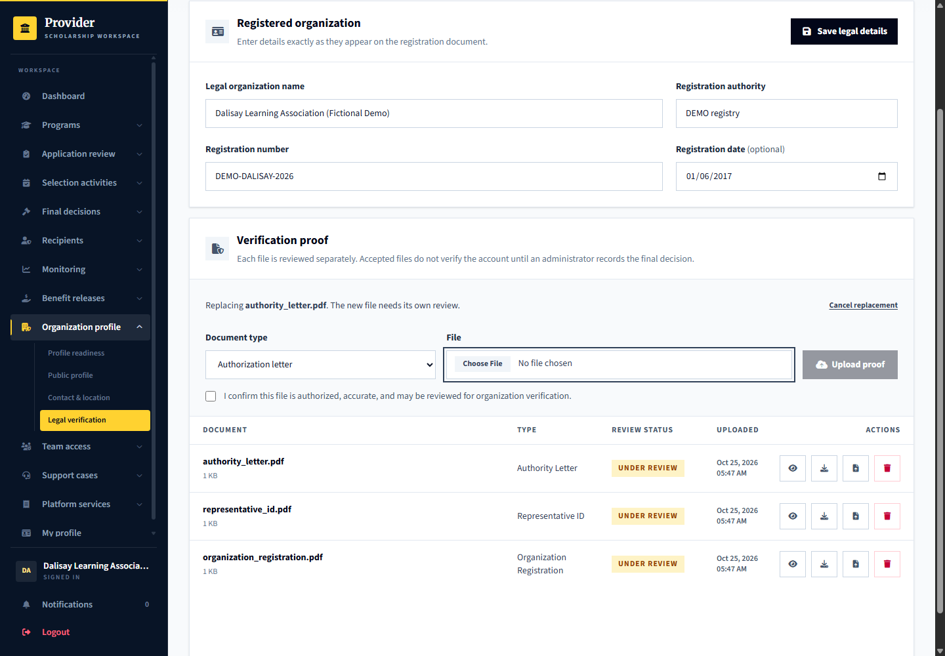
Local platform capture. No review decision or replacement upload was submitted for this screenshot.

6 Program creation and publication
Signed in account: marilag.programs
Page shown: Program creation and publication
The program coordinator prepares scholarship details, benefits, eligibility rules, requirements, selection stages, dates, applicant limits, and branding. Drafts and requested changes stay separate from published programs. The staged editor validates each step.
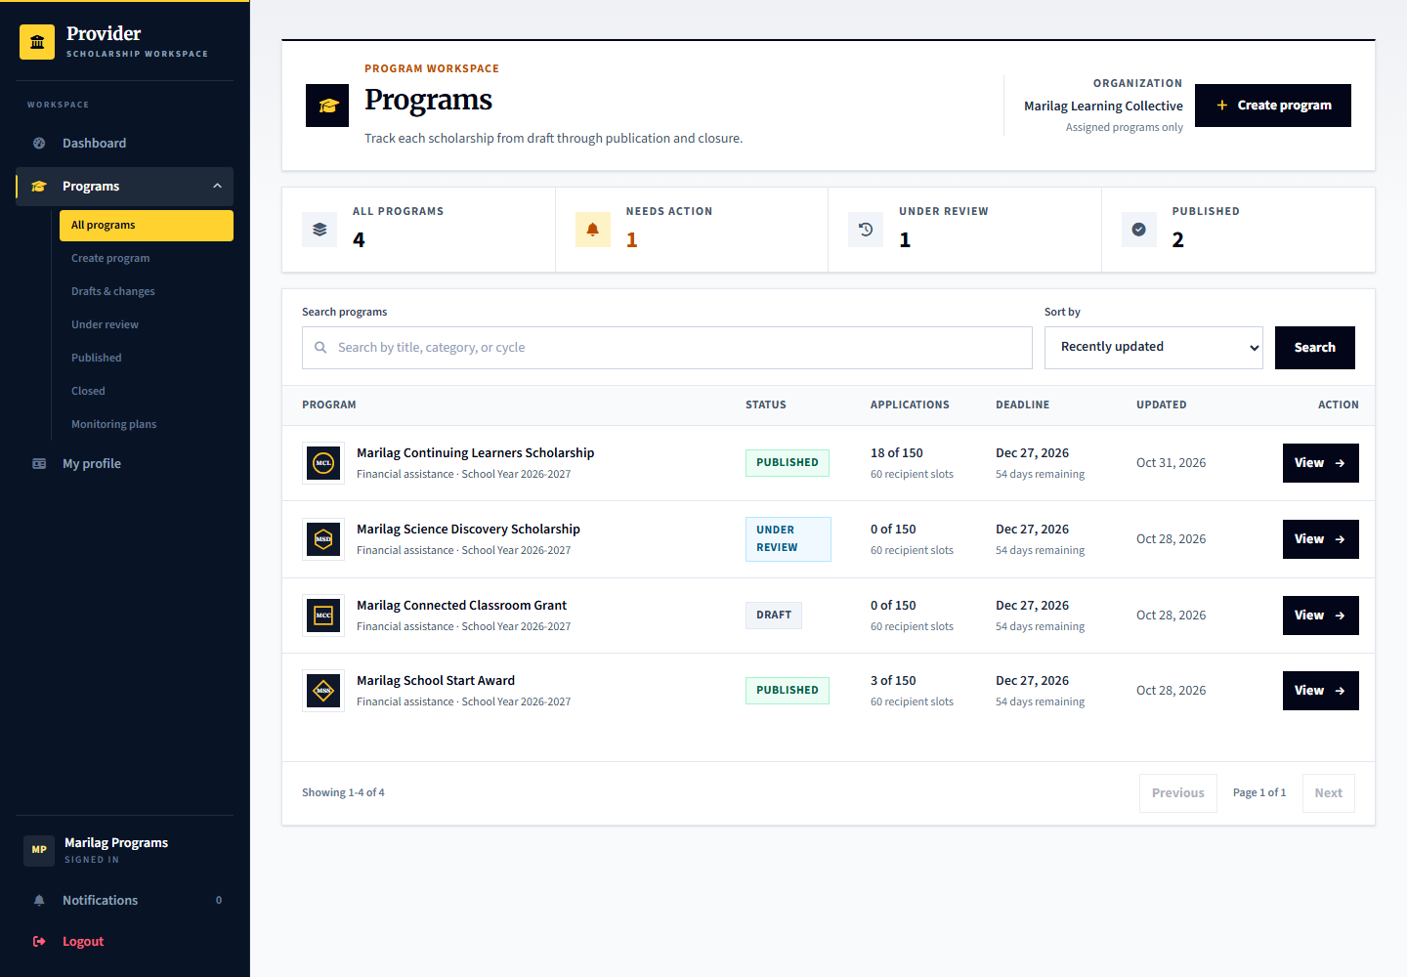
Applicant: sees published scholarships, not private drafts. Provider: marilag.programs prepares and submits programs. Admin: platform.reviews checks publication submissions; it does not make the provider final applicant selection.

Configure documents and the formal application handoff
Signed in account: marilag.programs
1. Open a program, choose Edit, and open Application in the staged editor.
2. Configure the pre-screening files, optional files and post-qualification requirements appropriate to the program.
3. Set formal handoff instructions, deadline and the official link or physical venue with its map pin where needed.
4. Choose common document requirements from the selector and type only provider-specific requirements. Review the remaining steps before saving or submitting.
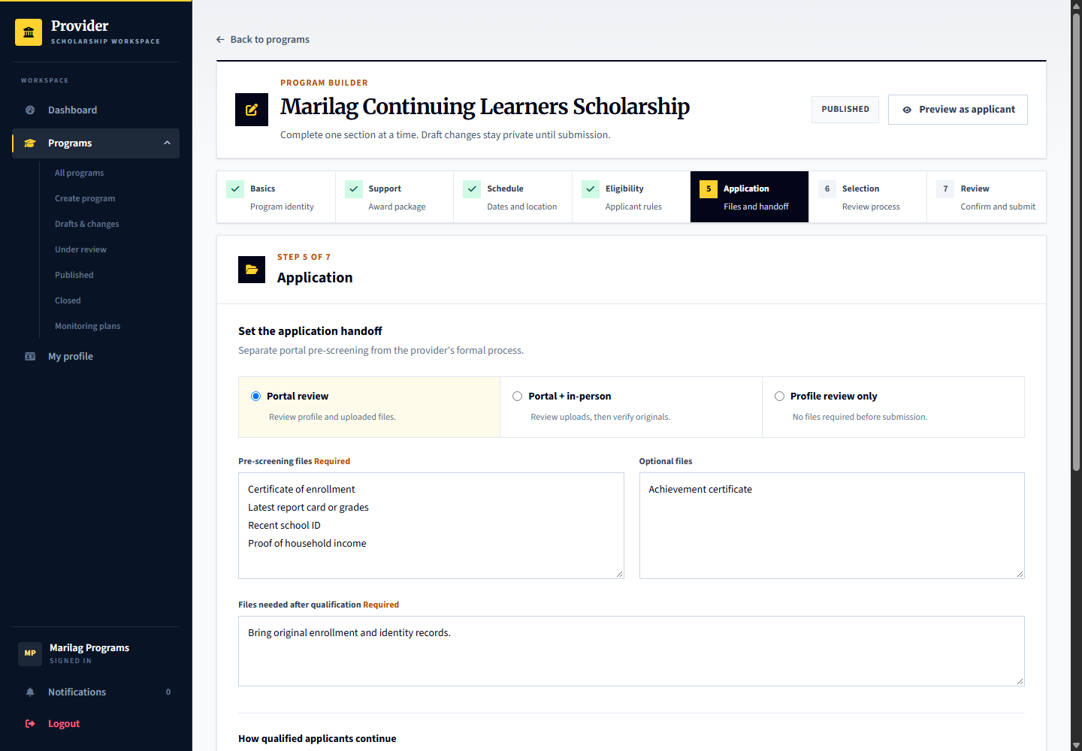
Capture only: no decision, response, upload or account change was submitted. Available actions depend on the role, current record state and completed prerequisites.

7 Admin program review
Signed in account: platform.reviews
Page shown: Admin program review
The program review queue separates publication checks from organization verification and applicant verification. The officer examines the program information and requests changes or records the publication review decision.
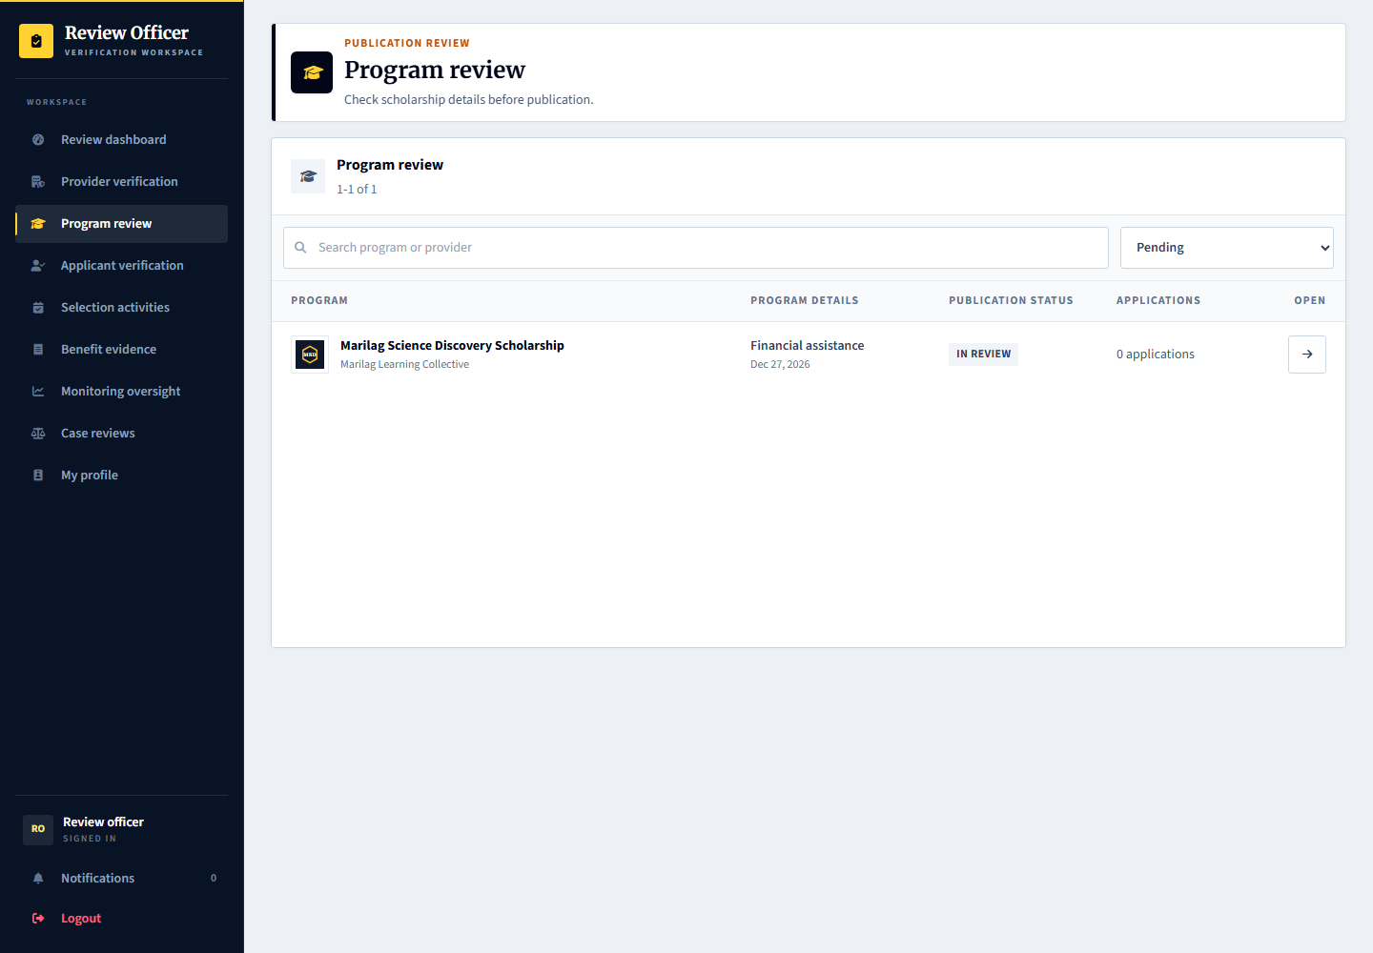
Applicant: can discover approved published programs. Provider: answers requested changes. Admin: verifies the submission through the program review workspace.

Inspect the submitted scholarship before publication
Signed in account: platform.reviews
1. Open a program from Program review and confirm its provider and submission status.
2. Review the advertised support, eligibility, requirements, dates, selection process and recipient terms.
3. Use the publication review controls to approve a valid submission or request clear changes.
4. Record the decision only after checking the full submission. This is not selection of a scholarship applicant.
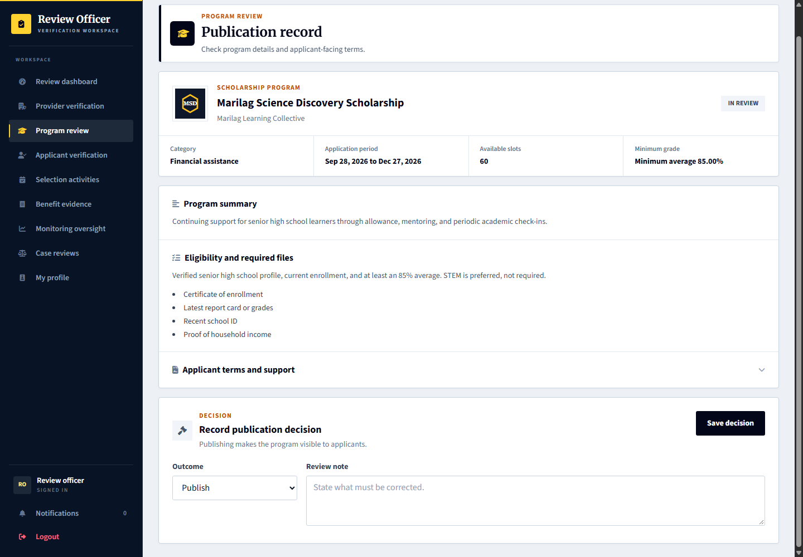
Capture only: no decision, response, upload or account change was submitted. Available actions depend on the role, current record state and completed prerequisites.

8 Scholarship discovery and preparation
Signed in account: learner.apply
Page shown: Scholarship discovery and preparation
The applicant finds a scholarship and opens its details to understand benefits, eligibility, documents, application instructions, and selection stages. The provider page helps applicants identify a specific organization.
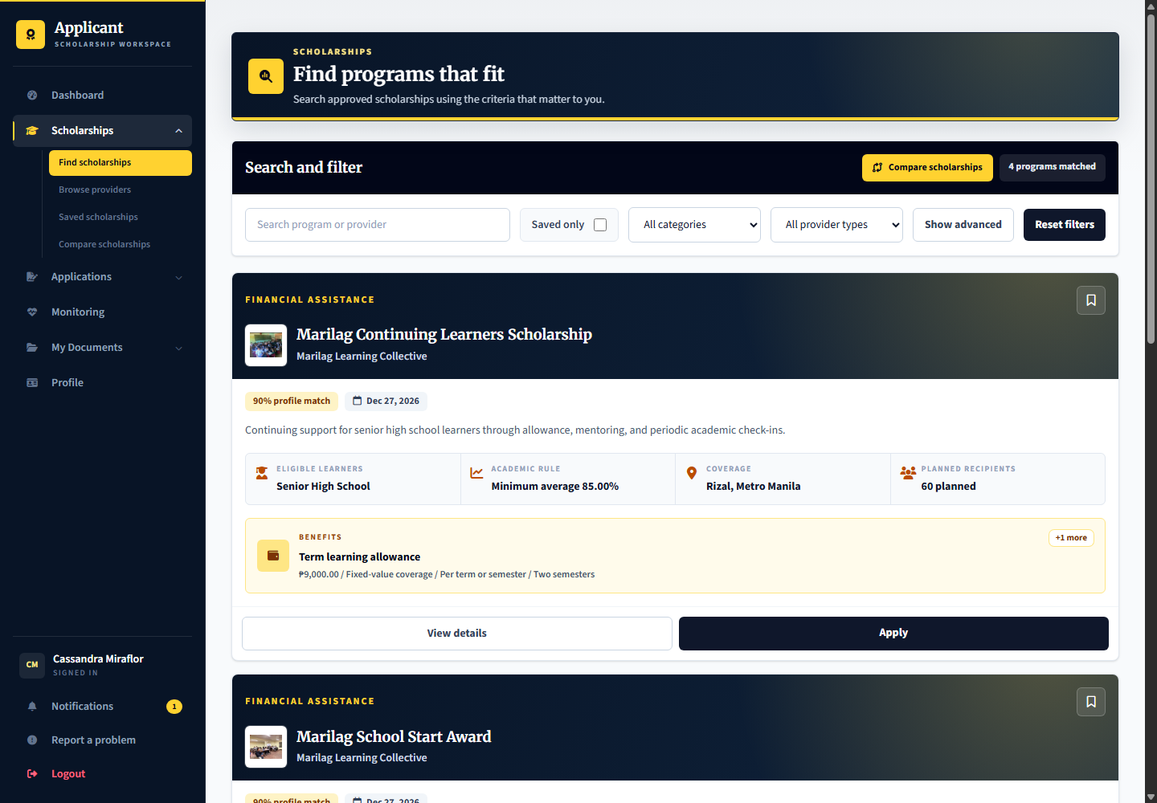
Applicant: learner.apply is ready to start a new application. Provider: supplies accurate program and organization content. Admin: oversees publication and trust checks, not the applicant choice of scholarship.

9 Reusable applicant documents
Signed in account: learner.apply
Page shown: Reusable applicant documents
My Documents holds reusable files for future applications. A saved document is not automatically an accepted application requirement; the applicant must choose appropriate current files during an application.
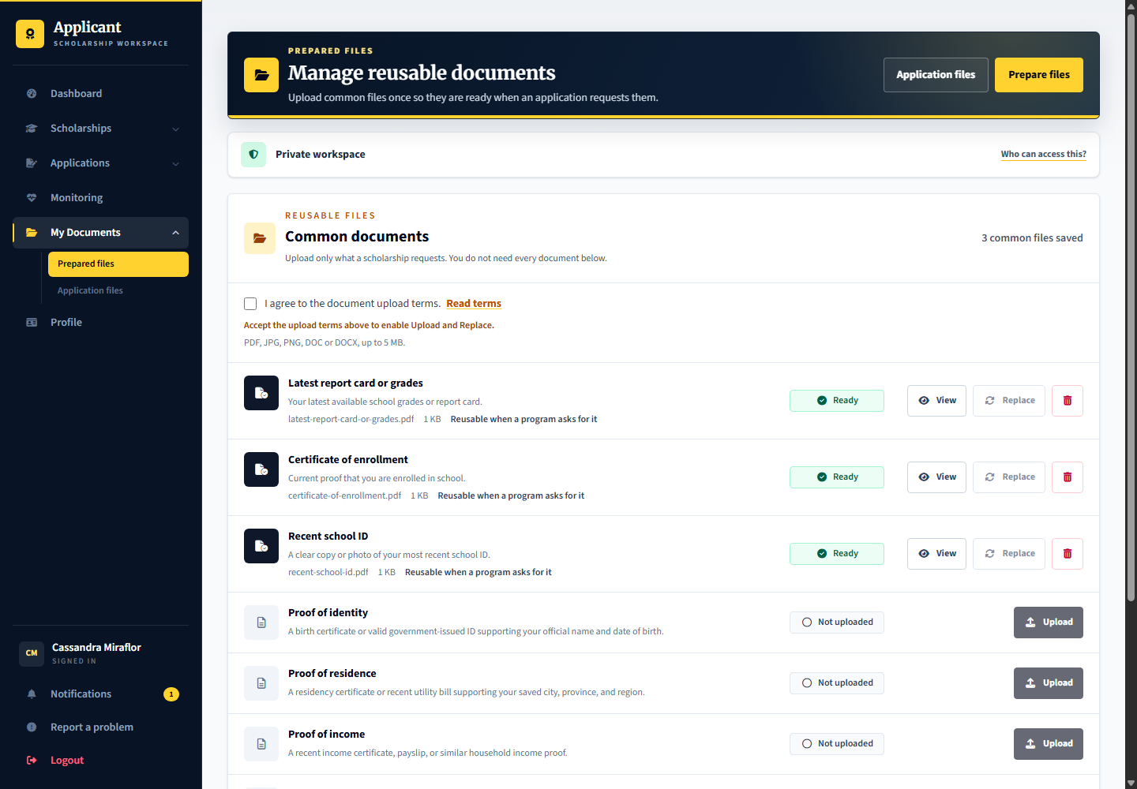
Applicant: uploads and manages documents. Provider: reviews files actually submitted to its program. Admin: profile evidence verification remains separate from a provider application document decision.

10 Submitted application and next action
Signed in account: learner.screening
Page shown: Submitted application and next action
The application details tell the applicant the current stage, what happens next, required submissions, schedule, decision, and history. learner.screening is waiting for the initial provider review.
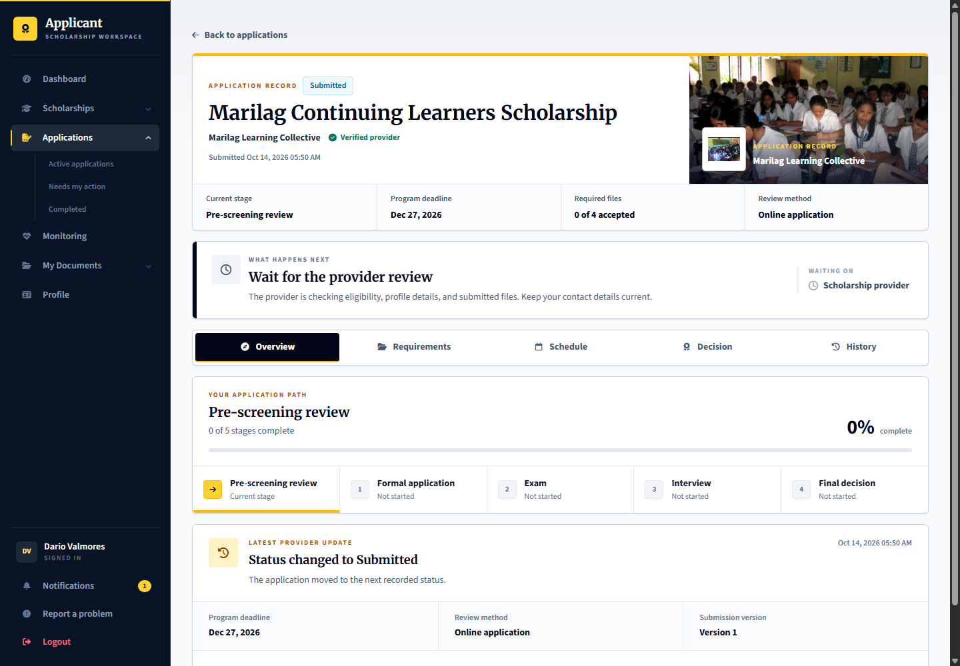
Applicant: follows the next-action guidance and answers correction requests. Provider: marilag.reviewer checks eligibility and submitted documents. Admin: handles platform verification or oversight, not routine scholarship screening.

11 Provider screening and document review
Signed in account: marilag.reviewer
Page shown: Provider screening and document review
The application reviewer works from the assigned queue instead of the manager overview. Review the applicant record, eligibility and document evidence before recording a screening result. Corrections should identify what the applicant must fix.
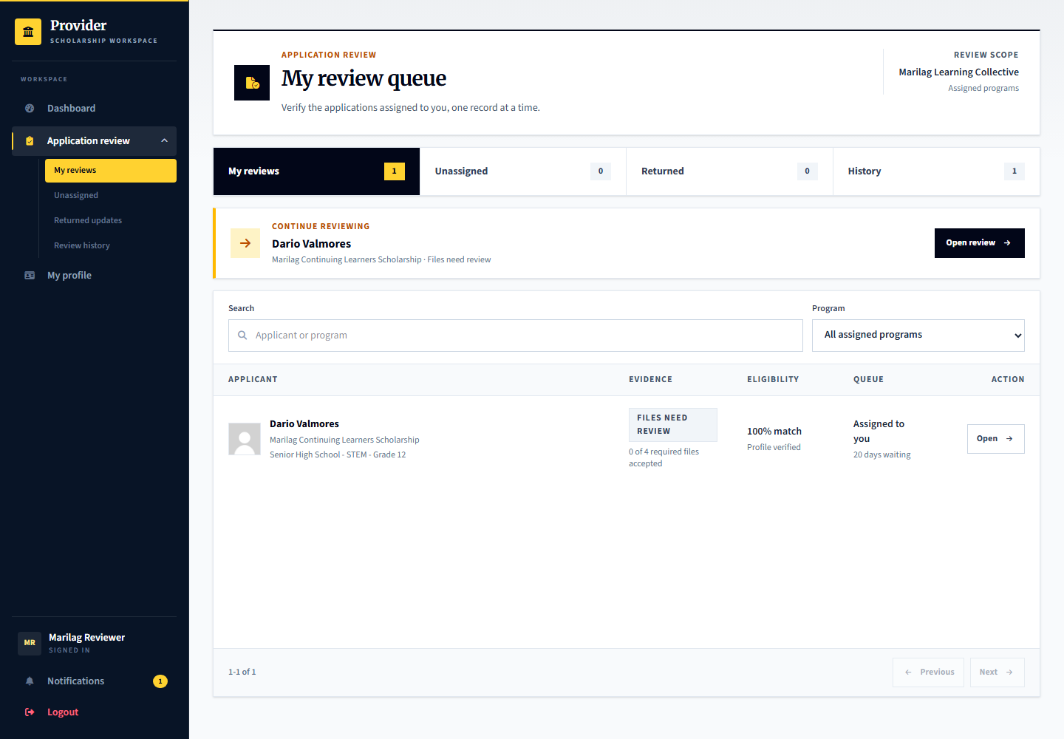
Applicant: learner.screening is the prepared screening record. Provider: marilag.reviewer performs the review. Admin: platform.reviews verifies profile evidence separately; passing screening does not itself award a scholarship.

Inspect application eligibility after selecting an applicant
Signed in account: marilag.reviewer
1. Open Dario Valmores from My review queue and confirm that the application is assigned to you.
2. Compare the declared profile against each program rule. Review unresolved items rather than relying only on an overall score.
3. Inspect the Profile tab and supporting evidence where a claim needs checking.
4. Hard requirements and reviewable qualifications must follow their configured policy; resolve the relevant review before recording a screening result.
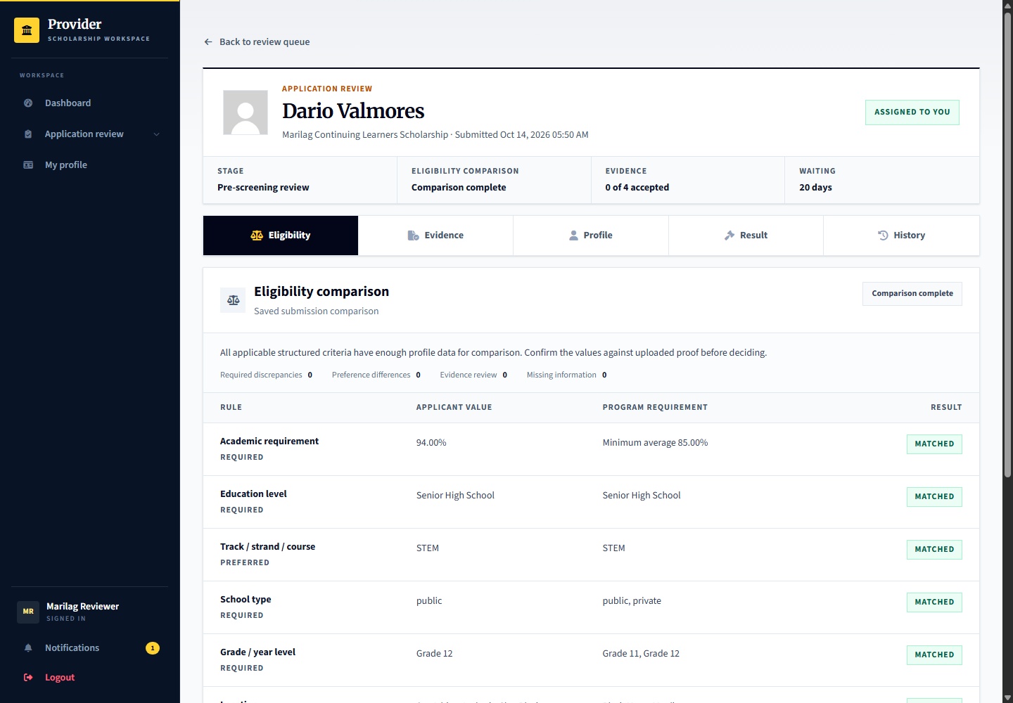
Capture only: no decision, response, upload or account change was submitted. Available actions depend on the role, current record state and completed prerequisites.

Review the application evidence
Signed in account: marilag.reviewer
1. Open Evidence in the selected application record.
2. Use View or the file preview to inspect the submitted file, then select Review beside that document.
3. Record an evidence status and specific review notes appropriate to the file. An upload alone is not accepted evidence.
4. Repeat for the required files before relying on document readiness for the screening result.
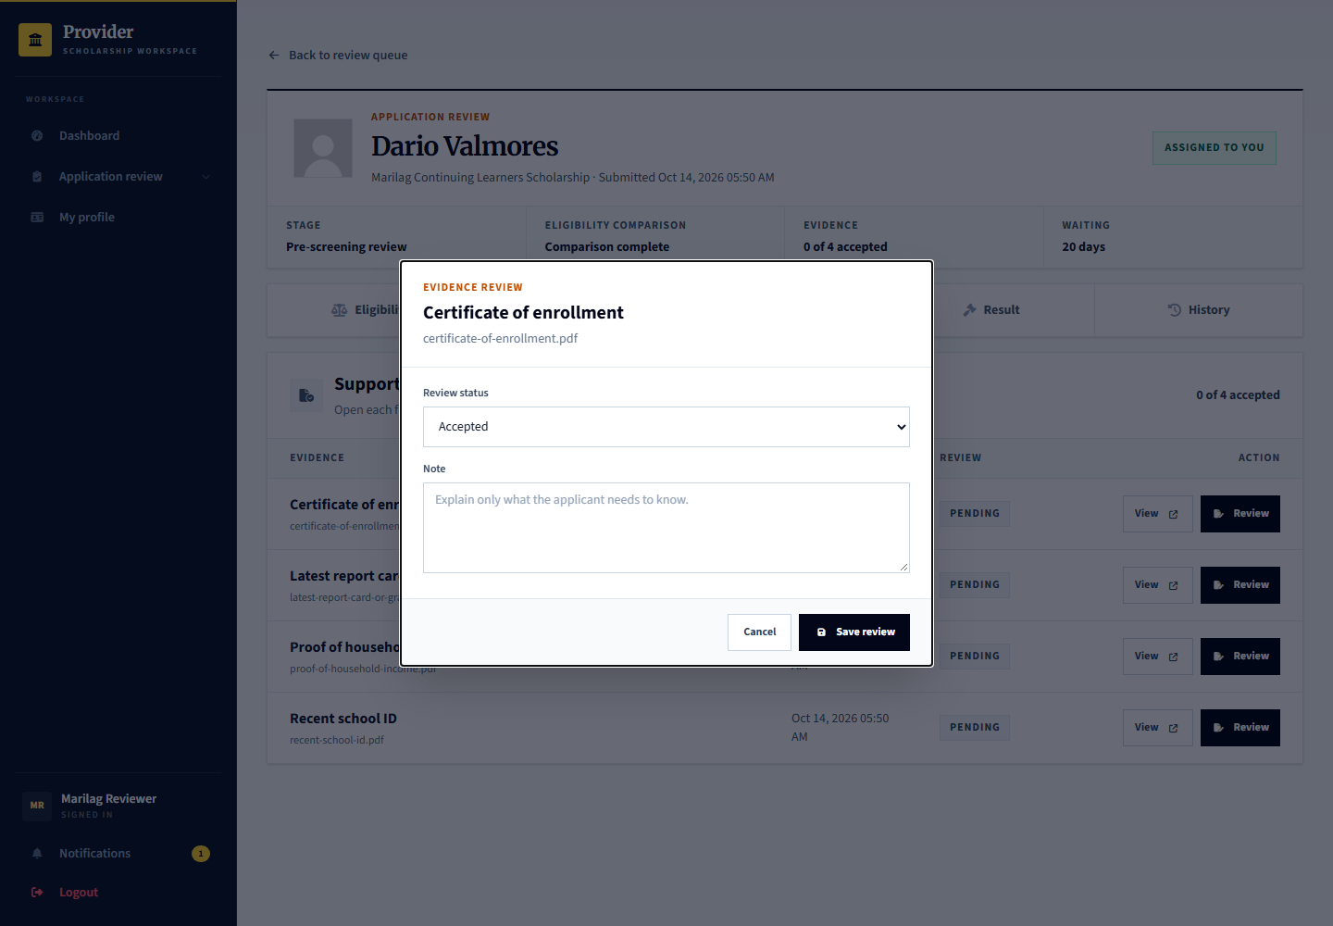
Capture only: no decision, response, upload or account change was submitted. Available actions depend on the role, current record state and completed prerequisites.

Record the screening result or request correction
Signed in account: marilag.reviewer
1. Open Result in the selected application record and check the readiness messages.
2. If information is missing, open Request correction and identify what the applicant must change.
3. Review the published rubric and record the required scores and reason before choosing the screening outcome.
4. Save the appropriate review or result only after completing its prerequisites. Claiming an unassigned application is a separate access action.
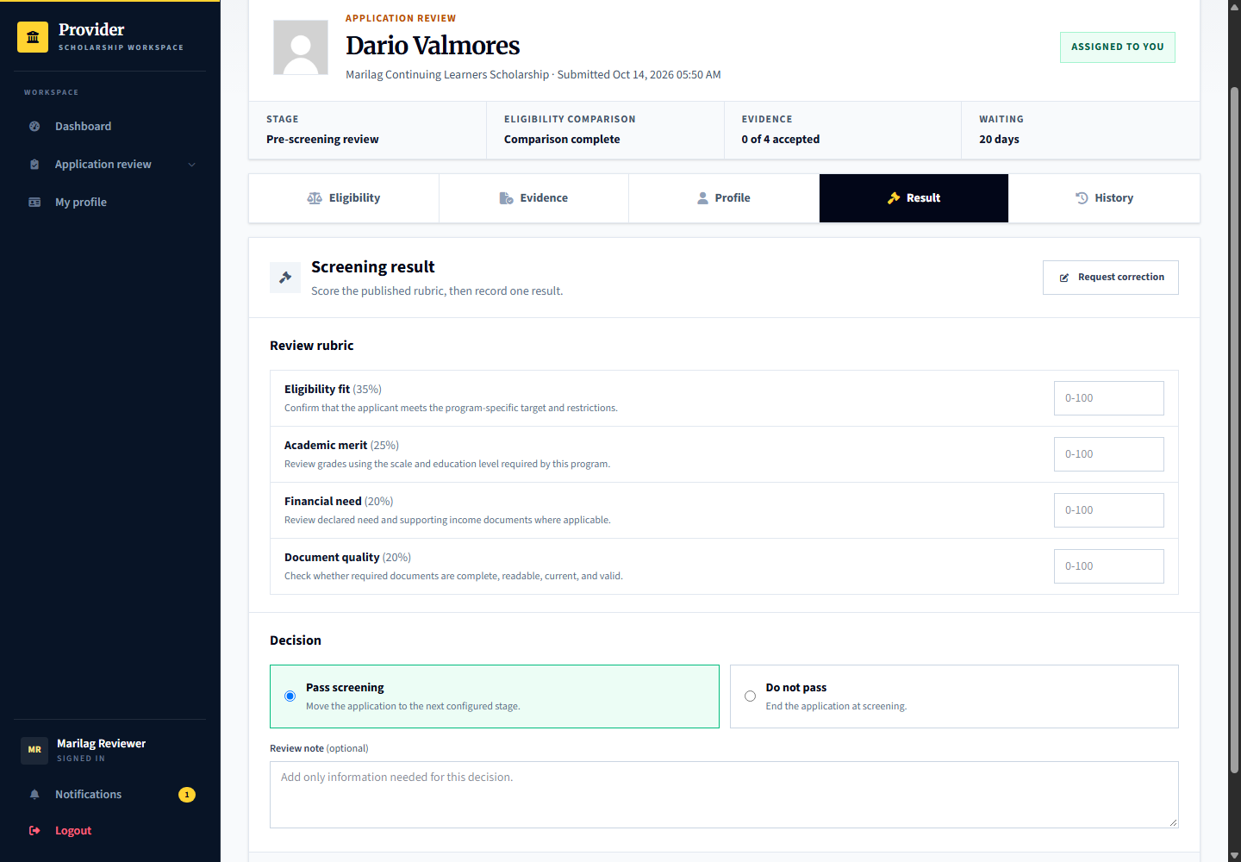
Capture only: no decision, response, upload or account change was submitted. Available actions depend on the role, current record state and completed prerequisites.

12 Formal application verification
Signed in account: learner.formal
Page shown: Formal application verification
Formal application is a configured stage for providers that require a further official application or in-person verification. Applicants follow the published instructions and schedule where applicable. A separate session is not always mandatory for this stage.
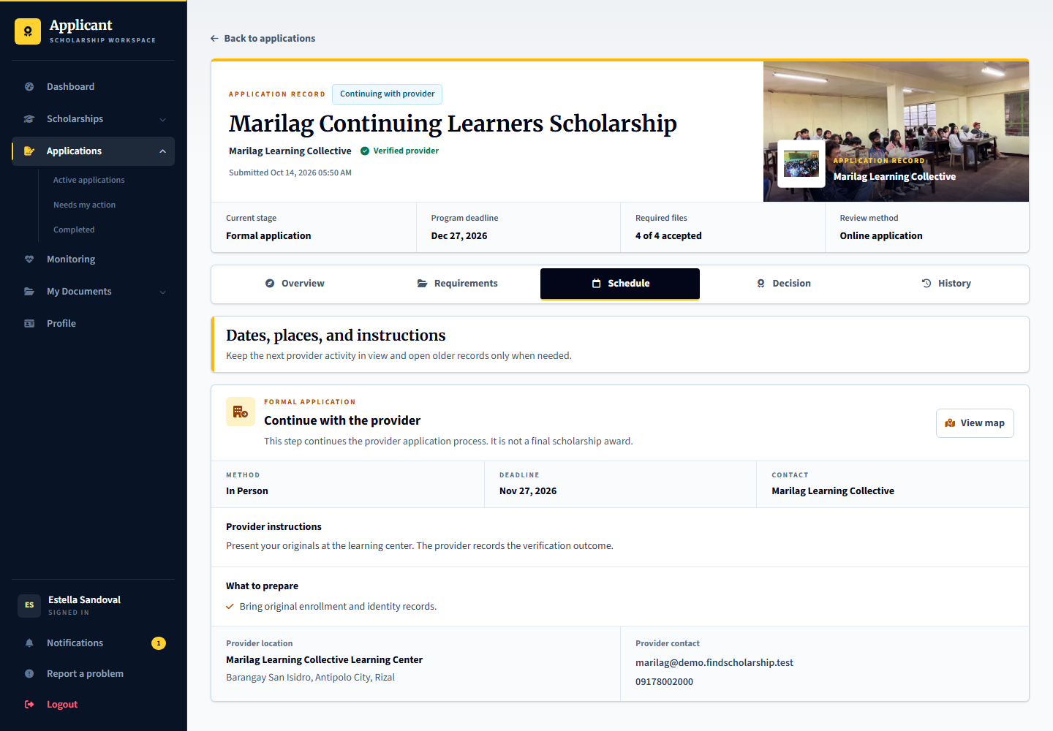
Applicant: learner.formal follows the formal instructions. Provider: marilag.selection records the verification, required proof and result according to the configured stage. Admin: can inspect selection activity evidence through oversight.

Record the formal application verification
Signed in account: marilag.selection
1. Select Estella Sandoval from the formal-application work queue.
2. Read the published handoff instructions and verify the actual formal application requirements or originals.
3. Complete the required stage verification and attach provider proof where requested. Use a session only when the configured formal workflow needs one.
4. Record the stage outcome after the prerequisites are satisfied; a published instruction is not proof that verification happened.
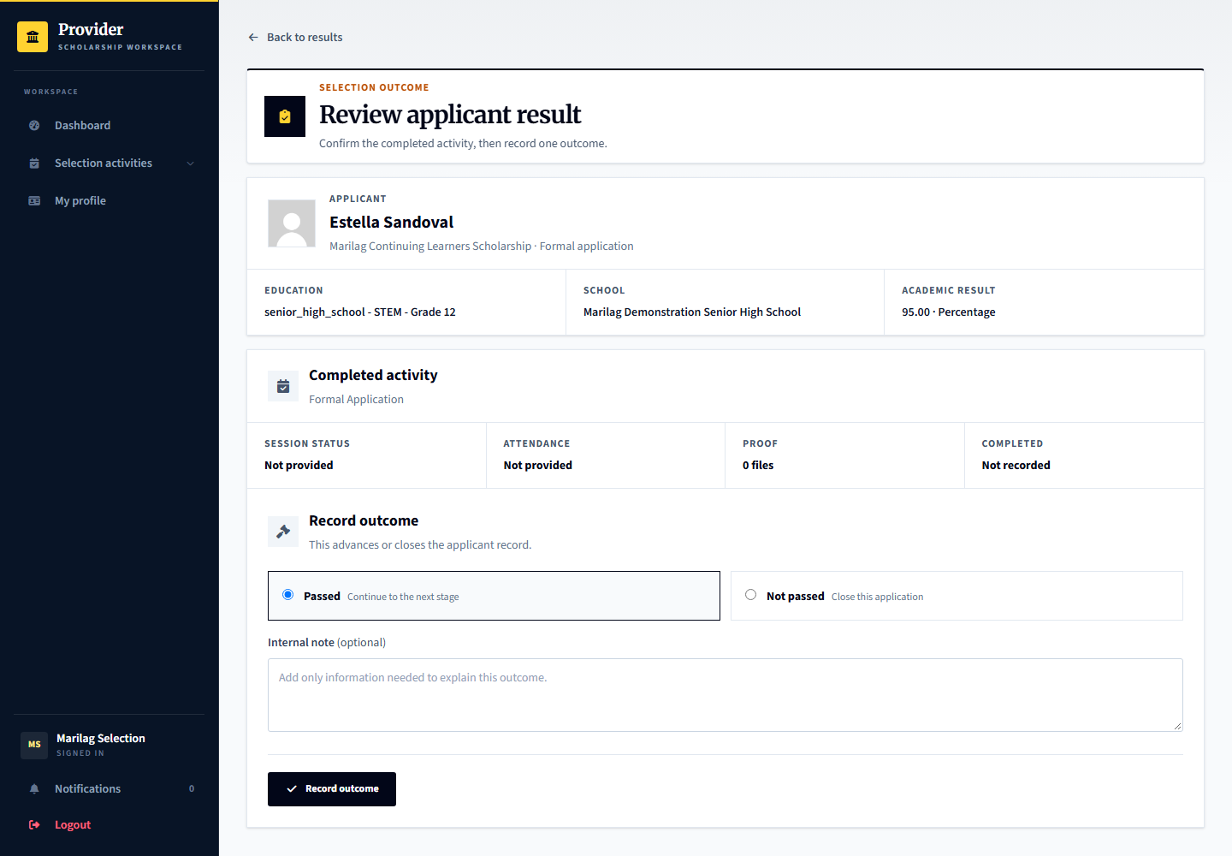
Capture only: no decision, response, upload or account change was submitted. Available actions depend on the role, current record state and completed prerequisites.

13 Examination and interview scheduling
Signed in account: marilag.selection
Page shown: Examination and interview scheduling
The selection officer assigns eligible applicants to sessions. Separate sessions support different dates or venues; online interviews use a meeting link. Session attendance or completion and an individual applicant result are different records.
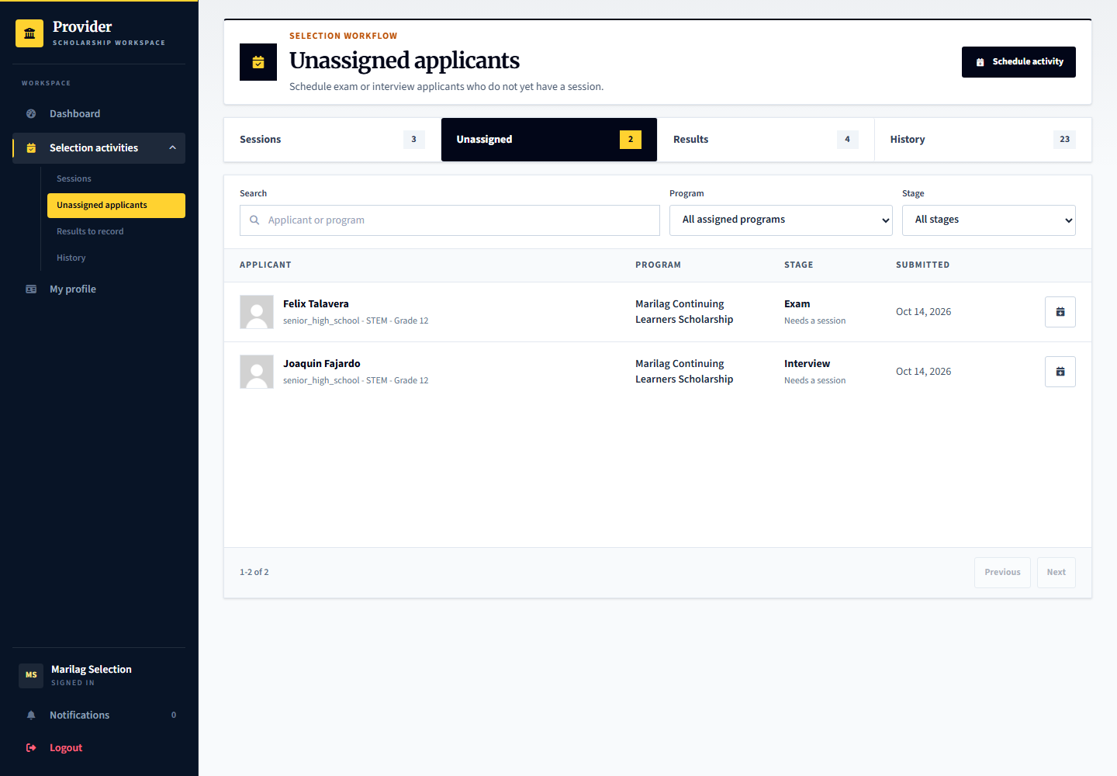
Applicant: learner.exam.assign or learner.interview.assign awaits assignment. Provider: marilag.selection manages sessions and outcomes. Admin: platform.reviews can inspect selection activity records and evidence.

14 Applicant examination schedule
Signed in account: learner.exam.confirm
Page shown: Applicant examination schedule
The applicant reads the assigned examination date, venue, instructions, and acknowledgement action. Other prepared accounts cover completing the conducted session and recording an individual examination result.
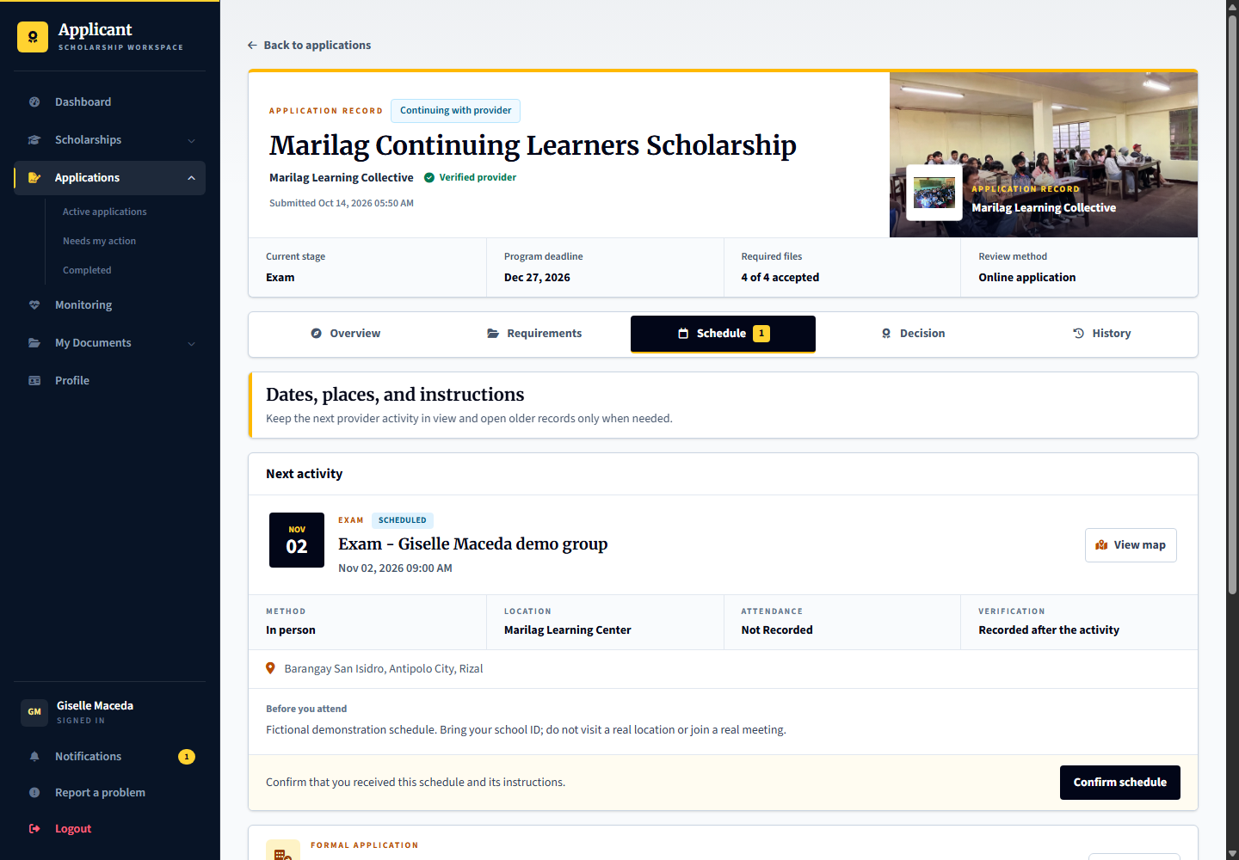
Applicant: learner.exam.confirm acknowledges the schedule. Provider: learner.exam.complete is the session-completion scenario and learner.exam.result awaits a result, both acted on by marilag.selection. Admin: provides oversight rather than taking the examination decision.

Record the conducted examination result
Signed in account: marilag.selection
1. Open Isabel Montano in the results queue and inspect the assigned examination and readiness checks.
2. Check attendance or participation and the required completion evidence for the conducted session.
3. Record the applicant examination result with its supporting notes through Record outcome.
4. Session completion and an individual applicant result are separate actions; do not pass an applicant simply because the schedule exists.
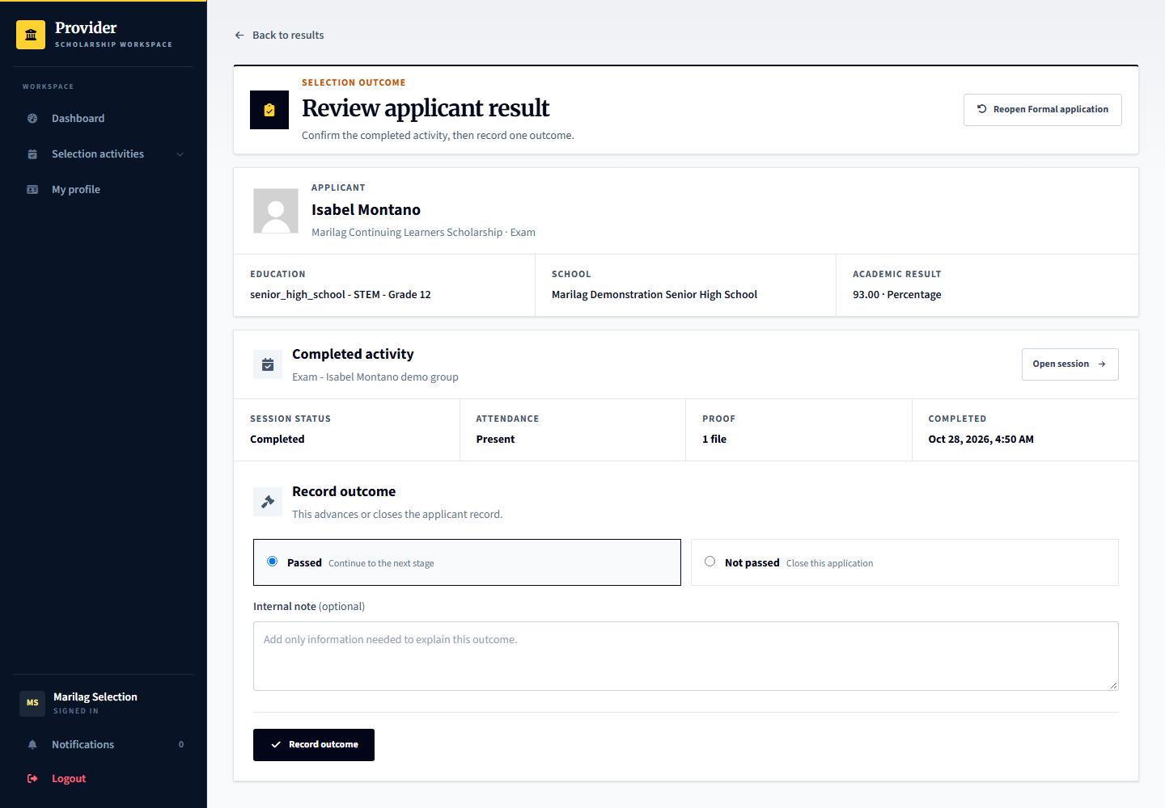
Capture only: no decision, response, upload or account change was submitted. Available actions depend on the role, current record state and completed prerequisites.

15 Applicant interview schedule
Signed in account: learner.interview.confirm
Page shown: Applicant interview schedule
The interview schedule tells the applicant when and how to attend, including the meeting link for an online interview. An applicant acknowledgement does not prove the interview took place.
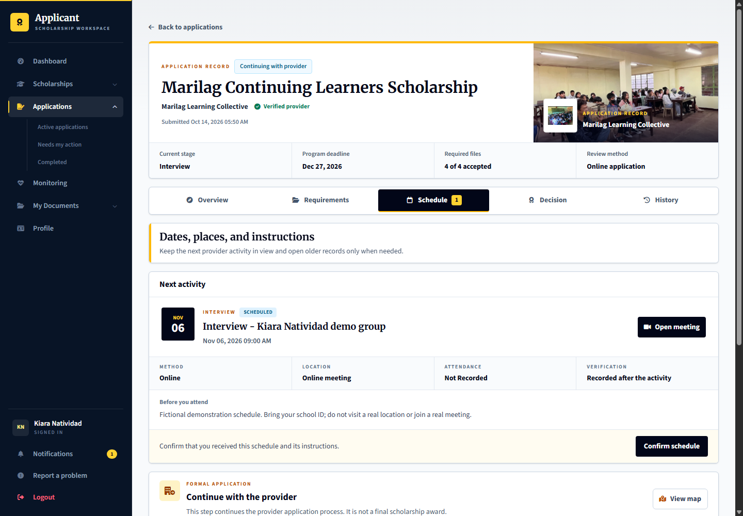
Applicant: learner.interview.confirm acknowledges its schedule. Provider: marilag.selection records attendance, stage proof and the interview result; learner.interview.result is ready for that result. Admin: can inspect supporting activity records.

Record the interview result
Signed in account: marilag.selection
1. Open Leandro Villacorta from the interview results queue.
2. Check that the interview actually occurred and review participation, stage proof and any recorded interview notes.
3. Record the appropriate interview outcome only when the stage-readiness checks permit it.
4. An online meeting link or applicant acknowledgement is a schedule instruction, not evidence that the interview was completed.
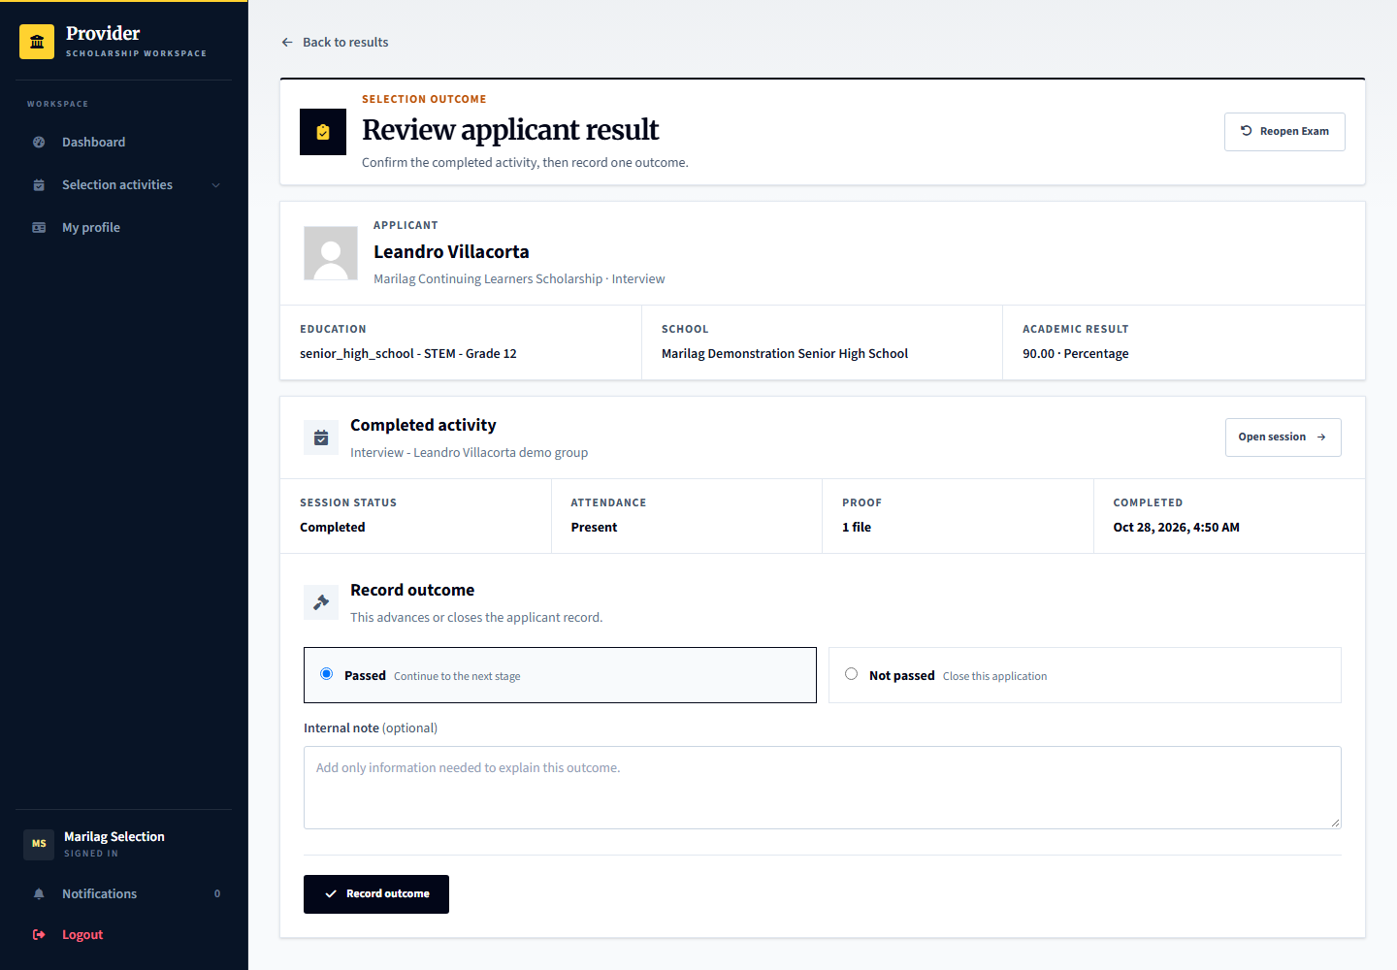
Capture only: no decision, response, upload or account change was submitted. Available actions depend on the role, current record state and completed prerequisites.

16 Recording conducted stage results
Signed in account: marilag.selection
Page shown: Recording conducted stage results
The results workspace separates work ready for result recording from scheduling work. Complete the required conducted-session or stage verification and attach proof where required before recording an applicant result.
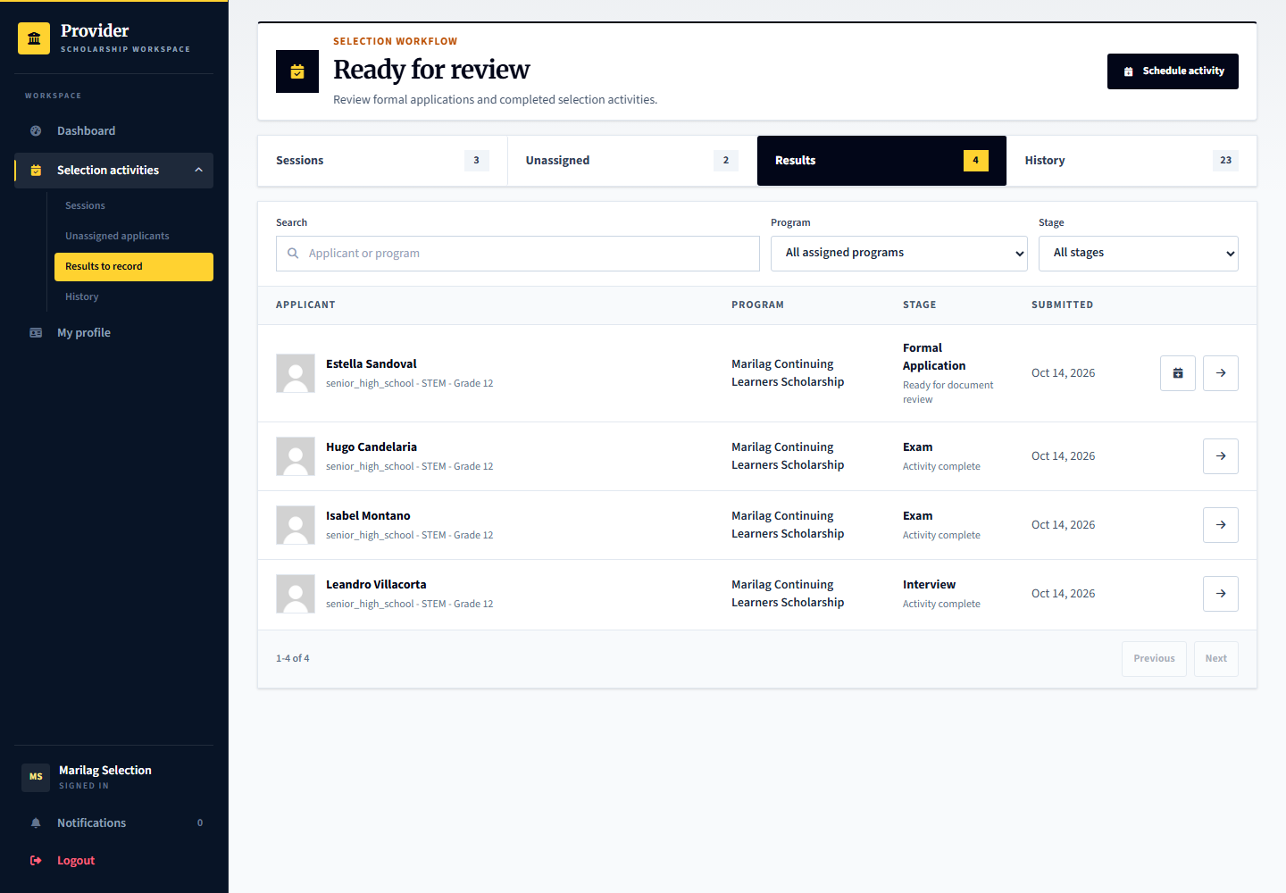
Applicant: sees the recorded result and next stage. Provider: records the evidence-based result and any permitted audited correction, rather than merely marking every applicant complete. Admin: oversight does not replace the provider stage result.

17 Final scholarship decision
Signed in account: marilag.decisions
Page shown: Final scholarship decision
The decision officer reviews applicants who have reached the final stage and records the final selection outcome and notes. Earlier exam or interview success is not a final scholarship award.
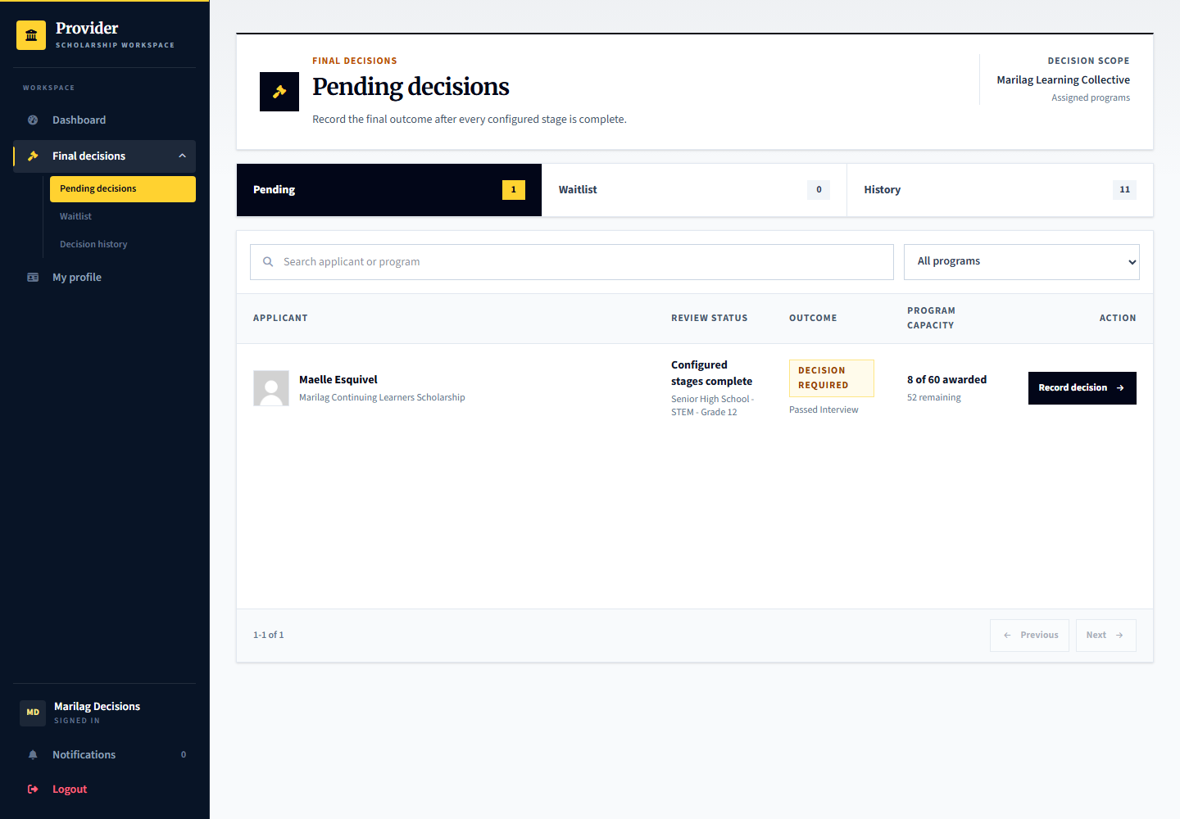
Applicant: learner.decision is ready for this tester-controlled decision. Provider: marilag.decisions records the final outcome. Admin: does not routinely select recipients for the provider.

Open the final decision form
Signed in account: marilag.decisions
1. Select Maelle Esquivel from Pending decisions and read Review summary, Applicant and History as needed.
2. Confirm that earlier configured stages are complete and inspect the readiness or capacity messages.
3. Choose the final outcome and give the required reason or notes in Record final outcome.
4. Review the confirmation before recording it. The applicant is notified after saving; opening this page does not choose an outcome.
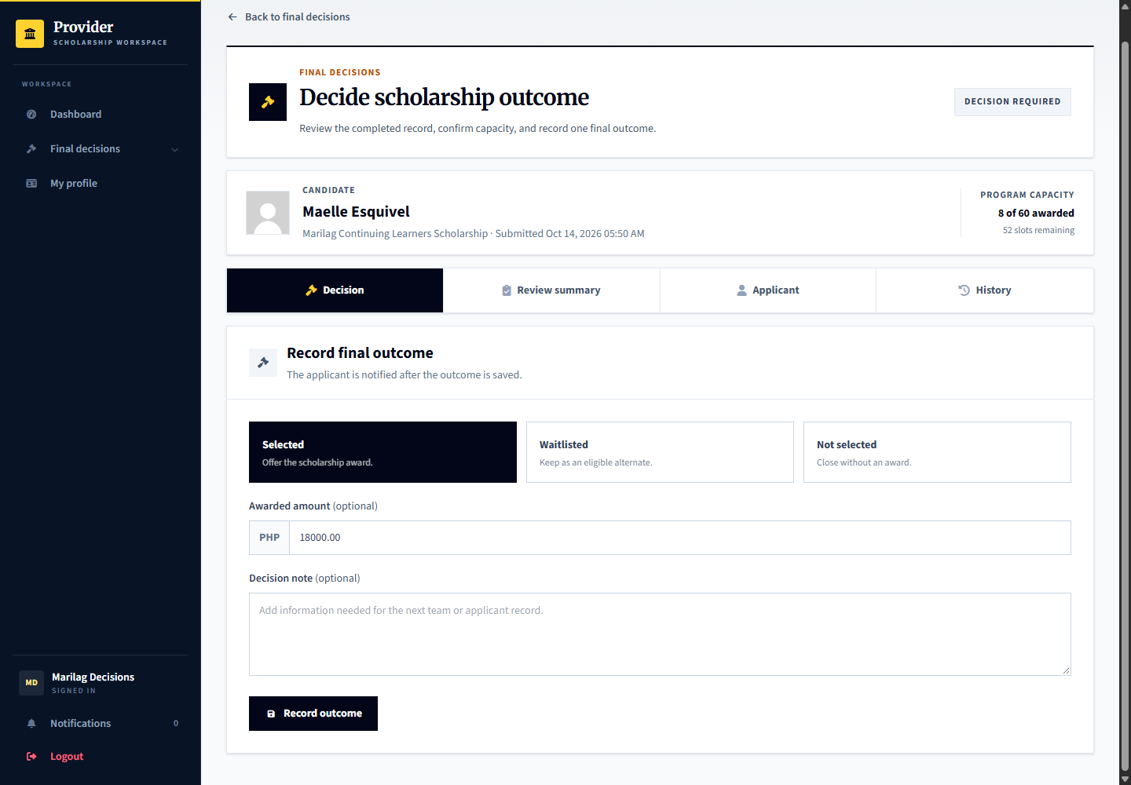
Capture only: no decision, response, upload or account change was submitted. Available actions depend on the role, current record state and completed prerequisites.

18 Applicant acceptance of the agreement
Signed in account: learner.agreement
Page shown: Applicant acceptance of the agreement
The selected applicant reviews the actual recipient terms before accepting or declining. Acceptance creates a clear record of the obligations the applicant agreed to; later program edits must not silently replace those accepted terms.
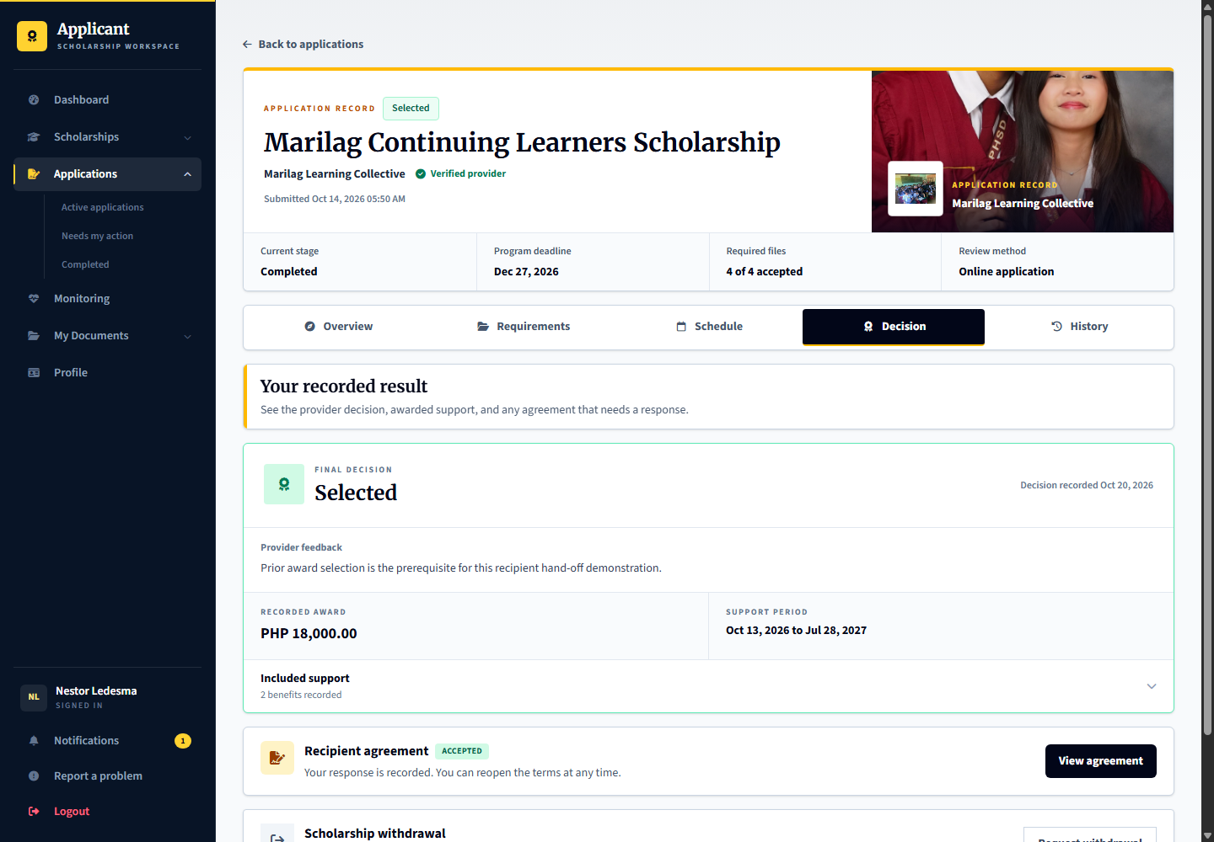
Applicant: learner.agreement is awaiting its agreement response. Provider: marilag.recipients tracks agreement responses. Admin: independent review later uses the accepted source, not an unrelated current program rule.

Read and respond to the recipient agreement
Signed in account: learner.agreement
1. Open the selected application and choose Review agreement.
2. Read the actual recipient terms, responsibilities and any stated consequences rather than accepting from the summary alone.
3. Use the acceptance acknowledgement and response note where required, then choose the intended response.
4. Only submit after understanding the agreement. The provider must wait for the applicant response before the corresponding support steps.
5. If the agreement is already accepted, View agreement shows the saved terms. Use a still-pending offer to demonstrate acceptance; do not reset an existing response.
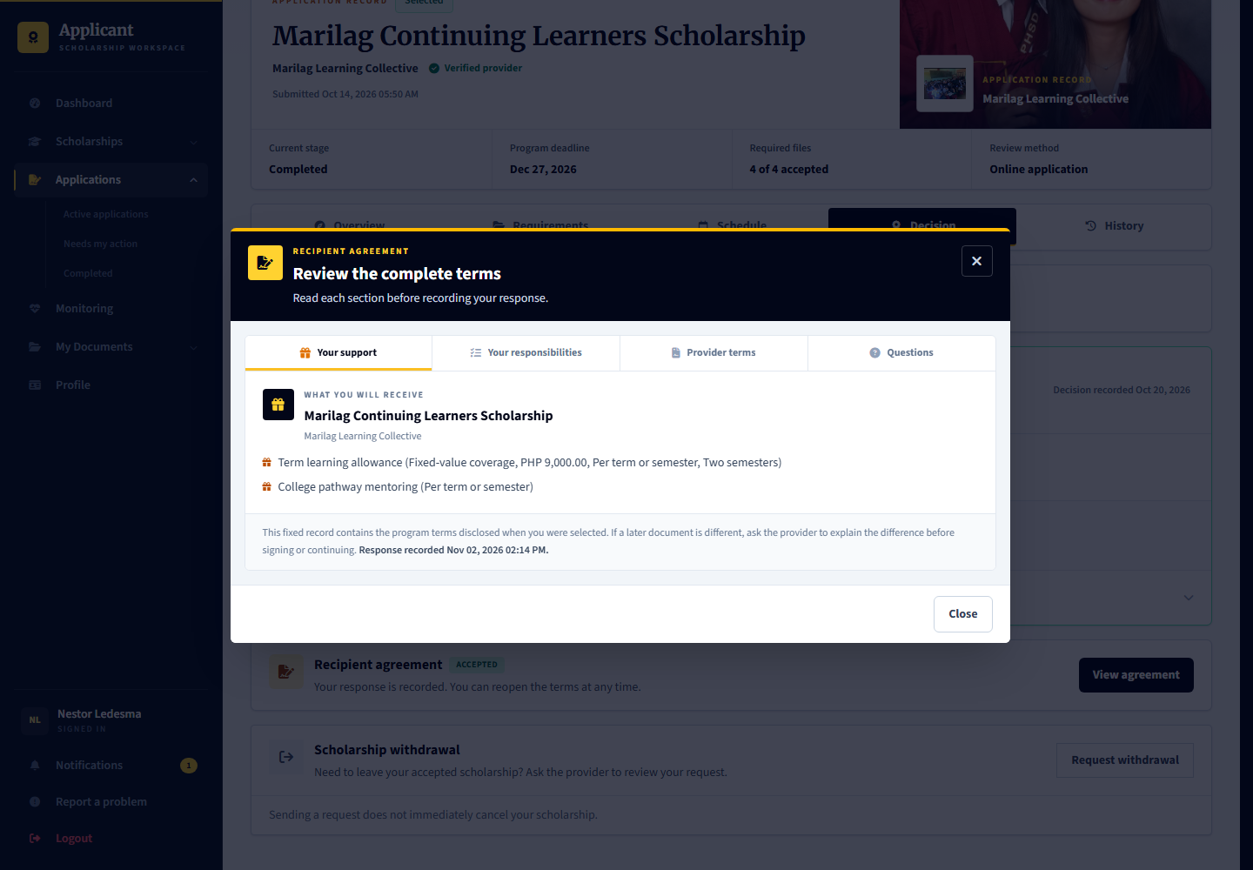
Capture only: no decision, response, upload or account change was submitted. Available actions depend on the role, current record state and completed prerequisites.

19 Recipient support and agreement tracking
Signed in account: marilag.recipients
Page shown: Recipient support and agreement tracking
The recipient officer tracks agreement responses and active scholarship support. Formal application, final selection, agreement acceptance and active support are separate process stages.
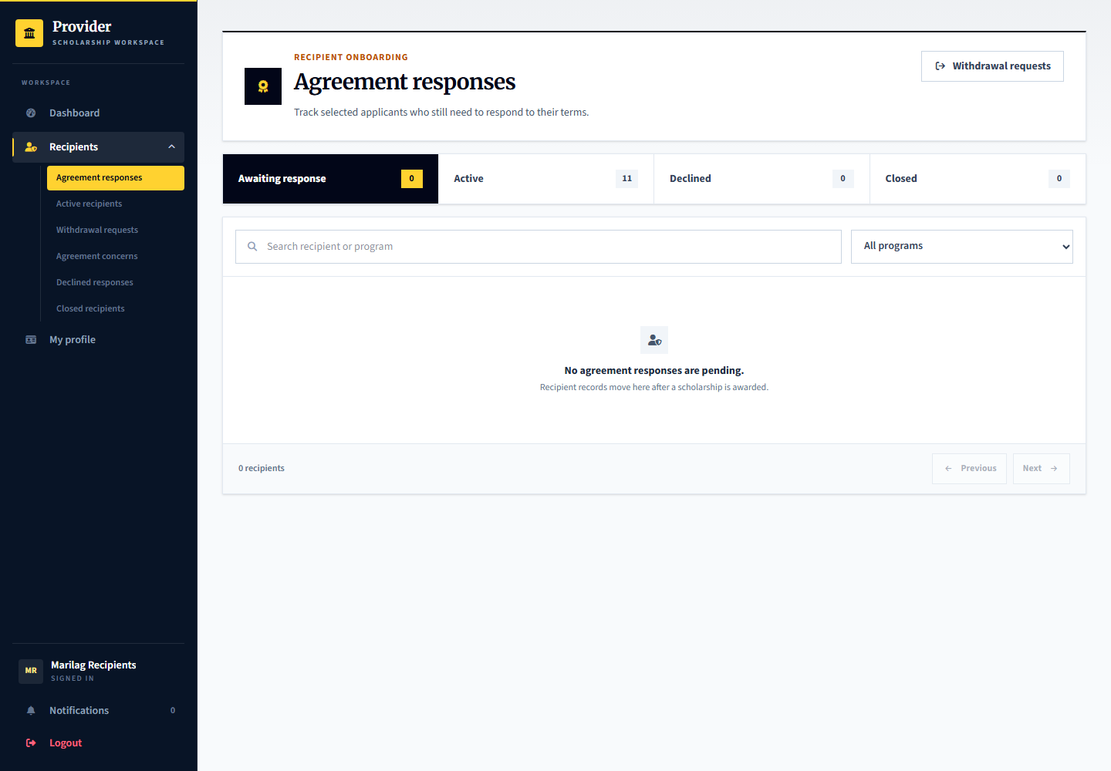
Applicant: responds to the agreement and follows accepted responsibilities. Provider: marilag.recipients manages the support record. Admin: handles independent cases or oversight when required.

20 Applicant monitoring and check in submission
Signed in account: learner.monitoring.upload
Page shown: Applicant monitoring and check in submission
The applicant opens the current check-in, reviews the requirements and deadline, and submits the requested records. Monitoring can cover more than grades when the plan includes enrollment or other agreed requirements.
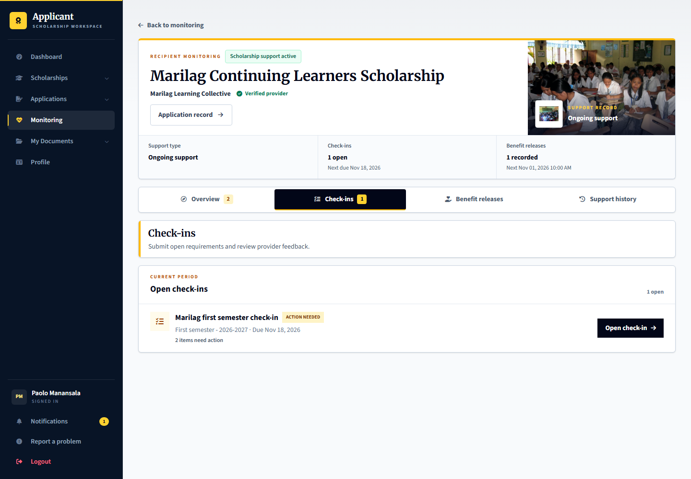
Applicant: learner.monitoring.upload prepares the submission. Provider: marilag.monitoring reviews evidence against the plan. Admin: oversees monitoring records without treating a missing document as an automatic misconduct finding.

Open a check in and submit the requested evidence
Signed in account: learner.monitoring.upload
1. Open the current check-in and read its checklist, period, instructions and deadline.
2. Select the requirement that needs your submission and inspect the requested file or information.
3. Choose a readable current file and complete any required result or acknowledgement fields.
4. Submit through the requirement form and then check the submission status. A saved upload still awaits the provider review.
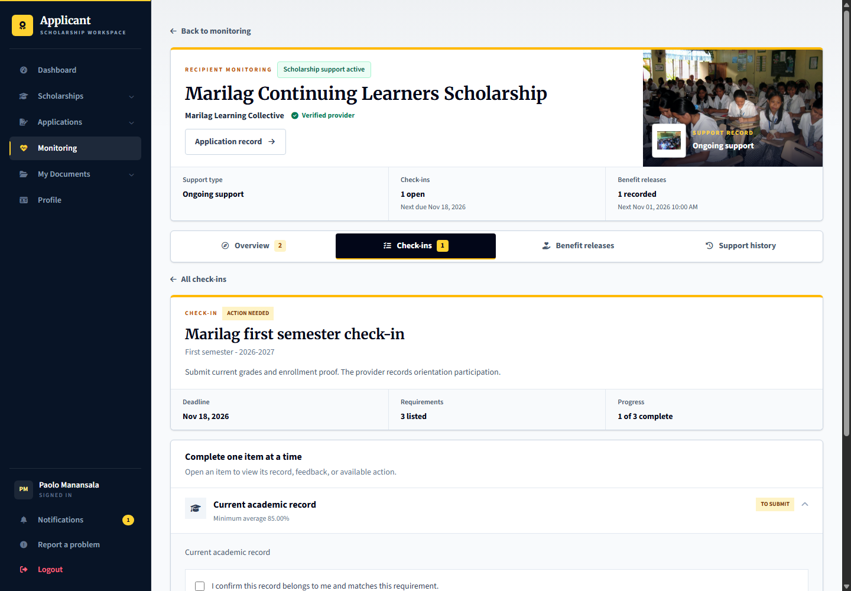
Capture only: no decision, response, upload or account change was submitted. Available actions depend on the role, current record state and completed prerequisites.

21 Provider monitoring evidence review
Signed in account: marilag.monitoring
Page shown: Provider monitoring evidence review
The monitoring officer reviews submitted checklist items, records feedback or requests correction, and handles justified adjustments through the monitoring workflow. Closing a check-in is different from deciding the entire scholarship support outcome.
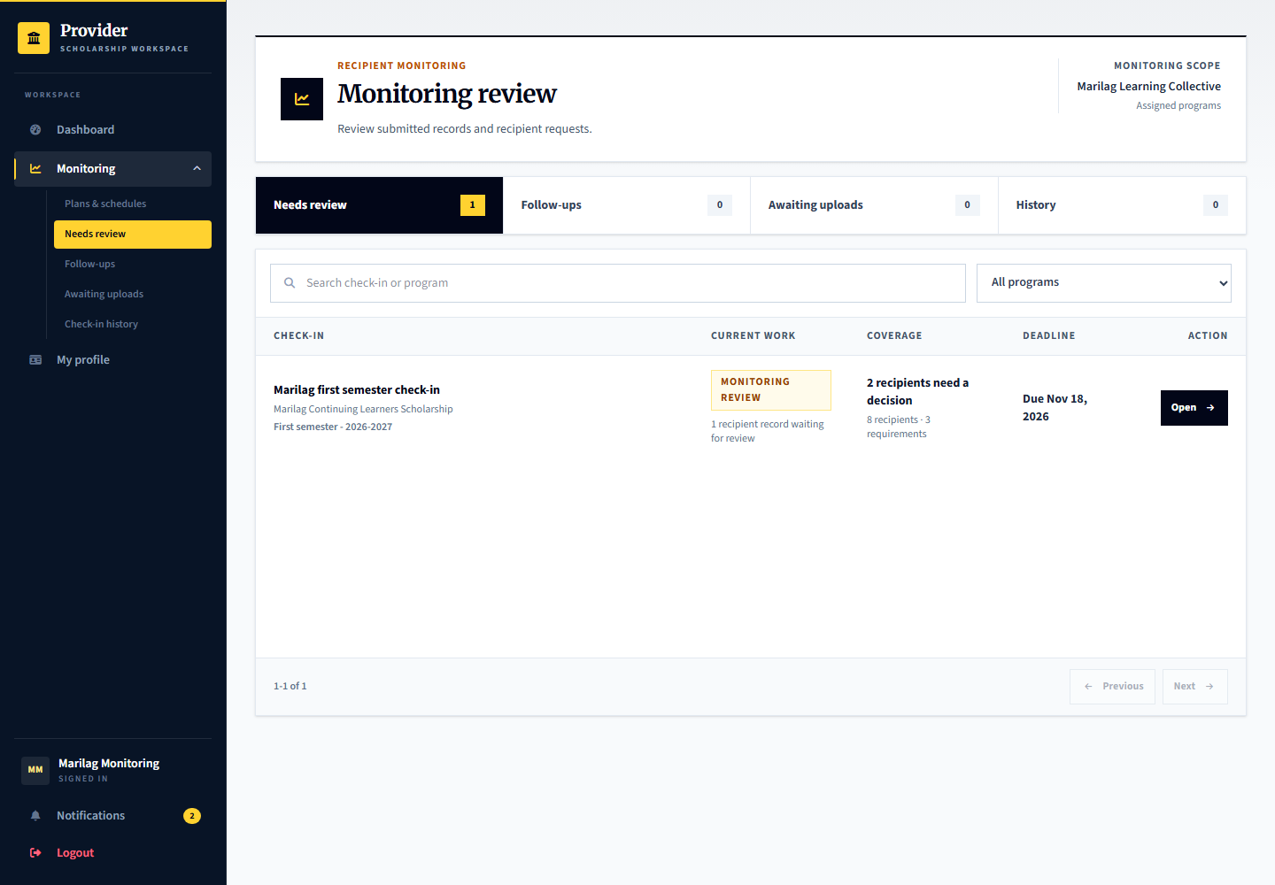
Applicant: learner.monitoring.review has submitted evidence for review. Provider: marilag.monitoring reviews it; learner.monitoring.close is ready for closing the reviewed case. Admin: platform.reviews can perform monitoring oversight.

Select a recipient and open the monitoring checklist
Signed in account: marilag.monitoring
1. Open the check-in from Monitoring review rather than stopping at the queue.
2. Choose the recipient who needs review. Querida Tolentino is the prepared submitted-evidence scenario.
3. Open each checklist requirement, inspect the uploaded record and record feedback, acceptance or a correction request as appropriate.
4. Close the monitoring case only after the checklist is ready. Closing the case is not the same as renewing or ending scholarship support.
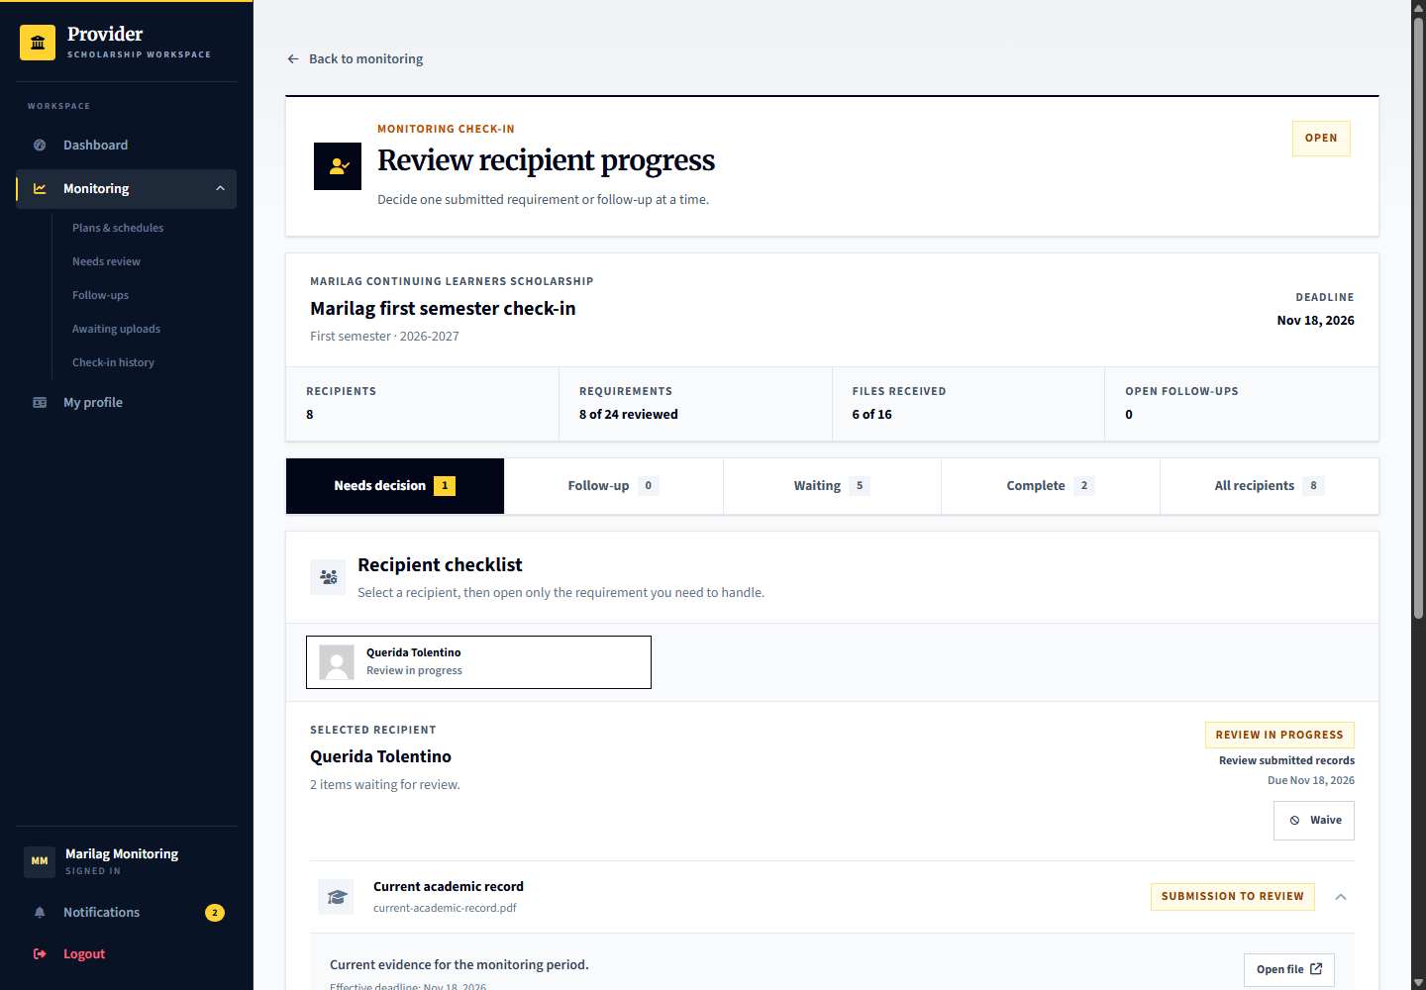
Capture only: no decision, response, upload or account change was submitted. Available actions depend on the role, current record state and completed prerequisites.

22 Admin monitoring oversight
Signed in account: platform.reviews
Page shown: Admin monitoring oversight
The review officer can inspect monitoring records and supporting evidence through its own oversight workspace. This is separate from routine provider checklist review.
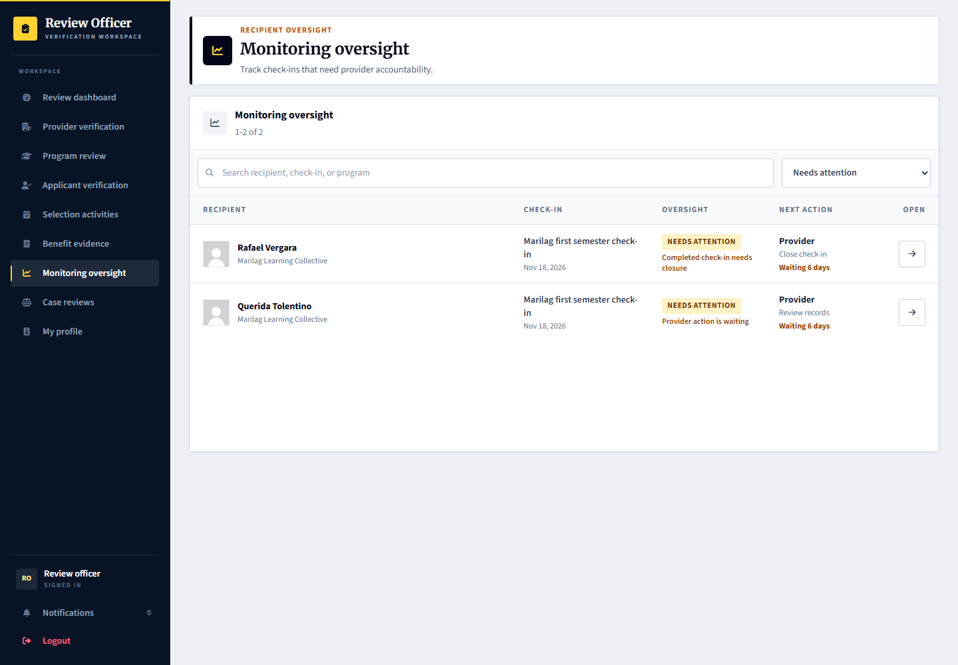
Applicant: supplies the requested evidence. Provider: performs the initial monitoring review and follow-up. Admin: records oversight through the permitted review tools, rather than silently replacing the provider records.

23 Renewal completion and support decisions
Signed in account: marilag.recipients
Page shown: Renewal completion and support decisions
The support record separates renewal, normal completion and ending support early. Sabina Ocampo has an accepted award ready for a tester-controlled support decision. Concern-related early termination is guarded by notice, response, independent review and the appeal opportunity.
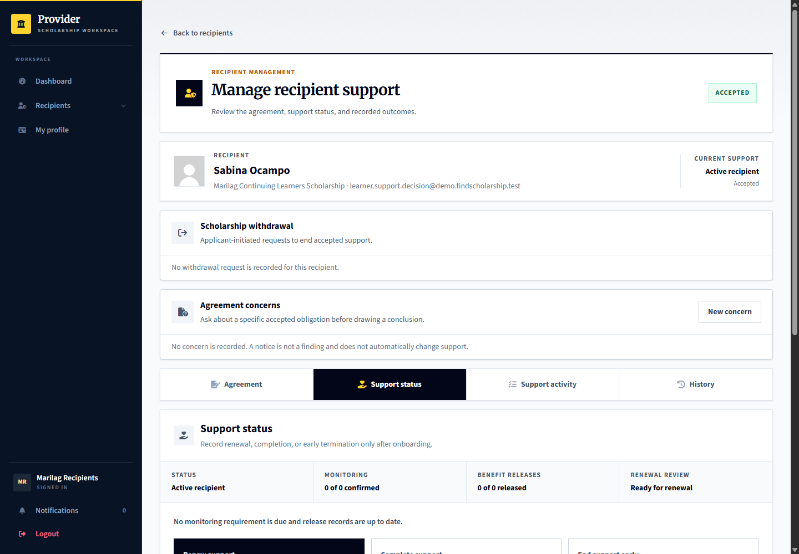
Applicant: learner.support.decision sees recorded notices and outcomes and may use the appropriate response route. Provider: marilag.recipients records a separate support decision. Admin: independently reviews escalated concerns and appeals; no automatic penalty is applied.

24 Planning the first or one time benefit release
Signed in account: marilag.releases
Page shown: Planning the first or one time benefit release
The benefit release officer can schedule the first distribution after the required agreement state without creating recurring monitoring merely to distribute a benefit. One-time awards can use no recurring monitoring policy.
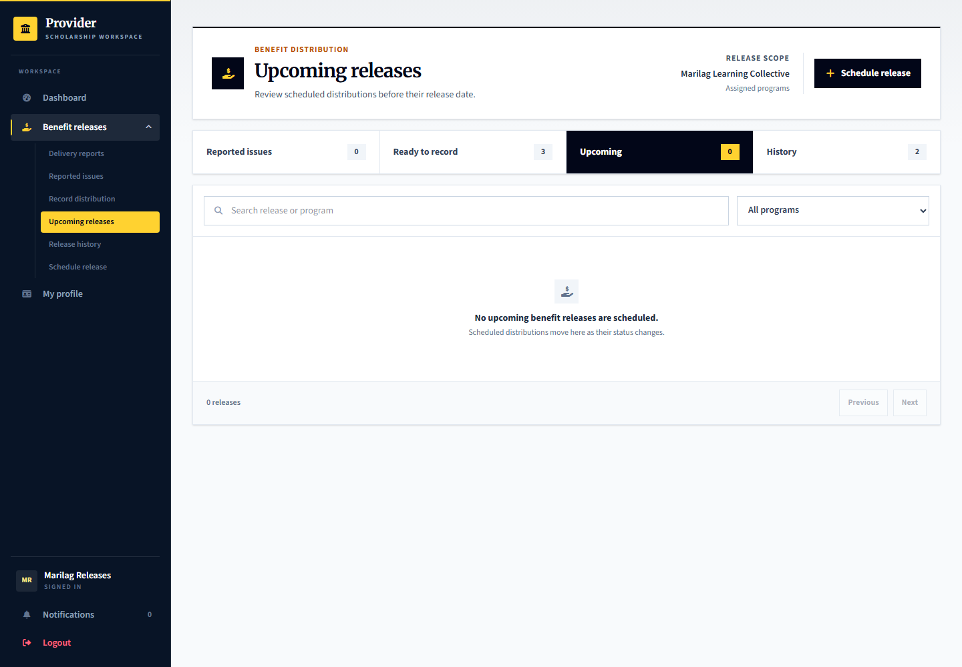
Applicant: learner.release.plan or learner.onetime.plan is ready for planning. Provider: marilag.releases schedules the benefit and instructions. Admin: checks benefit evidence or service payment records in the relevant separate workspace, not a fictitious scholarship transfer.

25 Recording actual benefit distribution
Signed in account: marilag.releases
Page shown: Recording actual benefit distribution
A published release schedule is a plan, not proof of delivery. The release officer records distribution per recipient and attaches the required delivery evidence. Mentoring or other non-cash benefits must also have clear delivery or participation instructions.
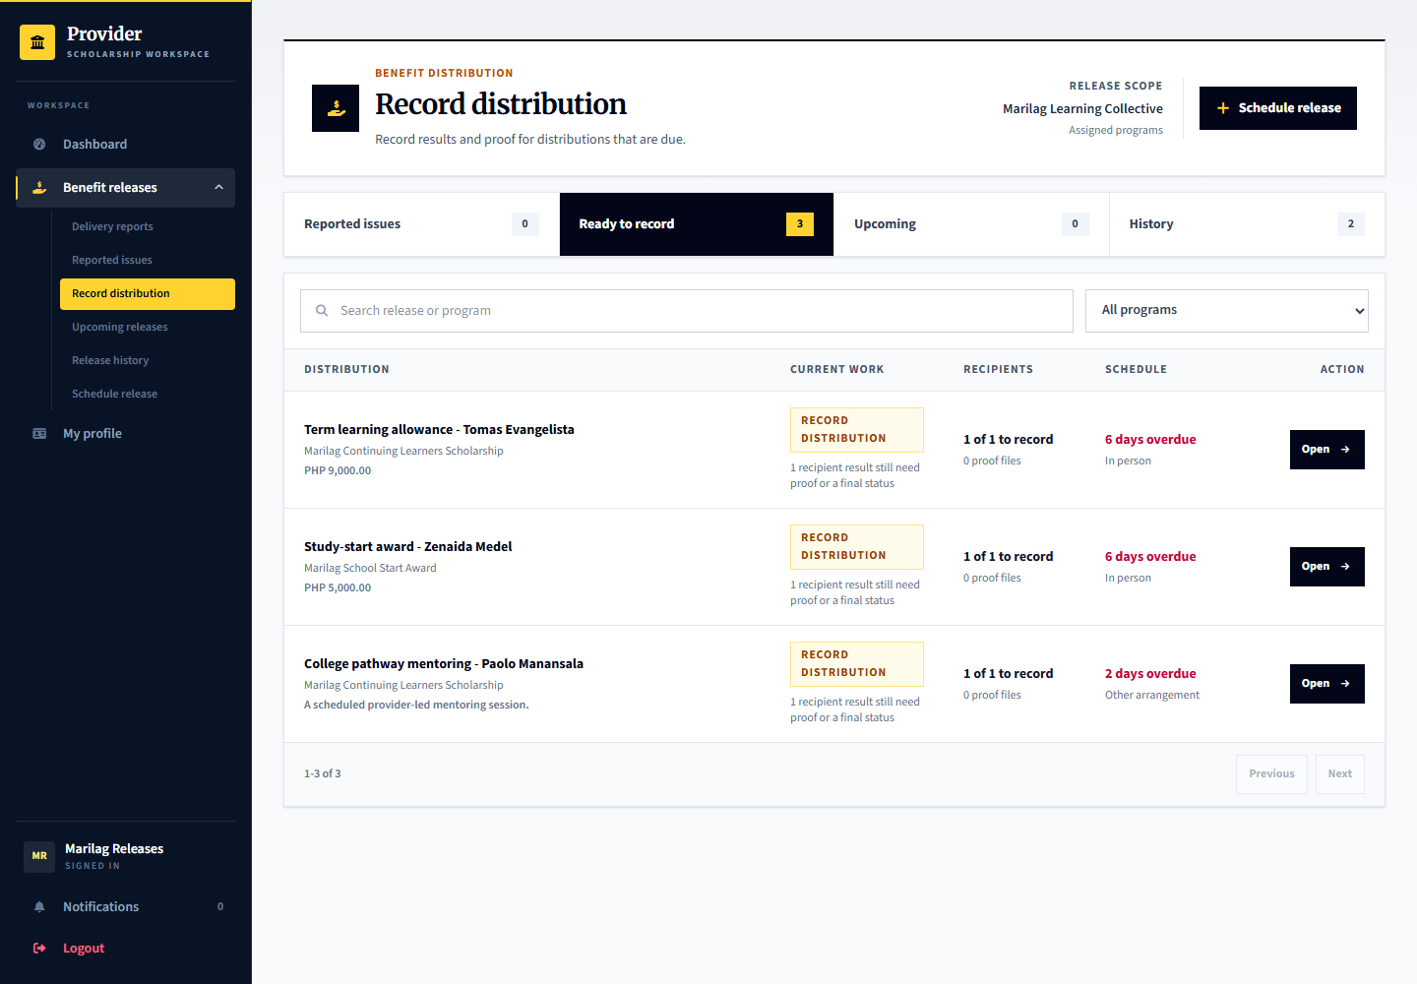
Applicant: learner.release.record and learner.onetime.record await provider distribution recording. Provider: marilag.releases records the distribution. Admin: can inspect benefit evidence; demo payment and benefit records do not prove real transfers.

Open the distribution record and record delivery
Signed in account: marilag.releases
1. Select the relevant release from Record distribution and confirm the title, schedule and recipients.
2. Select the intended recipient and inspect the current distribution status before entering a result.
3. Record actual delivery details and attach required proof. Do not mark a scheduled event as delivered merely because its date arrived.
4. The applicant must still confirm receipt or report an issue. Provider evidence alone cannot make that response for the applicant.
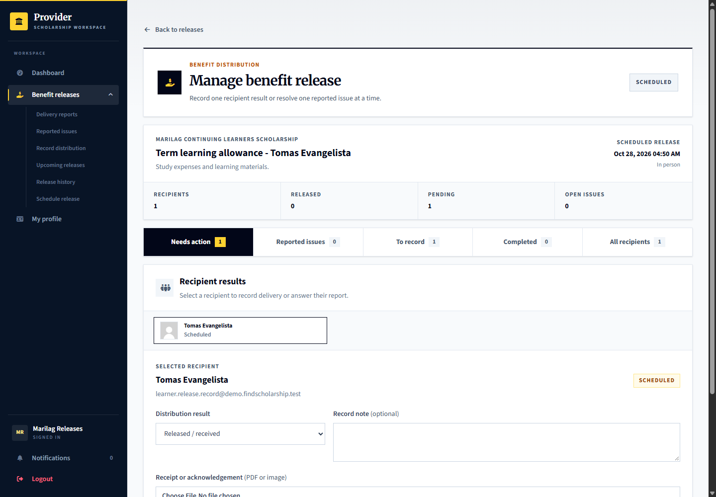
Capture only: no decision, response, upload or account change was submitted. Available actions depend on the role, current record state and completed prerequisites.

26 Applicant receipt and delivery reports
Signed in account: learner.release.confirm
Page shown: Applicant receipt and delivery reports
The applicant reviews recorded benefits and confirms actual receipt or reports missing, partial, or unclear delivery. A provider statement or upload alone does not count as the applicant confirming receipt.
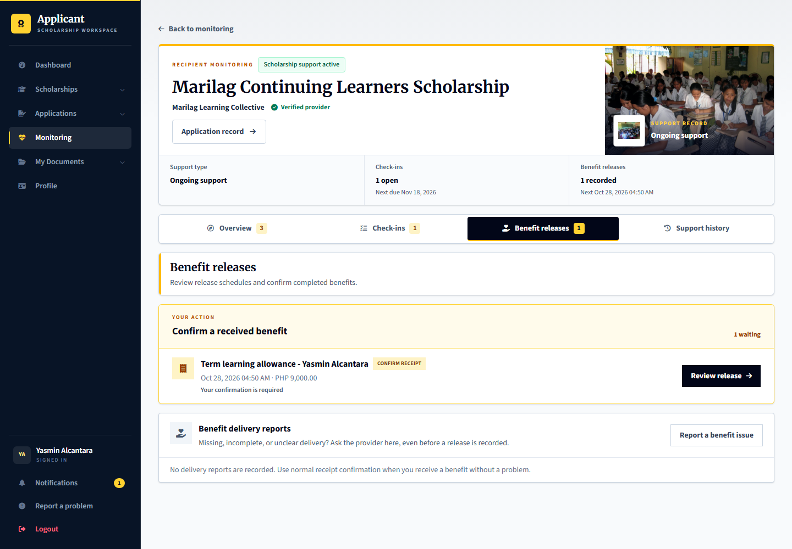
Applicant: learner.release.confirm is the recurring-support example and learner.onetime.confirm the one-time example. Provider: marilag.releases responds to delivery reports and supplies correction proof. Admin: can independently review escalated delivery cases but cannot substitute its finding for receipt confirmation.

Open a benefit record before confirming receipt
Signed in account: learner.release.confirm
1. Open the relevant benefit record rather than confirming from the list alone.
2. Read the recorded distribution details, benefit amount or description, and any available proof.
3. Confirm receipt only if you actually received the stated benefit. If it is missing or incomplete, use the delivery-issue response.
4. When a response is already recorded, inspect its status and history instead of sending a duplicate confirmation.
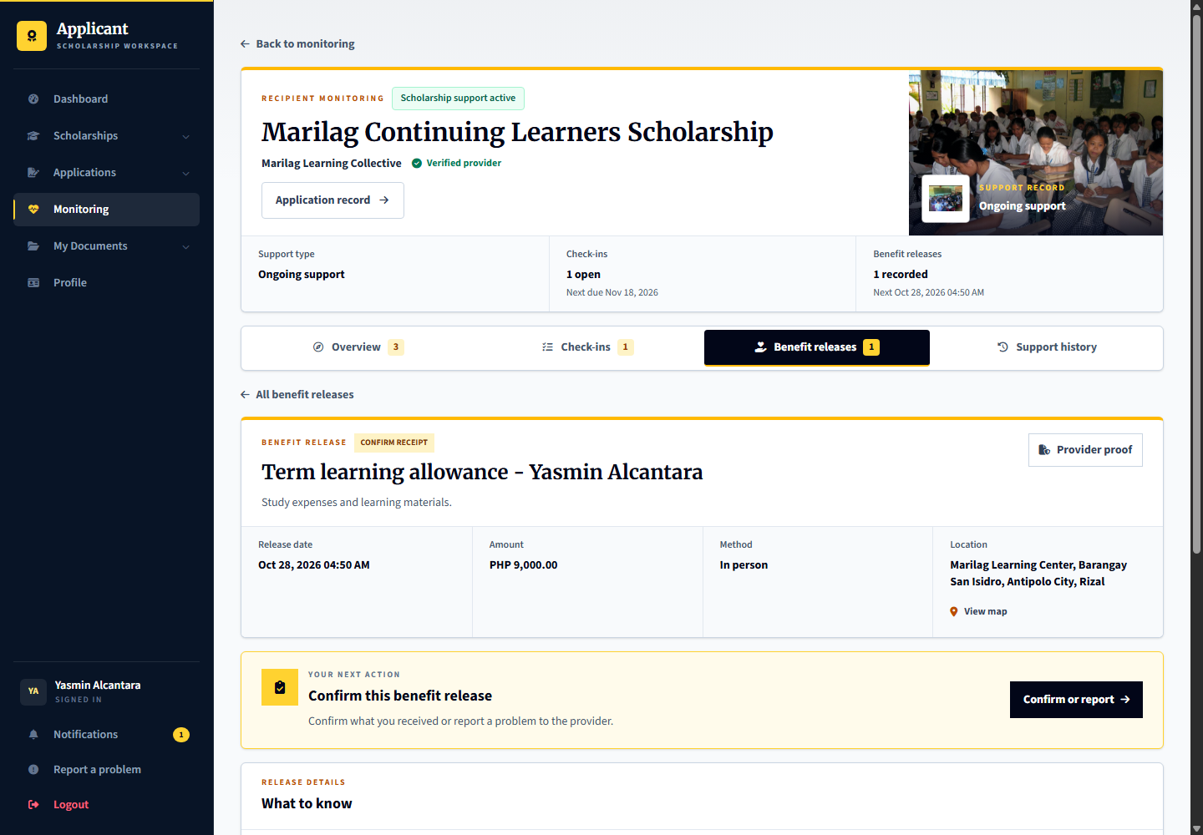
Capture only: no decision, response, upload or account change was submitted. Available actions depend on the role, current record state and completed prerequisites.

27 Recipient withdrawal requests
Signed in account: learner.support.decision
Page shown: Recipient withdrawal section
An accepted recipient can request withdrawal with an explanation. A request does not immediately erase the agreement or decide every support consequence. It is separate from alleging misconduct and from withdrawing an application before award.
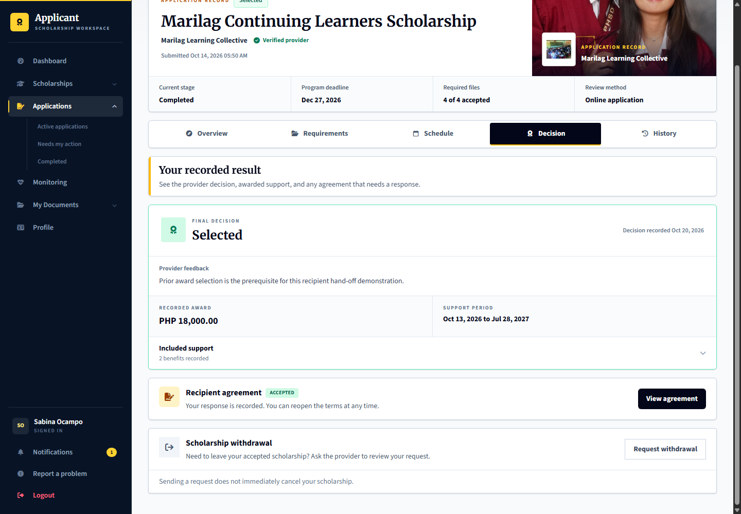
Applicant: learner.support.decision submits or cancels an eligible request. Provider: marilag.recipients reviews it in Withdrawal requests and records the outcome. Admin: handles any appropriate platform support or independent review rather than silently changing the provider decision.

28 Agreement concerns before conclusions
Signed in account: marilag.recipients
Page shown: Agreement concerns before conclusions
Agreement concerns begin as private drafts with a specific accepted obligation, factual explanation and proof. Sending the notice gives the applicant an opportunity to respond; a notice is not a confirmed breach. The live queue starts empty until a tester creates a case.
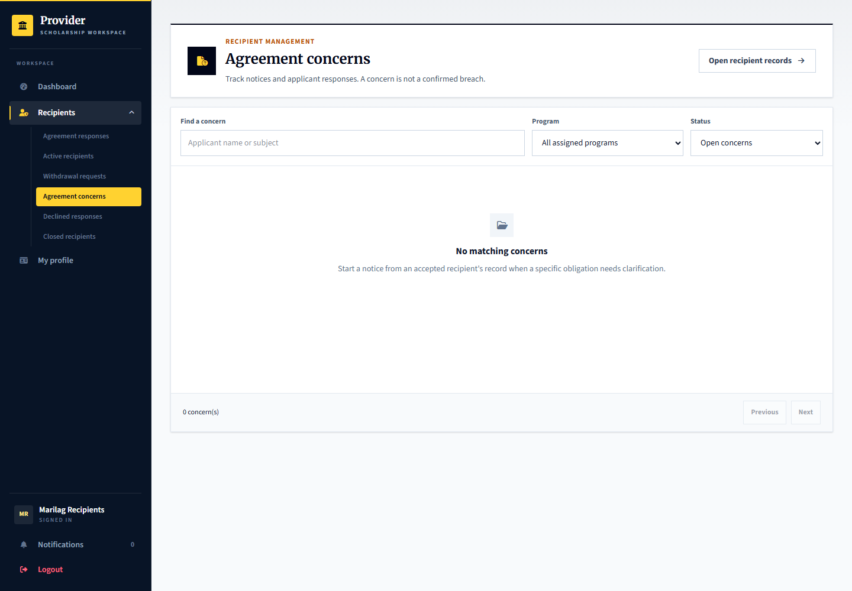
Applicant: learner.support.decision can respond to a concern created for Sabina. Provider: marilag.recipients prepares and issues notices. Admin: platform.reviews receives cases only when independently escalated. No cases were seeded merely to fill this page.

29 Provider delivery investigation and correction
Signed in account: marilag.releases
Page shown: Provider delivery investigation and correction
The release officer responds to missing-benefit reports, requests information or proposes a documented delivery correction. The report stays unresolved until the applicant confirms receipt or gives the appropriate response.
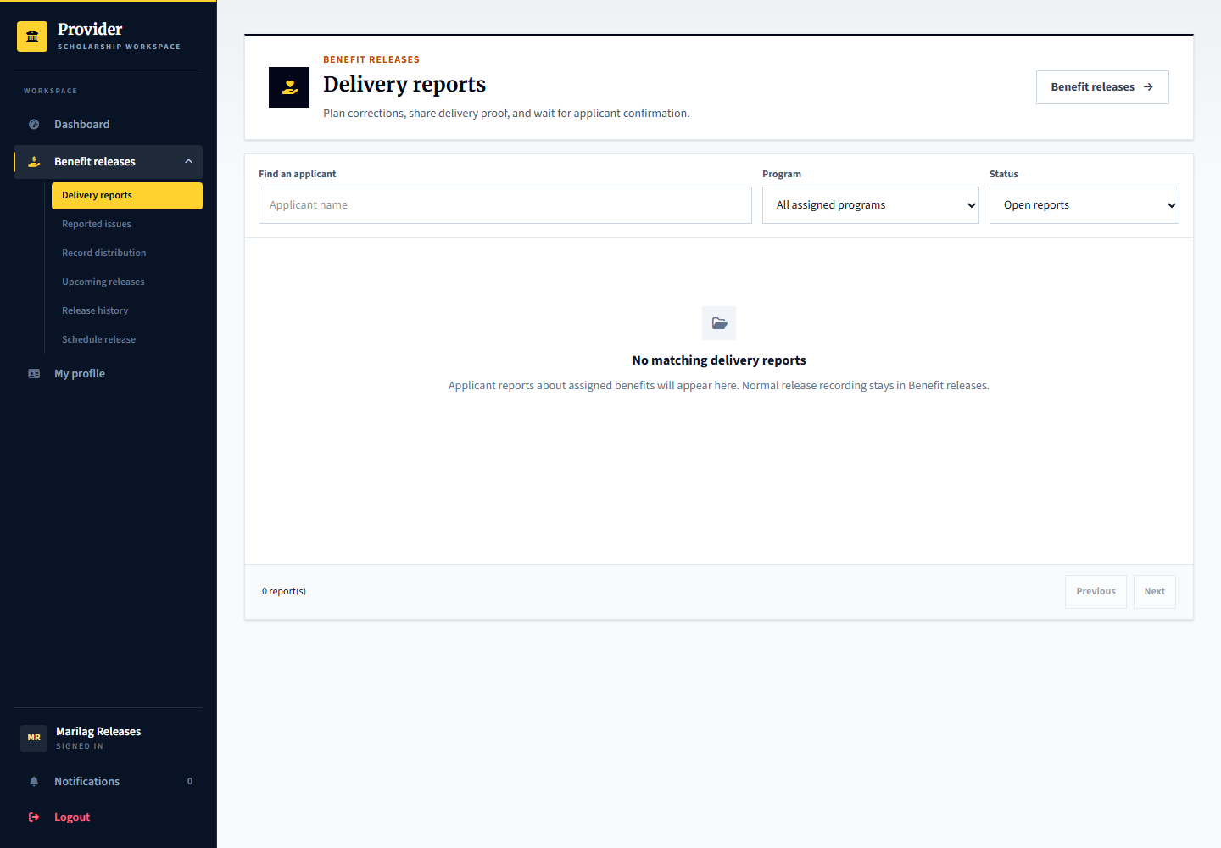
Applicant: learner.release.confirm can report an issue from its benefit page. Provider: marilag.releases investigates and supplies proof. Admin: may recommend follow-up on an escalated delivery review but cannot penalize the applicant for reporting a missing benefit.

30 Independent review appeals and privacy
Signed in account: platform.reviews
Page shown: Independent review appeals and privacy
The admin reviewer examines the accepted obligation or benefit, evidence, statements and response opportunity, then records a reasoned outcome. A different authorized reviewer must decide an appeal of the first reviewers outcome. Privacy and access details are collapsed inside an opened case.
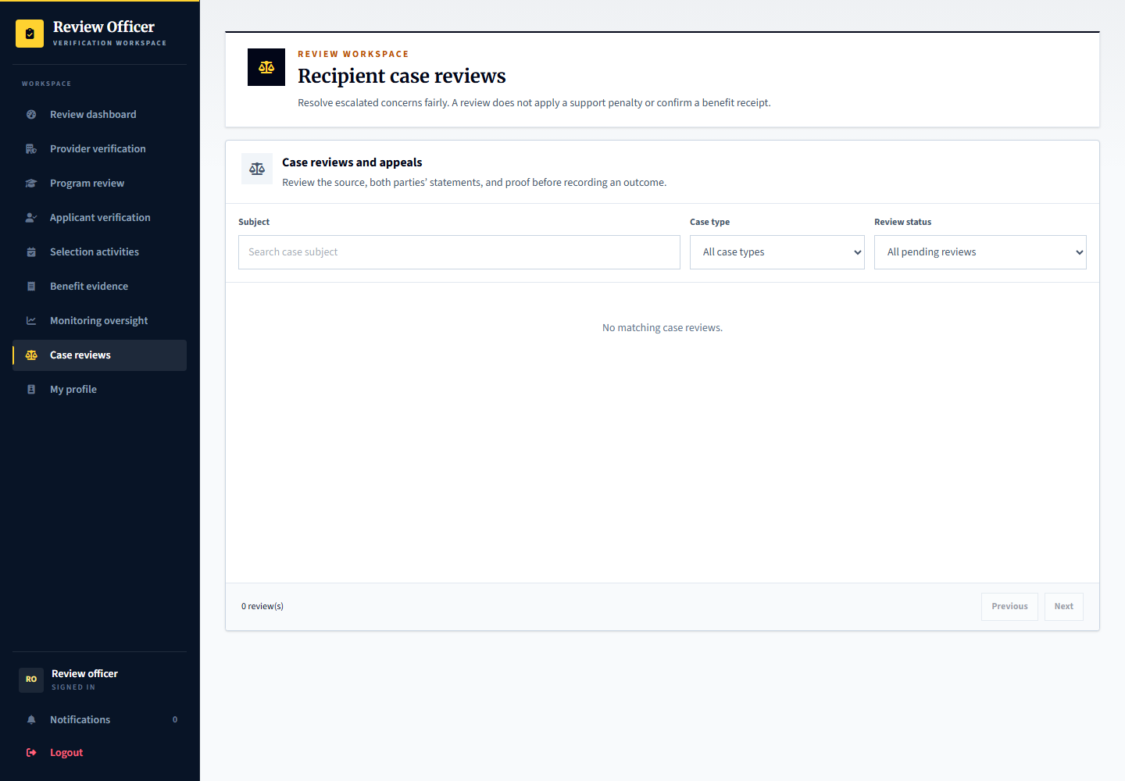
Applicant: may submit information and appeal. Provider: may request independent review but cannot decide its own appeal. Admin: platform.reviews handles the initial case and platform.manager can provide a different authorized reviewer. Cross-provider sharing stays disabled; no blacklist or automatic rejection is created.

Inspect and decide an escalated case
Signed in account: platform.reviews
Illustrative local browser test of the platform UI. The case and write responses were mocked; this is not a hosted case or a decision saved to the demo database.
1. Select a case from Case reviews after a party requests independent review.
2. Compare the accepted source, original proof and statements; request more information if the record is incomplete.
3. Choose a finding and recommendation explicitly, cite the proof considered and explain the reasons.
4. Complete the source and response acknowledgements before Record outcome. This does not automatically end support or confirm receipt.
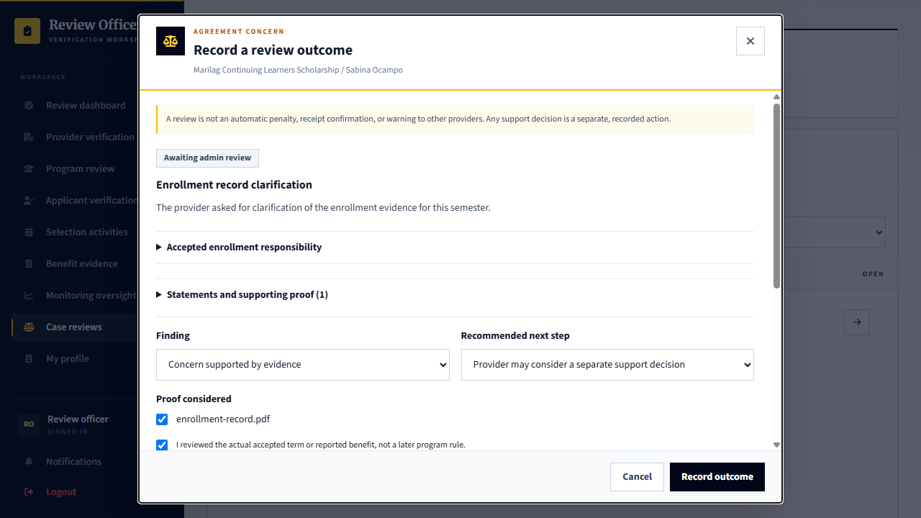
Capture only: no decision, response, upload or account change was submitted. Available actions depend on the role, current record state and completed prerequisites.

Record an internal privacy assessment
Signed in account: platform.reviews
Illustrative local browser test of the platform UI. The case and write responses were mocked; this is not a hosted case or a decision saved to the demo database.
1. Expand Privacy and access inside the opened case, then choose Record internal assessment.
2. Document the purpose, reasons, recheck date and any justified retention hold.
3. A case change or appeal supersedes an earlier assessment; it does not automatically release a retention hold.
4. Saving this assessment does not enable sharing with another provider or create a blacklist.
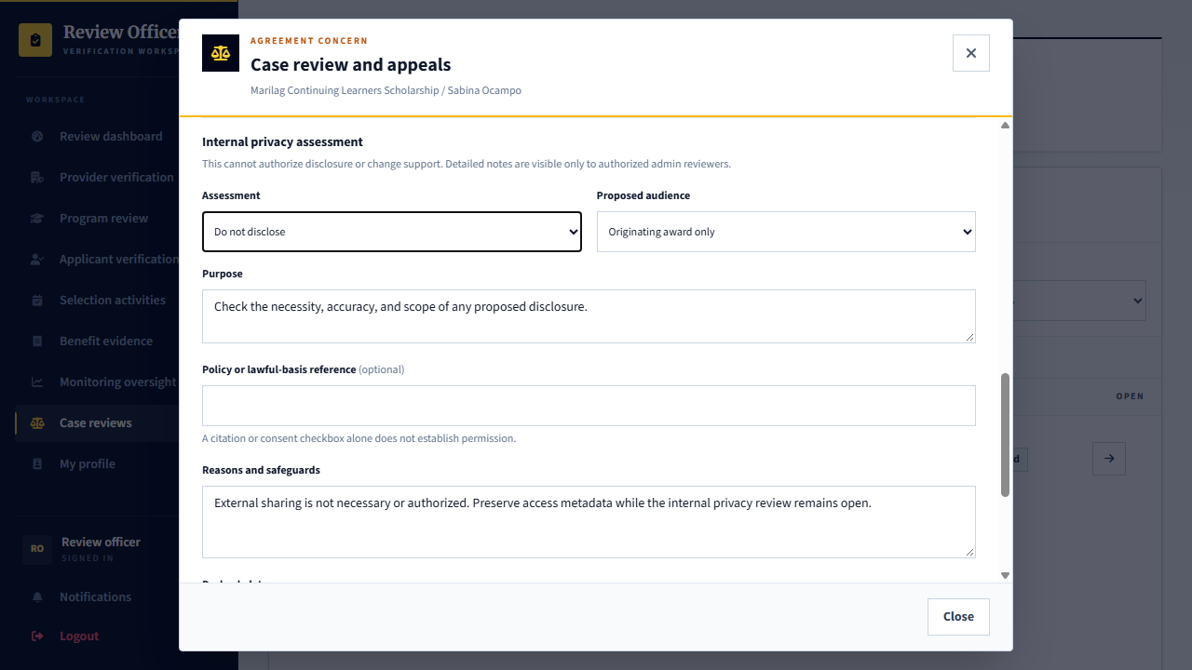
Capture only: no decision, response, upload or account change was submitted. Available actions depend on the role, current record state and completed prerequisites.

Respect independent appeal review
Signed in account: platform.reviews
Illustrative local browser test of the platform UI. The case and write responses were mocked; this is not a hosted case or a decision saved to the demo database.
1. An applicant can appeal the recorded review outcome through its case dialog.
2. The officer who made the original outcome cannot decide that appeal.
3. A different authorized admin reviews the preserved evidence and appeal explanation.
4. The original review and any separate support decision remain part of history; an appeal is not an automatic reversal.
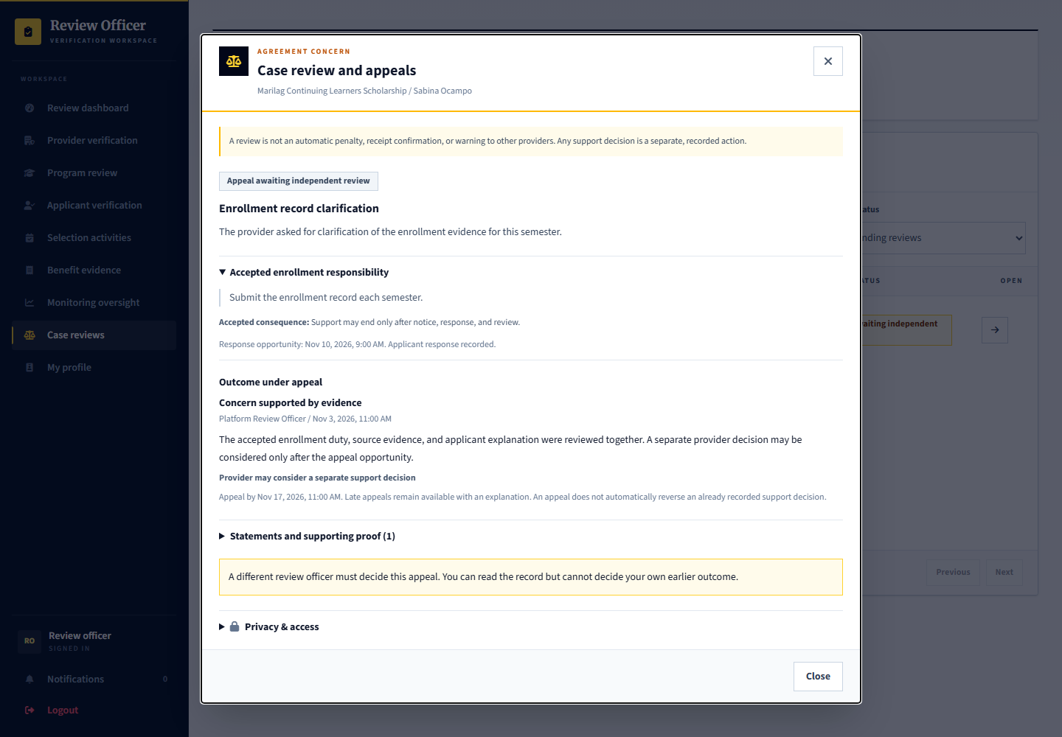
Capture only: no decision, response, upload or account change was submitted. Available actions depend on the role, current record state and completed prerequisites.

31 Provider support and platform reports
Signed in account: marilag.support
Page shown: Provider support and platform reports
Provider support staff handle questions and track replies within their organization. Platform problems and privacy requests can be escalated through the platform support process rather than changing an applicant decision informally.
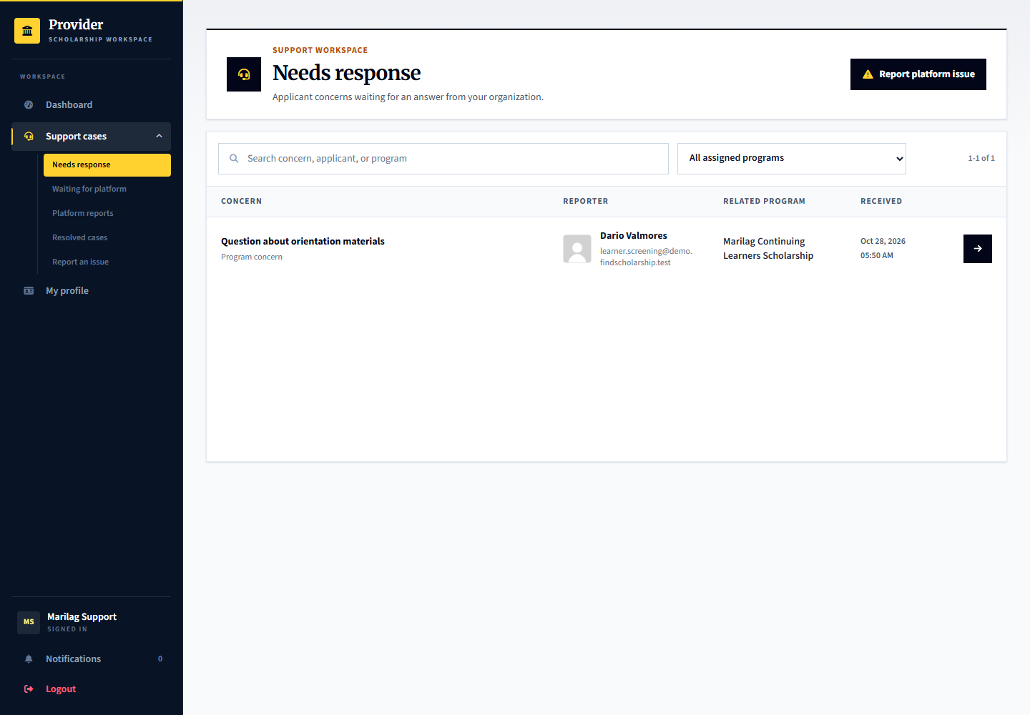
Applicant: uses its permitted help or problem-report entry points. Provider: marilag.support handles its inbox and platform escalations. Admin: platform.support handles platform-level support and privacy follow-up.

32 Admin support case handling
Signed in account: platform.support
Page shown: Admin support case handling
The support officer works from its own response queue and keeps case discussion and resolution recorded. A support reply is not a scholarship selection result, evidence approval or independent misconduct finding.
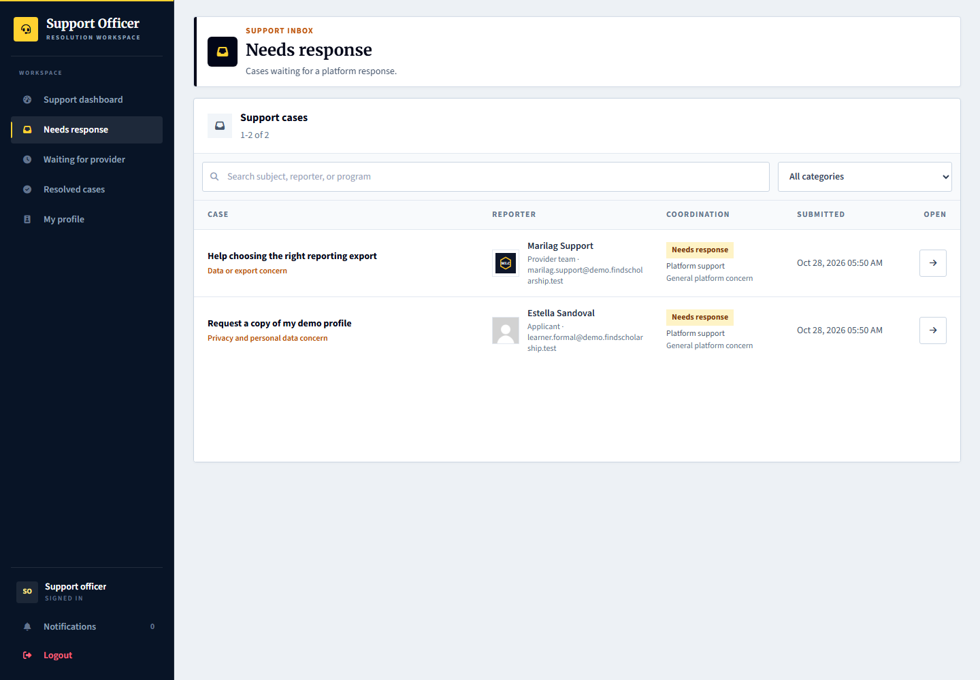
Applicant and provider: supply the relevant facts and respond to requests. Admin: platform.support routes and resolves platform issues using the support workspace.

Open a platform support case and respond
Signed in account: platform.support
1. Select the support case from Needs response and read the original report and conversation.
2. Check the requesting account, related program or page, and any attachments.
3. Use the response controls to ask for specific information or explain the resolution; set the appropriate case status when justified.
4. A support reply does not change a scholarship selection or replace an independent review. This screenshot does not send a reply.
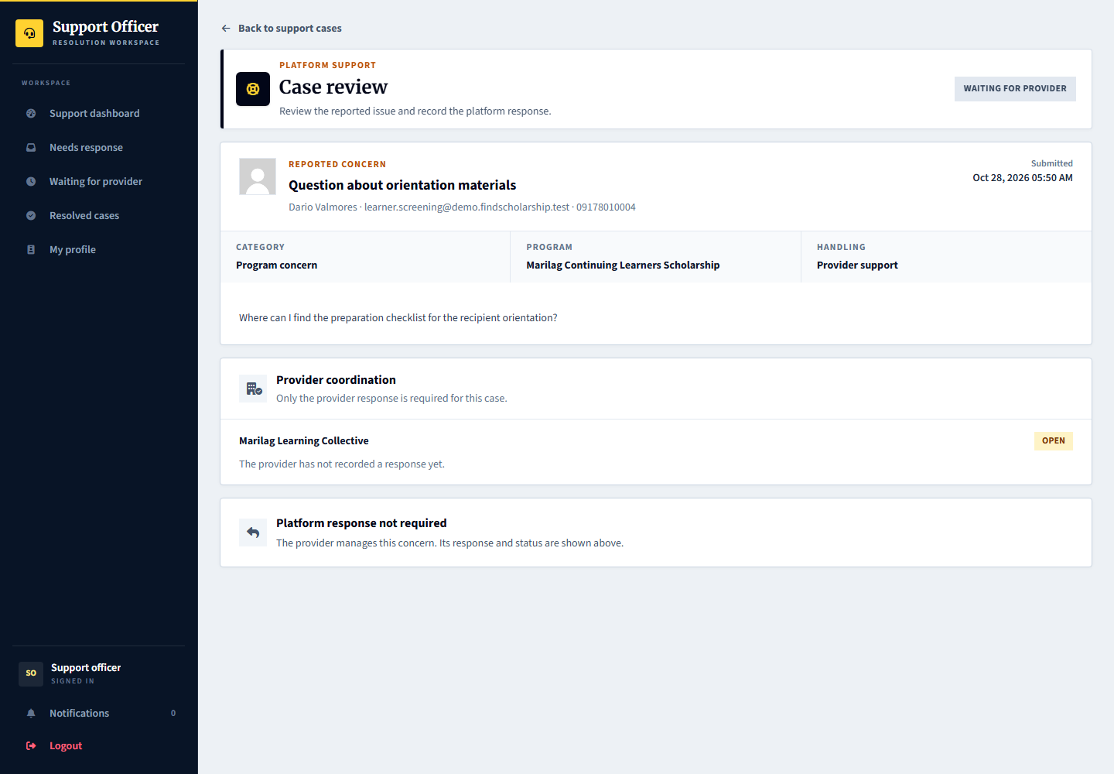
Capture only: no decision, response, upload or account change was submitted. Available actions depend on the role, current record state and completed prerequisites.

33 Provider staff and program assignment
Signed in account: marilag.team
Page shown: Provider staff and program assignment
The team administrator manages staff access, role responsibilities and assigned scholarships. Limited program assignment prevents a staff member from automatically working on every program. Newly invited staff complete their first-login setup.
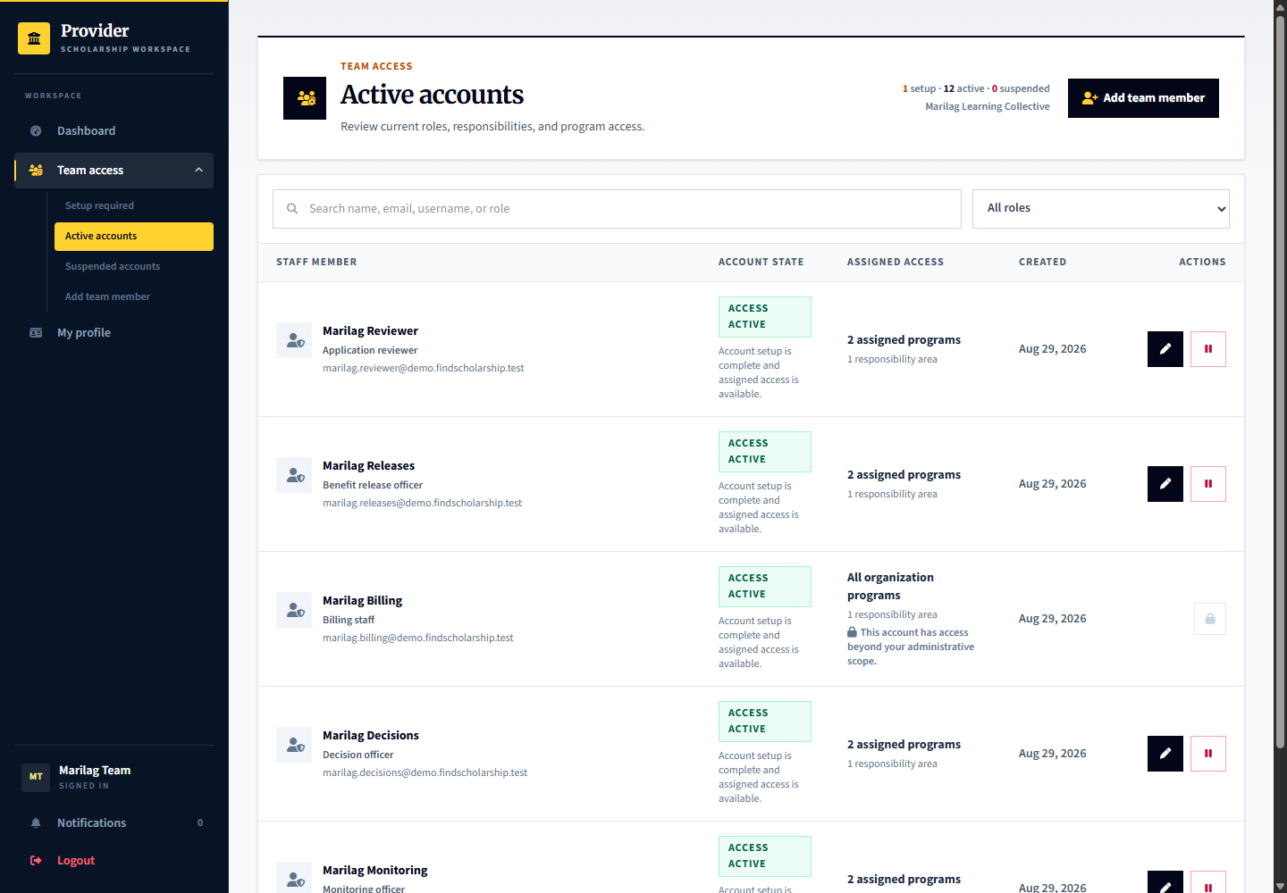
Applicant: has no staff-management access. Provider: marilag.team manages access; marilag.newstaff demonstrates first-login setup. Admin: platform.accounts manages platform account controls separately.

34 Admin account management
Signed in account: platform.accounts
Page shown: Admin account management
The account manager handles account access and managed-account administration in its own workspace. Account access changes should not be confused with profile or provider verification.
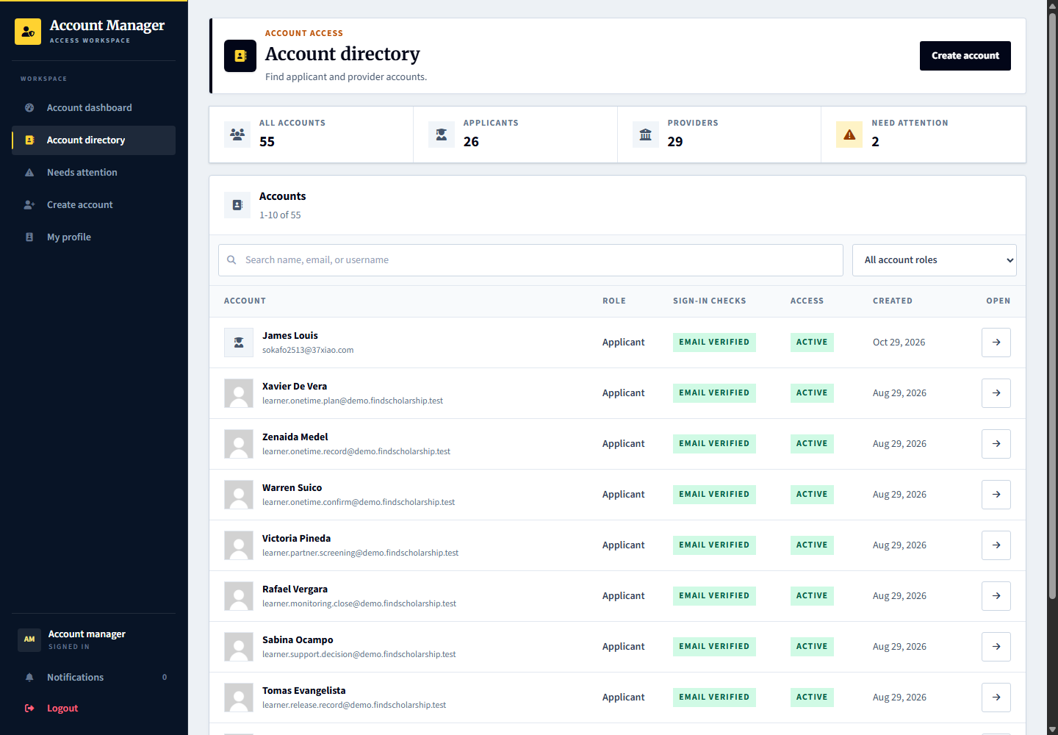
Applicant and provider: use their own profile and account settings. Admin: platform.accounts handles account controls, while platform.reviews performs verification and superadmin handles governance.

Inspect and manage the selected account
Signed in account: platform.accounts
1. Select the account from Account directory and verify the person, role, status and organization context.
2. Review the available access and setup controls for that account rather than acting from a similarly named row.
3. Use only the intended account action and review any confirmation or required explanation.
4. Do not confuse access status, a password reset or managed-account setup with profile verification. No account change is submitted here.
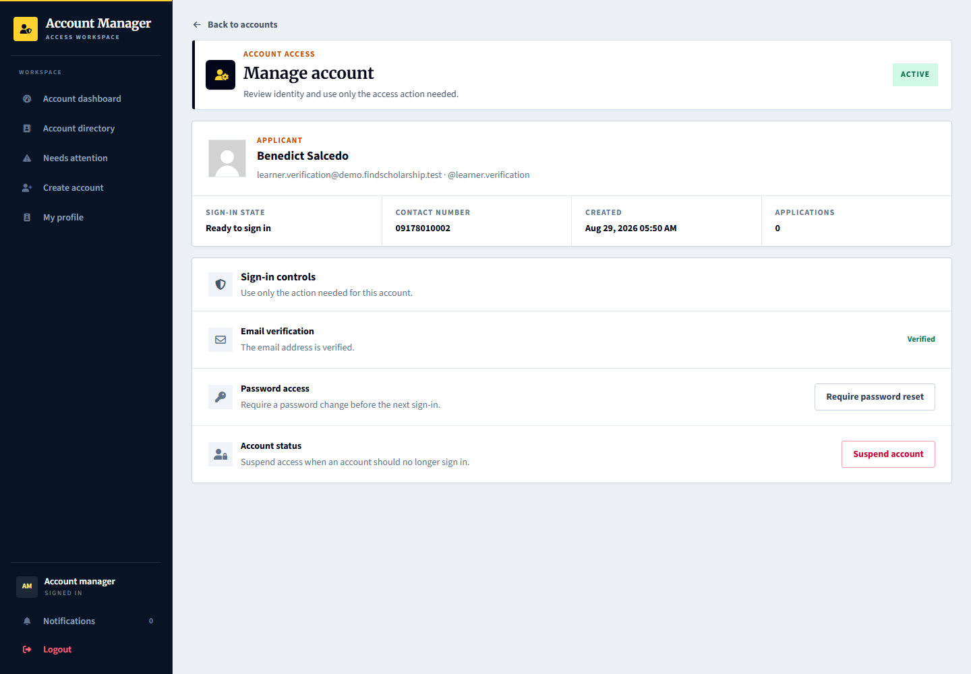
Capture only: no decision, response, upload or account change was submitted. Available actions depend on the role, current record state and completed prerequisites.

35 Provider paid services and requests
Signed in account: marilag.billing
Page shown: Optional support services
The provider billing role reviews available platform services, submits intake information, follows checkout and tracks delivery, files, meetings and acceptance. These are provider-to-platform services, not scholarship payments to applicants.
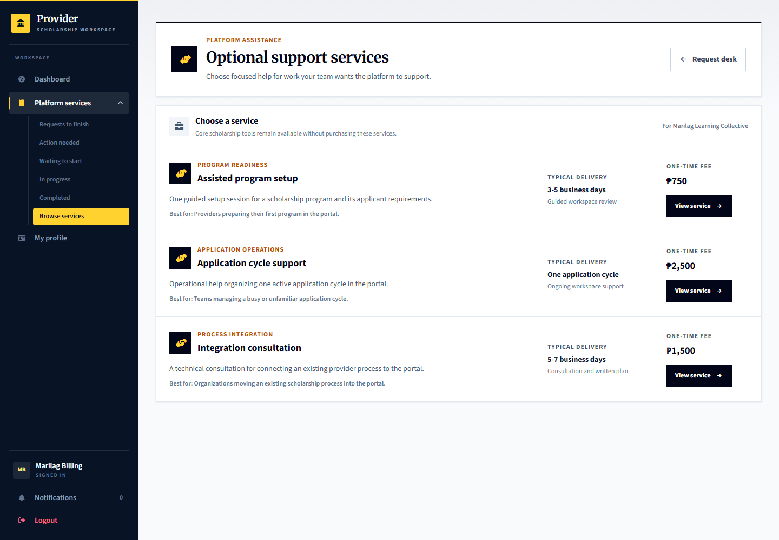
Applicant: is not the purchaser in this workflow. Provider: marilag.billing follows request, payment and delivery steps. Admin: platform.billing processes service delivery; platform.finance reviews financial records. Existing paid demo records are simulated.

Review service work and delivered files
Signed in account: marilag.billing
1. Open a service request from your provider billing workspace.
2. Review intake, updates, delivered files and meeting information for the actual purchased service.
3. Use the appropriate response or acceptance controls after checking the delivered work, rather than treating checkout as completed service.
4. These services are purchased by the provider from the platform. They are separate from scholarship benefits received by applicants.
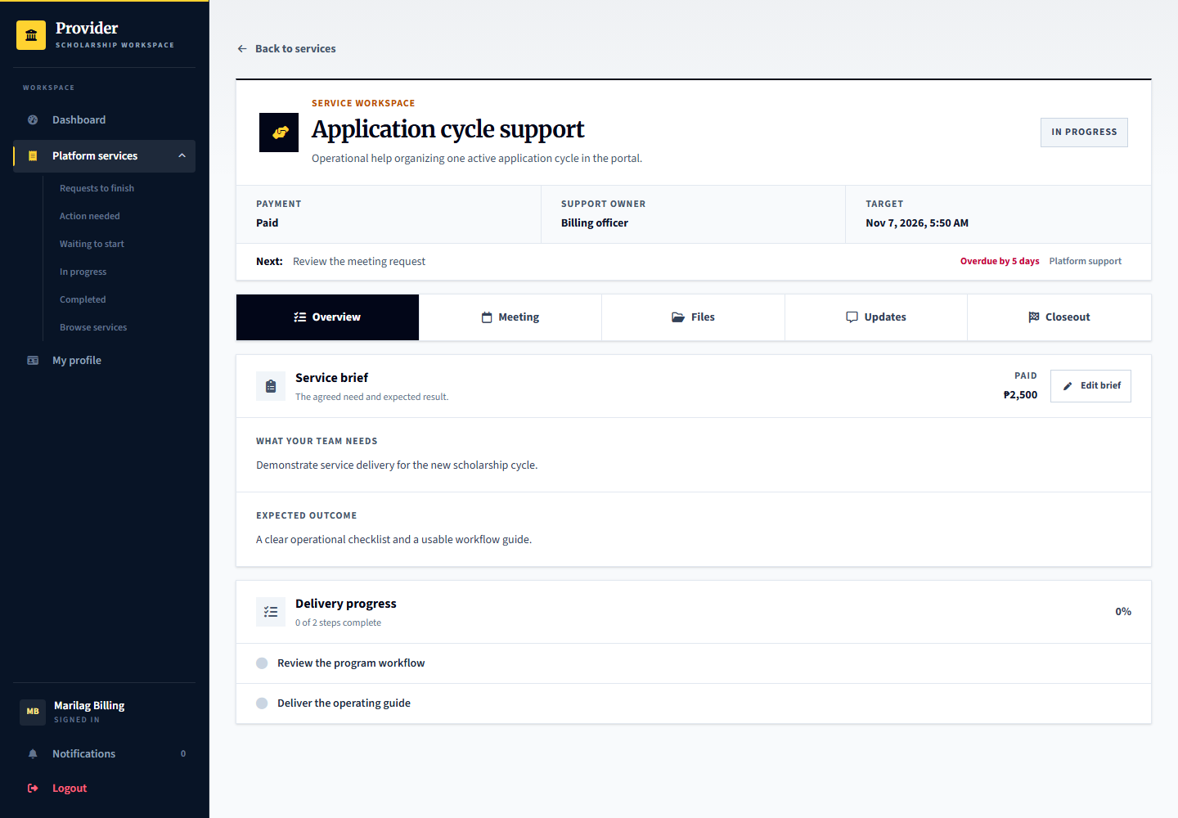
Capture only: no decision, response, upload or account change was submitted. Available actions depend on the role, current record state and completed prerequisites.

36 Admin service intake delivery and closeout
Signed in account: platform.billing
Page shown: Service request dashboard
The billing officer handles the service queue, intake readiness, assignment, delivery work, files and meetings, then closeout or provider acceptance where required. Status changes must reflect the actual step rather than treating checkout as delivered work.
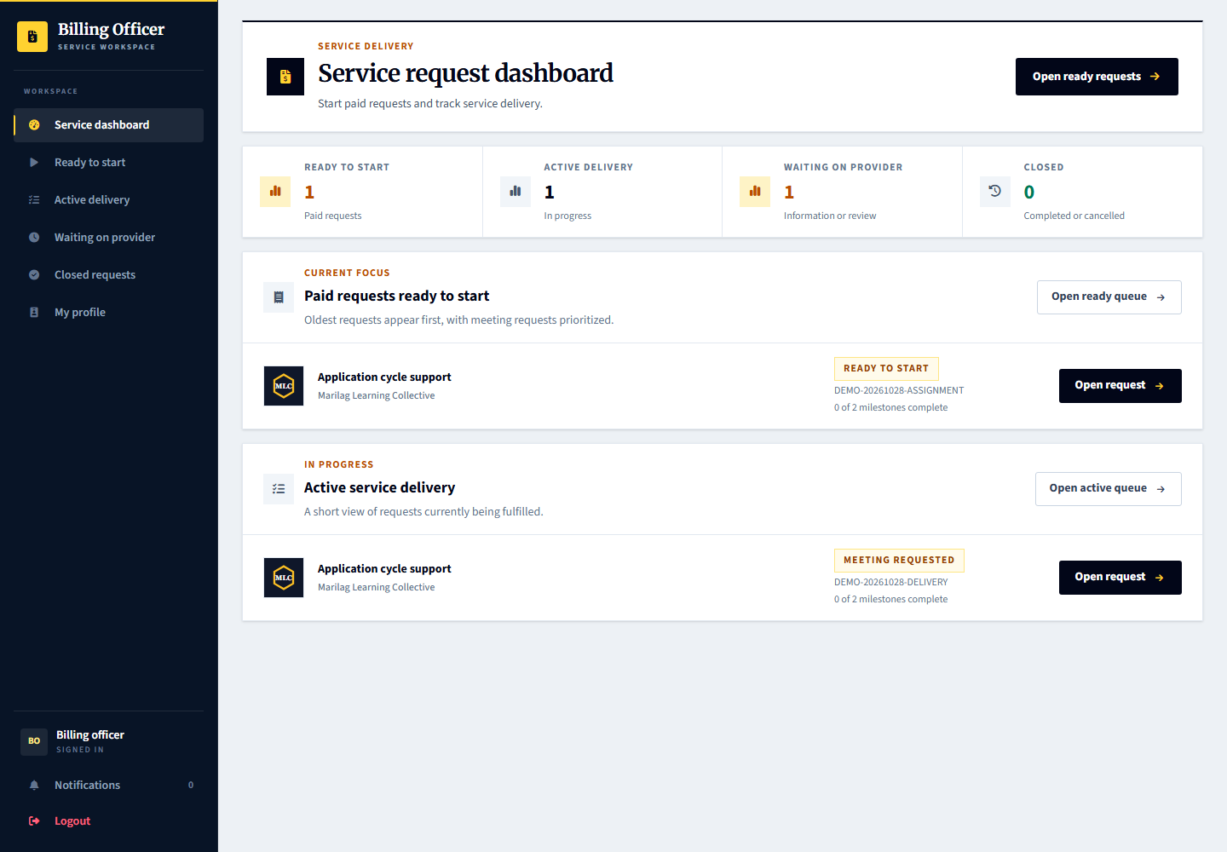
Provider: marilag.billing supplies intake information and reviews delivered work. Admin: platform.billing manages operational delivery. Applicant: no direct role in purchasing these provider services.

Work inside a service request
Signed in account: platform.billing
1. Open the request from the billing work queue and review its intake and current service stage.
2. Inspect the delivery section and the related files, meeting and updates tabs before deciding what is outstanding.
3. Record work, upload deliverables or arrange the required review through the corresponding controls.
4. Complete or close the service only after its workflow requirements and any provider acceptance are satisfied; payment is not delivery.
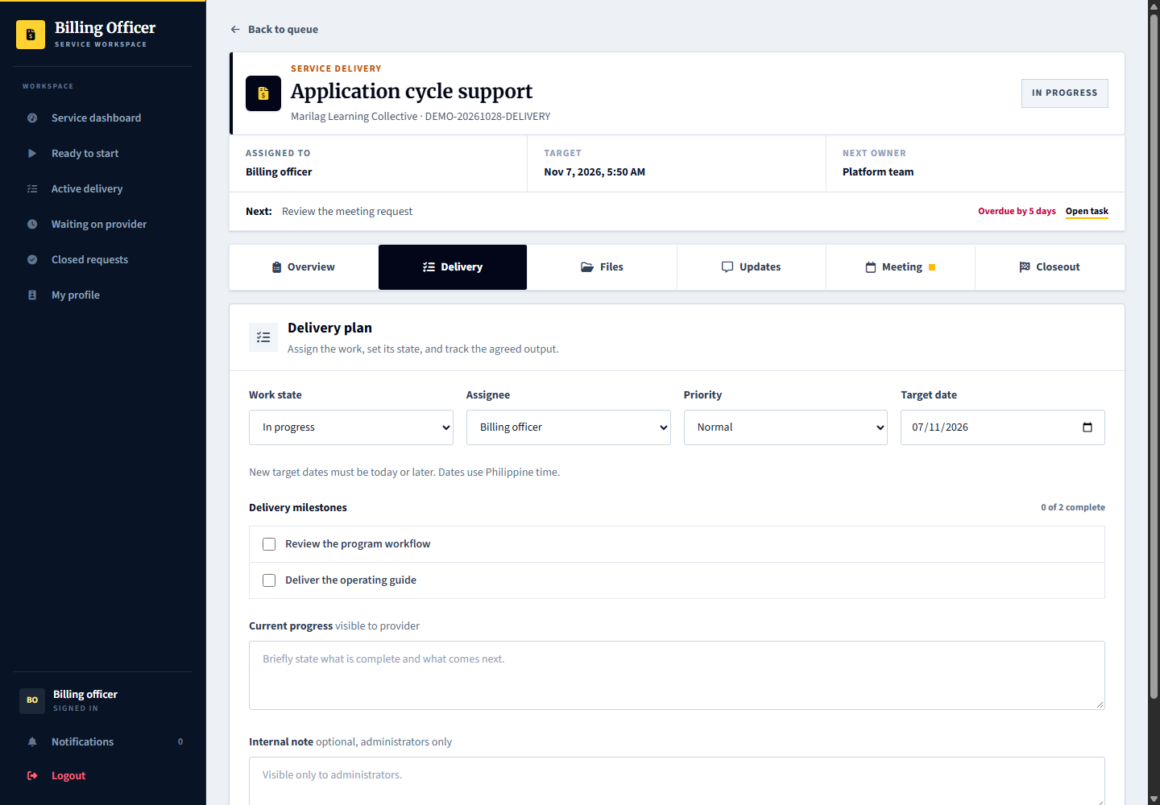
Capture only: no decision, response, upload or account change was submitted. Available actions depend on the role, current record state and completed prerequisites.

37 Admin finance and payment records
Signed in account: platform.finance
Page shown: Confirmed payments
The finance officer reviews payment records, receipts and exceptions in its own workspace. Payment status and service delivery status are separate. Demo paid records do not mean real money was transferred.
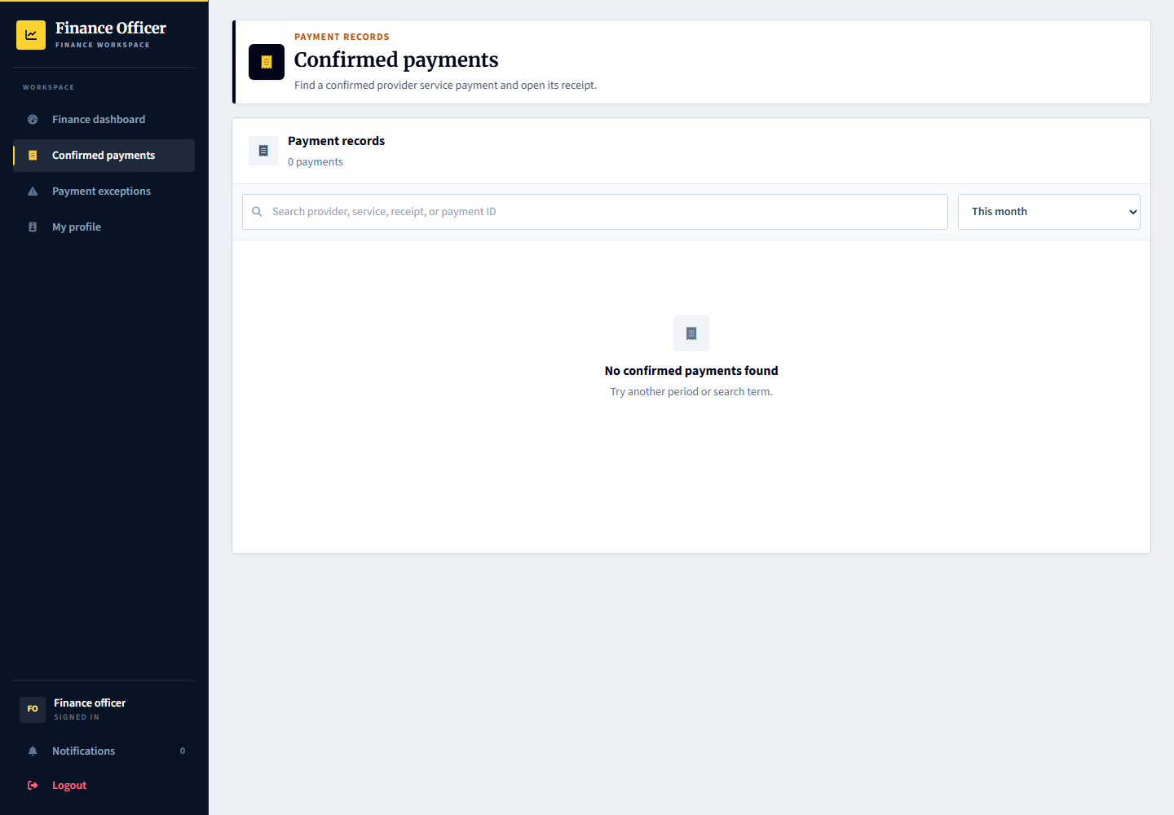
Provider: uses its billing workspace and payment or receipt links. Admin: platform.finance handles finance review; platform.billing handles the service work. Applicant scholarship benefits remain a separate workflow.

Inspect a payment or receipt record
Signed in account: platform.finance
1. Open the payment or receipt from the finance queue and confirm the provider, service and reference.
2. Compare the displayed payment status and receipt information with the permitted supporting records.
3. Handle exceptions through the available finance workflow, retaining the relevant reason or reference.
4. A demo payment record is simulated; this screen is not evidence that a real transfer or refund took place.
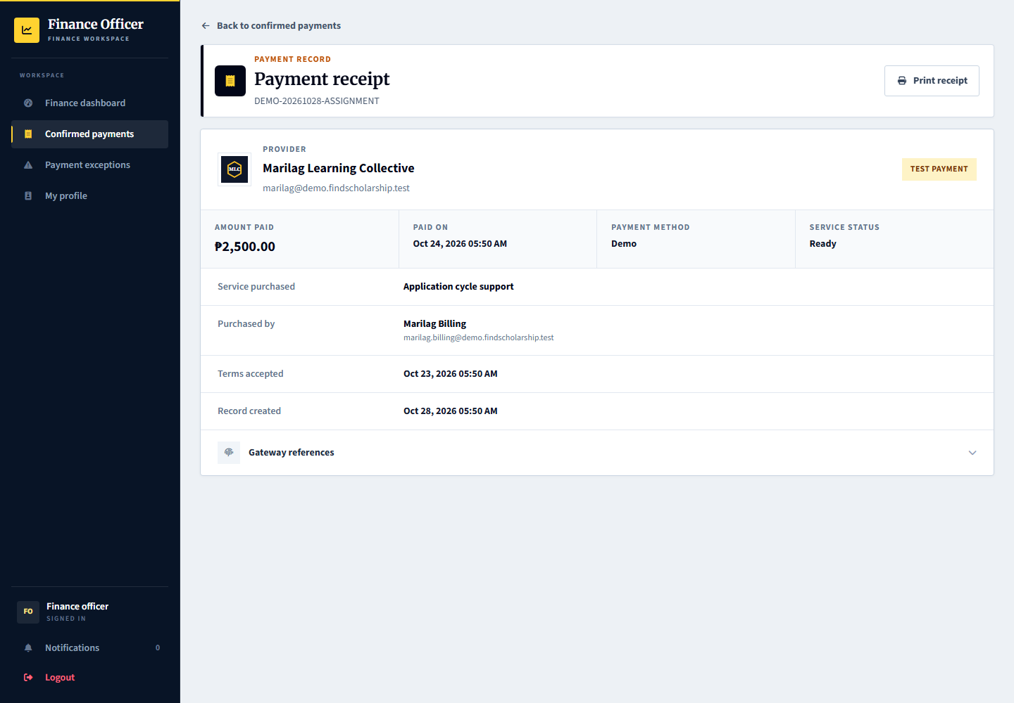
Capture only: no decision, response, upload or account change was submitted. Available actions depend on the role, current record state and completed prerequisites.

38 Admin audit history and exports
Signed in account: platform.records
Page shown: Activity records
The records officer inspects audit activity and permitted exports. Exports and activity records support traceability but are not authority to change scholarship decisions or share private accountability cases with other organizations.
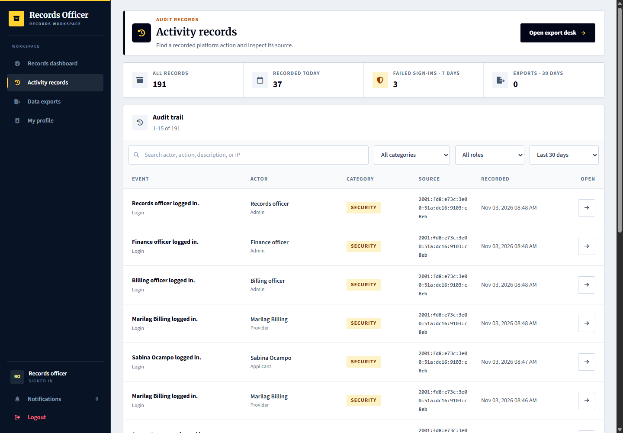
Applicant and provider: see only their permitted histories. Admin: platform.records reviews platform records and exports within its permission scope.

39 Provider manager overview and combined workspaces
Signed in account: marilag.manager
Page shown: Provider dashboard
The provider manager has a cross-workspace overview for its organization rather than a separate new scholarship process. It can move between permitted programs, reviews, selection, decisions, recipients, monitoring and releases. Program assignment and organization boundaries still apply.
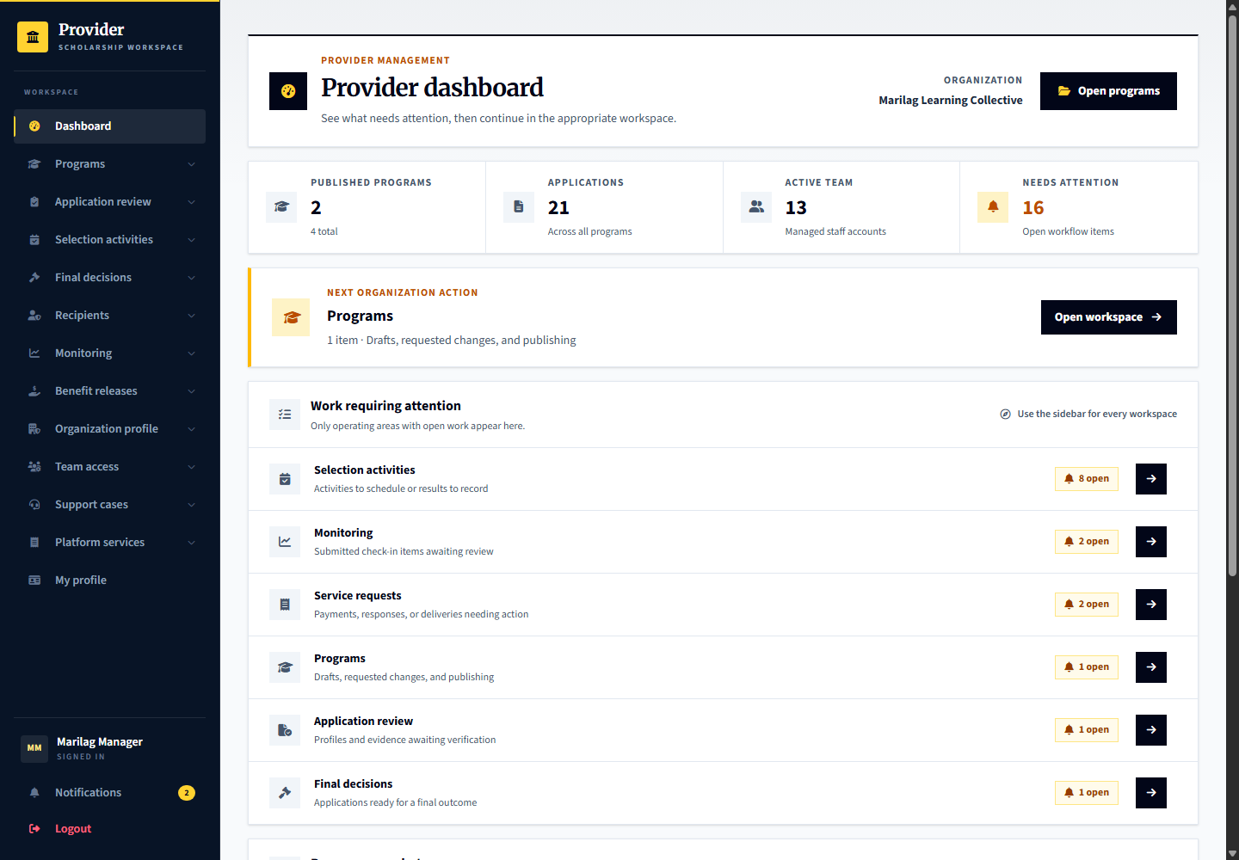
Comparison: operational staff see focused queues; the manager sees the broader organization picture. Having access to multiple workspaces does not remove evidence, notice, agreement, appeal or receipt-confirmation guards.

40 Organization representative view
Signed in account: marilag
Page shown: Provider dashboard
The organization representative is the organization owner account. Its visible navigation and actions follow the current role model; do not assume it is interchangeable with every specialist or the provider manager. Use the named operational account for the process being demonstrated.
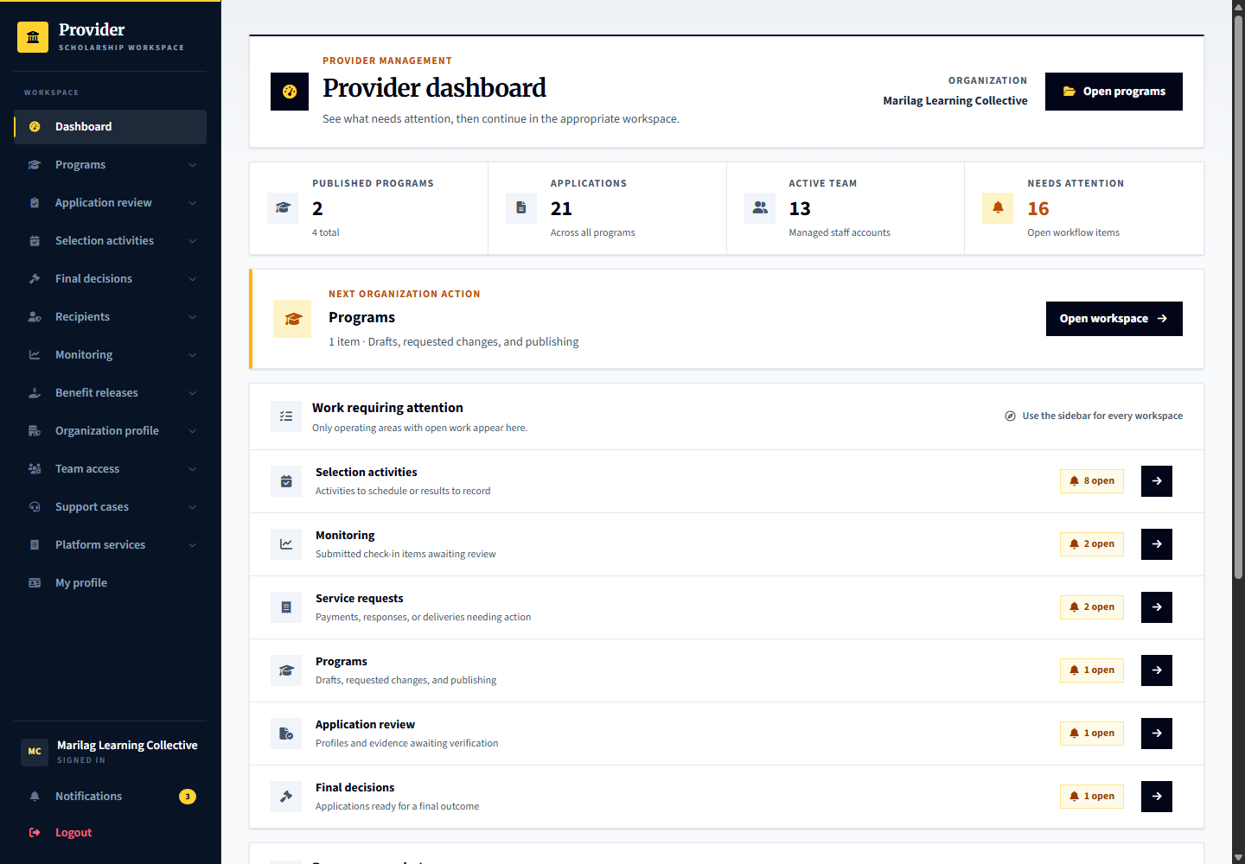
Comparison: the representative is shown here after the specialist workflows so organization ownership is not confused with the day-to-day duty of each role.

41 Portal manager overview
Signed in account: platform.manager
Page shown: Operations overview
The portal manager combines oversight across permitted admin service areas. Its overview helps locate work across accounts, reviews, support, billing, finance and records without treating all operational jobs as superadmin pages.
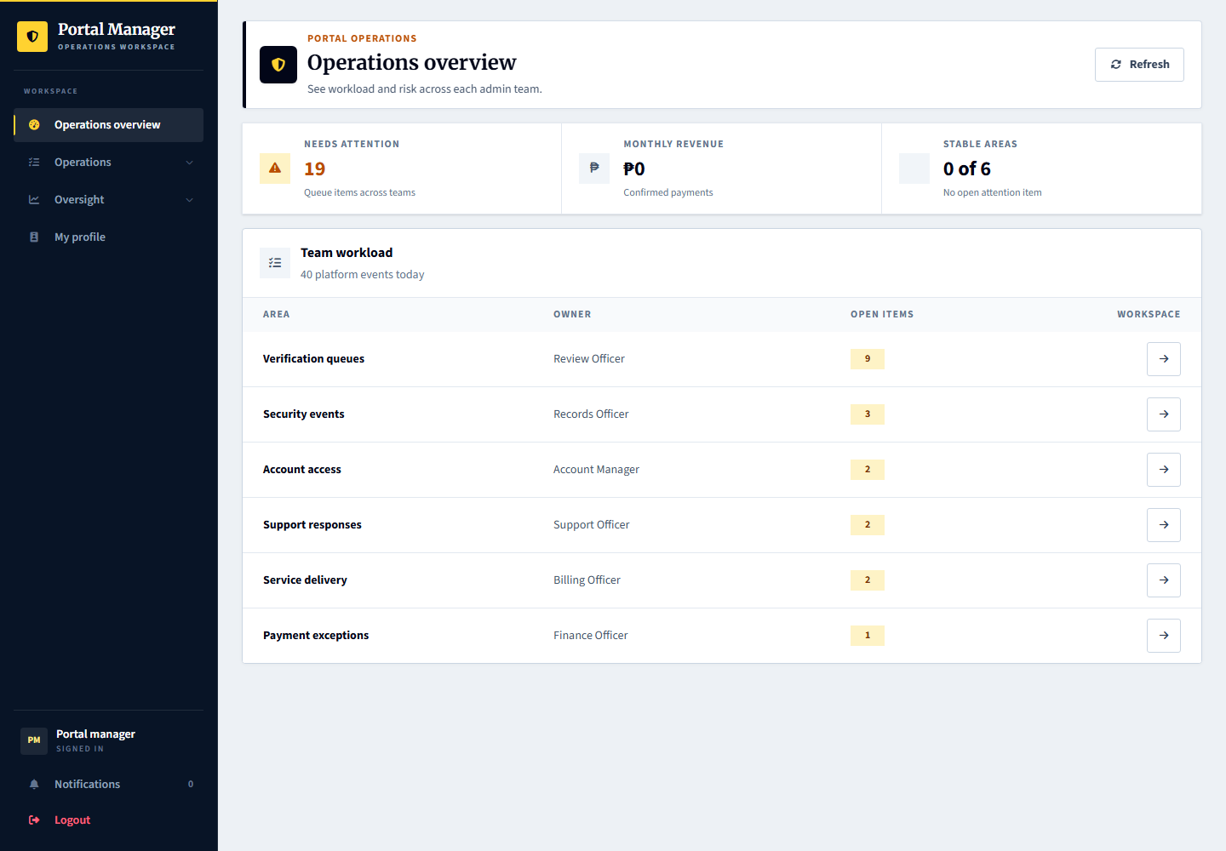
Comparison: specialists have focused workspaces. The manager has broader authorized navigation, but review independence still applies; it cannot decide an appeal of its own prior outcome.

Inspect applicant verification from portal manager oversight
Signed in account: platform.manager
1. Open Reviews from the portal manager Operations area. This manager route shows review oversight, not the review officer document-decision form.
2. Use the category tabs and available record links to inspect the relevant provider, program or applicant review work.
3. For the individual evidence decisions shown earlier, use the authorized operational reviewer workspace rather than assuming this overview can submit them.
4. An independent case appeal still requires a different authorized reviewer who did not decide the original outcome.
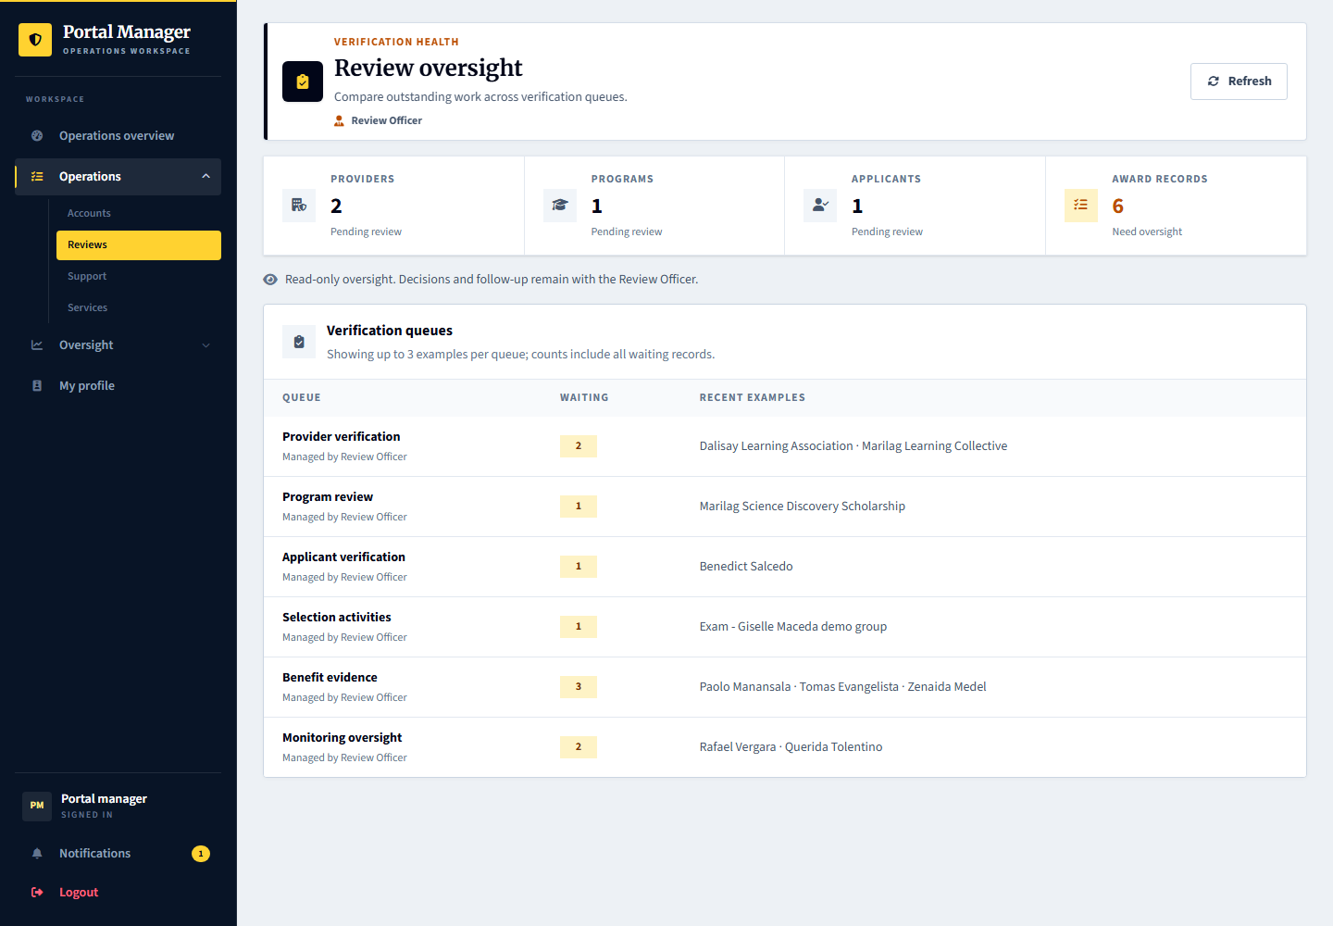
Capture only: no decision, response, upload or account change was submitted. Available actions depend on the role, current record state and completed prerequisites.

42 Superadmin governance view
Signed in account: superadmin
Page shown: Governance overview
Superadmin focuses on platform governance, admin-team access, platform health and its own profile. It is not the routine account to use for applicant verification, provider screening, examination decisions or benefit distribution.
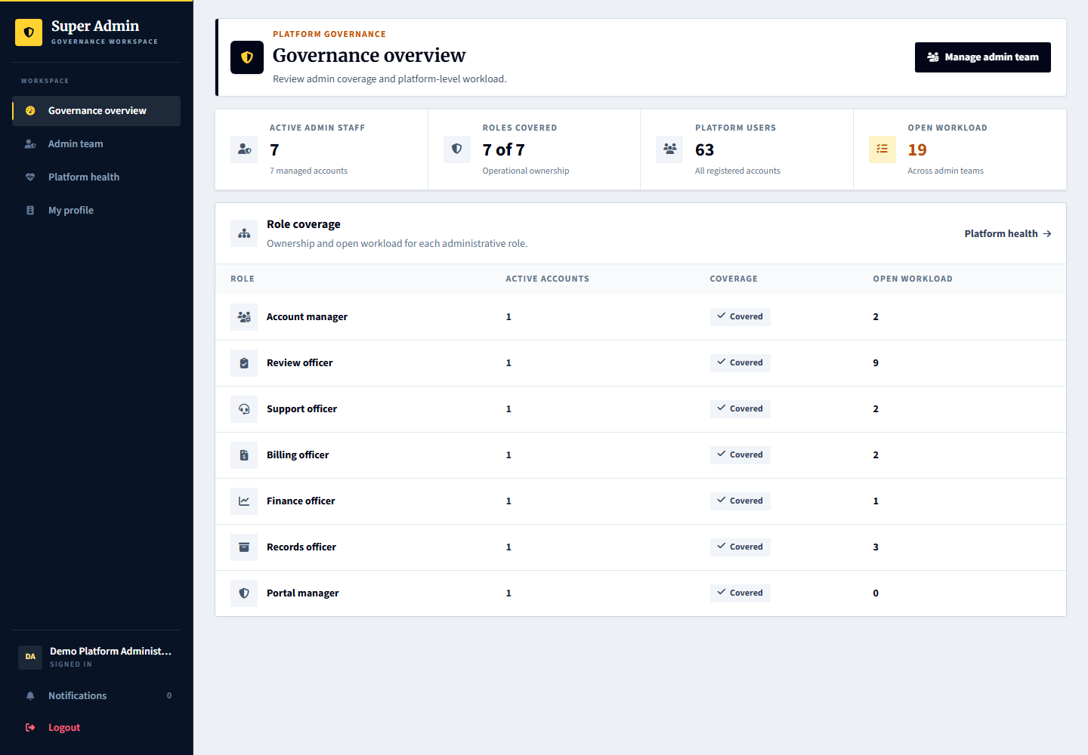
Comparison: demonstrate superadmin last. Use platform.accounts, platform.reviews, platform.support, platform.billing, platform.finance and platform.records for the corresponding operational process.

Open an admin team account in governance
Signed in account: superadmin
1. Open the relevant admin team account from Governance and confirm its identity.
2. Inspect its role, permission scope and available access controls.
3. Make only the intended governance change and review any confirmation before saving.
4. Use the operational admin account for applicant verification or service delivery, not this governance form.
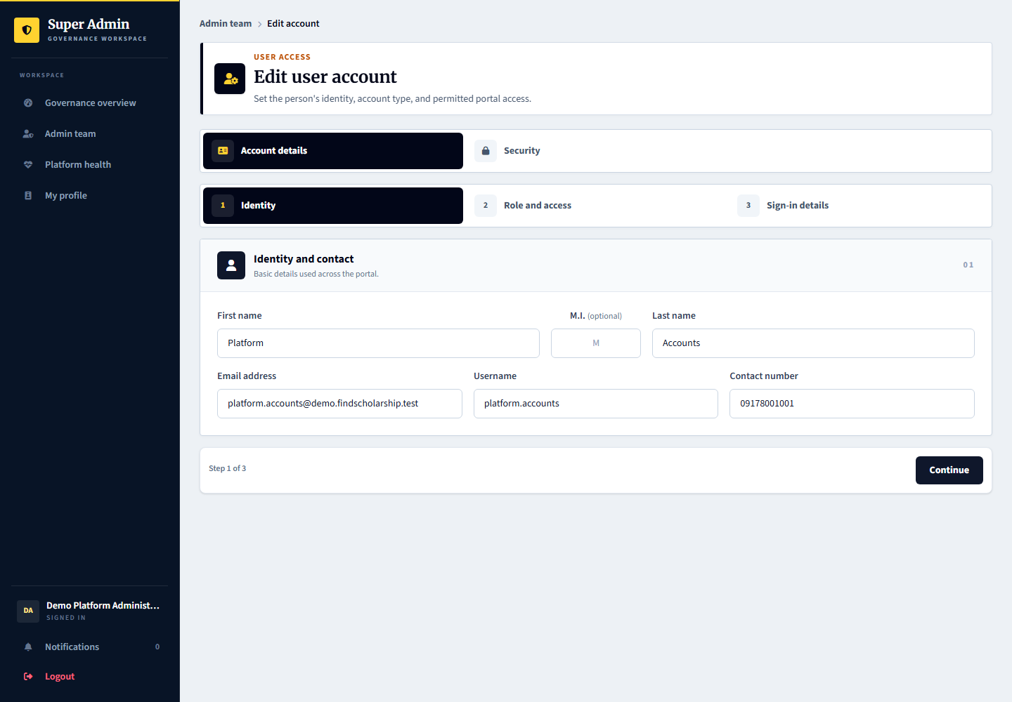
Capture only: no decision, response, upload or account change was submitted. Available actions depend on the role, current record state and completed prerequisites.

Demonstration boundaries
Shared demo credentials are unchanged. The demo data is fictional and applicants use neutral profile images. Do not use the demo credentials for a real launch. No financial transfer or successful external email delivery is implied by these screens.
A term-related early support termination requires its separate guarded decision and the appeal opportunity. Do not backdate records or change the clock to bypass it. Independent review and delivery receipt are separate actions. Cross-provider disclosure remains disabled.
Schedule definitions and cleanup command dry-runs were verified on hosting. The Hostinger hPanel scheduler invocation was not directly inspectable through SSH. Empty concern or appeal queues are intentional until the tester creates those cases.

