**Team Members:**

**Chitti Ankith Reddy 2015B3A70534H**

**KSSV Ramakrishna 2015B3A70610H**

**Aditya Addepalli 2015B1A70719H**

**Directory Structure:**

The inputs are located in the “input” directory. The files in this directory contains points of the form x_co-ordinate, y_co-ordinate.

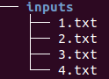

The outputs are located in the “outputs” directory. The files in this directory contains quadruples containing



To visualise the construction of the segments, we built gifs from the images obtained after each segment was obtained. These are located in the “gifs” directory. Each directory within the gif directory contains a gif for each test case.

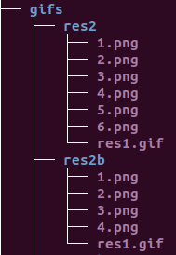

**Examples:**

1. Input is

1,1

1,-1

2,2

2,-2

3,3

3,-3

And cost = 0



1. Input is

1,1

1,-1

2,2

2,-2

3,3

3,-3

And cost = 10



1. Input is

1,1

1,-1

2,2

2,-2

3,3

3,-3

And cost = 100



1. Input is

1,1

2,2

3,6

4,8

And cost = 0



1. Input is

1,1

2,2

3,6

4,8

And cost = 10



**Inference:**

As we can see from the above examples (a good sample case would be example 1,2 and 3) as the cost of constructing a new segment increases, the segments produced are less.

If the cost of a constructing a segment is zero, all the lines would be interconnected, and if it is very high we will get a single line of best fit for all the lines