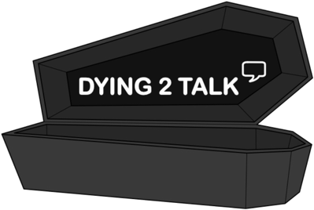**At my funeral…**

*What would you like at your ideal funeral?*

**Where would you like your funeral to be held?**

**What would you want people to wear?**

**What song(s) would you want played?**

**What food would be served?**

**Would you prefer to be buried or cremated?**

**What would you like be done with your ashes?**

**Where would you want to be buried?**

**Would you want to buried with anything?**

**How do you want to be remembered?**



**Would you donate your organs?**

