Glyph library and synthesis experiments
D.R. Braune, 23539195. Five changes to the glyph pipeline, measured one at a time and in combination, on nine writers chosen across the connectedness range: three cursive, three mid, three cleanly separated. Two sentences each, best of six, one fixed seed, existing trained weights.

1. What was changed
C1 join geometry
The connector between two joined letters used to put its control point below BOTH ends, so a join that had to climb first dived under the lower letter and hooked back up. It now places the control height between the two ends and follows a quadratic, so the pen leaves and arrives along its direction of travel. Synthesis only, no profile rebuild.
C2 aspect ratio in the shape descriptor
The 12x12 occupancy grid used to divide x by the glyph's own width and y by its own height, so a glyph twice as wide as the letter should be was squeezed back into the same box before being scored. Both axes are now divided by the same number, so width to height ratio survives into the descriptor. Changes every prior distance, so profiles rebuild.
C3 two pass letter prior
The reference shape per character used to be the median over every writer's RAW variants, contamination included, so the thing a variant was scored against was partly made of the bad cuts it was meant to reject. Now the prior is built, used to filter, then rebuilt from what survives. Profiles rebuild.
C4 whole stroke ownership in the cutter
Every traced centreline used to be chopped at the vertical cut, so a t crossbar or a y descender reaching over its neighbour left a fragment in the neighbour's cell. Pen length is now counted per cell and a stroke that is mostly in one cell goes there whole; a stroke genuinely shared between two letters is still split. Needs re-extraction, so only the three photographed writers whose crops pair to a transcript.
C5 joins across a swapped letter
A join needed both letters to come from the same source, so every anchor substitution broke the word on both sides. A cursive anchor may now join one of the writer's own shapes. Measured in the first round and left out of this one: it moved only the two writers that mix sources.

2. How to read the numbers
char and word accuracy and writer confidence are produced by the recogniser and the shape classifier. Those two networks also drive the best of N search, so these figures measure whether the pipeline can satisfy its own judges, not whether a person would read the output. margin is the true writer's probability minus the best other writer's, so a negative margin means another writer was more likely. lifts per letter, pen up fraction, prior distance, never eligible and anchor share involve no network at all and are the honest half of the table.

3. Summary, all nine writers
config | char % | word % | writer conf % | margin | identified | lifts/letter | own % | anchor %
baseline | 79.04 | 34.26 | 72.49 | +51.82 | 8/9 | 1.49 | 81.8 | 18.2
c1 | 80.55 | 39.81 | 76.91 | +60.65 | 7/9 | 1.46 | 81.2 | 18.8
c2 | 75.51 | 32.41 | 75.18 | +57.04 | 6/9 | 1.60 | 91.2 | 8.8
c3 | 76.52 | 28.70 | 75.43 | +57.95 | 8/9 | 1.48 | 83.2 | 16.8
c1_c2 | 79.04 | 28.24 | 80.59 | +65.35 | 7/9 | 1.59 | 88.3 | 11.7
c1_c3 | 78.79 | 32.40 | 72.48 | +53.86 | 6/9 | 1.46 | 81.5 | 18.5
c1_c2_c3 | 79.54 | 41.20 | 80.79 | +68.22 | 9/9 | 1.60 | 88.0 | 12.0

The cutter change needs re-extraction, so it is measured only on the three photographed writers, against its own re-extraction control:
config | writers | char % | writer conf % | margin | identified
c4_control | dylan, owen, thiya | 80.30 | 67.44 | +42.99 | 1/3
c4 | dylan, owen, thiya | 84.09 | 74.80 | +59.93 | 2/3
c1_c4_control | dylan, owen, thiya | 84.85 | 67.55 | +44.88 | 1/3
c1_c4 | dylan, owen, thiya | 90.15 | 71.94 | +49.84 | 2/3
c1_c3_c4 | dylan, owen, thiya | 89.39 | 71.82 | +52.25 | 2/3

4. Every writer, every configuration

thiya (cursive)
connectedness 0.962, slant 30.75 deg, x-height 15.0 px, 42 characters, 239 stored variants, 5.7 per character
config | char % | word % | conf % | margin | rank | ident | lifts/let | up % | own % | anchor % | lam | priorD med | priorD sprd | never % | anchor share % | variants
baseline | 65.91 | 12.50 | 89.64 | +82.06 | 1 | yes | 0.77 | 38 | 0.0 | 100.0 | 0.97 | 0.318 | 0.348 | 42.7 | 100.0 | 239
c1 | 70.45 | 25.00 | 92.95 | +88.08 | 1 | yes | 0.72 | 40 | 0.0 | 100.0 | 0.97 | 0.318 | 0.348 | 42.7 | 100.0 | 239
c2 | 54.55 | 12.50 | 79.16 | +63.78 | 1 | yes | 1.52 | 45 | 71.8 | 28.2 | 0.34 | 0.267 | 0.352 | 42.4 | 30.0 | 238
c3 | 70.46 | 12.50 | 85.80 | +76.10 | 1 | yes | 1.11 | 45 | 0.0 | 100.0 | 0.97 | 0.317 | 0.389 | 42.5 | 100.0 | 240
c1_c2 | 56.82 | 0.00 | 81.55 | +65.20 | 1 | yes | 1.70 | 49 | 82.1 | 17.9 | 0.34 | 0.267 | 0.352 | 42.4 | 30.0 | 238
c1_c3 | 75.00 | 25.00 | 82.75 | +74.56 | 1 | yes | 1.04 | 46 | 0.0 | 100.0 | 0.97 | 0.317 | 0.389 | 42.5 | 100.0 | 240
c1_c2_c3 | 52.27 | 12.50 | 82.88 | +70.38 | 1 | yes | 1.60 | 46 | 76.9 | 23.1 | 0.48 | 0.278 | 0.382 | 42.4 | 40.1 | 238
c4_control | 65.91 | 0.00 | 57.42 | +20.16 | 2 | NO | 0.96 | 36 | 0.0 | 100.0 | 1.00 | 0.321 | 0.313 | 44.2 | 100.0 | 249
c4 | 79.55 | 33.34 | 91.05 | +85.43 | 1 | yes | 0.67 | 37 | 0.0 | 100.0 | 1.00 | 0.324 | 0.320 | 43.9 | 100.0 | 246
c1_c4_control | 68.18 | 0.00 | 56.83 | +17.99 | 2 | NO | 0.91 | 34 | 0.0 | 100.0 | 1.00 | 0.321 | 0.313 | 44.2 | 100.0 | 249
c1_c4 | 84.09 | 45.84 | 82.69 | +67.79 | 1 | yes | 0.77 | 36 | 0.0 | 100.0 | 1.00 | 0.324 | 0.320 | 43.9 | 100.0 | 246
c1_c3_c4 | 90.91 | 54.16 | 81.91 | +68.29 | 1 | yes | 0.75 | 38 | 0.0 | 100.0 | 1.00 | 0.328 | 0.352 | 43.9 | 100.0 | 246

What it drew, sentence one
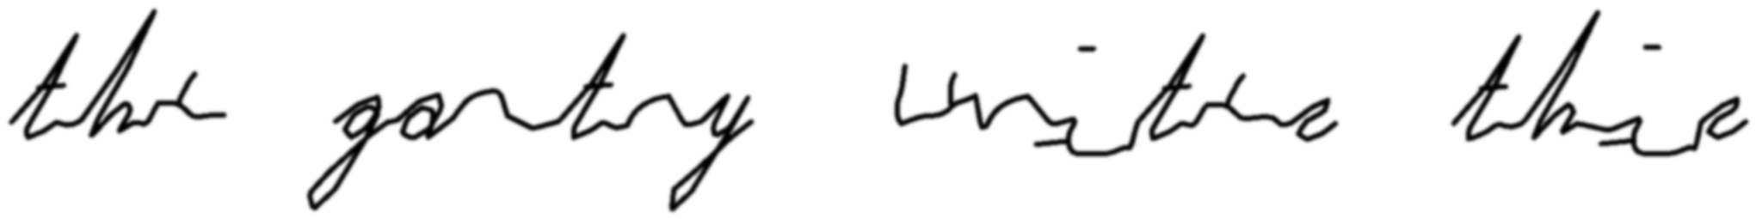
baseline - read back as "thee gantry unite the" (char 72.7%, writer thiya at 94.0%)
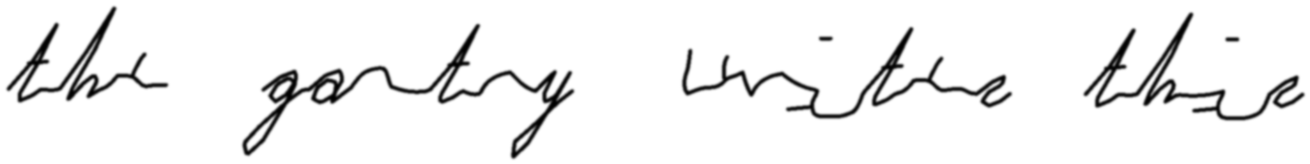
c1 - read back as "the gantry unitee thae" (char 77.3%, writer thiya at 95.7%)
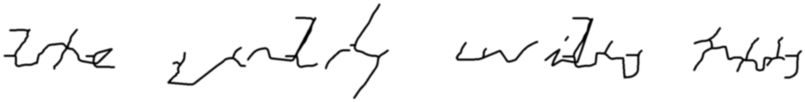
c2 - read back as "the nlrly wily trts" (char 54.5%, writer thiya at 64.6%)
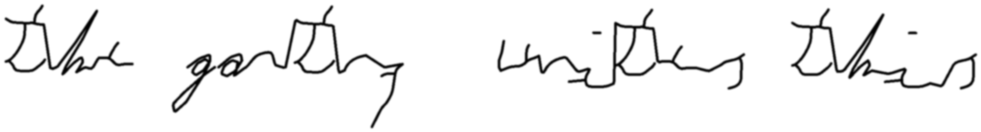
c3 - read back as "Thre gartty unites this" (char 72.7%, writer thiya at 88.5%)
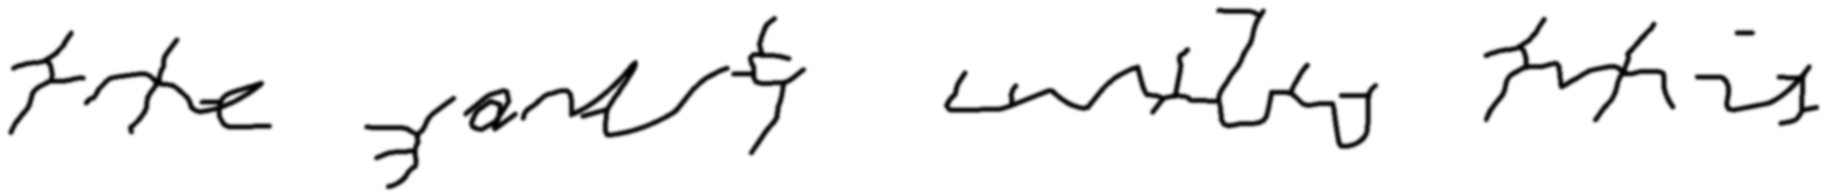
c1_c2 - read back as "trhe jandty untls tuthis" (char 54.5%, writer thiya at 79.4%)
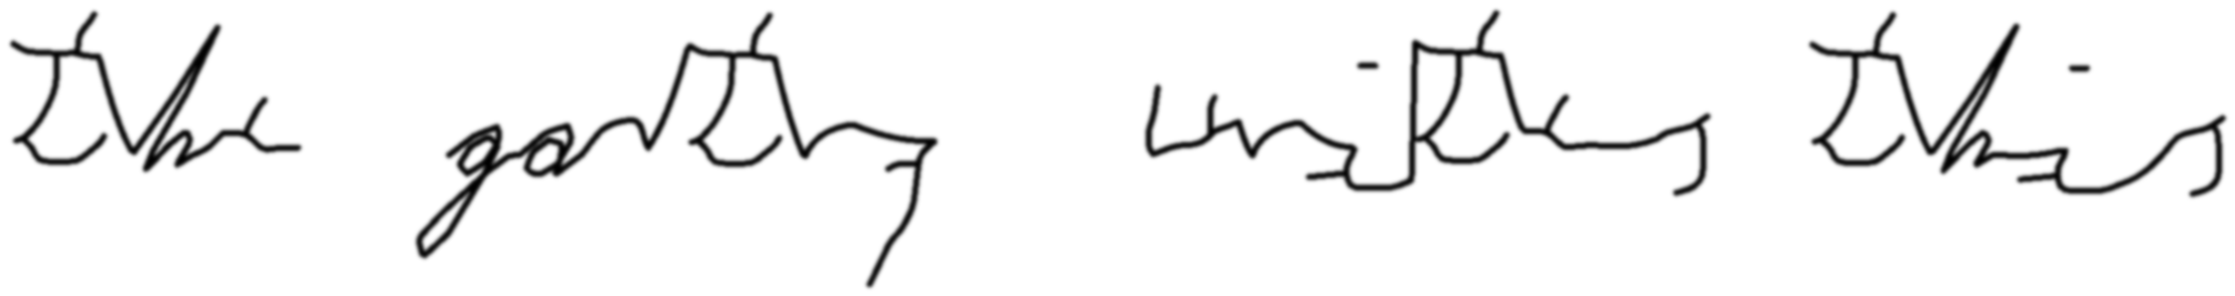
c1_c3 - read back as "The gartly unites this" (char 77.3%, writer thiya at 74.6%)
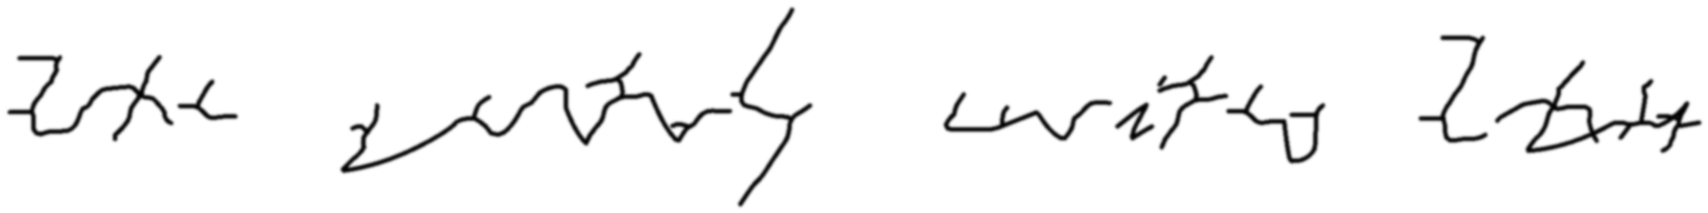
c1_c2_c3 - read back as "the sntrly uritey 2att" (char 59.1%, writer thiya at 70.0%)
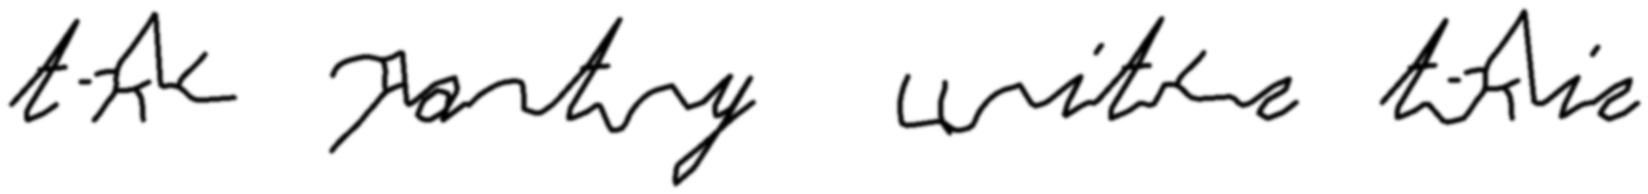
c4_control - read back as "te Pantry unite talin" (char 63.6%, writer thiya at 85.4%)
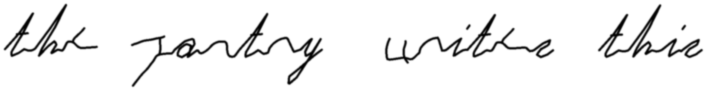
c4 - read back as "thee antry uitee thie" (char 72.7%, writer thiya at 93.4%)
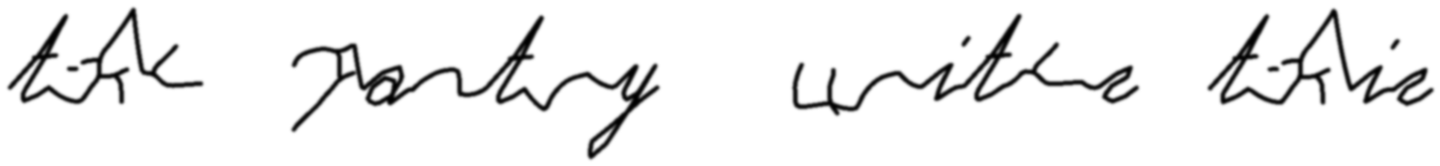
c1_c4_control - read back as "tie Ppantry wites Llin" (char 68.2%, writer thiya at 88.5%)
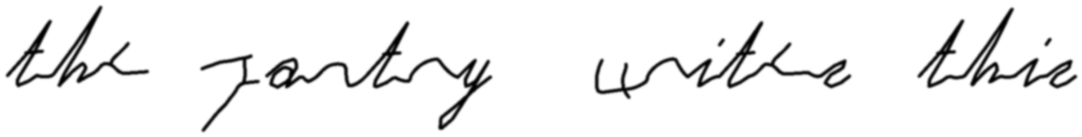
c1_c4 - read back as "the antry witee thie" (char 81.8%, writer thiya at 89.5%)

c1_c3_c4 - read back as "the gantry uites this" (char 90.9%, writer thiya at 86.4%)
Top five variants of a, e, n, r, t by rank
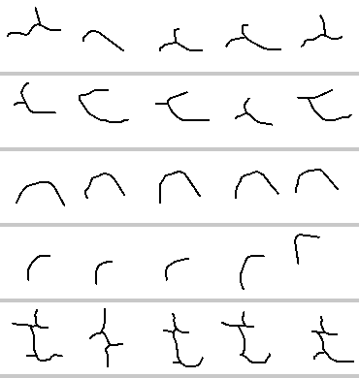
baseline prior distances a [0.41, 0.42, 0.451, 0.458, 0.488] e [0.117, 0.139, 0.173, 0.188, 0.199] n [0.113, 0.146, 0.158, 0.16, 0.169] r [0.104, 0.135, 0.139, 0.141, 0.149] t [0.249, 0.255, 0.31, 0.31, 0.313]
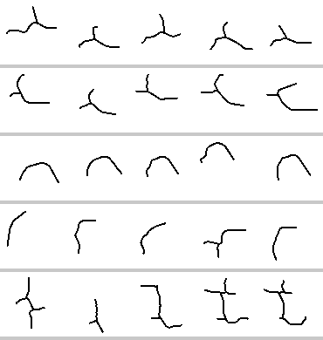
c2 prior distances a [0.375, 0.386, 0.396, 0.418, 0.426] e [0.136, 0.22, 0.257, 0.258, 0.261] n [0.137, 0.146, 0.154, 0.167, 0.173] r [0.136, 0.223, 0.232, 0.236, 0.355] t [0.099, 0.141, 0.196, 0.2, 0.201]
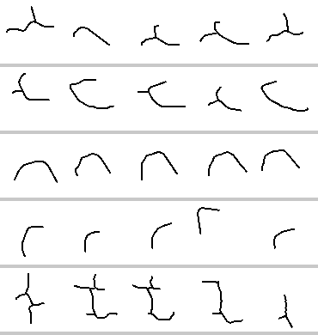
c3 prior distances a [0.409, 0.426, 0.461, 0.476, 0.496] e [0.103, 0.123, 0.178, 0.2, 0.21] n [0.105, 0.131, 0.136, 0.143, 0.167] r [0.105, 0.107, 0.135, 0.136, 0.141] t [0.192, 0.2, 0.246, 0.251, 0.284]
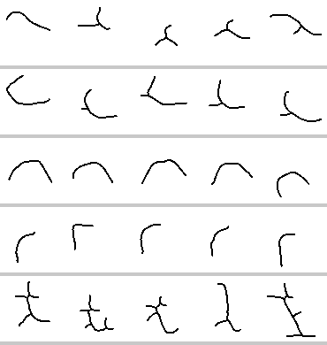
c4_control prior distances a [0.418, 0.422, 0.452, 0.459, 0.46] e [0.122, 0.124, 0.132, 0.161, 0.168] n [0.135, 0.168, 0.194, 0.196, 0.225] r [0.087, 0.102, 0.11, 0.147, 0.223] t [0.245, 0.26, 0.297, 0.317, 0.346]
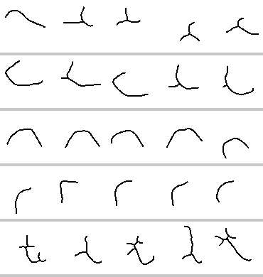
c4 prior distances a [0.418, 0.422, 0.428, 0.452, 0.459] e [0.122, 0.132, 0.134, 0.161, 0.169] n [0.135, 0.143, 0.168, 0.194, 0.225] r [0.087, 0.102, 0.11, 0.117, 0.123] t [0.267, 0.283, 0.302, 0.317, 0.348]

151 (cursive)
connectedness 0.968, slant 33.0 deg, x-height 22.0 px, 43 characters, 287 stored variants, 6.7 per character
config | char % | word % | conf % | margin | rank | ident | lifts/let | up % | own % | anchor % | lam | priorD med | priorD sprd | never % | anchor share % | variants
baseline | 68.18 | 0.00 | 67.39 | +47.05 | 1 | yes | 1.85 | 39 | 41.0 | 59.0 | 0.84 | 0.307 | 0.361 | 45.6 | 77.9 | 287
c1 | 70.46 | 0.00 | 68.53 | +51.00 | 1 | yes | 1.85 | 39 | 41.0 | 59.0 | 0.84 | 0.307 | 0.361 | 45.6 | 77.9 | 287
c2 | 61.37 | 33.34 | 82.43 | +69.44 | 1 | yes | 1.85 | 42 | 64.1 | 35.9 | 0.48 | 0.278 | 0.435 | 45.3 | 45.4 | 285
c3 | 68.18 | 16.66 | 72.31 | +50.20 | 1 | yes | 1.88 | 41 | 53.8 | 46.2 | 0.67 | 0.294 | 0.385 | 46.0 | 63.8 | 289
c1_c2 | 65.91 | 0.00 | 82.47 | +66.98 | 1 | yes | 1.88 | 42 | 53.8 | 46.2 | 0.48 | 0.278 | 0.435 | 45.3 | 45.4 | 285
c1_c3 | 75.00 | 16.66 | 76.61 | +58.30 | 1 | yes | 1.88 | 40 | 48.7 | 51.3 | 0.67 | 0.294 | 0.385 | 46.0 | 63.8 | 289
c1_c2_c3 | 72.73 | 16.66 | 84.13 | +71.25 | 1 | yes | 1.80 | 42 | 61.5 | 38.5 | 0.45 | 0.276 | 0.452 | 45.1 | 43.3 | 284

What it drew, sentence one
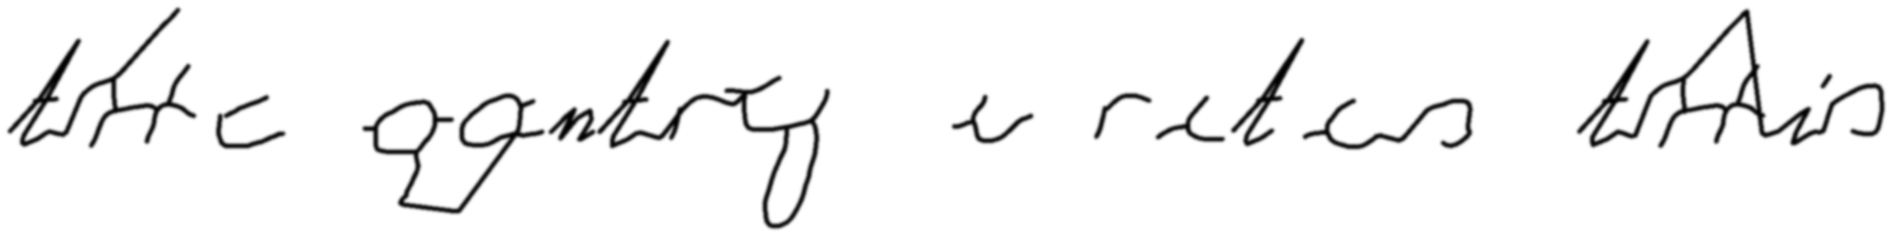
baseline - read back as "tc gontry arites toolis" (char 68.2%, writer 151 at 50.7%)
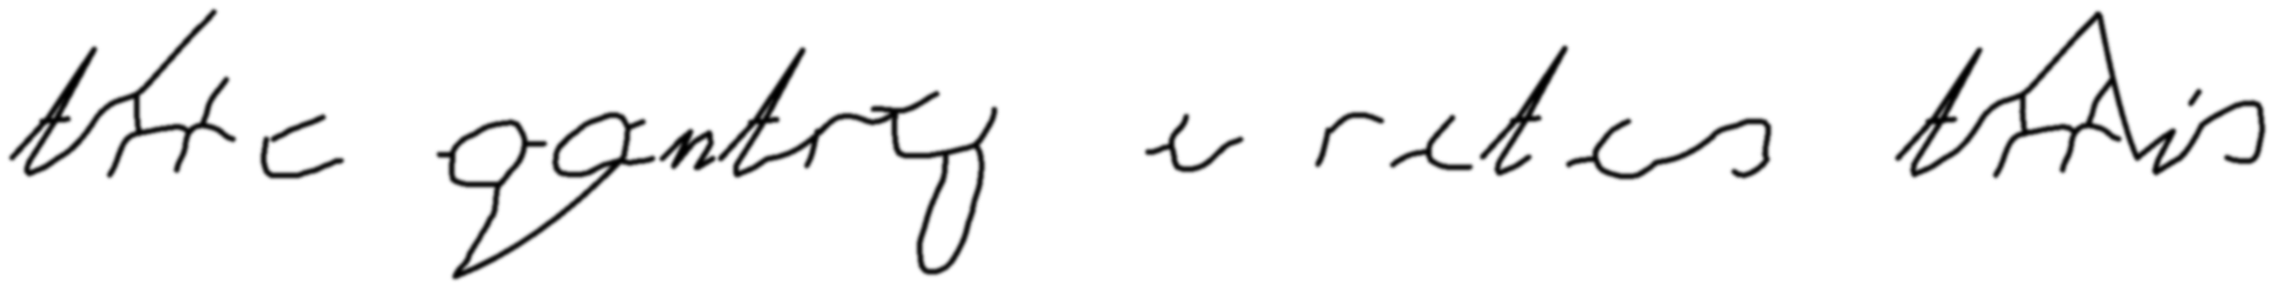
c1 - read back as "tc oogntry arites tois" (char 68.2%, writer 151 at 68.1%)
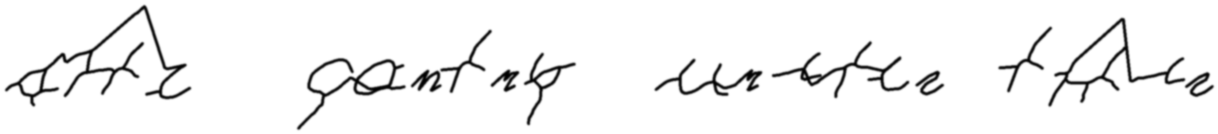
c2 - read back as "stfe antap wabte tace" (char 50.0%, writer 151 at 74.6%)
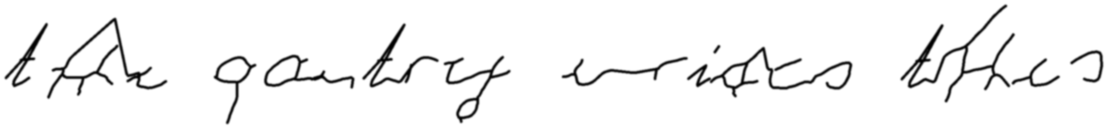
c3 - read back as "tae pantrty urnfes tohe?" (char 59.1%, writer 151 at 57.0%)
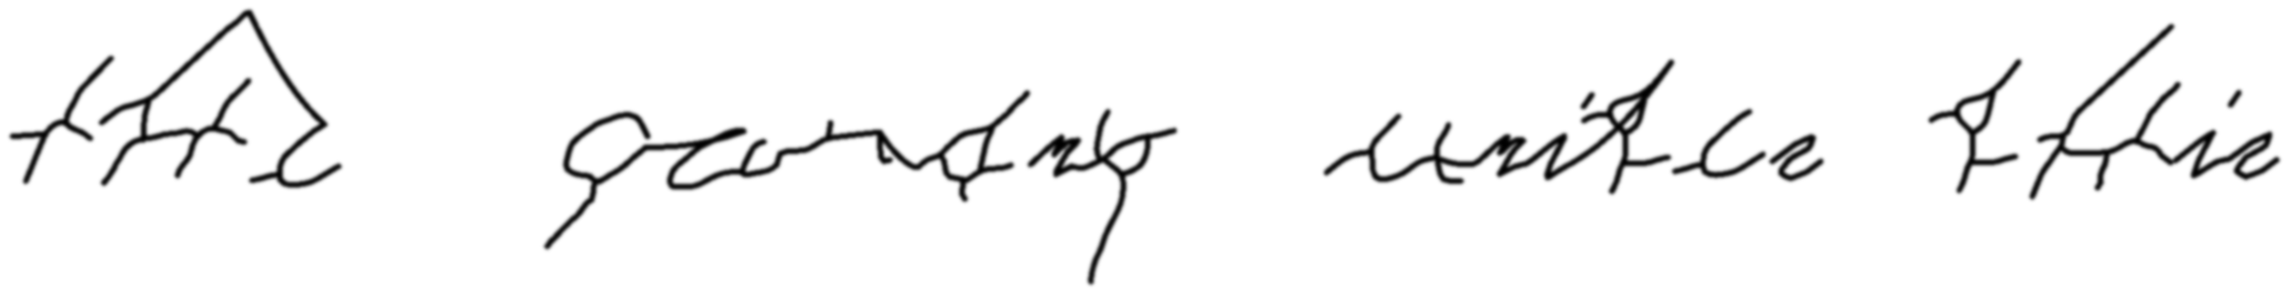
c1_c2 - read back as "tfr ernty witee hie" (char 59.1%, writer 151 at 73.7%)
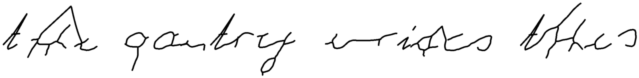
c1_c3 - read back as "tat pantry wrifes the?s" (char 72.7%, writer 151 at 68.7%)
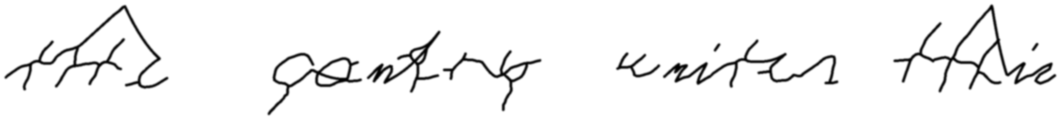
c1_c2_c3 - read back as "tae antp wniten taie" (char 63.6%, writer 151 at 71.0%)
Top five variants of a, e, n, r, t by rank
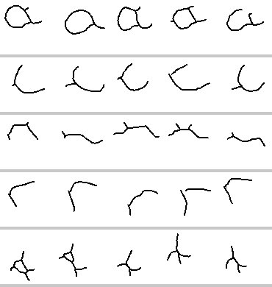
baseline prior distances a [0.122, 0.149, 0.174, 0.194, 0.196] e [0.13, 0.152, 0.158, 0.163, 0.17] n [0.219, 0.457, 0.46, 0.473, 0.501] r [0.199, 0.225, 0.227, 0.247, 0.25] t [0.272, 0.272, 0.307, 0.324, 0.326]
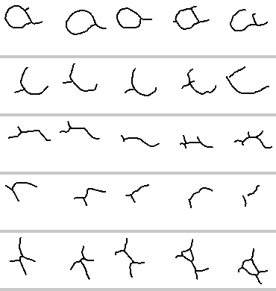
c2 prior distances a [0.147, 0.164, 0.168, 0.187, 0.2] e [0.145, 0.16, 0.201, 0.216, 0.275] n [0.312, 0.317, 0.375, 0.379, 0.381] r [0.289, 0.296, 0.376, 0.429, 0.446] t [0.115, 0.192, 0.221, 0.222, 0.223]
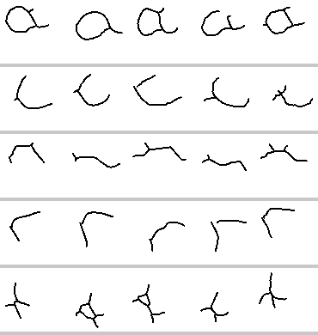
c3 prior distances a [0.119, 0.132, 0.181, 0.184, 0.196] e [0.104, 0.138, 0.138, 0.146, 0.148] n [0.232, 0.482, 0.485, 0.506, 0.508] r [0.196, 0.204, 0.227, 0.234, 0.243] t [0.154, 0.229, 0.233, 0.25, 0.263]

153 (cursive)
connectedness 0.961, slant 30.0 deg, x-height 33.0 px, 37 characters, 283 stored variants, 7.7 per character
config | char % | word % | conf % | margin | rank | ident | lifts/let | up % | own % | anchor % | lam | priorD med | priorD sprd | never % | anchor share % | variants
baseline | 70.45 | 16.66 | 56.02 | +22.32 | 1 | yes | 1.95 | 43 | 100.0 | 0.0 | 0.03 | 0.242 | 0.288 | 51.9 | 15.3 | 283
c1 | 79.54 | 29.16 | 74.94 | +56.92 | 1 | yes | 1.90 | 43 | 100.0 | 0.0 | 0.03 | 0.242 | 0.288 | 51.9 | 15.3 | 283
c2 | 52.27 | 0.00 | 51.61 | +24.42 | 2 | NO | 1.75 | 42 | 100.0 | 0.0 | 0.00 | 0.190 | 0.299 | 51.6 | 5.4 | 281
c3 | 63.64 | 0.00 | 56.39 | +26.53 | 1 | yes | 1.77 | 43 | 100.0 | 0.0 | 0.00 | 0.229 | 0.288 | 52.1 | 12.0 | 284
c1_c2 | 68.18 | 0.00 | 57.56 | +28.05 | 2 | NO | 1.77 | 43 | 100.0 | 0.0 | 0.00 | 0.190 | 0.299 | 51.6 | 5.4 | 281
c1_c3 | 61.37 | 0.00 | 43.30 | +1.69 | 2 | NO | 1.77 | 44 | 100.0 | 0.0 | 0.00 | 0.229 | 0.288 | 52.1 | 12.0 | 284
c1_c2_c3 | 72.72 | 12.50 | 68.59 | +47.28 | 1 | yes | 1.67 | 43 | 100.0 | 0.0 | 0.00 | 0.181 | 0.301 | 51.6 | 5.4 | 281

What it drew, sentence one
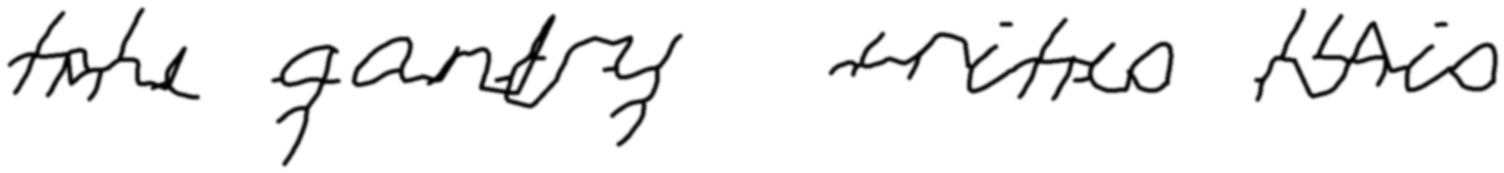
baseline - read back as "take anty triteo Nio" (char 59.1%, writer 153 at 47.1%)
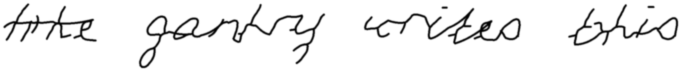
c1 - read back as "trke gantry cnites thio" (char 77.3%, writer 153 at 66.2%)
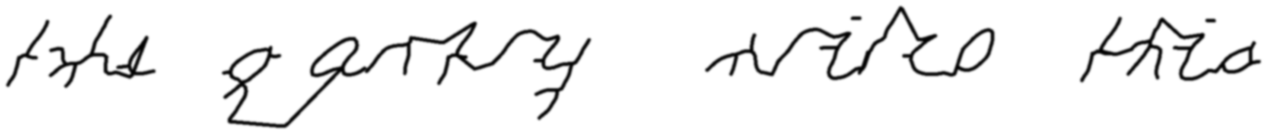
c2 - read back as "take e grrtry wiiee thia" (char 54.5%, writer thiya at 46.0%)
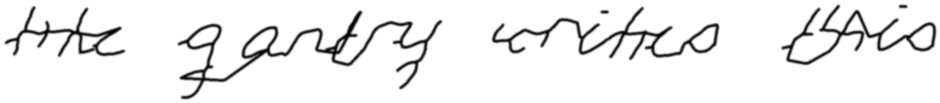
c3 - read back as "tre antry coritres taio" (char 68.2%, writer 153 at 60.6%)
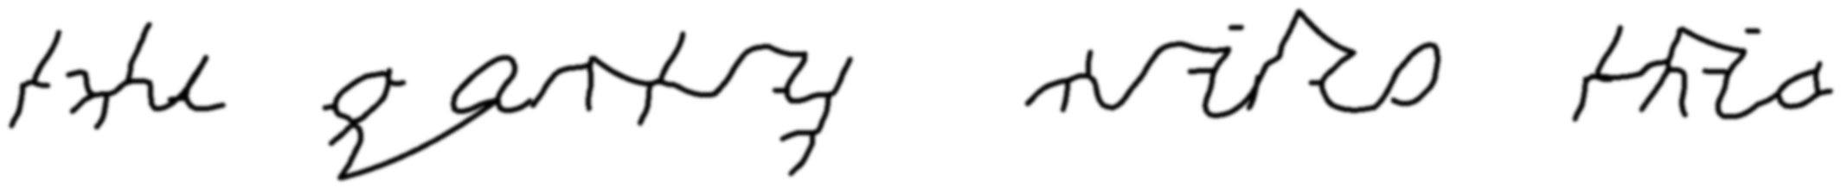
c1_c2 - read back as "take e antry wiles thia" (char 68.2%, writer thiya at 56.9%)
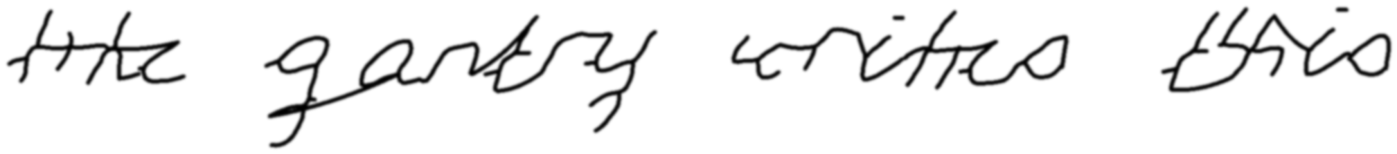
c1_c3 - read back as "tre anty cnitres tio" (char 63.6%, writer thiya at 48.2%)
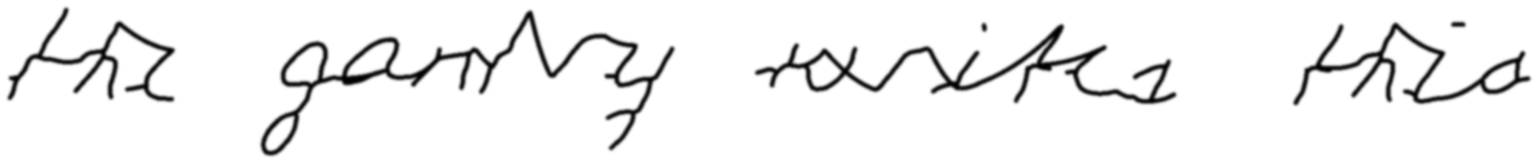
c1_c2_c3 - read back as "the gary tasites thie." (char 68.2%, writer 153 at 62.3%)
Top five variants of a, e, n, r, t by rank
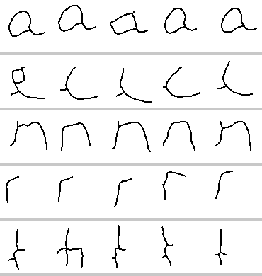
baseline prior distances a [0.141, 0.149, 0.156, 0.166, 0.169] e [0.109, 0.118, 0.121, 0.123, 0.13] n [0.08, 0.09, 0.096, 0.1, 0.118] r [0.065, 0.084, 0.145, 0.165, 0.198] t [0.225, 0.243, 0.29, 0.311, 0.313]
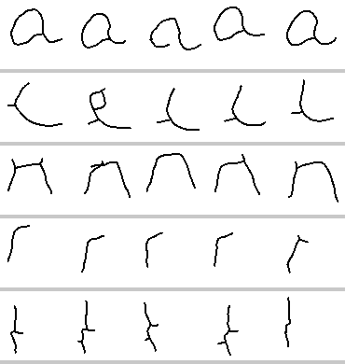
c2 prior distances a [0.138, 0.161, 0.172, 0.186, 0.186] e [0.144, 0.157, 0.16, 0.171, 0.175] n [0.086, 0.092, 0.112, 0.119, 0.142] r [0.079, 0.086, 0.094, 0.113, 0.163] t [0.091, 0.094, 0.095, 0.096, 0.106]
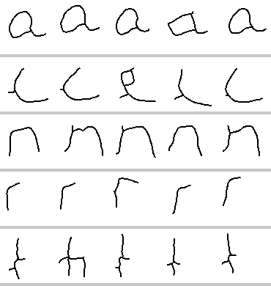
c3 prior distances a [0.144, 0.15, 0.163, 0.164, 0.172] e [0.095, 0.099, 0.102, 0.111, 0.112] n [0.066, 0.077, 0.08, 0.092, 0.101] r [0.064, 0.087, 0.136, 0.161, 0.213] t [0.169, 0.187, 0.228, 0.228, 0.263]

152 (mid)
connectedness 0.715, slant 19.5 deg, x-height 46.0 px, 38 characters, 273 stored variants, 7.2 per character
config | char % | word % | conf % | margin | rank | ident | lifts/let | up % | own % | anchor % | lam | priorD med | priorD sprd | never % | anchor share % | variants
baseline | 79.55 | 37.50 | 79.35 | +67.06 | 1 | yes | 1.83 | 37 | 100.0 | 0.0 | 0.00 | 0.223 | 0.365 | 49.5 | 7.9 | 273
c1 | 75.00 | 37.50 | 82.58 | +72.02 | 1 | yes | 1.83 | 38 | 100.0 | 0.0 | 0.00 | 0.223 | 0.365 | 49.5 | 7.9 | 273
c2 | 90.91 | 54.16 | 89.10 | +80.59 | 1 | yes | 1.75 | 36 | 100.0 | 0.0 | 0.00 | 0.177 | 0.250 | 49.6 | 3.0 | 272
c3 | 72.73 | 12.50 | 80.24 | +73.04 | 1 | yes | 1.80 | 42 | 100.0 | 0.0 | 0.00 | 0.212 | 0.377 | 49.4 | 6.0 | 271
c1_c2 | 86.36 | 54.16 | 90.53 | +84.12 | 1 | yes | 1.80 | 38 | 100.0 | 0.0 | 0.00 | 0.177 | 0.250 | 49.6 | 3.0 | 272
c1_c3 | 72.72 | 12.50 | 72.89 | +61.52 | 1 | yes | 1.67 | 42 | 100.0 | 0.0 | 0.00 | 0.212 | 0.377 | 49.4 | 6.0 | 271
c1_c2_c3 | 84.09 | 54.16 | 92.53 | +89.77 | 1 | yes | 1.78 | 38 | 100.0 | 0.0 | 0.00 | 0.168 | 0.286 | 49.6 | 0.4 | 272

What it drew, sentence one
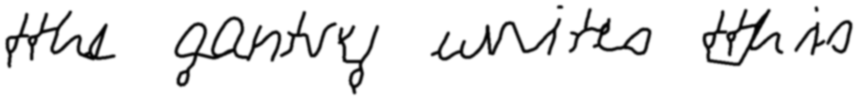
baseline - read back as "the gantry unites this" (char 90.9%, writer 152 at 81.9%)
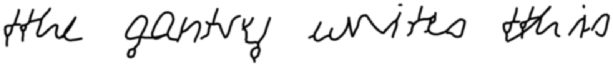
c1 - read back as "the gantry unites this" (char 90.9%, writer 152 at 79.4%)
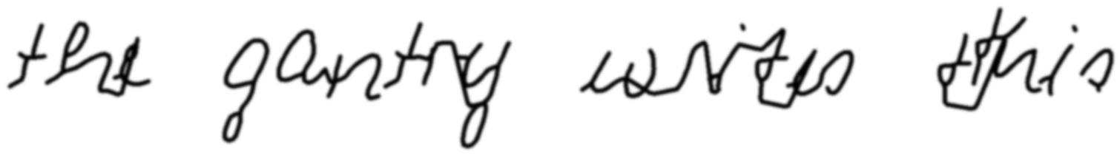
c2 - read back as "the gantry eaites this" (char 90.9%, writer 152 at 95.5%)
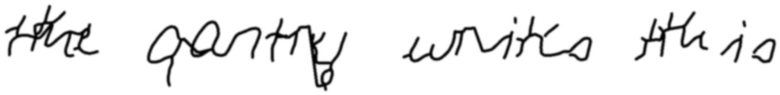
c3 - read back as "thre rantry unites this" (char 81.8%, writer 152 at 73.0%)
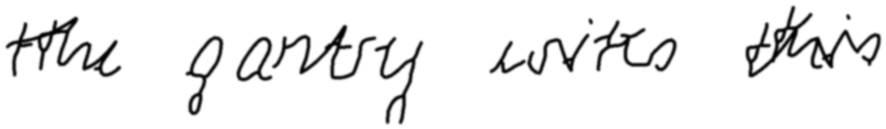
c1_c2 - read back as "the gantry wites this" (char 95.5%, writer 152 at 92.0%)
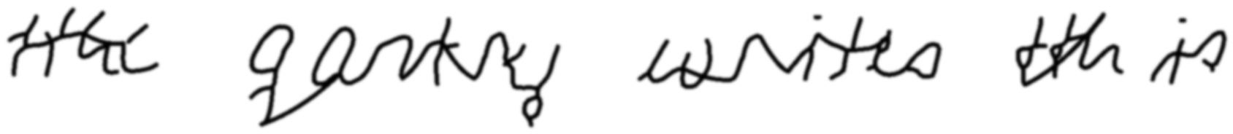
c1_c3 - read back as "the erntry laniteo th is" (char 68.2%, writer 152 at 80.8%)
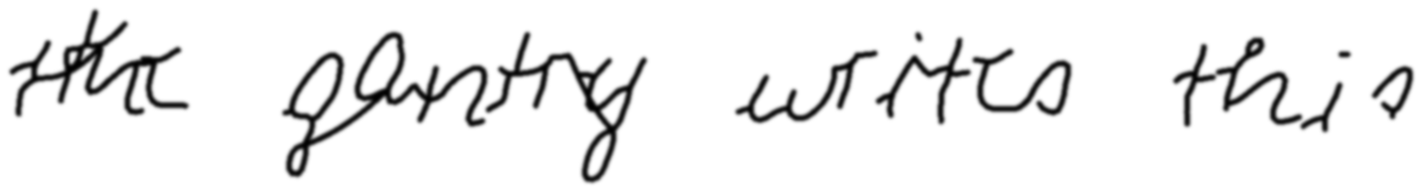
c1_c2_c3 - read back as "the entry writes this" (char 90.9%, writer 152 at 91.3%)
Top five variants of a, e, n, r, t by rank
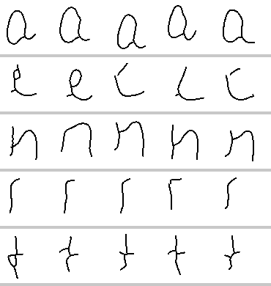
baseline prior distances a [0.127, 0.138, 0.153, 0.163, 0.169] e [0.115, 0.12, 0.138, 0.151, 0.152] n [0.125, 0.152, 0.153, 0.173, 0.185] r [0.163, 0.228, 0.252, 0.282, 0.446] t [0.208, 0.222, 0.241, 0.246, 0.287]
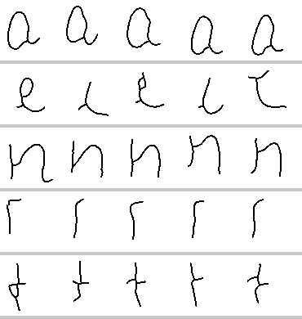
c2 prior distances a [0.16, 0.214, 0.223, 0.224, 0.226] e [0.142, 0.16, 0.168, 0.174, 0.182] n [0.124, 0.158, 0.16, 0.203, 0.205] r [0.224, 0.253, 0.254, 0.27, 0.289] t [0.063, 0.075, 0.081, 0.091, 0.095]
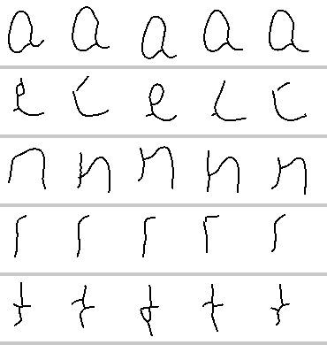
c3 prior distances a [0.119, 0.125, 0.143, 0.163, 0.165] e [0.102, 0.112, 0.119, 0.124, 0.126] n [0.117, 0.129, 0.132, 0.168, 0.183] r [0.156, 0.164, 0.208, 0.288, 0.475] t [0.157, 0.183, 0.189, 0.19, 0.226]

552 (mid)
connectedness 0.609, slant -10.5 deg, x-height 32.0 px, 40 characters, 288 stored variants, 7.2 per character
config | char % | word % | conf % | margin | rank | ident | lifts/let | up % | own % | anchor % | lam | priorD med | priorD sprd | never % | anchor share % | variants
baseline | 79.55 | 41.66 | 55.65 | +19.03 | 1 | yes | 1.42 | 38 | 100.0 | 0.0 | 0.00 | 0.238 | 0.312 | 46.2 | 6.5 | 288
c1 | 81.81 | 54.16 | 52.29 | +8.41 | 2 | NO | 1.36 | 40 | 94.9 | 5.1 | 0.00 | 0.238 | 0.312 | 46.2 | 6.5 | 288
c2 | 75.00 | 12.50 | 51.72 | +16.84 | 3 | NO | 1.69 | 39 | 100.0 | 0.0 | 0.00 | 0.206 | 0.267 | 44.9 | 3.2 | 287
c3 | 77.28 | 25.00 | 62.70 | +32.60 | 1 | yes | 1.45 | 39 | 100.0 | 0.0 | 0.00 | 0.216 | 0.331 | 45.8 | 5.2 | 286
c1_c2 | 79.54 | 12.50 | 77.04 | +60.35 | 1 | yes | 1.54 | 41 | 79.5 | 20.5 | 0.00 | 0.206 | 0.267 | 44.9 | 3.2 | 287
c1_c3 | 88.63 | 41.66 | 61.38 | +28.99 | 2 | NO | 1.49 | 38 | 100.0 | 0.0 | 0.00 | 0.216 | 0.331 | 45.8 | 5.2 | 286
c1_c2_c3 | 84.09 | 41.66 | 66.72 | +49.46 | 1 | yes | 1.62 | 42 | 89.7 | 10.3 | 0.00 | 0.200 | 0.271 | 45.7 | 3.2 | 289

What it drew, sentence one
baseline - read back as "the gentry wites this" (char 90.9%, writer 552 at 58.8%)
c1 - read back as "the gantry urites this" (char 95.5%, writer 552 at 65.8%)
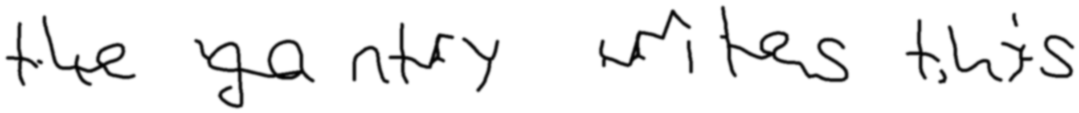
c2 - read back as "tike ga rtry writes tnis" (char 77.3%, writer 552 at 86.4%)
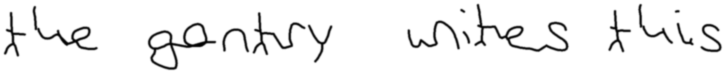
c3 - read back as "the gontry wites this" (char 90.9%, writer 552 at 75.8%)
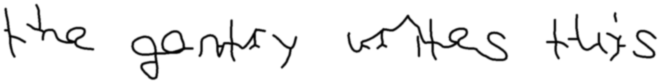
c1_c2 - read back as "the gotry uries thiis" (char 77.3%, writer 552 at 88.5%)
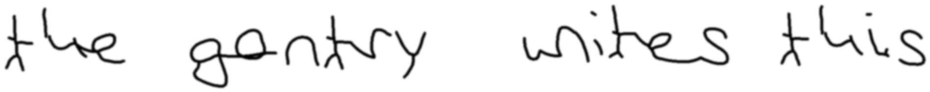
c1_c3 - read back as "the gontry wites this" (char 90.9%, writer 552 at 82.6%)
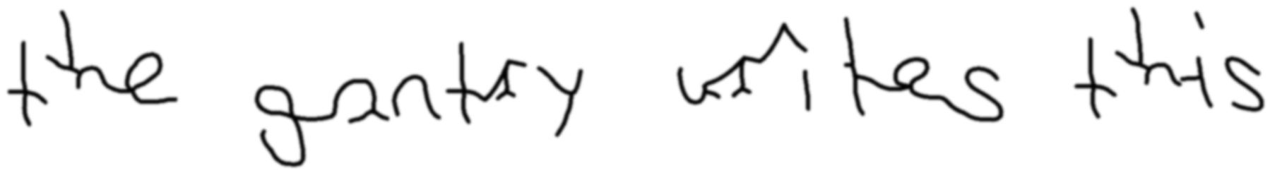
c1_c2_c3 - read back as "the gantay urites this" (char 90.9%, writer 552 at 83.7%)
Top five variants of a, e, n, r, t by rank
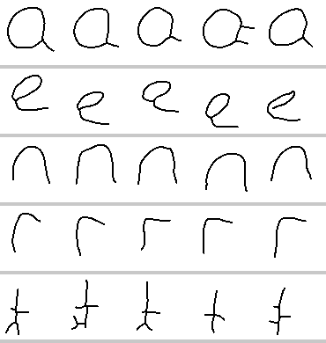
baseline prior distances a [0.08, 0.096, 0.099, 0.1, 0.11] e [0.18, 0.181, 0.183, 0.184, 0.189] n [0.108, 0.109, 0.117, 0.14, 0.147] r [0.099, 0.174, 0.178, 0.192, 0.209] t [0.174, 0.245, 0.251, 0.271, 0.271]
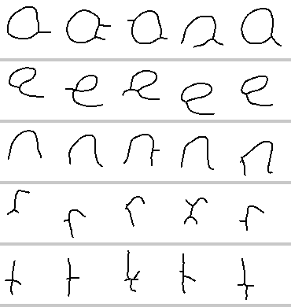
c2 prior distances a [0.095, 0.097, 0.138, 0.148, 0.151] e [0.196, 0.204, 0.236, 0.256, 0.257] n [0.193, 0.217, 0.227, 0.24, 0.261] r [0.218, 0.225, 0.227, 0.234, 0.26] t [0.11, 0.111, 0.12, 0.124, 0.134]
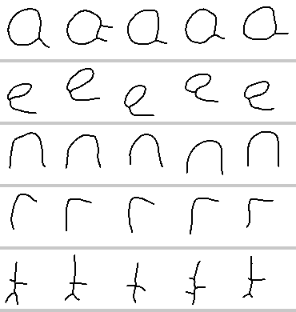
c3 prior distances a [0.062, 0.082, 0.083, 0.083, 0.095] e [0.188, 0.193, 0.203, 0.216, 0.229] n [0.076, 0.087, 0.103, 0.105, 0.123] r [0.077, 0.152, 0.163, 0.175, 0.183] t [0.133, 0.191, 0.205, 0.214, 0.216]

588 (mid)
connectedness 0.668, slant 0.0 deg, x-height 29.0 px, 41 characters, 254 stored variants, 6.2 per character
config | char % | word % | conf % | margin | rank | ident | lifts/let | up % | own % | anchor % | lam | priorD med | priorD sprd | never % | anchor share % | variants
baseline | 75.00 | 29.16 | 63.64 | +33.72 | 1 | yes | 1.34 | 40 | 94.9 | 5.1 | 0.00 | 0.240 | 0.313 | 45.3 | 5.3 | 254
c1 | 72.73 | 29.16 | 78.72 | +67.97 | 1 | yes | 1.21 | 39 | 94.9 | 5.1 | 0.00 | 0.240 | 0.313 | 45.3 | 5.3 | 254
c2 | 65.91 | 0.00 | 80.33 | +64.72 | 1 | yes | 1.44 | 40 | 89.7 | 10.3 | 0.00 | 0.209 | 0.288 | 44.2 | 3.0 | 249
c3 | 65.91 | 0.00 | 74.27 | +55.09 | 1 | yes | 1.19 | 37 | 100.0 | 0.0 | 0.00 | 0.227 | 0.322 | 44.7 | 4.9 | 253
c1_c2 | 77.28 | 12.50 | 90.12 | +83.62 | 1 | yes | 1.42 | 44 | 84.6 | 15.4 | 0.00 | 0.209 | 0.288 | 44.2 | 3.0 | 249
c1_c3 | 68.18 | 12.50 | 70.10 | +53.79 | 1 | yes | 1.24 | 40 | 84.6 | 15.4 | 0.00 | 0.227 | 0.322 | 44.7 | 4.9 | 253
c1_c2_c3 | 75.00 | 12.50 | 79.26 | +61.82 | 1 | yes | 1.39 | 43 | 84.6 | 15.4 | 0.00 | 0.202 | 0.305 | 44.0 | 2.6 | 250

What it drew, sentence one
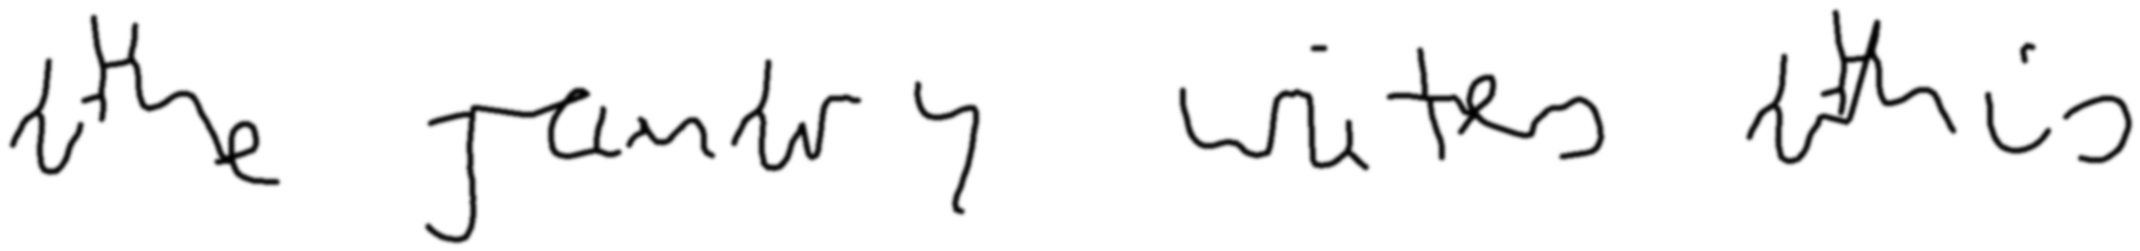
baseline - read back as "the runtery wites ahis" (char 77.3%, writer 588 at 65.9%)
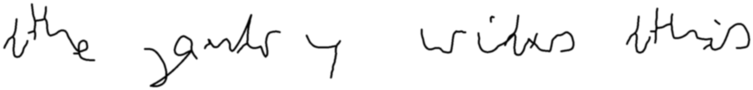
c1 - read back as "the guts y widus athis" (char 63.6%, writer 588 at 92.5%)
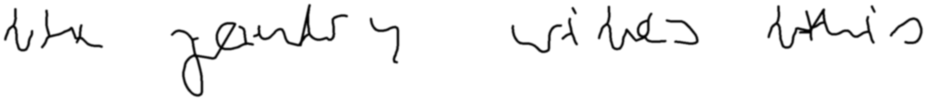
c2 - read back as "rte genery wines tthis" (char 68.2%, writer 588 at 96.8%)
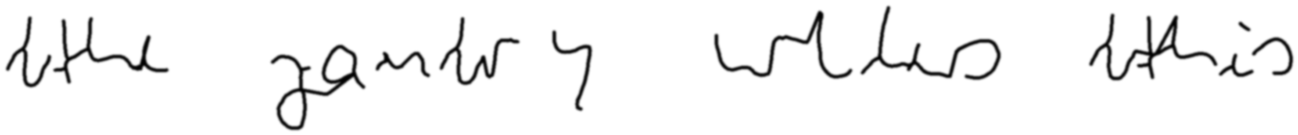
c3 - read back as "lothe yantry wllas tthis" (char 63.6%, writer 588 at 92.8%)
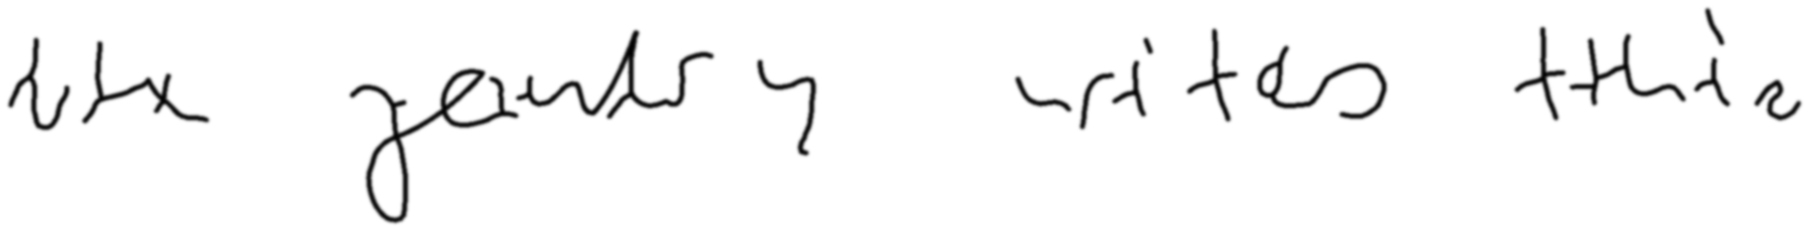
c1_c2 - read back as "the zeantry urites thin" (char 81.8%, writer 588 at 96.2%)
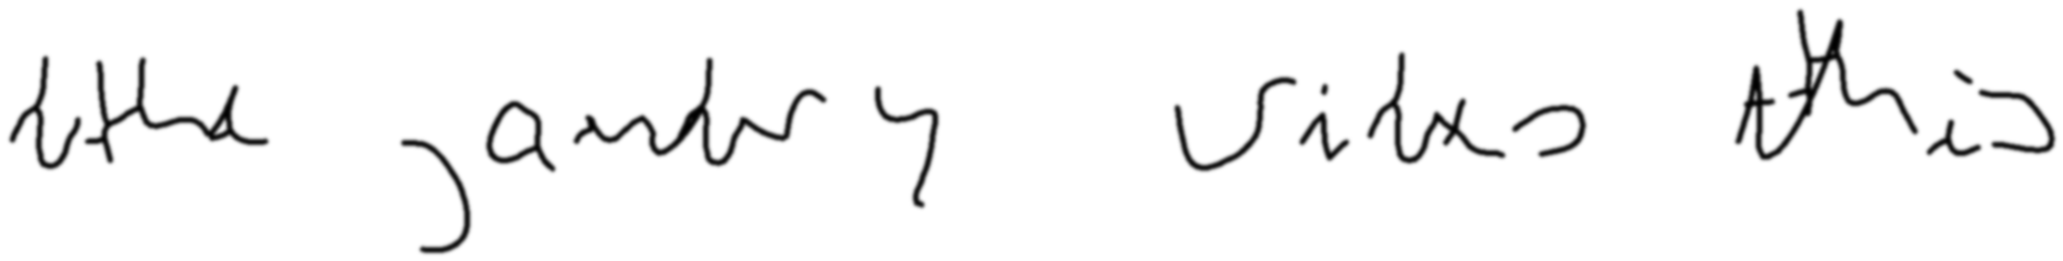
c1_c3 - read back as "-the antery Vites this" (char 77.3%, writer 588 at 92.4%)
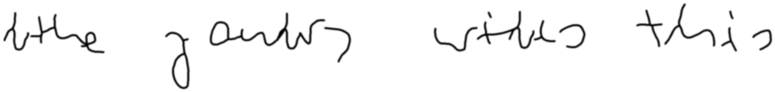
c1_c2_c3 - read back as "wthe yantry wtte this" (char 77.3%, writer 588 at 95.0%)
Top five variants of a, e, n, r, t by rank
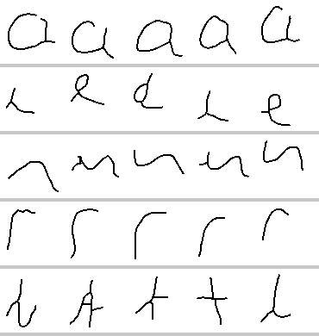
baseline prior distances a [0.083, 0.084, 0.093, 0.104, 0.113] e [0.144, 0.159, 0.204, 0.229, 0.24] n [0.239, 0.271, 0.305, 0.331, 0.34] r [0.069, 0.103, 0.12, 0.141, 0.165] t [0.275, 0.28, 0.286, 0.31, 0.332]
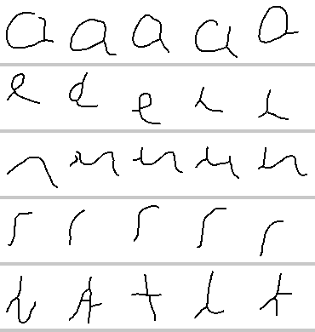
c2 prior distances a [0.096, 0.097, 0.138, 0.14, 0.146] e [0.148, 0.15, 0.171, 0.174, 0.202] n [0.186, 0.231, 0.25, 0.263, 0.278] r [0.124, 0.133, 0.147, 0.15, 0.176] t [0.138, 0.166, 0.185, 0.209, 0.226]
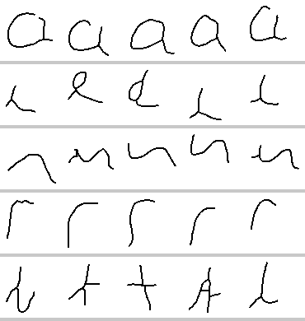
c3 prior distances a [0.067, 0.081, 0.091, 0.099, 0.101] e [0.143, 0.169, 0.238, 0.251, 0.262] n [0.227, 0.281, 0.315, 0.335, 0.342] r [0.06, 0.086, 0.092, 0.142, 0.158] t [0.223, 0.272, 0.272, 0.273, 0.309]

dylan (clean)
connectedness 0.195, slant -6.0 deg, x-height 26.0 px, 42 characters, 302 stored variants, 7.2 per character
config | char % | word % | conf % | margin | rank | ident | lifts/let | up % | own % | anchor % | lam | priorD med | priorD sprd | never % | anchor share % | variants
baseline | 84.09 | 25.00 | 49.84 | +12.80 | 2 | NO | 1.42 | 41 | 100.0 | 0.0 | 0.00 | 0.184 | 0.234 | 51.3 | 4.8 | 302
c1 | 84.09 | 25.00 | 49.77 | +16.07 | 2 | NO | 1.42 | 42 | 100.0 | 0.0 | 0.00 | 0.184 | 0.234 | 51.3 | 4.8 | 302
c2 | 90.91 | 37.50 | 50.90 | +10.65 | 2 | NO | 1.39 | 40 | 100.0 | 0.0 | 0.00 | 0.140 | 0.200 | 50.8 | 4.8 | 299
c3 | 81.82 | 37.50 | 58.00 | +29.59 | 2 | NO | 1.37 | 40 | 100.0 | 0.0 | 0.00 | 0.165 | 0.233 | 51.3 | 4.8 | 302
c1_c2 | 90.91 | 37.50 | 50.93 | +9.49 | 2 | NO | 1.39 | 41 | 100.0 | 0.0 | 0.00 | 0.140 | 0.200 | 50.8 | 4.8 | 299
c1_c3 | 88.63 | 54.16 | 58.33 | +31.39 | 2 | NO | 1.39 | 43 | 100.0 | 0.0 | 0.00 | 0.165 | 0.233 | 51.3 | 4.8 | 302
c1_c2_c3 | 81.81 | 54.16 | 60.23 | +38.23 | 1 | yes | 1.44 | 41 | 100.0 | 0.0 | 0.00 | 0.133 | 0.190 | 51.0 | 2.4 | 300
c4_control | 79.55 | 41.66 | 45.29 | +9.53 | 2 | NO | 1.42 | 43 | 100.0 | 0.0 | 0.00 | 0.193 | 0.245 | 52.5 | 0.0 | 320
c4 | 72.72 | 37.50 | 34.07 | -4.26 | 2 | NO | 1.59 | 45 | 89.7 | 10.3 | 0.00 | 0.191 | 0.247 | 52.4 | 1.3 | 319
c1_c4_control | 90.91 | 37.50 | 46.43 | +17.85 | 3 | NO | 1.44 | 42 | 100.0 | 0.0 | 0.00 | 0.193 | 0.245 | 52.5 | 0.0 | 320
c1_c4 | 88.63 | 54.16 | 33.59 | -17.35 | 2 | NO | 1.65 | 45 | 74.4 | 25.6 | 0.00 | 0.191 | 0.247 | 52.4 | 1.3 | 319
c1_c3_c4 | 79.55 | 25.00 | 34.33 | -10.07 | 2 | NO | 1.57 | 43 | 94.9 | 5.1 | 0.00 | 0.181 | 0.254 | 52.4 | 1.3 | 319

What it drew, sentence one
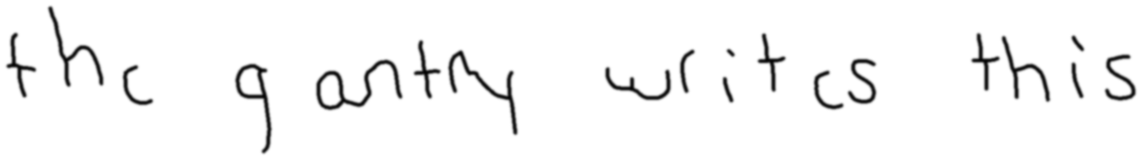
baseline - read back as "the y antry writ is this" (char 81.8%, writer dylan at 82.0%)
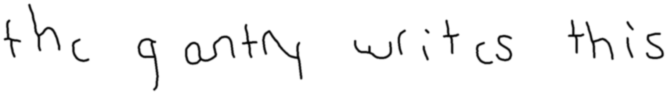
c1 - read back as "the yantry writ is this" (char 86.4%, writer dylan at 79.9%)
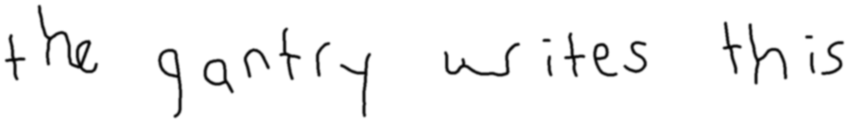
c2 - read back as "the gantry wites this" (char 95.5%, writer dylan at 77.2%)
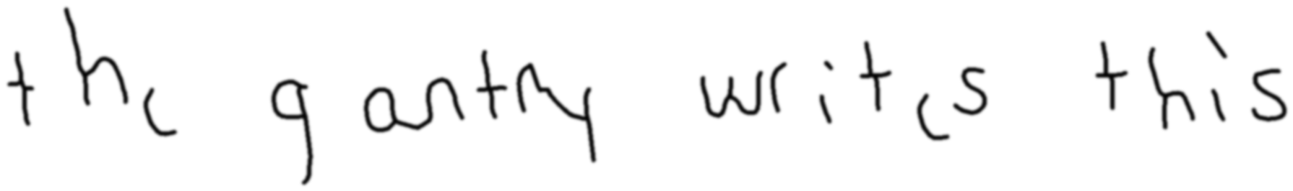
c3 - read back as "the gantry writ is this" (char 90.9%, writer dylan at 83.4%)
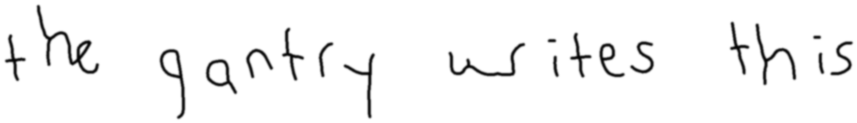
c1_c2 - read back as "the gantry wites this" (char 95.5%, writer dylan at 81.6%)
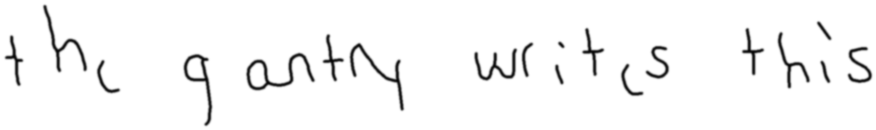
c1_c3 - read back as "the gantry writ is this" (char 90.9%, writer dylan at 78.5%)

c1_c2_c3 - read back as "the gantry wites this" (char 95.5%, writer dylan at 78.7%)

c4_control - read back as "the gantny writcs this" (char 90.9%, writer dylan at 71.3%)
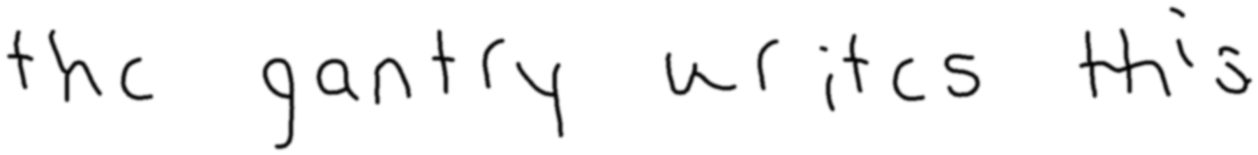
c4 - read back as "the gantry urit is this" (char 86.4%, writer dylan at 43.3%)

c1_c4_control - read back as "the gantry wites this" (char 95.5%, writer dylan at 70.6%)
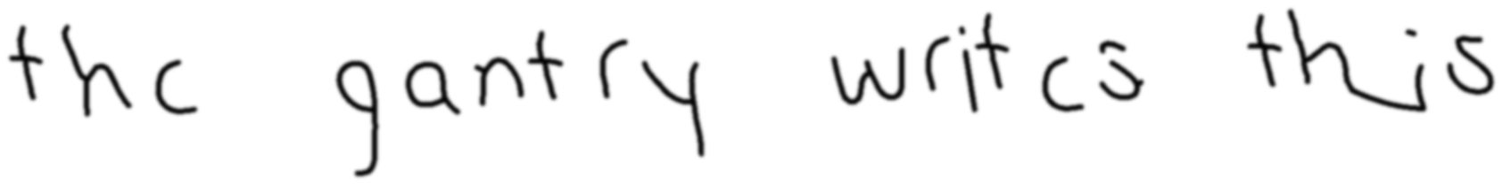
c1_c4 - read back as "the gantry writis this" (char 95.5%, writer dylan at 49.9%)
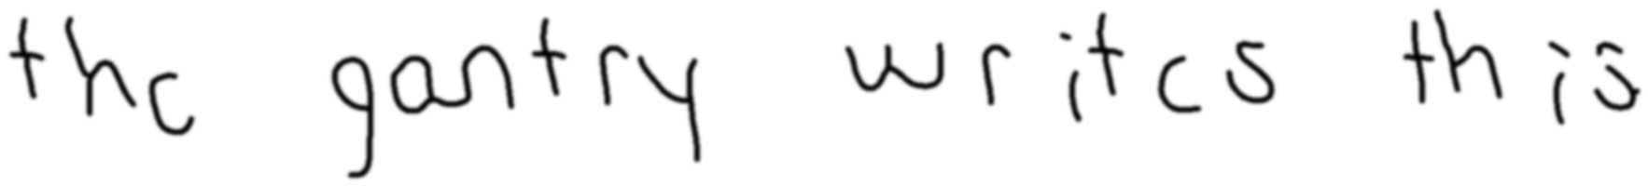
c1_c3_c4 - read back as "the gantry writ cs th is" (char 86.4%, writer dylan at 46.6%)
Top five variants of a, e, n, r, t by rank
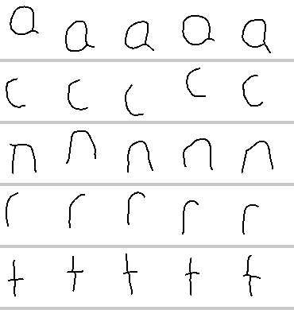
baseline prior distances a [0.099, 0.114, 0.123, 0.162, 0.164] e [0.137, 0.146, 0.148, 0.162, 0.174] n [0.107, 0.109, 0.122, 0.123, 0.137] r [0.073, 0.085, 0.091, 0.103, 0.121] t [0.209, 0.223, 0.234, 0.246, 0.259]
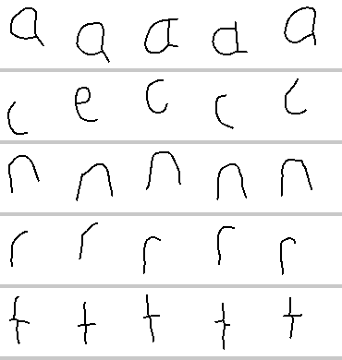
c2 prior distances a [0.132, 0.187, 0.193, 0.198, 0.201] e [0.157, 0.182, 0.192, 0.193, 0.204] n [0.215, 0.219, 0.224, 0.224, 0.227] r [0.072, 0.085, 0.087, 0.093, 0.095] t [0.076, 0.086, 0.087, 0.093, 0.094]
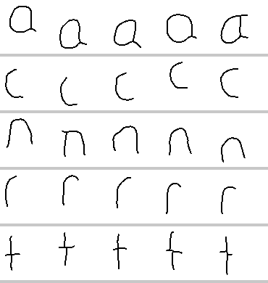
c3 prior distances a [0.094, 0.096, 0.11, 0.159, 0.169] e [0.097, 0.115, 0.118, 0.134, 0.14] n [0.083, 0.093, 0.096, 0.109, 0.109] r [0.057, 0.069, 0.07, 0.076, 0.09] t [0.148, 0.17, 0.189, 0.22, 0.222]
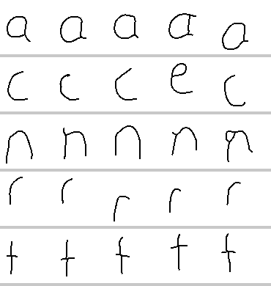
c4_control prior distances a [0.118, 0.134, 0.156, 0.16, 0.166] e [0.132, 0.157, 0.189, 0.19, 0.193] n [0.103, 0.112, 0.122, 0.147, 0.159] r [0.094, 0.106, 0.118, 0.119, 0.123] t [0.216, 0.235, 0.257, 0.271, 0.286]
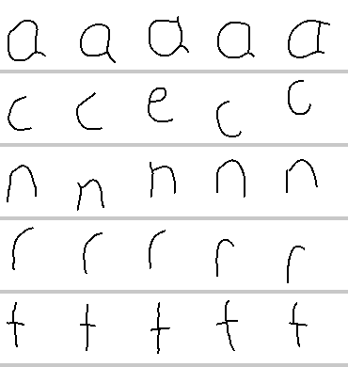
c4 prior distances a [0.085, 0.118, 0.129, 0.156, 0.16] e [0.132, 0.189, 0.19, 0.193, 0.193] n [0.103, 0.11, 0.112, 0.122, 0.138] r [0.094, 0.102, 0.106, 0.114, 0.119] t [0.201, 0.216, 0.235, 0.247, 0.255]

owen (clean)
connectedness 0.319, slant 0.0 deg, x-height 32.0 px, 43 characters, 307 stored variants, 7.1 per character
config | char % | word % | conf % | margin | rank | ident | lifts/let | up % | own % | anchor % | lam | priorD med | priorD sprd | never % | anchor share % | variants
baseline | 97.72 | 87.50 | 99.34 | +98.84 | 1 | yes | 1.50 | 34 | 100.0 | 0.0 | 0.00 | 0.191 | 0.259 | 50.5 | 5.3 | 307
c1 | 97.72 | 87.50 | 98.54 | +97.28 | 1 | yes | 1.50 | 34 | 100.0 | 0.0 | 0.00 | 0.191 | 0.259 | 50.5 | 5.3 | 307
c2 | 95.45 | 70.84 | 98.78 | +97.62 | 1 | yes | 1.57 | 36 | 94.9 | 5.1 | 0.00 | 0.153 | 0.257 | 50.5 | 4.7 | 307
c3 | 97.72 | 87.50 | 97.70 | +95.42 | 1 | yes | 1.36 | 33 | 100.0 | 0.0 | 0.00 | 0.179 | 0.232 | 50.6 | 5.3 | 308
c1_c2 | 95.45 | 70.84 | 99.34 | +98.78 | 1 | yes | 1.44 | 33 | 100.0 | 0.0 | 0.00 | 0.153 | 0.257 | 50.5 | 4.7 | 307
c1_c3 | 97.72 | 87.50 | 97.34 | +94.72 | 1 | yes | 1.36 | 33 | 100.0 | 0.0 | 0.00 | 0.179 | 0.232 | 50.6 | 5.3 | 308
c1_c2_c3 | 97.72 | 83.34 | 97.69 | +95.42 | 1 | yes | 1.65 | 38 | 94.9 | 5.1 | 0.00 | 0.136 | 0.255 | 50.5 | 4.7 | 307
c4_control | 95.45 | 66.66 | 99.61 | +99.28 | 1 | yes | 1.42 | 38 | 94.9 | 5.1 | 0.00 | 0.186 | 0.289 | 49.7 | 7.2 | 322
c4 | 100.00 | 100.00 | 99.29 | +98.62 | 1 | yes | 1.42 | 39 | 100.0 | 0.0 | 0.00 | 0.186 | 0.286 | 50.0 | 7.2 | 324
c1_c4_control | 95.45 | 83.34 | 99.40 | +98.81 | 1 | yes | 1.57 | 38 | 100.0 | 0.0 | 0.00 | 0.186 | 0.289 | 49.7 | 7.2 | 322
c1_c4 | 97.72 | 83.34 | 99.54 | +99.09 | 1 | yes | 1.47 | 36 | 100.0 | 0.0 | 0.00 | 0.186 | 0.286 | 50.0 | 7.2 | 324
c1_c3_c4 | 97.72 | 100.00 | 99.23 | +98.52 | 1 | yes | 1.42 | 39 | 100.0 | 0.0 | 0.00 | 0.173 | 0.247 | 50.3 | 7.2 | 328

What it drew, sentence one

baseline - read back as "the gantry wites this" (char 95.5%, writer owen at 98.8%)

c1 - read back as "the gantry wites this" (char 95.5%, writer owen at 97.2%)
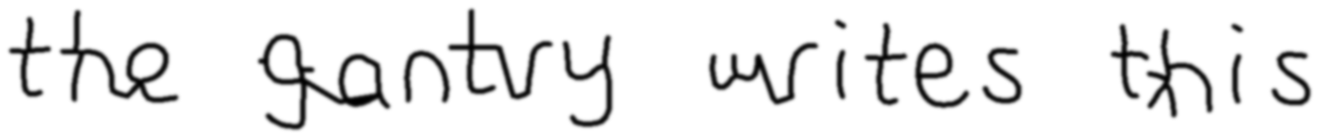
c2 - read back as "the antry writes this" (char 95.5%, writer owen at 98.5%)
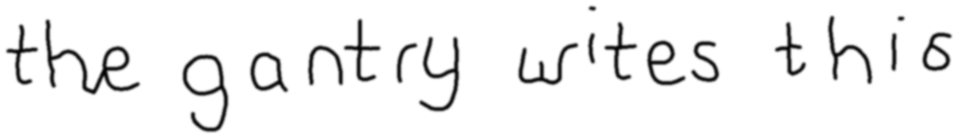
c3 - read back as "the gantry wites this" (char 95.5%, writer owen at 95.5%)

c1_c2 - read back as "the antry writes this" (char 95.5%, writer owen at 98.9%)

c1_c3 - read back as "the gantry wites this" (char 95.5%, writer owen at 94.8%)

c1_c2_c3 - read back as "the gantry writes this" (char 100.0%, writer owen at 98.8%)

c4_control - read back as "the gantry writes this" (char 100.0%, writer owen at 99.4%)

c4 - read back as "the gantry writes this" (char 100.0%, writer owen at 98.6%)

c1_c4_control - read back as "the gantry writes this" (char 100.0%, writer owen at 99.0%)
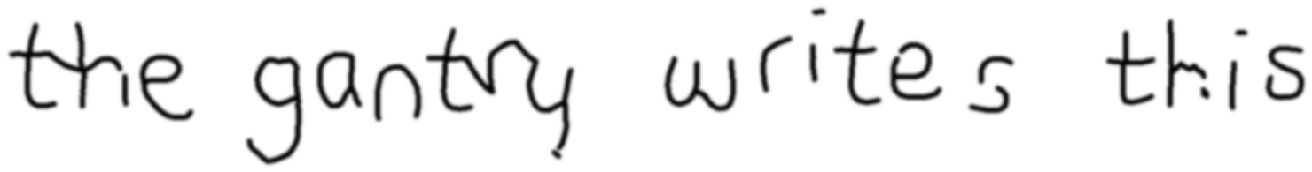
c1_c4 - read back as "the gantry writes this" (char 100.0%, writer owen at 99.3%)
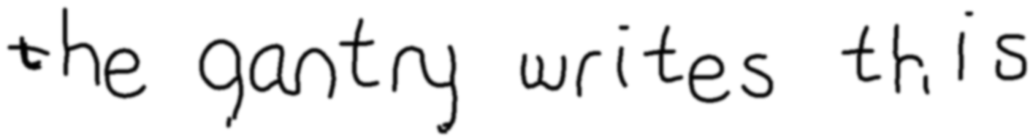
c1_c3_c4 - read back as "the gantry writes this" (char 100.0%, writer owen at 99.7%)
Top five variants of a, e, n, r, t by rank
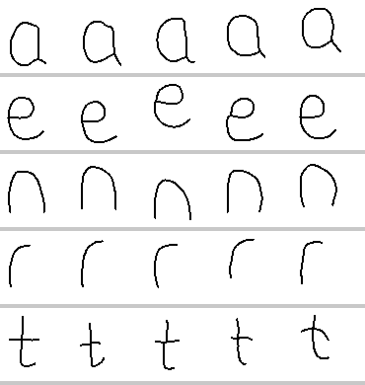
baseline prior distances a [0.088, 0.09, 0.103, 0.108, 0.118] e [0.157, 0.169, 0.183, 0.189, 0.195] n [0.092, 0.093, 0.108, 0.123, 0.127] r [0.065, 0.071, 0.082, 0.084, 0.088] t [0.151, 0.182, 0.192, 0.199, 0.223]
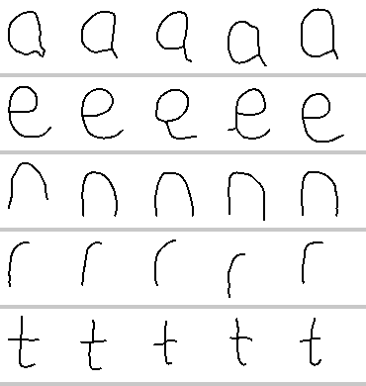
c2 prior distances a [0.172, 0.178, 0.195, 0.199, 0.204] e [0.208, 0.211, 0.24, 0.24, 0.243] n [0.172, 0.225, 0.233, 0.236, 0.244] r [0.052, 0.069, 0.075, 0.09, 0.094] t [0.073, 0.078, 0.078, 0.1, 0.103]
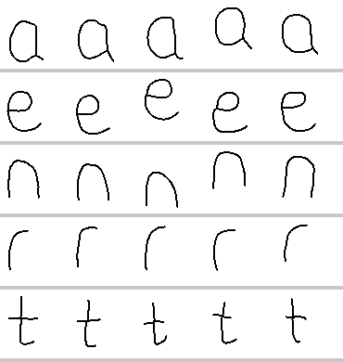
c3 prior distances a [0.077, 0.08, 0.096, 0.104, 0.107] e [0.171, 0.174, 0.189, 0.203, 0.21] n [0.066, 0.069, 0.093, 0.095, 0.1] r [0.043, 0.059, 0.059, 0.067, 0.071] t [0.105, 0.138, 0.151, 0.161, 0.167]
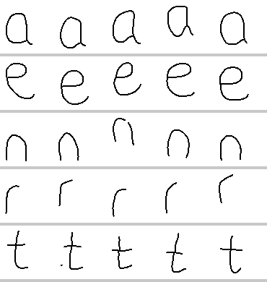
c4_control prior distances a [0.081, 0.089, 0.101, 0.104, 0.107] e [0.171, 0.173, 0.182, 0.183, 0.193] n [0.085, 0.1, 0.105, 0.113, 0.119] r [0.066, 0.073, 0.082, 0.084, 0.085] t [0.178, 0.18, 0.183, 0.193, 0.226]
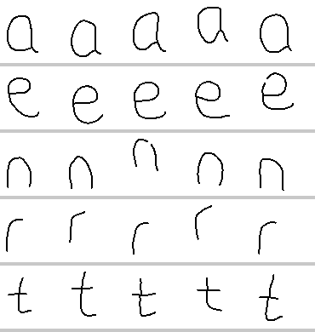
c4 prior distances a [0.081, 0.089, 0.101, 0.104, 0.107] e [0.171, 0.173, 0.193, 0.201, 0.214] n [0.088, 0.1, 0.105, 0.113, 0.121] r [0.065, 0.073, 0.082, 0.085, 0.092] t [0.154, 0.178, 0.183, 0.186, 0.193]

yeukita (clean)
connectedness 0.417, slant 0.0 deg, x-height 27.0 px, 58 characters, 333 stored variants, 5.7 per character
config | char % | word % | conf % | margin | rank | ident | lifts/let | up % | own % | anchor % | lam | priorD med | priorD sprd | never % | anchor share % | variants
baseline | 90.91 | 58.34 | 91.58 | +83.53 | 1 | yes | 1.36 | 38 | 100.0 | 0.0 | 0.00 | 0.224 | 0.325 | 44.1 | 5.8 | 333
c1 | 93.18 | 70.84 | 93.89 | +88.12 | 1 | yes | 1.36 | 38 | 100.0 | 0.0 | 0.00 | 0.224 | 0.325 | 44.1 | 5.8 | 333
c2 | 93.18 | 70.84 | 92.62 | +85.32 | 1 | yes | 1.44 | 36 | 100.0 | 0.0 | 0.00 | 0.156 | 0.323 | 43.8 | 4.7 | 329
c3 | 90.91 | 66.66 | 91.44 | +82.96 | 1 | yes | 1.38 | 33 | 94.9 | 5.1 | 0.00 | 0.203 | 0.341 | 43.8 | 5.8 | 331
c1_c2 | 90.91 | 66.66 | 95.73 | +91.55 | 1 | yes | 1.39 | 36 | 94.9 | 5.1 | 0.00 | 0.156 | 0.323 | 43.8 | 4.7 | 329
c1_c3 | 81.82 | 41.66 | 89.62 | +79.74 | 1 | yes | 1.26 | 34 | 100.0 | 0.0 | 0.00 | 0.203 | 0.341 | 43.8 | 5.8 | 331
c1_c2_c3 | 95.45 | 83.34 | 95.04 | +90.39 | 1 | yes | 1.44 | 35 | 84.6 | 15.4 | 0.00 | 0.148 | 0.334 | 43.6 | 3.5 | 328

What it drew, sentence one
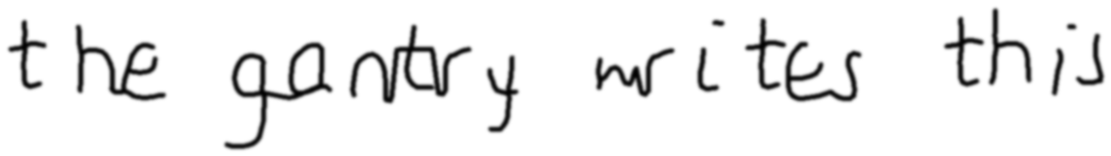
baseline - read back as "the gastery wites this" (char 86.4%, writer yeukita at 86.3%)
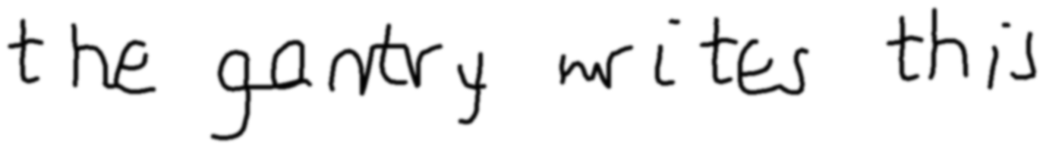
c1 - read back as "the gantry wites this" (char 95.5%, writer yeukita at 91.4%)

c2 - read back as "the gantry tristes this" (char 90.9%, writer yeukita at 97.5%)
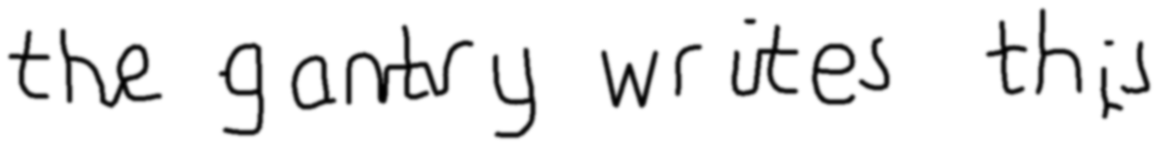
c3 - read back as "the gantry writes this" (char 100.0%, writer yeukita at 91.5%)

c1_c2 - read back as "the gantry writes this" (char 100.0%, writer yeukita at 95.3%)
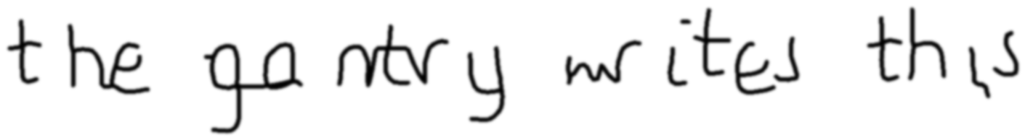
c1_c3 - read back as "the go try mites this" (char 81.8%, writer yeukita at 89.4%)

c1_c2_c3 - read back as "the gantry writes this" (char 100.0%, writer yeukita at 97.5%)
Top five variants of a, e, n, r, t by rank
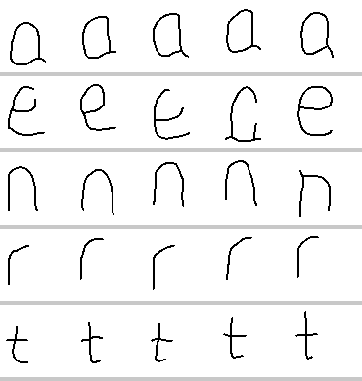
baseline prior distances a [0.093, 0.095, 0.108, 0.112, 0.117] e [0.143, 0.191, 0.196, 0.209, 0.227] n [0.088, 0.089, 0.099, 0.112, 0.117] r [0.075, 0.079, 0.093, 0.095, 0.097] t [0.169, 0.195, 0.198, 0.203, 0.207]
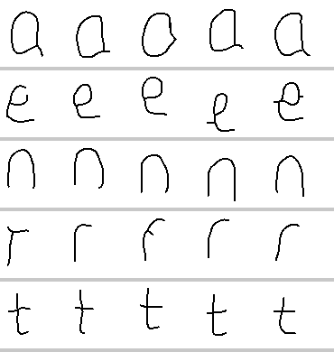
c2 prior distances a [0.137, 0.178, 0.202, 0.208, 0.214] e [0.182, 0.197, 0.202, 0.221, 0.235] n [0.159, 0.172, 0.184, 0.191, 0.196] r [0.079, 0.092, 0.109, 0.112, 0.113] t [0.071, 0.093, 0.094, 0.095, 0.095]
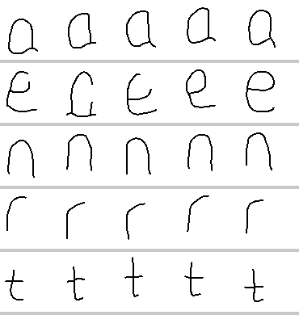
c3 prior distances a [0.083, 0.089, 0.092, 0.097, 0.118] e [0.152, 0.201, 0.207, 0.22, 0.241] n [0.062, 0.067, 0.072, 0.088, 0.1] r [0.06, 0.07, 0.071, 0.076, 0.078] t [0.128, 0.139, 0.14, 0.158, 0.184]

