Glyph libraries, every writer
D.R. Braune, 23539195. Each column is one character, the glyphs below it are that writer's stored variants from most typical downwards, up to 8. Fewer are shown where fewer were kept. Drawn from the stored stroke coordinates, with a faint baseline, by testing/glyphsheet.py

Writer 150
42 characters, 296 stored variants.
a | b | c | d | e | f | g | h | i | j | k | l
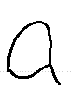 | 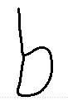 |  | 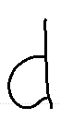 | 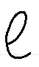 | 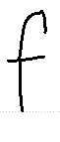 | 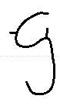 | 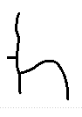 |  |  | 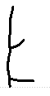 | 
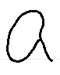 | 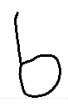 | 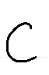 | 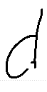 | 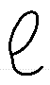 | 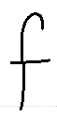 | 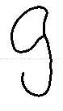 | 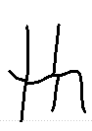 |  |  | 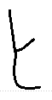 | 
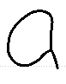 | 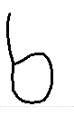 | 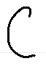 | 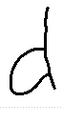 | 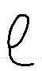 | 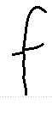 | 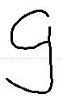 | 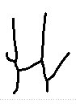 |  |  | 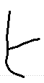 | 
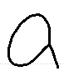 | 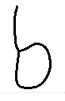 | 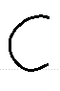 | 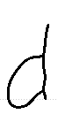 | 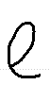 | 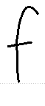 | 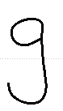 | 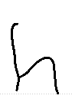 |  |  |  | 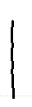
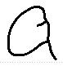 | 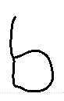 | 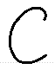 | 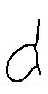 | 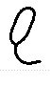 | 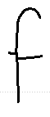 | 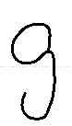 | 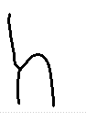 |  |  |  | 
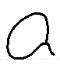 | 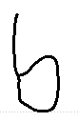 | 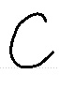 | 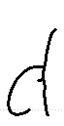 | 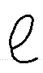 | 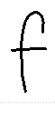 | 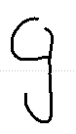 | 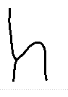 |  |  |  | 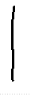
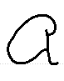 | 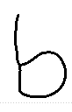 | 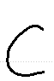 | 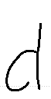 | 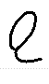 | 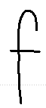 | 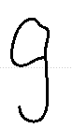 | 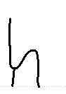 | 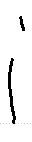 |  |  | 
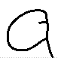 | 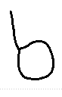 |  | 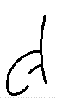 | 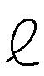 | 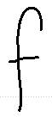 | 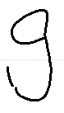 | 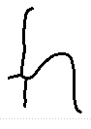 |  |  |  | 

m | n | o | p | q | r | s | t | u | v | w | x
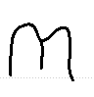 | 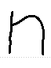 | 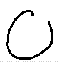 | 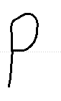 | 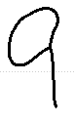 |  |  | 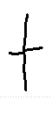 | 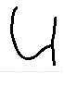 | 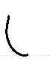 | 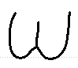 | 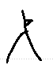
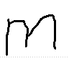 | 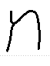 | 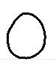 | 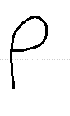 | 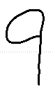 | 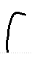 |  | 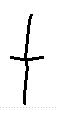 | 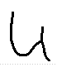 | 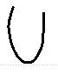 | 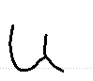 | 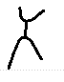
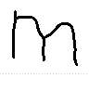 | 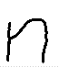 | 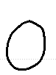 | 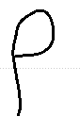 | 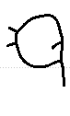 | 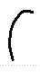 |  | 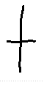 | 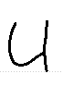 | 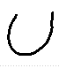 | 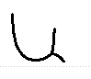 | 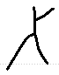
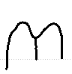 | 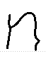 | 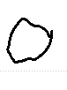 | 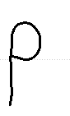 |  | 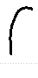 |  | 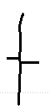 | 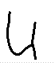 | 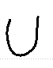 | 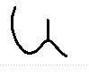 | 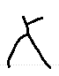
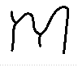 | 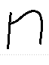 | 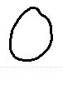 | 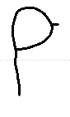 |  | 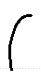 |  | 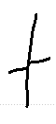 | 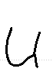 | 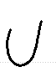 | 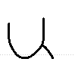
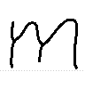 | 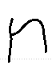 | 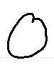 | 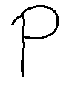 |  |  |  | 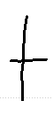 | 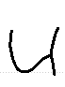 | 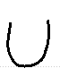 | 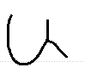
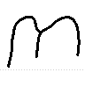 | 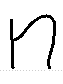 | 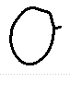 | 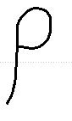 |  | 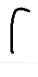 |  | 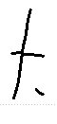 | 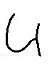 | 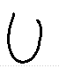 | 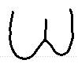
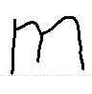 | 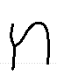 | 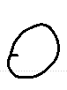 | 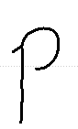 |  | 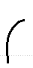 |  | 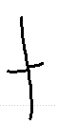 | 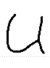 | 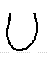 | 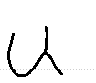

y | z | A | B | D | E | F | H | I | L | M | P
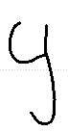 | 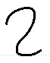 | 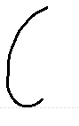 | 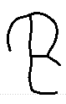 | 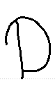 | 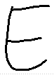 | 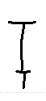 | 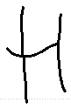 |  | 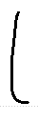 | 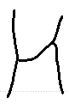 | 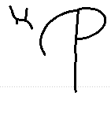
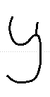 |  | 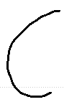 |  |  |  |  | 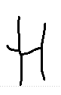 |  |  | 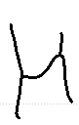
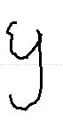 |  |  |  |  |  |  |  |  |  | 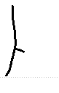
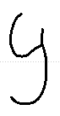
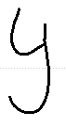
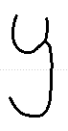
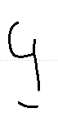
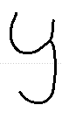

R | S | T | " | , | ;
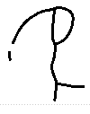 | 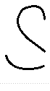 | 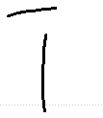 |  |  | 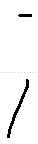
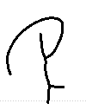 |  | 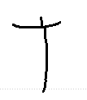 |  | 
 |  | 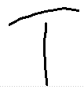 |  | 
 |  |  |  | 
 |  |  |  | 

Writer 151
43 characters, 287 stored variants.
a | b | c | d | e | f | g | h | i | k | l | m
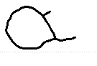 | 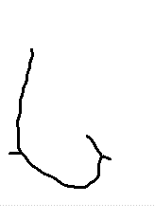 | 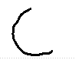 | 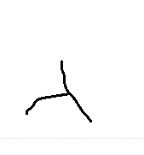 | 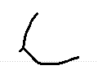 | 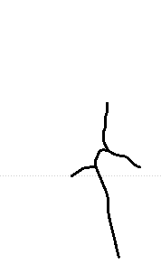 | 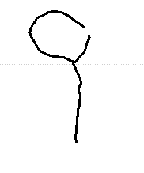 | 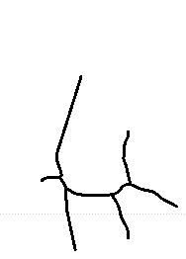 | 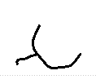 | 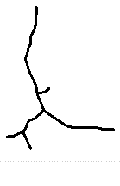 | 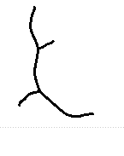 | 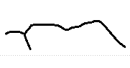
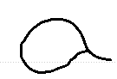 | 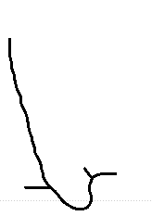 | 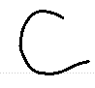 | 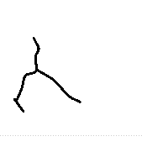 | 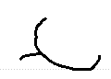 | 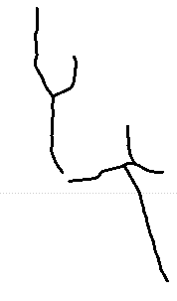 | 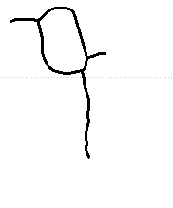 | 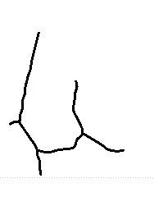 | 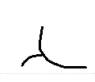 | 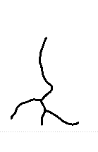 | 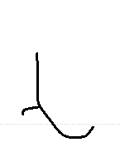 | 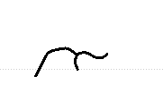
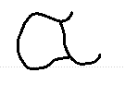 | 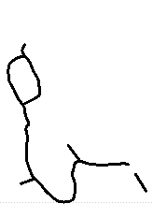 | 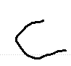 | 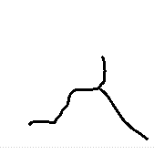 | 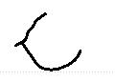 | 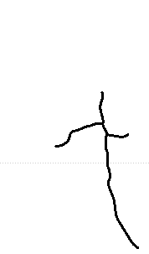 | 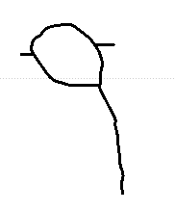 | 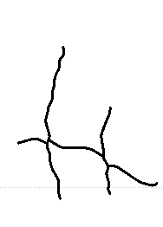 | 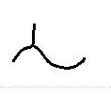 | 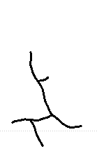 | 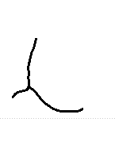 | 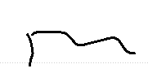
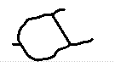 | 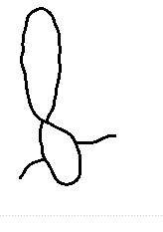 | 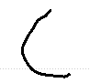 | 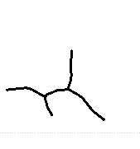 | 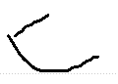 | 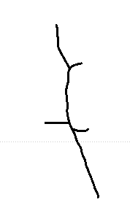 | 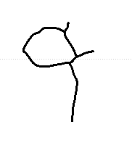 | 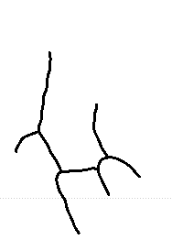 | 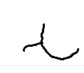 |  | 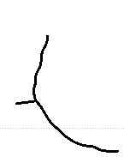 | 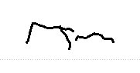
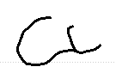 | 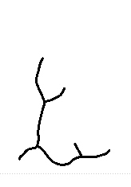 | 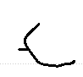 | 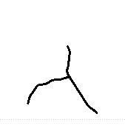 | 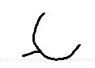 | 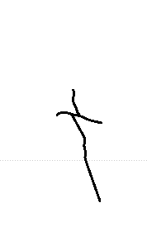 | 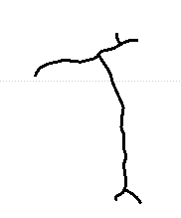 | 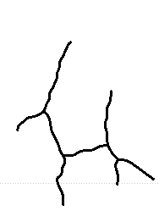 | 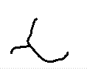 |  | 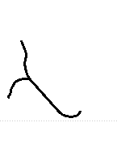 | 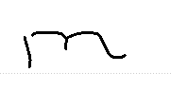
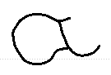 | 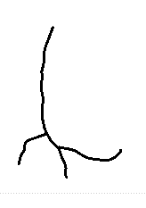 | 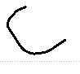 | 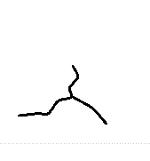 | 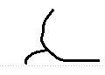 | 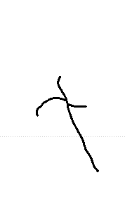 | 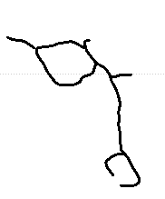 | 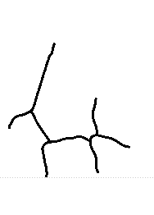 | 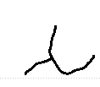 |  | 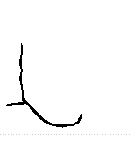 | 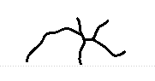
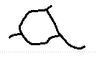 |  | 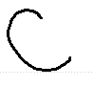 | 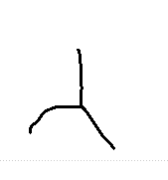 | 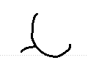 | 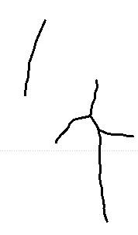 | 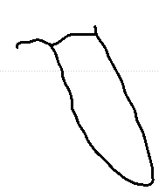 | 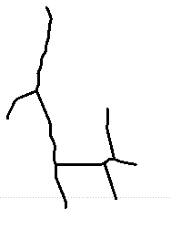 | 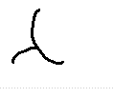 |  | 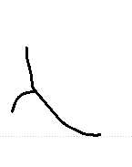 | 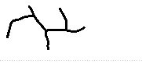
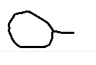 |  | 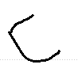 | 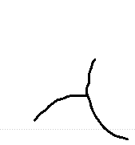 | 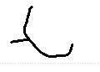 | 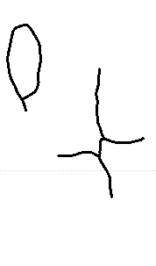 | 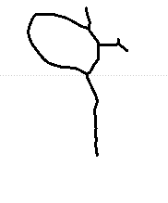 | 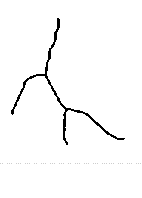 | 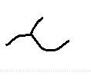 |  | 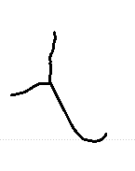 | 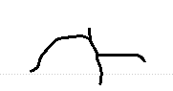

n | o | p | q | r | s | t | u | v | w | x | y
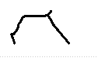 | 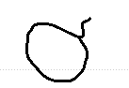 | 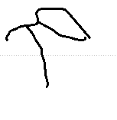 | 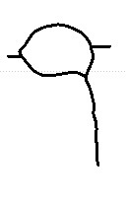 | 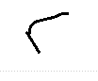 | 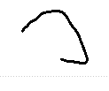 | 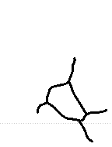 | 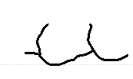 | 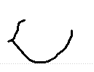 | 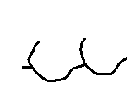 | 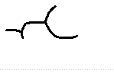 | 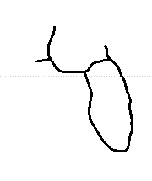
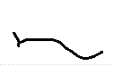 | 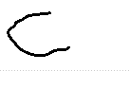 | 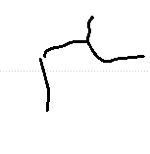 | 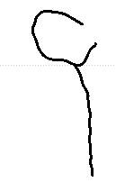 | 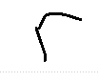 | 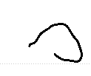 | 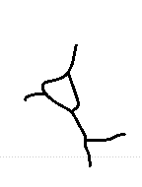 | 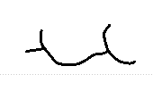 |  | 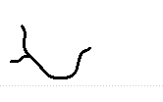 | 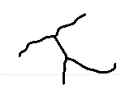 | 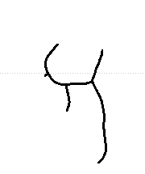
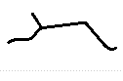 | 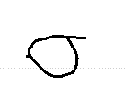 | 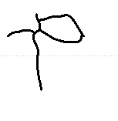 | 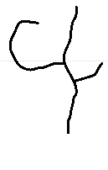 | 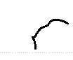 | 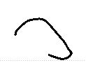 | 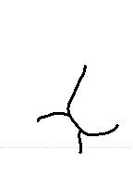 | 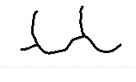 | 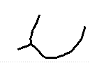 | 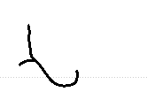 | 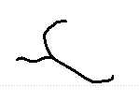 | 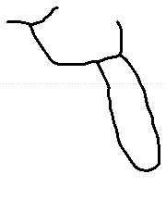
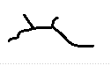 | 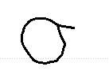 | 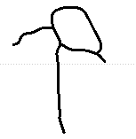 |  | 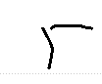 | 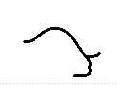 | 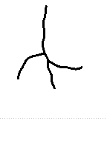 | 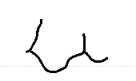 | 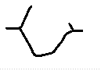 | 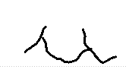 |  | 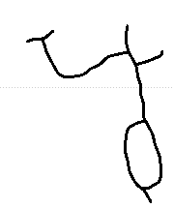
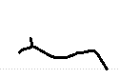 | 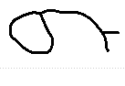 | 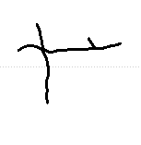 |  | 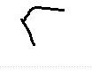 | 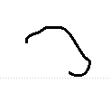 | 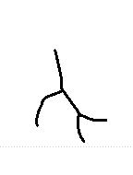 | 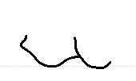 | 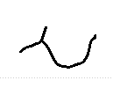 | 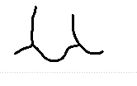 |  | 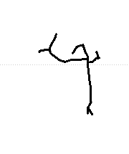
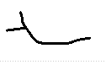 | 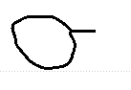 | 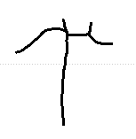 |  | 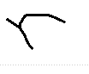 | 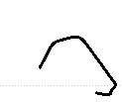 | 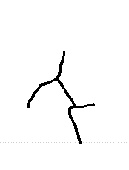 | 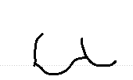 | 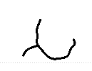 | 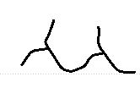 |  | 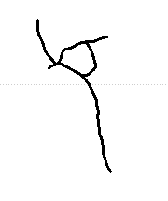
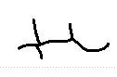 | 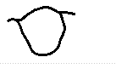 |  |  | 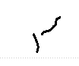 | 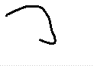 | 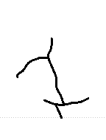 | 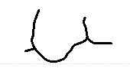 | 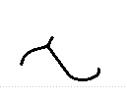 | 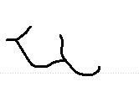 |  | 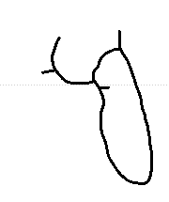
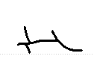 | 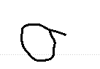 |  |  | 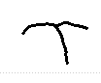 | 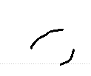 | 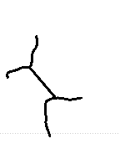 | 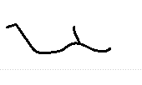 | 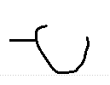 | 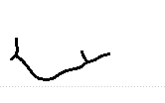 |  | 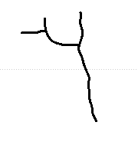

A | D | F | H | I | J | M | P | S | T | W | "
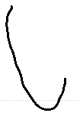 | 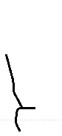 | 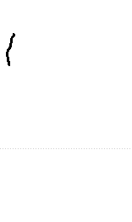 | 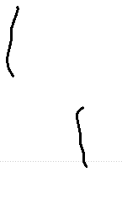 | 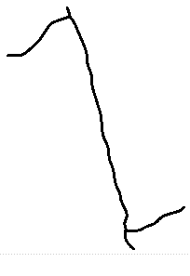 | 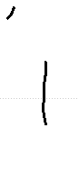 | 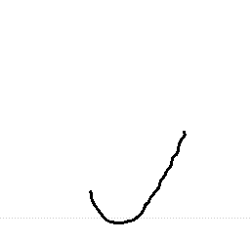 | 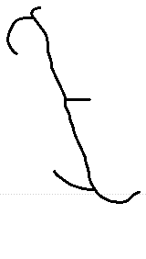 |  | 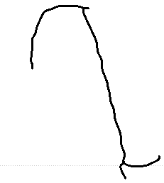 | 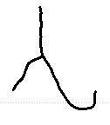 | 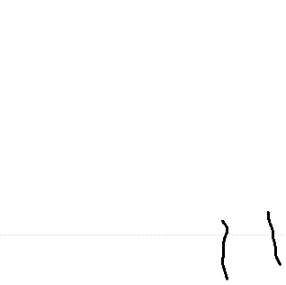
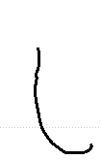 |  |  | 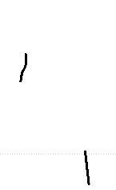 | 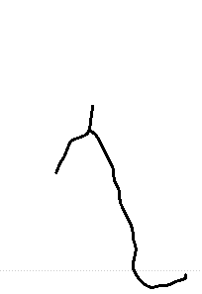 |  | 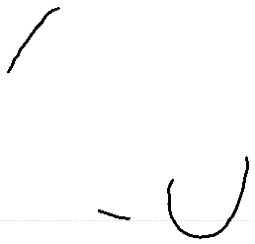 |  |  | 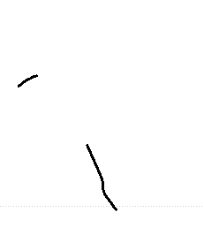 | 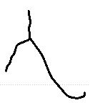 | 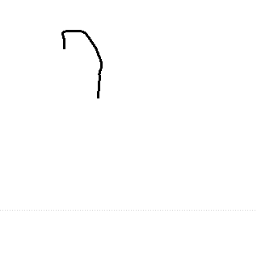
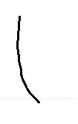 |  |  |  | 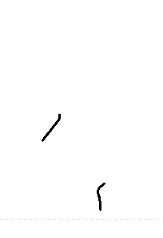 |  | 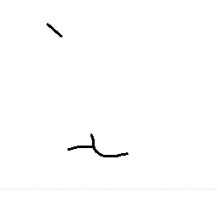 |  |  | 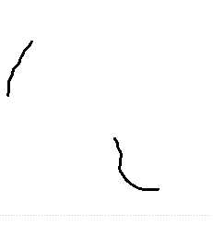 |  | 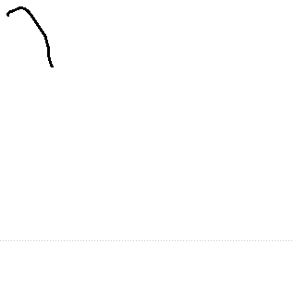

' | ( | ) | , | - | . | ;
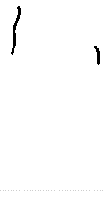 | 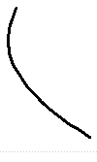 | 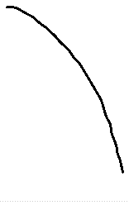 |  | 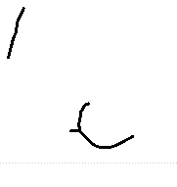 | 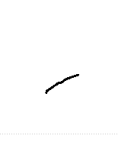 | 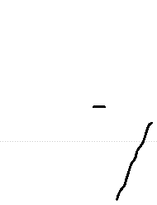
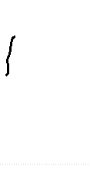 |  |  |  | 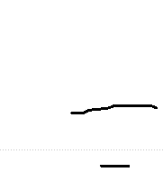 | 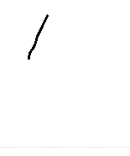 | 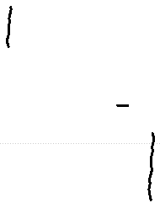
 |  |  |  |  | 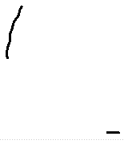
 |  |  | 
 |  |  | 
 |  |  | 

Writer 152
38 characters, 273 stored variants.
a | b | c | d | e | f | g | h | i | k | l | m
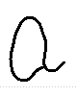 | 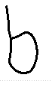 | 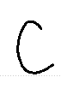 | 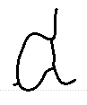 | 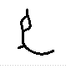 | 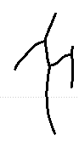 | 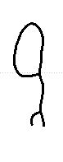 | 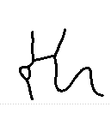 | 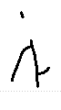 | 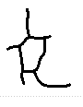 | 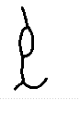 | 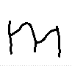
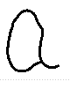 | 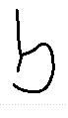 | 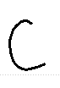 | 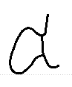 | 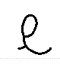 | 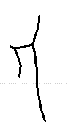 | 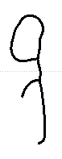 | 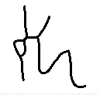 | 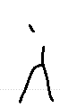 | 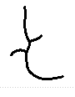 | 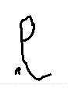 | 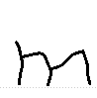
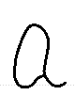 | 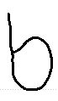 | 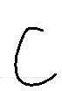 | 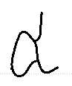 | 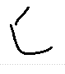 | 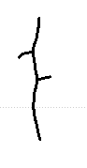 | 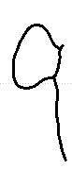 | 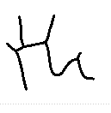 | 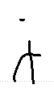 | 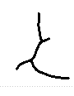 | 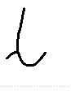 | 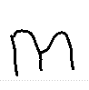
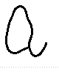 | 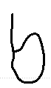 | 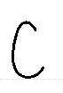 | 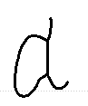 | 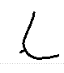 | 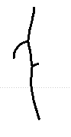 | 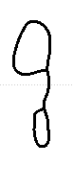 | 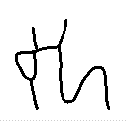 | 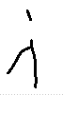 |  | 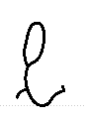 | 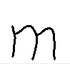
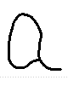 |  | 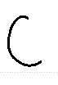 | 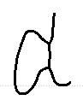 | 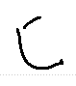 | 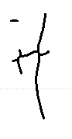 | 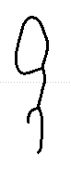 | 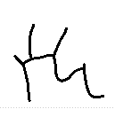 | 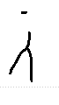 |  | 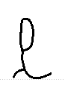 | 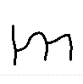
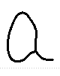 |  | 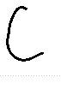 | 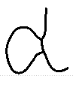 | 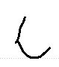 | 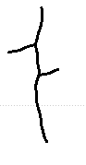 | 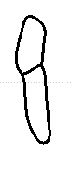 | 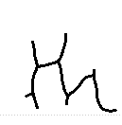 | 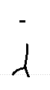 |  | 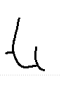 | 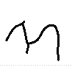
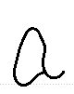 |  | 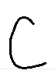 | 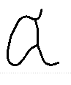 | 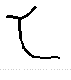 | 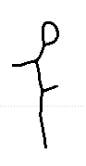 | 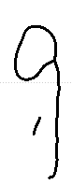 | 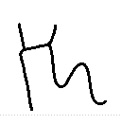 | 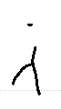 |  | 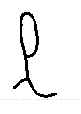 | 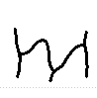
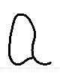 |  | 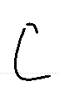 | 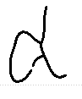 | 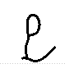 | 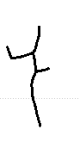 | 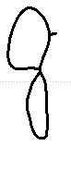 | 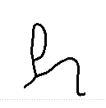 | 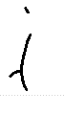 |  | 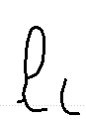 | 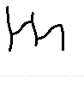

n | o | p | q | r | s | t | u | v | w | x | y
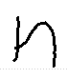 | 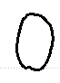 | 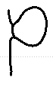 | 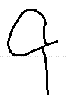 | 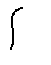 | 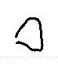 | 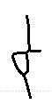 | 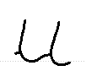 | 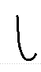 | 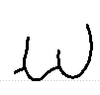 | 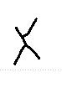 | 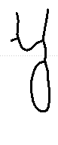
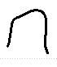 | 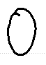 | 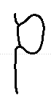 | 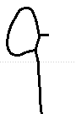 | 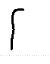 | 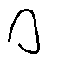 | 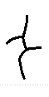 | 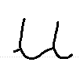 | 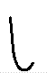 | 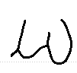 | 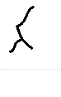 | 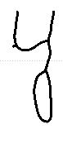
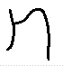 | 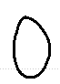 | 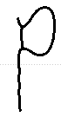 | 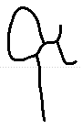 | 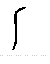 |  | 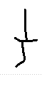 | 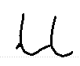 | 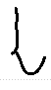 | 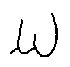 | 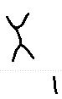 | 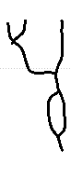
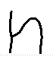 | 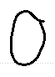 | 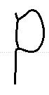 |  | 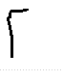 | 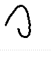 | 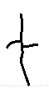 | 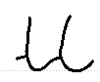 | 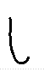 | 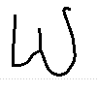 |  | 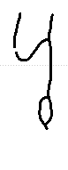
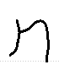 | 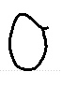 | 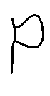 |  | 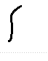 | 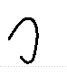 | 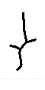 | 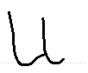 |  | 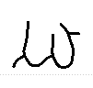 |  | 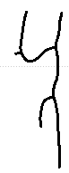
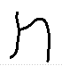 | 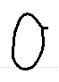 | 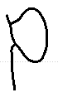 |  | 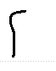 | 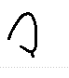 | 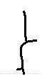 | 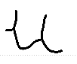 |  | 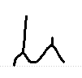 |  | 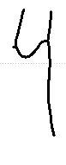
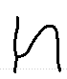 | 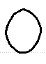 | 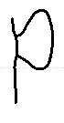 |  | 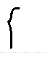 | 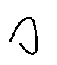 | 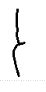 | 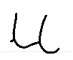 |  | 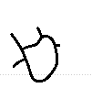 |  | 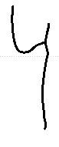
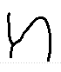 | 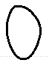 | 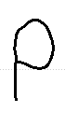 |  | 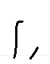 | 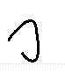 | 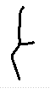 | 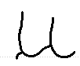 |  | 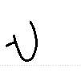 |  | 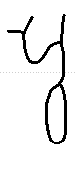

A | B | F | I | J | L | M | T | W | " | ) | ,
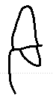 | 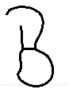 | 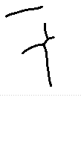 | 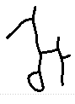 | 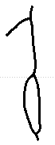 | 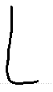 | 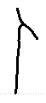 | 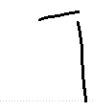 | 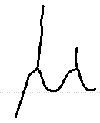 |  | 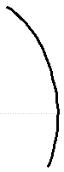
 |  | 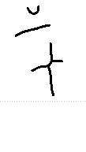 | 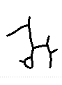 |  |  | 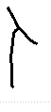 | 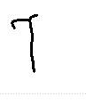
 |  |  |  |  |  | 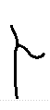 | 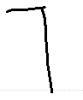
 |  |  |  |  |  |  | 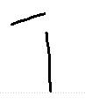

- | ;
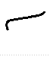 | 

Writer 153
37 characters, 283 stored variants.
a | b | c | d | e | f | g | h | i | j | k | l
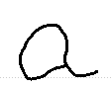 | 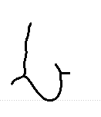 | 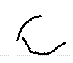 | 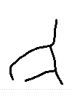 | 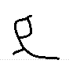 | 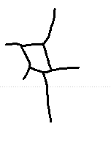 | 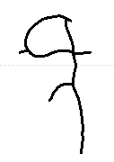 | 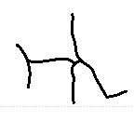 | 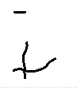 | 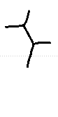 | 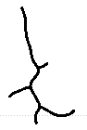 | 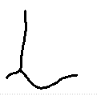
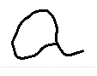 | 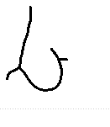 | 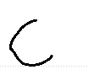 | 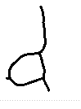 | 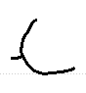 | 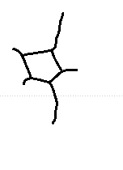 | 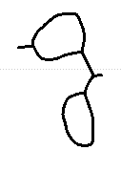 | 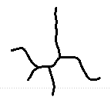 | 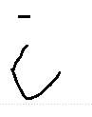 |  | 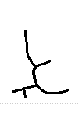 | 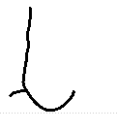
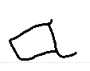 | 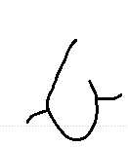 | 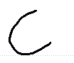 | 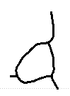 | 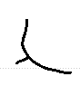 | 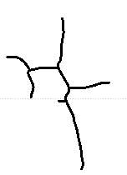 | 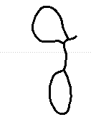 | 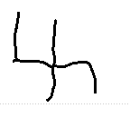 | 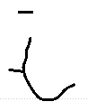 |  | 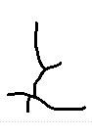 | 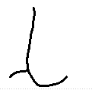
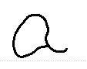 | 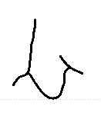 | 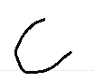 | 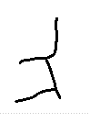 | 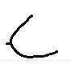 | 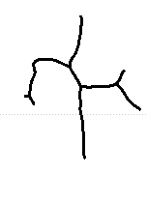 | 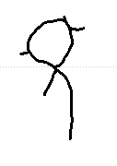 | 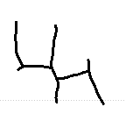 | 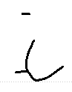 |  |  | 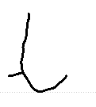
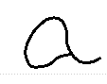 | 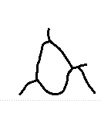 | 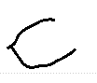 | 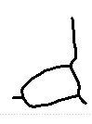 | 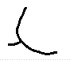 | 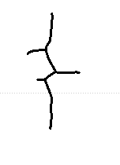 | 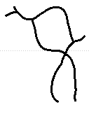 | 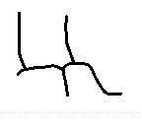 | 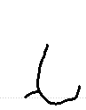 |  |  | 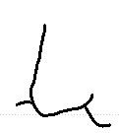
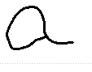 | 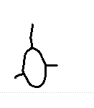 | 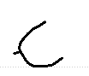 | 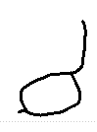 | 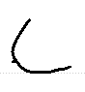 | 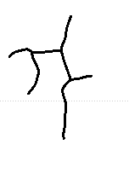 | 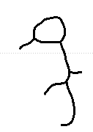 | 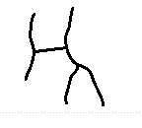 | 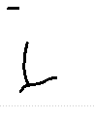 |  |  | 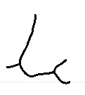
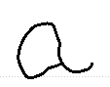 |  | 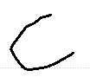 | 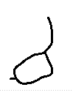 | 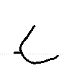 | 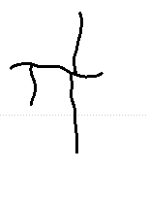 | 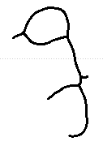 | 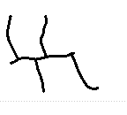 | 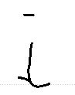 |  |  | 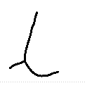
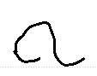 |  | 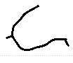 | 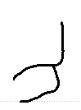 | 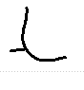 | 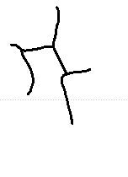 | 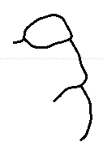 | 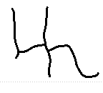 | 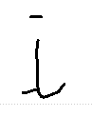 |  |  | 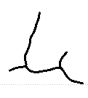

m | n | o | p | q | r | s | t | u | v | w | x
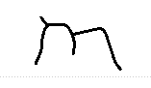 | 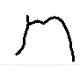 | 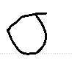 | 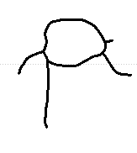 | 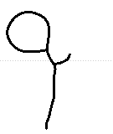 | 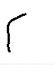 | 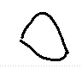 | 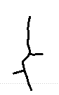 | 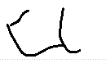 | 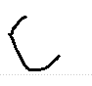 | 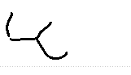 | 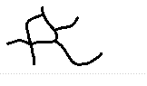
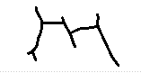 | 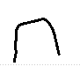 | 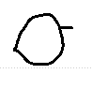 | 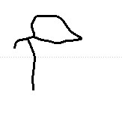 | 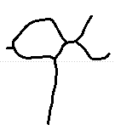 | 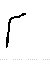 | 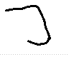 | 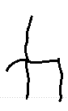 | 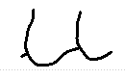 | 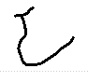 | 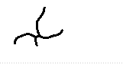 | 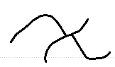
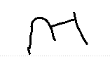 | 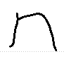 | 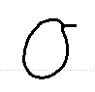 | 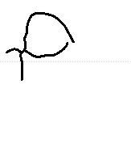 |  | 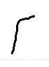 | 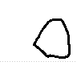 | 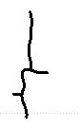 | 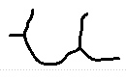 | 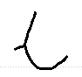 | 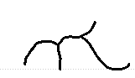 | 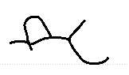
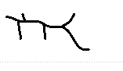 | 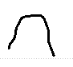 | 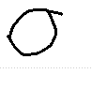 | 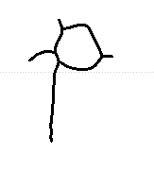 |  | 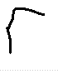 | 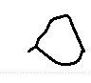 | 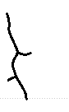 | 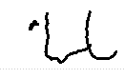 | 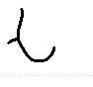 | 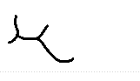
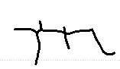 | 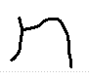 | 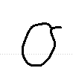 | 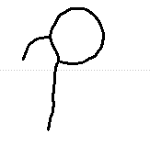 |  | 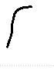 | 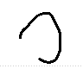 | 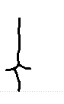 | 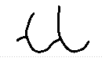 | 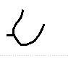 | 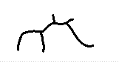
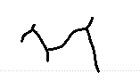 | 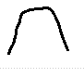 | 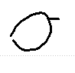 | 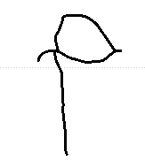 |  | 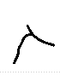 | 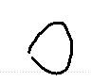 | 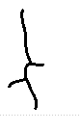 | 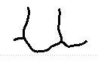 | 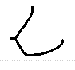 | 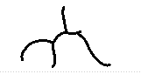
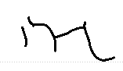 | 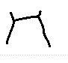 | 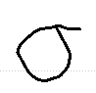 | 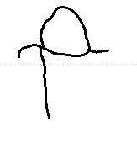 |  | 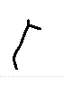 | 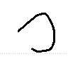 | 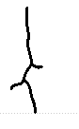 | 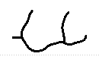 | 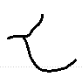 | 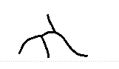
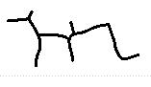 | 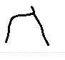 | 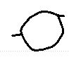 | 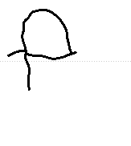 |  | 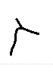 | 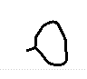 | 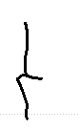 | 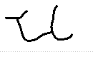 | 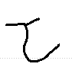 | 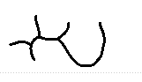

y | A | B | H | I | M | T | W | " | ) | , | .
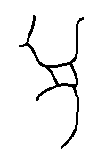 | 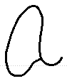 | 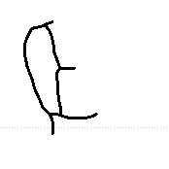 | 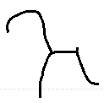 | 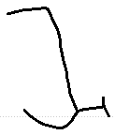 | 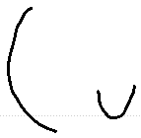 | 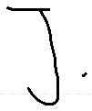 | 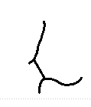 | 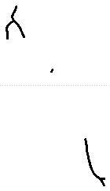 | 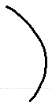 |  | 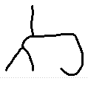
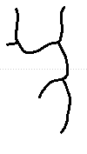 |  | 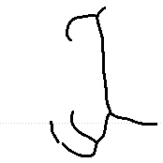 |  |  |  |  | 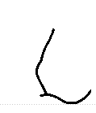 | 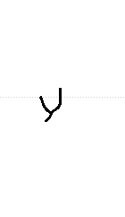 |  |  | 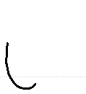
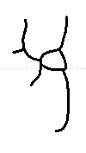 |  | 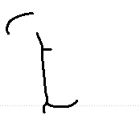 |  |  |  |  | 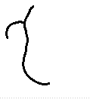 |  |  | 
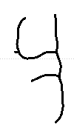 |  |  |  |  |  |  |  |  |  | 
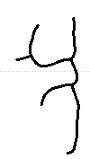 |  |  |  |  |  |  |  |  |  | 
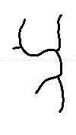 |  |  |  |  |  |  |  |  |  | 
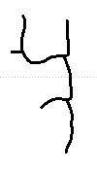 |  |  |  |  |  |  |  |  |  | 
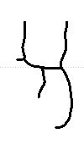 |  |  |  |  |  |  |  |  |  | 

;


Writer 384
36 characters, 252 stored variants.
a | b | c | d | e | f | g | h | i | j | k | l
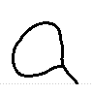 | 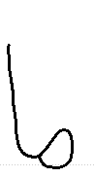 | 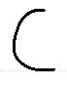 | 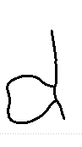 | 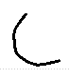 | 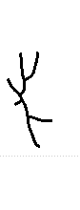 | 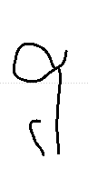 | 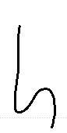 | 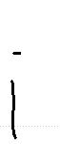 |  | 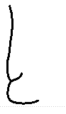 | 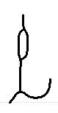
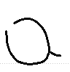 | 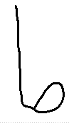 | 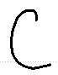 | 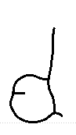 | 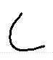 | 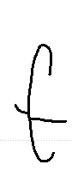 | 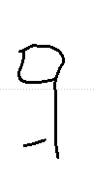 | 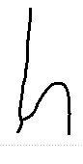 |  |  | 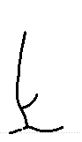 | 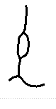
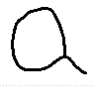 | 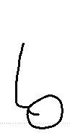 | 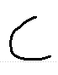 | 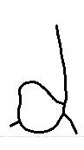 | 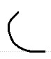 | 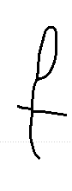 | 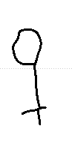 | 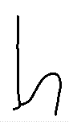 | 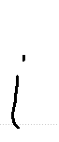 |  | 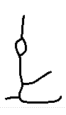 | 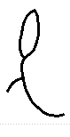
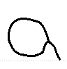 |  | 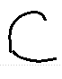 | 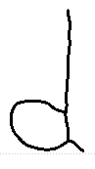 | 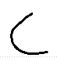 | 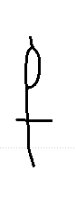 | 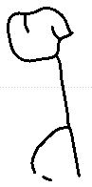 | 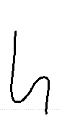 | 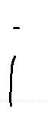 |  |  | 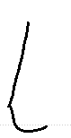
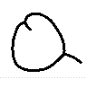 |  | 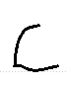 | 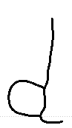 |  | 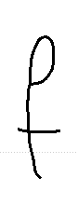 | 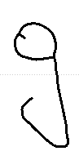 | 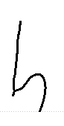 | 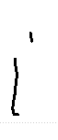 |  |  | 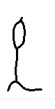
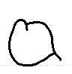 |  | 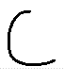 | 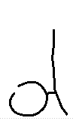 | 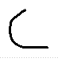 | 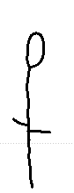 | 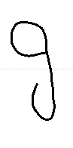 | 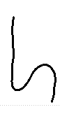 | 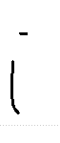 |  |  | 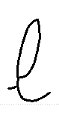
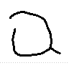 |  | 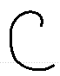 | 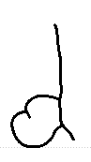 | 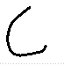 | 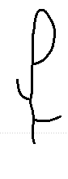 | 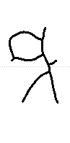 | 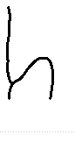 | 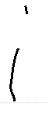 |  |  | 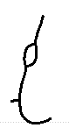
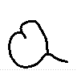 |  | 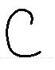 | 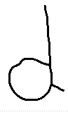 | 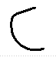 | 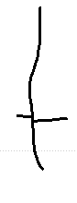 | 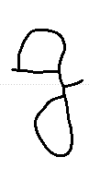 | 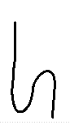 |  |  |  | 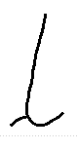

m | n | o | p | q | r | s | t | u | v | w | x
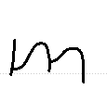 | 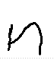 | 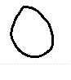 | 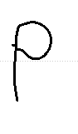 | 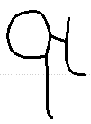 | 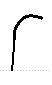 | 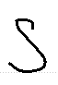 | 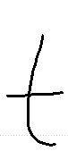 | 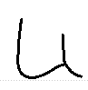 | 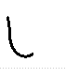 | 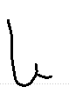 | 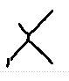
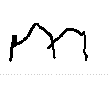 | 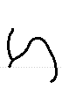 | 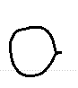 | 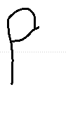 | 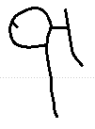 | 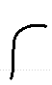 | 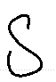 | 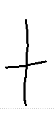 | 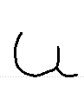 | 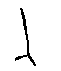 | 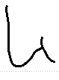 | 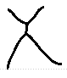
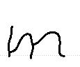 | 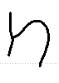 | 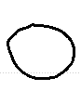 | 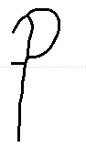 | 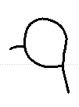 |  | 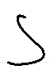 | 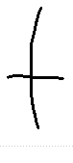 | 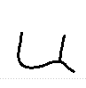 | 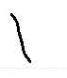 | 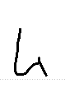 | 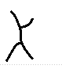
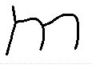 | 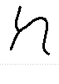 | 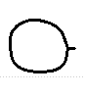 | 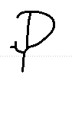 |  | 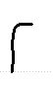 | 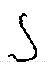 | 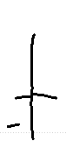 | 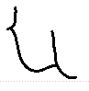 |  | 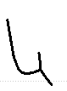
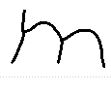 | 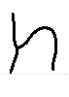 |  | 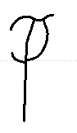 |  |  | 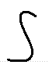 | 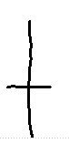 | 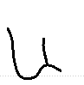
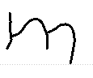 | 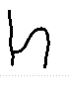 | 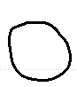 | 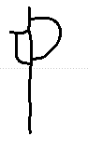 |  | 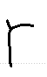 | 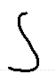 | 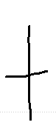 | 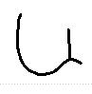
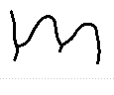 | 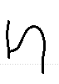 | 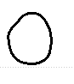 | 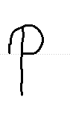 |  | 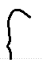 | 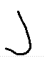 | 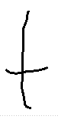 | 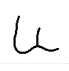
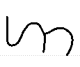 | 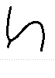 | 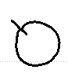 | 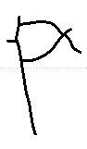 |  | 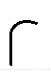 | 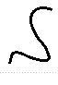 | 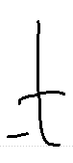 | 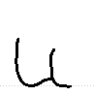

y | z | A | E | I | S | T | V | W | 8 | , | ;
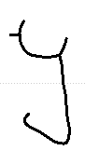 | 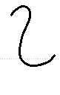 | 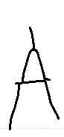 |  | 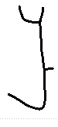 | 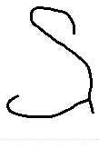 | 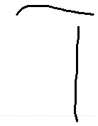 | 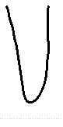 | 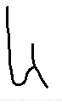 | 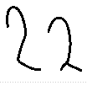 |  | 
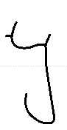 | 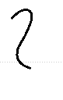 | 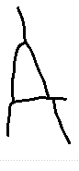 |  |  |  | 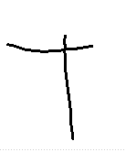
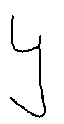 | 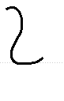 |  |  |  |  | 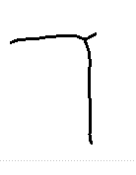
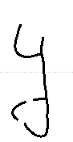
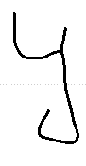
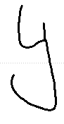
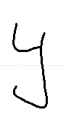
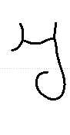

Writer 551
38 characters, 271 stored variants.
a | b | c | d | e | f | g | h | i | j | k | l
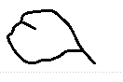
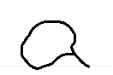
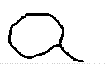
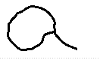
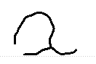
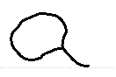
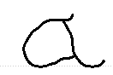

m | n | o | p | r | s | t | u | v | w | x | y

A | D | H | I | L | M | N | T | W | Y | " | '

, | .

Writer 552
40 characters, 288 stored variants.
a | b | c | d | e | f | g | h | i | j | k | l

m | n | o | p | r | s | t | u | v | w | y | B

C | F | H | I | M | O | S | T | W | Y | 4 | !

' | , | . | ?

Writer 588
41 characters, 254 stored variants.
a | b | c | d | e | f | g | h | i | k | l | m

n | o | p | r | s | t | u | v | w | x | y | A

B | D | G | H | J | L | M | O | P | S | T | W

" | ' | , | . | ?

Writer abhinav
56 characters, 335 stored variants.
a | b | c | d | e | f | g | h | i | j | k | l

m | n | o | p | r | s | t | u | v | w | x | y

A | B | C | D | E | F | G | H | I | L | M | O

Q | R | S | T | U | W | 0 | 1 | 2 | 3 | 4 | 5

8 | ' | ( | ) | , | . | : | ;

Writer dylan
42 characters, 302 stored variants.
a | b | c | d | e | f | g | h | i | k | l | m

n | o | p | q | r | s | t | u | v | w | x | y

z | C | D | E | F | L | M | O | P | R | T | U

X | 1 | 2 | ( | ) | ,

Writer owen
43 characters, 307 stored variants.
a | b | c | d | e | f | g | h | i | j | k | l

m | n | o | p | r | s | t | u | v | w | x | y

z | A | D | H | I | M | O | T | V | Y | 0 | 1

2 | 3 | 4 | 9 | , | . | ;

Writer thiya
42 characters, 239 stored variants.
a | b | c | d | e | f | g | h | i | k | l | m

n | o | p | q | r | s | t | u | v | w | x | y

A | L | O | U | V | W | 0 | 1 | 2 | 3 | 6 | 7

' | ( | ) | , | - | .

Writer yeukita
58 characters, 333 stored variants.
a | b | c | d | e | f | g | h | i | j | k | l

m | n | o | p | q | r | s | t | u | v | w | x

y | A | C | D | E | F | H | I | K | L | M | N

O | P | R | S | T | U | W | 0 | 1 | 2 | 3 | 4

5 | 8 | 9 | " | ( | ) | , | - | . | ?

