Stored glyph libraries, and the chance each one is used
D.R. Braune, 23539195. Every variant the profile builder kept for every writer, drawn from the stored stroke coordinates, beside the probability the synthesiser picks it. Generated by testing/glyphs.py
Variants are ranked by prior distance, which is how far the shape sits from the pooled shape of that character, so rank 1 is the most typical letter the writer actually produced. Only the top 5 are eligible: sampling evenly over a dozen variants averages a hand's signature away. Pick weight falls as 1/(1+1.4 i) with rank i, normalised over the eligible ones. A picked variant can still be swapped for the writer's anchor letterform, with probability rising from the legibility lambda and the variant's own prior distance; at or above 0.55 the swap is certain. The last row is what actually reaches the page. Rank and prior distance are stored, every chance is recomputed from the selection rule, and the join term is left out so these are the unjoined chances.

Writer 150
42 characters, 296 stored variants, median prior distance 0.197, legibility lambda 0.00, connectedness 0.343. Lambda is low, so the writer's own shapes are kept almost always.
'"' 2 variants
glyph | 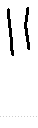 | 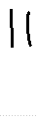 | 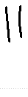
rank by priorD | 1 | 2 | anchor
prior distance | 0.214 | 0.237 | -
pick chance | 70.6% | 29.4% | -
swap to anchor | 0% | 0% | -
drawn as this variant | 70.6% | 29.4% | 0.0%

',' 5 variants
glyph | 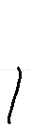 | 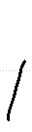 | 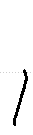 | 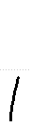 |  | 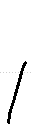
rank by priorD | 1 | 2 | 3 | 4 | 5 | anchor
prior distance | 0.098 | 0.112 | 0.147 | 0.238 | 0.244 | -
pick chance | 49.4% | 20.6% | 13.0% | 9.5% | 7.5% | -
swap to anchor | 0% | 0% | 0% | 0% | 0% | -
drawn as this variant | 49.4% | 20.6% | 13.0% | 9.5% | 7.5% | 0.0%

';' 1 variants
glyph | 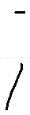 | 
rank by priorD | 1 | anchor
prior distance | 0.238 | -
pick chance | 100.0% | -
swap to anchor | 0% | -
drawn as this variant | 100.0% | 0.0%

'A' 2 variants
glyph | 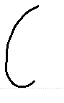 | 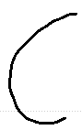 | 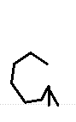
rank by priorD | 1 | 2 | anchor
prior distance | 0.423 | 0.487 | -
pick chance | 70.6% | 29.4% | -
swap to anchor | 0% | 0% | -
drawn as this variant | 70.6% | 29.4% | 0.0%

'B' 1 variants
glyph | 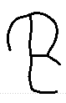 | 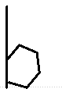
rank by priorD | 1 | anchor
prior distance | 0.223 | -
pick chance | 100.0% | -
swap to anchor | 0% | -
drawn as this variant | 100.0% | 0.0%

'D' 1 variants
glyph | 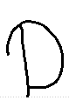 | 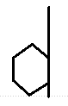
rank by priorD | 1 | anchor
prior distance | 0.333 | -
pick chance | 100.0% | -
swap to anchor | 0% | -
drawn as this variant | 100.0% | 0.0%

'E' 1 variants
glyph | 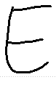 | 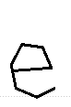
rank by priorD | 1 | anchor
prior distance | 0.058 | -
pick chance | 100.0% | -
swap to anchor | 0% | -
drawn as this variant | 100.0% | 0.0%

'F' 1 variants
glyph | 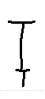 | 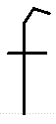
rank by priorD | 1 | anchor
prior distance | 0.409 | -
pick chance | 100.0% | -
swap to anchor | 0% | -
drawn as this variant | 100.0% | 0.0%

'H' 2 variants
glyph | 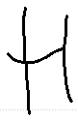 | 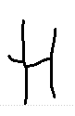 | 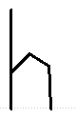
rank by priorD | 1 | 2 | anchor
prior distance | 0.498 | 0.586 | -
pick chance | 70.6% | 29.4% | -
swap to anchor | 0% | 100% | -
drawn as this variant | 70.6% | 0.0% | 29.4%

'I' 2 variants
glyph
rank by priorD | 1 | 2 | anchor
prior distance | 0.454 | 0.644 | -
pick chance | 70.6% | 29.4% | -
swap to anchor | 0% | 100% | -
drawn as this variant | 70.6% | 0.0% | 29.4%

'L' 2 variants
glyph | 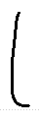 | 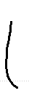 | 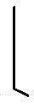
rank by priorD | 1 | 2 | anchor
prior distance | 0.205 | 0.309 | -
pick chance | 70.6% | 29.4% | -
swap to anchor | 0% | 0% | -
drawn as this variant | 70.6% | 29.4% | 0.0%

'M' 3 variants
glyph | 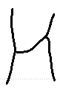 | 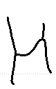 | 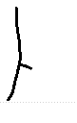 | 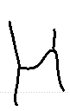
rank by priorD | 1 | 2 | 3 | anchor
prior distance | 0.127 | 0.180 | 0.752 | -
pick chance | 59.5% | 24.8% | 15.7% | -
swap to anchor | 0% | 0% | 100% | -
drawn as this variant | 59.5% | 24.8% | 0.0% | 15.7%

'P' 1 variants
glyph | 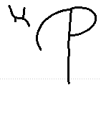 | 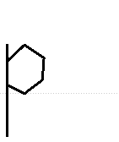
rank by priorD | 1 | anchor
prior distance | 0.261 | -
pick chance | 100.0% | -
swap to anchor | 0% | -
drawn as this variant | 100.0% | 0.0%

'R' 2 variants
glyph | 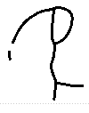 | 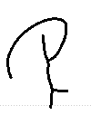 | 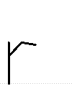
rank by priorD | 1 | 2 | anchor
prior distance | 0.307 | 0.308 | -
pick chance | 70.6% | 29.4% | -
swap to anchor | 0% | 0% | -
drawn as this variant | 70.6% | 29.4% | 0.0%

'S' 1 variants
glyph | 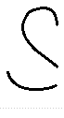 | 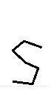
rank by priorD | 1 | anchor
prior distance | 0.217 | -
pick chance | 100.0% | -
swap to anchor | 0% | -
drawn as this variant | 100.0% | 0.0%

'T' 3 variants
glyph | 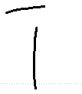 | 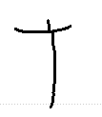 | 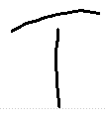 | 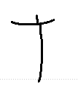
rank by priorD | 1 | 2 | 3 | anchor
prior distance | 0.264 | 0.282 | 0.357 | -
pick chance | 59.5% | 24.8% | 15.7% | -
swap to anchor | 0% | 0% | 0% | -
drawn as this variant | 59.5% | 24.8% | 15.7% | 0.0%

'a' 12 variants
glyph | 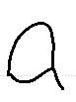 | 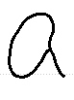 | 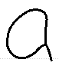 | 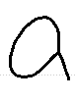 | 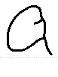 | 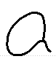 | 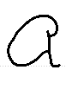 | 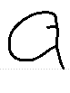 | 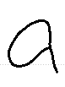 | 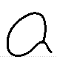
rank by priorD | 1 | 2 | 3 | 4 | 5 | 6 | 7 | 8 | 9 | anchor
prior distance | 0.096 | 0.100 | 0.105 | 0.127 | 0.134 | 0.136 | 0.149 | 0.172 | 0.207 | -
pick chance | 49.4% | 20.6% | 13.0% | 9.5% | 7.5% | never | never | never | never | -
swap to anchor | 0% | 0% | 0% | 0% | 0% | - | - | - | - | -
drawn as this variant | 49.4% | 20.6% | 13.0% | 9.5% | 7.5% | 0% | 0% | 0% | 0% | 0.0%

glyph | 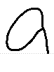 | 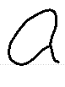 | 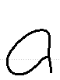
rank by priorD | 10 | 11 | 12
prior distance | 0.223 | 0.231 | 0.243
pick chance | never | never | never
swap to anchor | - | - | -
drawn as this variant | 0% | 0% | 0%

'b' 12 variants
glyph | 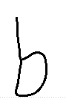 | 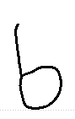 | 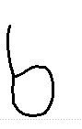 | 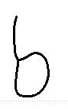 | 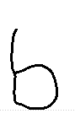 | 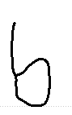 | 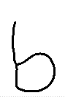 | 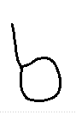 | 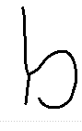 | 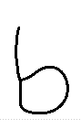
rank by priorD | 1 | 2 | 3 | 4 | 5 | 6 | 7 | 8 | 9 | anchor
prior distance | 0.058 | 0.068 | 0.073 | 0.074 | 0.077 | 0.087 | 0.097 | 0.097 | 0.097 | -
pick chance | 49.4% | 20.6% | 13.0% | 9.5% | 7.5% | never | never | never | never | -
swap to anchor | 0% | 0% | 0% | 0% | 0% | - | - | - | - | -
drawn as this variant | 49.4% | 20.6% | 13.0% | 9.5% | 7.5% | 0% | 0% | 0% | 0% | 0.0%

glyph | 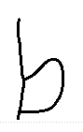 | 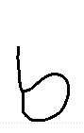 | 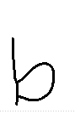
rank by priorD | 10 | 11 | 12
prior distance | 0.112 | 0.120 | 0.124
pick chance | never | never | never
swap to anchor | - | - | -
drawn as this variant | 0% | 0% | 0%

'c' 13 variants
glyph | 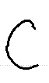 | 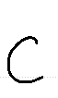 | 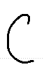 | 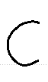 | 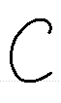 | 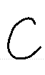 | 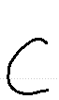 | 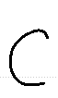 | 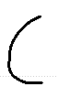 | 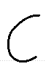
rank by priorD | 1 | 2 | 3 | 4 | 5 | 6 | 7 | 8 | 9 | anchor
prior distance | 0.092 | 0.102 | 0.104 | 0.116 | 0.125 | 0.134 | 0.142 | 0.146 | 0.154 | -
pick chance | 49.4% | 20.6% | 13.0% | 9.5% | 7.5% | never | never | never | never | -
swap to anchor | 0% | 0% | 0% | 0% | 0% | - | - | - | - | -
drawn as this variant | 49.4% | 20.6% | 13.0% | 9.5% | 7.5% | 0% | 0% | 0% | 0% | 0.0%

glyph | 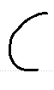 | 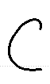 | 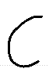 | 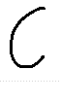
rank by priorD | 10 | 11 | 12 | 13
prior distance | 0.176 | 0.188 | 0.201 | 0.220
pick chance | never | never | never | never
swap to anchor | - | - | - | -
drawn as this variant | 0% | 0% | 0% | 0%

'd' 12 variants
glyph | 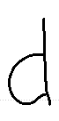 | 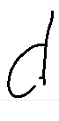 | 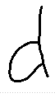 | 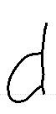 | 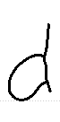 | 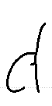 | 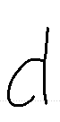 | 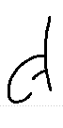 | 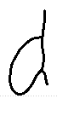 | 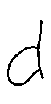
rank by priorD | 1 | 2 | 3 | 4 | 5 | 6 | 7 | 8 | 9 | anchor
prior distance | 0.098 | 0.099 | 0.100 | 0.106 | 0.116 | 0.119 | 0.131 | 0.131 | 0.133 | -
pick chance | 49.4% | 20.6% | 13.0% | 9.5% | 7.5% | never | never | never | never | -
swap to anchor | 0% | 0% | 0% | 0% | 0% | - | - | - | - | -
drawn as this variant | 49.4% | 20.6% | 13.0% | 9.5% | 7.5% | 0% | 0% | 0% | 0% | 0.0%

glyph | 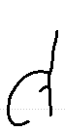 | 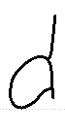 | 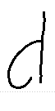
rank by priorD | 10 | 11 | 12
prior distance | 0.133 | 0.150 | 0.153
pick chance | never | never | never
swap to anchor | - | - | -
drawn as this variant | 0% | 0% | 0%

'e' 13 variants
glyph | 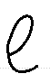 | 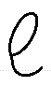 | 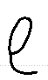 | 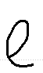 | 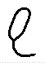 | 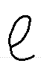 | 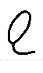 | 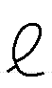 | 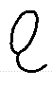 | 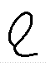
rank by priorD | 1 | 2 | 3 | 4 | 5 | 6 | 7 | 8 | 9 | anchor
prior distance | 0.215 | 0.224 | 0.230 | 0.235 | 0.248 | 0.253 | 0.263 | 0.290 | 0.299 | -
pick chance | 49.4% | 20.6% | 13.0% | 9.5% | 7.5% | never | never | never | never | -
swap to anchor | 0% | 0% | 0% | 0% | 0% | - | - | - | - | -
drawn as this variant | 49.4% | 20.6% | 13.0% | 9.5% | 7.5% | 0% | 0% | 0% | 0% | 0.0%

glyph | 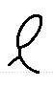 | 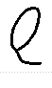 | 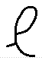 | 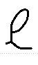
rank by priorD | 10 | 11 | 12 | 13
prior distance | 0.324 | 0.337 | 0.358 | 0.374
pick chance | never | never | never | never
swap to anchor | - | - | - | -
drawn as this variant | 0% | 0% | 0% | 0%

'f' 13 variants
glyph | 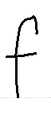 | 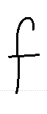 | 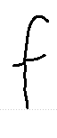 | 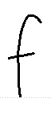 | 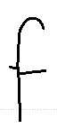 | 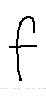 | 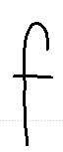 | 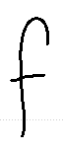 | 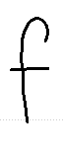 | 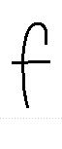
rank by priorD | 1 | 2 | 3 | 4 | 5 | 6 | 7 | 8 | 9 | anchor
prior distance | 0.171 | 0.192 | 0.217 | 0.223 | 0.225 | 0.225 | 0.236 | 0.239 | 0.250 | -
pick chance | 49.4% | 20.6% | 13.0% | 9.5% | 7.5% | never | never | never | never | -
swap to anchor | 0% | 0% | 0% | 0% | 0% | - | - | - | - | -
drawn as this variant | 49.4% | 20.6% | 13.0% | 9.5% | 7.5% | 0% | 0% | 0% | 0% | 0.0%

glyph | 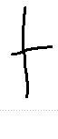 | 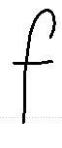 | 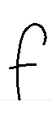 | 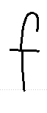
rank by priorD | 10 | 11 | 12 | 13
prior distance | 0.252 | 0.259 | 0.268 | 0.278
pick chance | never | never | never | never
swap to anchor | - | - | - | -
drawn as this variant | 0% | 0% | 0% | 0%

'g' 12 variants
glyph | 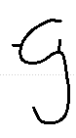 | 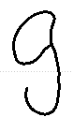 | 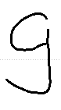 | 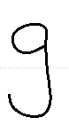 | 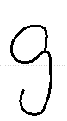 | 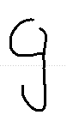 | 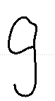 | 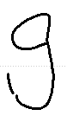 | 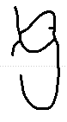 | 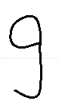
rank by priorD | 1 | 2 | 3 | 4 | 5 | 6 | 7 | 8 | 9 | anchor
prior distance | 0.097 | 0.122 | 0.123 | 0.124 | 0.124 | 0.131 | 0.131 | 0.132 | 0.133 | -
pick chance | 49.4% | 20.6% | 13.0% | 9.5% | 7.5% | never | never | never | never | -
swap to anchor | 0% | 0% | 0% | 0% | 0% | - | - | - | - | -
drawn as this variant | 49.4% | 20.6% | 13.0% | 9.5% | 7.5% | 0% | 0% | 0% | 0% | 0.0%

glyph | 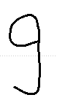 | 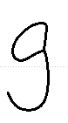 | 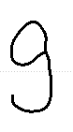
rank by priorD | 10 | 11 | 12
prior distance | 0.134 | 0.154 | 0.161
pick chance | never | never | never
swap to anchor | - | - | -
drawn as this variant | 0% | 0% | 0%

'h' 12 variants
glyph | 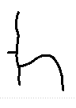 | 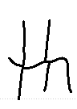 | 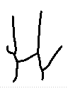 | 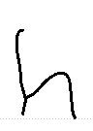 | 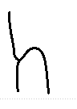 | 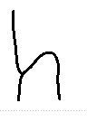 | 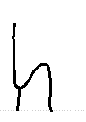 | 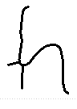 | 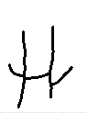 | 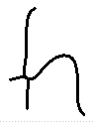
rank by priorD | 1 | 2 | 3 | 4 | 5 | 6 | 7 | 8 | 9 | anchor
prior distance | 0.129 | 0.151 | 0.159 | 0.176 | 0.182 | 0.182 | 0.202 | 0.208 | 0.218 | -
pick chance | 49.4% | 20.6% | 13.0% | 9.5% | 7.5% | never | never | never | never | -
swap to anchor | 0% | 0% | 0% | 0% | 0% | - | - | - | - | -
drawn as this variant | 49.4% | 20.6% | 13.0% | 9.5% | 7.5% | 0% | 0% | 0% | 0% | 0.0%

glyph | 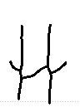 | 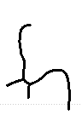 | 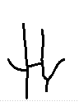
rank by priorD | 10 | 11 | 12
prior distance | 0.229 | 0.231 | 0.235
pick chance | never | never | never
swap to anchor | - | - | -
drawn as this variant | 0% | 0% | 0%

'i' 12 variants
glyph | 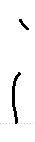 | 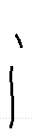 | 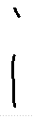 | 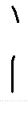 | 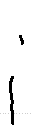 | 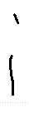 | 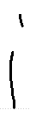 | 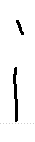 | 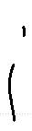 | 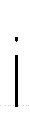
rank by priorD | 1 | 2 | 3 | 4 | 5 | 6 | 7 | 8 | 9 | anchor
prior distance | 0.373 | 0.375 | 0.375 | 0.378 | 0.383 | 0.384 | 0.396 | 0.400 | 0.401 | -
pick chance | 49.4% | 20.6% | 13.0% | 9.5% | 7.5% | never | never | never | never | -
swap to anchor | 0% | 0% | 0% | 0% | 0% | - | - | - | - | -
drawn as this variant | 49.4% | 20.6% | 13.0% | 9.5% | 7.5% | 0% | 0% | 0% | 0% | 0.0%

glyph | 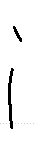 | 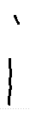 | 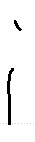
rank by priorD | 10 | 11 | 12
prior distance | 0.405 | 0.413 | 0.425
pick chance | never | never | never
swap to anchor | - | - | -
drawn as this variant | 0% | 0% | 0%

'j' 1 variants
glyph | 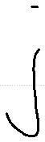 | 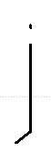
rank by priorD | 1 | anchor
prior distance | 0.257 | -
pick chance | 100.0% | -
swap to anchor | 0% | -
drawn as this variant | 100.0% | 0.0%

'k' 3 variants
glyph | 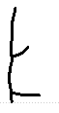 | 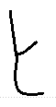 | 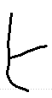 | 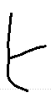
rank by priorD | 1 | 2 | 3 | anchor
prior distance | 0.169 | 0.181 | 0.242 | -
pick chance | 59.5% | 24.8% | 15.7% | -
swap to anchor | 0% | 0% | 0% | -
drawn as this variant | 59.5% | 24.8% | 15.7% | 0.0%

'l' 12 variants
glyph | 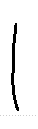 | 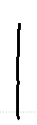 | 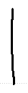 | 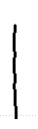 | 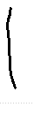 | 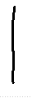 | 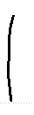 | 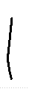 | 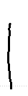 | 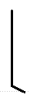
rank by priorD | 1 | 2 | 3 | 4 | 5 | 6 | 7 | 8 | 9 | anchor
prior distance | 0.304 | 0.309 | 0.311 | 0.319 | 0.339 | 0.340 | 0.347 | 0.379 | 0.389 | -
pick chance | 49.4% | 20.6% | 13.0% | 9.5% | 7.5% | never | never | never | never | -
swap to anchor | 0% | 0% | 0% | 0% | 0% | - | - | - | - | -
drawn as this variant | 49.4% | 20.6% | 13.0% | 9.5% | 7.5% | 0% | 0% | 0% | 0% | 0.0%

glyph | 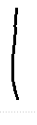 | 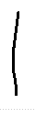 | 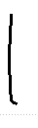
rank by priorD | 10 | 11 | 12
prior distance | 0.416 | 0.416 | 0.424
pick chance | never | never | never
swap to anchor | - | - | -
drawn as this variant | 0% | 0% | 0%

'm' 13 variants
glyph | 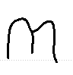 | 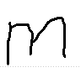 | 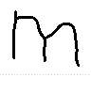 | 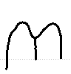 | 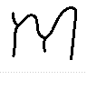 | 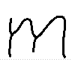 | 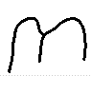 | 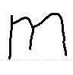 | 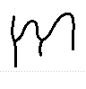 | 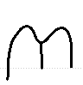
rank by priorD | 1 | 2 | 3 | 4 | 5 | 6 | 7 | 8 | 9 | anchor
prior distance | 0.112 | 0.116 | 0.119 | 0.137 | 0.137 | 0.137 | 0.139 | 0.140 | 0.161 | -
pick chance | 49.4% | 20.6% | 13.0% | 9.5% | 7.5% | never | never | never | never | -
swap to anchor | 0% | 0% | 0% | 0% | 0% | - | - | - | - | -
drawn as this variant | 49.4% | 20.6% | 13.0% | 9.5% | 7.5% | 0% | 0% | 0% | 0% | 0.0%

glyph | 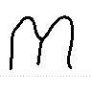 | 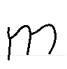 | 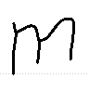 | 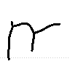
rank by priorD | 10 | 11 | 12 | 13
prior distance | 0.164 | 0.173 | 0.175 | 0.200
pick chance | never | never | never | never
swap to anchor | - | - | - | -
drawn as this variant | 0% | 0% | 0% | 0%

'n' 13 variants
glyph | 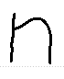 | 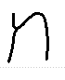 | 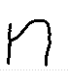 | 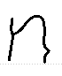 | 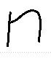 | 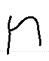 | 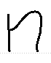 | 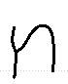 | 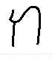 | 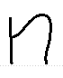
rank by priorD | 1 | 2 | 3 | 4 | 5 | 6 | 7 | 8 | 9 | anchor
prior distance | 0.112 | 0.124 | 0.127 | 0.144 | 0.158 | 0.181 | 0.191 | 0.197 | 0.215 | -
pick chance | 49.4% | 20.6% | 13.0% | 9.5% | 7.5% | never | never | never | never | -
swap to anchor | 0% | 0% | 0% | 0% | 0% | - | - | - | - | -
drawn as this variant | 49.4% | 20.6% | 13.0% | 9.5% | 7.5% | 0% | 0% | 0% | 0% | 0.0%

glyph | 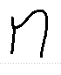 | 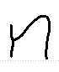 | 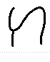 | 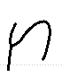
rank by priorD | 10 | 11 | 12 | 13
prior distance | 0.228 | 0.244 | 0.261 | 0.262
pick chance | never | never | never | never
swap to anchor | - | - | - | -
drawn as this variant | 0% | 0% | 0% | 0%

'o' 13 variants
glyph | 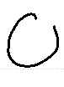 | 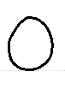 | 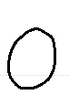 | 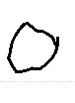 | 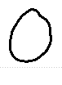 | 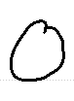 | 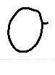 | 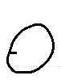 | 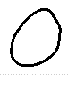 | 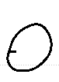
rank by priorD | 1 | 2 | 3 | 4 | 5 | 6 | 7 | 8 | 9 | anchor
prior distance | 0.083 | 0.083 | 0.098 | 0.105 | 0.106 | 0.113 | 0.125 | 0.136 | 0.140 | -
pick chance | 49.4% | 20.6% | 13.0% | 9.5% | 7.5% | never | never | never | never | -
swap to anchor | 0% | 0% | 0% | 0% | 0% | - | - | - | - | -
drawn as this variant | 49.4% | 20.6% | 13.0% | 9.5% | 7.5% | 0% | 0% | 0% | 0% | 0.0%

glyph | 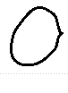 | 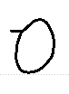 | 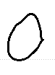 | 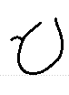
rank by priorD | 10 | 11 | 12 | 13
prior distance | 0.141 | 0.158 | 0.164 | 0.185
pick chance | never | never | never | never
swap to anchor | - | - | - | -
drawn as this variant | 0% | 0% | 0% | 0%

'p' 12 variants
glyph | 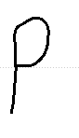 | 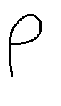 | 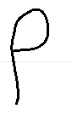 | 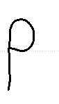 | 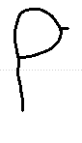 | 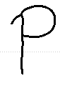 | 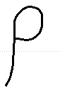 | 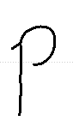 | 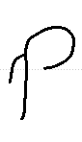 | 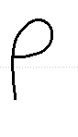
rank by priorD | 1 | 2 | 3 | 4 | 5 | 6 | 7 | 8 | 9 | anchor
prior distance | 0.074 | 0.090 | 0.097 | 0.106 | 0.113 | 0.147 | 0.155 | 0.160 | 0.162 | -
pick chance | 49.4% | 20.6% | 13.0% | 9.5% | 7.5% | never | never | never | never | -
swap to anchor | 0% | 0% | 0% | 0% | 0% | - | - | - | - | -
drawn as this variant | 49.4% | 20.6% | 13.0% | 9.5% | 7.5% | 0% | 0% | 0% | 0% | 0.0%

glyph | 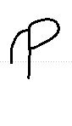 | 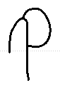 | 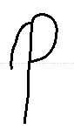
rank by priorD | 10 | 11 | 12
prior distance | 0.197 | 0.205 | 0.233
pick chance | never | never | never
swap to anchor | - | - | -
drawn as this variant | 0% | 0% | 0%

'q' 3 variants
glyph | 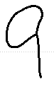 | 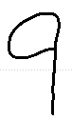 | 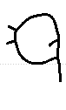 | 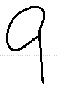
rank by priorD | 1 | 2 | 3 | anchor
prior distance | 0.163 | 0.176 | 0.238 | -
pick chance | 59.5% | 24.8% | 15.7% | -
swap to anchor | 0% | 0% | 0% | -
drawn as this variant | 59.5% | 24.8% | 15.7% | 0.0%

'r' 13 variants
glyph | 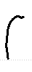 | 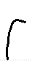 | 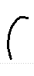 | 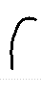 | 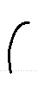 | 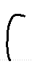 | 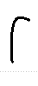 | 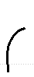 | 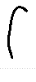 | 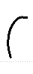
rank by priorD | 1 | 2 | 3 | 4 | 5 | 6 | 7 | 8 | 9 | anchor
prior distance | 0.063 | 0.090 | 0.108 | 0.108 | 0.114 | 0.116 | 0.116 | 0.117 | 0.126 | -
pick chance | 49.4% | 20.6% | 13.0% | 9.5% | 7.5% | never | never | never | never | -
swap to anchor | 0% | 0% | 0% | 0% | 0% | - | - | - | - | -
drawn as this variant | 49.4% | 20.6% | 13.0% | 9.5% | 7.5% | 0% | 0% | 0% | 0% | 0.0%

glyph | 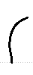 | 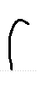 | 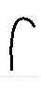 | 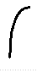
rank by priorD | 10 | 11 | 12 | 13
prior distance | 0.132 | 0.147 | 0.149 | 0.180
pick chance | never | never | never | never
swap to anchor | - | - | - | -
drawn as this variant | 0% | 0% | 0% | 0%

's' 13 variants
glyph | 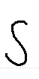 | 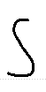 | 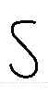 | 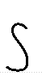 | 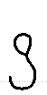 | 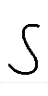 | 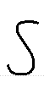 | 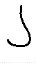 | 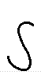 | 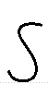
rank by priorD | 1 | 2 | 3 | 4 | 5 | 6 | 7 | 8 | 9 | anchor
prior distance | 0.127 | 0.167 | 0.183 | 0.185 | 0.210 | 0.231 | 0.238 | 0.248 | 0.262 | -
pick chance | 49.4% | 20.6% | 13.0% | 9.5% | 7.5% | never | never | never | never | -
swap to anchor | 0% | 0% | 0% | 0% | 0% | - | - | - | - | -
drawn as this variant | 49.4% | 20.6% | 13.0% | 9.5% | 7.5% | 0% | 0% | 0% | 0% | 0.0%

glyph | 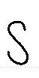 | 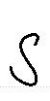 | 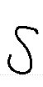 | 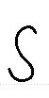
rank by priorD | 10 | 11 | 12 | 13
prior distance | 0.271 | 0.290 | 0.314 | 0.344
pick chance | never | never | never | never
swap to anchor | - | - | - | -
drawn as this variant | 0% | 0% | 0% | 0%

't' 12 variants
glyph | 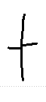 | 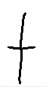 | 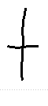 | 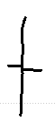 | 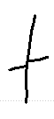 | 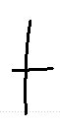 | 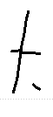 | 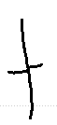 | 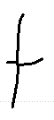 | 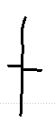
rank by priorD | 1 | 2 | 3 | 4 | 5 | 6 | 7 | 8 | 9 | anchor
prior distance | 0.192 | 0.220 | 0.229 | 0.231 | 0.238 | 0.242 | 0.278 | 0.284 | 0.285 | -
pick chance | 49.4% | 20.6% | 13.0% | 9.5% | 7.5% | never | never | never | never | -
swap to anchor | 0% | 0% | 0% | 0% | 0% | - | - | - | - | -
drawn as this variant | 49.4% | 20.6% | 13.0% | 9.5% | 7.5% | 0% | 0% | 0% | 0% | 0.0%

glyph | 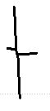 | 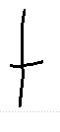 | 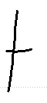
rank by priorD | 10 | 11 | 12
prior distance | 0.286 | 0.291 | 0.330
pick chance | never | never | never
swap to anchor | - | - | -
drawn as this variant | 0% | 0% | 0%

'u' 12 variants
glyph | 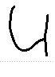 | 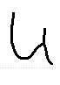 | 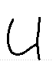 | 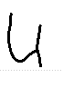 | 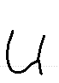 | 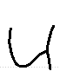 | 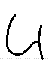 | 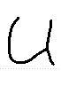 | 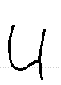 | 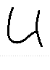
rank by priorD | 1 | 2 | 3 | 4 | 5 | 6 | 7 | 8 | 9 | anchor
prior distance | 0.164 | 0.167 | 0.178 | 0.178 | 0.180 | 0.198 | 0.199 | 0.202 | 0.207 | -
pick chance | 49.4% | 20.6% | 13.0% | 9.5% | 7.5% | never | never | never | never | -
swap to anchor | 0% | 0% | 0% | 0% | 0% | - | - | - | - | -
drawn as this variant | 49.4% | 20.6% | 13.0% | 9.5% | 7.5% | 0% | 0% | 0% | 0% | 0.0%

glyph | 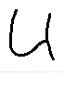 | 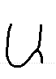 | 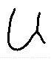
rank by priorD | 10 | 11 | 12
prior distance | 0.224 | 0.256 | 0.308
pick chance | never | never | never
swap to anchor | - | - | -
drawn as this variant | 0% | 0% | 0%

'v' 8 variants
glyph | 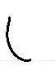 | 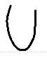 | 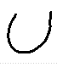 | 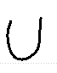 | 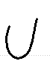 | 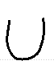 | 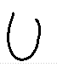 | 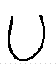 | 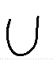
rank by priorD | 1 | 2 | 3 | 4 | 5 | 6 | 7 | 8 | anchor
prior distance | 0.192 | 0.204 | 0.227 | 0.252 | 0.255 | 0.281 | 0.287 | 0.293 | -
pick chance | 49.4% | 20.6% | 13.0% | 9.5% | 7.5% | never | never | never | -
swap to anchor | 0% | 0% | 0% | 0% | 0% | - | - | - | -
drawn as this variant | 49.4% | 20.6% | 13.0% | 9.5% | 7.5% | 0% | 0% | 0% | 0.0%

'w' 9 variants
glyph | 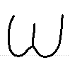 | 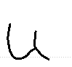 | 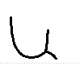 | 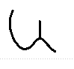 | 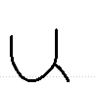 | 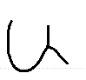 | 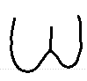 | 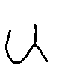 | 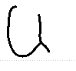 | 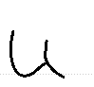
rank by priorD | 1 | 2 | 3 | 4 | 5 | 6 | 7 | 8 | 9 | anchor
prior distance | 0.206 | 0.220 | 0.222 | 0.238 | 0.244 | 0.274 | 0.276 | 0.279 | 0.288 | -
pick chance | 49.4% | 20.6% | 13.0% | 9.5% | 7.5% | never | never | never | never | -
swap to anchor | 0% | 0% | 0% | 0% | 0% | - | - | - | - | -
drawn as this variant | 49.4% | 20.6% | 13.0% | 9.5% | 7.5% | 0% | 0% | 0% | 0% | 0.0%

'x' 4 variants
glyph | 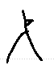 | 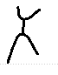 | 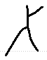 | 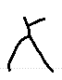 | 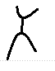
rank by priorD | 1 | 2 | 3 | 4 | anchor
prior distance | 0.225 | 0.231 | 0.255 | 0.319 | -
pick chance | 53.4% | 22.3% | 14.1% | 10.3% | -
swap to anchor | 0% | 0% | 0% | 0% | -
drawn as this variant | 53.4% | 22.3% | 14.1% | 10.3% | 0.0%

'y' 13 variants
glyph | 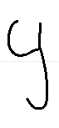 | 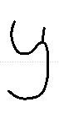 | 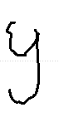 | 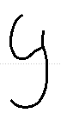 | 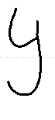 | 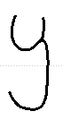 | 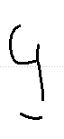 | 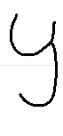 | 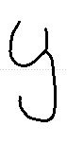 | 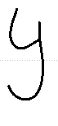
rank by priorD | 1 | 2 | 3 | 4 | 5 | 6 | 7 | 8 | 9 | anchor
prior distance | 0.149 | 0.150 | 0.155 | 0.171 | 0.174 | 0.182 | 0.183 | 0.192 | 0.197 | -
pick chance | 49.4% | 20.6% | 13.0% | 9.5% | 7.5% | never | never | never | never | -
swap to anchor | 0% | 0% | 0% | 0% | 0% | - | - | - | - | -
drawn as this variant | 49.4% | 20.6% | 13.0% | 9.5% | 7.5% | 0% | 0% | 0% | 0% | 0.0%

glyph | 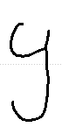 | 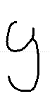 | 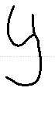 | 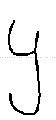
rank by priorD | 10 | 11 | 12 | 13
prior distance | 0.200 | 0.206 | 0.220 | 0.220
pick chance | never | never | never | never
swap to anchor | - | - | - | -
drawn as this variant | 0% | 0% | 0% | 0%

'z' 1 variants
glyph | 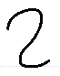 | 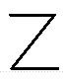
rank by priorD | 1 | anchor
prior distance | 0.219 | -
pick chance | 100.0% | -
swap to anchor | 0% | -
drawn as this variant | 100.0% | 0.0%

Writer 151
43 characters, 287 stored variants, median prior distance 0.307, legibility lambda 0.84, connectedness 0.968. Lambda is high, so most picks are swapped for the anchor.
'"' 3 variants
glyph | 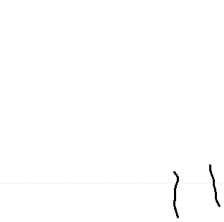 | 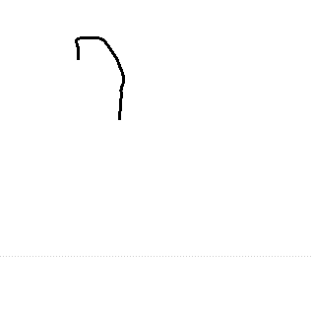 | 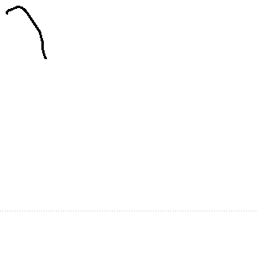
rank by priorD | 1 | 2 | 3
prior distance | 0.279 | 0.455 | 0.548
pick chance | 59.5% | 24.8% | 15.7%
swap to anchor | 74% | 100% | 100%
drawn as this variant | 15.3% | 0.0% | 0.0%

''' 2 variants
glyph | 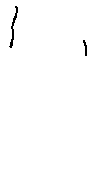 | 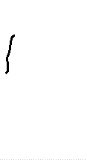
rank by priorD | 1 | 2
prior distance | 0.485 | 0.829
pick chance | 70.6% | 29.4%
swap to anchor | 100% | 100%
drawn as this variant | 0.0% | 0.0%

'(' 1 variants
glyph | 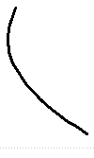
rank by priorD | 1
prior distance | 0.547
pick chance | 100.0%
swap to anchor | 100%
drawn as this variant | 0.0%

')' 1 variants
glyph | 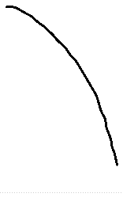
rank by priorD | 1
prior distance | 0.482
pick chance | 100.0%
swap to anchor | 100%
drawn as this variant | 0.0%

',' 6 variants
glyph | 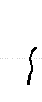 | 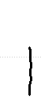 | 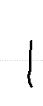 | 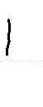 | 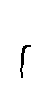 | 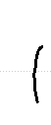
rank by priorD | 1 | 2 | 3 | 4 | 5 | 6
prior distance | 0.466 | 0.480 | 0.492 | 0.532 | 0.623 | 0.669
pick chance | 49.4% | 20.6% | 13.0% | 9.5% | 7.5% | never
swap to anchor | 100% | 100% | 100% | 100% | 100% | -
drawn as this variant | 0.0% | 0.0% | 0.0% | 0.0% | 0.0% | 0%

'-' 2 variants
glyph | 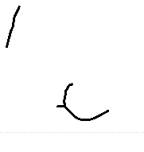 | 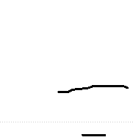
rank by priorD | 1 | 2
prior distance | 0.939 | 0.962
pick chance | 70.6% | 29.4%
swap to anchor | 100% | 100%
drawn as this variant | 0.0% | 0.0%

'.' 3 variants
glyph | 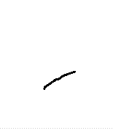 | 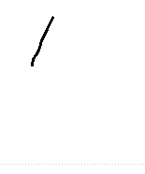 | 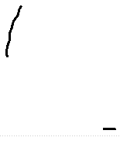
rank by priorD | 1 | 2 | 3
prior distance | 0.764 | 0.815 | 0.826
pick chance | 59.5% | 24.8% | 15.7%
swap to anchor | 100% | 100% | 100%
drawn as this variant | 0.0% | 0.0% | 0.0%

';' 2 variants
glyph | 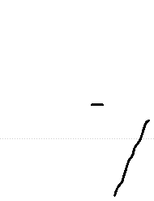 | 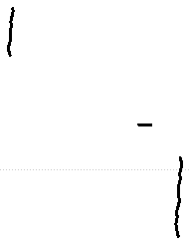
rank by priorD | 1 | 2
prior distance | 0.529 | 0.723
pick chance | 70.6% | 29.4%
swap to anchor | 100% | 100%
drawn as this variant | 0.0% | 0.0%

'A' 3 variants
glyph | 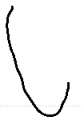 | 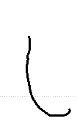 | 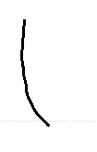 | 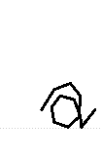
rank by priorD | 1 | 2 | 3 | anchor
prior distance | 0.504 | 0.507 | 0.527 | -
pick chance | 59.5% | 24.8% | 15.7% | -
swap to anchor | 100% | 100% | 100% | -
drawn as this variant | 0.0% | 0.0% | 0.0% | 100.0%

'D' 1 variants
glyph | 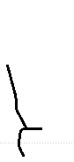 | 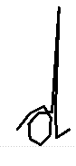
rank by priorD | 1 | anchor
prior distance | 0.658 | -
pick chance | 100.0% | -
swap to anchor | 100% | -
drawn as this variant | 0.0% | 100.0%

'F' 3 variants
glyph | 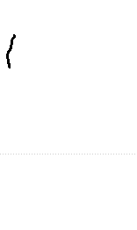 | 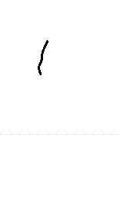 | 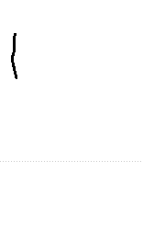 | 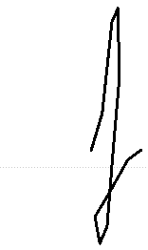
rank by priorD | 1 | 2 | 3 | anchor
prior distance | 0.475 | 0.605 | 0.646 | -
pick chance | 59.5% | 24.8% | 15.7% | -
swap to anchor | 100% | 100% | 100% | -
drawn as this variant | 0.0% | 0.0% | 0.0% | 100.0%

'H' 2 variants
glyph | 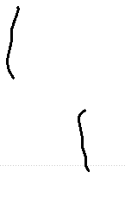 | 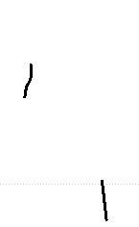 | 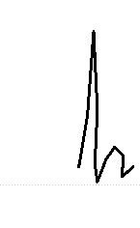
rank by priorD | 1 | 2 | anchor
prior distance | 0.471 | 0.605 | -
pick chance | 70.6% | 29.4% | -
swap to anchor | 100% | 100% | -
drawn as this variant | 0.0% | 0.0% | 100.0%

'I' 3 variants
glyph | 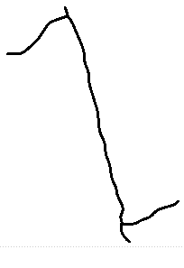 | 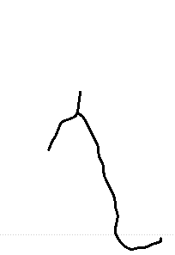 | 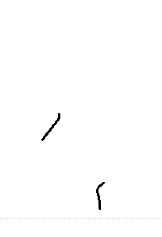 | 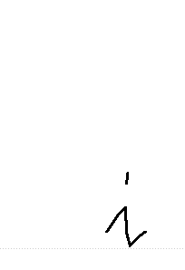
rank by priorD | 1 | 2 | 3 | anchor
prior distance | 0.313 | 0.368 | 0.384 | -
pick chance | 59.5% | 24.8% | 15.7% | -
swap to anchor | 80% | 90% | 93% | -
drawn as this variant | 11.7% | 2.5% | 1.1% | 84.7%

'J' 1 variants
glyph | 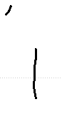 | 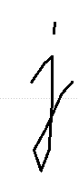
rank by priorD | 1 | anchor
prior distance | 0.179 | -
pick chance | 100.0% | -
swap to anchor | 57% | -
drawn as this variant | 43.3% | 56.7%

'M' 3 variants
glyph | 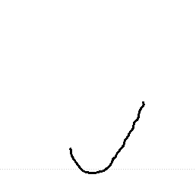 | 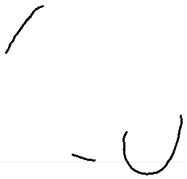 | 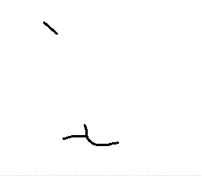 | 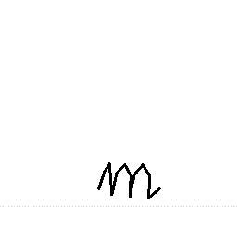
rank by priorD | 1 | 2 | 3 | anchor
prior distance | 0.524 | 0.611 | 0.844 | -
pick chance | 59.5% | 24.8% | 15.7% | -
swap to anchor | 100% | 100% | 100% | -
drawn as this variant | 0.0% | 0.0% | 0.0% | 100.0%

'P' 1 variants
glyph | 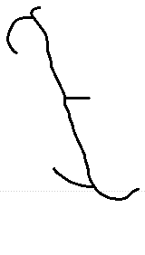 | 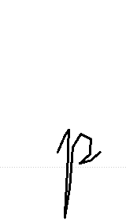
rank by priorD | 1 | anchor
prior distance | 0.535 | -
pick chance | 100.0% | -
swap to anchor | 100% | -
drawn as this variant | 0.0% | 100.0%

'S' 1 variants
glyph | 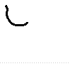 | 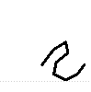
rank by priorD | 1 | anchor
prior distance | 0.417 | -
pick chance | 100.0% | -
swap to anchor | 99% | -
drawn as this variant | 1.4% | 98.6%

'T' 3 variants
glyph | 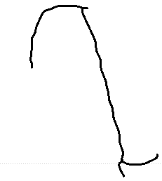 | 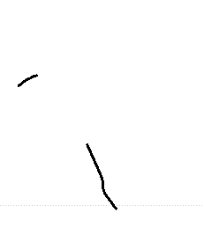 | 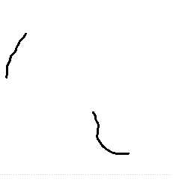 | 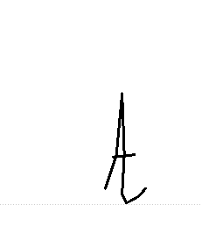
rank by priorD | 1 | 2 | 3 | anchor
prior distance | 0.513 | 0.660 | 0.661 | -
pick chance | 59.5% | 24.8% | 15.7% | -
swap to anchor | 100% | 100% | 100% | -
drawn as this variant | 0.0% | 0.0% | 0.0% | 100.0%

'W' 2 variants
glyph | 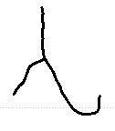 | 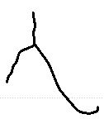 | 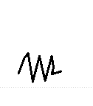
rank by priorD | 1 | 2 | anchor
prior distance | 0.435 | 0.470 | -
pick chance | 70.6% | 29.4% | -
swap to anchor | 100% | 100% | -
drawn as this variant | 0.0% | 0.0% | 100.0%

'a' 12 variants
glyph | 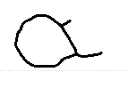 | 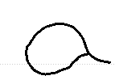 | 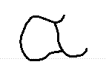 | 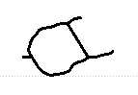 | 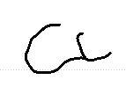 | 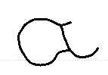 | 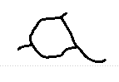 | 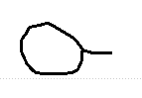 | 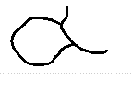 | 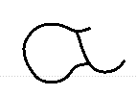
rank by priorD | 1 | 2 | 3 | 4 | 5 | 6 | 7 | 8 | 9 | anchor
prior distance | 0.122 | 0.149 | 0.174 | 0.194 | 0.196 | 0.201 | 0.201 | 0.207 | 0.233 | -
pick chance | 49.4% | 20.6% | 13.0% | 9.5% | 7.5% | never | never | never | never | -
swap to anchor | 47% | 51% | 56% | 59% | 60% | - | - | - | - | -
drawn as this variant | 26.4% | 10.0% | 5.7% | 3.9% | 3.0% | 0% | 0% | 0% | 0% | 51.0%

glyph | 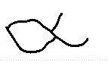 | 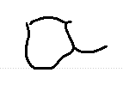 | 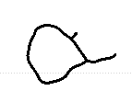
rank by priorD | 10 | 11 | 12
prior distance | 0.265 | 0.277 | 0.304
pick chance | never | never | never
swap to anchor | - | - | -
drawn as this variant | 0% | 0% | 0%

'b' 6 variants
glyph | 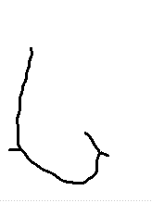 | 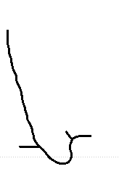 | 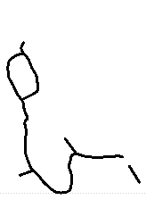 | 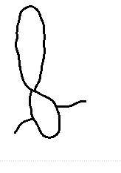 | 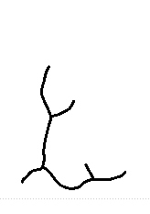 | 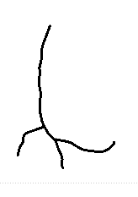 | 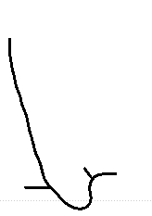
rank by priorD | 1 | 2 | 3 | 4 | 5 | 6 | anchor
prior distance | 0.183 | 0.200 | 0.240 | 0.246 | 0.266 | 0.329 | -
pick chance | 49.4% | 20.6% | 13.0% | 9.5% | 7.5% | never | -
swap to anchor | 57% | 60% | 67% | 68% | 72% | - | -
drawn as this variant | 21.1% | 8.2% | 4.2% | 3.0% | 2.1% | 0% | 61.4%

'c' 12 variants
glyph | 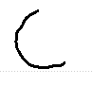 | 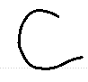 | 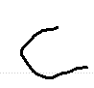 | 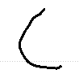 | 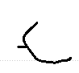 | 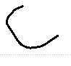 | 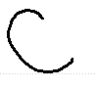 | 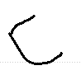 | 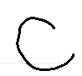 | 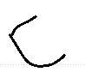
rank by priorD | 1 | 2 | 3 | 4 | 5 | 6 | 7 | 8 | 9 | anchor
prior distance | 0.041 | 0.117 | 0.121 | 0.123 | 0.150 | 0.169 | 0.184 | 0.186 | 0.205 | -
pick chance | 49.4% | 20.6% | 13.0% | 9.5% | 7.5% | never | never | never | never | -
swap to anchor | 5% | 5% | 46% | 47% | 52% | - | - | - | - | -
drawn as this variant | 46.9% | 19.6% | 7.0% | 5.0% | 3.6% | 0% | 0% | 0% | 0% | 17.9%

glyph | 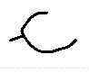 | 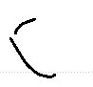 | 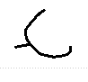
rank by priorD | 10 | 11 | 12
prior distance | 0.220 | 0.232 | 0.256
pick chance | never | never | never
swap to anchor | - | - | -
drawn as this variant | 0% | 0% | 0%

'd' 12 variants
glyph | 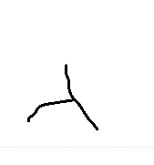 | 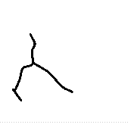 | 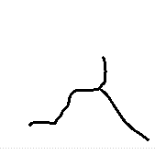 | 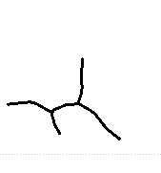 | 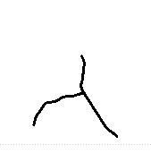 | 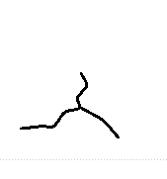 | 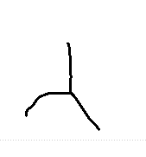 | 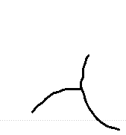 | 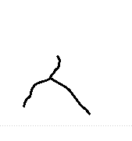 | 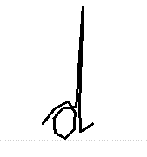
rank by priorD | 1 | 2 | 3 | 4 | 5 | 6 | 7 | 8 | 9 | anchor
prior distance | 0.356 | 0.360 | 0.366 | 0.369 | 0.371 | 0.385 | 0.407 | 0.409 | 0.417 | -
pick chance | 49.4% | 20.6% | 13.0% | 9.5% | 7.5% | never | never | never | never | -
swap to anchor | 88% | 88% | 90% | 90% | 91% | - | - | - | - | -
drawn as this variant | 6.0% | 2.4% | 1.4% | 0.9% | 0.7% | 0% | 0% | 0% | 0% | 88.6%

glyph | 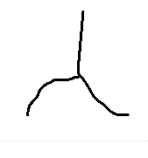 | 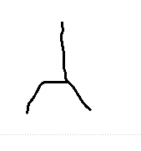 | 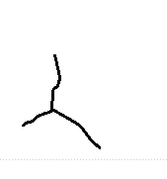
rank by priorD | 10 | 11 | 12
prior distance | 0.434 | 0.441 | 0.463
pick chance | never | never | never
swap to anchor | - | - | -
drawn as this variant | 0% | 0% | 0%

'e' 12 variants
glyph | 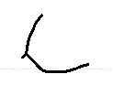 | 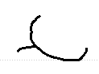 | 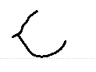 | 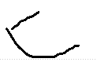 | 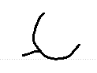 | 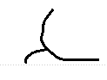 | 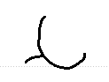 | 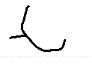 | 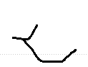 | 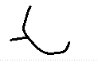
rank by priorD | 1 | 2 | 3 | 4 | 5 | 6 | 7 | 8 | 9 | anchor
prior distance | 0.130 | 0.152 | 0.158 | 0.163 | 0.170 | 0.173 | 0.189 | 0.190 | 0.227 | -
pick chance | 49.4% | 20.6% | 13.0% | 9.5% | 7.5% | never | never | never | never | -
swap to anchor | 48% | 52% | 53% | 54% | 55% | - | - | - | - | -
drawn as this variant | 25.7% | 9.9% | 6.1% | 4.4% | 3.4% | 0% | 0% | 0% | 0% | 50.5%

glyph | 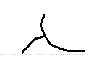 | 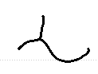 | 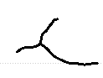
rank by priorD | 10 | 11 | 12
prior distance | 0.239 | 0.243 | 0.245
pick chance | never | never | never
swap to anchor | - | - | -
drawn as this variant | 0% | 0% | 0%

'f' 8 variants
glyph | 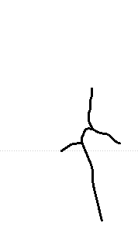 | 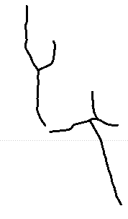 | 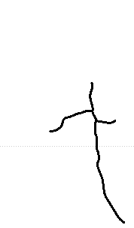 | 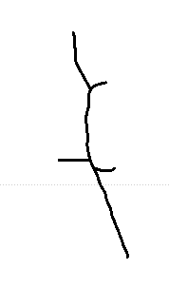 | 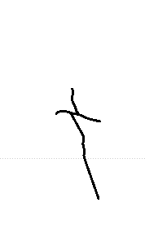 | 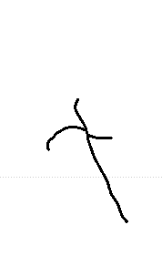 | 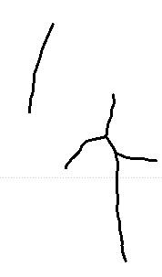 | 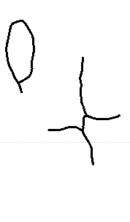 | 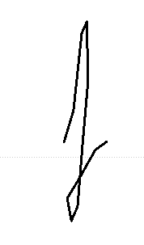
rank by priorD | 1 | 2 | 3 | 4 | 5 | 6 | 7 | 8 | anchor
prior distance | 0.294 | 0.351 | 0.364 | 0.368 | 0.376 | 0.385 | 0.446 | 0.490 | -
pick chance | 49.4% | 20.6% | 13.0% | 9.5% | 7.5% | never | never | never | -
swap to anchor | 77% | 87% | 89% | 90% | 91% | - | - | - | -
drawn as this variant | 11.4% | 2.7% | 1.4% | 1.0% | 0.6% | 0% | 0% | 0% | 82.9%

'g' 12 variants
glyph | 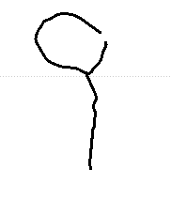 | 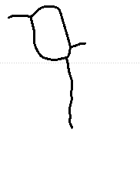 | 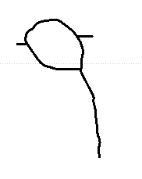 | 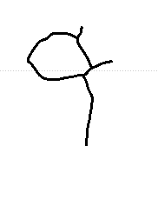 | 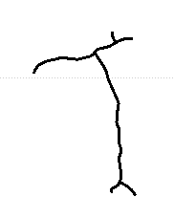 | 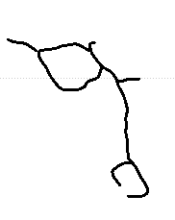 | 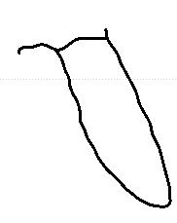 | 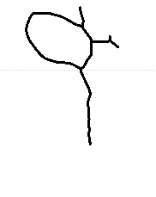 | 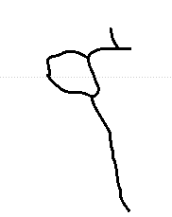 | 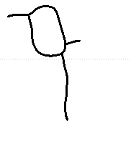
rank by priorD | 1 | 2 | 3 | 4 | 5 | 6 | 7 | 8 | 9 | anchor
prior distance | 0.140 | 0.164 | 0.172 | 0.182 | 0.216 | 0.217 | 0.228 | 0.247 | 0.249 | -
pick chance | 49.4% | 20.6% | 13.0% | 9.5% | 7.5% | never | never | never | never | -
swap to anchor | 50% | 54% | 55% | 57% | 63% | - | - | - | - | -
drawn as this variant | 24.8% | 9.4% | 5.8% | 4.1% | 2.8% | 0% | 0% | 0% | 0% | 53.1%

glyph | 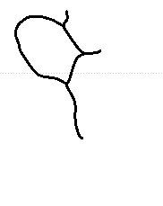 | 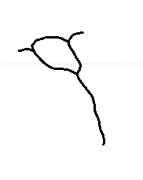 | 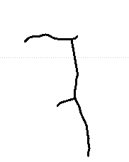
rank by priorD | 10 | 11 | 12
prior distance | 0.252 | 0.255 | 0.269
pick chance | never | never | never
swap to anchor | - | - | -
drawn as this variant | 0% | 0% | 0%

'h' 12 variants
glyph | 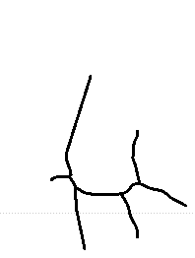 | 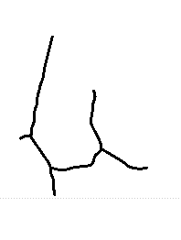 | 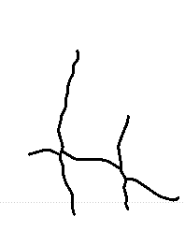 | 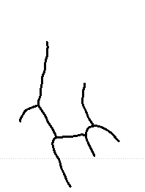 | 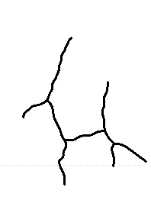 | 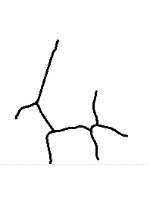 | 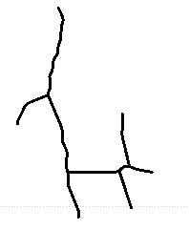 | 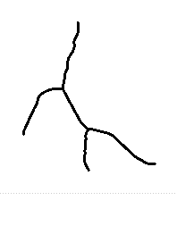 | 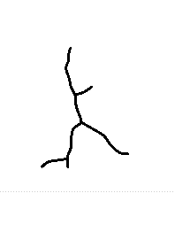 | 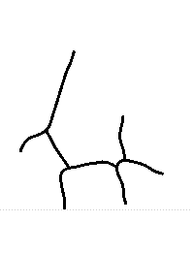
rank by priorD | 1 | 2 | 3 | 4 | 5 | 6 | 7 | 8 | 9 | anchor
prior distance | 0.148 | 0.170 | 0.213 | 0.221 | 0.221 | 0.260 | 0.272 | 0.310 | 0.326 | -
pick chance | 49.4% | 20.6% | 13.0% | 9.5% | 7.5% | never | never | never | never | -
swap to anchor | 51% | 55% | 63% | 64% | 64% | - | - | - | - | -
drawn as this variant | 24.1% | 9.2% | 4.9% | 3.4% | 2.7% | 0% | 0% | 0% | 0% | 55.6%

glyph | 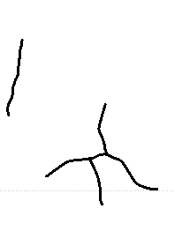 | 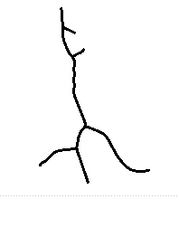 | 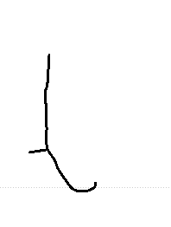
rank by priorD | 10 | 11 | 12
prior distance | 0.346 | 0.365 | 0.392
pick chance | never | never | never
swap to anchor | - | - | -
drawn as this variant | 0% | 0% | 0%

'i' 13 variants
glyph | 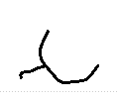 | 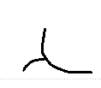 | 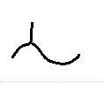 | 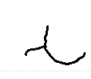 | 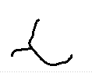 | 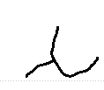 | 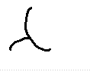 | 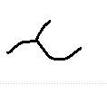 | 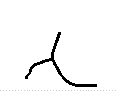 | 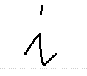
rank by priorD | 1 | 2 | 3 | 4 | 5 | 6 | 7 | 8 | 9 | anchor
prior distance | 0.254 | 0.272 | 0.281 | 0.306 | 0.309 | 0.325 | 0.352 | 0.363 | 0.370 | -
pick chance | 49.4% | 20.6% | 13.0% | 9.5% | 7.5% | never | never | never | never | -
swap to anchor | 70% | 73% | 75% | 79% | 80% | - | - | - | - | -
drawn as this variant | 14.9% | 5.6% | 3.3% | 2.0% | 1.5% | 0% | 0% | 0% | 0% | 72.8%

glyph | 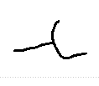 | 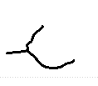 | 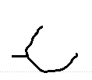 | 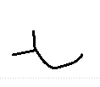
rank by priorD | 10 | 11 | 12 | 13
prior distance | 0.382 | 0.385 | 0.409 | 0.452
pick chance | never | never | never | never
swap to anchor | - | - | - | -
drawn as this variant | 0% | 0% | 0% | 0%

'k' 3 variants
glyph | 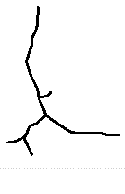 | 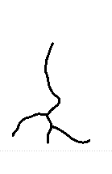 | 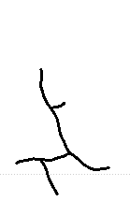 | 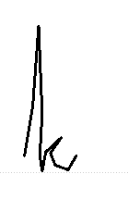
rank by priorD | 1 | 2 | 3 | anchor
prior distance | 0.242 | 0.345 | 0.398 | -
pick chance | 59.5% | 24.8% | 15.7% | -
swap to anchor | 68% | 86% | 95% | -
drawn as this variant | 19.1% | 3.5% | 0.7% | 76.6%

'l' 12 variants
glyph | 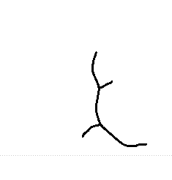 | 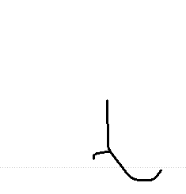 | 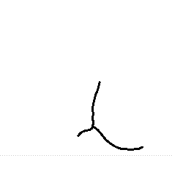 | 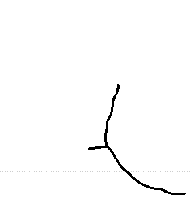 | 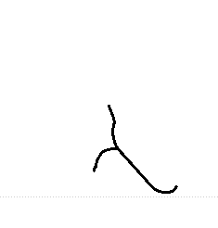 | 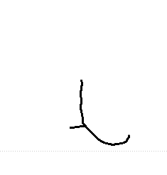 | 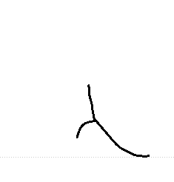 | 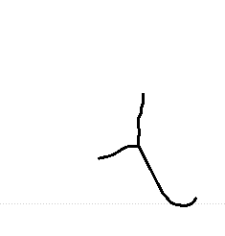 | 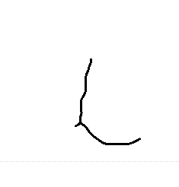 | 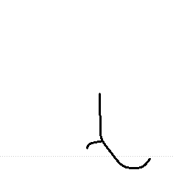
rank by priorD | 1 | 2 | 3 | 4 | 5 | 6 | 7 | 8 | 9 | anchor
prior distance | 0.170 | 0.211 | 0.216 | 0.242 | 0.252 | 0.259 | 0.281 | 0.292 | 0.319 | -
pick chance | 49.4% | 20.6% | 13.0% | 9.5% | 7.5% | never | never | never | never | -
swap to anchor | 55% | 62% | 63% | 68% | 70% | - | - | - | - | -
drawn as this variant | 22.2% | 7.8% | 4.8% | 3.1% | 2.3% | 0% | 0% | 0% | 0% | 59.8%

glyph | 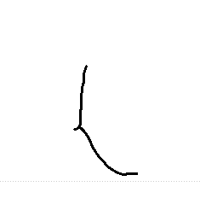 | 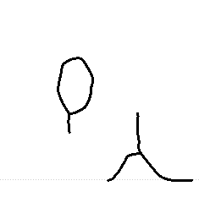 | 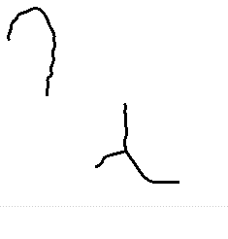
rank by priorD | 10 | 11 | 12
prior distance | 0.338 | 0.434 | 0.473
pick chance | never | never | never
swap to anchor | - | - | -
drawn as this variant | 0% | 0% | 0%

'm' 13 variants
glyph | 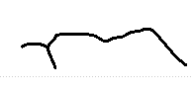 | 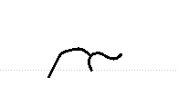 | 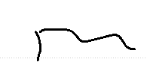 | 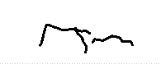 | 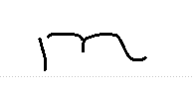 | 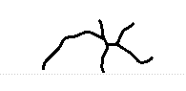 | 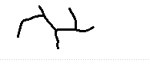 | 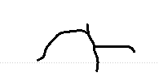 | 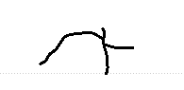 | 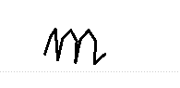
rank by priorD | 1 | 2 | 3 | 4 | 5 | 6 | 7 | 8 | 9 | anchor
prior distance | 0.192 | 0.195 | 0.200 | 0.278 | 0.285 | 0.309 | 0.315 | 0.323 | 0.331 | -
pick chance | 49.4% | 20.6% | 13.0% | 9.5% | 7.5% | never | never | never | never | -
swap to anchor | 59% | 59% | 60% | 74% | 75% | - | - | - | - | -
drawn as this variant | 20.3% | 8.4% | 5.2% | 2.5% | 1.8% | 0% | 0% | 0% | 0% | 61.9%

glyph | 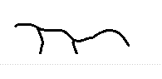 | 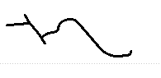 | 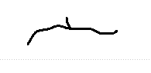 | 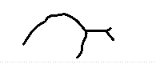
rank by priorD | 10 | 11 | 12 | 13
prior distance | 0.334 | 0.343 | 0.347 | 0.353
pick chance | never | never | never | never
swap to anchor | - | - | - | -
drawn as this variant | 0% | 0% | 0% | 0%

'n' 12 variants
glyph | 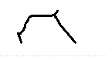 | 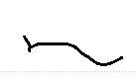 | 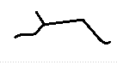 | 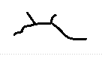 | 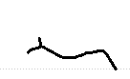 | 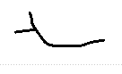 | 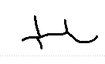 | 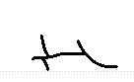 | 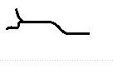 | 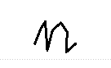
rank by priorD | 1 | 2 | 3 | 4 | 5 | 6 | 7 | 8 | 9 | anchor
prior distance | 0.219 | 0.457 | 0.460 | 0.473 | 0.501 | 0.511 | 0.526 | 0.531 | 0.533 | -
pick chance | 49.4% | 20.6% | 13.0% | 9.5% | 7.5% | never | never | never | never | -
swap to anchor | 64% | 100% | 100% | 100% | 100% | - | - | - | - | -
drawn as this variant | 17.9% | 0.0% | 0.0% | 0.0% | 0.0% | 0% | 0% | 0% | 0% | 82.0%

glyph | 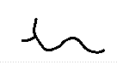 | 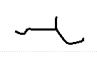 | 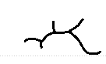
rank by priorD | 10 | 11 | 12
prior distance | 0.536 | 0.543 | 0.589
pick chance | never | never | never
swap to anchor | - | - | -
drawn as this variant | 0% | 0% | 0%

'o' 12 variants
glyph | 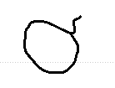 | 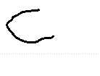 | 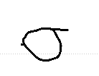 | 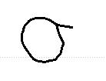 | 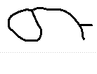 | 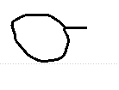 | 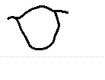 | 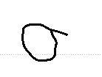 | 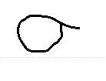 | 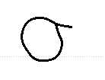
rank by priorD | 1 | 2 | 3 | 4 | 5 | 6 | 7 | 8 | 9 | anchor
prior distance | 0.139 | 0.154 | 0.163 | 0.174 | 0.212 | 0.240 | 0.263 | 0.271 | 0.287 | -
pick chance | 49.4% | 20.6% | 13.0% | 9.5% | 7.5% | never | never | never | never | -
swap to anchor | 50% | 52% | 54% | 56% | 63% | - | - | - | - | -
drawn as this variant | 24.9% | 9.8% | 6.0% | 4.2% | 2.8% | 0% | 0% | 0% | 0% | 52.3%

glyph | 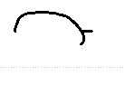 | 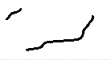 | 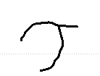
rank by priorD | 10 | 11 | 12
prior distance | 0.346 | 0.399 | 0.417
pick chance | never | never | never
swap to anchor | - | - | -
drawn as this variant | 0% | 0% | 0%

'p' 6 variants
glyph | 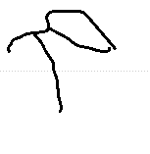 | 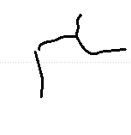 | 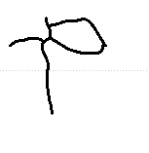 | 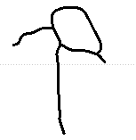 | 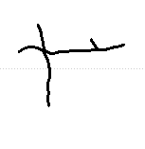 | 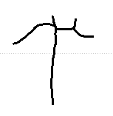 | 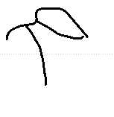
rank by priorD | 1 | 2 | 3 | 4 | 5 | 6 | anchor
prior distance | 0.291 | 0.303 | 0.309 | 0.337 | 0.370 | 0.377 | -
pick chance | 49.4% | 20.6% | 13.0% | 9.5% | 7.5% | never | -
swap to anchor | 76% | 78% | 80% | 85% | 90% | - | -
drawn as this variant | 11.7% | 4.4% | 2.6% | 1.5% | 0.7% | 0% | 79.1%

'q' 3 variants
glyph | 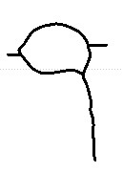 | 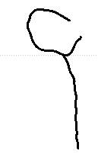 | 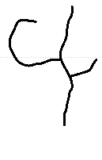 | 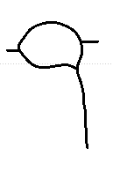
rank by priorD | 1 | 2 | 3 | anchor
prior distance | 0.144 | 0.177 | 0.203 | -
pick chance | 59.5% | 24.8% | 15.7% | -
swap to anchor | 50% | 56% | 61% | -
drawn as this variant | 29.5% | 10.8% | 6.1% | 53.6%

'r' 12 variants
glyph | 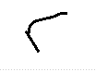 | 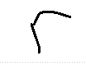 | 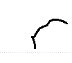 | 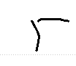 | 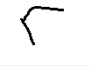 | 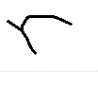 | 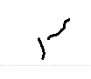 | 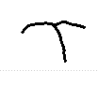 | 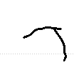 | 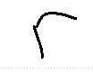
rank by priorD | 1 | 2 | 3 | 4 | 5 | 6 | 7 | 8 | 9 | anchor
prior distance | 0.199 | 0.225 | 0.227 | 0.247 | 0.250 | 0.460 | 0.528 | 0.554 | 0.557 | -
pick chance | 49.4% | 20.6% | 13.0% | 9.5% | 7.5% | never | never | never | never | -
swap to anchor | 60% | 65% | 65% | 69% | 69% | - | - | - | - | -
drawn as this variant | 19.7% | 7.2% | 4.5% | 3.0% | 2.3% | 0% | 0% | 0% | 0% | 63.2%

glyph | 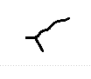 | 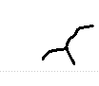 | 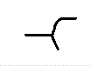
rank by priorD | 10 | 11 | 12
prior distance | 0.592 | 0.611 | 0.646
pick chance | never | never | never
swap to anchor | - | - | -
drawn as this variant | 0% | 0% | 0%

's' 12 variants
glyph | 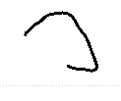 | 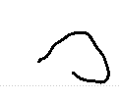 | 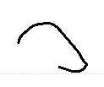 | 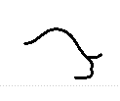 | 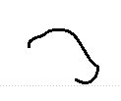 | 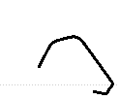 | 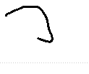 | 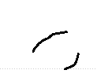 | 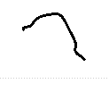 | 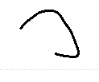
rank by priorD | 1 | 2 | 3 | 4 | 5 | 6 | 7 | 8 | 9 | anchor
prior distance | 0.272 | 0.285 | 0.287 | 0.293 | 0.310 | 0.320 | 0.331 | 0.341 | 0.346 | -
pick chance | 49.4% | 20.6% | 13.0% | 9.5% | 7.5% | never | never | never | never | -
swap to anchor | 73% | 75% | 76% | 77% | 80% | - | - | - | - | -
drawn as this variant | 13.3% | 5.1% | 3.2% | 2.2% | 1.5% | 0% | 0% | 0% | 0% | 74.7%

glyph | 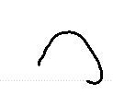 | 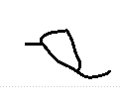 | 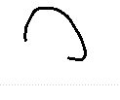
rank by priorD | 10 | 11 | 12
prior distance | 0.361 | 0.377 | 0.392
pick chance | never | never | never
swap to anchor | - | - | -
drawn as this variant | 0% | 0% | 0%

't' 12 variants
glyph | 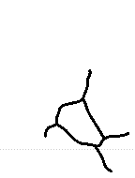 | 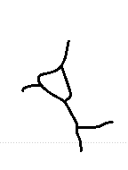 | 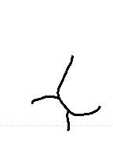 | 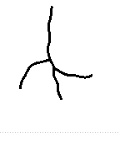 | 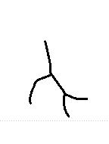 | 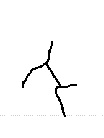 | 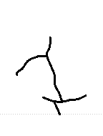 | 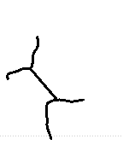 | 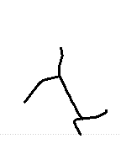 | 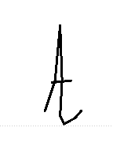
rank by priorD | 1 | 2 | 3 | 4 | 5 | 6 | 7 | 8 | 9 | anchor
prior distance | 0.272 | 0.272 | 0.307 | 0.324 | 0.326 | 0.333 | 0.341 | 0.343 | 0.344 | -
pick chance | 49.4% | 20.6% | 13.0% | 9.5% | 7.5% | never | never | never | never | -
swap to anchor | 73% | 73% | 79% | 82% | 83% | - | - | - | - | -
drawn as this variant | 13.3% | 5.5% | 2.7% | 1.7% | 1.3% | 0% | 0% | 0% | 0% | 75.4%

glyph | 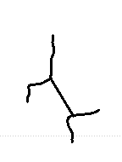 | 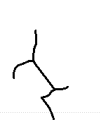 | 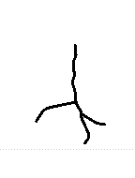
rank by priorD | 10 | 11 | 12
prior distance | 0.349 | 0.354 | 0.373
pick chance | never | never | never
swap to anchor | - | - | -
drawn as this variant | 0% | 0% | 0%

'u' 11 variants
glyph | 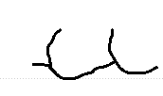 | 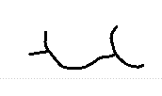 | 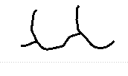 | 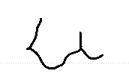 | 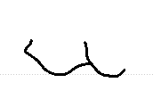 | 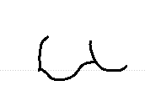 | 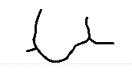 | 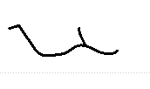 | 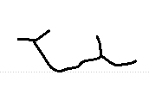 | 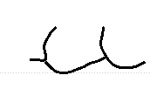
rank by priorD | 1 | 2 | 3 | 4 | 5 | 6 | 7 | 8 | 9 | anchor
prior distance | 0.154 | 0.155 | 0.174 | 0.193 | 0.196 | 0.208 | 0.212 | 0.213 | 0.237 | -
pick chance | 49.4% | 20.6% | 13.0% | 9.5% | 7.5% | never | never | never | never | -
swap to anchor | 52% | 52% | 56% | 59% | 60% | - | - | - | - | -
drawn as this variant | 23.6% | 9.8% | 5.8% | 3.9% | 3.0% | 0% | 0% | 0% | 0% | 54.0%

glyph | 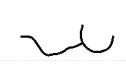 | 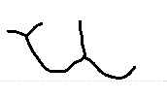
rank by priorD | 10 | 11
prior distance | 0.269 | 0.299
pick chance | never | never
swap to anchor | - | -
drawn as this variant | 0% | 0%

'v' 8 variants
glyph | 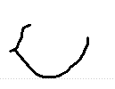 |  | 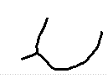 | 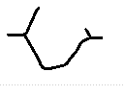 | 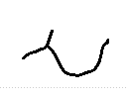 | 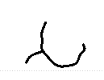 | 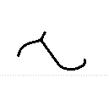 | 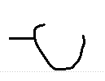 | 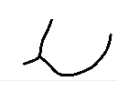
rank by priorD | 1 | 2 | 3 | 4 | 5 | 6 | 7 | 8 | anchor
prior distance | 0.191 | 0.247 | 0.281 | 0.291 | 0.364 | 0.387 | 0.485 | 0.488 | -
pick chance | 49.4% | 20.6% | 13.0% | 9.5% | 7.5% | never | never | never | -
swap to anchor | 59% | 69% | 75% | 76% | 89% | - | - | - | -
drawn as this variant | 20.4% | 6.5% | 3.3% | 2.2% | 0.8% | 0% | 0% | 0% | 66.8%

'w' 13 variants
glyph | 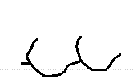 | 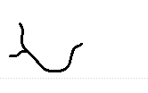 | 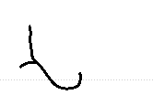 | 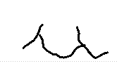 | 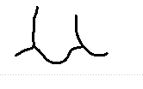 | 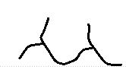 | 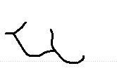 | 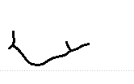 | 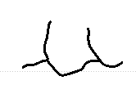 | 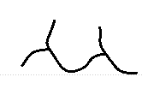
rank by priorD | 1 | 2 | 3 | 4 | 5 | 6 | 7 | 8 | 9 | anchor
prior distance | 0.208 | 0.236 | 0.250 | 0.251 | 0.281 | 0.296 | 0.304 | 0.324 | 0.347 | -
pick chance | 49.4% | 20.6% | 13.0% | 9.5% | 7.5% | never | never | never | never | -
swap to anchor | 62% | 67% | 69% | 69% | 75% | - | - | - | - | -
drawn as this variant | 18.9% | 6.9% | 4.0% | 2.9% | 1.9% | 0% | 0% | 0% | 0% | 65.4%

glyph | 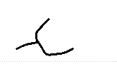 | 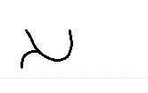 | 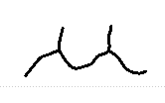 | 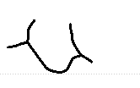
rank by priorD | 10 | 11 | 12 | 13
prior distance | 0.361 | 0.368 | 0.384 | 0.404
pick chance | never | never | never | never
swap to anchor | - | - | - | -
drawn as this variant | 0% | 0% | 0% | 0%

'x' 3 variants
glyph | 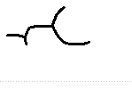 | 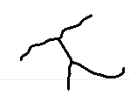 | 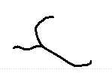 | 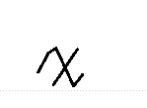
rank by priorD | 1 | 2 | 3 | anchor
prior distance | 0.231 | 0.323 | 0.409 | -
pick chance | 59.5% | 24.8% | 15.7% | -
swap to anchor | 66% | 82% | 97% | -
drawn as this variant | 20.3% | 4.5% | 0.5% | 74.8%

'y' 13 variants
glyph | 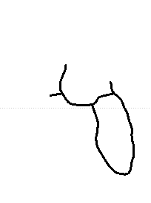 | 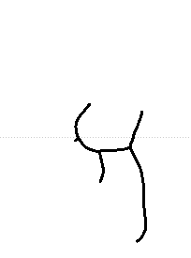 | 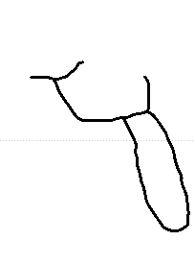 | 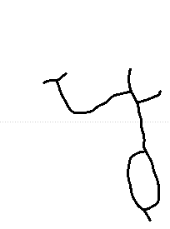 | 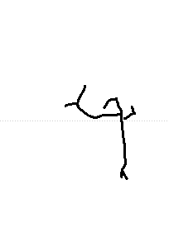 | 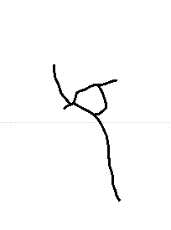 | 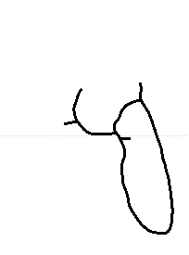 | 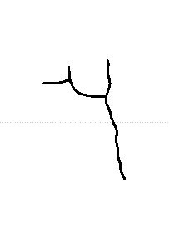 | 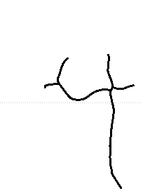 | 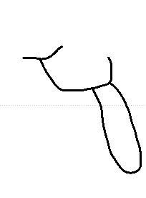
rank by priorD | 1 | 2 | 3 | 4 | 5 | 6 | 7 | 8 | 9 | anchor
prior distance | 0.136 | 0.142 | 0.145 | 0.156 | 0.169 | 0.175 | 0.195 | 0.210 | 0.213 | -
pick chance | 49.4% | 20.6% | 13.0% | 9.5% | 7.5% | never | never | never | never | -
swap to anchor | 49% | 50% | 51% | 53% | 55% | - | - | - | - | -
drawn as this variant | 25.1% | 10.3% | 6.4% | 4.5% | 3.4% | 0% | 0% | 0% | 0% | 50.3%

glyph | 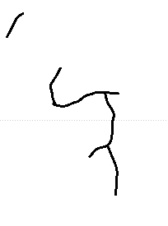 | 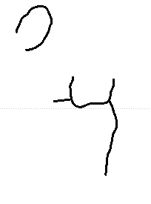 | 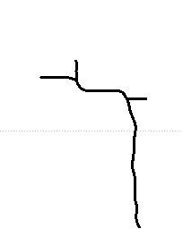 | 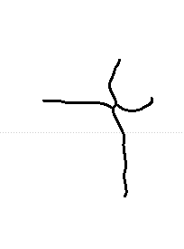
rank by priorD | 10 | 11 | 12 | 13
prior distance | 0.214 | 0.273 | 0.275 | 0.297
pick chance | never | never | never | never
swap to anchor | - | - | - | -
drawn as this variant | 0% | 0% | 0% | 0%

Writer 152
38 characters, 273 stored variants, median prior distance 0.223, legibility lambda 0.00, connectedness 0.715. Lambda is low, so the writer's own shapes are kept almost always.
'"' 1 variants
glyph | 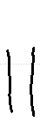
rank by priorD | 1
prior distance | 0.197
pick chance | 100.0%
swap to anchor | 0%
drawn as this variant | 100.0%

')' 1 variants
glyph | 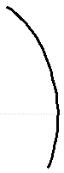
rank by priorD | 1
prior distance | 0.201
pick chance | 100.0%
swap to anchor | 0%
drawn as this variant | 100.0%

',' 8 variants
glyph
rank by priorD | 1 | 2 | 3 | 4 | 5 | 6 | 7 | 8
prior distance | 0.241 | 0.368 | 0.399 | 0.483 | 0.508 | 0.527 | 0.599 | 0.618
pick chance | 49.4% | 20.6% | 13.0% | 9.5% | 7.5% | never | never | never
swap to anchor | 0% | 0% | 0% | 0% | 0% | - | - | -
drawn as this variant | 49.4% | 20.6% | 13.0% | 9.5% | 7.5% | 0% | 0% | 0%

'-' 1 variants
glyph | 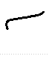
rank by priorD | 1
prior distance | 0.901
pick chance | 100.0%
swap to anchor | 100%
drawn as this variant | 0.0%

';' 1 variants
glyph | 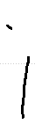
rank by priorD | 1
prior distance | 0.325
pick chance | 100.0%
swap to anchor | 0%
drawn as this variant | 100.0%

'A' 1 variants
glyph | 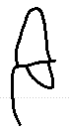 | 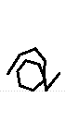
rank by priorD | 1 | anchor
prior distance | 0.251 | -
pick chance | 100.0% | -
swap to anchor | 0% | -
drawn as this variant | 100.0% | 0.0%

'B' 1 variants
glyph | 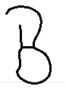 | 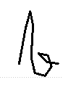
rank by priorD | 1 | anchor
prior distance | 0.228 | -
pick chance | 100.0% | -
swap to anchor | 0% | -
drawn as this variant | 100.0% | 0.0%

'F' 2 variants
glyph | 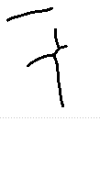 | 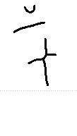 | 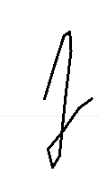
rank by priorD | 1 | 2 | anchor
prior distance | 0.501 | 0.543 | -
pick chance | 70.6% | 29.4% | -
swap to anchor | 0% | 0% | -
drawn as this variant | 70.6% | 29.4% | 0.0%

'I' 2 variants
glyph | 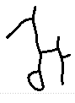 | 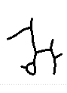 | 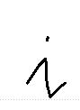
rank by priorD | 1 | 2 | anchor
prior distance | 0.627 | 0.687 | -
pick chance | 70.6% | 29.4% | -
swap to anchor | 100% | 100% | -
drawn as this variant | 0.0% | 0.0% | 100.0%

'J' 1 variants
glyph | 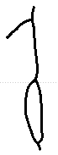 | 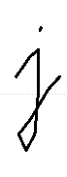
rank by priorD | 1 | anchor
prior distance | 0.353 | -
pick chance | 100.0% | -
swap to anchor | 0% | -
drawn as this variant | 100.0% | 0.0%

'L' 1 variants
glyph | 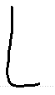 | 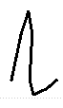
rank by priorD | 1 | anchor
prior distance | 0.043 | -
pick chance | 100.0% | -
swap to anchor | 0% | -
drawn as this variant | 100.0% | 0.0%

'M' 3 variants
glyph | 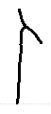 | 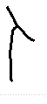 | 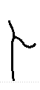 | 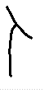
rank by priorD | 1 | 2 | 3 | anchor
prior distance | 0.206 | 0.264 | 0.289 | -
pick chance | 59.5% | 24.8% | 15.7% | -
swap to anchor | 0% | 0% | 0% | -
drawn as this variant | 59.5% | 24.8% | 15.7% | 0.0%

'T' 4 variants
glyph | 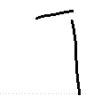 | 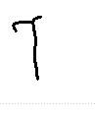 | 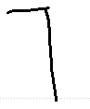 | 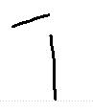 | 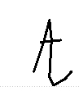
rank by priorD | 1 | 2 | 3 | 4 | anchor
prior distance | 0.276 | 0.279 | 0.365 | 0.470 | -
pick chance | 53.4% | 22.3% | 14.1% | 10.3% | -
swap to anchor | 0% | 0% | 0% | 0% | -
drawn as this variant | 53.4% | 22.3% | 14.1% | 10.3% | 0.0%

'W' 1 variants
glyph | 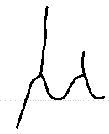 | 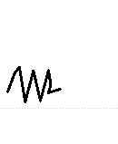
rank by priorD | 1 | anchor
prior distance | 0.563 | -
pick chance | 100.0% | -
swap to anchor | 100% | -
drawn as this variant | 0.0% | 100.0%

'a' 12 variants
glyph | 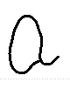 | 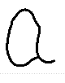 | 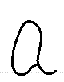 | 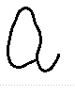 | 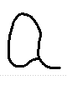 | 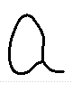 | 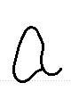 | 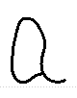 | 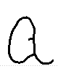 | 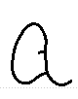
rank by priorD | 1 | 2 | 3 | 4 | 5 | 6 | 7 | 8 | 9 | anchor
prior distance | 0.127 | 0.138 | 0.153 | 0.163 | 0.169 | 0.173 | 0.177 | 0.191 | 0.202 | -
pick chance | 49.4% | 20.6% | 13.0% | 9.5% | 7.5% | never | never | never | never | -
swap to anchor | 0% | 0% | 0% | 0% | 0% | - | - | - | - | -
drawn as this variant | 49.4% | 20.6% | 13.0% | 9.5% | 7.5% | 0% | 0% | 0% | 0% | 0.0%

glyph | 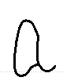 | 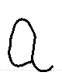 | 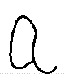
rank by priorD | 10 | 11 | 12
prior distance | 0.210 | 0.229 | 0.231
pick chance | never | never | never
swap to anchor | - | - | -
drawn as this variant | 0% | 0% | 0%

'b' 4 variants
glyph | 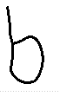 | 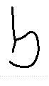 | 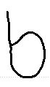 | 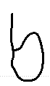 | 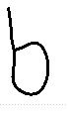
rank by priorD | 1 | 2 | 3 | 4 | anchor
prior distance | 0.088 | 0.099 | 0.127 | 0.167 | -
pick chance | 53.4% | 22.3% | 14.1% | 10.3% | -
swap to anchor | 0% | 0% | 0% | 0% | -
drawn as this variant | 53.4% | 22.3% | 14.1% | 10.3% | 0.0%

'c' 13 variants
glyph | 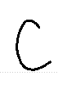 | 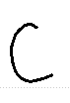 | 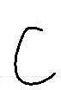 | 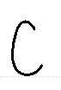 | 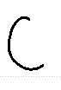 | 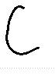 | 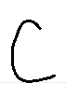 | 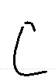 | 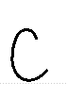 | 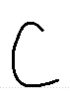
rank by priorD | 1 | 2 | 3 | 4 | 5 | 6 | 7 | 8 | 9 | anchor
prior distance | 0.069 | 0.072 | 0.072 | 0.075 | 0.076 | 0.089 | 0.096 | 0.104 | 0.135 | -
pick chance | 49.4% | 20.6% | 13.0% | 9.5% | 7.5% | never | never | never | never | -
swap to anchor | 0% | 0% | 0% | 0% | 0% | - | - | - | - | -
drawn as this variant | 49.4% | 20.6% | 13.0% | 9.5% | 7.5% | 0% | 0% | 0% | 0% | 0.0%

glyph | 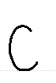 | 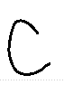 | 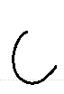 | 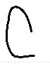
rank by priorD | 10 | 11 | 12 | 13
prior distance | 0.137 | 0.146 | 0.153 | 0.160
pick chance | never | never | never | never
swap to anchor | - | - | - | -
drawn as this variant | 0% | 0% | 0% | 0%

'd' 12 variants
glyph | 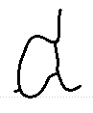 | 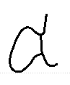 | 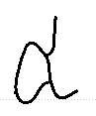 | 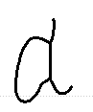 | 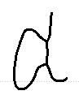 | 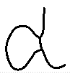 | 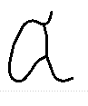 | 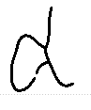 | 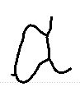 | 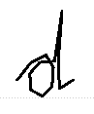
rank by priorD | 1 | 2 | 3 | 4 | 5 | 6 | 7 | 8 | 9 | anchor
prior distance | 0.273 | 0.294 | 0.324 | 0.337 | 0.344 | 0.354 | 0.364 | 0.364 | 0.367 | -
pick chance | 49.4% | 20.6% | 13.0% | 9.5% | 7.5% | never | never | never | never | -
swap to anchor | 0% | 0% | 0% | 0% | 0% | - | - | - | - | -
drawn as this variant | 49.4% | 20.6% | 13.0% | 9.5% | 7.5% | 0% | 0% | 0% | 0% | 0.0%

glyph | 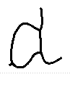 | 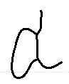 | 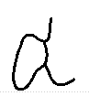
rank by priorD | 10 | 11 | 12
prior distance | 0.368 | 0.372 | 0.386
pick chance | never | never | never
swap to anchor | - | - | -
drawn as this variant | 0% | 0% | 0%

'e' 12 variants
glyph | 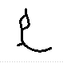 | 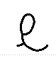 | 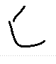 | 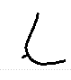 | 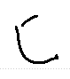 | 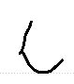 | 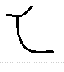 | 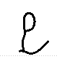 | 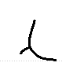 | 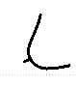
rank by priorD | 1 | 2 | 3 | 4 | 5 | 6 | 7 | 8 | 9 | anchor
prior distance | 0.115 | 0.120 | 0.138 | 0.151 | 0.152 | 0.172 | 0.177 | 0.181 | 0.192 | -
pick chance | 49.4% | 20.6% | 13.0% | 9.5% | 7.5% | never | never | never | never | -
swap to anchor | 0% | 0% | 0% | 0% | 0% | - | - | - | - | -
drawn as this variant | 49.4% | 20.6% | 13.0% | 9.5% | 7.5% | 0% | 0% | 0% | 0% | 0.0%

glyph | 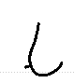 | 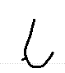 | 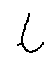
rank by priorD | 10 | 11 | 12
prior distance | 0.202 | 0.202 | 0.214
pick chance | never | never | never
swap to anchor | - | - | -
drawn as this variant | 0% | 0% | 0%

'f' 10 variants
glyph | 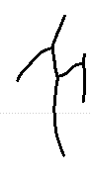 | 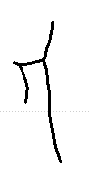 | 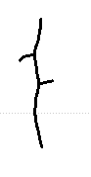 | 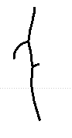 | 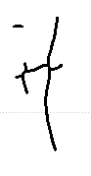 | 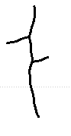 | 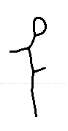 | 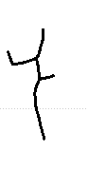 | 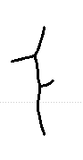 | 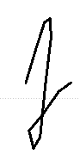
rank by priorD | 1 | 2 | 3 | 4 | 5 | 6 | 7 | 8 | 9 | anchor
prior distance | 0.313 | 0.322 | 0.340 | 0.347 | 0.348 | 0.349 | 0.371 | 0.383 | 0.400 | -
pick chance | 49.4% | 20.6% | 13.0% | 9.5% | 7.5% | never | never | never | never | -
swap to anchor | 0% | 0% | 0% | 0% | 0% | - | - | - | - | -
drawn as this variant | 49.4% | 20.6% | 13.0% | 9.5% | 7.5% | 0% | 0% | 0% | 0% | 0.0%

glyph | 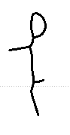
rank by priorD | 10
prior distance | 0.406
pick chance | never
swap to anchor | -
drawn as this variant | 0%

'g' 12 variants
glyph | 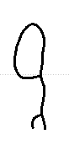 | 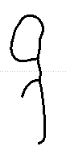 | 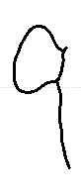 | 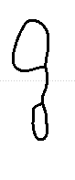 | 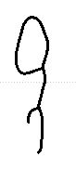 | 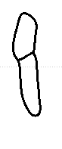 | 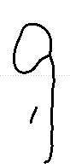 | 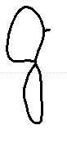 | 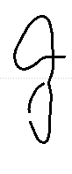 | 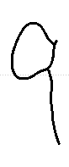
rank by priorD | 1 | 2 | 3 | 4 | 5 | 6 | 7 | 8 | 9 | anchor
prior distance | 0.114 | 0.142 | 0.144 | 0.148 | 0.163 | 0.194 | 0.195 | 0.197 | 0.200 | -
pick chance | 49.4% | 20.6% | 13.0% | 9.5% | 7.5% | never | never | never | never | -
swap to anchor | 0% | 0% | 0% | 0% | 0% | - | - | - | - | -
drawn as this variant | 49.4% | 20.6% | 13.0% | 9.5% | 7.5% | 0% | 0% | 0% | 0% | 0.0%

glyph | 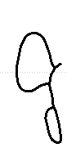 | 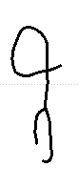 | 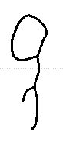
rank by priorD | 10 | 11 | 12
prior distance | 0.207 | 0.208 | 0.231
pick chance | never | never | never
swap to anchor | - | - | -
drawn as this variant | 0% | 0% | 0%

'h' 12 variants
glyph | 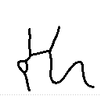 | 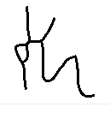 | 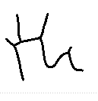 | 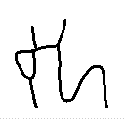 | 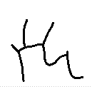 | 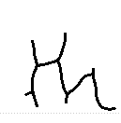 | 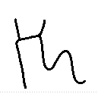 | 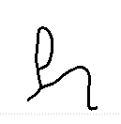 | 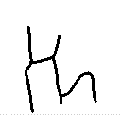 | 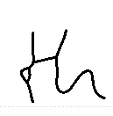
rank by priorD | 1 | 2 | 3 | 4 | 5 | 6 | 7 | 8 | 9 | anchor
prior distance | 0.101 | 0.108 | 0.113 | 0.131 | 0.137 | 0.139 | 0.142 | 0.147 | 0.182 | -
pick chance | 49.4% | 20.6% | 13.0% | 9.5% | 7.5% | never | never | never | never | -
swap to anchor | 0% | 0% | 0% | 0% | 0% | - | - | - | - | -
drawn as this variant | 49.4% | 20.6% | 13.0% | 9.5% | 7.5% | 0% | 0% | 0% | 0% | 0.0%

glyph | 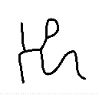 | 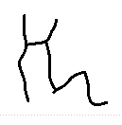 | 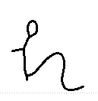
rank by priorD | 10 | 11 | 12
prior distance | 0.183 | 0.196 | 0.226
pick chance | never | never | never
swap to anchor | - | - | -
drawn as this variant | 0% | 0% | 0%

'i' 12 variants
glyph | 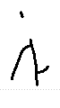 | 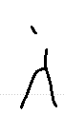 | 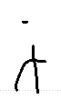 | 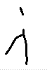 | 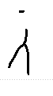 | 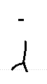 | 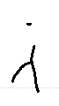 | 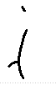 | 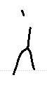 | 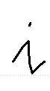
rank by priorD | 1 | 2 | 3 | 4 | 5 | 6 | 7 | 8 | 9 | anchor
prior distance | 0.332 | 0.430 | 0.476 | 0.483 | 0.490 | 0.495 | 0.513 | 0.532 | 0.552 | -
pick chance | 49.4% | 20.6% | 13.0% | 9.5% | 7.5% | never | never | never | never | -
swap to anchor | 0% | 0% | 0% | 0% | 0% | - | - | - | - | -
drawn as this variant | 49.4% | 20.6% | 13.0% | 9.5% | 7.5% | 0% | 0% | 0% | 0% | 0.0%

glyph | 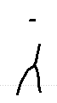 | 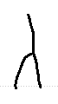 | 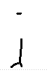
rank by priorD | 10 | 11 | 12
prior distance | 0.563 | 0.572 | 0.578
pick chance | never | never | never
swap to anchor | - | - | -
drawn as this variant | 0% | 0% | 0%

'k' 3 variants
glyph | 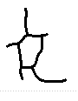 | 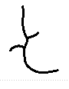 | 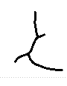 | 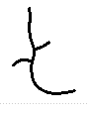
rank by priorD | 1 | 2 | 3 | anchor
prior distance | 0.264 | 0.278 | 0.337 | -
pick chance | 59.5% | 24.8% | 15.7% | -
swap to anchor | 0% | 0% | 0% | -
drawn as this variant | 59.5% | 24.8% | 15.7% | 0.0%

'l' 13 variants
glyph | 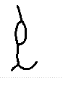 | 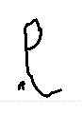 | 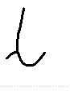 | 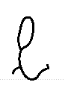 | 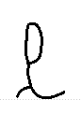 | 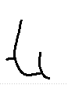 | 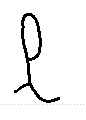 | 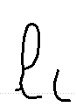 | 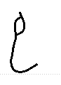 | 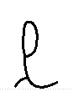
rank by priorD | 1 | 2 | 3 | 4 | 5 | 6 | 7 | 8 | 9 | anchor
prior distance | 0.200 | 0.223 | 0.226 | 0.226 | 0.236 | 0.247 | 0.264 | 0.265 | 0.295 | -
pick chance | 49.4% | 20.6% | 13.0% | 9.5% | 7.5% | never | never | never | never | -
swap to anchor | 0% | 0% | 0% | 0% | 0% | - | - | - | - | -
drawn as this variant | 49.4% | 20.6% | 13.0% | 9.5% | 7.5% | 0% | 0% | 0% | 0% | 0.0%

glyph | 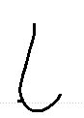 | 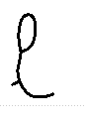 | 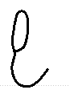 | 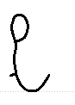
rank by priorD | 10 | 11 | 12 | 13
prior distance | 0.298 | 0.302 | 0.314 | 0.326
pick chance | never | never | never | never
swap to anchor | - | - | - | -
drawn as this variant | 0% | 0% | 0% | 0%

'm' 12 variants
glyph | 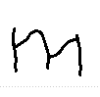 | 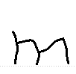 | 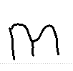 | 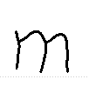 | 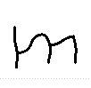 | 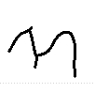 | 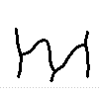 | 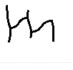 | 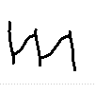 | 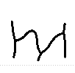
rank by priorD | 1 | 2 | 3 | 4 | 5 | 6 | 7 | 8 | 9 | anchor
prior distance | 0.151 | 0.153 | 0.153 | 0.163 | 0.178 | 0.209 | 0.210 | 0.214 | 0.231 | -
pick chance | 49.4% | 20.6% | 13.0% | 9.5% | 7.5% | never | never | never | never | -
swap to anchor | 0% | 0% | 0% | 0% | 0% | - | - | - | - | -
drawn as this variant | 49.4% | 20.6% | 13.0% | 9.5% | 7.5% | 0% | 0% | 0% | 0% | 0.0%

glyph | 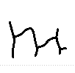 | 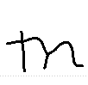 | 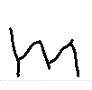
rank by priorD | 10 | 11 | 12
prior distance | 0.243 | 0.251 | 0.256
pick chance | never | never | never
swap to anchor | - | - | -
drawn as this variant | 0% | 0% | 0%

'n' 13 variants
glyph | 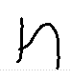 | 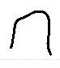 | 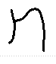 | 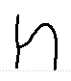 | 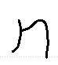 | 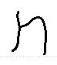 | 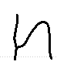 | 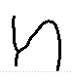 | 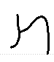 | 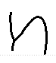
rank by priorD | 1 | 2 | 3 | 4 | 5 | 6 | 7 | 8 | 9 | anchor
prior distance | 0.125 | 0.152 | 0.153 | 0.173 | 0.185 | 0.205 | 0.233 | 0.238 | 0.241 | -
pick chance | 49.4% | 20.6% | 13.0% | 9.5% | 7.5% | never | never | never | never | -
swap to anchor | 0% | 0% | 0% | 0% | 0% | - | - | - | - | -
drawn as this variant | 49.4% | 20.6% | 13.0% | 9.5% | 7.5% | 0% | 0% | 0% | 0% | 0.0%

glyph | 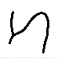 | 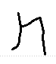 | 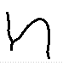 | 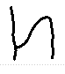
rank by priorD | 10 | 11 | 12 | 13
prior distance | 0.282 | 0.320 | 0.325 | 0.338
pick chance | never | never | never | never
swap to anchor | - | - | - | -
drawn as this variant | 0% | 0% | 0% | 0%

'o' 13 variants
glyph | 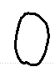 | 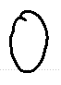 | 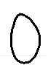 | 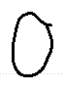 | 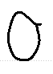 | 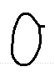 | 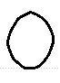 | 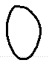 | 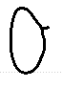 | 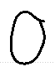
rank by priorD | 1 | 2 | 3 | 4 | 5 | 6 | 7 | 8 | 9 | anchor
prior distance | 0.071 | 0.075 | 0.082 | 0.091 | 0.098 | 0.102 | 0.107 | 0.117 | 0.119 | -
pick chance | 49.4% | 20.6% | 13.0% | 9.5% | 7.5% | never | never | never | never | -
swap to anchor | 0% | 0% | 0% | 0% | 0% | - | - | - | - | -
drawn as this variant | 49.4% | 20.6% | 13.0% | 9.5% | 7.5% | 0% | 0% | 0% | 0% | 0.0%

glyph | 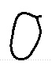 | 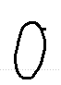 | 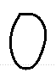 | 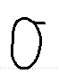
rank by priorD | 10 | 11 | 12 | 13
prior distance | 0.121 | 0.125 | 0.130 | 0.135
pick chance | never | never | never | never
swap to anchor | - | - | - | -
drawn as this variant | 0% | 0% | 0% | 0%

'p' 11 variants
glyph | 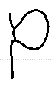 | 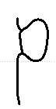 | 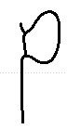 | 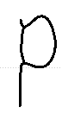 | 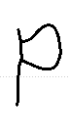 | 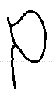 | 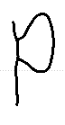 | 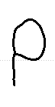 | 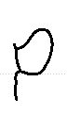 | 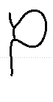
rank by priorD | 1 | 2 | 3 | 4 | 5 | 6 | 7 | 8 | 9 | anchor
prior distance | 0.091 | 0.095 | 0.105 | 0.122 | 0.127 | 0.138 | 0.144 | 0.146 | 0.157 | -
pick chance | 49.4% | 20.6% | 13.0% | 9.5% | 7.5% | never | never | never | never | -
swap to anchor | 0% | 0% | 0% | 0% | 0% | - | - | - | - | -
drawn as this variant | 49.4% | 20.6% | 13.0% | 9.5% | 7.5% | 0% | 0% | 0% | 0% | 0.0%

glyph | 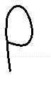 | 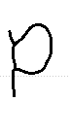
rank by priorD | 10 | 11
prior distance | 0.160 | 0.190
pick chance | never | never
swap to anchor | - | -
drawn as this variant | 0% | 0%

'q' 3 variants
glyph | 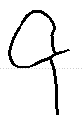 | 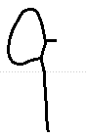 | 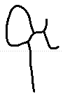 | 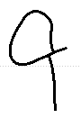
rank by priorD | 1 | 2 | 3 | anchor
prior distance | 0.126 | 0.133 | 0.221 | -
pick chance | 59.5% | 24.8% | 15.7% | -
swap to anchor | 0% | 0% | 0% | -
drawn as this variant | 59.5% | 24.8% | 15.7% | 0.0%

'r' 13 variants
glyph | 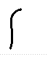 | 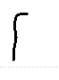 | 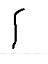 | 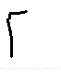 | 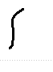 | 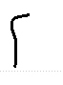 | 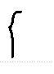 | 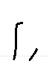 | 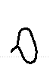 | 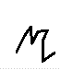
rank by priorD | 1 | 2 | 3 | 4 | 5 | 6 | 7 | 8 | 9 | anchor
prior distance | 0.163 | 0.228 | 0.252 | 0.282 | 0.446 | 0.480 | 0.481 | 0.498 | 0.519 | -
pick chance | 49.4% | 20.6% | 13.0% | 9.5% | 7.5% | never | never | never | never | -
swap to anchor | 0% | 0% | 0% | 0% | 0% | - | - | - | - | -
drawn as this variant | 49.4% | 20.6% | 13.0% | 9.5% | 7.5% | 0% | 0% | 0% | 0% | 0.0%

glyph | 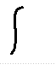 | 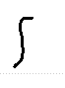 | 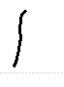 | 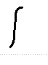
rank by priorD | 10 | 11 | 12 | 13
prior distance | 0.621 | 0.641 | 0.680 | 0.735
pick chance | never | never | never | never
swap to anchor | - | - | - | -
drawn as this variant | 0% | 0% | 0% | 0%

's' 13 variants
glyph | 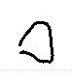 | 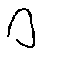 | 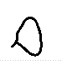 | 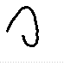 | 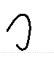 | 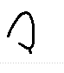 | 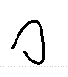 | 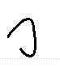 | 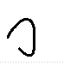 | 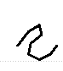
rank by priorD | 1 | 2 | 3 | 4 | 5 | 6 | 7 | 8 | 9 | anchor
prior distance | 0.265 | 0.321 | 0.356 | 0.365 | 0.375 | 0.376 | 0.396 | 0.407 | 0.410 | -
pick chance | 49.4% | 20.6% | 13.0% | 9.5% | 7.5% | never | never | never | never | -
swap to anchor | 0% | 0% | 0% | 0% | 0% | - | - | - | - | -
drawn as this variant | 49.4% | 20.6% | 13.0% | 9.5% | 7.5% | 0% | 0% | 0% | 0% | 0.0%

glyph | 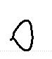 | 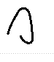 | 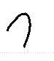 | 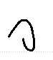
rank by priorD | 10 | 11 | 12 | 13
prior distance | 0.421 | 0.434 | 0.441 | 0.461
pick chance | never | never | never | never
swap to anchor | - | - | - | -
drawn as this variant | 0% | 0% | 0% | 0%

't' 12 variants
glyph | 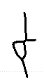 | 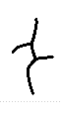 | 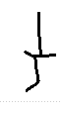 | 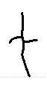 | 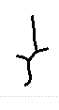 | 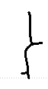 | 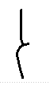 | 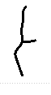 | 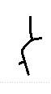 | 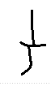
rank by priorD | 1 | 2 | 3 | 4 | 5 | 6 | 7 | 8 | 9 | anchor
prior distance | 0.208 | 0.222 | 0.241 | 0.246 | 0.287 | 0.314 | 0.315 | 0.319 | 0.337 | -
pick chance | 49.4% | 20.6% | 13.0% | 9.5% | 7.5% | never | never | never | never | -
swap to anchor | 0% | 0% | 0% | 0% | 0% | - | - | - | - | -
drawn as this variant | 49.4% | 20.6% | 13.0% | 9.5% | 7.5% | 0% | 0% | 0% | 0% | 0.0%

glyph | 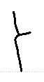 | 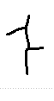 | 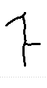
rank by priorD | 10 | 11 | 12
prior distance | 0.349 | 0.359 | 0.418
pick chance | never | never | never
swap to anchor | - | - | -
drawn as this variant | 0% | 0% | 0%

'u' 12 variants
glyph | 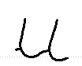 | 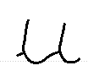 | 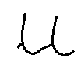 | 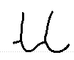 | 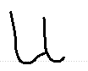 | 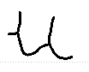 | 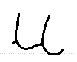 | 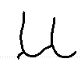 | 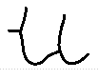 | 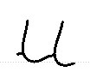
rank by priorD | 1 | 2 | 3 | 4 | 5 | 6 | 7 | 8 | 9 | anchor
prior distance | 0.169 | 0.182 | 0.185 | 0.189 | 0.199 | 0.218 | 0.222 | 0.223 | 0.227 | -
pick chance | 49.4% | 20.6% | 13.0% | 9.5% | 7.5% | never | never | never | never | -
swap to anchor | 0% | 0% | 0% | 0% | 0% | - | - | - | - | -
drawn as this variant | 49.4% | 20.6% | 13.0% | 9.5% | 7.5% | 0% | 0% | 0% | 0% | 0.0%

glyph | 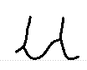 | 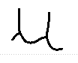 | 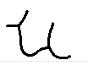
rank by priorD | 10 | 11 | 12
prior distance | 0.242 | 0.246 | 0.312
pick chance | never | never | never
swap to anchor | - | - | -
drawn as this variant | 0% | 0% | 0%

'v' 5 variants
glyph | 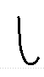 | 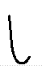 | 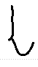 | 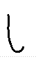 | 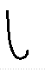 | 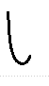
rank by priorD | 1 | 2 | 3 | 4 | 5 | anchor
prior distance | 0.186 | 0.187 | 0.202 | 0.214 | 0.254 | -
pick chance | 49.4% | 20.6% | 13.0% | 9.5% | 7.5% | -
swap to anchor | 0% | 0% | 0% | 0% | 0% | -
drawn as this variant | 49.4% | 20.6% | 13.0% | 9.5% | 7.5% | 0.0%

'w' 8 variants
glyph | 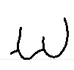 | 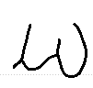 | 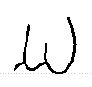 | 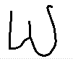 | 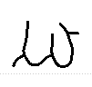 | 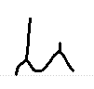 | 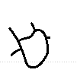 | 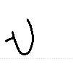 | 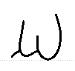
rank by priorD | 1 | 2 | 3 | 4 | 5 | 6 | 7 | 8 | anchor
prior distance | 0.199 | 0.229 | 0.235 | 0.241 | 0.258 | 0.283 | 0.394 | 0.490 | -
pick chance | 49.4% | 20.6% | 13.0% | 9.5% | 7.5% | never | never | never | -
swap to anchor | 0% | 0% | 0% | 0% | 0% | - | - | - | -
drawn as this variant | 49.4% | 20.6% | 13.0% | 9.5% | 7.5% | 0% | 0% | 0% | 0.0%

'x' 3 variants
glyph | 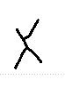 | 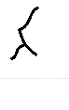 | 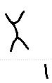 | 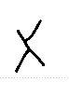
rank by priorD | 1 | 2 | 3 | anchor
prior distance | 0.169 | 0.223 | 0.412 | -
pick chance | 59.5% | 24.8% | 15.7% | -
swap to anchor | 0% | 0% | 0% | -
drawn as this variant | 59.5% | 24.8% | 15.7% | 0.0%

'y' 12 variants
glyph | 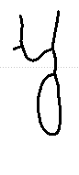 | 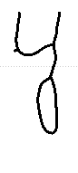 | 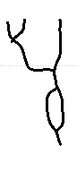 | 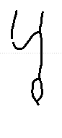 | 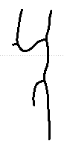 | 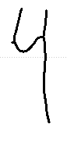 | 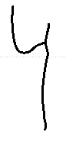 | 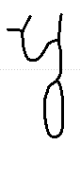 | 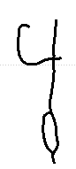 | 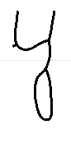
rank by priorD | 1 | 2 | 3 | 4 | 5 | 6 | 7 | 8 | 9 | anchor
prior distance | 0.103 | 0.108 | 0.122 | 0.124 | 0.126 | 0.128 | 0.134 | 0.139 | 0.144 | -
pick chance | 49.4% | 20.6% | 13.0% | 9.5% | 7.5% | never | never | never | never | -
swap to anchor | 0% | 0% | 0% | 0% | 0% | - | - | - | - | -
drawn as this variant | 49.4% | 20.6% | 13.0% | 9.5% | 7.5% | 0% | 0% | 0% | 0% | 0.0%

glyph | 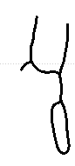 | 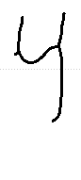 | 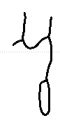
rank by priorD | 10 | 11 | 12
prior distance | 0.147 | 0.164 | 0.188
pick chance | never | never | never
swap to anchor | - | - | -
drawn as this variant | 0% | 0% | 0%

Writer 153
37 characters, 283 stored variants, median prior distance 0.242, legibility lambda 0.03, connectedness 0.961. Lambda is low, so the writer's own shapes are kept almost always.
'"' 2 variants
glyph | 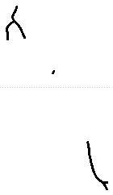 | 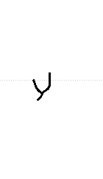
rank by priorD | 1 | 2
prior distance | 0.554 | 0.661
pick chance | 70.6% | 29.4%
swap to anchor | 100% | 100%
drawn as this variant | 0.0% | 0.0%

')' 1 variants
glyph | 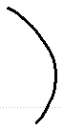
rank by priorD | 1
prior distance | 0.153
pick chance | 100.0%
swap to anchor | 2%
drawn as this variant | 98.5%

',' 10 variants
glyph |  | 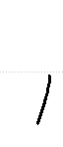 | 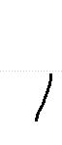 |  | 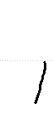 | 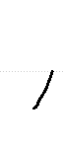 | 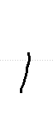 | 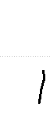 | 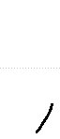 | 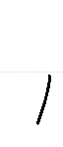
rank by priorD | 1 | 2 | 3 | 4 | 5 | 6 | 7 | 8 | 9 | anchor
prior distance | 0.189 | 0.194 | 0.242 | 0.243 | 0.256 | 0.296 | 0.310 | 0.319 | 0.345 | -
pick chance | 49.4% | 20.6% | 13.0% | 9.5% | 7.5% | never | never | never | never | -
swap to anchor | 2% | 2% | 2% | 2% | 2% | - | - | - | - | -
drawn as this variant | 48.6% | 20.2% | 12.7% | 9.3% | 7.3% | 0% | 0% | 0% | 0% | 1.8%

glyph | 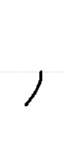
rank by priorD | 10
prior distance | 0.448
pick chance | never
swap to anchor | -
drawn as this variant | 0%

'.' 2 variants
glyph | 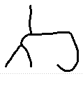 | 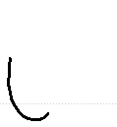
rank by priorD | 1 | 2
prior distance | 0.731 | 0.835
pick chance | 70.6% | 29.4%
swap to anchor | 100% | 100%
drawn as this variant | 0.0% | 0.0%

';' 1 variants
glyph | 
rank by priorD | 1
prior distance | 0.419
pick chance | 100.0%
swap to anchor | 3%
drawn as this variant | 97.1%

'A' 1 variants
glyph | 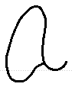 | 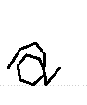
rank by priorD | 1 | anchor
prior distance | 0.284 | -
pick chance | 100.0% | -
swap to anchor | 2% | -
drawn as this variant | 97.8% | 2.2%

'B' 3 variants
glyph | 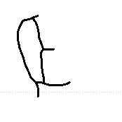 | 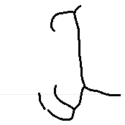 | 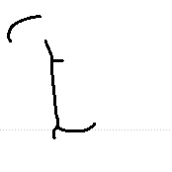 | 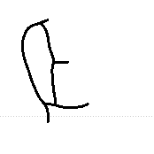
rank by priorD | 1 | 2 | 3 | anchor
prior distance | 0.292 | 0.389 | 0.416 | -
pick chance | 59.5% | 24.8% | 15.7% | -
swap to anchor | 2% | 3% | 3% | -
drawn as this variant | 58.2% | 24.1% | 15.2% | 2.5%

'H' 1 variants
glyph | 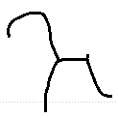 | 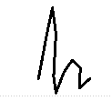
rank by priorD | 1 | anchor
prior distance | 0.554 | -
pick chance | 100.0% | -
swap to anchor | 100% | -
drawn as this variant | 0.0% | 100.0%

'I' 1 variants
glyph | 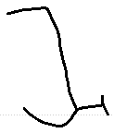 | 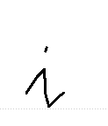
rank by priorD | 1 | anchor
prior distance | 0.366 | -
pick chance | 100.0% | -
swap to anchor | 3% | -
drawn as this variant | 97.3% | 2.7%

'M' 1 variants
glyph | 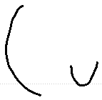 | 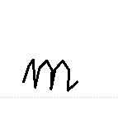
rank by priorD | 1 | anchor
prior distance | 0.302 | -
pick chance | 100.0% | -
swap to anchor | 2% | -
drawn as this variant | 97.7% | 2.3%

'T' 1 variants
glyph | 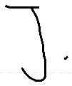 | 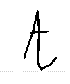
rank by priorD | 1 | anchor
prior distance | 0.564 | -
pick chance | 100.0% | -
swap to anchor | 100% | -
drawn as this variant | 0.0% | 100.0%

'W' 3 variants
glyph | 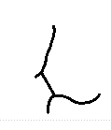 | 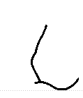 | 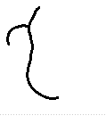 | 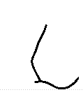
rank by priorD | 1 | 2 | 3 | anchor
prior distance | 0.232 | 0.255 | 0.605 | -
pick chance | 59.5% | 24.8% | 15.7% | -
swap to anchor | 2% | 2% | 100% | -
drawn as this variant | 58.4% | 24.3% | 0.0% | 17.4%

'a' 13 variants
glyph | 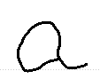 | 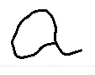 | 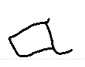 | 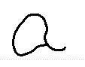 | 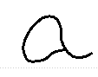 | 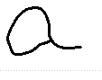 | 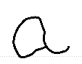 | 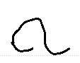 | 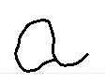 | 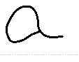
rank by priorD | 1 | 2 | 3 | 4 | 5 | 6 | 7 | 8 | 9 | anchor
prior distance | 0.141 | 0.149 | 0.156 | 0.166 | 0.169 | 0.173 | 0.181 | 0.197 | 0.202 | -
pick chance | 49.4% | 20.6% | 13.0% | 9.5% | 7.5% | never | never | never | never | -
swap to anchor | 1% | 2% | 2% | 2% | 2% | - | - | - | - | -
drawn as this variant | 48.7% | 20.3% | 12.8% | 9.3% | 7.4% | 0% | 0% | 0% | 0% | 1.5%

glyph
rank by priorD | 10 | 11 | 12 | 13
prior distance | 0.213 | 0.228 | 0.231 | 0.231
pick chance | never | never | never | never
swap to anchor | - | - | - | -
drawn as this variant | 0% | 0% | 0% | 0%

'b' 6 variants
glyph
rank by priorD | 1 | 2 | 3 | 4 | 5 | 6 | anchor
prior distance | 0.278 | 0.289 | 0.327 | 0.328 | 0.350 | 0.360 | -
pick chance | 49.4% | 20.6% | 13.0% | 9.5% | 7.5% | never | -
swap to anchor | 2% | 2% | 2% | 2% | 3% | - | -
drawn as this variant | 48.3% | 20.1% | 12.7% | 9.3% | 7.3% | 0% | 2.3%

'c' 13 variants
glyph
rank by priorD | 1 | 2 | 3 | 4 | 5 | 6 | 7 | 8 | 9 | anchor
prior distance | 0.112 | 0.118 | 0.141 | 0.156 | 0.173 | 0.181 | 0.182 | 0.183 | 0.199 | -
pick chance | 49.4% | 20.6% | 13.0% | 9.5% | 7.5% | never | never | never | never | -
swap to anchor | 0% | 0% | 1% | 2% | 2% | - | - | - | - | -
drawn as this variant | 49.3% | 20.6% | 12.8% | 9.3% | 7.4% | 0% | 0% | 0% | 0% | 0.6%

glyph
rank by priorD | 10 | 11 | 12 | 13
prior distance | 0.215 | 0.220 | 0.280 | 0.297
pick chance | never | never | never | never
swap to anchor | - | - | - | -
drawn as this variant | 0% | 0% | 0% | 0%

'd' 12 variants
glyph
rank by priorD | 1 | 2 | 3 | 4 | 5 | 6 | 7 | 8 | 9 | anchor
prior distance | 0.086 | 0.101 | 0.117 | 0.127 | 0.134 | 0.148 | 0.161 | 0.173 | 0.179 | -
pick chance | 49.4% | 20.6% | 13.0% | 9.5% | 7.5% | never | never | never | never | -
swap to anchor | 0% | 0% | 0% | 1% | 1% | - | - | - | - | -
drawn as this variant | 49.3% | 20.6% | 13.0% | 9.4% | 7.4% | 0% | 0% | 0% | 0% | 0.4%

glyph
rank by priorD | 10 | 11 | 12
prior distance | 0.179 | 0.188 | 0.241
pick chance | never | never | never
swap to anchor | - | - | -
drawn as this variant | 0% | 0% | 0%

'e' 12 variants
glyph
rank by priorD | 1 | 2 | 3 | 4 | 5 | 6 | 7 | 8 | 9 | anchor
prior distance | 0.109 | 0.118 | 0.121 | 0.123 | 0.130 | 0.138 | 0.153 | 0.167 | 0.172 | -
pick chance | 49.4% | 20.6% | 13.0% | 9.5% | 7.5% | never | never | never | never | -
swap to anchor | 0% | 0% | 1% | 1% | 1% | - | - | - | - | -
drawn as this variant | 49.3% | 20.6% | 12.8% | 9.4% | 7.4% | 0% | 0% | 0% | 0% | 0.5%

glyph
rank by priorD | 10 | 11 | 12
prior distance | 0.192 | 0.223 | 0.224
pick chance | never | never | never
swap to anchor | - | - | -
drawn as this variant | 0% | 0% | 0%

'f' 12 variants
glyph
rank by priorD | 1 | 2 | 3 | 4 | 5 | 6 | 7 | 8 | 9 | anchor
prior distance | 0.179 | 0.190 | 0.221 | 0.221 | 0.227 | 0.243 | 0.256 | 0.257 | 0.287 | -
pick chance | 49.4% | 20.6% | 13.0% | 9.5% | 7.5% | never | never | never | never | -
swap to anchor | 2% | 2% | 2% | 2% | 2% | - | - | - | - | -
drawn as this variant | 48.6% | 20.2% | 12.8% | 9.3% | 7.3% | 0% | 0% | 0% | 0% | 1.8%

glyph
rank by priorD | 10 | 11 | 12
prior distance | 0.292 | 0.296 | 0.330
pick chance | never | never | never
swap to anchor | - | - | -
drawn as this variant | 0% | 0% | 0%

'g' 12 variants
glyph
rank by priorD | 1 | 2 | 3 | 4 | 5 | 6 | 7 | 8 | 9 | anchor
prior distance | 0.141 | 0.148 | 0.155 | 0.160 | 0.162 | 0.182 | 0.184 | 0.197 | 0.207 | -
pick chance | 49.4% | 20.6% | 13.0% | 9.5% | 7.5% | never | never | never | never | -
swap to anchor | 1% | 2% | 2% | 2% | 2% | - | - | - | - | -
drawn as this variant | 48.7% | 20.3% | 12.8% | 9.3% | 7.4% | 0% | 0% | 0% | 0% | 1.5%

glyph
rank by priorD | 10 | 11 | 12
prior distance | 0.212 | 0.229 | 0.246
pick chance | never | never | never
swap to anchor | - | - | -
drawn as this variant | 0% | 0% | 0%

'h' 12 variants
glyph
rank by priorD | 1 | 2 | 3 | 4 | 5 | 6 | 7 | 8 | 9 | anchor
prior distance | 0.173 | 0.178 | 0.185 | 0.196 | 0.204 | 0.208 | 0.211 | 0.211 | 0.217 | -
pick chance | 49.4% | 20.6% | 13.0% | 9.5% | 7.5% | never | never | never | never | -
swap to anchor | 2% | 2% | 2% | 2% | 2% | - | - | - | - | -
drawn as this variant | 48.6% | 20.2% | 12.8% | 9.3% | 7.3% | 0% | 0% | 0% | 0% | 1.7%

glyph
rank by priorD | 10 | 11 | 12
prior distance | 0.223 | 0.239 | 0.258
pick chance | never | never | never
swap to anchor | - | - | -
drawn as this variant | 0% | 0% | 0%

'i' 12 variants
glyph
rank by priorD | 1 | 2 | 3 | 4 | 5 | 6 | 7 | 8 | 9 | anchor
prior distance | 0.240 | 0.251 | 0.278 | 0.284 | 0.355 | 0.385 | 0.386 | 0.400 | 0.409 | -
pick chance | 49.4% | 20.6% | 13.0% | 9.5% | 7.5% | never | never | never | never | -
swap to anchor | 2% | 2% | 2% | 2% | 3% | - | - | - | - | -
drawn as this variant | 48.4% | 20.2% | 12.7% | 9.3% | 7.3% | 0% | 0% | 0% | 0% | 2.1%

glyph
rank by priorD | 10 | 11 | 12
prior distance | 0.433 | 0.436 | 0.438
pick chance | never | never | never
swap to anchor | - | - | -
drawn as this variant | 0% | 0% | 0%

'j' 1 variants
glyph
rank by priorD | 1 | anchor
prior distance | 0.612 | -
pick chance | 100.0% | -
swap to anchor | 100% | -
drawn as this variant | 0.0% | 100.0%

'k' 3 variants
glyph
rank by priorD | 1 | 2 | 3 | anchor
prior distance | 0.261 | 0.266 | 0.301 | -
pick chance | 59.5% | 24.8% | 15.7% | -
swap to anchor | 2% | 2% | 2% | -
drawn as this variant | 58.3% | 24.3% | 15.3% | 2.1%

'l' 12 variants
glyph
rank by priorD | 1 | 2 | 3 | 4 | 5 | 6 | 7 | 8 | 9 | anchor
prior distance | 0.170 | 0.172 | 0.175 | 0.181 | 0.200 | 0.203 | 0.215 | 0.216 | 0.226 | -
pick chance | 49.4% | 20.6% | 13.0% | 9.5% | 7.5% | never | never | never | never | -
swap to anchor | 2% | 2% | 2% | 2% | 2% | - | - | - | - | -
drawn as this variant | 48.6% | 20.2% | 12.8% | 9.3% | 7.3% | 0% | 0% | 0% | 0% | 1.7%

glyph
rank by priorD | 10 | 11 | 12
prior distance | 0.258 | 0.269 | 0.322
pick chance | never | never | never
swap to anchor | - | - | -
drawn as this variant | 0% | 0% | 0%

'm' 12 variants
glyph
rank by priorD | 1 | 2 | 3 | 4 | 5 | 6 | 7 | 8 | 9 | anchor
prior distance | 0.085 | 0.106 | 0.109 | 0.192 | 0.232 | 0.262 | 0.266 | 0.269 | 0.271 | -
pick chance | 49.4% | 20.6% | 13.0% | 9.5% | 7.5% | never | never | never | never | -
swap to anchor | 0% | 0% | 0% | 2% | 2% | - | - | - | - | -
drawn as this variant | 49.3% | 20.6% | 13.0% | 9.3% | 7.3% | 0% | 0% | 0% | 0% | 0.4%

glyph
rank by priorD | 10 | 11 | 12
prior distance | 0.276 | 0.288 | 0.333
pick chance | never | never | never
swap to anchor | - | - | -
drawn as this variant | 0% | 0% | 0%

'n' 13 variants
glyph
rank by priorD | 1 | 2 | 3 | 4 | 5 | 6 | 7 | 8 | 9 | anchor
prior distance | 0.080 | 0.090 | 0.096 | 0.100 | 0.118 | 0.119 | 0.157 | 0.187 | 0.254 | -
pick chance | 49.4% | 20.6% | 13.0% | 9.5% | 7.5% | never | never | never | never | -
swap to anchor | 0% | 0% | 0% | 0% | 0% | - | - | - | - | -
drawn as this variant | 49.3% | 20.6% | 13.0% | 9.5% | 7.5% | 0% | 0% | 0% | 0% | 0.1%

glyph
rank by priorD | 10 | 11 | 12 | 13
prior distance | 0.262 | 0.287 | 0.320 | 0.403
pick chance | never | never | never | never
swap to anchor | - | - | - | -
drawn as this variant | 0% | 0% | 0% | 0%

'o' 12 variants
glyph
rank by priorD | 1 | 2 | 3 | 4 | 5 | 6 | 7 | 8 | 9 | anchor
prior distance | 0.109 | 0.115 | 0.117 | 0.117 | 0.151 | 0.183 | 0.188 | 0.199 | 0.254 | -
pick chance | 49.4% | 20.6% | 13.0% | 9.5% | 7.5% | never | never | never | never | -
swap to anchor | 0% | 0% | 0% | 0% | 2% | - | - | - | - | -
drawn as this variant | 49.3% | 20.6% | 13.0% | 9.5% | 7.4% | 0% | 0% | 0% | 0% | 0.2%

glyph
rank by priorD | 10 | 11 | 12
prior distance | 0.259 | 0.274 | 0.286
pick chance | never | never | never
swap to anchor | - | - | -
drawn as this variant | 0% | 0% | 0%

'p' 11 variants
glyph
rank by priorD | 1 | 2 | 3 | 4 | 5 | 6 | 7 | 8 | 9 | anchor
prior distance | 0.200 | 0.220 | 0.255 | 0.256 | 0.256 | 0.266 | 0.269 | 0.276 | 0.287 | -
pick chance | 49.4% | 20.6% | 13.0% | 9.5% | 7.5% | never | never | never | never | -
swap to anchor | 2% | 2% | 2% | 2% | 2% | - | - | - | - | -
drawn as this variant | 48.5% | 20.2% | 12.7% | 9.3% | 7.3% | 0% | 0% | 0% | 0% | 1.9%

glyph
rank by priorD | 10 | 11
prior distance | 0.295 | 0.332
pick chance | never | never
swap to anchor | - | -
drawn as this variant | 0% | 0%

'q' 2 variants
glyph
rank by priorD | 1 | 2 | anchor
prior distance | 0.218 | 0.243 | -
pick chance | 70.6% | 29.4% | -
swap to anchor | 2% | 2% | -
drawn as this variant | 69.3% | 28.8% | 1.9%

'r' 12 variants
glyph
rank by priorD | 1 | 2 | 3 | 4 | 5 | 6 | 7 | 8 | 9 | anchor
prior distance | 0.065 | 0.084 | 0.145 | 0.165 | 0.198 | 0.343 | 0.355 | 0.378 | 0.394 | -
pick chance | 49.4% | 20.6% | 13.0% | 9.5% | 7.5% | never | never | never | never | -
swap to anchor | 0% | 0% | 2% | 2% | 2% | - | - | - | - | -
drawn as this variant | 49.3% | 20.6% | 12.8% | 9.3% | 7.3% | 0% | 0% | 0% | 0% | 0.6%

glyph
rank by priorD | 10 | 11 | 12
prior distance | 0.410 | 0.431 | 0.628
pick chance | never | never | never
swap to anchor | - | - | -
drawn as this variant | 0% | 0% | 0%

's' 13 variants
glyph
rank by priorD | 1 | 2 | 3 | 4 | 5 | 6 | 7 | 8 | 9 | anchor
prior distance | 0.237 | 0.252 | 0.256 | 0.286 | 0.295 | 0.305 | 0.307 | 0.314 | 0.316 | -
pick chance | 49.4% | 20.6% | 13.0% | 9.5% | 7.5% | never | never | never | never | -
swap to anchor | 2% | 2% | 2% | 2% | 2% | - | - | - | - | -
drawn as this variant | 48.4% | 20.2% | 12.7% | 9.3% | 7.3% | 0% | 0% | 0% | 0% | 2.1%

glyph
rank by priorD | 10 | 11 | 12 | 13
prior distance | 0.344 | 0.354 | 0.358 | 0.383
pick chance | never | never | never | never
swap to anchor | - | - | - | -
drawn as this variant | 0% | 0% | 0% | 0%

't' 12 variants
glyph
rank by priorD | 1 | 2 | 3 | 4 | 5 | 6 | 7 | 8 | 9 | anchor
prior distance | 0.225 | 0.243 | 0.290 | 0.311 | 0.313 | 0.316 | 0.333 | 0.350 | 0.361 | -
pick chance | 49.4% | 20.6% | 13.0% | 9.5% | 7.5% | never | never | never | never | -
swap to anchor | 2% | 2% | 2% | 2% | 2% | - | - | - | - | -
drawn as this variant | 48.5% | 20.2% | 12.7% | 9.3% | 7.3% | 0% | 0% | 0% | 0% | 2.1%

glyph
rank by priorD | 10 | 11 | 12
prior distance | 0.364 | 0.370 | 0.370
pick chance | never | never | never
swap to anchor | - | - | -
drawn as this variant | 0% | 0% | 0%

'u' 13 variants
glyph
rank by priorD | 1 | 2 | 3 | 4 | 5 | 6 | 7 | 8 | 9 | anchor
prior distance | 0.168 | 0.183 | 0.201 | 0.214 | 0.223 | 0.232 | 0.244 | 0.286 | 0.293 | -
pick chance | 49.4% | 20.6% | 13.0% | 9.5% | 7.5% | never | never | never | never | -
swap to anchor | 2% | 2% | 2% | 2% | 2% | - | - | - | - | -
drawn as this variant | 48.6% | 20.2% | 12.8% | 9.3% | 7.3% | 0% | 0% | 0% | 0% | 1.7%

glyph
rank by priorD | 10 | 11 | 12 | 13
prior distance | 0.297 | 0.307 | 0.320 | 0.330
pick chance | never | never | never | never
swap to anchor | - | - | - | -
drawn as this variant | 0% | 0% | 0% | 0%

'v' 9 variants
glyph
rank by priorD | 1 | 2 | 3 | 4 | 5 | 6 | 7 | 8 | 9 | anchor
prior distance | 0.216 | 0.235 | 0.344 | 0.354 | 0.432 | 0.435 | 0.447 | 0.459 | 0.473 | -
pick chance | 49.4% | 20.6% | 13.0% | 9.5% | 7.5% | never | never | never | never | -
swap to anchor | 2% | 2% | 3% | 3% | 3% | - | - | - | - | -
drawn as this variant | 48.5% | 20.2% | 12.7% | 9.3% | 7.3% | 0% | 0% | 0% | 0% | 2.1%

'w' 12 variants
glyph
rank by priorD | 1 | 2 | 3 | 4 | 5 | 6 | 7 | 8 | 9 | anchor
prior distance | 0.363 | 0.398 | 0.400 | 0.409 | 0.453 | 0.461 | 0.461 | 0.468 | 0.503 | -
pick chance | 49.4% | 20.6% | 13.0% | 9.5% | 7.5% | never | never | never | never | -
swap to anchor | 3% | 3% | 3% | 3% | 3% | - | - | - | - | -
drawn as this variant | 48.1% | 20.0% | 12.6% | 9.2% | 7.2% | 0% | 0% | 0% | 0% | 2.8%

glyph
rank by priorD | 10 | 11 | 12
prior distance | 0.519 | 0.525 | 0.536
pick chance | never | never | never
swap to anchor | - | - | -
drawn as this variant | 0% | 0% | 0%

'x' 3 variants
glyph
rank by priorD | 1 | 2 | 3 | anchor
prior distance | 0.214 | 0.257 | 0.278 | -
pick chance | 59.5% | 24.8% | 15.7% | -
swap to anchor | 2% | 2% | 2% | -
drawn as this variant | 58.4% | 24.3% | 15.3% | 2.0%

'y' 12 variants
glyph
rank by priorD | 1 | 2 | 3 | 4 | 5 | 6 | 7 | 8 | 9 | anchor
prior distance | 0.071 | 0.098 | 0.104 | 0.119 | 0.126 | 0.131 | 0.131 | 0.134 | 0.135 | -
pick chance | 49.4% | 20.6% | 13.0% | 9.5% | 7.5% | never | never | never | never | -
swap to anchor | 0% | 0% | 0% | 0% | 1% | - | - | - | - | -
drawn as this variant | 49.3% | 20.6% | 13.0% | 9.5% | 7.4% | 0% | 0% | 0% | 0% | 0.2%

glyph
rank by priorD | 10 | 11 | 12
prior distance | 0.138 | 0.169 | 0.176
pick chance | never | never | never
swap to anchor | - | - | -
drawn as this variant | 0% | 0% | 0%

Writer 384
36 characters, 252 stored variants, median prior distance 0.196, legibility lambda 0.00, connectedness 0.500. Lambda is low, so the writer's own shapes are kept almost always.
',' 4 variants
glyph
rank by priorD | 1 | 2 | 3 | 4 | anchor
prior distance | 0.077 | 0.204 | 0.205 | 0.301 | -
pick chance | 53.4% | 22.3% | 14.1% | 10.3% | -
swap to anchor | 0% | 0% | 0% | 0% | -
drawn as this variant | 53.4% | 22.3% | 14.1% | 10.3% | 0.0%

'8' 1 variants
glyph
rank by priorD | 1
prior distance | 0.000
pick chance | 100.0%
swap to anchor | 0%
drawn as this variant | 100.0%

';' 1 variants
glyph
rank by priorD | 1
prior distance | 0.398
pick chance | 100.0%
swap to anchor | 0%
drawn as this variant | 100.0%

'A' 2 variants
glyph
rank by priorD | 1 | 2 | anchor
prior distance | 0.213 | 0.259 | -
pick chance | 70.6% | 29.4% | -
swap to anchor | 0% | 0% | -
drawn as this variant | 70.6% | 29.4% | 0.0%

'E' 1 variants
glyph
rank by priorD | 1 | anchor
prior distance | 0.092 | -
pick chance | 100.0% | -
swap to anchor | 0% | -
drawn as this variant | 100.0% | 0.0%

'I' 1 variants
glyph
rank by priorD | 1 | anchor
prior distance | 0.513 | -
pick chance | 100.0% | -
swap to anchor | 0% | -
drawn as this variant | 100.0% | 0.0%

'S' 1 variants
glyph
rank by priorD | 1 | anchor
prior distance | 0.295 | -
pick chance | 100.0% | -
swap to anchor | 0% | -
drawn as this variant | 100.0% | 0.0%

'T' 3 variants
glyph
rank by priorD | 1 | 2 | 3 | anchor
prior distance | 0.213 | 0.242 | 0.323 | -
pick chance | 59.5% | 24.8% | 15.7% | -
swap to anchor | 0% | 0% | 0% | -
drawn as this variant | 59.5% | 24.8% | 15.7% | 0.0%

'V' 1 variants
glyph
rank by priorD | 1 | anchor
prior distance | 0.000 | -
pick chance | 100.0% | -
swap to anchor | 0% | -
drawn as this variant | 100.0% | 0.0%

'W' 1 variants
glyph
rank by priorD | 1 | anchor
prior distance | 0.127 | -
pick chance | 100.0% | -
swap to anchor | 0% | -
drawn as this variant | 100.0% | 0.0%

'a' 12 variants
glyph
rank by priorD | 1 | 2 | 3 | 4 | 5 | 6 | 7 | 8 | 9 | anchor
prior distance | 0.096 | 0.104 | 0.108 | 0.115 | 0.116 | 0.117 | 0.127 | 0.128 | 0.137 | -
pick chance | 49.4% | 20.6% | 13.0% | 9.5% | 7.5% | never | never | never | never | -
swap to anchor | 0% | 0% | 0% | 0% | 0% | - | - | - | - | -
drawn as this variant | 49.4% | 20.6% | 13.0% | 9.5% | 7.5% | 0% | 0% | 0% | 0% | 0.0%

glyph
rank by priorD | 10 | 11 | 12
prior distance | 0.144 | 0.149 | 0.151
pick chance | never | never | never
swap to anchor | - | - | -
drawn as this variant | 0% | 0% | 0%

'b' 3 variants
glyph
rank by priorD | 1 | 2 | 3 | anchor
prior distance | 0.177 | 0.186 | 0.216 | -
pick chance | 59.5% | 24.8% | 15.7% | -
swap to anchor | 0% | 0% | 0% | -
drawn as this variant | 59.5% | 24.8% | 15.7% | 0.0%

'c' 12 variants
glyph
rank by priorD | 1 | 2 | 3 | 4 | 5 | 6 | 7 | 8 | 9 | anchor
prior distance | 0.068 | 0.072 | 0.073 | 0.077 | 0.087 | 0.097 | 0.098 | 0.102 | 0.130 | -
pick chance | 49.4% | 20.6% | 13.0% | 9.5% | 7.5% | never | never | never | never | -
swap to anchor | 0% | 0% | 0% | 0% | 0% | - | - | - | - | -
drawn as this variant | 49.4% | 20.6% | 13.0% | 9.5% | 7.5% | 0% | 0% | 0% | 0% | 0.0%

glyph
rank by priorD | 10 | 11 | 12
prior distance | 0.138 | 0.142 | 0.145
pick chance | never | never | never
swap to anchor | - | - | -
drawn as this variant | 0% | 0% | 0%

'd' 12 variants
glyph
rank by priorD | 1 | 2 | 3 | 4 | 5 | 6 | 7 | 8 | 9 | anchor
prior distance | 0.063 | 0.064 | 0.100 | 0.136 | 0.137 | 0.149 | 0.154 | 0.160 | 0.164 | -
pick chance | 49.4% | 20.6% | 13.0% | 9.5% | 7.5% | never | never | never | never | -
swap to anchor | 0% | 0% | 0% | 0% | 0% | - | - | - | - | -
drawn as this variant | 49.4% | 20.6% | 13.0% | 9.5% | 7.5% | 0% | 0% | 0% | 0% | 0.0%

glyph
rank by priorD | 10 | 11 | 12
prior distance | 0.174 | 0.176 | 0.220
pick chance | never | never | never
swap to anchor | - | - | -
drawn as this variant | 0% | 0% | 0%

'e' 13 variants
glyph
rank by priorD | 1 | 2 | 3 | 4 | 5 | 6 | 7 | 8 | 9 | anchor
prior distance | 0.149 | 0.160 | 0.170 | 0.170 | 0.180 | 0.181 | 0.188 | 0.192 | 0.200 | -
pick chance | 49.4% | 20.6% | 13.0% | 9.5% | 7.5% | never | never | never | never | -
swap to anchor | 0% | 0% | 0% | 0% | 0% | - | - | - | - | -
drawn as this variant | 49.4% | 20.6% | 13.0% | 9.5% | 7.5% | 0% | 0% | 0% | 0% | 0.0%

glyph
rank by priorD | 10 | 11 | 12 | 13
prior distance | 0.207 | 0.209 | 0.218 | 0.226
pick chance | never | never | never | never
swap to anchor | - | - | - | -
drawn as this variant | 0% | 0% | 0% | 0%

'f' 10 variants
glyph
rank by priorD | 1 | 2 | 3 | 4 | 5 | 6 | 7 | 8 | 9 | anchor
prior distance | 0.255 | 0.267 | 0.270 | 0.273 | 0.316 | 0.321 | 0.337 | 0.377 | 0.378 | -
pick chance | 49.4% | 20.6% | 13.0% | 9.5% | 7.5% | never | never | never | never | -
swap to anchor | 0% | 0% | 0% | 0% | 0% | - | - | - | - | -
drawn as this variant | 49.4% | 20.6% | 13.0% | 9.5% | 7.5% | 0% | 0% | 0% | 0% | 0.0%

glyph
rank by priorD | 10
prior distance | 0.382
pick chance | never
swap to anchor | -
drawn as this variant | 0%

'g' 9 variants
glyph
rank by priorD | 1 | 2 | 3 | 4 | 5 | 6 | 7 | 8 | 9 | anchor
prior distance | 0.151 | 0.161 | 0.169 | 0.176 | 0.182 | 0.184 | 0.186 | 0.188 | 0.189 | -
pick chance | 49.4% | 20.6% | 13.0% | 9.5% | 7.5% | never | never | never | never | -
swap to anchor | 0% | 0% | 0% | 0% | 0% | - | - | - | - | -
drawn as this variant | 49.4% | 20.6% | 13.0% | 9.5% | 7.5% | 0% | 0% | 0% | 0% | 0.0%

'h' 12 variants
glyph
rank by priorD | 1 | 2 | 3 | 4 | 5 | 6 | 7 | 8 | 9 | anchor
prior distance | 0.170 | 0.173 | 0.184 | 0.197 | 0.201 | 0.206 | 0.210 | 0.212 | 0.214 | -
pick chance | 49.4% | 20.6% | 13.0% | 9.5% | 7.5% | never | never | never | never | -
swap to anchor | 0% | 0% | 0% | 0% | 0% | - | - | - | - | -
drawn as this variant | 49.4% | 20.6% | 13.0% | 9.5% | 7.5% | 0% | 0% | 0% | 0% | 0.0%

glyph
rank by priorD | 10 | 11 | 12
prior distance | 0.222 | 0.224 | 0.231
pick chance | never | never | never
swap to anchor | - | - | -
drawn as this variant | 0% | 0% | 0%

'i' 12 variants
glyph
rank by priorD | 1 | 2 | 3 | 4 | 5 | 6 | 7 | 8 | 9 | anchor
prior distance | 0.324 | 0.366 | 0.384 | 0.398 | 0.403 | 0.419 | 0.420 | 0.422 | 0.428 | -
pick chance | 49.4% | 20.6% | 13.0% | 9.5% | 7.5% | never | never | never | never | -
swap to anchor | 0% | 0% | 0% | 0% | 0% | - | - | - | - | -
drawn as this variant | 49.4% | 20.6% | 13.0% | 9.5% | 7.5% | 0% | 0% | 0% | 0% | 0.0%

glyph
rank by priorD | 10 | 11 | 12
prior distance | 0.440 | 0.534 | 0.542
pick chance | never | never | never
swap to anchor | - | - | -
drawn as this variant | 0% | 0% | 0%

'j' 1 variants
glyph
rank by priorD | 1 | anchor
prior distance | 0.344 | -
pick chance | 100.0% | -
swap to anchor | 0% | -
drawn as this variant | 100.0% | 0.0%

'k' 3 variants
glyph
rank by priorD | 1 | 2 | 3 | anchor
prior distance | 0.151 | 0.182 | 0.296 | -
pick chance | 59.5% | 24.8% | 15.7% | -
swap to anchor | 0% | 0% | 0% | -
drawn as this variant | 59.5% | 24.8% | 15.7% | 0.0%

'l' 12 variants
glyph
rank by priorD | 1 | 2 | 3 | 4 | 5 | 6 | 7 | 8 | 9 | anchor
prior distance | 0.158 | 0.209 | 0.219 | 0.255 | 0.260 | 0.289 | 0.296 | 0.318 | 0.332 | -
pick chance | 49.4% | 20.6% | 13.0% | 9.5% | 7.5% | never | never | never | never | -
swap to anchor | 0% | 0% | 0% | 0% | 0% | - | - | - | - | -
drawn as this variant | 49.4% | 20.6% | 13.0% | 9.5% | 7.5% | 0% | 0% | 0% | 0% | 0.0%

glyph
rank by priorD | 10 | 11 | 12
prior distance | 0.341 | 0.346 | 0.395
pick chance | never | never | never
swap to anchor | - | - | -
drawn as this variant | 0% | 0% | 0%

'm' 13 variants
glyph
rank by priorD | 1 | 2 | 3 | 4 | 5 | 6 | 7 | 8 | 9 | anchor
prior distance | 0.115 | 0.137 | 0.143 | 0.152 | 0.154 | 0.158 | 0.168 | 0.169 | 0.180 | -
pick chance | 49.4% | 20.6% | 13.0% | 9.5% | 7.5% | never | never | never | never | -
swap to anchor | 0% | 0% | 0% | 0% | 0% | - | - | - | - | -
drawn as this variant | 49.4% | 20.6% | 13.0% | 9.5% | 7.5% | 0% | 0% | 0% | 0% | 0.0%

glyph
rank by priorD | 10 | 11 | 12 | 13
prior distance | 0.180 | 0.186 | 0.203 | 0.249
pick chance | never | never | never | never
swap to anchor | - | - | - | -
drawn as this variant | 0% | 0% | 0% | 0%

'n' 13 variants
glyph
rank by priorD | 1 | 2 | 3 | 4 | 5 | 6 | 7 | 8 | 9 | anchor
prior distance | 0.162 | 0.224 | 0.250 | 0.251 | 0.263 | 0.286 | 0.292 | 0.295 | 0.299 | -
pick chance | 49.4% | 20.6% | 13.0% | 9.5% | 7.5% | never | never | never | never | -
swap to anchor | 0% | 0% | 0% | 0% | 0% | - | - | - | - | -
drawn as this variant | 49.4% | 20.6% | 13.0% | 9.5% | 7.5% | 0% | 0% | 0% | 0% | 0.0%

glyph
rank by priorD | 10 | 11 | 12 | 13
prior distance | 0.324 | 0.337 | 0.343 | 0.346
pick chance | never | never | never | never
swap to anchor | - | - | - | -
drawn as this variant | 0% | 0% | 0% | 0%

'o' 12 variants
glyph
rank by priorD | 1 | 2 | 3 | 4 | 5 | 6 | 7 | 8 | 9 | anchor
prior distance | 0.085 | 0.092 | 0.094 | 0.097 | 0.102 | 0.103 | 0.107 | 0.108 | 0.115 | -
pick chance | 49.4% | 20.6% | 13.0% | 9.5% | 7.5% | never | never | never | never | -
swap to anchor | 0% | 0% | 0% | 0% | 0% | - | - | - | - | -
drawn as this variant | 49.4% | 20.6% | 13.0% | 9.5% | 7.5% | 0% | 0% | 0% | 0% | 0.0%

glyph
rank by priorD | 10 | 11 | 12
prior distance | 0.116 | 0.119 | 0.131
pick chance | never | never | never
swap to anchor | - | - | -
drawn as this variant | 0% | 0% | 0%

'p' 12 variants
glyph
rank by priorD | 1 | 2 | 3 | 4 | 5 | 6 | 7 | 8 | 9 | anchor
prior distance | 0.086 | 0.105 | 0.186 | 0.229 | 0.261 | 0.265 | 0.266 | 0.275 | 0.281 | -
pick chance | 49.4% | 20.6% | 13.0% | 9.5% | 7.5% | never | never | never | never | -
swap to anchor | 0% | 0% | 0% | 0% | 0% | - | - | - | - | -
drawn as this variant | 49.4% | 20.6% | 13.0% | 9.5% | 7.5% | 0% | 0% | 0% | 0% | 0.0%

glyph
rank by priorD | 10 | 11 | 12
prior distance | 0.284 | 0.295 | 0.315
pick chance | never | never | never
swap to anchor | - | - | -
drawn as this variant | 0% | 0% | 0%

'q' 3 variants
glyph
rank by priorD | 1 | 2 | 3 | anchor
prior distance | 0.207 | 0.235 | 0.239 | -
pick chance | 59.5% | 24.8% | 15.7% | -
swap to anchor | 0% | 0% | 0% | -
drawn as this variant | 59.5% | 24.8% | 15.7% | 0.0%

'r' 13 variants
glyph
rank by priorD | 1 | 2 | 3 | 4 | 5 | 6 | 7 | 8 | 9 | anchor
prior distance | 0.079 | 0.090 | 0.095 | 0.102 | 0.111 | 0.138 | 0.154 | 0.166 | 0.168 | -
pick chance | 49.4% | 20.6% | 13.0% | 9.5% | 7.5% | never | never | never | never | -
swap to anchor | 0% | 0% | 0% | 0% | 0% | - | - | - | - | -
drawn as this variant | 49.4% | 20.6% | 13.0% | 9.5% | 7.5% | 0% | 0% | 0% | 0% | 0.0%

glyph
rank by priorD | 10 | 11 | 12 | 13
prior distance | 0.187 | 0.204 | 0.213 | 0.250
pick chance | never | never | never | never
swap to anchor | - | - | - | -
drawn as this variant | 0% | 0% | 0% | 0%

's' 13 variants
glyph
rank by priorD | 1 | 2 | 3 | 4 | 5 | 6 | 7 | 8 | 9 | anchor
prior distance | 0.148 | 0.174 | 0.181 | 0.188 | 0.201 | 0.210 | 0.215 | 0.230 | 0.234 | -
pick chance | 49.4% | 20.6% | 13.0% | 9.5% | 7.5% | never | never | never | never | -
swap to anchor | 0% | 0% | 0% | 0% | 0% | - | - | - | - | -
drawn as this variant | 49.4% | 20.6% | 13.0% | 9.5% | 7.5% | 0% | 0% | 0% | 0% | 0.0%

glyph
rank by priorD | 10 | 11 | 12 | 13
prior distance | 0.235 | 0.239 | 0.242 | 0.247
pick chance | never | never | never | never
swap to anchor | - | - | - | -
drawn as this variant | 0% | 0% | 0% | 0%

't' 12 variants
glyph
rank by priorD | 1 | 2 | 3 | 4 | 5 | 6 | 7 | 8 | 9 | anchor
prior distance | 0.184 | 0.226 | 0.247 | 0.257 | 0.262 | 0.273 | 0.279 | 0.283 | 0.298 | -
pick chance | 49.4% | 20.6% | 13.0% | 9.5% | 7.5% | never | never | never | never | -
swap to anchor | 0% | 0% | 0% | 0% | 0% | - | - | - | - | -
drawn as this variant | 49.4% | 20.6% | 13.0% | 9.5% | 7.5% | 0% | 0% | 0% | 0% | 0.0%

glyph
rank by priorD | 10 | 11 | 12
prior distance | 0.302 | 0.343 | 0.344
pick chance | never | never | never
swap to anchor | - | - | -
drawn as this variant | 0% | 0% | 0%

'u' 11 variants
glyph
rank by priorD | 1 | 2 | 3 | 4 | 5 | 6 | 7 | 8 | 9 | anchor
prior distance | 0.113 | 0.121 | 0.133 | 0.155 | 0.163 | 0.165 | 0.167 | 0.169 | 0.172 | -
pick chance | 49.4% | 20.6% | 13.0% | 9.5% | 7.5% | never | never | never | never | -
swap to anchor | 0% | 0% | 0% | 0% | 0% | - | - | - | - | -
drawn as this variant | 49.4% | 20.6% | 13.0% | 9.5% | 7.5% | 0% | 0% | 0% | 0% | 0.0%

glyph
rank by priorD | 10 | 11
prior distance | 0.174 | 0.182
pick chance | never | never
swap to anchor | - | -
drawn as this variant | 0% | 0%

'v' 3 variants
glyph
rank by priorD | 1 | 2 | 3 | anchor
prior distance | 0.245 | 0.656 | 0.729 | -
pick chance | 59.5% | 24.8% | 15.7% | -
swap to anchor | 0% | 100% | 100% | -
drawn as this variant | 59.5% | 0.0% | 0.0% | 40.5%

'w' 4 variants
glyph
rank by priorD | 1 | 2 | 3 | 4 | anchor
prior distance | 0.094 | 0.161 | 0.187 | 0.217 | -
pick chance | 53.4% | 22.3% | 14.1% | 10.3% | -
swap to anchor | 0% | 0% | 0% | 0% | -
drawn as this variant | 53.4% | 22.3% | 14.1% | 10.3% | 0.0%

'x' 3 variants
glyph
rank by priorD | 1 | 2 | 3 | anchor
prior distance | 0.146 | 0.205 | 0.226 | -
pick chance | 59.5% | 24.8% | 15.7% | -
swap to anchor | 0% | 0% | 0% | -
drawn as this variant | 59.5% | 24.8% | 15.7% | 0.0%

'y' 10 variants
glyph
rank by priorD | 1 | 2 | 3 | 4 | 5 | 6 | 7 | 8 | 9 | anchor
prior distance | 0.175 | 0.177 | 0.193 | 0.196 | 0.198 | 0.202 | 0.207 | 0.208 | 0.214 | -
pick chance | 49.4% | 20.6% | 13.0% | 9.5% | 7.5% | never | never | never | never | -
swap to anchor | 0% | 0% | 0% | 0% | 0% | - | - | - | - | -
drawn as this variant | 49.4% | 20.6% | 13.0% | 9.5% | 7.5% | 0% | 0% | 0% | 0% | 0.0%

glyph
rank by priorD | 10
prior distance | 0.254
pick chance | never
swap to anchor | -
drawn as this variant | 0%

'z' 3 variants
glyph
rank by priorD | 1 | 2 | 3 | anchor
prior distance | 0.356 | 0.390 | 0.434 | -
pick chance | 59.5% | 24.8% | 15.7% | -
swap to anchor | 0% | 0% | 0% | -
drawn as this variant | 59.5% | 24.8% | 15.7% | 0.0%

Writer 551
38 characters, 271 stored variants, median prior distance 0.235, legibility lambda 0.00, connectedness 0.557. Lambda is low, so the writer's own shapes are kept almost always.
'"' 3 variants
glyph
rank by priorD | 1 | 2 | 3
prior distance | 0.176 | 0.358 | 0.456
pick chance | 59.5% | 24.8% | 15.7%
swap to anchor | 0% | 0% | 0%
drawn as this variant | 59.5% | 24.8% | 15.7%

''' 3 variants
glyph
rank by priorD | 1 | 2 | 3
prior distance | 0.460 | 0.544 | 0.614
pick chance | 59.5% | 24.8% | 15.7%
swap to anchor | 0% | 0% | 100%
drawn as this variant | 59.5% | 24.8% | 0.0%

',' 6 variants
glyph
rank by priorD | 1 | 2 | 3 | 4 | 5 | 6 | anchor
prior distance | 0.090 | 0.183 | 0.197 | 0.234 | 0.358 | 0.538 | -
pick chance | 49.4% | 20.6% | 13.0% | 9.5% | 7.5% | never | -
swap to anchor | 0% | 0% | 0% | 0% | 0% | - | -
drawn as this variant | 49.4% | 20.6% | 13.0% | 9.5% | 7.5% | 0% | 0.0%

'.' 2 variants
glyph
rank by priorD | 1 | 2
prior distance | 0.812 | 0.837
pick chance | 70.6% | 29.4%
swap to anchor | 100% | 100%
drawn as this variant | 0.0% | 0.0%

'A' 2 variants
glyph
rank by priorD | 1 | 2 | anchor
prior distance | 0.173 | 0.652 | -
pick chance | 70.6% | 29.4% | -
swap to anchor | 0% | 100% | -
drawn as this variant | 70.6% | 0.0% | 29.4%

'D' 3 variants
glyph
rank by priorD | 1 | 2 | 3 | anchor
prior distance | 0.208 | 0.249 | 0.249 | -
pick chance | 59.5% | 24.8% | 15.7% | -
swap to anchor | 0% | 0% | 0% | -
drawn as this variant | 59.5% | 24.8% | 15.7% | 0.0%

'H' 2 variants
glyph
rank by priorD | 1 | 2 | anchor
prior distance | 0.206 | 0.246 | -
pick chance | 70.6% | 29.4% | -
swap to anchor | 0% | 0% | -
drawn as this variant | 70.6% | 29.4% | 0.0%

'I' 3 variants
glyph
rank by priorD | 1 | 2 | 3 | anchor
prior distance | 0.229 | 0.273 | 0.535 | -
pick chance | 59.5% | 24.8% | 15.7% | -
swap to anchor | 0% | 0% | 0% | -
drawn as this variant | 59.5% | 24.8% | 15.7% | 0.0%

'L' 1 variants
glyph
rank by priorD | 1 | anchor
prior distance | 0.291 | -
pick chance | 100.0% | -
swap to anchor | 0% | -
drawn as this variant | 100.0% | 0.0%

'M' 2 variants
glyph
rank by priorD | 1 | 2 | anchor
prior distance | 0.251 | 0.312 | -
pick chance | 70.6% | 29.4% | -
swap to anchor | 0% | 0% | -
drawn as this variant | 70.6% | 29.4% | 0.0%

'N' 2 variants
glyph
rank by priorD | 1 | 2 | anchor
prior distance | 0.313 | 0.389 | -
pick chance | 70.6% | 29.4% | -
swap to anchor | 0% | 0% | -
drawn as this variant | 70.6% | 29.4% | 0.0%

'T' 4 variants
glyph
rank by priorD | 1 | 2 | 3 | 4 | anchor
prior distance | 0.373 | 0.384 | 0.506 | 0.590 | -
pick chance | 53.4% | 22.3% | 14.1% | 10.3% | -
swap to anchor | 0% | 0% | 0% | 100% | -
drawn as this variant | 53.4% | 22.3% | 14.1% | 0.0% | 10.3%

'W' 3 variants
glyph
rank by priorD | 1 | 2 | 3 | anchor
prior distance | 0.087 | 0.103 | 0.137 | -
pick chance | 59.5% | 24.8% | 15.7% | -
swap to anchor | 0% | 0% | 0% | -
drawn as this variant | 59.5% | 24.8% | 15.7% | 0.0%

'Y' 1 variants
glyph
rank by priorD | 1 | anchor
prior distance | 0.331 | -
pick chance | 100.0% | -
swap to anchor | 0% | -
drawn as this variant | 100.0% | 0.0%

'a' 12 variants
glyph
rank by priorD | 1 | 2 | 3 | 4 | 5 | 6 | 7 | 8 | 9 | anchor
prior distance | 0.069 | 0.113 | 0.135 | 0.147 | 0.152 | 0.156 | 0.197 | 0.197 | 0.204 | -
pick chance | 49.4% | 20.6% | 13.0% | 9.5% | 7.5% | never | never | never | never | -
swap to anchor | 0% | 0% | 0% | 0% | 0% | - | - | - | - | -
drawn as this variant | 49.4% | 20.6% | 13.0% | 9.5% | 7.5% | 0% | 0% | 0% | 0% | 0.0%

glyph
rank by priorD | 10 | 11 | 12
prior distance | 0.250 | 0.279 | 0.290
pick chance | never | never | never
swap to anchor | - | - | -
drawn as this variant | 0% | 0% | 0%

'b' 6 variants
glyph
rank by priorD | 1 | 2 | 3 | 4 | 5 | 6 | anchor
prior distance | 0.087 | 0.122 | 0.124 | 0.130 | 0.150 | 0.189 | -
pick chance | 49.4% | 20.6% | 13.0% | 9.5% | 7.5% | never | -
swap to anchor | 0% | 0% | 0% | 0% | 0% | - | -
drawn as this variant | 49.4% | 20.6% | 13.0% | 9.5% | 7.5% | 0% | 0.0%

'c' 8 variants
glyph
rank by priorD | 1 | 2 | 3 | 4 | 5 | 6 | 7 | 8 | anchor
prior distance | 0.068 | 0.076 | 0.118 | 0.134 | 0.138 | 0.153 | 0.162 | 0.166 | -
pick chance | 49.4% | 20.6% | 13.0% | 9.5% | 7.5% | never | never | never | -
swap to anchor | 0% | 0% | 0% | 0% | 0% | - | - | - | -
drawn as this variant | 49.4% | 20.6% | 13.0% | 9.5% | 7.5% | 0% | 0% | 0% | 0.0%

'd' 10 variants
glyph
rank by priorD | 1 | 2 | 3 | 4 | 5 | 6 | 7 | 8 | 9 | anchor
prior distance | 0.113 | 0.156 | 0.194 | 0.196 | 0.243 | 0.285 | 0.291 | 0.319 | 0.347 | -
pick chance | 49.4% | 20.6% | 13.0% | 9.5% | 7.5% | never | never | never | never | -
swap to anchor | 0% | 0% | 0% | 0% | 0% | - | - | - | - | -
drawn as this variant | 49.4% | 20.6% | 13.0% | 9.5% | 7.5% | 0% | 0% | 0% | 0% | 0.0%

glyph
rank by priorD | 10
prior distance | 0.352
pick chance | never
swap to anchor | -
drawn as this variant | 0%

'e' 12 variants
glyph
rank by priorD | 1 | 2 | 3 | 4 | 5 | 6 | 7 | 8 | 9 | anchor
prior distance | 0.127 | 0.131 | 0.131 | 0.132 | 0.138 | 0.141 | 0.144 | 0.159 | 0.164 | -
pick chance | 49.4% | 20.6% | 13.0% | 9.5% | 7.5% | never | never | never | never | -
swap to anchor | 0% | 0% | 0% | 0% | 0% | - | - | - | - | -
drawn as this variant | 49.4% | 20.6% | 13.0% | 9.5% | 7.5% | 0% | 0% | 0% | 0% | 0.0%

glyph
rank by priorD | 10 | 11 | 12
prior distance | 0.206 | 0.209 | 0.212
pick chance | never | never | never
swap to anchor | - | - | -
drawn as this variant | 0% | 0% | 0%

'f' 8 variants
glyph
rank by priorD | 1 | 2 | 3 | 4 | 5 | 6 | 7 | 8 | anchor
prior distance | 0.283 | 0.285 | 0.334 | 0.344 | 0.366 | 0.395 | 0.398 | 0.430 | -
pick chance | 49.4% | 20.6% | 13.0% | 9.5% | 7.5% | never | never | never | -
swap to anchor | 0% | 0% | 0% | 0% | 0% | - | - | - | -
drawn as this variant | 49.4% | 20.6% | 13.0% | 9.5% | 7.5% | 0% | 0% | 0% | 0.0%

'g' 12 variants
glyph
rank by priorD | 1 | 2 | 3 | 4 | 5 | 6 | 7 | 8 | 9 | anchor
prior distance | 0.134 | 0.144 | 0.172 | 0.173 | 0.193 | 0.233 | 0.279 | 0.304 | 0.322 | -
pick chance | 49.4% | 20.6% | 13.0% | 9.5% | 7.5% | never | never | never | never | -
swap to anchor | 0% | 0% | 0% | 0% | 0% | - | - | - | - | -
drawn as this variant | 49.4% | 20.6% | 13.0% | 9.5% | 7.5% | 0% | 0% | 0% | 0% | 0.0%

glyph
rank by priorD | 10 | 11 | 12
prior distance | 0.330 | 0.341 | 0.370
pick chance | never | never | never
swap to anchor | - | - | -
drawn as this variant | 0% | 0% | 0%

'h' 12 variants
glyph
rank by priorD | 1 | 2 | 3 | 4 | 5 | 6 | 7 | 8 | 9 | anchor
prior distance | 0.125 | 0.151 | 0.152 | 0.170 | 0.184 | 0.197 | 0.205 | 0.208 | 0.221 | -
pick chance | 49.4% | 20.6% | 13.0% | 9.5% | 7.5% | never | never | never | never | -
swap to anchor | 0% | 0% | 0% | 0% | 0% | - | - | - | - | -
drawn as this variant | 49.4% | 20.6% | 13.0% | 9.5% | 7.5% | 0% | 0% | 0% | 0% | 0.0%

glyph
rank by priorD | 10 | 11 | 12
prior distance | 0.225 | 0.253 | 0.282
pick chance | never | never | never
swap to anchor | - | - | -
drawn as this variant | 0% | 0% | 0%

'i' 12 variants
glyph
rank by priorD | 1 | 2 | 3 | 4 | 5 | 6 | 7 | 8 | 9 | anchor
prior distance | 0.261 | 0.349 | 0.376 | 0.437 | 0.438 | 0.485 | 0.504 | 0.509 | 0.521 | -
pick chance | 49.4% | 20.6% | 13.0% | 9.5% | 7.5% | never | never | never | never | -
swap to anchor | 0% | 0% | 0% | 0% | 0% | - | - | - | - | -
drawn as this variant | 49.4% | 20.6% | 13.0% | 9.5% | 7.5% | 0% | 0% | 0% | 0% | 0.0%

glyph
rank by priorD | 10 | 11 | 12
prior distance | 0.546 | 0.557 | 0.557
pick chance | never | never | never
swap to anchor | - | - | -
drawn as this variant | 0% | 0% | 0%

'j' 4 variants
glyph
rank by priorD | 1 | 2 | 3 | 4 | anchor
prior distance | 0.244 | 0.244 | 0.271 | 0.618 | -
pick chance | 53.4% | 22.3% | 14.1% | 10.3% | -
swap to anchor | 0% | 0% | 0% | 100% | -
drawn as this variant | 53.4% | 22.3% | 14.1% | 0.0% | 10.3%

'k' 10 variants
glyph
rank by priorD | 1 | 2 | 3 | 4 | 5 | 6 | 7 | 8 | 9 | anchor
prior distance | 0.068 | 0.076 | 0.082 | 0.088 | 0.102 | 0.103 | 0.104 | 0.129 | 0.130 | -
pick chance | 49.4% | 20.6% | 13.0% | 9.5% | 7.5% | never | never | never | never | -
swap to anchor | 0% | 0% | 0% | 0% | 0% | - | - | - | - | -
drawn as this variant | 49.4% | 20.6% | 13.0% | 9.5% | 7.5% | 0% | 0% | 0% | 0% | 0.0%

glyph
rank by priorD | 10
prior distance | 0.147
pick chance | never
swap to anchor | -
drawn as this variant | 0%

'l' 12 variants
glyph
rank by priorD | 1 | 2 | 3 | 4 | 5 | 6 | 7 | 8 | 9 | anchor
prior distance | 0.269 | 0.359 | 0.393 | 0.436 | 0.479 | 0.481 | 0.512 | 0.525 | 0.557 | -
pick chance | 49.4% | 20.6% | 13.0% | 9.5% | 7.5% | never | never | never | never | -
swap to anchor | 0% | 0% | 0% | 0% | 0% | - | - | - | - | -
drawn as this variant | 49.4% | 20.6% | 13.0% | 9.5% | 7.5% | 0% | 0% | 0% | 0% | 0.0%

glyph
rank by priorD | 10 | 11 | 12
prior distance | 0.578 | 0.640 | 0.643
pick chance | never | never | never
swap to anchor | - | - | -
drawn as this variant | 0% | 0% | 0%

'm' 12 variants
glyph
rank by priorD | 1 | 2 | 3 | 4 | 5 | 6 | 7 | 8 | 9 | anchor
prior distance | 0.124 | 0.156 | 0.163 | 0.163 | 0.174 | 0.179 | 0.182 | 0.214 | 0.222 | -
pick chance | 49.4% | 20.6% | 13.0% | 9.5% | 7.5% | never | never | never | never | -
swap to anchor | 0% | 0% | 0% | 0% | 0% | - | - | - | - | -
drawn as this variant | 49.4% | 20.6% | 13.0% | 9.5% | 7.5% | 0% | 0% | 0% | 0% | 0.0%

glyph
rank by priorD | 10 | 11 | 12
prior distance | 0.247 | 0.268 | 0.276
pick chance | never | never | never
swap to anchor | - | - | -
drawn as this variant | 0% | 0% | 0%

'n' 12 variants
glyph
rank by priorD | 1 | 2 | 3 | 4 | 5 | 6 | 7 | 8 | 9 | anchor
prior distance | 0.117 | 0.123 | 0.162 | 0.186 | 0.238 | 0.281 | 0.304 | 0.306 | 0.310 | -
pick chance | 49.4% | 20.6% | 13.0% | 9.5% | 7.5% | never | never | never | never | -
swap to anchor | 0% | 0% | 0% | 0% | 0% | - | - | - | - | -
drawn as this variant | 49.4% | 20.6% | 13.0% | 9.5% | 7.5% | 0% | 0% | 0% | 0% | 0.0%

glyph
rank by priorD | 10 | 11 | 12
prior distance | 0.311 | 0.375 | 0.415
pick chance | never | never | never
swap to anchor | - | - | -
drawn as this variant | 0% | 0% | 0%

'o' 12 variants
glyph
rank by priorD | 1 | 2 | 3 | 4 | 5 | 6 | 7 | 8 | 9 | anchor
prior distance | 0.070 | 0.081 | 0.087 | 0.088 | 0.092 | 0.099 | 0.106 | 0.113 | 0.125 | -
pick chance | 49.4% | 20.6% | 13.0% | 9.5% | 7.5% | never | never | never | never | -
swap to anchor | 0% | 0% | 0% | 0% | 0% | - | - | - | - | -
drawn as this variant | 49.4% | 20.6% | 13.0% | 9.5% | 7.5% | 0% | 0% | 0% | 0% | 0.0%

glyph
rank by priorD | 10 | 11 | 12
prior distance | 0.127 | 0.133 | 0.134
pick chance | never | never | never
swap to anchor | - | - | -
drawn as this variant | 0% | 0% | 0%

'p' 1 variants
glyph
rank by priorD | 1 | anchor
prior distance | 0.350 | -
pick chance | 100.0% | -
swap to anchor | 0% | -
drawn as this variant | 100.0% | 0.0%

'r' 12 variants
glyph
rank by priorD | 1 | 2 | 3 | 4 | 5 | 6 | 7 | 8 | 9 | anchor
prior distance | 0.167 | 0.185 | 0.192 | 0.205 | 0.228 | 0.234 | 0.240 | 0.254 | 0.258 | -
pick chance | 49.4% | 20.6% | 13.0% | 9.5% | 7.5% | never | never | never | never | -
swap to anchor | 0% | 0% | 0% | 0% | 0% | - | - | - | - | -
drawn as this variant | 49.4% | 20.6% | 13.0% | 9.5% | 7.5% | 0% | 0% | 0% | 0% | 0.0%

glyph
rank by priorD | 10 | 11 | 12
prior distance | 0.274 | 0.287 | 0.339
pick chance | never | never | never
swap to anchor | - | - | -
drawn as this variant | 0% | 0% | 0%

's' 13 variants
glyph
rank by priorD | 1 | 2 | 3 | 4 | 5 | 6 | 7 | 8 | 9 | anchor
prior distance | 0.192 | 0.207 | 0.217 | 0.221 | 0.237 | 0.242 | 0.262 | 0.269 | 0.277 | -
pick chance | 49.4% | 20.6% | 13.0% | 9.5% | 7.5% | never | never | never | never | -
swap to anchor | 0% | 0% | 0% | 0% | 0% | - | - | - | - | -
drawn as this variant | 49.4% | 20.6% | 13.0% | 9.5% | 7.5% | 0% | 0% | 0% | 0% | 0.0%

glyph
rank by priorD | 10 | 11 | 12 | 13
prior distance | 0.287 | 0.291 | 0.312 | 0.335
pick chance | never | never | never | never
swap to anchor | - | - | - | -
drawn as this variant | 0% | 0% | 0% | 0%

't' 12 variants
glyph
rank by priorD | 1 | 2 | 3 | 4 | 5 | 6 | 7 | 8 | 9 | anchor
prior distance | 0.146 | 0.290 | 0.297 | 0.302 | 0.335 | 0.395 | 0.424 | 0.444 | 0.445 | -
pick chance | 49.4% | 20.6% | 13.0% | 9.5% | 7.5% | never | never | never | never | -
swap to anchor | 0% | 0% | 0% | 0% | 0% | - | - | - | - | -
drawn as this variant | 49.4% | 20.6% | 13.0% | 9.5% | 7.5% | 0% | 0% | 0% | 0% | 0.0%

glyph
rank by priorD | 10 | 11 | 12
prior distance | 0.468 | 0.470 | 0.543
pick chance | never | never | never
swap to anchor | - | - | -
drawn as this variant | 0% | 0% | 0%

'u' 12 variants
glyph
rank by priorD | 1 | 2 | 3 | 4 | 5 | 6 | 7 | 8 | 9 | anchor
prior distance | 0.066 | 0.103 | 0.109 | 0.130 | 0.134 | 0.152 | 0.189 | 0.199 | 0.226 | -
pick chance | 49.4% | 20.6% | 13.0% | 9.5% | 7.5% | never | never | never | never | -
swap to anchor | 0% | 0% | 0% | 0% | 0% | - | - | - | - | -
drawn as this variant | 49.4% | 20.6% | 13.0% | 9.5% | 7.5% | 0% | 0% | 0% | 0% | 0.0%

glyph
rank by priorD | 10 | 11 | 12
prior distance | 0.235 | 0.259 | 0.319
pick chance | never | never | never
swap to anchor | - | - | -
drawn as this variant | 0% | 0% | 0%

'v' 3 variants
glyph
rank by priorD | 1 | 2 | 3 | anchor
prior distance | 0.185 | 0.227 | 0.244 | -
pick chance | 59.5% | 24.8% | 15.7% | -
swap to anchor | 0% | 0% | 0% | -
drawn as this variant | 59.5% | 24.8% | 15.7% | 0.0%

'w' 12 variants
glyph
rank by priorD | 1 | 2 | 3 | 4 | 5 | 6 | 7 | 8 | 9 | anchor
prior distance | 0.127 | 0.155 | 0.156 | 0.167 | 0.192 | 0.196 | 0.198 | 0.215 | 0.230 | -
pick chance | 49.4% | 20.6% | 13.0% | 9.5% | 7.5% | never | never | never | never | -
swap to anchor | 0% | 0% | 0% | 0% | 0% | - | - | - | - | -
drawn as this variant | 49.4% | 20.6% | 13.0% | 9.5% | 7.5% | 0% | 0% | 0% | 0% | 0.0%

glyph
rank by priorD | 10 | 11 | 12
prior distance | 0.269 | 0.310 | 0.373
pick chance | never | never | never
swap to anchor | - | - | -
drawn as this variant | 0% | 0% | 0%

'x' 2 variants
glyph
rank by priorD | 1 | 2 | anchor
prior distance | 0.192 | 0.210 | -
pick chance | 70.6% | 29.4% | -
swap to anchor | 0% | 0% | -
drawn as this variant | 70.6% | 29.4% | 0.0%

'y' 13 variants
glyph
rank by priorD | 1 | 2 | 3 | 4 | 5 | 6 | 7 | 8 | 9 | anchor
prior distance | 0.253 | 0.255 | 0.266 | 0.274 | 0.275 | 0.283 | 0.295 | 0.304 | 0.305 | -
pick chance | 49.4% | 20.6% | 13.0% | 9.5% | 7.5% | never | never | never | never | -
swap to anchor | 0% | 0% | 0% | 0% | 0% | - | - | - | - | -
drawn as this variant | 49.4% | 20.6% | 13.0% | 9.5% | 7.5% | 0% | 0% | 0% | 0% | 0.0%

glyph
rank by priorD | 10 | 11 | 12 | 13
prior distance | 0.314 | 0.314 | 0.322 | 0.324
pick chance | never | never | never | never
swap to anchor | - | - | - | -
drawn as this variant | 0% | 0% | 0% | 0%

Writer 552
40 characters, 288 stored variants, median prior distance 0.238, legibility lambda 0.00, connectedness 0.609. Lambda is low, so the writer's own shapes are kept almost always.
'!' 1 variants
glyph
rank by priorD | 1
prior distance | 0.000
pick chance | 100.0%
swap to anchor | 0%
drawn as this variant | 100.0%

''' 4 variants
glyph
rank by priorD | 1 | 2 | 3 | 4
prior distance | 0.597 | 0.742 | 0.808 | 0.846
pick chance | 53.4% | 22.3% | 14.1% | 10.3%
swap to anchor | 100% | 100% | 100% | 100%
drawn as this variant | 0.0% | 0.0% | 0.0% | 0.0%

',' 3 variants
glyph
rank by priorD | 1 | 2 | 3
prior distance | 0.224 | 0.446 | 0.659
pick chance | 59.5% | 24.8% | 15.7%
swap to anchor | 0% | 0% | 100%
drawn as this variant | 59.5% | 24.8% | 0.0%

'.' 1 variants
glyph
rank by priorD | 1
prior distance | 0.873
pick chance | 100.0%
swap to anchor | 100%
drawn as this variant | 0.0%

'4' 1 variants
glyph
rank by priorD | 1
prior distance | 0.308
pick chance | 100.0%
swap to anchor | 0%
drawn as this variant | 100.0%

'?' 2 variants
glyph
rank by priorD | 1 | 2 | anchor
prior distance | 0.096 | 0.253 | -
pick chance | 70.6% | 29.4% | -
swap to anchor | 0% | 0% | -
drawn as this variant | 70.6% | 29.4% | 0.0%

'B' 4 variants
glyph
rank by priorD | 1 | 2 | 3 | 4 | anchor
prior distance | 0.097 | 0.100 | 0.175 | 0.177 | -
pick chance | 53.4% | 22.3% | 14.1% | 10.3% | -
swap to anchor | 0% | 0% | 0% | 0% | -
drawn as this variant | 53.4% | 22.3% | 14.1% | 10.3% | 0.0%

'C' 4 variants
glyph
rank by priorD | 1 | 2 | 3 | 4 | anchor
prior distance | 0.084 | 0.085 | 0.124 | 0.181 | -
pick chance | 53.4% | 22.3% | 14.1% | 10.3% | -
swap to anchor | 0% | 0% | 0% | 0% | -
drawn as this variant | 53.4% | 22.3% | 14.1% | 10.3% | 0.0%

'F' 3 variants
glyph
rank by priorD | 1 | 2 | 3 | anchor
prior distance | 0.332 | 0.370 | 0.388 | -
pick chance | 59.5% | 24.8% | 15.7% | -
swap to anchor | 0% | 0% | 0% | -
drawn as this variant | 59.5% | 24.8% | 15.7% | 0.0%

'H' 3 variants
glyph
rank by priorD | 1 | 2 | 3 | anchor
prior distance | 0.166 | 0.214 | 0.246 | -
pick chance | 59.5% | 24.8% | 15.7% | -
swap to anchor | 0% | 0% | 0% | -
drawn as this variant | 59.5% | 24.8% | 15.7% | 0.0%

'I' 2 variants
glyph
rank by priorD | 1 | 2 | anchor
prior distance | 0.324 | 0.665 | -
pick chance | 70.6% | 29.4% | -
swap to anchor | 0% | 100% | -
drawn as this variant | 70.6% | 0.0% | 29.4%

'M' 2 variants
glyph
rank by priorD | 1 | 2 | anchor
prior distance | 0.139 | 0.215 | -
pick chance | 70.6% | 29.4% | -
swap to anchor | 0% | 0% | -
drawn as this variant | 70.6% | 29.4% | 0.0%

'O' 1 variants
glyph
rank by priorD | 1 | anchor
prior distance | 0.270 | -
pick chance | 100.0% | -
swap to anchor | 0% | -
drawn as this variant | 100.0% | 0.0%

'S' 4 variants
glyph
rank by priorD | 1 | 2 | 3 | 4 | anchor
prior distance | 0.219 | 0.295 | 0.327 | 0.360 | -
pick chance | 53.4% | 22.3% | 14.1% | 10.3% | -
swap to anchor | 0% | 0% | 0% | 0% | -
drawn as this variant | 53.4% | 22.3% | 14.1% | 10.3% | 0.0%

'T' 3 variants
glyph
rank by priorD | 1 | 2 | 3 | anchor
prior distance | 0.346 | 0.437 | 0.466 | -
pick chance | 59.5% | 24.8% | 15.7% | -
swap to anchor | 0% | 0% | 0% | -
drawn as this variant | 59.5% | 24.8% | 15.7% | 0.0%

'W' 3 variants
glyph
rank by priorD | 1 | 2 | 3 | anchor
prior distance | 0.100 | 0.114 | 0.164 | -
pick chance | 59.5% | 24.8% | 15.7% | -
swap to anchor | 0% | 0% | 0% | -
drawn as this variant | 59.5% | 24.8% | 15.7% | 0.0%

'Y' 3 variants
glyph
rank by priorD | 1 | 2 | 3 | anchor
prior distance | 0.260 | 0.353 | 0.365 | -
pick chance | 59.5% | 24.8% | 15.7% | -
swap to anchor | 0% | 0% | 0% | -
drawn as this variant | 59.5% | 24.8% | 15.7% | 0.0%

'a' 12 variants
glyph
rank by priorD | 1 | 2 | 3 | 4 | 5 | 6 | 7 | 8 | 9 | anchor
prior distance | 0.080 | 0.096 | 0.099 | 0.100 | 0.110 | 0.112 | 0.117 | 0.120 | 0.141 | -
pick chance | 49.4% | 20.6% | 13.0% | 9.5% | 7.5% | never | never | never | never | -
swap to anchor | 0% | 0% | 0% | 0% | 0% | - | - | - | - | -
drawn as this variant | 49.4% | 20.6% | 13.0% | 9.5% | 7.5% | 0% | 0% | 0% | 0% | 0.0%

glyph
rank by priorD | 10 | 11 | 12
prior distance | 0.150 | 0.151 | 0.160
pick chance | never | never | never
swap to anchor | - | - | -
drawn as this variant | 0% | 0% | 0%

'b' 8 variants
glyph
rank by priorD | 1 | 2 | 3 | 4 | 5 | 6 | 7 | 8 | anchor
prior distance | 0.128 | 0.162 | 0.189 | 0.193 | 0.290 | 0.295 | 0.298 | 0.301 | -
pick chance | 49.4% | 20.6% | 13.0% | 9.5% | 7.5% | never | never | never | -
swap to anchor | 0% | 0% | 0% | 0% | 0% | - | - | - | -
drawn as this variant | 49.4% | 20.6% | 13.0% | 9.5% | 7.5% | 0% | 0% | 0% | 0.0%

'c' 9 variants
glyph
rank by priorD | 1 | 2 | 3 | 4 | 5 | 6 | 7 | 8 | 9 | anchor
prior distance | 0.134 | 0.156 | 0.170 | 0.172 | 0.174 | 0.177 | 0.201 | 0.209 | 0.210 | -
pick chance | 49.4% | 20.6% | 13.0% | 9.5% | 7.5% | never | never | never | never | -
swap to anchor | 0% | 0% | 0% | 0% | 0% | - | - | - | - | -
drawn as this variant | 49.4% | 20.6% | 13.0% | 9.5% | 7.5% | 0% | 0% | 0% | 0% | 0.0%

'd' 12 variants
glyph
rank by priorD | 1 | 2 | 3 | 4 | 5 | 6 | 7 | 8 | 9 | anchor
prior distance | 0.059 | 0.062 | 0.071 | 0.079 | 0.102 | 0.106 | 0.107 | 0.112 | 0.121 | -
pick chance | 49.4% | 20.6% | 13.0% | 9.5% | 7.5% | never | never | never | never | -
swap to anchor | 0% | 0% | 0% | 0% | 0% | - | - | - | - | -
drawn as this variant | 49.4% | 20.6% | 13.0% | 9.5% | 7.5% | 0% | 0% | 0% | 0% | 0.0%

glyph
rank by priorD | 10 | 11 | 12
prior distance | 0.124 | 0.124 | 0.139
pick chance | never | never | never
swap to anchor | - | - | -
drawn as this variant | 0% | 0% | 0%

'e' 13 variants
glyph
rank by priorD | 1 | 2 | 3 | 4 | 5 | 6 | 7 | 8 | 9 | anchor
prior distance | 0.180 | 0.181 | 0.183 | 0.184 | 0.189 | 0.190 | 0.207 | 0.211 | 0.225 | -
pick chance | 49.4% | 20.6% | 13.0% | 9.5% | 7.5% | never | never | never | never | -
swap to anchor | 0% | 0% | 0% | 0% | 0% | - | - | - | - | -
drawn as this variant | 49.4% | 20.6% | 13.0% | 9.5% | 7.5% | 0% | 0% | 0% | 0% | 0.0%

glyph
rank by priorD | 10 | 11 | 12 | 13
prior distance | 0.229 | 0.270 | 0.290 | 0.327
pick chance | never | never | never | never
swap to anchor | - | - | - | -
drawn as this variant | 0% | 0% | 0% | 0%

'f' 9 variants
glyph
rank by priorD | 1 | 2 | 3 | 4 | 5 | 6 | 7 | 8 | 9 | anchor
prior distance | 0.227 | 0.244 | 0.346 | 0.356 | 0.358 | 0.371 | 0.372 | 0.389 | 0.423 | -
pick chance | 49.4% | 20.6% | 13.0% | 9.5% | 7.5% | never | never | never | never | -
swap to anchor | 0% | 0% | 0% | 0% | 0% | - | - | - | - | -
drawn as this variant | 49.4% | 20.6% | 13.0% | 9.5% | 7.5% | 0% | 0% | 0% | 0% | 0.0%

'g' 12 variants
glyph
rank by priorD | 1 | 2 | 3 | 4 | 5 | 6 | 7 | 8 | 9 | anchor
prior distance | 0.138 | 0.166 | 0.171 | 0.175 | 0.182 | 0.182 | 0.185 | 0.195 | 0.196 | -
pick chance | 49.4% | 20.6% | 13.0% | 9.5% | 7.5% | never | never | never | never | -
swap to anchor | 0% | 0% | 0% | 0% | 0% | - | - | - | - | -
drawn as this variant | 49.4% | 20.6% | 13.0% | 9.5% | 7.5% | 0% | 0% | 0% | 0% | 0.0%

glyph
rank by priorD | 10 | 11 | 12
prior distance | 0.198 | 0.212 | 0.238
pick chance | never | never | never
swap to anchor | - | - | -
drawn as this variant | 0% | 0% | 0%

'h' 12 variants
glyph
rank by priorD | 1 | 2 | 3 | 4 | 5 | 6 | 7 | 8 | 9 | anchor
prior distance | 0.239 | 0.250 | 0.296 | 0.298 | 0.301 | 0.301 | 0.306 | 0.308 | 0.317 | -
pick chance | 49.4% | 20.6% | 13.0% | 9.5% | 7.5% | never | never | never | never | -
swap to anchor | 0% | 0% | 0% | 0% | 0% | - | - | - | - | -
drawn as this variant | 49.4% | 20.6% | 13.0% | 9.5% | 7.5% | 0% | 0% | 0% | 0% | 0.0%

glyph
rank by priorD | 10 | 11 | 12
prior distance | 0.321 | 0.329 | 0.329
pick chance | never | never | never
swap to anchor | - | - | -
drawn as this variant | 0% | 0% | 0%

'i' 12 variants
glyph
rank by priorD | 1 | 2 | 3 | 4 | 5 | 6 | 7 | 8 | 9 | anchor
prior distance | 0.172 | 0.279 | 0.316 | 0.330 | 0.357 | 0.359 | 0.359 | 0.362 | 0.383 | -
pick chance | 49.4% | 20.6% | 13.0% | 9.5% | 7.5% | never | never | never | never | -
swap to anchor | 0% | 0% | 0% | 0% | 0% | - | - | - | - | -
drawn as this variant | 49.4% | 20.6% | 13.0% | 9.5% | 7.5% | 0% | 0% | 0% | 0% | 0.0%

glyph
rank by priorD | 10 | 11 | 12
prior distance | 0.390 | 0.500 | 0.552
pick chance | never | never | never
swap to anchor | - | - | -
drawn as this variant | 0% | 0% | 0%

'j' 3 variants
glyph
rank by priorD | 1 | 2 | 3 | anchor
prior distance | 0.403 | 0.548 | 0.737 | -
pick chance | 59.5% | 24.8% | 15.7% | -
swap to anchor | 0% | 0% | 100% | -
drawn as this variant | 59.5% | 24.8% | 0.0% | 15.7%

'k' 3 variants
glyph
rank by priorD | 1 | 2 | 3 | anchor
prior distance | 0.128 | 0.128 | 0.169 | -
pick chance | 59.5% | 24.8% | 15.7% | -
swap to anchor | 0% | 0% | 0% | -
drawn as this variant | 59.5% | 24.8% | 15.7% | 0.0%

'l' 12 variants
glyph
rank by priorD | 1 | 2 | 3 | 4 | 5 | 6 | 7 | 8 | 9 | anchor
prior distance | 0.243 | 0.275 | 0.294 | 0.297 | 0.298 | 0.299 | 0.317 | 0.325 | 0.336 | -
pick chance | 49.4% | 20.6% | 13.0% | 9.5% | 7.5% | never | never | never | never | -
swap to anchor | 0% | 0% | 0% | 0% | 0% | - | - | - | - | -
drawn as this variant | 49.4% | 20.6% | 13.0% | 9.5% | 7.5% | 0% | 0% | 0% | 0% | 0.0%

glyph
rank by priorD | 10 | 11 | 12
prior distance | 0.430 | 0.468 | 0.474
pick chance | never | never | never
swap to anchor | - | - | -
drawn as this variant | 0% | 0% | 0%

'm' 13 variants
glyph
rank by priorD | 1 | 2 | 3 | 4 | 5 | 6 | 7 | 8 | 9 | anchor
prior distance | 0.182 | 0.251 | 0.255 | 0.256 | 0.287 | 0.294 | 0.302 | 0.304 | 0.333 | -
pick chance | 49.4% | 20.6% | 13.0% | 9.5% | 7.5% | never | never | never | never | -
swap to anchor | 0% | 0% | 0% | 0% | 0% | - | - | - | - | -
drawn as this variant | 49.4% | 20.6% | 13.0% | 9.5% | 7.5% | 0% | 0% | 0% | 0% | 0.0%

glyph
rank by priorD | 10 | 11 | 12 | 13
prior distance | 0.337 | 0.348 | 0.358 | 0.372
pick chance | never | never | never | never
swap to anchor | - | - | - | -
drawn as this variant | 0% | 0% | 0% | 0%

'n' 13 variants
glyph
rank by priorD | 1 | 2 | 3 | 4 | 5 | 6 | 7 | 8 | 9 | anchor
prior distance | 0.108 | 0.109 | 0.117 | 0.140 | 0.147 | 0.149 | 0.161 | 0.162 | 0.237 | -
pick chance | 49.4% | 20.6% | 13.0% | 9.5% | 7.5% | never | never | never | never | -
swap to anchor | 0% | 0% | 0% | 0% | 0% | - | - | - | - | -
drawn as this variant | 49.4% | 20.6% | 13.0% | 9.5% | 7.5% | 0% | 0% | 0% | 0% | 0.0%

glyph
rank by priorD | 10 | 11 | 12 | 13
prior distance | 0.264 | 0.283 | 0.299 | 0.308
pick chance | never | never | never | never
swap to anchor | - | - | - | -
drawn as this variant | 0% | 0% | 0% | 0%

'o' 13 variants
glyph
rank by priorD | 1 | 2 | 3 | 4 | 5 | 6 | 7 | 8 | 9 | anchor
prior distance | 0.073 | 0.082 | 0.101 | 0.108 | 0.120 | 0.129 | 0.139 | 0.148 | 0.149 | -
pick chance | 49.4% | 20.6% | 13.0% | 9.5% | 7.5% | never | never | never | never | -
swap to anchor | 0% | 0% | 0% | 0% | 0% | - | - | - | - | -
drawn as this variant | 49.4% | 20.6% | 13.0% | 9.5% | 7.5% | 0% | 0% | 0% | 0% | 0.0%

glyph
rank by priorD | 10 | 11 | 12 | 13
prior distance | 0.155 | 0.169 | 0.215 | 0.248
pick chance | never | never | never | never
swap to anchor | - | - | - | -
drawn as this variant | 0% | 0% | 0% | 0%

'p' 9 variants
glyph
rank by priorD | 1 | 2 | 3 | 4 | 5 | 6 | 7 | 8 | 9 | anchor
prior distance | 0.079 | 0.089 | 0.094 | 0.095 | 0.103 | 0.181 | 0.186 | 0.194 | 0.203 | -
pick chance | 49.4% | 20.6% | 13.0% | 9.5% | 7.5% | never | never | never | never | -
swap to anchor | 0% | 0% | 0% | 0% | 0% | - | - | - | - | -
drawn as this variant | 49.4% | 20.6% | 13.0% | 9.5% | 7.5% | 0% | 0% | 0% | 0% | 0.0%

'r' 13 variants
glyph
rank by priorD | 1 | 2 | 3 | 4 | 5 | 6 | 7 | 8 | 9 | anchor
prior distance | 0.099 | 0.174 | 0.178 | 0.192 | 0.209 | 0.255 | 0.256 | 0.268 | 0.285 | -
pick chance | 49.4% | 20.6% | 13.0% | 9.5% | 7.5% | never | never | never | never | -
swap to anchor | 0% | 0% | 0% | 0% | 0% | - | - | - | - | -
drawn as this variant | 49.4% | 20.6% | 13.0% | 9.5% | 7.5% | 0% | 0% | 0% | 0% | 0.0%

glyph
rank by priorD | 10 | 11 | 12 | 13
prior distance | 0.316 | 0.319 | 0.332 | 0.398
pick chance | never | never | never | never
swap to anchor | - | - | - | -
drawn as this variant | 0% | 0% | 0% | 0%

's' 13 variants
glyph
rank by priorD | 1 | 2 | 3 | 4 | 5 | 6 | 7 | 8 | 9 | anchor
prior distance | 0.146 | 0.150 | 0.168 | 0.173 | 0.188 | 0.194 | 0.205 | 0.213 | 0.218 | -
pick chance | 49.4% | 20.6% | 13.0% | 9.5% | 7.5% | never | never | never | never | -
swap to anchor | 0% | 0% | 0% | 0% | 0% | - | - | - | - | -
drawn as this variant | 49.4% | 20.6% | 13.0% | 9.5% | 7.5% | 0% | 0% | 0% | 0% | 0.0%

glyph
rank by priorD | 10 | 11 | 12 | 13
prior distance | 0.265 | 0.287 | 0.296 | 0.301
pick chance | never | never | never | never
swap to anchor | - | - | - | -
drawn as this variant | 0% | 0% | 0% | 0%

't' 12 variants
glyph
rank by priorD | 1 | 2 | 3 | 4 | 5 | 6 | 7 | 8 | 9 | anchor
prior distance | 0.174 | 0.245 | 0.251 | 0.271 | 0.271 | 0.274 | 0.330 | 0.335 | 0.342 | -
pick chance | 49.4% | 20.6% | 13.0% | 9.5% | 7.5% | never | never | never | never | -
swap to anchor | 0% | 0% | 0% | 0% | 0% | - | - | - | - | -
drawn as this variant | 49.4% | 20.6% | 13.0% | 9.5% | 7.5% | 0% | 0% | 0% | 0% | 0.0%

glyph
rank by priorD | 10 | 11 | 12
prior distance | 0.367 | 0.392 | 0.414
pick chance | never | never | never
swap to anchor | - | - | -
drawn as this variant | 0% | 0% | 0%

'u' 12 variants
glyph
rank by priorD | 1 | 2 | 3 | 4 | 5 | 6 | 7 | 8 | 9 | anchor
prior distance | 0.101 | 0.168 | 0.264 | 0.366 | 0.370 | 0.371 | 0.378 | 0.415 | 0.419 | -
pick chance | 49.4% | 20.6% | 13.0% | 9.5% | 7.5% | never | never | never | never | -
swap to anchor | 0% | 0% | 0% | 0% | 0% | - | - | - | - | -
drawn as this variant | 49.4% | 20.6% | 13.0% | 9.5% | 7.5% | 0% | 0% | 0% | 0% | 0.0%

glyph
rank by priorD | 10 | 11 | 12
prior distance | 0.472 | 0.480 | 0.503
pick chance | never | never | never
swap to anchor | - | - | -
drawn as this variant | 0% | 0% | 0%

'v' 6 variants
glyph
rank by priorD | 1 | 2 | 3 | 4 | 5 | 6 | anchor
prior distance | 0.204 | 0.219 | 0.225 | 0.231 | 0.235 | 0.241 | -
pick chance | 49.4% | 20.6% | 13.0% | 9.5% | 7.5% | never | -
swap to anchor | 0% | 0% | 0% | 0% | 0% | - | -
drawn as this variant | 49.4% | 20.6% | 13.0% | 9.5% | 7.5% | 0% | 0.0%

'w' 11 variants
glyph
rank by priorD | 1 | 2 | 3 | 4 | 5 | 6 | 7 | 8 | 9 | anchor
prior distance | 0.141 | 0.148 | 0.158 | 0.164 | 0.175 | 0.176 | 0.200 | 0.212 | 0.215 | -
pick chance | 49.4% | 20.6% | 13.0% | 9.5% | 7.5% | never | never | never | never | -
swap to anchor | 0% | 0% | 0% | 0% | 0% | - | - | - | - | -
drawn as this variant | 49.4% | 20.6% | 13.0% | 9.5% | 7.5% | 0% | 0% | 0% | 0% | 0.0%

glyph
rank by priorD | 10 | 11
prior distance | 0.239 | 0.241
pick chance | never | never
swap to anchor | - | -
drawn as this variant | 0% | 0%

'y' 12 variants
glyph
rank by priorD | 1 | 2 | 3 | 4 | 5 | 6 | 7 | 8 | 9 | anchor
prior distance | 0.380 | 0.398 | 0.413 | 0.419 | 0.439 | 0.449 | 0.451 | 0.460 | 0.461 | -
pick chance | 49.4% | 20.6% | 13.0% | 9.5% | 7.5% | never | never | never | never | -
swap to anchor | 0% | 0% | 0% | 0% | 0% | - | - | - | - | -
drawn as this variant | 49.4% | 20.6% | 13.0% | 9.5% | 7.5% | 0% | 0% | 0% | 0% | 0.0%

glyph
rank by priorD | 10 | 11 | 12
prior distance | 0.466 | 0.467 | 0.483
pick chance | never | never | never
swap to anchor | - | - | -
drawn as this variant | 0% | 0% | 0%

Writer 588
41 characters, 254 stored variants, median prior distance 0.240, legibility lambda 0.00, connectedness 0.668. Lambda is low, so the writer's own shapes are kept almost always.
'"' 4 variants
glyph
rank by priorD | 1 | 2 | 3 | 4
prior distance | 0.293 | 0.322 | 0.390 | 0.430
pick chance | 53.4% | 22.3% | 14.1% | 10.3%
swap to anchor | 0% | 0% | 0% | 0%
drawn as this variant | 53.4% | 22.3% | 14.1% | 10.3%

''' 3 variants
glyph
rank by priorD | 1 | 2 | 3
prior distance | 0.527 | 0.546 | 0.623
pick chance | 59.5% | 24.8% | 15.7%
swap to anchor | 0% | 0% | 100%
drawn as this variant | 59.5% | 24.8% | 0.0%

',' 4 variants
glyph
rank by priorD | 1 | 2 | 3 | 4 | anchor
prior distance | 0.088 | 0.097 | 0.117 | 0.122 | -
pick chance | 53.4% | 22.3% | 14.1% | 10.3% | -
swap to anchor | 0% | 0% | 0% | 0% | -
drawn as this variant | 53.4% | 22.3% | 14.1% | 10.3% | 0.0%

'.' 1 variants
glyph
rank by priorD | 1
prior distance | 0.965
pick chance | 100.0%
swap to anchor | 100%
drawn as this variant | 0.0%

'?' 1 variants
glyph
rank by priorD | 1
prior distance | 0.203
pick chance | 100.0%
swap to anchor | 0%
drawn as this variant | 100.0%

'A' 2 variants
glyph
rank by priorD | 1 | 2 | anchor
prior distance | 0.239 | 0.316 | -
pick chance | 70.6% | 29.4% | -
swap to anchor | 0% | 0% | -
drawn as this variant | 70.6% | 29.4% | 0.0%

'B' 1 variants
glyph
rank by priorD | 1 | anchor
prior distance | 0.196 | -
pick chance | 100.0% | -
swap to anchor | 0% | -
drawn as this variant | 100.0% | 0.0%

'D' 2 variants
glyph
rank by priorD | 1 | 2 | anchor
prior distance | 0.128 | 0.300 | -
pick chance | 70.6% | 29.4% | -
swap to anchor | 0% | 0% | -
drawn as this variant | 70.6% | 29.4% | 0.0%

'G' 1 variants
glyph
rank by priorD | 1 | anchor
prior distance | 0.000 | -
pick chance | 100.0% | -
swap to anchor | 0% | -
drawn as this variant | 100.0% | 0.0%

'H' 1 variants
glyph
rank by priorD | 1 | anchor
prior distance | 0.310 | -
pick chance | 100.0% | -
swap to anchor | 0% | -
drawn as this variant | 100.0% | 0.0%

'J' 1 variants
glyph
rank by priorD | 1 | anchor
prior distance | 0.475 | -
pick chance | 100.0% | -
swap to anchor | 0% | -
drawn as this variant | 100.0% | 0.0%

'L' 1 variants
glyph
rank by priorD | 1 | anchor
prior distance | 0.700 | -
pick chance | 100.0% | -
swap to anchor | 100% | -
drawn as this variant | 0.0% | 100.0%

'M' 2 variants
glyph
rank by priorD | 1 | 2 | anchor
prior distance | 0.200 | 0.278 | -
pick chance | 70.6% | 29.4% | -
swap to anchor | 0% | 0% | -
drawn as this variant | 70.6% | 29.4% | 0.0%

'O' 1 variants
glyph
rank by priorD | 1 | anchor
prior distance | 0.117 | -
pick chance | 100.0% | -
swap to anchor | 0% | -
drawn as this variant | 100.0% | 0.0%

'P' 1 variants
glyph
rank by priorD | 1 | anchor
prior distance | 0.378 | -
pick chance | 100.0% | -
swap to anchor | 0% | -
drawn as this variant | 100.0% | 0.0%

'S' 1 variants
glyph
rank by priorD | 1 | anchor
prior distance | 0.331 | -
pick chance | 100.0% | -
swap to anchor | 0% | -
drawn as this variant | 100.0% | 0.0%

'T' 1 variants
glyph
rank by priorD | 1 | anchor
prior distance | 0.357 | -
pick chance | 100.0% | -
swap to anchor | 0% | -
drawn as this variant | 100.0% | 0.0%

'W' 3 variants
glyph
rank by priorD | 1 | 2 | 3 | anchor
prior distance | 0.068 | 0.079 | 0.354 | -
pick chance | 59.5% | 24.8% | 15.7% | -
swap to anchor | 0% | 0% | 0% | -
drawn as this variant | 59.5% | 24.8% | 15.7% | 0.0%

'a' 12 variants
glyph
rank by priorD | 1 | 2 | 3 | 4 | 5 | 6 | 7 | 8 | 9 | anchor
prior distance | 0.083 | 0.084 | 0.093 | 0.104 | 0.113 | 0.123 | 0.135 | 0.152 | 0.168 | -
pick chance | 49.4% | 20.6% | 13.0% | 9.5% | 7.5% | never | never | never | never | -
swap to anchor | 0% | 0% | 0% | 0% | 0% | - | - | - | - | -
drawn as this variant | 49.4% | 20.6% | 13.0% | 9.5% | 7.5% | 0% | 0% | 0% | 0% | 0.0%

glyph
rank by priorD | 10 | 11 | 12
prior distance | 0.169 | 0.194 | 0.219
pick chance | never | never | never
swap to anchor | - | - | -
drawn as this variant | 0% | 0% | 0%

'b' 4 variants
glyph
rank by priorD | 1 | 2 | 3 | 4 | anchor
prior distance | 0.164 | 0.185 | 0.254 | 0.310 | -
pick chance | 53.4% | 22.3% | 14.1% | 10.3% | -
swap to anchor | 0% | 0% | 0% | 0% | -
drawn as this variant | 53.4% | 22.3% | 14.1% | 10.3% | 0.0%

'c' 9 variants
glyph
rank by priorD | 1 | 2 | 3 | 4 | 5 | 6 | 7 | 8 | 9 | anchor
prior distance | 0.057 | 0.060 | 0.075 | 0.086 | 0.087 | 0.096 | 0.107 | 0.123 | 0.129 | -
pick chance | 49.4% | 20.6% | 13.0% | 9.5% | 7.5% | never | never | never | never | -
swap to anchor | 0% | 0% | 0% | 0% | 0% | - | - | - | - | -
drawn as this variant | 49.4% | 20.6% | 13.0% | 9.5% | 7.5% | 0% | 0% | 0% | 0% | 0.0%

'd' 12 variants
glyph
rank by priorD | 1 | 2 | 3 | 4 | 5 | 6 | 7 | 8 | 9 | anchor
prior distance | 0.080 | 0.098 | 0.113 | 0.119 | 0.131 | 0.141 | 0.143 | 0.151 | 0.163 | -
pick chance | 49.4% | 20.6% | 13.0% | 9.5% | 7.5% | never | never | never | never | -
swap to anchor | 0% | 0% | 0% | 0% | 0% | - | - | - | - | -
drawn as this variant | 49.4% | 20.6% | 13.0% | 9.5% | 7.5% | 0% | 0% | 0% | 0% | 0.0%

glyph
rank by priorD | 10 | 11 | 12
prior distance | 0.182 | 0.184 | 0.204
pick chance | never | never | never
swap to anchor | - | - | -
drawn as this variant | 0% | 0% | 0%

'e' 12 variants
glyph
rank by priorD | 1 | 2 | 3 | 4 | 5 | 6 | 7 | 8 | 9 | anchor
prior distance | 0.144 | 0.159 | 0.204 | 0.229 | 0.240 | 0.240 | 0.271 | 0.274 | 0.296 | -
pick chance | 49.4% | 20.6% | 13.0% | 9.5% | 7.5% | never | never | never | never | -
swap to anchor | 0% | 0% | 0% | 0% | 0% | - | - | - | - | -
drawn as this variant | 49.4% | 20.6% | 13.0% | 9.5% | 7.5% | 0% | 0% | 0% | 0% | 0.0%

glyph
rank by priorD | 10 | 11 | 12
prior distance | 0.330 | 0.330 | 0.364
pick chance | never | never | never
swap to anchor | - | - | -
drawn as this variant | 0% | 0% | 0%

'f' 9 variants
glyph
rank by priorD | 1 | 2 | 3 | 4 | 5 | 6 | 7 | 8 | 9 | anchor
prior distance | 0.257 | 0.262 | 0.326 | 0.328 | 0.348 | 0.349 | 0.357 | 0.363 | 0.386 | -
pick chance | 49.4% | 20.6% | 13.0% | 9.5% | 7.5% | never | never | never | never | -
swap to anchor | 0% | 0% | 0% | 0% | 0% | - | - | - | - | -
drawn as this variant | 49.4% | 20.6% | 13.0% | 9.5% | 7.5% | 0% | 0% | 0% | 0% | 0.0%

'g' 12 variants
glyph
rank by priorD | 1 | 2 | 3 | 4 | 5 | 6 | 7 | 8 | 9 | anchor
prior distance | 0.192 | 0.229 | 0.229 | 0.263 | 0.271 | 0.277 | 0.285 | 0.289 | 0.296 | -
pick chance | 49.4% | 20.6% | 13.0% | 9.5% | 7.5% | never | never | never | never | -
swap to anchor | 0% | 0% | 0% | 0% | 0% | - | - | - | - | -
drawn as this variant | 49.4% | 20.6% | 13.0% | 9.5% | 7.5% | 0% | 0% | 0% | 0% | 0.0%

glyph
rank by priorD | 10 | 11 | 12
prior distance | 0.347 | 0.351 | 0.355
pick chance | never | never | never
swap to anchor | - | - | -
drawn as this variant | 0% | 0% | 0%

'h' 12 variants
glyph
rank by priorD | 1 | 2 | 3 | 4 | 5 | 6 | 7 | 8 | 9 | anchor
prior distance | 0.096 | 0.128 | 0.132 | 0.138 | 0.149 | 0.159 | 0.163 | 0.192 | 0.218 | -
pick chance | 49.4% | 20.6% | 13.0% | 9.5% | 7.5% | never | never | never | never | -
swap to anchor | 0% | 0% | 0% | 0% | 0% | - | - | - | - | -
drawn as this variant | 49.4% | 20.6% | 13.0% | 9.5% | 7.5% | 0% | 0% | 0% | 0% | 0.0%

glyph
rank by priorD | 10 | 11 | 12
prior distance | 0.231 | 0.260 | 0.277
pick chance | never | never | never
swap to anchor | - | - | -
drawn as this variant | 0% | 0% | 0%

'i' 12 variants
glyph
rank by priorD | 1 | 2 | 3 | 4 | 5 | 6 | 7 | 8 | 9 | anchor
prior distance | 0.253 | 0.259 | 0.382 | 0.405 | 0.414 | 0.462 | 0.462 | 0.485 | 0.489 | -
pick chance | 49.4% | 20.6% | 13.0% | 9.5% | 7.5% | never | never | never | never | -
swap to anchor | 0% | 0% | 0% | 0% | 0% | - | - | - | - | -
drawn as this variant | 49.4% | 20.6% | 13.0% | 9.5% | 7.5% | 0% | 0% | 0% | 0% | 0.0%

glyph
rank by priorD | 10 | 11 | 12
prior distance | 0.490 | 0.494 | 0.510
pick chance | never | never | never
swap to anchor | - | - | -
drawn as this variant | 0% | 0% | 0%

'k' 5 variants
glyph
rank by priorD | 1 | 2 | 3 | 4 | 5 | anchor
prior distance | 0.092 | 0.110 | 0.148 | 0.168 | 0.186 | -
pick chance | 49.4% | 20.6% | 13.0% | 9.5% | 7.5% | -
swap to anchor | 0% | 0% | 0% | 0% | 0% | -
drawn as this variant | 49.4% | 20.6% | 13.0% | 9.5% | 7.5% | 0.0%

'l' 12 variants
glyph
rank by priorD | 1 | 2 | 3 | 4 | 5 | 6 | 7 | 8 | 9 | anchor
prior distance | 0.192 | 0.195 | 0.241 | 0.279 | 0.311 | 0.316 | 0.346 | 0.350 | 0.360 | -
pick chance | 49.4% | 20.6% | 13.0% | 9.5% | 7.5% | never | never | never | never | -
swap to anchor | 0% | 0% | 0% | 0% | 0% | - | - | - | - | -
drawn as this variant | 49.4% | 20.6% | 13.0% | 9.5% | 7.5% | 0% | 0% | 0% | 0% | 0.0%

glyph
rank by priorD | 10 | 11 | 12
prior distance | 0.375 | 0.383 | 0.391
pick chance | never | never | never
swap to anchor | - | - | -
drawn as this variant | 0% | 0% | 0%

'm' 9 variants
glyph
rank by priorD | 1 | 2 | 3 | 4 | 5 | 6 | 7 | 8 | 9 | anchor
prior distance | 0.186 | 0.187 | 0.188 | 0.196 | 0.219 | 0.241 | 0.258 | 0.259 | 0.272 | -
pick chance | 49.4% | 20.6% | 13.0% | 9.5% | 7.5% | never | never | never | never | -
swap to anchor | 0% | 0% | 0% | 0% | 0% | - | - | - | - | -
drawn as this variant | 49.4% | 20.6% | 13.0% | 9.5% | 7.5% | 0% | 0% | 0% | 0% | 0.0%

'n' 13 variants
glyph
rank by priorD | 1 | 2 | 3 | 4 | 5 | 6 | 7 | 8 | 9 | anchor
prior distance | 0.239 | 0.271 | 0.305 | 0.331 | 0.340 | 0.408 | 0.413 | 0.419 | 0.437 | -
pick chance | 49.4% | 20.6% | 13.0% | 9.5% | 7.5% | never | never | never | never | -
swap to anchor | 0% | 0% | 0% | 0% | 0% | - | - | - | - | -
drawn as this variant | 49.4% | 20.6% | 13.0% | 9.5% | 7.5% | 0% | 0% | 0% | 0% | 0.0%

glyph
rank by priorD | 10 | 11 | 12 | 13
prior distance | 0.437 | 0.455 | 0.460 | 0.472
pick chance | never | never | never | never
swap to anchor | - | - | - | -
drawn as this variant | 0% | 0% | 0% | 0%

'o' 13 variants
glyph
rank by priorD | 1 | 2 | 3 | 4 | 5 | 6 | 7 | 8 | 9 | anchor
prior distance | 0.092 | 0.102 | 0.105 | 0.107 | 0.112 | 0.122 | 0.133 | 0.151 | 0.155 | -
pick chance | 49.4% | 20.6% | 13.0% | 9.5% | 7.5% | never | never | never | never | -
swap to anchor | 0% | 0% | 0% | 0% | 0% | - | - | - | - | -
drawn as this variant | 49.4% | 20.6% | 13.0% | 9.5% | 7.5% | 0% | 0% | 0% | 0% | 0.0%

glyph
rank by priorD | 10 | 11 | 12 | 13
prior distance | 0.165 | 0.172 | 0.174 | 0.217
pick chance | never | never | never | never
swap to anchor | - | - | - | -
drawn as this variant | 0% | 0% | 0% | 0%

'p' 5 variants
glyph
rank by priorD | 1 | 2 | 3 | 4 | 5 | anchor
prior distance | 0.165 | 0.194 | 0.211 | 0.223 | 0.247 | -
pick chance | 49.4% | 20.6% | 13.0% | 9.5% | 7.5% | -
swap to anchor | 0% | 0% | 0% | 0% | 0% | -
drawn as this variant | 49.4% | 20.6% | 13.0% | 9.5% | 7.5% | 0.0%

'r' 13 variants
glyph
rank by priorD | 1 | 2 | 3 | 4 | 5 | 6 | 7 | 8 | 9 | anchor
prior distance | 0.069 | 0.103 | 0.120 | 0.141 | 0.165 | 0.177 | 0.192 | 0.196 | 0.218 | -
pick chance | 49.4% | 20.6% | 13.0% | 9.5% | 7.5% | never | never | never | never | -
swap to anchor | 0% | 0% | 0% | 0% | 0% | - | - | - | - | -
drawn as this variant | 49.4% | 20.6% | 13.0% | 9.5% | 7.5% | 0% | 0% | 0% | 0% | 0.0%

glyph
rank by priorD | 10 | 11 | 12 | 13
prior distance | 0.224 | 0.344 | 0.392 | 0.430
pick chance | never | never | never | never
swap to anchor | - | - | - | -
drawn as this variant | 0% | 0% | 0% | 0%

's' 13 variants
glyph
rank by priorD | 1 | 2 | 3 | 4 | 5 | 6 | 7 | 8 | 9 | anchor
prior distance | 0.275 | 0.290 | 0.295 | 0.327 | 0.329 | 0.381 | 0.382 | 0.385 | 0.388 | -
pick chance | 49.4% | 20.6% | 13.0% | 9.5% | 7.5% | never | never | never | never | -
swap to anchor | 0% | 0% | 0% | 0% | 0% | - | - | - | - | -
drawn as this variant | 49.4% | 20.6% | 13.0% | 9.5% | 7.5% | 0% | 0% | 0% | 0% | 0.0%

glyph
rank by priorD | 10 | 11 | 12 | 13
prior distance | 0.393 | 0.405 | 0.415 | 0.471
pick chance | never | never | never | never
swap to anchor | - | - | - | -
drawn as this variant | 0% | 0% | 0% | 0%

't' 12 variants
glyph
rank by priorD | 1 | 2 | 3 | 4 | 5 | 6 | 7 | 8 | 9 | anchor
prior distance | 0.275 | 0.280 | 0.286 | 0.310 | 0.332 | 0.350 | 0.355 | 0.358 | 0.387 | -
pick chance | 49.4% | 20.6% | 13.0% | 9.5% | 7.5% | never | never | never | never | -
swap to anchor | 0% | 0% | 0% | 0% | 0% | - | - | - | - | -
drawn as this variant | 49.4% | 20.6% | 13.0% | 9.5% | 7.5% | 0% | 0% | 0% | 0% | 0.0%

glyph
rank by priorD | 10 | 11 | 12
prior distance | 0.399 | 0.410 | 0.460
pick chance | never | never | never
swap to anchor | - | - | -
drawn as this variant | 0% | 0% | 0%

'u' 13 variants
glyph
rank by priorD | 1 | 2 | 3 | 4 | 5 | 6 | 7 | 8 | 9 | anchor
prior distance | 0.090 | 0.122 | 0.136 | 0.145 | 0.167 | 0.172 | 0.175 | 0.183 | 0.190 | -
pick chance | 49.4% | 20.6% | 13.0% | 9.5% | 7.5% | never | never | never | never | -
swap to anchor | 0% | 0% | 0% | 0% | 0% | - | - | - | - | -
drawn as this variant | 49.4% | 20.6% | 13.0% | 9.5% | 7.5% | 0% | 0% | 0% | 0% | 0.0%

glyph
rank by priorD | 10 | 11 | 12 | 13
prior distance | 0.215 | 0.233 | 0.246 | 0.275
pick chance | never | never | never | never
swap to anchor | - | - | - | -
drawn as this variant | 0% | 0% | 0% | 0%

'v' 3 variants
glyph
rank by priorD | 1 | 2 | 3 | anchor
prior distance | 0.205 | 0.333 | 0.359 | -
pick chance | 59.5% | 24.8% | 15.7% | -
swap to anchor | 0% | 0% | 0% | -
drawn as this variant | 59.5% | 24.8% | 15.7% | 0.0%

'w' 7 variants
glyph
rank by priorD | 1 | 2 | 3 | 4 | 5 | 6 | 7 | anchor
prior distance | 0.101 | 0.138 | 0.139 | 0.149 | 0.168 | 0.172 | 0.199 | -
pick chance | 49.4% | 20.6% | 13.0% | 9.5% | 7.5% | never | never | -
swap to anchor | 0% | 0% | 0% | 0% | 0% | - | - | -
drawn as this variant | 49.4% | 20.6% | 13.0% | 9.5% | 7.5% | 0% | 0% | 0.0%

'x' 1 variants
glyph
rank by priorD | 1 | anchor
prior distance | 0.341 | -
pick chance | 100.0% | -
swap to anchor | 0% | -
drawn as this variant | 100.0% | 0.0%

'y' 10 variants
glyph
rank by priorD | 1 | 2 | 3 | 4 | 5 | 6 | 7 | 8 | 9 | anchor
prior distance | 0.193 | 0.239 | 0.365 | 0.386 | 0.388 | 0.409 | 0.411 | 0.430 | 0.432 | -
pick chance | 49.4% | 20.6% | 13.0% | 9.5% | 7.5% | never | never | never | never | -
swap to anchor | 0% | 0% | 0% | 0% | 0% | - | - | - | - | -
drawn as this variant | 49.4% | 20.6% | 13.0% | 9.5% | 7.5% | 0% | 0% | 0% | 0% | 0.0%

glyph
rank by priorD | 10
prior distance | 0.433
pick chance | never
swap to anchor | -
drawn as this variant | 0%

Writer abhinav
56 characters, 335 stored variants, median prior distance 0.180, legibility lambda 0.00, connectedness 0.789. Lambda is low, so the writer's own shapes are kept almost always.
''' 3 variants
glyph
rank by priorD | 1 | 2 | 3
prior distance | 0.626 | 0.670 | 0.698
pick chance | 59.5% | 24.8% | 15.7%
swap to anchor | 100% | 100% | 100%
drawn as this variant | 0.0% | 0.0% | 0.0%

'(' 2 variants
glyph
rank by priorD | 1 | 2 | anchor
prior distance | 0.064 | 0.119 | -
pick chance | 70.6% | 29.4% | -
swap to anchor | 0% | 0% | -
drawn as this variant | 70.6% | 29.4% | 0.0%

')' 5 variants
glyph
rank by priorD | 1 | 2 | 3 | 4 | 5 | anchor
prior distance | 0.203 | 0.207 | 0.228 | 0.238 | 0.254 | -
pick chance | 49.4% | 20.6% | 13.0% | 9.5% | 7.5% | -
swap to anchor | 0% | 0% | 0% | 0% | 0% | -
drawn as this variant | 49.4% | 20.6% | 13.0% | 9.5% | 7.5% | 0.0%

',' 6 variants
glyph
rank by priorD | 1 | 2 | 3 | 4 | 5 | 6 | anchor
prior distance | 0.077 | 0.125 | 0.169 | 0.177 | 0.177 | 0.290 | -
pick chance | 49.4% | 20.6% | 13.0% | 9.5% | 7.5% | never | -
swap to anchor | 0% | 0% | 0% | 0% | 0% | - | -
drawn as this variant | 49.4% | 20.6% | 13.0% | 9.5% | 7.5% | 0% | 0.0%

'.' 2 variants
glyph
rank by priorD | 1 | 2
prior distance | 0.688 | 0.752
pick chance | 70.6% | 29.4%
swap to anchor | 100% | 100%
drawn as this variant | 0.0% | 0.0%

'0' 3 variants
glyph
rank by priorD | 1 | 2 | 3 | anchor
prior distance | 0.089 | 0.098 | 0.136 | -
pick chance | 59.5% | 24.8% | 15.7% | -
swap to anchor | 0% | 0% | 0% | -
drawn as this variant | 59.5% | 24.8% | 15.7% | 0.0%

'1' 3 variants
glyph
rank by priorD | 1 | 2 | 3 | anchor
prior distance | 0.267 | 0.296 | 0.504 | -
pick chance | 59.5% | 24.8% | 15.7% | -
swap to anchor | 0% | 0% | 0% | -
drawn as this variant | 59.5% | 24.8% | 15.7% | 0.0%

'2' 2 variants
glyph
rank by priorD | 1 | 2 | anchor
prior distance | 0.210 | 0.225 | -
pick chance | 70.6% | 29.4% | -
swap to anchor | 0% | 0% | -
drawn as this variant | 70.6% | 29.4% | 0.0%

'3' 1 variants
glyph
rank by priorD | 1
prior distance | 0.468
pick chance | 100.0%
swap to anchor | 0%
drawn as this variant | 100.0%

'4' 1 variants
glyph
rank by priorD | 1
prior distance | 0.189
pick chance | 100.0%
swap to anchor | 0%
drawn as this variant | 100.0%

'5' 1 variants
glyph
rank by priorD | 1
prior distance | 0.309
pick chance | 100.0%
swap to anchor | 0%
drawn as this variant | 100.0%

'8' 1 variants
glyph
rank by priorD | 1
prior distance | 0.000
pick chance | 100.0%
swap to anchor | 0%
drawn as this variant | 100.0%

':' 1 variants
glyph
rank by priorD | 1
prior distance | 0.946
pick chance | 100.0%
swap to anchor | 100%
drawn as this variant | 0.0%

';' 3 variants
glyph
rank by priorD | 1 | 2 | 3 | anchor
prior distance | 0.183 | 0.350 | 0.393 | -
pick chance | 59.5% | 24.8% | 15.7% | -
swap to anchor | 0% | 0% | 0% | -
drawn as this variant | 59.5% | 24.8% | 15.7% | 0.0%

'A' 3 variants
glyph
rank by priorD | 1 | 2 | 3 | anchor
prior distance | 0.173 | 0.311 | 0.313 | -
pick chance | 59.5% | 24.8% | 15.7% | -
swap to anchor | 0% | 0% | 0% | -
drawn as this variant | 59.5% | 24.8% | 15.7% | 0.0%

'B' 2 variants
glyph
rank by priorD | 1 | 2 | anchor
prior distance | 0.124 | 0.199 | -
pick chance | 70.6% | 29.4% | -
swap to anchor | 0% | 0% | -
drawn as this variant | 70.6% | 29.4% | 0.0%

'C' 4 variants
glyph
rank by priorD | 1 | 2 | 3 | 4 | anchor
prior distance | 0.031 | 0.064 | 0.097 | 0.168 | -
pick chance | 53.4% | 22.3% | 14.1% | 10.3% | -
swap to anchor | 0% | 0% | 0% | 0% | -
drawn as this variant | 53.4% | 22.3% | 14.1% | 10.3% | 0.0%

'D' 1 variants
glyph
rank by priorD | 1 | anchor
prior distance | 0.067 | -
pick chance | 100.0% | -
swap to anchor | 0% | -
drawn as this variant | 100.0% | 0.0%

'E' 3 variants
glyph
rank by priorD | 1 | 2 | 3 | anchor
prior distance | 0.109 | 0.140 | 0.143 | -
pick chance | 59.5% | 24.8% | 15.7% | -
swap to anchor | 0% | 0% | 0% | -
drawn as this variant | 59.5% | 24.8% | 15.7% | 0.0%

'F' 3 variants
glyph
rank by priorD | 1 | 2 | 3 | anchor
prior distance | 0.170 | 0.228 | 0.248 | -
pick chance | 59.5% | 24.8% | 15.7% | -
swap to anchor | 0% | 0% | 0% | -
drawn as this variant | 59.5% | 24.8% | 15.7% | 0.0%

'G' 3 variants
glyph
rank by priorD | 1 | 2 | 3 | anchor
prior distance | 0.000 | 0.000 | 0.000 | -
pick chance | 59.5% | 24.8% | 15.7% | -
swap to anchor | 0% | 0% | 0% | -
drawn as this variant | 59.5% | 24.8% | 15.7% | 0.0%

'H' 1 variants
glyph
rank by priorD | 1 | anchor
prior distance | 0.150 | -
pick chance | 100.0% | -
swap to anchor | 0% | -
drawn as this variant | 100.0% | 0.0%

'I' 3 variants
glyph
rank by priorD | 1 | 2 | 3 | anchor
prior distance | 0.418 | 0.473 | 0.476 | -
pick chance | 59.5% | 24.8% | 15.7% | -
swap to anchor | 0% | 0% | 0% | -
drawn as this variant | 59.5% | 24.8% | 15.7% | 0.0%

'L' 2 variants
glyph
rank by priorD | 1 | 2 | anchor
prior distance | 0.105 | 0.372 | -
pick chance | 70.6% | 29.4% | -
swap to anchor | 0% | 0% | -
drawn as this variant | 70.6% | 29.4% | 0.0%

'M' 1 variants
glyph
rank by priorD | 1 | anchor
prior distance | 0.392 | -
pick chance | 100.0% | -
swap to anchor | 0% | -
drawn as this variant | 100.0% | 0.0%

'O' 4 variants
glyph
rank by priorD | 1 | 2 | 3 | 4 | anchor
prior distance | 0.048 | 0.054 | 0.074 | 0.237 | -
pick chance | 53.4% | 22.3% | 14.1% | 10.3% | -
swap to anchor | 0% | 0% | 0% | 0% | -
drawn as this variant | 53.4% | 22.3% | 14.1% | 10.3% | 0.0%

'Q' 1 variants
glyph
rank by priorD | 1 | anchor
prior distance | 0.000 | -
pick chance | 100.0% | -
swap to anchor | 0% | -
drawn as this variant | 100.0% | 0.0%

'R' 1 variants
glyph
rank by priorD | 1 | anchor
prior distance | 0.190 | -
pick chance | 100.0% | -
swap to anchor | 0% | -
drawn as this variant | 100.0% | 0.0%

'S' 3 variants
glyph
rank by priorD | 1 | 2 | 3 | anchor
prior distance | 0.208 | 0.252 | 0.538 | -
pick chance | 59.5% | 24.8% | 15.7% | -
swap to anchor | 0% | 0% | 0% | -
drawn as this variant | 59.5% | 24.8% | 15.7% | 0.0%

'T' 3 variants
glyph
rank by priorD | 1 | 2 | 3 | anchor
prior distance | 0.191 | 0.286 | 0.328 | -
pick chance | 59.5% | 24.8% | 15.7% | -
swap to anchor | 0% | 0% | 0% | -
drawn as this variant | 59.5% | 24.8% | 15.7% | 0.0%

'U' 1 variants
glyph
rank by priorD | 1 | anchor
prior distance | 0.340 | -
pick chance | 100.0% | -
swap to anchor | 0% | -
drawn as this variant | 100.0% | 0.0%

'W' 3 variants
glyph
rank by priorD | 1 | 2 | 3 | anchor
prior distance | 0.230 | 0.265 | 0.272 | -
pick chance | 59.5% | 24.8% | 15.7% | -
swap to anchor | 0% | 0% | 0% | -
drawn as this variant | 59.5% | 24.8% | 15.7% | 0.0%

'a' 12 variants
glyph
rank by priorD | 1 | 2 | 3 | 4 | 5 | 6 | 7 | 8 | 9 | anchor
prior distance | 0.089 | 0.092 | 0.094 | 0.101 | 0.117 | 0.119 | 0.120 | 0.139 | 0.142 | -
pick chance | 49.4% | 20.6% | 13.0% | 9.5% | 7.5% | never | never | never | never | -
swap to anchor | 0% | 0% | 0% | 0% | 0% | - | - | - | - | -
drawn as this variant | 49.4% | 20.6% | 13.0% | 9.5% | 7.5% | 0% | 0% | 0% | 0% | 0.0%

glyph
rank by priorD | 10 | 11 | 12
prior distance | 0.161 | 0.164 | 0.165
pick chance | never | never | never
swap to anchor | - | - | -
drawn as this variant | 0% | 0% | 0%

'b' 10 variants
glyph
rank by priorD | 1 | 2 | 3 | 4 | 5 | 6 | 7 | 8 | 9 | anchor
prior distance | 0.068 | 0.081 | 0.081 | 0.133 | 0.145 | 0.170 | 0.213 | 0.217 | 0.221 | -
pick chance | 49.4% | 20.6% | 13.0% | 9.5% | 7.5% | never | never | never | never | -
swap to anchor | 0% | 0% | 0% | 0% | 0% | - | - | - | - | -
drawn as this variant | 49.4% | 20.6% | 13.0% | 9.5% | 7.5% | 0% | 0% | 0% | 0% | 0.0%

glyph
rank by priorD | 10
prior distance | 0.259
pick chance | never
swap to anchor | -
drawn as this variant | 0%

'c' 13 variants
glyph
rank by priorD | 1 | 2 | 3 | 4 | 5 | 6 | 7 | 8 | 9 | anchor
prior distance | 0.057 | 0.062 | 0.080 | 0.108 | 0.112 | 0.115 | 0.119 | 0.123 | 0.125 | -
pick chance | 49.4% | 20.6% | 13.0% | 9.5% | 7.5% | never | never | never | never | -
swap to anchor | 0% | 0% | 0% | 0% | 0% | - | - | - | - | -
drawn as this variant | 49.4% | 20.6% | 13.0% | 9.5% | 7.5% | 0% | 0% | 0% | 0% | 0.0%

glyph
rank by priorD | 10 | 11 | 12 | 13
prior distance | 0.133 | 0.166 | 0.169 | 0.190
pick chance | never | never | never | never
swap to anchor | - | - | - | -
drawn as this variant | 0% | 0% | 0% | 0%

'd' 12 variants
glyph
rank by priorD | 1 | 2 | 3 | 4 | 5 | 6 | 7 | 8 | 9 | anchor
prior distance | 0.073 | 0.083 | 0.098 | 0.113 | 0.126 | 0.138 | 0.144 | 0.154 | 0.155 | -
pick chance | 49.4% | 20.6% | 13.0% | 9.5% | 7.5% | never | never | never | never | -
swap to anchor | 0% | 0% | 0% | 0% | 0% | - | - | - | - | -
drawn as this variant | 49.4% | 20.6% | 13.0% | 9.5% | 7.5% | 0% | 0% | 0% | 0% | 0.0%

glyph
rank by priorD | 10 | 11 | 12
prior distance | 0.161 | 0.176 | 0.194
pick chance | never | never | never
swap to anchor | - | - | -
drawn as this variant | 0% | 0% | 0%

'e' 12 variants
glyph
rank by priorD | 1 | 2 | 3 | 4 | 5 | 6 | 7 | 8 | 9 | anchor
prior distance | 0.157 | 0.172 | 0.178 | 0.180 | 0.185 | 0.191 | 0.195 | 0.198 | 0.206 | -
pick chance | 49.4% | 20.6% | 13.0% | 9.5% | 7.5% | never | never | never | never | -
swap to anchor | 0% | 0% | 0% | 0% | 0% | - | - | - | - | -
drawn as this variant | 49.4% | 20.6% | 13.0% | 9.5% | 7.5% | 0% | 0% | 0% | 0% | 0.0%

glyph
rank by priorD | 10 | 11 | 12
prior distance | 0.225 | 0.248 | 0.264
pick chance | never | never | never
swap to anchor | - | - | -
drawn as this variant | 0% | 0% | 0%

'f' 13 variants
glyph
rank by priorD | 1 | 2 | 3 | 4 | 5 | 6 | 7 | 8 | 9 | anchor
prior distance | 0.134 | 0.175 | 0.177 | 0.204 | 0.221 | 0.232 | 0.241 | 0.242 | 0.244 | -
pick chance | 49.4% | 20.6% | 13.0% | 9.5% | 7.5% | never | never | never | never | -
swap to anchor | 0% | 0% | 0% | 0% | 0% | - | - | - | - | -
drawn as this variant | 49.4% | 20.6% | 13.0% | 9.5% | 7.5% | 0% | 0% | 0% | 0% | 0.0%

glyph
rank by priorD | 10 | 11 | 12 | 13
prior distance | 0.249 | 0.261 | 0.262 | 0.280
pick chance | never | never | never | never
swap to anchor | - | - | - | -
drawn as this variant | 0% | 0% | 0% | 0%

'g' 12 variants
glyph
rank by priorD | 1 | 2 | 3 | 4 | 5 | 6 | 7 | 8 | 9 | anchor
prior distance | 0.092 | 0.094 | 0.100 | 0.109 | 0.113 | 0.122 | 0.164 | 0.173 | 0.178 | -
pick chance | 49.4% | 20.6% | 13.0% | 9.5% | 7.5% | never | never | never | never | -
swap to anchor | 0% | 0% | 0% | 0% | 0% | - | - | - | - | -
drawn as this variant | 49.4% | 20.6% | 13.0% | 9.5% | 7.5% | 0% | 0% | 0% | 0% | 0.0%

glyph
rank by priorD | 10 | 11 | 12
prior distance | 0.178 | 0.211 | 0.228
pick chance | never | never | never
swap to anchor | - | - | -
drawn as this variant | 0% | 0% | 0%

'h' 12 variants
glyph
rank by priorD | 1 | 2 | 3 | 4 | 5 | 6 | 7 | 8 | 9 | anchor
prior distance | 0.105 | 0.109 | 0.112 | 0.113 | 0.115 | 0.131 | 0.135 | 0.139 | 0.141 | -
pick chance | 49.4% | 20.6% | 13.0% | 9.5% | 7.5% | never | never | never | never | -
swap to anchor | 0% | 0% | 0% | 0% | 0% | - | - | - | - | -
drawn as this variant | 49.4% | 20.6% | 13.0% | 9.5% | 7.5% | 0% | 0% | 0% | 0% | 0.0%

glyph
rank by priorD | 10 | 11 | 12
prior distance | 0.157 | 0.158 | 0.180
pick chance | never | never | never
swap to anchor | - | - | -
drawn as this variant | 0% | 0% | 0%

'i' 12 variants
glyph
rank by priorD | 1 | 2 | 3 | 4 | 5 | 6 | 7 | 8 | 9 | anchor
prior distance | 0.318 | 0.374 | 0.377 | 0.377 | 0.419 | 0.431 | 0.469 | 0.472 | 0.496 | -
pick chance | 49.4% | 20.6% | 13.0% | 9.5% | 7.5% | never | never | never | never | -
swap to anchor | 0% | 0% | 0% | 0% | 0% | - | - | - | - | -
drawn as this variant | 49.4% | 20.6% | 13.0% | 9.5% | 7.5% | 0% | 0% | 0% | 0% | 0.0%

glyph
rank by priorD | 10 | 11 | 12
prior distance | 0.496 | 0.508 | 0.515
pick chance | never | never | never
swap to anchor | - | - | -
drawn as this variant | 0% | 0% | 0%

'j' 3 variants
glyph
rank by priorD | 1 | 2 | 3 | anchor
prior distance | 0.494 | 0.516 | 0.582 | -
pick chance | 59.5% | 24.8% | 15.7% | -
swap to anchor | 0% | 0% | 100% | -
drawn as this variant | 59.5% | 24.8% | 0.0% | 15.7%

'k' 8 variants
glyph
rank by priorD | 1 | 2 | 3 | 4 | 5 | 6 | 7 | 8 | anchor
prior distance | 0.086 | 0.086 | 0.141 | 0.148 | 0.168 | 0.181 | 0.191 | 0.262 | -
pick chance | 49.4% | 20.6% | 13.0% | 9.5% | 7.5% | never | never | never | -
swap to anchor | 0% | 0% | 0% | 0% | 0% | - | - | - | -
drawn as this variant | 49.4% | 20.6% | 13.0% | 9.5% | 7.5% | 0% | 0% | 0% | 0.0%

'l' 13 variants
glyph
rank by priorD | 1 | 2 | 3 | 4 | 5 | 6 | 7 | 8 | 9 | anchor
prior distance | 0.186 | 0.197 | 0.209 | 0.217 | 0.225 | 0.243 | 0.247 | 0.272 | 0.289 | -
pick chance | 49.4% | 20.6% | 13.0% | 9.5% | 7.5% | never | never | never | never | -
swap to anchor | 0% | 0% | 0% | 0% | 0% | - | - | - | - | -
drawn as this variant | 49.4% | 20.6% | 13.0% | 9.5% | 7.5% | 0% | 0% | 0% | 0% | 0.0%

glyph
rank by priorD | 10 | 11 | 12 | 13
prior distance | 0.306 | 0.350 | 0.362 | 0.403
pick chance | never | never | never | never
swap to anchor | - | - | - | -
drawn as this variant | 0% | 0% | 0% | 0%

'm' 13 variants
glyph
rank by priorD | 1 | 2 | 3 | 4 | 5 | 6 | 7 | 8 | 9 | anchor
prior distance | 0.103 | 0.121 | 0.128 | 0.129 | 0.143 | 0.144 | 0.161 | 0.168 | 0.184 | -
pick chance | 49.4% | 20.6% | 13.0% | 9.5% | 7.5% | never | never | never | never | -
swap to anchor | 0% | 0% | 0% | 0% | 0% | - | - | - | - | -
drawn as this variant | 49.4% | 20.6% | 13.0% | 9.5% | 7.5% | 0% | 0% | 0% | 0% | 0.0%

glyph
rank by priorD | 10 | 11 | 12 | 13
prior distance | 0.203 | 0.209 | 0.210 | 0.251
pick chance | never | never | never | never
swap to anchor | - | - | - | -
drawn as this variant | 0% | 0% | 0% | 0%

'n' 13 variants
glyph
rank by priorD | 1 | 2 | 3 | 4 | 5 | 6 | 7 | 8 | 9 | anchor
prior distance | 0.143 | 0.150 | 0.153 | 0.164 | 0.176 | 0.179 | 0.216 | 0.219 | 0.223 | -
pick chance | 49.4% | 20.6% | 13.0% | 9.5% | 7.5% | never | never | never | never | -
swap to anchor | 0% | 0% | 0% | 0% | 0% | - | - | - | - | -
drawn as this variant | 49.4% | 20.6% | 13.0% | 9.5% | 7.5% | 0% | 0% | 0% | 0% | 0.0%

glyph
rank by priorD | 10 | 11 | 12 | 13
prior distance | 0.229 | 0.269 | 0.290 | 0.304
pick chance | never | never | never | never
swap to anchor | - | - | - | -
drawn as this variant | 0% | 0% | 0% | 0%

'o' 12 variants
glyph
rank by priorD | 1 | 2 | 3 | 4 | 5 | 6 | 7 | 8 | 9 | anchor
prior distance | 0.091 | 0.100 | 0.110 | 0.114 | 0.116 | 0.125 | 0.140 | 0.140 | 0.149 | -
pick chance | 49.4% | 20.6% | 13.0% | 9.5% | 7.5% | never | never | never | never | -
swap to anchor | 0% | 0% | 0% | 0% | 0% | - | - | - | - | -
drawn as this variant | 49.4% | 20.6% | 13.0% | 9.5% | 7.5% | 0% | 0% | 0% | 0% | 0.0%

glyph
rank by priorD | 10 | 11 | 12
prior distance | 0.154 | 0.155 | 0.185
pick chance | never | never | never
swap to anchor | - | - | -
drawn as this variant | 0% | 0% | 0%

'p' 12 variants
glyph
rank by priorD | 1 | 2 | 3 | 4 | 5 | 6 | 7 | 8 | 9 | anchor
prior distance | 0.070 | 0.081 | 0.093 | 0.104 | 0.105 | 0.119 | 0.129 | 0.133 | 0.133 | -
pick chance | 49.4% | 20.6% | 13.0% | 9.5% | 7.5% | never | never | never | never | -
swap to anchor | 0% | 0% | 0% | 0% | 0% | - | - | - | - | -
drawn as this variant | 49.4% | 20.6% | 13.0% | 9.5% | 7.5% | 0% | 0% | 0% | 0% | 0.0%

glyph
rank by priorD | 10 | 11 | 12
prior distance | 0.136 | 0.169 | 0.181
pick chance | never | never | never
swap to anchor | - | - | -
drawn as this variant | 0% | 0% | 0%

'r' 12 variants
glyph
rank by priorD | 1 | 2 | 3 | 4 | 5 | 6 | 7 | 8 | 9 | anchor
prior distance | 0.103 | 0.141 | 0.146 | 0.148 | 0.155 | 0.169 | 0.194 | 0.260 | 0.291 | -
pick chance | 49.4% | 20.6% | 13.0% | 9.5% | 7.5% | never | never | never | never | -
swap to anchor | 0% | 0% | 0% | 0% | 0% | - | - | - | - | -
drawn as this variant | 49.4% | 20.6% | 13.0% | 9.5% | 7.5% | 0% | 0% | 0% | 0% | 0.0%

glyph
rank by priorD | 10 | 11 | 12
prior distance | 0.301 | 0.306 | 0.403
pick chance | never | never | never
swap to anchor | - | - | -
drawn as this variant | 0% | 0% | 0%

's' 12 variants
glyph
rank by priorD | 1 | 2 | 3 | 4 | 5 | 6 | 7 | 8 | 9 | anchor
prior distance | 0.100 | 0.105 | 0.146 | 0.156 | 0.156 | 0.166 | 0.200 | 0.210 | 0.210 | -
pick chance | 49.4% | 20.6% | 13.0% | 9.5% | 7.5% | never | never | never | never | -
swap to anchor | 0% | 0% | 0% | 0% | 0% | - | - | - | - | -
drawn as this variant | 49.4% | 20.6% | 13.0% | 9.5% | 7.5% | 0% | 0% | 0% | 0% | 0.0%

glyph
rank by priorD | 10 | 11 | 12
prior distance | 0.212 | 0.213 | 0.231
pick chance | never | never | never
swap to anchor | - | - | -
drawn as this variant | 0% | 0% | 0%

't' 12 variants
glyph
rank by priorD | 1 | 2 | 3 | 4 | 5 | 6 | 7 | 8 | 9 | anchor
prior distance | 0.144 | 0.153 | 0.160 | 0.168 | 0.177 | 0.209 | 0.230 | 0.254 | 0.262 | -
pick chance | 49.4% | 20.6% | 13.0% | 9.5% | 7.5% | never | never | never | never | -
swap to anchor | 0% | 0% | 0% | 0% | 0% | - | - | - | - | -
drawn as this variant | 49.4% | 20.6% | 13.0% | 9.5% | 7.5% | 0% | 0% | 0% | 0% | 0.0%

glyph
rank by priorD | 10 | 11 | 12
prior distance | 0.270 | 0.289 | 0.289
pick chance | never | never | never
swap to anchor | - | - | -
drawn as this variant | 0% | 0% | 0%

'u' 12 variants
glyph
rank by priorD | 1 | 2 | 3 | 4 | 5 | 6 | 7 | 8 | 9 | anchor
prior distance | 0.127 | 0.145 | 0.147 | 0.161 | 0.165 | 0.168 | 0.178 | 0.186 | 0.204 | -
pick chance | 49.4% | 20.6% | 13.0% | 9.5% | 7.5% | never | never | never | never | -
swap to anchor | 0% | 0% | 0% | 0% | 0% | - | - | - | - | -
drawn as this variant | 49.4% | 20.6% | 13.0% | 9.5% | 7.5% | 0% | 0% | 0% | 0% | 0.0%

glyph
rank by priorD | 10 | 11 | 12
prior distance | 0.237 | 0.238 | 0.241
pick chance | never | never | never
swap to anchor | - | - | -
drawn as this variant | 0% | 0% | 0%

'v' 8 variants
glyph
rank by priorD | 1 | 2 | 3 | 4 | 5 | 6 | 7 | 8 | anchor
prior distance | 0.247 | 0.257 | 0.319 | 0.382 | 0.404 | 0.466 | 0.467 | 0.468 | -
pick chance | 49.4% | 20.6% | 13.0% | 9.5% | 7.5% | never | never | never | -
swap to anchor | 0% | 0% | 0% | 0% | 0% | - | - | - | -
drawn as this variant | 49.4% | 20.6% | 13.0% | 9.5% | 7.5% | 0% | 0% | 0% | 0.0%

'w' 7 variants
glyph
rank by priorD | 1 | 2 | 3 | 4 | 5 | 6 | 7 | anchor
prior distance | 0.165 | 0.206 | 0.222 | 0.242 | 0.244 | 0.247 | 0.277 | -
pick chance | 49.4% | 20.6% | 13.0% | 9.5% | 7.5% | never | never | -
swap to anchor | 0% | 0% | 0% | 0% | 0% | - | - | -
drawn as this variant | 49.4% | 20.6% | 13.0% | 9.5% | 7.5% | 0% | 0% | 0.0%

'x' 2 variants
glyph
rank by priorD | 1 | 2 | anchor
prior distance | 0.249 | 0.292 | -
pick chance | 70.6% | 29.4% | -
swap to anchor | 0% | 0% | -
drawn as this variant | 70.6% | 29.4% | 0.0%

'y' 12 variants
glyph
rank by priorD | 1 | 2 | 3 | 4 | 5 | 6 | 7 | 8 | 9 | anchor
prior distance | 0.144 | 0.167 | 0.229 | 0.266 | 0.270 | 0.271 | 0.277 | 0.286 | 0.299 | -
pick chance | 49.4% | 20.6% | 13.0% | 9.5% | 7.5% | never | never | never | never | -
swap to anchor | 0% | 0% | 0% | 0% | 0% | - | - | - | - | -
drawn as this variant | 49.4% | 20.6% | 13.0% | 9.5% | 7.5% | 0% | 0% | 0% | 0% | 0.0%

glyph
rank by priorD | 10 | 11 | 12
prior distance | 0.313 | 0.340 | 0.372
pick chance | never | never | never
swap to anchor | - | - | -
drawn as this variant | 0% | 0% | 0%

Writer dylan
42 characters, 302 stored variants, median prior distance 0.184, legibility lambda 0.00, connectedness 0.195. Lambda is low, so the writer's own shapes are kept almost always.
'(' 2 variants
glyph
rank by priorD | 1 | 2 | anchor
prior distance | 0.142 | 0.157 | -
pick chance | 70.6% | 29.4% | -
swap to anchor | 0% | 0% | -
drawn as this variant | 70.6% | 29.4% | 0.0%

')' 4 variants
glyph
rank by priorD | 1 | 2 | 3 | 4 | anchor
prior distance | 0.066 | 0.101 | 0.115 | 0.208 | -
pick chance | 53.4% | 22.3% | 14.1% | 10.3% | -
swap to anchor | 0% | 0% | 0% | 0% | -
drawn as this variant | 53.4% | 22.3% | 14.1% | 10.3% | 0.0%

',' 4 variants
glyph
rank by priorD | 1 | 2 | 3 | 4 | anchor
prior distance | 0.189 | 0.198 | 0.283 | 0.300 | -
pick chance | 53.4% | 22.3% | 14.1% | 10.3% | -
swap to anchor | 0% | 0% | 0% | 0% | -
drawn as this variant | 53.4% | 22.3% | 14.1% | 10.3% | 0.0%

'1' 1 variants
glyph
rank by priorD | 1 | anchor
prior distance | 0.800 | -
pick chance | 100.0% | -
swap to anchor | 100% | -
drawn as this variant | 0.0% | 100.0%

'2' 2 variants
glyph
rank by priorD | 1 | 2 | anchor
prior distance | 0.296 | 0.342 | -
pick chance | 70.6% | 29.4% | -
swap to anchor | 0% | 0% | -
drawn as this variant | 70.6% | 29.4% | 0.0%

'C' 1 variants
glyph
rank by priorD | 1 | anchor
prior distance | 0.071 | -
pick chance | 100.0% | -
swap to anchor | 0% | -
drawn as this variant | 100.0% | 0.0%

'D' 1 variants
glyph
rank by priorD | 1 | anchor
prior distance | 0.639 | -
pick chance | 100.0% | -
swap to anchor | 100% | -
drawn as this variant | 0.0% | 100.0%

'E' 1 variants
glyph
rank by priorD | 1 | anchor
prior distance | 0.094 | -
pick chance | 100.0% | -
swap to anchor | 0% | -
drawn as this variant | 100.0% | 0.0%

'F' 1 variants
glyph
rank by priorD | 1 | anchor
prior distance | 0.226 | -
pick chance | 100.0% | -
swap to anchor | 0% | -
drawn as this variant | 100.0% | 0.0%

'L' 1 variants
glyph
rank by priorD | 1 | anchor
prior distance | 0.050 | -
pick chance | 100.0% | -
swap to anchor | 0% | -
drawn as this variant | 100.0% | 0.0%

'M' 1 variants
glyph
rank by priorD | 1 | anchor
prior distance | 0.214 | -
pick chance | 100.0% | -
swap to anchor | 0% | -
drawn as this variant | 100.0% | 0.0%

'O' 1 variants
glyph
rank by priorD | 1 | anchor
prior distance | 0.025 | -
pick chance | 100.0% | -
swap to anchor | 0% | -
drawn as this variant | 100.0% | 0.0%

'P' 1 variants
glyph
rank by priorD | 1 | anchor
prior distance | 0.135 | -
pick chance | 100.0% | -
swap to anchor | 0% | -
drawn as this variant | 100.0% | 0.0%

'R' 1 variants
glyph
rank by priorD | 1 | anchor
prior distance | 0.132 | -
pick chance | 100.0% | -
swap to anchor | 0% | -
drawn as this variant | 100.0% | 0.0%

'T' 1 variants
glyph
rank by priorD | 1 | anchor
prior distance | 0.128 | -
pick chance | 100.0% | -
swap to anchor | 0% | -
drawn as this variant | 100.0% | 0.0%

'U' 1 variants
glyph
rank by priorD | 1 | anchor
prior distance | 0.316 | -
pick chance | 100.0% | -
swap to anchor | 0% | -
drawn as this variant | 100.0% | 0.0%

'X' 1 variants
glyph
rank by priorD | 1 | anchor
prior distance | 0.000 | -
pick chance | 100.0% | -
swap to anchor | 0% | -
drawn as this variant | 100.0% | 0.0%

'a' 12 variants
glyph
rank by priorD | 1 | 2 | 3 | 4 | 5 | 6 | 7 | 8 | 9 | anchor
prior distance | 0.099 | 0.114 | 0.123 | 0.162 | 0.164 | 0.179 | 0.184 | 0.186 | 0.208 | -
pick chance | 49.4% | 20.6% | 13.0% | 9.5% | 7.5% | never | never | never | never | -
swap to anchor | 0% | 0% | 0% | 0% | 0% | - | - | - | - | -
drawn as this variant | 49.4% | 20.6% | 13.0% | 9.5% | 7.5% | 0% | 0% | 0% | 0% | 0.0%

glyph
rank by priorD | 10 | 11 | 12
prior distance | 0.214 | 0.225 | 0.230
pick chance | never | never | never
swap to anchor | - | - | -
drawn as this variant | 0% | 0% | 0%

'b' 13 variants
glyph
rank by priorD | 1 | 2 | 3 | 4 | 5 | 6 | 7 | 8 | 9 | anchor
prior distance | 0.064 | 0.075 | 0.099 | 0.102 | 0.106 | 0.110 | 0.124 | 0.127 | 0.130 | -
pick chance | 49.4% | 20.6% | 13.0% | 9.5% | 7.5% | never | never | never | never | -
swap to anchor | 0% | 0% | 0% | 0% | 0% | - | - | - | - | -
drawn as this variant | 49.4% | 20.6% | 13.0% | 9.5% | 7.5% | 0% | 0% | 0% | 0% | 0.0%

glyph
rank by priorD | 10 | 11 | 12 | 13
prior distance | 0.135 | 0.145 | 0.156 | 0.196
pick chance | never | never | never | never
swap to anchor | - | - | - | -
drawn as this variant | 0% | 0% | 0% | 0%

'c' 12 variants
glyph
rank by priorD | 1 | 2 | 3 | 4 | 5 | 6 | 7 | 8 | 9 | anchor
prior distance | 0.046 | 0.061 | 0.089 | 0.093 | 0.096 | 0.105 | 0.107 | 0.111 | 0.124 | -
pick chance | 49.4% | 20.6% | 13.0% | 9.5% | 7.5% | never | never | never | never | -
swap to anchor | 0% | 0% | 0% | 0% | 0% | - | - | - | - | -
drawn as this variant | 49.4% | 20.6% | 13.0% | 9.5% | 7.5% | 0% | 0% | 0% | 0% | 0.0%

glyph
rank by priorD | 10 | 11 | 12
prior distance | 0.125 | 0.138 | 0.153
pick chance | never | never | never
swap to anchor | - | - | -
drawn as this variant | 0% | 0% | 0%

'd' 12 variants
glyph
rank by priorD | 1 | 2 | 3 | 4 | 5 | 6 | 7 | 8 | 9 | anchor
prior distance | 0.086 | 0.112 | 0.122 | 0.130 | 0.150 | 0.156 | 0.162 | 0.170 | 0.176 | -
pick chance | 49.4% | 20.6% | 13.0% | 9.5% | 7.5% | never | never | never | never | -
swap to anchor | 0% | 0% | 0% | 0% | 0% | - | - | - | - | -
drawn as this variant | 49.4% | 20.6% | 13.0% | 9.5% | 7.5% | 0% | 0% | 0% | 0% | 0.0%

glyph
rank by priorD | 10 | 11 | 12
prior distance | 0.191 | 0.196 | 0.197
pick chance | never | never | never
swap to anchor | - | - | -
drawn as this variant | 0% | 0% | 0%

'e' 13 variants
glyph
rank by priorD | 1 | 2 | 3 | 4 | 5 | 6 | 7 | 8 | 9 | anchor
prior distance | 0.137 | 0.146 | 0.148 | 0.162 | 0.174 | 0.179 | 0.190 | 0.195 | 0.202 | -
pick chance | 49.4% | 20.6% | 13.0% | 9.5% | 7.5% | never | never | never | never | -
swap to anchor | 0% | 0% | 0% | 0% | 0% | - | - | - | - | -
drawn as this variant | 49.4% | 20.6% | 13.0% | 9.5% | 7.5% | 0% | 0% | 0% | 0% | 0.0%

glyph
rank by priorD | 10 | 11 | 12 | 13
prior distance | 0.203 | 0.225 | 0.229 | 0.251
pick chance | never | never | never | never
swap to anchor | - | - | - | -
drawn as this variant | 0% | 0% | 0% | 0%

'f' 8 variants
glyph
rank by priorD | 1 | 2 | 3 | 4 | 5 | 6 | 7 | 8 | anchor
prior distance | 0.244 | 0.267 | 0.280 | 0.316 | 0.328 | 0.328 | 0.339 | 0.348 | -
pick chance | 49.4% | 20.6% | 13.0% | 9.5% | 7.5% | never | never | never | -
swap to anchor | 0% | 0% | 0% | 0% | 0% | - | - | - | -
drawn as this variant | 49.4% | 20.6% | 13.0% | 9.5% | 7.5% | 0% | 0% | 0% | 0.0%

'g' 13 variants
glyph
rank by priorD | 1 | 2 | 3 | 4 | 5 | 6 | 7 | 8 | 9 | anchor
prior distance | 0.115 | 0.153 | 0.174 | 0.177 | 0.180 | 0.184 | 0.184 | 0.191 | 0.193 | -
pick chance | 49.4% | 20.6% | 13.0% | 9.5% | 7.5% | never | never | never | never | -
swap to anchor | 0% | 0% | 0% | 0% | 0% | - | - | - | - | -
drawn as this variant | 49.4% | 20.6% | 13.0% | 9.5% | 7.5% | 0% | 0% | 0% | 0% | 0.0%

glyph
rank by priorD | 10 | 11 | 12 | 13
prior distance | 0.207 | 0.207 | 0.256 | 0.302
pick chance | never | never | never | never
swap to anchor | - | - | - | -
drawn as this variant | 0% | 0% | 0% | 0%

'h' 13 variants
glyph
rank by priorD | 1 | 2 | 3 | 4 | 5 | 6 | 7 | 8 | 9 | anchor
prior distance | 0.146 | 0.162 | 0.175 | 0.178 | 0.180 | 0.187 | 0.189 | 0.207 | 0.211 | -
pick chance | 49.4% | 20.6% | 13.0% | 9.5% | 7.5% | never | never | never | never | -
swap to anchor | 0% | 0% | 0% | 0% | 0% | - | - | - | - | -
drawn as this variant | 49.4% | 20.6% | 13.0% | 9.5% | 7.5% | 0% | 0% | 0% | 0% | 0.0%

glyph
rank by priorD | 10 | 11 | 12 | 13
prior distance | 0.217 | 0.222 | 0.227 | 0.234
pick chance | never | never | never | never
swap to anchor | - | - | - | -
drawn as this variant | 0% | 0% | 0% | 0%

'i' 12 variants
glyph
rank by priorD | 1 | 2 | 3 | 4 | 5 | 6 | 7 | 8 | 9 | anchor
prior distance | 0.396 | 0.409 | 0.442 | 0.442 | 0.497 | 0.527 | 0.558 | 0.575 | 0.626 | -
pick chance | 49.4% | 20.6% | 13.0% | 9.5% | 7.5% | never | never | never | never | -
swap to anchor | 0% | 0% | 0% | 0% | 0% | - | - | - | - | -
drawn as this variant | 49.4% | 20.6% | 13.0% | 9.5% | 7.5% | 0% | 0% | 0% | 0% | 0.0%

glyph
rank by priorD | 10 | 11 | 12
prior distance | 0.667 | 0.683 | 0.694
pick chance | never | never | never
swap to anchor | - | - | -
drawn as this variant | 0% | 0% | 0%

'k' 11 variants
glyph
rank by priorD | 1 | 2 | 3 | 4 | 5 | 6 | 7 | 8 | 9 | anchor
prior distance | 0.104 | 0.106 | 0.107 | 0.111 | 0.114 | 0.122 | 0.123 | 0.125 | 0.128 | -
pick chance | 49.4% | 20.6% | 13.0% | 9.5% | 7.5% | never | never | never | never | -
swap to anchor | 0% | 0% | 0% | 0% | 0% | - | - | - | - | -
drawn as this variant | 49.4% | 20.6% | 13.0% | 9.5% | 7.5% | 0% | 0% | 0% | 0% | 0.0%

glyph
rank by priorD | 10 | 11
prior distance | 0.150 | 0.155
pick chance | never | never
swap to anchor | - | -
drawn as this variant | 0% | 0%

'l' 12 variants
glyph
rank by priorD | 1 | 2 | 3 | 4 | 5 | 6 | 7 | 8 | 9 | anchor
prior distance | 0.247 | 0.324 | 0.327 | 0.345 | 0.349 | 0.351 | 0.367 | 0.369 | 0.390 | -
pick chance | 49.4% | 20.6% | 13.0% | 9.5% | 7.5% | never | never | never | never | -
swap to anchor | 0% | 0% | 0% | 0% | 0% | - | - | - | - | -
drawn as this variant | 49.4% | 20.6% | 13.0% | 9.5% | 7.5% | 0% | 0% | 0% | 0% | 0.0%

glyph
rank by priorD | 10 | 11 | 12
prior distance | 0.413 | 0.418 | 0.433
pick chance | never | never | never
swap to anchor | - | - | -
drawn as this variant | 0% | 0% | 0%

'm' 12 variants
glyph
rank by priorD | 1 | 2 | 3 | 4 | 5 | 6 | 7 | 8 | 9 | anchor
prior distance | 0.110 | 0.117 | 0.152 | 0.153 | 0.166 | 0.167 | 0.168 | 0.173 | 0.178 | -
pick chance | 49.4% | 20.6% | 13.0% | 9.5% | 7.5% | never | never | never | never | -
swap to anchor | 0% | 0% | 0% | 0% | 0% | - | - | - | - | -
drawn as this variant | 49.4% | 20.6% | 13.0% | 9.5% | 7.5% | 0% | 0% | 0% | 0% | 0.0%

glyph
rank by priorD | 10 | 11 | 12
prior distance | 0.186 | 0.192 | 0.206
pick chance | never | never | never
swap to anchor | - | - | -
drawn as this variant | 0% | 0% | 0%

'n' 12 variants
glyph
rank by priorD | 1 | 2 | 3 | 4 | 5 | 6 | 7 | 8 | 9 | anchor
prior distance | 0.107 | 0.109 | 0.122 | 0.123 | 0.137 | 0.141 | 0.145 | 0.157 | 0.198 | -
pick chance | 49.4% | 20.6% | 13.0% | 9.5% | 7.5% | never | never | never | never | -
swap to anchor | 0% | 0% | 0% | 0% | 0% | - | - | - | - | -
drawn as this variant | 49.4% | 20.6% | 13.0% | 9.5% | 7.5% | 0% | 0% | 0% | 0% | 0.0%

glyph
rank by priorD | 10 | 11 | 12
prior distance | 0.206 | 0.207 | 0.238
pick chance | never | never | never
swap to anchor | - | - | -
drawn as this variant | 0% | 0% | 0%

'o' 13 variants
glyph
rank by priorD | 1 | 2 | 3 | 4 | 5 | 6 | 7 | 8 | 9 | anchor
prior distance | 0.087 | 0.099 | 0.105 | 0.119 | 0.127 | 0.130 | 0.132 | 0.147 | 0.161 | -
pick chance | 49.4% | 20.6% | 13.0% | 9.5% | 7.5% | never | never | never | never | -
swap to anchor | 0% | 0% | 0% | 0% | 0% | - | - | - | - | -
drawn as this variant | 49.4% | 20.6% | 13.0% | 9.5% | 7.5% | 0% | 0% | 0% | 0% | 0.0%

glyph
rank by priorD | 10 | 11 | 12 | 13
prior distance | 0.171 | 0.189 | 0.190 | 0.205
pick chance | never | never | never | never
swap to anchor | - | - | - | -
drawn as this variant | 0% | 0% | 0% | 0%

'p' 12 variants
glyph
rank by priorD | 1 | 2 | 3 | 4 | 5 | 6 | 7 | 8 | 9 | anchor
prior distance | 0.060 | 0.091 | 0.096 | 0.100 | 0.110 | 0.110 | 0.116 | 0.126 | 0.128 | -
pick chance | 49.4% | 20.6% | 13.0% | 9.5% | 7.5% | never | never | never | never | -
swap to anchor | 0% | 0% | 0% | 0% | 0% | - | - | - | - | -
drawn as this variant | 49.4% | 20.6% | 13.0% | 9.5% | 7.5% | 0% | 0% | 0% | 0% | 0.0%

glyph
rank by priorD | 10 | 11 | 12
prior distance | 0.151 | 0.156 | 0.161
pick chance | never | never | never
swap to anchor | - | - | -
drawn as this variant | 0% | 0% | 0%

'q' 3 variants
glyph
rank by priorD | 1 | 2 | 3 | anchor
prior distance | 0.134 | 0.142 | 0.219 | -
pick chance | 59.5% | 24.8% | 15.7% | -
swap to anchor | 0% | 0% | 0% | -
drawn as this variant | 59.5% | 24.8% | 15.7% | 0.0%

'r' 13 variants
glyph
rank by priorD | 1 | 2 | 3 | 4 | 5 | 6 | 7 | 8 | 9 | anchor
prior distance | 0.073 | 0.085 | 0.091 | 0.103 | 0.121 | 0.121 | 0.127 | 0.133 | 0.136 | -
pick chance | 49.4% | 20.6% | 13.0% | 9.5% | 7.5% | never | never | never | never | -
swap to anchor | 0% | 0% | 0% | 0% | 0% | - | - | - | - | -
drawn as this variant | 49.4% | 20.6% | 13.0% | 9.5% | 7.5% | 0% | 0% | 0% | 0% | 0.0%

glyph
rank by priorD | 10 | 11 | 12 | 13
prior distance | 0.155 | 0.156 | 0.167 | 0.171
pick chance | never | never | never | never
swap to anchor | - | - | - | -
drawn as this variant | 0% | 0% | 0% | 0%

's' 13 variants
glyph
rank by priorD | 1 | 2 | 3 | 4 | 5 | 6 | 7 | 8 | 9 | anchor
prior distance | 0.102 | 0.119 | 0.149 | 0.150 | 0.163 | 0.163 | 0.170 | 0.183 | 0.184 | -
pick chance | 49.4% | 20.6% | 13.0% | 9.5% | 7.5% | never | never | never | never | -
swap to anchor | 0% | 0% | 0% | 0% | 0% | - | - | - | - | -
drawn as this variant | 49.4% | 20.6% | 13.0% | 9.5% | 7.5% | 0% | 0% | 0% | 0% | 0.0%

glyph
rank by priorD | 10 | 11 | 12 | 13
prior distance | 0.218 | 0.234 | 0.236 | 0.288
pick chance | never | never | never | never
swap to anchor | - | - | - | -
drawn as this variant | 0% | 0% | 0% | 0%

't' 12 variants
glyph
rank by priorD | 1 | 2 | 3 | 4 | 5 | 6 | 7 | 8 | 9 | anchor
prior distance | 0.209 | 0.223 | 0.234 | 0.246 | 0.259 | 0.269 | 0.286 | 0.312 | 0.346 | -
pick chance | 49.4% | 20.6% | 13.0% | 9.5% | 7.5% | never | never | never | never | -
swap to anchor | 0% | 0% | 0% | 0% | 0% | - | - | - | - | -
drawn as this variant | 49.4% | 20.6% | 13.0% | 9.5% | 7.5% | 0% | 0% | 0% | 0% | 0.0%

glyph
rank by priorD | 10 | 11 | 12
prior distance | 0.387 | 0.408 | 0.437
pick chance | never | never | never
swap to anchor | - | - | -
drawn as this variant | 0% | 0% | 0%

'u' 12 variants
glyph
rank by priorD | 1 | 2 | 3 | 4 | 5 | 6 | 7 | 8 | 9 | anchor
prior distance | 0.125 | 0.174 | 0.188 | 0.197 | 0.202 | 0.216 | 0.217 | 0.219 | 0.223 | -
pick chance | 49.4% | 20.6% | 13.0% | 9.5% | 7.5% | never | never | never | never | -
swap to anchor | 0% | 0% | 0% | 0% | 0% | - | - | - | - | -
drawn as this variant | 49.4% | 20.6% | 13.0% | 9.5% | 7.5% | 0% | 0% | 0% | 0% | 0.0%

glyph
rank by priorD | 10 | 11 | 12
prior distance | 0.250 | 0.276 | 0.287
pick chance | never | never | never
swap to anchor | - | - | -
drawn as this variant | 0% | 0% | 0%

'v' 11 variants
glyph
rank by priorD | 1 | 2 | 3 | 4 | 5 | 6 | 7 | 8 | 9 | anchor
prior distance | 0.166 | 0.184 | 0.186 | 0.189 | 0.193 | 0.220 | 0.229 | 0.232 | 0.264 | -
pick chance | 49.4% | 20.6% | 13.0% | 9.5% | 7.5% | never | never | never | never | -
swap to anchor | 0% | 0% | 0% | 0% | 0% | - | - | - | - | -
drawn as this variant | 49.4% | 20.6% | 13.0% | 9.5% | 7.5% | 0% | 0% | 0% | 0% | 0.0%

glyph
rank by priorD | 10 | 11
prior distance | 0.283 | 0.287
pick chance | never | never
swap to anchor | - | -
drawn as this variant | 0% | 0%

'w' 7 variants
glyph
rank by priorD | 1 | 2 | 3 | 4 | 5 | 6 | 7 | anchor
prior distance | 0.196 | 0.252 | 0.254 | 0.261 | 0.272 | 0.303 | 0.326 | -
pick chance | 49.4% | 20.6% | 13.0% | 9.5% | 7.5% | never | never | -
swap to anchor | 0% | 0% | 0% | 0% | 0% | - | - | -
drawn as this variant | 49.4% | 20.6% | 13.0% | 9.5% | 7.5% | 0% | 0% | 0.0%

'x' 10 variants
glyph
rank by priorD | 1 | 2 | 3 | 4 | 5 | 6 | 7 | 8 | 9 | anchor
prior distance | 0.089 | 0.107 | 0.142 | 0.185 | 0.220 | 0.234 | 0.235 | 0.251 | 0.261 | -
pick chance | 49.4% | 20.6% | 13.0% | 9.5% | 7.5% | never | never | never | never | -
swap to anchor | 0% | 0% | 0% | 0% | 0% | - | - | - | - | -
drawn as this variant | 49.4% | 20.6% | 13.0% | 9.5% | 7.5% | 0% | 0% | 0% | 0% | 0.0%

glyph
rank by priorD | 10
prior distance | 0.268
pick chance | never
swap to anchor | -
drawn as this variant | 0%

'y' 12 variants
glyph
rank by priorD | 1 | 2 | 3 | 4 | 5 | 6 | 7 | 8 | 9 | anchor
prior distance | 0.095 | 0.203 | 0.223 | 0.234 | 0.234 | 0.236 | 0.268 | 0.283 | 0.285 | -
pick chance | 49.4% | 20.6% | 13.0% | 9.5% | 7.5% | never | never | never | never | -
swap to anchor | 0% | 0% | 0% | 0% | 0% | - | - | - | - | -
drawn as this variant | 49.4% | 20.6% | 13.0% | 9.5% | 7.5% | 0% | 0% | 0% | 0% | 0.0%

glyph
rank by priorD | 10 | 11 | 12
prior distance | 0.291 | 0.312 | 0.383
pick chance | never | never | never
swap to anchor | - | - | -
drawn as this variant | 0% | 0% | 0%

'z' 4 variants
glyph
rank by priorD | 1 | 2 | 3 | 4 | anchor
prior distance | 0.147 | 0.209 | 0.275 | 0.277 | -
pick chance | 53.4% | 22.3% | 14.1% | 10.3% | -
swap to anchor | 0% | 0% | 0% | 0% | -
drawn as this variant | 53.4% | 22.3% | 14.1% | 10.3% | 0.0%

Writer owen
43 characters, 307 stored variants, median prior distance 0.191, legibility lambda 0.00, connectedness 0.319. Lambda is low, so the writer's own shapes are kept almost always.
',' 3 variants
glyph
rank by priorD | 1 | 2 | 3 | anchor
prior distance | 0.232 | 0.323 | 0.324 | -
pick chance | 59.5% | 24.8% | 15.7% | -
swap to anchor | 0% | 0% | 0% | -
drawn as this variant | 59.5% | 24.8% | 15.7% | 0.0%

'.' 1 variants
glyph
rank by priorD | 1 | anchor
prior distance | 0.740 | -
pick chance | 100.0% | -
swap to anchor | 100% | -
drawn as this variant | 0.0% | 100.0%

'0' 1 variants
glyph
rank by priorD | 1 | anchor
prior distance | 0.240 | -
pick chance | 100.0% | -
swap to anchor | 0% | -
drawn as this variant | 100.0% | 0.0%

'1' 4 variants
glyph
rank by priorD | 1 | 2 | 3 | 4 | anchor
prior distance | 0.175 | 0.206 | 0.326 | 0.334 | -
pick chance | 53.4% | 22.3% | 14.1% | 10.3% | -
swap to anchor | 0% | 0% | 0% | 0% | -
drawn as this variant | 53.4% | 22.3% | 14.1% | 10.3% | 0.0%

'2' 1 variants
glyph
rank by priorD | 1 | anchor
prior distance | 0.340 | -
pick chance | 100.0% | -
swap to anchor | 0% | -
drawn as this variant | 100.0% | 0.0%

'3' 3 variants
glyph
rank by priorD | 1 | 2 | 3 | anchor
prior distance | 0.097 | 0.112 | 0.137 | -
pick chance | 59.5% | 24.8% | 15.7% | -
swap to anchor | 0% | 0% | 0% | -
drawn as this variant | 59.5% | 24.8% | 15.7% | 0.0%

'4' 1 variants
glyph
rank by priorD | 1 | anchor
prior distance | 0.143 | -
pick chance | 100.0% | -
swap to anchor | 0% | -
drawn as this variant | 100.0% | 0.0%

'9' 1 variants
glyph
rank by priorD | 1 | anchor
prior distance | 0.000 | -
pick chance | 100.0% | -
swap to anchor | 0% | -
drawn as this variant | 100.0% | 0.0%

';' 1 variants
glyph
rank by priorD | 1 | anchor
prior distance | 0.828 | -
pick chance | 100.0% | -
swap to anchor | 100% | -
drawn as this variant | 0.0% | 100.0%

'A' 2 variants
glyph
rank by priorD | 1 | 2 | anchor
prior distance | 0.115 | 0.187 | -
pick chance | 70.6% | 29.4% | -
swap to anchor | 0% | 0% | -
drawn as this variant | 70.6% | 29.4% | 0.0%

'D' 2 variants
glyph
rank by priorD | 1 | 2 | anchor
prior distance | 0.094 | 0.159 | -
pick chance | 70.6% | 29.4% | -
swap to anchor | 0% | 0% | -
drawn as this variant | 70.6% | 29.4% | 0.0%

'H' 1 variants
glyph
rank by priorD | 1 | anchor
prior distance | 0.295 | -
pick chance | 100.0% | -
swap to anchor | 0% | -
drawn as this variant | 100.0% | 0.0%

'I' 2 variants
glyph
rank by priorD | 1 | 2 | anchor
prior distance | 0.322 | 0.693 | -
pick chance | 70.6% | 29.4% | -
swap to anchor | 0% | 100% | -
drawn as this variant | 70.6% | 0.0% | 29.4%

'M' 1 variants
glyph
rank by priorD | 1 | anchor
prior distance | 0.236 | -
pick chance | 100.0% | -
swap to anchor | 0% | -
drawn as this variant | 100.0% | 0.0%

'O' 2 variants
glyph
rank by priorD | 1 | 2 | anchor
prior distance | 0.181 | 0.242 | -
pick chance | 70.6% | 29.4% | -
swap to anchor | 0% | 0% | -
drawn as this variant | 70.6% | 29.4% | 0.0%

'T' 5 variants
glyph
rank by priorD | 1 | 2 | 3 | 4 | 5 | anchor
prior distance | 0.118 | 0.158 | 0.209 | 0.230 | 0.233 | -
pick chance | 49.4% | 20.6% | 13.0% | 9.5% | 7.5% | -
swap to anchor | 0% | 0% | 0% | 0% | 0% | -
drawn as this variant | 49.4% | 20.6% | 13.0% | 9.5% | 7.5% | 0.0%

'V' 2 variants
glyph
rank by priorD | 1 | 2 | anchor
prior distance | 0.000 | 0.000 | -
pick chance | 70.6% | 29.4% | -
swap to anchor | 0% | 0% | -
drawn as this variant | 70.6% | 29.4% | 0.0%

'Y' 2 variants
glyph
rank by priorD | 1 | 2 | anchor
prior distance | 0.331 | 0.438 | -
pick chance | 70.6% | 29.4% | -
swap to anchor | 0% | 0% | -
drawn as this variant | 70.6% | 29.4% | 0.0%

'a' 12 variants
glyph
rank by priorD | 1 | 2 | 3 | 4 | 5 | 6 | 7 | 8 | 9 | anchor
prior distance | 0.088 | 0.090 | 0.103 | 0.108 | 0.118 | 0.135 | 0.138 | 0.158 | 0.210 | -
pick chance | 49.4% | 20.6% | 13.0% | 9.5% | 7.5% | never | never | never | never | -
swap to anchor | 0% | 0% | 0% | 0% | 0% | - | - | - | - | -
drawn as this variant | 49.4% | 20.6% | 13.0% | 9.5% | 7.5% | 0% | 0% | 0% | 0% | 0.0%

glyph
rank by priorD | 10 | 11 | 12
prior distance | 0.217 | 0.228 | 0.238
pick chance | never | never | never
swap to anchor | - | - | -
drawn as this variant | 0% | 0% | 0%

'b' 12 variants
glyph
rank by priorD | 1 | 2 | 3 | 4 | 5 | 6 | 7 | 8 | 9 | anchor
prior distance | 0.075 | 0.086 | 0.097 | 0.100 | 0.100 | 0.104 | 0.107 | 0.110 | 0.110 | -
pick chance | 49.4% | 20.6% | 13.0% | 9.5% | 7.5% | never | never | never | never | -
swap to anchor | 0% | 0% | 0% | 0% | 0% | - | - | - | - | -
drawn as this variant | 49.4% | 20.6% | 13.0% | 9.5% | 7.5% | 0% | 0% | 0% | 0% | 0.0%

glyph
rank by priorD | 10 | 11 | 12
prior distance | 0.112 | 0.117 | 0.160
pick chance | never | never | never
swap to anchor | - | - | -
drawn as this variant | 0% | 0% | 0%

'c' 13 variants
glyph
rank by priorD | 1 | 2 | 3 | 4 | 5 | 6 | 7 | 8 | 9 | anchor
prior distance | 0.063 | 0.065 | 0.071 | 0.076 | 0.077 | 0.080 | 0.095 | 0.104 | 0.113 | -
pick chance | 49.4% | 20.6% | 13.0% | 9.5% | 7.5% | never | never | never | never | -
swap to anchor | 0% | 0% | 0% | 0% | 0% | - | - | - | - | -
drawn as this variant | 49.4% | 20.6% | 13.0% | 9.5% | 7.5% | 0% | 0% | 0% | 0% | 0.0%

glyph
rank by priorD | 10 | 11 | 12 | 13
prior distance | 0.120 | 0.125 | 0.146 | 0.149
pick chance | never | never | never | never
swap to anchor | - | - | - | -
drawn as this variant | 0% | 0% | 0% | 0%

'd' 12 variants
glyph
rank by priorD | 1 | 2 | 3 | 4 | 5 | 6 | 7 | 8 | 9 | anchor
prior distance | 0.089 | 0.100 | 0.110 | 0.117 | 0.129 | 0.133 | 0.149 | 0.165 | 0.178 | -
pick chance | 49.4% | 20.6% | 13.0% | 9.5% | 7.5% | never | never | never | never | -
swap to anchor | 0% | 0% | 0% | 0% | 0% | - | - | - | - | -
drawn as this variant | 49.4% | 20.6% | 13.0% | 9.5% | 7.5% | 0% | 0% | 0% | 0% | 0.0%

glyph
rank by priorD | 10 | 11 | 12
prior distance | 0.189 | 0.197 | 0.220
pick chance | never | never | never
swap to anchor | - | - | -
drawn as this variant | 0% | 0% | 0%

'e' 13 variants
glyph
rank by priorD | 1 | 2 | 3 | 4 | 5 | 6 | 7 | 8 | 9 | anchor
prior distance | 0.157 | 0.169 | 0.183 | 0.189 | 0.195 | 0.209 | 0.211 | 0.237 | 0.245 | -
pick chance | 49.4% | 20.6% | 13.0% | 9.5% | 7.5% | never | never | never | never | -
swap to anchor | 0% | 0% | 0% | 0% | 0% | - | - | - | - | -
drawn as this variant | 49.4% | 20.6% | 13.0% | 9.5% | 7.5% | 0% | 0% | 0% | 0% | 0.0%

glyph
rank by priorD | 10 | 11 | 12 | 13
prior distance | 0.246 | 0.258 | 0.276 | 0.282
pick chance | never | never | never | never
swap to anchor | - | - | - | -
drawn as this variant | 0% | 0% | 0% | 0%

'f' 12 variants
glyph
rank by priorD | 1 | 2 | 3 | 4 | 5 | 6 | 7 | 8 | 9 | anchor
prior distance | 0.217 | 0.218 | 0.222 | 0.228 | 0.234 | 0.240 | 0.241 | 0.257 | 0.266 | -
pick chance | 49.4% | 20.6% | 13.0% | 9.5% | 7.5% | never | never | never | never | -
swap to anchor | 0% | 0% | 0% | 0% | 0% | - | - | - | - | -
drawn as this variant | 49.4% | 20.6% | 13.0% | 9.5% | 7.5% | 0% | 0% | 0% | 0% | 0.0%

glyph
rank by priorD | 10 | 11 | 12
prior distance | 0.284 | 0.285 | 0.289
pick chance | never | never | never
swap to anchor | - | - | -
drawn as this variant | 0% | 0% | 0%

'g' 12 variants
glyph
rank by priorD | 1 | 2 | 3 | 4 | 5 | 6 | 7 | 8 | 9 | anchor
prior distance | 0.089 | 0.101 | 0.108 | 0.126 | 0.141 | 0.143 | 0.152 | 0.169 | 0.176 | -
pick chance | 49.4% | 20.6% | 13.0% | 9.5% | 7.5% | never | never | never | never | -
swap to anchor | 0% | 0% | 0% | 0% | 0% | - | - | - | - | -
drawn as this variant | 49.4% | 20.6% | 13.0% | 9.5% | 7.5% | 0% | 0% | 0% | 0% | 0.0%

glyph
rank by priorD | 10 | 11 | 12
prior distance | 0.182 | 0.184 | 0.218
pick chance | never | never | never
swap to anchor | - | - | -
drawn as this variant | 0% | 0% | 0%

'h' 13 variants
glyph
rank by priorD | 1 | 2 | 3 | 4 | 5 | 6 | 7 | 8 | 9 | anchor
prior distance | 0.160 | 0.162 | 0.175 | 0.186 | 0.195 | 0.195 | 0.203 | 0.204 | 0.207 | -
pick chance | 49.4% | 20.6% | 13.0% | 9.5% | 7.5% | never | never | never | never | -
swap to anchor | 0% | 0% | 0% | 0% | 0% | - | - | - | - | -
drawn as this variant | 49.4% | 20.6% | 13.0% | 9.5% | 7.5% | 0% | 0% | 0% | 0% | 0.0%

glyph
rank by priorD | 10 | 11 | 12 | 13
prior distance | 0.209 | 0.241 | 0.243 | 0.249
pick chance | never | never | never | never
swap to anchor | - | - | - | -
drawn as this variant | 0% | 0% | 0% | 0%

'i' 12 variants
glyph
rank by priorD | 1 | 2 | 3 | 4 | 5 | 6 | 7 | 8 | 9 | anchor
prior distance | 0.314 | 0.321 | 0.361 | 0.375 | 0.379 | 0.400 | 0.423 | 0.425 | 0.438 | -
pick chance | 49.4% | 20.6% | 13.0% | 9.5% | 7.5% | never | never | never | never | -
swap to anchor | 0% | 0% | 0% | 0% | 0% | - | - | - | - | -
drawn as this variant | 49.4% | 20.6% | 13.0% | 9.5% | 7.5% | 0% | 0% | 0% | 0% | 0.0%

glyph
rank by priorD | 10 | 11 | 12
prior distance | 0.472 | 0.479 | 0.512
pick chance | never | never | never
swap to anchor | - | - | -
drawn as this variant | 0% | 0% | 0%

'j' 2 variants
glyph
rank by priorD | 1 | 2 | anchor
prior distance | 0.295 | 0.423 | -
pick chance | 70.6% | 29.4% | -
swap to anchor | 0% | 0% | -
drawn as this variant | 70.6% | 29.4% | 0.0%

'k' 6 variants
glyph
rank by priorD | 1 | 2 | 3 | 4 | 5 | 6 | anchor
prior distance | 0.110 | 0.160 | 0.162 | 0.176 | 0.187 | 0.191 | -
pick chance | 49.4% | 20.6% | 13.0% | 9.5% | 7.5% | never | -
swap to anchor | 0% | 0% | 0% | 0% | 0% | - | -
drawn as this variant | 49.4% | 20.6% | 13.0% | 9.5% | 7.5% | 0% | 0.0%

'l' 12 variants
glyph
rank by priorD | 1 | 2 | 3 | 4 | 5 | 6 | 7 | 8 | 9 | anchor
prior distance | 0.315 | 0.334 | 0.367 | 0.368 | 0.372 | 0.388 | 0.399 | 0.404 | 0.414 | -
pick chance | 49.4% | 20.6% | 13.0% | 9.5% | 7.5% | never | never | never | never | -
swap to anchor | 0% | 0% | 0% | 0% | 0% | - | - | - | - | -
drawn as this variant | 49.4% | 20.6% | 13.0% | 9.5% | 7.5% | 0% | 0% | 0% | 0% | 0.0%

glyph
rank by priorD | 10 | 11 | 12
prior distance | 0.422 | 0.426 | 0.464
pick chance | never | never | never
swap to anchor | - | - | -
drawn as this variant | 0% | 0% | 0%

'm' 12 variants
glyph
rank by priorD | 1 | 2 | 3 | 4 | 5 | 6 | 7 | 8 | 9 | anchor
prior distance | 0.115 | 0.133 | 0.137 | 0.143 | 0.145 | 0.151 | 0.166 | 0.174 | 0.182 | -
pick chance | 49.4% | 20.6% | 13.0% | 9.5% | 7.5% | never | never | never | never | -
swap to anchor | 0% | 0% | 0% | 0% | 0% | - | - | - | - | -
drawn as this variant | 49.4% | 20.6% | 13.0% | 9.5% | 7.5% | 0% | 0% | 0% | 0% | 0.0%

glyph
rank by priorD | 10 | 11 | 12
prior distance | 0.184 | 0.197 | 0.207
pick chance | never | never | never
swap to anchor | - | - | -
drawn as this variant | 0% | 0% | 0%

'n' 13 variants
glyph
rank by priorD | 1 | 2 | 3 | 4 | 5 | 6 | 7 | 8 | 9 | anchor
prior distance | 0.092 | 0.093 | 0.108 | 0.123 | 0.127 | 0.129 | 0.130 | 0.134 | 0.139 | -
pick chance | 49.4% | 20.6% | 13.0% | 9.5% | 7.5% | never | never | never | never | -
swap to anchor | 0% | 0% | 0% | 0% | 0% | - | - | - | - | -
drawn as this variant | 49.4% | 20.6% | 13.0% | 9.5% | 7.5% | 0% | 0% | 0% | 0% | 0.0%

glyph
rank by priorD | 10 | 11 | 12 | 13
prior distance | 0.143 | 0.167 | 0.180 | 0.188
pick chance | never | never | never | never
swap to anchor | - | - | - | -
drawn as this variant | 0% | 0% | 0% | 0%

'o' 12 variants
glyph
rank by priorD | 1 | 2 | 3 | 4 | 5 | 6 | 7 | 8 | 9 | anchor
prior distance | 0.076 | 0.076 | 0.097 | 0.098 | 0.102 | 0.108 | 0.110 | 0.111 | 0.133 | -
pick chance | 49.4% | 20.6% | 13.0% | 9.5% | 7.5% | never | never | never | never | -
swap to anchor | 0% | 0% | 0% | 0% | 0% | - | - | - | - | -
drawn as this variant | 49.4% | 20.6% | 13.0% | 9.5% | 7.5% | 0% | 0% | 0% | 0% | 0.0%

glyph
rank by priorD | 10 | 11 | 12
prior distance | 0.136 | 0.158 | 0.189
pick chance | never | never | never
swap to anchor | - | - | -
drawn as this variant | 0% | 0% | 0%

'p' 12 variants
glyph
rank by priorD | 1 | 2 | 3 | 4 | 5 | 6 | 7 | 8 | 9 | anchor
prior distance | 0.076 | 0.098 | 0.100 | 0.102 | 0.103 | 0.103 | 0.109 | 0.109 | 0.121 | -
pick chance | 49.4% | 20.6% | 13.0% | 9.5% | 7.5% | never | never | never | never | -
swap to anchor | 0% | 0% | 0% | 0% | 0% | - | - | - | - | -
drawn as this variant | 49.4% | 20.6% | 13.0% | 9.5% | 7.5% | 0% | 0% | 0% | 0% | 0.0%

glyph
rank by priorD | 10 | 11 | 12
prior distance | 0.123 | 0.129 | 0.133
pick chance | never | never | never
swap to anchor | - | - | -
drawn as this variant | 0% | 0% | 0%

'r' 13 variants
glyph
rank by priorD | 1 | 2 | 3 | 4 | 5 | 6 | 7 | 8 | 9 | anchor
prior distance | 0.065 | 0.071 | 0.082 | 0.084 | 0.088 | 0.099 | 0.102 | 0.112 | 0.122 | -
pick chance | 49.4% | 20.6% | 13.0% | 9.5% | 7.5% | never | never | never | never | -
swap to anchor | 0% | 0% | 0% | 0% | 0% | - | - | - | - | -
drawn as this variant | 49.4% | 20.6% | 13.0% | 9.5% | 7.5% | 0% | 0% | 0% | 0% | 0.0%

glyph
rank by priorD | 10 | 11 | 12 | 13
prior distance | 0.124 | 0.132 | 0.174 | 0.178
pick chance | never | never | never | never
swap to anchor | - | - | - | -
drawn as this variant | 0% | 0% | 0% | 0%

's' 13 variants
glyph
rank by priorD | 1 | 2 | 3 | 4 | 5 | 6 | 7 | 8 | 9 | anchor
prior distance | 0.117 | 0.129 | 0.167 | 0.176 | 0.176 | 0.184 | 0.191 | 0.203 | 0.209 | -
pick chance | 49.4% | 20.6% | 13.0% | 9.5% | 7.5% | never | never | never | never | -
swap to anchor | 0% | 0% | 0% | 0% | 0% | - | - | - | - | -
drawn as this variant | 49.4% | 20.6% | 13.0% | 9.5% | 7.5% | 0% | 0% | 0% | 0% | 0.0%

glyph
rank by priorD | 10 | 11 | 12 | 13
prior distance | 0.211 | 0.241 | 0.246 | 0.270
pick chance | never | never | never | never
swap to anchor | - | - | - | -
drawn as this variant | 0% | 0% | 0% | 0%

't' 12 variants
glyph
rank by priorD | 1 | 2 | 3 | 4 | 5 | 6 | 7 | 8 | 9 | anchor
prior distance | 0.151 | 0.182 | 0.192 | 0.199 | 0.223 | 0.226 | 0.231 | 0.234 | 0.251 | -
pick chance | 49.4% | 20.6% | 13.0% | 9.5% | 7.5% | never | never | never | never | -
swap to anchor | 0% | 0% | 0% | 0% | 0% | - | - | - | - | -
drawn as this variant | 49.4% | 20.6% | 13.0% | 9.5% | 7.5% | 0% | 0% | 0% | 0% | 0.0%

glyph
rank by priorD | 10 | 11 | 12
prior distance | 0.258 | 0.276 | 0.306
pick chance | never | never | never
swap to anchor | - | - | -
drawn as this variant | 0% | 0% | 0%

'u' 12 variants
glyph
rank by priorD | 1 | 2 | 3 | 4 | 5 | 6 | 7 | 8 | 9 | anchor
prior distance | 0.203 | 0.208 | 0.222 | 0.234 | 0.246 | 0.261 | 0.277 | 0.279 | 0.287 | -
pick chance | 49.4% | 20.6% | 13.0% | 9.5% | 7.5% | never | never | never | never | -
swap to anchor | 0% | 0% | 0% | 0% | 0% | - | - | - | - | -
drawn as this variant | 49.4% | 20.6% | 13.0% | 9.5% | 7.5% | 0% | 0% | 0% | 0% | 0.0%

glyph
rank by priorD | 10 | 11 | 12
prior distance | 0.292 | 0.302 | 0.307
pick chance | never | never | never
swap to anchor | - | - | -
drawn as this variant | 0% | 0% | 0%

'v' 13 variants
glyph
rank by priorD | 1 | 2 | 3 | 4 | 5 | 6 | 7 | 8 | 9 | anchor
prior distance | 0.247 | 0.298 | 0.299 | 0.310 | 0.330 | 0.344 | 0.350 | 0.361 | 0.390 | -
pick chance | 49.4% | 20.6% | 13.0% | 9.5% | 7.5% | never | never | never | never | -
swap to anchor | 0% | 0% | 0% | 0% | 0% | - | - | - | - | -
drawn as this variant | 49.4% | 20.6% | 13.0% | 9.5% | 7.5% | 0% | 0% | 0% | 0% | 0.0%

glyph
rank by priorD | 10 | 11 | 12 | 13
prior distance | 0.397 | 0.404 | 0.406 | 0.449
pick chance | never | never | never | never
swap to anchor | - | - | - | -
drawn as this variant | 0% | 0% | 0% | 0%

'w' 12 variants
glyph
rank by priorD | 1 | 2 | 3 | 4 | 5 | 6 | 7 | 8 | 9 | anchor
prior distance | 0.214 | 0.222 | 0.229 | 0.242 | 0.249 | 0.254 | 0.264 | 0.265 | 0.274 | -
pick chance | 49.4% | 20.6% | 13.0% | 9.5% | 7.5% | never | never | never | never | -
swap to anchor | 0% | 0% | 0% | 0% | 0% | - | - | - | - | -
drawn as this variant | 49.4% | 20.6% | 13.0% | 9.5% | 7.5% | 0% | 0% | 0% | 0% | 0.0%

glyph
rank by priorD | 10 | 11 | 12
prior distance | 0.280 | 0.308 | 0.309
pick chance | never | never | never
swap to anchor | - | - | -
drawn as this variant | 0% | 0% | 0%

'x' 3 variants
glyph
rank by priorD | 1 | 2 | 3 | anchor
prior distance | 0.138 | 0.238 | 0.280 | -
pick chance | 59.5% | 24.8% | 15.7% | -
swap to anchor | 0% | 0% | 0% | -
drawn as this variant | 59.5% | 24.8% | 15.7% | 0.0%

'y' 12 variants
glyph
rank by priorD | 1 | 2 | 3 | 4 | 5 | 6 | 7 | 8 | 9 | anchor
prior distance | 0.158 | 0.204 | 0.207 | 0.209 | 0.216 | 0.217 | 0.217 | 0.231 | 0.233 | -
pick chance | 49.4% | 20.6% | 13.0% | 9.5% | 7.5% | never | never | never | never | -
swap to anchor | 0% | 0% | 0% | 0% | 0% | - | - | - | - | -
drawn as this variant | 49.4% | 20.6% | 13.0% | 9.5% | 7.5% | 0% | 0% | 0% | 0% | 0.0%

glyph
rank by priorD | 10 | 11 | 12
prior distance | 0.233 | 0.253 | 0.270
pick chance | never | never | never
swap to anchor | - | - | -
drawn as this variant | 0% | 0% | 0%

'z' 2 variants
glyph
rank by priorD | 1 | 2 | anchor
prior distance | 0.229 | 0.355 | -
pick chance | 70.6% | 29.4% | -
swap to anchor | 0% | 0% | -
drawn as this variant | 70.6% | 29.4% | 0.0%

Writer thiya
42 characters, 239 stored variants, median prior distance 0.318, legibility lambda 0.97, connectedness 0.962. Lambda is high, so most picks are swapped for the anchor.
''' 1 variants
glyph
rank by priorD | 1
prior distance | 0.977
pick chance | 100.0%
swap to anchor | 100%
drawn as this variant | 0.0%

'(' 1 variants
glyph
rank by priorD | 1
prior distance | 0.430
pick chance | 100.0%
swap to anchor | 100%
drawn as this variant | 0.0%

')' 1 variants
glyph
rank by priorD | 1
prior distance | 0.586
pick chance | 100.0%
swap to anchor | 100%
drawn as this variant | 0.0%

',' 2 variants
glyph
rank by priorD | 1 | 2
prior distance | 0.848 | 0.987
pick chance | 70.6% | 29.4%
swap to anchor | 100% | 100%
drawn as this variant | 0.0% | 0.0%

'-' 1 variants
glyph
rank by priorD | 1
prior distance | 0.791
pick chance | 100.0%
swap to anchor | 100%
drawn as this variant | 0.0%

'.' 3 variants
glyph
rank by priorD | 1 | 2 | 3
prior distance | 0.833 | 0.878 | 0.879
pick chance | 59.5% | 24.8% | 15.7%
swap to anchor | 100% | 100% | 100%
drawn as this variant | 0.0% | 0.0% | 0.0%

'0' 3 variants
glyph
rank by priorD | 1 | 2 | 3 | anchor
prior distance | 0.030 | 0.064 | 0.399 | -
pick chance | 59.5% | 24.8% | 15.7% | -
swap to anchor | 100% | 100% | 100% | -
drawn as this variant | 0.0% | 0.0% | 0.0% | 100.0%

'1' 1 variants
glyph
rank by priorD | 1
prior distance | 0.163
pick chance | 100.0%
swap to anchor | 100%
drawn as this variant | 0.0%

'2' 3 variants
glyph
rank by priorD | 1 | 2 | 3
prior distance | 0.301 | 0.312 | 0.340
pick chance | 59.5% | 24.8% | 15.7%
swap to anchor | 100% | 100% | 100%
drawn as this variant | 0.0% | 0.0% | 0.0%

'3' 2 variants
glyph
rank by priorD | 1 | 2 | anchor
prior distance | 0.181 | 0.301 | -
pick chance | 70.6% | 29.4% | -
swap to anchor | 100% | 100% | -
drawn as this variant | 0.0% | 0.0% | 100.0%

'6' 1 variants
glyph
rank by priorD | 1
prior distance | 0.000
pick chance | 100.0%
swap to anchor | 100%
drawn as this variant | 0.0%

'7' 1 variants
glyph
rank by priorD | 1
prior distance | 0.000
pick chance | 100.0%
swap to anchor | 100%
drawn as this variant | 0.0%

'A' 1 variants
glyph
rank by priorD | 1 | anchor
prior distance | 0.613 | -
pick chance | 100.0% | -
swap to anchor | 100% | -
drawn as this variant | 0.0% | 100.0%

'L' 1 variants
glyph
rank by priorD | 1 | anchor
prior distance | 0.067 | -
pick chance | 100.0% | -
swap to anchor | 100% | -
drawn as this variant | 0.0% | 100.0%

'O' 1 variants
glyph
rank by priorD | 1 | anchor
prior distance | 0.072 | -
pick chance | 100.0% | -
swap to anchor | 100% | -
drawn as this variant | 0.0% | 100.0%

'U' 2 variants
glyph
rank by priorD | 1 | 2 | anchor
prior distance | 0.218 | 0.518 | -
pick chance | 70.6% | 29.4% | -
swap to anchor | 100% | 100% | -
drawn as this variant | 0.0% | 0.0% | 100.0%

'V' 1 variants
glyph
rank by priorD | 1 | anchor
prior distance | 0.000 | -
pick chance | 100.0% | -
swap to anchor | 100% | -
drawn as this variant | 0.0% | 100.0%

'W' 3 variants
glyph
rank by priorD | 1 | 2 | 3 | anchor
prior distance | 0.305 | 0.487 | 0.511 | -
pick chance | 59.5% | 24.8% | 15.7% | -
swap to anchor | 100% | 100% | 100% | -
drawn as this variant | 0.0% | 0.0% | 0.0% | 100.0%

'a' 12 variants
glyph
rank by priorD | 1 | 2 | 3 | 4 | 5 | 6 | 7 | 8 | 9 | anchor
prior distance | 0.410 | 0.420 | 0.451 | 0.458 | 0.488 | 0.499 | 0.510 | 0.512 | 0.513 | -
pick chance | 49.4% | 20.6% | 13.0% | 9.5% | 7.5% | never | never | never | never | -
swap to anchor | 100% | 100% | 100% | 100% | 100% | - | - | - | - | -
drawn as this variant | 0.0% | 0.0% | 0.0% | 0.0% | 0.0% | 0% | 0% | 0% | 0% | 100.0%

glyph
rank by priorD | 10 | 11 | 12
prior distance | 0.524 | 0.528 | 0.529
pick chance | never | never | never
swap to anchor | - | - | -
drawn as this variant | 0% | 0% | 0%

'b' 4 variants
glyph
rank by priorD | 1 | 2 | 3 | 4 | anchor
prior distance | 0.250 | 0.305 | 0.310 | 0.331 | -
pick chance | 53.4% | 22.3% | 14.1% | 10.3% | -
swap to anchor | 100% | 100% | 100% | 100% | -
drawn as this variant | 0.0% | 0.0% | 0.0% | 0.0% | 100.0%

'c' 12 variants
glyph
rank by priorD | 1 | 2 | 3 | 4 | 5 | 6 | 7 | 8 | 9 | anchor
prior distance | 0.052 | 0.057 | 0.069 | 0.076 | 0.087 | 0.110 | 0.111 | 0.172 | 0.268 | -
pick chance | 49.4% | 20.6% | 13.0% | 9.5% | 7.5% | never | never | never | never | -
swap to anchor | 100% | 100% | 100% | 100% | 100% | - | - | - | - | -
drawn as this variant | 0.0% | 0.0% | 0.0% | 0.0% | 0.0% | 0% | 0% | 0% | 0% | 100.0%

glyph
rank by priorD | 10 | 11 | 12
prior distance | 0.380 | 0.400 | 0.459
pick chance | never | never | never
swap to anchor | - | - | -
drawn as this variant | 0% | 0% | 0%

'd' 5 variants
glyph
rank by priorD | 1 | 2 | 3 | 4 | 5 | anchor
prior distance | 0.384 | 0.418 | 0.453 | 0.462 | 0.467 | -
pick chance | 49.4% | 20.6% | 13.0% | 9.5% | 7.5% | -
swap to anchor | 100% | 100% | 100% | 100% | 100% | -
drawn as this variant | 0.0% | 0.0% | 0.0% | 0.0% | 0.0% | 100.0%

'e' 12 variants
glyph
rank by priorD | 1 | 2 | 3 | 4 | 5 | 6 | 7 | 8 | 9 | anchor
prior distance | 0.117 | 0.139 | 0.173 | 0.188 | 0.199 | 0.204 | 0.236 | 0.242 | 0.247 | -
pick chance | 49.4% | 20.6% | 13.0% | 9.5% | 7.5% | never | never | never | never | -
swap to anchor | 100% | 100% | 100% | 100% | 100% | - | - | - | - | -
drawn as this variant | 0.0% | 0.0% | 0.0% | 0.0% | 0.0% | 0% | 0% | 0% | 0% | 100.0%

glyph
rank by priorD | 10 | 11 | 12
prior distance | 0.253 | 0.259 | 0.324
pick chance | never | never | never
swap to anchor | - | - | -
drawn as this variant | 0% | 0% | 0%

'f' 3 variants
glyph
rank by priorD | 1 | 2 | 3 | anchor
prior distance | 0.317 | 0.362 | 0.546 | -
pick chance | 59.5% | 24.8% | 15.7% | -
swap to anchor | 100% | 100% | 100% | -
drawn as this variant | 0.0% | 0.0% | 0.0% | 100.0%

'g' 13 variants
glyph
rank by priorD | 1 | 2 | 3 | 4 | 5 | 6 | 7 | 8 | 9 | anchor
prior distance | 0.237 | 0.278 | 0.280 | 0.281 | 0.282 | 0.316 | 0.323 | 0.324 | 0.328 | -
pick chance | 49.4% | 20.6% | 13.0% | 9.5% | 7.5% | never | never | never | never | -
swap to anchor | 100% | 100% | 100% | 100% | 100% | - | - | - | - | -
drawn as this variant | 0.0% | 0.0% | 0.0% | 0.0% | 0.0% | 0% | 0% | 0% | 0% | 100.0%

glyph
rank by priorD | 10 | 11 | 12 | 13
prior distance | 0.340 | 0.349 | 0.374 | 0.389
pick chance | never | never | never | never
swap to anchor | - | - | - | -
drawn as this variant | 0% | 0% | 0% | 0%

'h' 10 variants
glyph
rank by priorD | 1 | 2 | 3 | 4 | 5 | 6 | 7 | 8 | 9 | anchor
prior distance | 0.207 | 0.244 | 0.260 | 0.273 | 0.308 | 0.310 | 0.312 | 0.323 | 0.326 | -
pick chance | 49.4% | 20.6% | 13.0% | 9.5% | 7.5% | never | never | never | never | -
swap to anchor | 100% | 100% | 100% | 100% | 100% | - | - | - | - | -
drawn as this variant | 0.0% | 0.0% | 0.0% | 0.0% | 0.0% | 0% | 0% | 0% | 0% | 100.0%

glyph
rank by priorD | 10
prior distance | 0.347
pick chance | never
swap to anchor | -
drawn as this variant | 0%

'i' 12 variants
glyph
rank by priorD | 1 | 2 | 3 | 4 | 5 | 6 | 7 | 8 | 9 | anchor
prior distance | 0.216 | 0.278 | 0.282 | 0.298 | 0.300 | 0.304 | 0.355 | 0.373 | 0.374 | -
pick chance | 49.4% | 20.6% | 13.0% | 9.5% | 7.5% | never | never | never | never | -
swap to anchor | 100% | 100% | 100% | 100% | 100% | - | - | - | - | -
drawn as this variant | 0.0% | 0.0% | 0.0% | 0.0% | 0.0% | 0% | 0% | 0% | 0% | 100.0%

glyph
rank by priorD | 10 | 11 | 12
prior distance | 0.403 | 0.410 | 0.433
pick chance | never | never | never
swap to anchor | - | - | -
drawn as this variant | 0% | 0% | 0%

'k' 3 variants
glyph
rank by priorD | 1 | 2 | 3 | anchor
prior distance | 0.167 | 0.230 | 0.279 | -
pick chance | 59.5% | 24.8% | 15.7% | -
swap to anchor | 100% | 100% | 100% | -
drawn as this variant | 0.0% | 0.0% | 0.0% | 100.0%

'l' 10 variants
glyph
rank by priorD | 1 | 2 | 3 | 4 | 5 | 6 | 7 | 8 | 9 | anchor
prior distance | 0.171 | 0.192 | 0.210 | 0.222 | 0.236 | 0.251 | 0.289 | 0.358 | 0.390 | -
pick chance | 49.4% | 20.6% | 13.0% | 9.5% | 7.5% | never | never | never | never | -
swap to anchor | 100% | 100% | 100% | 100% | 100% | - | - | - | - | -
drawn as this variant | 0.0% | 0.0% | 0.0% | 0.0% | 0.0% | 0% | 0% | 0% | 0% | 100.0%

glyph
rank by priorD | 10
prior distance | 0.461
pick chance | never
swap to anchor | -
drawn as this variant | 0%

'm' 12 variants
glyph
rank by priorD | 1 | 2 | 3 | 4 | 5 | 6 | 7 | 8 | 9 | anchor
prior distance | 0.191 | 0.265 | 0.267 | 0.277 | 0.288 | 0.356 | 0.358 | 0.366 | 0.370 | -
pick chance | 49.4% | 20.6% | 13.0% | 9.5% | 7.5% | never | never | never | never | -
swap to anchor | 100% | 100% | 100% | 100% | 100% | - | - | - | - | -
drawn as this variant | 0.0% | 0.0% | 0.0% | 0.0% | 0.0% | 0% | 0% | 0% | 0% | 100.0%

glyph
rank by priorD | 10 | 11 | 12
prior distance | 0.370 | 0.374 | 0.379
pick chance | never | never | never
swap to anchor | - | - | -
drawn as this variant | 0% | 0% | 0%

'n' 13 variants
glyph
rank by priorD | 1 | 2 | 3 | 4 | 5 | 6 | 7 | 8 | 9 | anchor
prior distance | 0.113 | 0.146 | 0.158 | 0.160 | 0.169 | 0.188 | 0.207 | 0.224 | 0.239 | -
pick chance | 49.4% | 20.6% | 13.0% | 9.5% | 7.5% | never | never | never | never | -
swap to anchor | 100% | 100% | 100% | 100% | 100% | - | - | - | - | -
drawn as this variant | 0.0% | 0.0% | 0.0% | 0.0% | 0.0% | 0% | 0% | 0% | 0% | 100.0%

glyph
rank by priorD | 10 | 11 | 12 | 13
prior distance | 0.248 | 0.250 | 0.263 | 0.297
pick chance | never | never | never | never
swap to anchor | - | - | - | -
drawn as this variant | 0% | 0% | 0% | 0%

'o' 12 variants
glyph
rank by priorD | 1 | 2 | 3 | 4 | 5 | 6 | 7 | 8 | 9 | anchor
prior distance | 0.144 | 0.166 | 0.202 | 0.238 | 0.279 | 0.313 | 0.351 | 0.357 | 0.381 | -
pick chance | 49.4% | 20.6% | 13.0% | 9.5% | 7.5% | never | never | never | never | -
swap to anchor | 100% | 100% | 100% | 100% | 100% | - | - | - | - | -
drawn as this variant | 0.0% | 0.0% | 0.0% | 0.0% | 0.0% | 0% | 0% | 0% | 0% | 100.0%

glyph
rank by priorD | 10 | 11 | 12
prior distance | 0.454 | 0.482 | 0.483
pick chance | never | never | never
swap to anchor | - | - | -
drawn as this variant | 0% | 0% | 0%

'p' 8 variants
glyph
rank by priorD | 1 | 2 | 3 | 4 | 5 | 6 | 7 | 8 | anchor
prior distance | 0.252 | 0.359 | 0.381 | 0.414 | 0.417 | 0.453 | 0.458 | 0.463 | -
pick chance | 49.4% | 20.6% | 13.0% | 9.5% | 7.5% | never | never | never | -
swap to anchor | 100% | 100% | 100% | 100% | 100% | - | - | - | -
drawn as this variant | 0.0% | 0.0% | 0.0% | 0.0% | 0.0% | 0% | 0% | 0% | 100.0%

'q' 1 variants
glyph
rank by priorD | 1 | anchor
prior distance | 0.318 | -
pick chance | 100.0% | -
swap to anchor | 100% | -
drawn as this variant | 0.0% | 100.0%

'r' 13 variants
glyph
rank by priorD | 1 | 2 | 3 | 4 | 5 | 6 | 7 | 8 | 9 | anchor
prior distance | 0.104 | 0.135 | 0.139 | 0.141 | 0.149 | 0.153 | 0.156 | 0.174 | 0.241 | -
pick chance | 49.4% | 20.6% | 13.0% | 9.5% | 7.5% | never | never | never | never | -
swap to anchor | 100% | 100% | 100% | 100% | 100% | - | - | - | - | -
drawn as this variant | 0.0% | 0.0% | 0.0% | 0.0% | 0.0% | 0% | 0% | 0% | 0% | 100.0%

glyph
rank by priorD | 10 | 11 | 12 | 13
prior distance | 0.245 | 0.273 | 0.329 | 0.340
pick chance | never | never | never | never
swap to anchor | - | - | - | -
drawn as this variant | 0% | 0% | 0% | 0%

's' 12 variants
glyph
rank by priorD | 1 | 2 | 3 | 4 | 5 | 6 | 7 | 8 | 9 | anchor
prior distance | 0.307 | 0.319 | 0.336 | 0.362 | 0.369 | 0.390 | 0.396 | 0.398 | 0.403 | -
pick chance | 49.4% | 20.6% | 13.0% | 9.5% | 7.5% | never | never | never | never | -
swap to anchor | 100% | 100% | 100% | 100% | 100% | - | - | - | - | -
drawn as this variant | 0.0% | 0.0% | 0.0% | 0.0% | 0.0% | 0% | 0% | 0% | 0% | 100.0%

glyph
rank by priorD | 10 | 11 | 12
prior distance | 0.408 | 0.487 | 0.502
pick chance | never | never | never
swap to anchor | - | - | -
drawn as this variant | 0% | 0% | 0%

't' 12 variants
glyph
rank by priorD | 1 | 2 | 3 | 4 | 5 | 6 | 7 | 8 | 9 | anchor
prior distance | 0.249 | 0.255 | 0.310 | 0.310 | 0.313 | 0.329 | 0.339 | 0.383 | 0.396 | -
pick chance | 49.4% | 20.6% | 13.0% | 9.5% | 7.5% | never | never | never | never | -
swap to anchor | 100% | 100% | 100% | 100% | 100% | - | - | - | - | -
drawn as this variant | 0.0% | 0.0% | 0.0% | 0.0% | 0.0% | 0% | 0% | 0% | 0% | 100.0%

glyph
rank by priorD | 10 | 11 | 12
prior distance | 0.402 | 0.416 | 0.460
pick chance | never | never | never
swap to anchor | - | - | -
drawn as this variant | 0% | 0% | 0%

'u' 8 variants
glyph
rank by priorD | 1 | 2 | 3 | 4 | 5 | 6 | 7 | 8 | anchor
prior distance | 0.344 | 0.358 | 0.361 | 0.365 | 0.368 | 0.371 | 0.448 | 0.455 | -
pick chance | 49.4% | 20.6% | 13.0% | 9.5% | 7.5% | never | never | never | -
swap to anchor | 100% | 100% | 100% | 100% | 100% | - | - | - | -
drawn as this variant | 0.0% | 0.0% | 0.0% | 0.0% | 0.0% | 0% | 0% | 0% | 100.0%

'v' 6 variants
glyph
rank by priorD | 1 | 2 | 3 | 4 | 5 | 6 | anchor
prior distance | 0.497 | 0.538 | 0.571 | 0.633 | 0.633 | 0.651 | -
pick chance | 49.4% | 20.6% | 13.0% | 9.5% | 7.5% | never | -
swap to anchor | 100% | 100% | 100% | 100% | 100% | - | -
drawn as this variant | 0.0% | 0.0% | 0.0% | 0.0% | 0.0% | 0% | 100.0%

'w' 4 variants
glyph
rank by priorD | 1 | 2 | 3 | 4 | anchor
prior distance | 0.237 | 0.264 | 0.313 | 0.329 | -
pick chance | 53.4% | 22.3% | 14.1% | 10.3% | -
swap to anchor | 100% | 100% | 100% | 100% | -
drawn as this variant | 0.0% | 0.0% | 0.0% | 0.0% | 100.0%

'x' 3 variants
glyph
rank by priorD | 1 | 2 | 3 | anchor
prior distance | 0.179 | 0.200 | 0.461 | -
pick chance | 59.5% | 24.8% | 15.7% | -
swap to anchor | 100% | 100% | 100% | -
drawn as this variant | 0.0% | 0.0% | 0.0% | 100.0%

'y' 10 variants
glyph
rank by priorD | 1 | 2 | 3 | 4 | 5 | 6 | 7 | 8 | 9 | anchor
prior distance | 0.232 | 0.240 | 0.269 | 0.298 | 0.315 | 0.339 | 0.340 | 0.345 | 0.352 | -
pick chance | 49.4% | 20.6% | 13.0% | 9.5% | 7.5% | never | never | never | never | -
swap to anchor | 100% | 100% | 100% | 100% | 100% | - | - | - | - | -
drawn as this variant | 0.0% | 0.0% | 0.0% | 0.0% | 0.0% | 0% | 0% | 0% | 0% | 100.0%

glyph
rank by priorD | 10
prior distance | 0.352
pick chance | never
swap to anchor | -
drawn as this variant | 0%

Writer yeukita
58 characters, 333 stored variants, median prior distance 0.224, legibility lambda 0.00, connectedness 0.417. Lambda is low, so the writer's own shapes are kept almost always.
'"' 2 variants
glyph
rank by priorD | 1 | 2 | anchor
prior distance | 0.352 | 0.693 | -
pick chance | 70.6% | 29.4% | -
swap to anchor | 0% | 100% | -
drawn as this variant | 70.6% | 0.0% | 29.4%

'(' 7 variants
glyph
rank by priorD | 1 | 2 | 3 | 4 | 5 | 6 | 7 | anchor
prior distance | 0.043 | 0.053 | 0.073 | 0.077 | 0.083 | 0.088 | 0.104 | -
pick chance | 49.4% | 20.6% | 13.0% | 9.5% | 7.5% | never | never | -
swap to anchor | 0% | 0% | 0% | 0% | 0% | - | - | -
drawn as this variant | 49.4% | 20.6% | 13.0% | 9.5% | 7.5% | 0% | 0% | 0.0%

')' 5 variants
glyph
rank by priorD | 1 | 2 | 3 | 4 | 5 | anchor
prior distance | 0.061 | 0.068 | 0.089 | 0.092 | 0.097 | -
pick chance | 49.4% | 20.6% | 13.0% | 9.5% | 7.5% | -
swap to anchor | 0% | 0% | 0% | 0% | 0% | -
drawn as this variant | 49.4% | 20.6% | 13.0% | 9.5% | 7.5% | 0.0%

',' 1 variants
glyph
rank by priorD | 1 | anchor
prior distance | 0.370 | -
pick chance | 100.0% | -
swap to anchor | 0% | -
drawn as this variant | 100.0% | 0.0%

'-' 2 variants
glyph
rank by priorD | 1 | 2 | anchor
prior distance | 0.685 | 0.976 | -
pick chance | 70.6% | 29.4% | -
swap to anchor | 100% | 100% | -
drawn as this variant | 0.0% | 0.0% | 100.0%

'.' 3 variants
glyph
rank by priorD | 1 | 2 | 3 | anchor
prior distance | 0.624 | 0.752 | 0.888 | -
pick chance | 59.5% | 24.8% | 15.7% | -
swap to anchor | 100% | 100% | 100% | -
drawn as this variant | 0.0% | 0.0% | 0.0% | 100.0%

'0' 1 variants
glyph
rank by priorD | 1 | anchor
prior distance | 0.418 | -
pick chance | 100.0% | -
swap to anchor | 0% | -
drawn as this variant | 100.0% | 0.0%

'1' 2 variants
glyph
rank by priorD | 1 | 2 | anchor
prior distance | 0.563 | 0.824 | -
pick chance | 70.6% | 29.4% | -
swap to anchor | 100% | 100% | -
drawn as this variant | 0.0% | 0.0% | 100.0%

'2' 2 variants
glyph
rank by priorD | 1 | 2 | anchor
prior distance | 0.301 | 0.303 | -
pick chance | 70.6% | 29.4% | -
swap to anchor | 0% | 0% | -
drawn as this variant | 70.6% | 29.4% | 0.0%

'3' 3 variants
glyph
rank by priorD | 1 | 2 | 3 | anchor
prior distance | 0.122 | 0.237 | 0.357 | -
pick chance | 59.5% | 24.8% | 15.7% | -
swap to anchor | 0% | 0% | 0% | -
drawn as this variant | 59.5% | 24.8% | 15.7% | 0.0%

'4' 2 variants
glyph
rank by priorD | 1 | 2 | anchor
prior distance | 0.380 | 0.412 | -
pick chance | 70.6% | 29.4% | -
swap to anchor | 0% | 0% | -
drawn as this variant | 70.6% | 29.4% | 0.0%

'5' 2 variants
glyph
rank by priorD | 1 | 2 | anchor
prior distance | 0.248 | 0.341 | -
pick chance | 70.6% | 29.4% | -
swap to anchor | 0% | 0% | -
drawn as this variant | 70.6% | 29.4% | 0.0%

'8' 2 variants
glyph
rank by priorD | 1 | 2 | anchor
prior distance | 0.000 | 0.000 | -
pick chance | 70.6% | 29.4% | -
swap to anchor | 0% | 0% | -
drawn as this variant | 70.6% | 29.4% | 0.0%

'9' 2 variants
glyph
rank by priorD | 1 | 2 | anchor
prior distance | 0.000 | 0.000 | -
pick chance | 70.6% | 29.4% | -
swap to anchor | 0% | 0% | -
drawn as this variant | 70.6% | 29.4% | 0.0%

'?' 1 variants
glyph
rank by priorD | 1 | anchor
prior distance | 0.135 | -
pick chance | 100.0% | -
swap to anchor | 0% | -
drawn as this variant | 100.0% | 0.0%

'A' 2 variants
glyph
rank by priorD | 1 | 2 | anchor
prior distance | 0.293 | 0.351 | -
pick chance | 70.6% | 29.4% | -
swap to anchor | 0% | 0% | -
drawn as this variant | 70.6% | 29.4% | 0.0%

'C' 2 variants
glyph
rank by priorD | 1 | 2 | anchor
prior distance | 0.060 | 0.439 | -
pick chance | 70.6% | 29.4% | -
swap to anchor | 0% | 0% | -
drawn as this variant | 70.6% | 29.4% | 0.0%

'D' 3 variants
glyph
rank by priorD | 1 | 2 | 3 | anchor
prior distance | 0.079 | 0.099 | 0.272 | -
pick chance | 59.5% | 24.8% | 15.7% | -
swap to anchor | 0% | 0% | 0% | -
drawn as this variant | 59.5% | 24.8% | 15.7% | 0.0%

'E' 3 variants
glyph
rank by priorD | 1 | 2 | 3 | anchor
prior distance | 0.076 | 0.086 | 0.098 | -
pick chance | 59.5% | 24.8% | 15.7% | -
swap to anchor | 0% | 0% | 0% | -
drawn as this variant | 59.5% | 24.8% | 15.7% | 0.0%

'F' 1 variants
glyph
rank by priorD | 1 | anchor
prior distance | 0.303 | -
pick chance | 100.0% | -
swap to anchor | 0% | -
drawn as this variant | 100.0% | 0.0%

'H' 1 variants
glyph
rank by priorD | 1 | anchor
prior distance | 0.397 | -
pick chance | 100.0% | -
swap to anchor | 0% | -
drawn as this variant | 100.0% | 0.0%

'I' 1 variants
glyph
rank by priorD | 1 | anchor
prior distance | 0.507 | -
pick chance | 100.0% | -
swap to anchor | 0% | -
drawn as this variant | 100.0% | 0.0%

'K' 2 variants
glyph
rank by priorD | 1 | 2 | anchor
prior distance | 0.274 | 0.279 | -
pick chance | 70.6% | 29.4% | -
swap to anchor | 0% | 0% | -
drawn as this variant | 70.6% | 29.4% | 0.0%

'L' 1 variants
glyph
rank by priorD | 1 | anchor
prior distance | 0.259 | -
pick chance | 100.0% | -
swap to anchor | 0% | -
drawn as this variant | 100.0% | 0.0%

'M' 4 variants
glyph
rank by priorD | 1 | 2 | 3 | 4 | anchor
prior distance | 0.263 | 0.280 | 0.358 | 0.430 | -
pick chance | 53.4% | 22.3% | 14.1% | 10.3% | -
swap to anchor | 0% | 0% | 0% | 0% | -
drawn as this variant | 53.4% | 22.3% | 14.1% | 10.3% | 0.0%

'N' 3 variants
glyph
rank by priorD | 1 | 2 | 3 | anchor
prior distance | 0.072 | 0.104 | 0.113 | -
pick chance | 59.5% | 24.8% | 15.7% | -
swap to anchor | 0% | 0% | 0% | -
drawn as this variant | 59.5% | 24.8% | 15.7% | 0.0%

'O' 1 variants
glyph
rank by priorD | 1 | anchor
prior distance | 0.099 | -
pick chance | 100.0% | -
swap to anchor | 0% | -
drawn as this variant | 100.0% | 0.0%

'P' 1 variants
glyph
rank by priorD | 1 | anchor
prior distance | 0.165 | -
pick chance | 100.0% | -
swap to anchor | 0% | -
drawn as this variant | 100.0% | 0.0%

'R' 3 variants
glyph
rank by priorD | 1 | 2 | 3 | anchor
prior distance | 0.106 | 0.120 | 0.121 | -
pick chance | 59.5% | 24.8% | 15.7% | -
swap to anchor | 0% | 0% | 0% | -
drawn as this variant | 59.5% | 24.8% | 15.7% | 0.0%

'S' 2 variants
glyph
rank by priorD | 1 | 2 | anchor
prior distance | 0.265 | 0.352 | -
pick chance | 70.6% | 29.4% | -
swap to anchor | 0% | 0% | -
drawn as this variant | 70.6% | 29.4% | 0.0%

'T' 1 variants
glyph
rank by priorD | 1 | anchor
prior distance | 0.445 | -
pick chance | 100.0% | -
swap to anchor | 0% | -
drawn as this variant | 100.0% | 0.0%

'U' 1 variants
glyph
rank by priorD | 1 | anchor
prior distance | 0.180 | -
pick chance | 100.0% | -
swap to anchor | 0% | -
drawn as this variant | 100.0% | 0.0%

'W' 1 variants
glyph
rank by priorD | 1 | anchor
prior distance | 0.402 | -
pick chance | 100.0% | -
swap to anchor | 0% | -
drawn as this variant | 100.0% | 0.0%

'a' 12 variants
glyph
rank by priorD | 1 | 2 | 3 | 4 | 5 | 6 | 7 | 8 | 9 | anchor
prior distance | 0.093 | 0.095 | 0.108 | 0.112 | 0.117 | 0.147 | 0.153 | 0.164 | 0.173 | -
pick chance | 49.4% | 20.6% | 13.0% | 9.5% | 7.5% | never | never | never | never | -
swap to anchor | 0% | 0% | 0% | 0% | 0% | - | - | - | - | -
drawn as this variant | 49.4% | 20.6% | 13.0% | 9.5% | 7.5% | 0% | 0% | 0% | 0% | 0.0%

glyph
rank by priorD | 10 | 11 | 12
prior distance | 0.176 | 0.229 | 0.240
pick chance | never | never | never
swap to anchor | - | - | -
drawn as this variant | 0% | 0% | 0%

'b' 10 variants
glyph
rank by priorD | 1 | 2 | 3 | 4 | 5 | 6 | 7 | 8 | 9 | anchor
prior distance | 0.086 | 0.114 | 0.137 | 0.143 | 0.144 | 0.146 | 0.147 | 0.164 | 0.191 | -
pick chance | 49.4% | 20.6% | 13.0% | 9.5% | 7.5% | never | never | never | never | -
swap to anchor | 0% | 0% | 0% | 0% | 0% | - | - | - | - | -
drawn as this variant | 49.4% | 20.6% | 13.0% | 9.5% | 7.5% | 0% | 0% | 0% | 0% | 0.0%

glyph
rank by priorD | 10
prior distance | 0.202
pick chance | never
swap to anchor | -
drawn as this variant | 0%

'c' 13 variants
glyph
rank by priorD | 1 | 2 | 3 | 4 | 5 | 6 | 7 | 8 | 9 | anchor
prior distance | 0.063 | 0.068 | 0.074 | 0.078 | 0.081 | 0.104 | 0.117 | 0.122 | 0.123 | -
pick chance | 49.4% | 20.6% | 13.0% | 9.5% | 7.5% | never | never | never | never | -
swap to anchor | 0% | 0% | 0% | 0% | 0% | - | - | - | - | -
drawn as this variant | 49.4% | 20.6% | 13.0% | 9.5% | 7.5% | 0% | 0% | 0% | 0% | 0.0%

glyph
rank by priorD | 10 | 11 | 12 | 13
prior distance | 0.140 | 0.150 | 0.160 | 0.164
pick chance | never | never | never | never
swap to anchor | - | - | - | -
drawn as this variant | 0% | 0% | 0% | 0%

'd' 13 variants
glyph
rank by priorD | 1 | 2 | 3 | 4 | 5 | 6 | 7 | 8 | 9 | anchor
prior distance | 0.082 | 0.114 | 0.120 | 0.128 | 0.133 | 0.145 | 0.155 | 0.168 | 0.169 | -
pick chance | 49.4% | 20.6% | 13.0% | 9.5% | 7.5% | never | never | never | never | -
swap to anchor | 0% | 0% | 0% | 0% | 0% | - | - | - | - | -
drawn as this variant | 49.4% | 20.6% | 13.0% | 9.5% | 7.5% | 0% | 0% | 0% | 0% | 0.0%

glyph
rank by priorD | 10 | 11 | 12 | 13
prior distance | 0.195 | 0.213 | 0.222 | 0.229
pick chance | never | never | never | never
swap to anchor | - | - | - | -
drawn as this variant | 0% | 0% | 0% | 0%

'e' 12 variants
glyph
rank by priorD | 1 | 2 | 3 | 4 | 5 | 6 | 7 | 8 | 9 | anchor
prior distance | 0.143 | 0.191 | 0.196 | 0.209 | 0.227 | 0.231 | 0.243 | 0.260 | 0.272 | -
pick chance | 49.4% | 20.6% | 13.0% | 9.5% | 7.5% | never | never | never | never | -
swap to anchor | 0% | 0% | 0% | 0% | 0% | - | - | - | - | -
drawn as this variant | 49.4% | 20.6% | 13.0% | 9.5% | 7.5% | 0% | 0% | 0% | 0% | 0.0%

glyph
rank by priorD | 10 | 11 | 12
prior distance | 0.281 | 0.284 | 0.298
pick chance | never | never | never
swap to anchor | - | - | -
drawn as this variant | 0% | 0% | 0%

'f' 11 variants
glyph
rank by priorD | 1 | 2 | 3 | 4 | 5 | 6 | 7 | 8 | 9 | anchor
prior distance | 0.156 | 0.199 | 0.210 | 0.228 | 0.231 | 0.237 | 0.253 | 0.257 | 0.261 | -
pick chance | 49.4% | 20.6% | 13.0% | 9.5% | 7.5% | never | never | never | never | -
swap to anchor | 0% | 0% | 0% | 0% | 0% | - | - | - | - | -
drawn as this variant | 49.4% | 20.6% | 13.0% | 9.5% | 7.5% | 0% | 0% | 0% | 0% | 0.0%

glyph
rank by priorD | 10 | 11
prior distance | 0.268 | 0.308
pick chance | never | never
swap to anchor | - | -
drawn as this variant | 0% | 0%

'g' 12 variants
glyph
rank by priorD | 1 | 2 | 3 | 4 | 5 | 6 | 7 | 8 | 9 | anchor
prior distance | 0.109 | 0.124 | 0.130 | 0.131 | 0.138 | 0.159 | 0.170 | 0.209 | 0.219 | -
pick chance | 49.4% | 20.6% | 13.0% | 9.5% | 7.5% | never | never | never | never | -
swap to anchor | 0% | 0% | 0% | 0% | 0% | - | - | - | - | -
drawn as this variant | 49.4% | 20.6% | 13.0% | 9.5% | 7.5% | 0% | 0% | 0% | 0% | 0.0%

glyph
rank by priorD | 10 | 11 | 12
prior distance | 0.228 | 0.229 | 0.237
pick chance | never | never | never
swap to anchor | - | - | -
drawn as this variant | 0% | 0% | 0%

'h' 13 variants
glyph
rank by priorD | 1 | 2 | 3 | 4 | 5 | 6 | 7 | 8 | 9 | anchor
prior distance | 0.181 | 0.189 | 0.191 | 0.192 | 0.204 | 0.206 | 0.211 | 0.244 | 0.248 | -
pick chance | 49.4% | 20.6% | 13.0% | 9.5% | 7.5% | never | never | never | never | -
swap to anchor | 0% | 0% | 0% | 0% | 0% | - | - | - | - | -
drawn as this variant | 49.4% | 20.6% | 13.0% | 9.5% | 7.5% | 0% | 0% | 0% | 0% | 0.0%

glyph
rank by priorD | 10 | 11 | 12 | 13
prior distance | 0.263 | 0.269 | 0.280 | 0.288
pick chance | never | never | never | never
swap to anchor | - | - | - | -
drawn as this variant | 0% | 0% | 0% | 0%

'i' 6 variants
glyph
rank by priorD | 1 | 2 | 3 | 4 | 5 | 6 | anchor
prior distance | 0.224 | 0.240 | 0.310 | 0.405 | 0.409 | 0.606 | -
pick chance | 49.4% | 20.6% | 13.0% | 9.5% | 7.5% | never | -
swap to anchor | 0% | 0% | 0% | 0% | 0% | - | -
drawn as this variant | 49.4% | 20.6% | 13.0% | 9.5% | 7.5% | 0% | 0.0%

'j' 3 variants
glyph
rank by priorD | 1 | 2 | 3 | anchor
prior distance | 0.336 | 0.387 | 0.410 | -
pick chance | 59.5% | 24.8% | 15.7% | -
swap to anchor | 0% | 0% | 0% | -
drawn as this variant | 59.5% | 24.8% | 15.7% | 0.0%

'k' 3 variants
glyph
rank by priorD | 1 | 2 | 3 | anchor
prior distance | 0.187 | 0.218 | 0.228 | -
pick chance | 59.5% | 24.8% | 15.7% | -
swap to anchor | 0% | 0% | 0% | -
drawn as this variant | 59.5% | 24.8% | 15.7% | 0.0%

'l' 11 variants
glyph
rank by priorD | 1 | 2 | 3 | 4 | 5 | 6 | 7 | 8 | 9 | anchor
prior distance | 0.418 | 0.428 | 0.509 | 0.539 | 0.593 | 0.594 | 0.622 | 0.624 | 0.664 | -
pick chance | 49.4% | 20.6% | 13.0% | 9.5% | 7.5% | never | never | never | never | -
swap to anchor | 0% | 0% | 0% | 0% | 100% | - | - | - | - | -
drawn as this variant | 49.4% | 20.6% | 13.0% | 9.5% | 0.0% | 0% | 0% | 0% | 0% | 7.5%

glyph
rank by priorD | 10 | 11
prior distance | 0.712 | 0.755
pick chance | never | never
swap to anchor | - | -
drawn as this variant | 0% | 0%

'm' 12 variants
glyph
rank by priorD | 1 | 2 | 3 | 4 | 5 | 6 | 7 | 8 | 9 | anchor
prior distance | 0.108 | 0.163 | 0.172 | 0.180 | 0.184 | 0.207 | 0.224 | 0.236 | 0.244 | -
pick chance | 49.4% | 20.6% | 13.0% | 9.5% | 7.5% | never | never | never | never | -
swap to anchor | 0% | 0% | 0% | 0% | 0% | - | - | - | - | -
drawn as this variant | 49.4% | 20.6% | 13.0% | 9.5% | 7.5% | 0% | 0% | 0% | 0% | 0.0%

glyph
rank by priorD | 10 | 11 | 12
prior distance | 0.254 | 0.276 | 0.304
pick chance | never | never | never
swap to anchor | - | - | -
drawn as this variant | 0% | 0% | 0%

'n' 13 variants
glyph
rank by priorD | 1 | 2 | 3 | 4 | 5 | 6 | 7 | 8 | 9 | anchor
prior distance | 0.088 | 0.089 | 0.099 | 0.112 | 0.117 | 0.120 | 0.139 | 0.143 | 0.153 | -
pick chance | 49.4% | 20.6% | 13.0% | 9.5% | 7.5% | never | never | never | never | -
swap to anchor | 0% | 0% | 0% | 0% | 0% | - | - | - | - | -
drawn as this variant | 49.4% | 20.6% | 13.0% | 9.5% | 7.5% | 0% | 0% | 0% | 0% | 0.0%

glyph
rank by priorD | 10 | 11 | 12 | 13
prior distance | 0.164 | 0.182 | 0.245 | 0.250
pick chance | never | never | never | never
swap to anchor | - | - | - | -
drawn as this variant | 0% | 0% | 0% | 0%

'o' 13 variants
glyph
rank by priorD | 1 | 2 | 3 | 4 | 5 | 6 | 7 | 8 | 9 | anchor
prior distance | 0.115 | 0.124 | 0.124 | 0.127 | 0.130 | 0.133 | 0.145 | 0.150 | 0.157 | -
pick chance | 49.4% | 20.6% | 13.0% | 9.5% | 7.5% | never | never | never | never | -
swap to anchor | 0% | 0% | 0% | 0% | 0% | - | - | - | - | -
drawn as this variant | 49.4% | 20.6% | 13.0% | 9.5% | 7.5% | 0% | 0% | 0% | 0% | 0.0%

glyph
rank by priorD | 10 | 11 | 12 | 13
prior distance | 0.164 | 0.182 | 0.182 | 0.184
pick chance | never | never | never | never
swap to anchor | - | - | - | -
drawn as this variant | 0% | 0% | 0% | 0%

'p' 12 variants
glyph
rank by priorD | 1 | 2 | 3 | 4 | 5 | 6 | 7 | 8 | 9 | anchor
prior distance | 0.068 | 0.073 | 0.108 | 0.118 | 0.120 | 0.134 | 0.146 | 0.162 | 0.168 | -
pick chance | 49.4% | 20.6% | 13.0% | 9.5% | 7.5% | never | never | never | never | -
swap to anchor | 0% | 0% | 0% | 0% | 0% | - | - | - | - | -
drawn as this variant | 49.4% | 20.6% | 13.0% | 9.5% | 7.5% | 0% | 0% | 0% | 0% | 0.0%

glyph
rank by priorD | 10 | 11 | 12
prior distance | 0.168 | 0.170 | 0.187
pick chance | never | never | never
swap to anchor | - | - | -
drawn as this variant | 0% | 0% | 0%

'q' 3 variants
glyph
rank by priorD | 1 | 2 | 3 | anchor
prior distance | 0.213 | 0.260 | 0.319 | -
pick chance | 59.5% | 24.8% | 15.7% | -
swap to anchor | 0% | 0% | 0% | -
drawn as this variant | 59.5% | 24.8% | 15.7% | 0.0%

'r' 13 variants
glyph
rank by priorD | 1 | 2 | 3 | 4 | 5 | 6 | 7 | 8 | 9 | anchor
prior distance | 0.075 | 0.079 | 0.093 | 0.095 | 0.097 | 0.098 | 0.098 | 0.111 | 0.113 | -
pick chance | 49.4% | 20.6% | 13.0% | 9.5% | 7.5% | never | never | never | never | -
swap to anchor | 0% | 0% | 0% | 0% | 0% | - | - | - | - | -
drawn as this variant | 49.4% | 20.6% | 13.0% | 9.5% | 7.5% | 0% | 0% | 0% | 0% | 0.0%

glyph
rank by priorD | 10 | 11 | 12 | 13
prior distance | 0.114 | 0.118 | 0.128 | 0.131
pick chance | never | never | never | never
swap to anchor | - | - | - | -
drawn as this variant | 0% | 0% | 0% | 0%

's' 13 variants
glyph
rank by priorD | 1 | 2 | 3 | 4 | 5 | 6 | 7 | 8 | 9 | anchor
prior distance | 0.235 | 0.239 | 0.243 | 0.264 | 0.295 | 0.296 | 0.297 | 0.342 | 0.348 | -
pick chance | 49.4% | 20.6% | 13.0% | 9.5% | 7.5% | never | never | never | never | -
swap to anchor | 0% | 0% | 0% | 0% | 0% | - | - | - | - | -
drawn as this variant | 49.4% | 20.6% | 13.0% | 9.5% | 7.5% | 0% | 0% | 0% | 0% | 0.0%

glyph
rank by priorD | 10 | 11 | 12 | 13
prior distance | 0.354 | 0.361 | 0.371 | 0.390
pick chance | never | never | never | never
swap to anchor | - | - | - | -
drawn as this variant | 0% | 0% | 0% | 0%

't' 12 variants
glyph
rank by priorD | 1 | 2 | 3 | 4 | 5 | 6 | 7 | 8 | 9 | anchor
prior distance | 0.169 | 0.195 | 0.198 | 0.203 | 0.207 | 0.214 | 0.227 | 0.232 | 0.233 | -
pick chance | 49.4% | 20.6% | 13.0% | 9.5% | 7.5% | never | never | never | never | -
swap to anchor | 0% | 0% | 0% | 0% | 0% | - | - | - | - | -
drawn as this variant | 49.4% | 20.6% | 13.0% | 9.5% | 7.5% | 0% | 0% | 0% | 0% | 0.0%

glyph
rank by priorD | 10 | 11 | 12
prior distance | 0.243 | 0.263 | 0.265
pick chance | never | never | never
swap to anchor | - | - | -
drawn as this variant | 0% | 0% | 0%

'u' 12 variants
glyph
rank by priorD | 1 | 2 | 3 | 4 | 5 | 6 | 7 | 8 | 9 | anchor
prior distance | 0.235 | 0.244 | 0.249 | 0.259 | 0.261 | 0.264 | 0.270 | 0.290 | 0.302 | -
pick chance | 49.4% | 20.6% | 13.0% | 9.5% | 7.5% | never | never | never | never | -
swap to anchor | 0% | 0% | 0% | 0% | 0% | - | - | - | - | -
drawn as this variant | 49.4% | 20.6% | 13.0% | 9.5% | 7.5% | 0% | 0% | 0% | 0% | 0.0%

glyph
rank by priorD | 10 | 11 | 12
prior distance | 0.310 | 0.314 | 0.319
pick chance | never | never | never
swap to anchor | - | - | -
drawn as this variant | 0% | 0% | 0%

'v' 12 variants
glyph
rank by priorD | 1 | 2 | 3 | 4 | 5 | 6 | 7 | 8 | 9 | anchor
prior distance | 0.283 | 0.333 | 0.353 | 0.361 | 0.378 | 0.395 | 0.406 | 0.441 | 0.443 | -
pick chance | 49.4% | 20.6% | 13.0% | 9.5% | 7.5% | never | never | never | never | -
swap to anchor | 0% | 0% | 0% | 0% | 0% | - | - | - | - | -
drawn as this variant | 49.4% | 20.6% | 13.0% | 9.5% | 7.5% | 0% | 0% | 0% | 0% | 0.0%

glyph
rank by priorD | 10 | 11 | 12
prior distance | 0.451 | 0.525 | 0.531
pick chance | never | never | never
swap to anchor | - | - | -
drawn as this variant | 0% | 0% | 0%

'w' 12 variants
glyph
rank by priorD | 1 | 2 | 3 | 4 | 5 | 6 | 7 | 8 | 9 | anchor
prior distance | 0.261 | 0.332 | 0.340 | 0.349 | 0.375 | 0.379 | 0.389 | 0.425 | 0.426 | -
pick chance | 49.4% | 20.6% | 13.0% | 9.5% | 7.5% | never | never | never | never | -
swap to anchor | 0% | 0% | 0% | 0% | 0% | - | - | - | - | -
drawn as this variant | 49.4% | 20.6% | 13.0% | 9.5% | 7.5% | 0% | 0% | 0% | 0% | 0.0%

glyph
rank by priorD | 10 | 11 | 12
prior distance | 0.428 | 0.456 | 0.457
pick chance | never | never | never
swap to anchor | - | - | -
drawn as this variant | 0% | 0% | 0%

'x' 4 variants
glyph
rank by priorD | 1 | 2 | 3 | 4 | anchor
prior distance | 0.246 | 0.293 | 0.315 | 0.391 | -
pick chance | 53.4% | 22.3% | 14.1% | 10.3% | -
swap to anchor | 0% | 0% | 0% | 0% | -
drawn as this variant | 53.4% | 22.3% | 14.1% | 10.3% | 0.0%

'y' 13 variants
glyph
rank by priorD | 1 | 2 | 3 | 4 | 5 | 6 | 7 | 8 | 9 | anchor
prior distance | 0.198 | 0.229 | 0.243 | 0.247 | 0.254 | 0.255 | 0.263 | 0.267 | 0.284 | -
pick chance | 49.4% | 20.6% | 13.0% | 9.5% | 7.5% | never | never | never | never | -
swap to anchor | 0% | 0% | 0% | 0% | 0% | - | - | - | - | -
drawn as this variant | 49.4% | 20.6% | 13.0% | 9.5% | 7.5% | 0% | 0% | 0% | 0% | 0.0%

glyph
rank by priorD | 10 | 11 | 12 | 13
prior distance | 0.293 | 0.299 | 0.303 | 0.312
pick chance | never | never | never | never
swap to anchor | - | - | - | -
drawn as this variant | 0% | 0% | 0% | 0%

