Handwriting robot: full pipeline results
D.R. Braune, 23539195. Every stage of the pipeline measured per writer on the existing trained weights, with the example images the numbers came from. Generated by testing/full_results.py, testing/examples.py and testing/makedoc.py.

Part A: results per writer

Handwriting robot: per writer results, every pipeline stage
Produced by testing/full_results.py on the existing trained weights; nothing was retrained.
Writers 150 to 588 come from the public database, the five named writers were photographed for this project.

1. Segmentation
Ground truth is the transcript typed when the page was collected, so the line count is exact. Photographed writers only.
writer | pages | lines found | lines true | exact | s/page mean | s min | s max | pitch px | skew deg
abhinav | 8 | 206 | 206 | yes | 8.35 | 7.49 | 9.45 | 48-51 | -0.5..+1.5
dylan | 5 | 124 | 124 | yes | 8.38 | 7.97 | 9.0 | 47-50 | +0.0..+1.0
owen | 7 | 148 | 148 | yes | 7.67 | 6.12 | 8.78 | 50-58 | -1.5..+3.0
thiya | 5 | 75 | 75 | yes | 5.73 | 4.52 | 6.77 | 49-53 | +0.0..+1.5
yeukita | 5 | 116 | 116 | yes | 7.44 | 6.45 | 8.3 | 49-51 | -0.5..+1.5

2. Text recognition on real crops
Crops whose count matches the transcript, so each line pairs with its label. Measured with BOTH text checkpoints: scratch is the one the loader picks by default, joint is the one the report figures were taken on.
writer | crops | char % scratch | word % scratch | char % joint | word % joint | ms/char
abhinav | 206 | 25.6 | 0.91 | 98.93 | 95.37 | 24.65
dylan | 124 | 23.19 | 0.38 | 99.01 | 96.66 | 16.0
owen | 148 | 23.56 | 0.06 | 99.14 | 96.47 | 19.29
thiya | 75 | 25.4 | 0.12 | 96.49 | 85.42 | 18.31
yeukita | 116 | 22.2 | 0.14 | 98.3 | 92.07 | 18.39

3. Writer identification, ink classifier
Raw grey crops, which is what the live server uses on a photograph.
writer | crops | accuracy %
abhinav | 206 | 100.0
dylan | 124 | 99.19
owen | 148 | 99.32
thiya | 75 | 100.0
yeukita | 116 | 100.0

4. Writer identification, shape classifier
The same crops after stroke normalising, which is the judge used on drawn output.
writer | crops | accuracy %
abhinav | 206 | 100.0
dylan | 124 | 94.35
owen | 148 | 99.32
thiya | 75 | 94.67
yeukita | 116 | 100.0

5. Style profiles
What the builder extracted per writer, and how far the library is trusted. lam is what AutoLegibility derives from the median prior distance.
writer | chars | variants | prototypes | slant deg | x-height px | ascender | descender | word gap | connectedness | median priorD | lam | stored lam
150 | 42 | 296 | 23 | -4.5 | 47.0 | 1.58 | -0.72 | 1.33 | 0.343 | 0.197 | 0.0 | -
151 | 43 | 287 | 24 | 33.0 | 22.0 | 2.69 | -1.09 | 1.59 | 0.968 | 0.3073 | 0.841 | -
152 | 38 | 273 | 24 | 19.5 | 46.0 | 1.48 | -0.79 | 1.47 | 0.715 | 0.2229 | 0.0 | -
153 | 37 | 283 | 23 | 30.0 | 33.0 | 1.59 | -1.1 | 1.59 | 0.961 | 0.242 | 0.025 | -
384 | 36 | 252 | 21 | 4.5 | 43.0 | 1.93 | -0.71 | 1.37 | 0.5 | 0.1962 | 0.0 | -
551 | 38 | 271 | 25 | 42.0 | 20.0 | 1.84 | -0.67 | 2.68 | 0.557 | 0.2349 | 0.0 | -
552 | 40 | 288 | 29 | -10.5 | 32.0 | 1.62 | -0.56 | 1.53 | 0.609 | 0.2377 | 0.0 | -
588 | 41 | 254 | 25 | 0.0 | 29.0 | 1.73 | -0.68 | 2.07 | 0.668 | 0.24 | 0.0 | -
abhinav | 56 | 335 | 31 | 6.0 | 28.0 | 1.78 | -0.84 | 2.13 | 0.789 | 0.1797 | 0.0 | -
dylan | 42 | 302 | 26 | -6.0 | 26.0 | 1.68 | -0.62 | 1.79 | 0.195 | 0.1842 | 0.0 | -
owen | 43 | 307 | 25 | 0.0 | 32.0 | 1.51 | -0.68 | 1.1 | 0.319 | 0.1912 | 0.0 | -
thiya | 42 | 239 | 22 | 30.75 | 15.0 | 2.24 | -1.0 | 1.65 | 0.962 | 0.3177 | 0.971 | -
yeukita | 58 | 333 | 27 | 0.0 | 27.0 | 1.45 | -0.58 | 0.94 | 0.417 | 0.2237 | 0.0 | -

6. Synthesis, judged by both networks
Best of 6, two sentences, one seed. Both judges also drive the search, so these figures are not independent of it.
writer | char % | writer conf % | identified | s/line
150 | 90.91 | 89.28 | yes | 9.4
151 | 68.18 | 67.38 | yes | 13.2
152 | 79.55 | 79.35 | yes | 10.7
153 | 70.45 | 56.03 | yes | 11.3
384 | 90.91 | 97.13 | yes | 10.0
551 | 61.36 | 73.49 | yes | 15.4
552 | 79.55 | 55.65 | yes | 10.3
588 | 75.0 | 63.65 | yes | 11.7
abhinav | 86.36 | 99.77 | yes | 11.2
dylan | 84.09 | 49.83 | no | 10.0
owen | 97.73 | 99.35 | yes | 7.2
thiya | 65.91 | 89.64 | yes | 12.2
yeukita | 90.91 | 91.58 | yes | 9.1

7. G-code round trip
Geometry written out, then read back by a separate parser and compared. This measures rounding, stroke reordering and clamping only, not the machine.
writer | IoU | mean err mm | max err mm
150 | 0.9974 | 0.0004 | 0.0007
151 | 0.9985 | 0.0004 | 0.0007
152 | 0.9979 | 0.0004 | 0.0007
153 | 0.9986 | 0.0004 | 0.0007
384 | 0.9984 | 0.0004 | 0.0007
551 | 0.9984 | 0.0004 | 0.0007
552 | 0.9986 | 0.0004 | 0.0007
588 | 0.999 | 0.0004 | 0.0007
abhinav | 0.9989 | 0.0004 | 0.0007
dylan | 0.9974 | 0.0004 | 0.0007
owen | 0.9976 | 0.0004 | 0.0007
thiya | 0.9986 | 0.0004 | 0.0007
yeukita | 0.9992 | 0.0004 | 0.0007

Part B: example images

Example images, with the expected text beside what was read
Companion to RESULTS.md. Same weights, nothing retrained. Every image below is a real file under results/images/, so each number can be checked by eye.

1. Real line crops
One page per writer, 5 lines spread down it. expected is the transcript typed when the page was collected. Two readers are shown: *joint* is the checkpoint the report figures were taken on, *scratch* is the one the loader currently picks first.

abhinav, page Abhinav01
abhinav line 1
 | text | char %%
expected | 1) Generating 20 000 samples in Cartesian
read, joint | 1 Generating 20 000 samples in Cartesion | 95.1
read, scratch | f peey a pes poed ' pepee , | 26.8

writer id on this crop: ink says abhinav at 100.0%, shape says abhinav at 100.0%
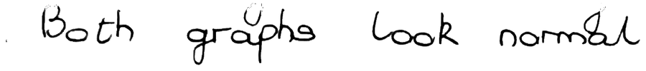
abhinav line 7
 | text | char %%
expected | Both graphs look normal.
read, joint | Both graphs look normal. | 100.0
read, scratch | , ged pge eed pged | 16.7

writer id on this crop: ink says abhinav at 100.0%, shape says abhinav at 100.0%
abhinav line 13
 | text | char %%
expected | Correlation shows a nonlinear effect
read, joint | Correlation shows a nonlinear effect | 100.0
read, scratch | pepgee, ed o peee pped | 19.4

writer id on this crop: ink says abhinav at 100.0%, shape says abhinav at 100.0%
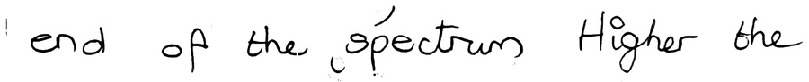
abhinav line 19
 | text | char %%
expected | end of the spectrum. Higher the
read, joint | end of the spectrum Migher the | 93.5
read, scratch | "ed of e, peee, pfe pe | 38.7

writer id on this crop: ink says abhinav at 100.0%, shape says abhinav at 99.9%
abhinav line 26
 | text | char %%
expected | of other way around). As it gets pointier.
read, joint | of other way around). As it gets pointier. | 100.0
read, scratch | oy , e ey peee , f y of pe d | 28.6

writer id on this crop: ink says abhinav at 100.0%, shape says abhinav at 99.4%

dylan, page Dylan01
dylan line 1
 | text | char %%
expected | The input to this stage is a raw photo of
read, joint | The input to this stage is a raw photo of | 100.0
read, scratch | oy s s , , ed et of | 29.3

writer id on this crop: ink says dylan at 100.0%, shape says dylan at 95.6%
dylan line 6
 | text | char %%
expected | of classical image-processing stages, not a learned
read, joint | of classical image-processing stages, not a learned | 100.0
read, scratch | of ed pey y es , t ped | 29.4

writer id on this crop: ink says dylan at 100.0%, shape says dylan at 78.3%
dylan line 12
 | text | char %%
expected | into a "below" class and an "above" class, and
read, joint | into a "below" class and an "above class, and | 97.8
read, scratch | es , ,pes , es et es es , et | 28.3

writer id on this crop: ink says dylan at 100.0%, shape says dylan at 47.8%
dylan line 18
 | text | char %%
expected | everything reachable from the image border as
read, joint | everything reachable from the image border as | 100.0
read, scratch | es ped pe y ped , | 22.2

writer id on this crop: ink says dylan at 100.0%, shape says dylan at 92.5%
dylan line 24
 | text | char %%
expected | the background estimate and rescaling. The corrected
read, joint | the background estimate and rescaling. The corrected | 100.0
read, scratch | of peed ed pet pe, pe d | 21.2

writer id on this crop: ink says dylan at 100.0%, shape says dylan at 99.5%

owen, page Owen01
owen line 1
 | text | char %%
expected | 1.9. Vloggers using fame to support charities is a positive way
read, joint | 1.9. Vloggers using fame to support charities is a positive way | 100.0
read, scratch | ,s s ped a ee , , g y | 22.2

writer id on this crop: ink says owen at 99.7%, shape says owen at 99.6%
owen line 5
 | text | char %%
expected | 1.10. I disagree with Didda, as Youtube cannot produce the money
read, joint | 1.10. I disagree with Didda, as Youtube cannot produce the money | 100.0
read, scratch | s . s s ed s ed ed pe ey | 26.6

writer id on this crop: ink says owen at 99.1%, shape says owen at 99.5%
owen line 10
 | text | char %%
expected | for a subscription, while Youtube offers a free, easily accessible
read, joint | for a subscription, while Youtube offers a free, easily accessible | 100.0
read, scratch | o , g d ed e pe , ey ee | 25.8

writer id on this crop: ink says owen at 100.0%, shape says owen at 100.0%
owen line 15
 | text | char %%
expected | while male activities are mostly sport.
read, joint | while male activities are mostly sport. | 100.0
read, scratch | o pee ges poey y , | 23.1

writer id on this crop: ink says owen at 100.0%, shape says owen at 100.0%
owen line 20
 | text | char %%
expected | very little creative categories are viewed on Youtube.
read, joint | very little creative categories are viewed on 'Youtube. | 98.1
read, scratch | ey s s d s ee . | 20.4

writer id on this crop: ink says owen at 100.0%, shape says owen at 100.0%

thiya, page Thiya01
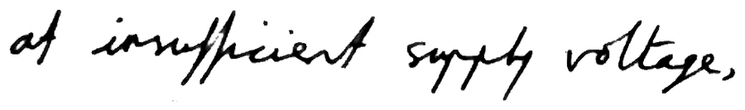
thiya line 1
 | text | char %%
expected | at insufficient supply voltage,
read, joint | of insufficient suppty voltage . | 83.9
read, scratch | oy igied pogey pege . | 25.8

writer id on this crop: ink says thiya at 99.9%, shape says thiya at 95.3%
thiya line 4
 | text | char %%
expected | power transistor may become only partially switched on.
read, joint | power transistor may become only partially switched on. | 100.0
read, scratch | poe peoides pay e ay poheg padeed a . | 34.5

writer id on this crop: ink says thiya at 100.0%, shape says thiya at 99.8%
thiya line 8
 | text | char %%
expected | above threshold but below recommended operating range.
read, joint | above threshold but below recommended operating range. | 100.0
read, scratch | agee , peley ot ehe poed plg pege , | 31.5

writer id on this crop: ink says thiya at 100.0%, shape says thiya at 96.1%
thiya line 12
 | text | char %%
expected | voltage range where the designer can't know whether the
read, joint | voltage range where the designer can't know whether the | 100.0
read, scratch | y pey ge , e go ad ee plete , he | 30.9

writer id on this crop: ink says thiya at 100.0%, shape says thiya at 94.6%
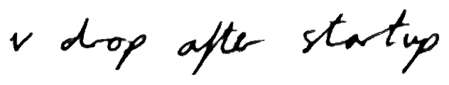
thiya line 16
 | text | char %%
expected | v drop after startup
read, joint | v drop after startup | 100.0
read, scratch | o e age he. | 25.0

writer id on this crop: ink says thiya at 99.2%, shape says thiya at 79.5%

yeukita, page Yeukita01
yeukita line 1
 | text | char %%
expected | single runs NEES is noisy, so you average over many Monte Carlo
read, joint | single runs NEES is noisy, so you average over many Monte Carlo | 100.0
read, scratch | ey es es , y s ey es e. | 23.8

writer id on this crop: ink says yeukita at 99.9%, shape says yeukita at 99.9%
yeukita line 7
 | text | char %%
expected | overconfident (bad ANEES) - meaning it doesn't know how wrong it
read, joint | overconfident (bad ANEES) - meaning it doesn't know how wrong it | 100.0
read, scratch | eeed d , aey , es peey | 18.8

writer id on this crop: ink says yeukita at 99.9%, shape says yeukita at 99.5%
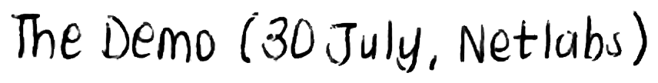
yeukita line 13
 | text | char %%
expected | The Demo (30 July, Netlabs)
read, joint | The Demo (30 July, Netlabs) | 100.0
read, scratch | g e, o a , pege , | 25.9

writer id on this crop: ink says yeukita at 99.7%, shape says yeukita at 99.8%
yeukita line 19
 | text | char %%
expected | verified your research model (ANEES & NEES)
read, joint | verified your research model (ANEES NEES) | 97.7
read, scratch | peged ps ped ed ee eed | 23.3

writer id on this crop: ink says yeukita at 99.9%, shape says yeukita at 99.8%
yeukita line 26
 | text | char %%
expected | - experimental setup (1pg) - detailed enough that someone else could
read, joint | - experimental setup (1pg) - detailed enough that someone else could | 100.0
read, scratch | a pd ,eey d es ed | 17.6

writer id on this crop: ink says yeukita at 100.0%, shape says yeukita at 100.0%

2. Real crops, all examples in one table
writer | line | expected | read, joint | char % | read, scratch | char % | ink | shape
abhinav | 1 | 1) Generating 20 000 samples in Cartesian | 1 Generating 20 000 samples in Cartesion | 95.1 | f peey a pes poed ' pepee , | 26.8 | abhinav 100.0% | abhinav 100.0%
abhinav | 7 | Both graphs look normal. | Both graphs look normal. | 100.0 | , ged pge eed pged | 16.7 | abhinav 100.0% | abhinav 100.0%
abhinav | 13 | Correlation shows a nonlinear effect | Correlation shows a nonlinear effect | 100.0 | pepgee, ed o peee pped | 19.4 | abhinav 100.0% | abhinav 100.0%
abhinav | 19 | end of the spectrum. Higher the | end of the spectrum Migher the | 93.5 | "ed of e, peee, pfe pe | 38.7 | abhinav 100.0% | abhinav 99.9%
abhinav | 26 | of other way around). As it gets pointier. | of other way around). As it gets pointier. | 100.0 | oy , e ey peee , f y of pe d | 28.6 | abhinav 100.0% | abhinav 99.4%
dylan | 1 | The input to this stage is a raw photo of | The input to this stage is a raw photo of | 100.0 | oy s s , , ed et of | 29.3 | dylan 100.0% | dylan 95.6%
dylan | 6 | of classical image-processing stages, not a learned | of classical image-processing stages, not a learned | 100.0 | of ed pey y es , t ped | 29.4 | dylan 100.0% | dylan 78.3%
dylan | 12 | into a "below" class and an "above" class, and | into a "below" class and an "above class, and | 97.8 | es , ,pes , es et es es , et | 28.3 | dylan 100.0% | dylan 47.8%
dylan | 18 | everything reachable from the image border as | everything reachable from the image border as | 100.0 | es ped pe y ped , | 22.2 | dylan 100.0% | dylan 92.5%
dylan | 24 | the background estimate and rescaling. The corrected | the background estimate and rescaling. The corrected | 100.0 | of peed ed pet pe, pe d | 21.2 | dylan 100.0% | dylan 99.5%
owen | 1 | 1.9. Vloggers using fame to support charities is a positive way | 1.9. Vloggers using fame to support charities is a positive way | 100.0 | ,s s ped a ee , , g y | 22.2 | owen 99.7% | owen 99.6%
owen | 5 | 1.10. I disagree with Didda, as Youtube cannot produce the money | 1.10. I disagree with Didda, as Youtube cannot produce the money | 100.0 | s . s s ed s ed ed pe ey | 26.6 | owen 99.1% | owen 99.5%
owen | 10 | for a subscription, while Youtube offers a free, easily accessible | for a subscription, while Youtube offers a free, easily accessible | 100.0 | o , g d ed e pe , ey ee | 25.8 | owen 100.0% | owen 100.0%
owen | 15 | while male activities are mostly sport. | while male activities are mostly sport. | 100.0 | o pee ges poey y , | 23.1 | owen 100.0% | owen 100.0%
owen | 20 | very little creative categories are viewed on Youtube. | very little creative categories are viewed on 'Youtube. | 98.1 | ey s s d s ee . | 20.4 | owen 100.0% | owen 100.0%
thiya | 1 | at insufficient supply voltage, | of insufficient suppty voltage . | 83.9 | oy igied pogey pege . | 25.8 | thiya 99.9% | thiya 95.3%
thiya | 4 | power transistor may become only partially switched on. | power transistor may become only partially switched on. | 100.0 | poe peoides pay e ay poheg padeed a . | 34.5 | thiya 100.0% | thiya 99.8%
thiya | 8 | above threshold but below recommended operating range. | above threshold but below recommended operating range. | 100.0 | agee , peley ot ehe poed plg pege , | 31.5 | thiya 100.0% | thiya 96.1%
thiya | 12 | voltage range where the designer can't know whether the | voltage range where the designer can't know whether the | 100.0 | y pey ge , e go ad ee plete , he | 30.9 | thiya 100.0% | thiya 94.6%
thiya | 16 | v drop after startup | v drop after startup | 100.0 | o e age he. | 25.0 | thiya 99.2% | thiya 79.5%
yeukita | 1 | single runs NEES is noisy, so you average over many Monte Carlo | single runs NEES is noisy, so you average over many Monte Carlo | 100.0 | ey es es , y s ey es e. | 23.8 | yeukita 99.9% | yeukita 99.9%
yeukita | 7 | overconfident (bad ANEES) - meaning it doesn't know how wrong it | overconfident (bad ANEES) - meaning it doesn't know how wrong it | 100.0 | eeed d , aey , es peey | 18.8 | yeukita 99.9% | yeukita 99.5%
yeukita | 13 | The Demo (30 July, Netlabs) | The Demo (30 July, Netlabs) | 100.0 | g e, o a , pege , | 25.9 | yeukita 99.7% | yeukita 99.8%
yeukita | 19 | verified your research model (ANEES & NEES) | verified your research model (ANEES NEES) | 97.7 | peged ps ped ed ee eed | 23.3 | yeukita 99.9% | yeukita 99.8%
yeukita | 26 | - experimental setup (1pg) - detailed enough that someone else could | - experimental setup (1pg) - detailed enough that someone else could | 100.0 | a pd ,eey d es ed | 17.6 | yeukita 100.0% | yeukita 100.0%

3. Synthesised lines
Target text the gantry writes this, best of 6, one seed, rendered at 18 px/mm then read back. The same two networks score the search, so these are not an independent test of it.

150

synth 150
target | the gantry writes this
read back | the gantry urites this
char accuracy | 95.5%
word accuracy | 75.0%
writer predicted | 150 at 86.5%
confidence in the true writer | 86.5%
strokes / time | 39 / 10.3 s

151
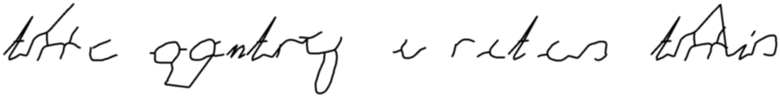
synth 151
target | the gantry writes this
read back | tc gontry arites toolis
char accuracy | 68.2%
word accuracy | 0.0%
writer predicted | 151 at 50.7%
confidence in the true writer | 50.7%
strokes / time | 36 / 15.1 s

152
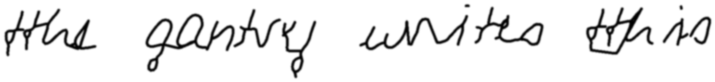
synth 152
target | the gantry writes this
read back | the gantry unites this
char accuracy | 90.9%
word accuracy | 75.0%
writer predicted | 152 at 81.9%
confidence in the true writer | 81.9%
strokes / time | 40 / 11.4 s

153
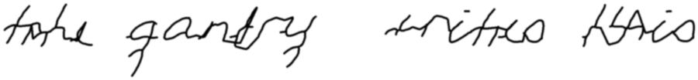
synth 153
target | the gantry writes this
read back | take anty triteo Nio
char accuracy | 59.1%
word accuracy | 0.0%
writer predicted | 153 at 47.1%
confidence in the true writer | 47.1%
strokes / time | 40 / 12.0 s

384
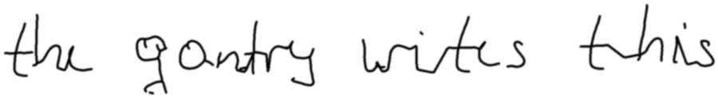
synth 384
target | the gantry writes this
read back | the gantry wites this
char accuracy | 95.5%
word accuracy | 75.0%
writer predicted | 384 at 99.4%
confidence in the true writer | 99.4%
strokes / time | 34 / 14.0 s

551
synth 551
target | the gantry writes this
read back | takc gete y whies tohirs
char accuracy | 50.0%
word accuracy | 0.0%
writer predicted | 551 at 71.6%
confidence in the true writer | 71.6%
strokes / time | 38 / 20.0 s

552
synth 552
target | the gantry writes this
read back | the gentry wites this
char accuracy | 90.9%
word accuracy | 50.0%
writer predicted | 552 at 58.8%
confidence in the true writer | 58.8%
strokes / time | 32 / 10.9 s

588
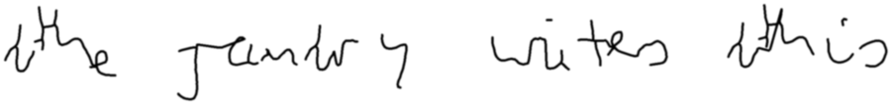
synth 588
target | the gantry writes this
read back | the runtery wites ahis
char accuracy | 77.3%
word accuracy | 25.0%
writer predicted | 588 at 65.9%
confidence in the true writer | 65.9%
strokes / time | 30 / 13.6 s

abhinav
synth abhinav
target | the gantry writes this
read back | the gontry urtites this
char accuracy | 86.4%
word accuracy | 50.0%
writer predicted | abhinav at 99.5%
confidence in the true writer | 99.5%
strokes / time | 43 / 13.3 s

dylan
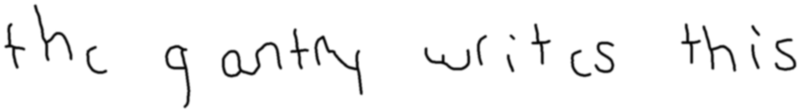
synth dylan
target | the gantry writes this
read back | the y antry writ is this
char accuracy | 81.8%
word accuracy | 50.0%
writer predicted | dylan at 82.0%
confidence in the true writer | 82.0%
strokes / time | 31 / 11.1 s

owen
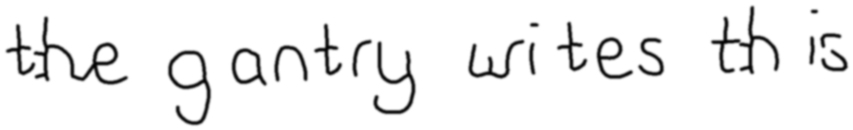
synth owen
target | the gantry writes this
read back | the gantry wites this
char accuracy | 95.5%
word accuracy | 75.0%
writer predicted | owen at 98.8%
confidence in the true writer | 98.8%
strokes / time | 36 / 10.8 s

thiya
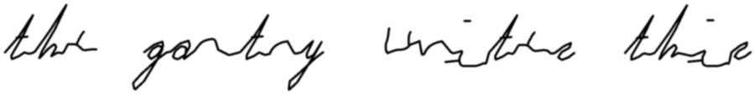
synth thiya
target | the gantry writes this
read back | thee gantry unite the
char accuracy | 72.7%
word accuracy | 25.0%
writer predicted | thiya at 94.0%
confidence in the true writer | 94.0%
strokes / time | 16 / 13.0 s

yeukita
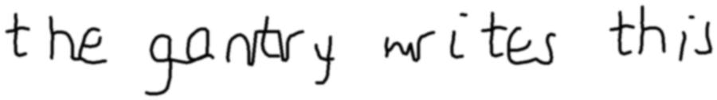
synth yeukita
target | the gantry writes this
read back | the gastery wites this
char accuracy | 86.4%
word accuracy | 50.0%
writer predicted | yeukita at 86.3%
confidence in the true writer | 86.3%
strokes / time | 27 / 9.9 s

4. Synthesised lines, all in one table
writer | target | read back | char % | word % | predicted | conf % | true conf % | strokes | s
150 | the gantry writes this | the gantry urites this | 95.5 | 75.0 | 150 | 86.5 | 86.5 | 39 | 10.3
151 | the gantry writes this | tc gontry arites toolis | 68.2 | 0.0 | 151 | 50.7 | 50.7 | 36 | 15.1
152 | the gantry writes this | the gantry unites this | 90.9 | 75.0 | 152 | 81.9 | 81.9 | 40 | 11.4
153 | the gantry writes this | take anty triteo Nio | 59.1 | 0.0 | 153 | 47.1 | 47.1 | 40 | 12.0
384 | the gantry writes this | the gantry wites this | 95.5 | 75.0 | 384 | 99.4 | 99.4 | 34 | 14.0
551 | the gantry writes this | takc gete y whies tohirs | 50.0 | 0.0 | 551 | 71.6 | 71.6 | 38 | 20.0
552 | the gantry writes this | the gentry wites this | 90.9 | 50.0 | 552 | 58.8 | 58.8 | 32 | 10.9
588 | the gantry writes this | the runtery wites ahis | 77.3 | 25.0 | 588 | 65.9 | 65.9 | 30 | 13.6
abhinav | the gantry writes this | the gontry urtites this | 86.4 | 50.0 | abhinav | 99.5 | 99.5 | 43 | 13.3
dylan | the gantry writes this | the y antry writ is this | 81.8 | 50.0 | dylan | 82.0 | 82.0 | 31 | 11.1
owen | the gantry writes this | the gantry wites this | 95.5 | 75.0 | owen | 98.8 | 98.8 | 36 | 10.8
thiya | the gantry writes this | thee gantry unite the | 72.7 | 25.0 | thiya | 94.0 | 94.0 | 16 | 13.0
yeukita | the gantry writes this | the gastery wites this | 86.4 | 50.0 | yeukita | 86.3 | 86.3 | 27 | 9.9

