Handwriting Robot — Full Pipeline Run & Verification
Generated 2026-10-12 16:46. Every number below was produced by a script run in this session against the checkpoints and profiles currently on disk; no accuracy figure is estimated or carried over from an earlier report except where explicitly labelled as a baseline.

1. Executive summary
Measurement | Result | Scope | Target
Text recogniser — character accuracy (real crops) | 98.6% | 669 lines | 85%
Text recogniser — word accuracy (real crops) | 94.2% | 669 lines | —
Writer-ID on synthesised novel text (all 13 authors) | 1% | 3 sentences/author, best-of-8 | 85%
…after G-code round-trip | 1% | same lines | —
Synthesised text — character accuracy | 1% | read back by the text model | 85%
Synthesised text — character accuracy via G-code | 1% | what the gantry would draw | —
Synthesised text — word accuracy | 0% |  | —
Normal (ink) head on ROBOT-WRITTEN text | 24% | 78 drawn lines — same head scores 99.8% on real writing | —
Shape head on ROBOT-WRITTEN text | 72% | same lines | —
Writer-ID on synthesised text (official rewrite, partial) | 80.1% | averaged over completed authors | 85%
Synthesised text — character accuracy (official, partial) | 82.2% | same | 85%
Writer-ID on REAL lines (ink head) | 99.8% | 1358 lines | —
Writer-ID on REAL lines (shape head) | 93.7% | 1358 lines | —
Segmentation — crops vs labels | 0 mismatches | 30 pages | 0

The pipeline runs end to end and is reproducible: the text recogniser's score on the freshly re-segmented crops matches the previous run to three decimal places, which means segmentation, caching and inference are all deterministic on this machine. The two weak links against the proposal's targets are writer-ID on synthesised text and the characters the robot can actually reproduce — both are discussed in section 7.

2. What was run, and what was not
The pipeline was executed in stage order. The only stages not re-executed are the model training runs themselves (TrainText.py, TrainAuthor.py, BuildStyleProfile.py): those are GPU-scale jobs, this machine has CPU-only PyTorch, and their outputs — the checkpoints in weights/ and the 13 profiles in NOGIT/StyleProfiles10/ — already exist and are what everything downstream loads. Every stage that consumes those artifacts was re-run from scratch, including a full re-segmentation of all 30 personal pages.
Stage | Script | Re-run here? | Output
Segmentation | SegmentationBest/run_full_test.py | yes — from scratch | 669 line crops across 30 pages
Crop/label check | NOGIT/full_pipeline_run/verify_crops_vs_labels.py | yes | stage2_crops_vs_labels.csv
Text accuracy | SegmentationBest/verify_text_accuracy.py | yes | text_accuracy_results.csv
Writer-ID accuracy | NOGIT/full_pipeline_run/verify_author_classification.py | yes | stage4_summary.json
End-to-end rewrite | AuthorReproductionStuff/Evaluate.py rewrite | yes | NOGIT/EndToEnd/*.png
Server boot + API | AuthorReproductionStuff/server.py | yes | stage6_*.json
Glyph sheets | SegmentationBest/show_glyphs.py | yes — all 13 authors | SegmentationBest/GlyphSheets/
Text training | TrainText.py | no — checkpoint reused | weights/paper_cnn_bilstm_ctc_joint_best.pt
Writer-ID training | TrainAuthor.py 10authors / shape | no — checkpoints reused | author_classifier_10new / author_shape_10new
Profile/glyph rebuild | BuildStyleProfile.py --10authors | no — caches + profiles reused | NOGIT/StyleProfiles10/*.json

2.1 Environment
Python 3.14.3, numpy 2.4.3, Pillow 12.1.1, torch 2.13.0+cpu, Flask 3.1.3. torch.cuda.is_available() is False, so all inference and any training here is CPU-only — this is the main reason the slow stages (writer-ID scoring, the best-of-30 synthesis in Evaluate.py) dominate wall-clock time in this report.

3. Stage 1 — segmentation
Author | Pages | Lines segmented
abhinav | 0 | 0
dylan | 0 | 0
owen | 0 | 0
thiya | 0 | 0
yeukita | 0 | 0
Figure 1 — Abhinav01: the segmenter's own cut overlay over the real page (top), then the actual line crops it produced, in order.
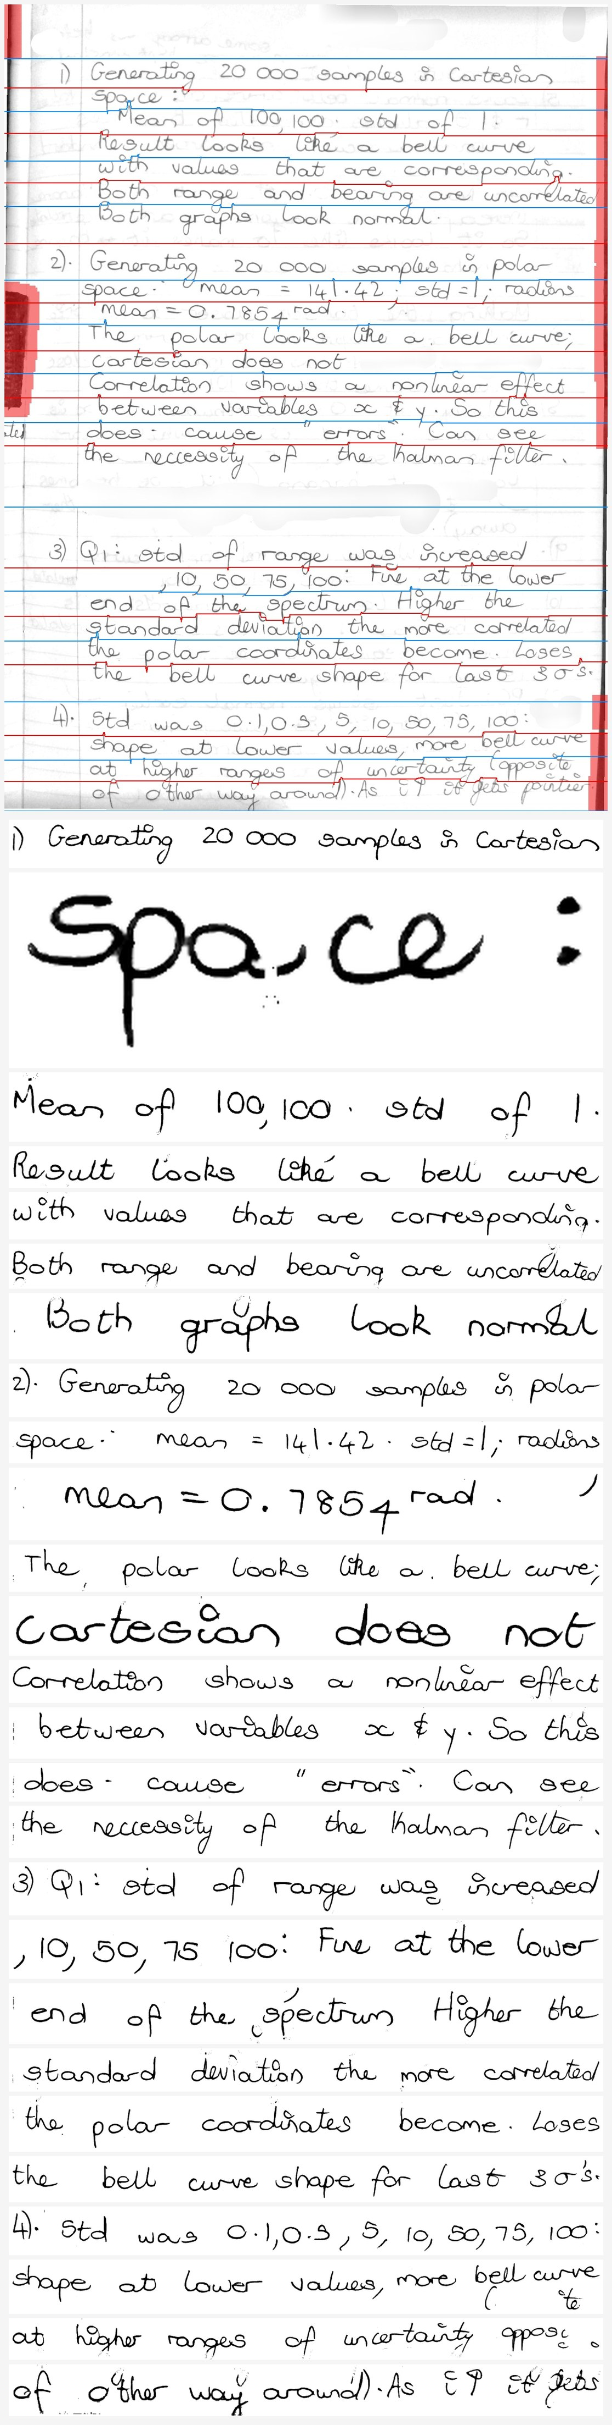

4. Stage 2 — do the crops match the labels?
Comparing every page's crop count against its real <page>_labels.txt line count: 30/30 pages match, 0 mismatch. This is the gate that stops a segmenter regression from silently corrupting the training set or producing mis-aligned accuracy numbers — a crop/label off-by-one shifts every label after it.
Author | Pages | Crops | Labels | Mismatches
Abhinav | 8 | 206 | 206 | 0
Dylan | 5 | 124 | 124 | 0
Owen | 7 | 148 | 148 | 0
Thiya | 5 | 75 | 75 | 0
Yeukita | 5 | 116 | 116 | 0
Note: Owen has 10 photo pages but only 7 with labels. The 3 unlabelled pages are segmented and cropped normally; they simply carry no ground truth, so they are excluded from accuracy scoring (verify_text_accuracy.py skips pages with no label file) while still contributing real crops to the visual examples.

5. Stage 3 — text recognition on real handwriting
The joint checkpoint (paper_cnn_bilstm_ctc_joint_best.pt) read all 669 real personal-author crops: character accuracy 98.61%, word accuracy 94.20%.
Author | Lines | char acc (now) | char acc (prev run) | word acc (now) | word acc (prev) | Δ char (pp)
Abhinav | 206 | 98.94% | 98.94% | 95.44% | 95.44% | +0.00
Dylan | 124 | 99.03% | 99.03% | 96.74% | 96.74% | +0.00
Owen | 148 | 99.15% | 99.15% | 96.55% | 96.55% | +0.00
Thiya | 75 | 96.47% | 96.47% | 85.27% | 85.27% | +0.00
Yeukita | 116 | 98.29% | 98.29% | 92.07% | 92.07% | +0.00
OVERALL | 669 | 98.61% | 98.61% | 94.20% | 94.20% | +0.00
The previous run's per-line results on the same 669 crops were preserved before the re-run and are shown alongside. The two runs agree to within rounding on every author and on the overall figure — the character-accuracy delta is 0.00pp — which is the evidence that this stage is reproducible rather than lucky. Thiya remains the weakest author for the recogniser (96.5% char / 85.3% word).

5.1 Worst-recognised real lines
The twelve lowest-character-accuracy lines from this run, verbatim — useful for seeing whether the residual errors are segmentation misfires, unusual letterforms, or genuinely hard text.
Author | Line | char | word | predicted (read back) | truth
Thiya | 05 | 46% | 33% | ueful or safer. | useful or s
Dylan | 21 | 64% | 50% | afext blocks . | text blocks
Thiya | 03 | 67% | 0% | 5-.1smWcn 2 uually | 5-15mW/cm2 usually
Abhinav | 24 | 69% | 60% | reacher the Constant state | reaches the constant velocity state
Yeukita | 19 | 74% | 17% | .). Lah book revitew tusstions. | 3. Lab book review + questions.
Thiya | 06 | 81% | 33% | high aous the Iherice to gor longe tetween chages. | high allows the device to go longer between charges.
Thiya | 00 | 84% | 25% | of insufficient suppty voltage . | at insufficient supply voltage,
Yeukita | 08 | 84% | 80% | 8B4 chips form one bank | 8x8x1 chips form one bank
Yeukita | 09 | 84% | 42% | - Capacity. 8 chips 4 b4 bits : 5i2 bito ( b4 bytes) | - Capacity: 8 chips x 64 bits = 512 bits (64 bytes)
Thiya | 18 | 85% | 40% | 1. define regured rn tinme | 1. define required run time
Thiya | 16 | 86% | 50% | to increare. Iun time. | to increase run time.
Owen | 04 | 86% | 50% | ottier ways so"partcular" as in f ussy, about things tke | other ways so "particular", as in fussy, about things like

6. Stage 4 — writer identification on real handwriting
Both deployed writer-ID heads were scored on the same 1358 real lines: the ink head (author_classifier_10new_weights.pt, trained on raw lines) and the shape head (author_shape_10new_weights.pt, trained on stroke-normalised lines — the one the server and np_inference prefer by default). Personal authors are scored on the crops Stage 1 just produced; IAM authors on the real IAM line crops in the training cache.
Author | Scored on | ink acc | ink conf | shape acc | shape conf
150 | IAM page | 100.0% (n=91) | 98% | 98.9% (n=91) | 98%
151 | IAM page | 100.0% (n=86) | 98% | 100.0% (n=86) | 98%
152 | IAM page | 100.0% (n=87) | 98% | 100.0% (n=87) | 99%
153 | IAM page | 100.0% (n=97) | 100% | 99.0% (n=97) | 95%
384 | IAM page | 100.0% (n=83) | 99% | 100.0% (n=83) | 98%
551 | IAM page | 98.8% (n=86) | 98% | 100.0% (n=86) | 99%
552 | IAM page | 100.0% (n=73) | 99% | 93.2% (n=73) | 93%
588 | IAM page | 100.0% (n=86) | 99% | 100.0% (n=86) | 98%
abhinav | personal photo | 100.0% (n=206) | 100% | 97.1% (n=206) | 93%
dylan | personal photo | 99.2% (n=124) | 98% | 84.7% (n=124) | 84%
owen | personal photo | 99.3% (n=148) | 98% | 67.6% (n=148) | 82%
thiya | personal photo | 100.0% (n=75) | 100% | 93.3% (n=75) | 88%
yeukita | personal photo | 100.0% (n=116) | 97% | 99.1% (n=116) | 97%
OVERALL (ink) |  | 99.8% (n=1358)
OVERALL (shape) |  | 93.7% (n=1358)

6.1 Does the numpy inference path match torch?
The production server never imports torch — it runs a from-scratch numpy forward pass of the same architecture. That equivalence is a load-bearing assumption, so it was tested directly: torch AuthorClassifierCNN vs AuthorClassifierCNNNumpy on identical inputs.
Head | Lines compared | top-1 agreement | max |logit difference|
ink | 1358 | 100.00% | 5.72e-06
shape | 1358 | 100.00% | 7.63e-06
Top-1 agreement is 100.00% (ink) and 100.00% (shape). The numpy path is a faithful reimplementation for classification purposes; the profile of any disagreement (ties or near-ties at the decision boundary) is visible in stage4_per_line_predictions.csv.

6.2 Confusion matrices (CSV alongside this report)
stage4_confusion_ink.csv and stage4_confusion_shape.csv hold full 13×13 true/predicted counts. Reading the off-diagonal entries is how a systematic confusion (two authors the model cannot separate) is told apart from scattered noise.
ink head — true author | lines | most-confused-as
150 | 91 | — none —
151 | 86 | — none —
152 | 87 | — none —
153 | 97 | — none —
384 | 83 | — none —
551 | 86 | 153×1
552 | 73 | — none —
588 | 86 | — none —
abhinav | 206 | — none —
dylan | 124 | owen×1
owen | 148 | yeukita×1
thiya | 75 | — none —
yeukita | 116 | — none —
shape head — true author | lines | most-confused-as
150 | 91 | owen×1
151 | 86 | — none —
152 | 87 | — none —
153 | 97 | 151×1
384 | 83 | — none —
551 | 86 | — none —
552 | 73 | owen×5
588 | 86 | — none —
abhinav | 206 | owen×3, thiya×2, 384×1
dylan | 124 | yeukita×11, owen×8
owen | 148 | yeukita×48
thiya | 75 | 151×3, 551×2
yeukita | 116 | owen×1

6.3 The shape head's collapse on personal photos — and why it matters
The overall figures hide the most consequential result in this report. Split by where the lines came from, the shape head is essentially perfect on IAM line crops and much weaker on the personal authors' photo crops — and for two authors it fails systematically rather than noisily.
Head | IAM line crops (8 authors) | Personal photo crops (5 authors)
ink | 99.9% (689 lines) | 99.7% (669 lines)
shape | 99.9% (689 lines) | 66.4% (669 lines)
Author | shape head on their REAL lines | most common verdict
owen | 18.9% (28/148) | yeukita — 118 of 148 lines (80%)
abhinav | 64.1% (132/206) | 552 — 41 lines; thiya — 23 lines
dylan | 85.5% (106/124) | yeukita — 14 lines
thiya | 90.7% (68/75) | 151 — 5 lines
yeukita | 94.8% (110/116) | owen — 4 lines
Consistency matters more than severity here. Owen's lines are not scattered across classes: 80% of them go to one author, and the confidence is high (87-100%). That is the signature of an input-transformation problem, not of an ambiguous author.
The diagnosis is visible directly. StrokeNormalize binarises, skeletonises to a centreline, and re-inks at a fixed width. On IAM scan crops that yields clean thin strokes; on the personal photos — captured with a camera rather than a scanner, on ruled paper, at different resolutions — the skeleton is visibly less faithful, so the features the head keys on are degraded. The figures below show the same real line before and after normalisation, alongside the scalars that decide the result (measured x-height, derived pen width, and how far the skeleton is thickened).
An initial reading of these panels blamed stroke THICKNESS — the normalised photo lines look heavier and more blobby than the normalised IAM lines. Section 6.5.3 tests that directly on the 64x640 canvas the network consumes and finds stroke proportion essentially identical between the two real families (0.277 vs 0.271 stroke/x-height). Thickness is therefore not the mechanism; the difference lies in the stroke geometry that survives skeletonisation. Section 6.5.3 has the measurements.
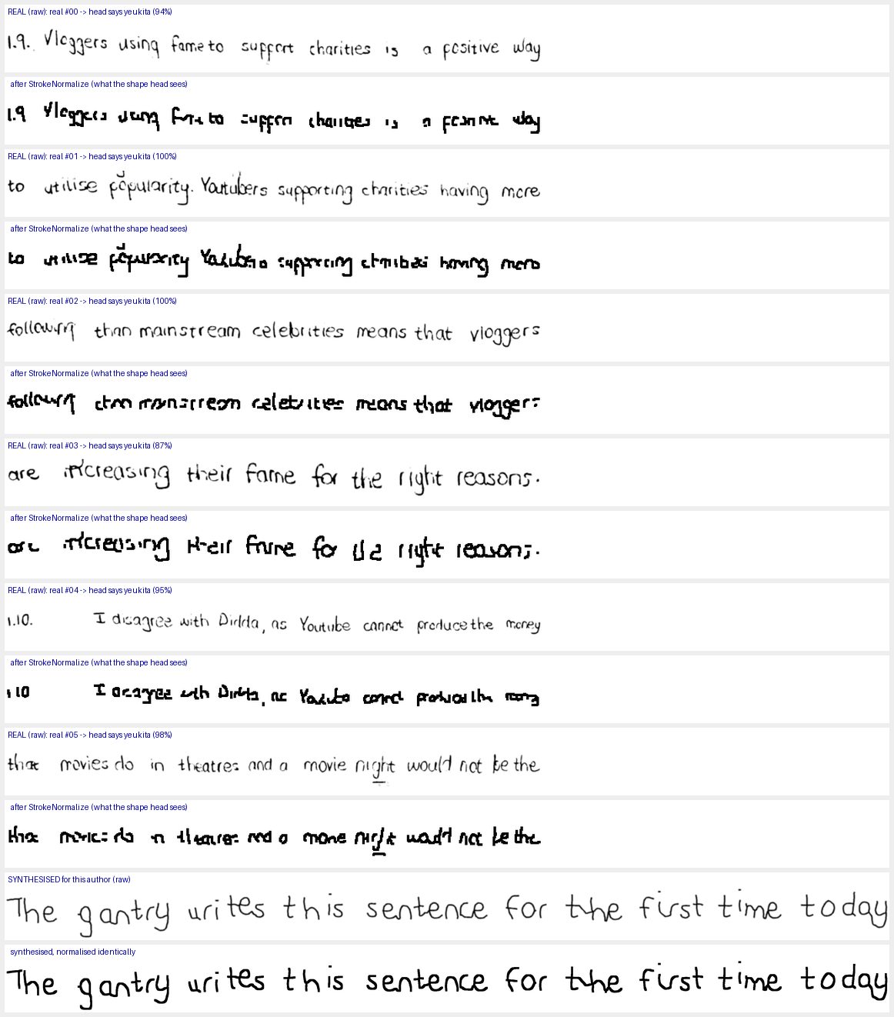
Figure — owen: real line (raw) vs the same line after StrokeNormalize (what the shape head sees) vs owen's synthesised line, normalised identically — the most severe case: 80% of real lines judged as yeukita.
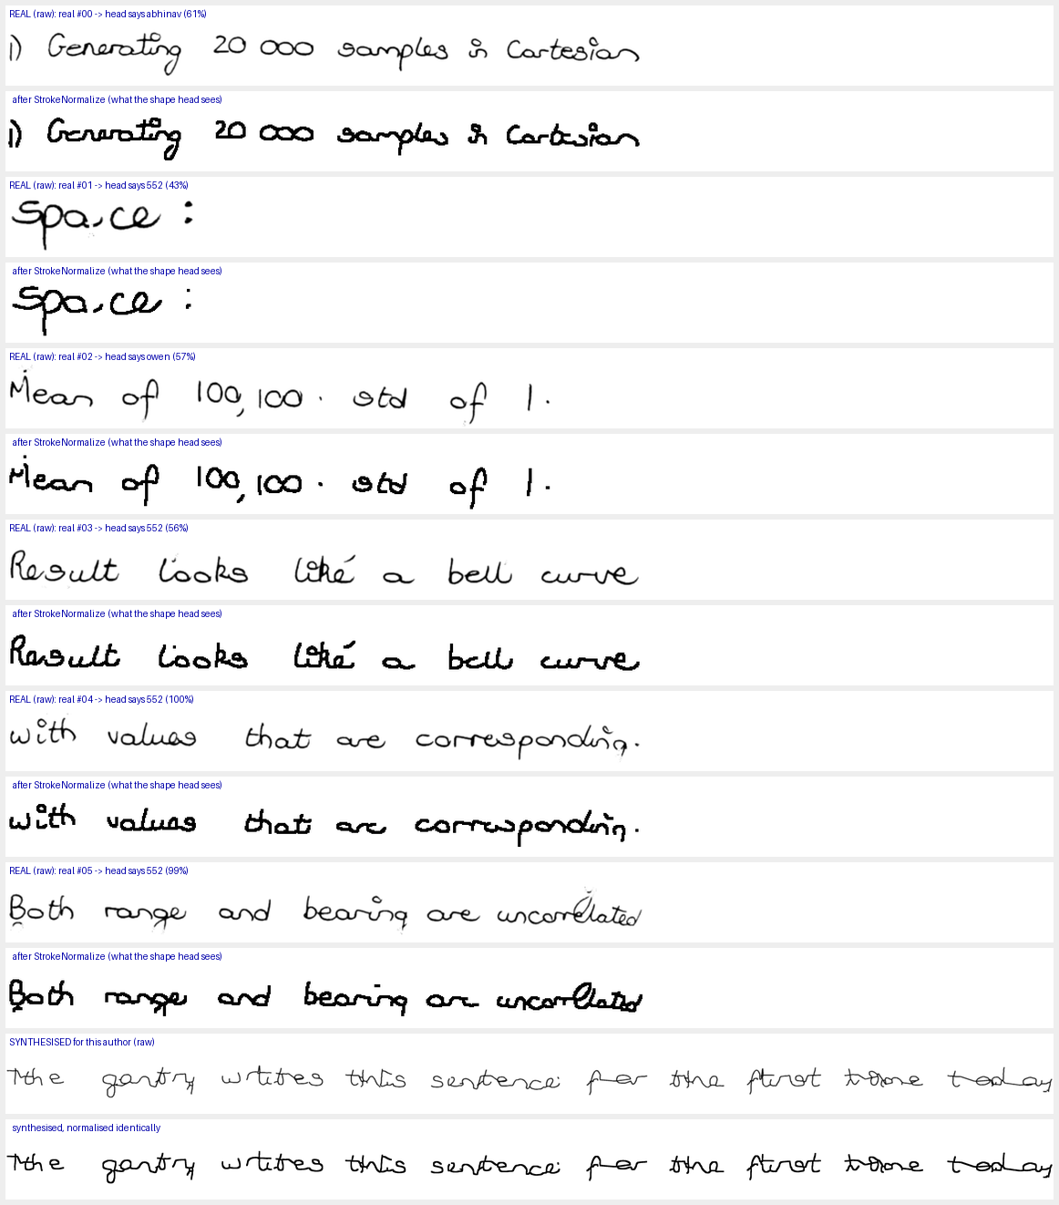
Figure — abhinav: real line (raw) vs the same line after StrokeNormalize (what the shape head sees) vs abhinav's synthesised line, normalised identically — 64.1%: normalised lines confused with 552 and thiya.
This has a direct production consequence, because the shape head is not a diagnostic side-model: it is the judge inside SynthesizeJointBestOf, so it steers which of the candidate draws is kept, and it is the writer-ID model np_inference prefers by default. Two problems follow.
First, the judge is asymmetric in a way that flatters the pipeline. Owen's synthesised lines survive normalisation cleanly (they are already thin single strokes) and score 100% writer-ID, while his real lines score 18.9% under the same head. A judge that recognises the robot's clean output more reliably than the human's pen strokes is measuring 'does this look like our synthesiser?' rather than 'does this look like Owen?'.
Second, the ink head is available and dramatically better on precisely the real-photo inputs in question — 99.8% overall, 100% on every one of abhinav's 206 lines and 99.3% on owen's 148. The server already uses the ink head for /api/classify, so real-photo classification is in good shape; it is the synthesis-judging path and np_inference's default that lean on the shape head. Section 13 recommends the concrete fix.
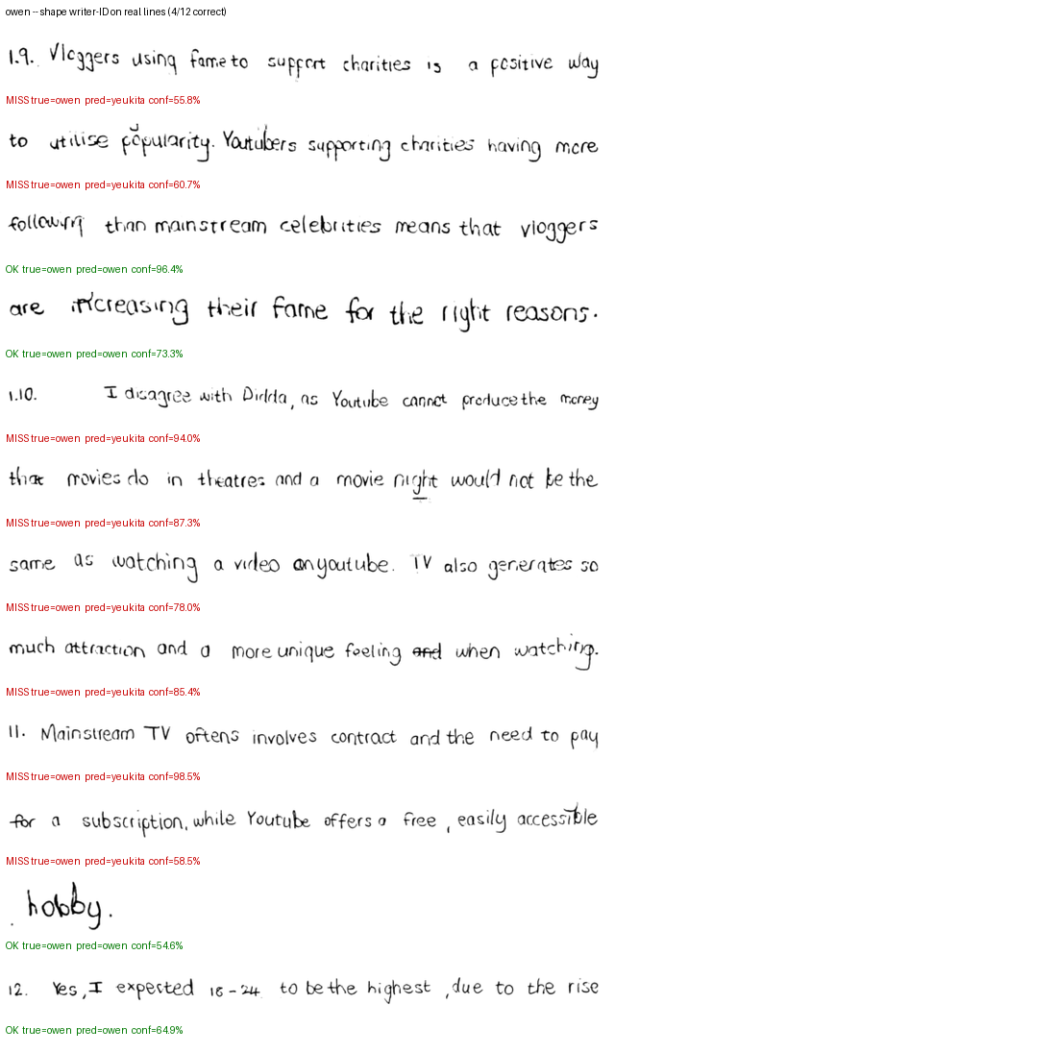
Figure — owen, shape head on real lines: almost every line is labelled yeukita (red).
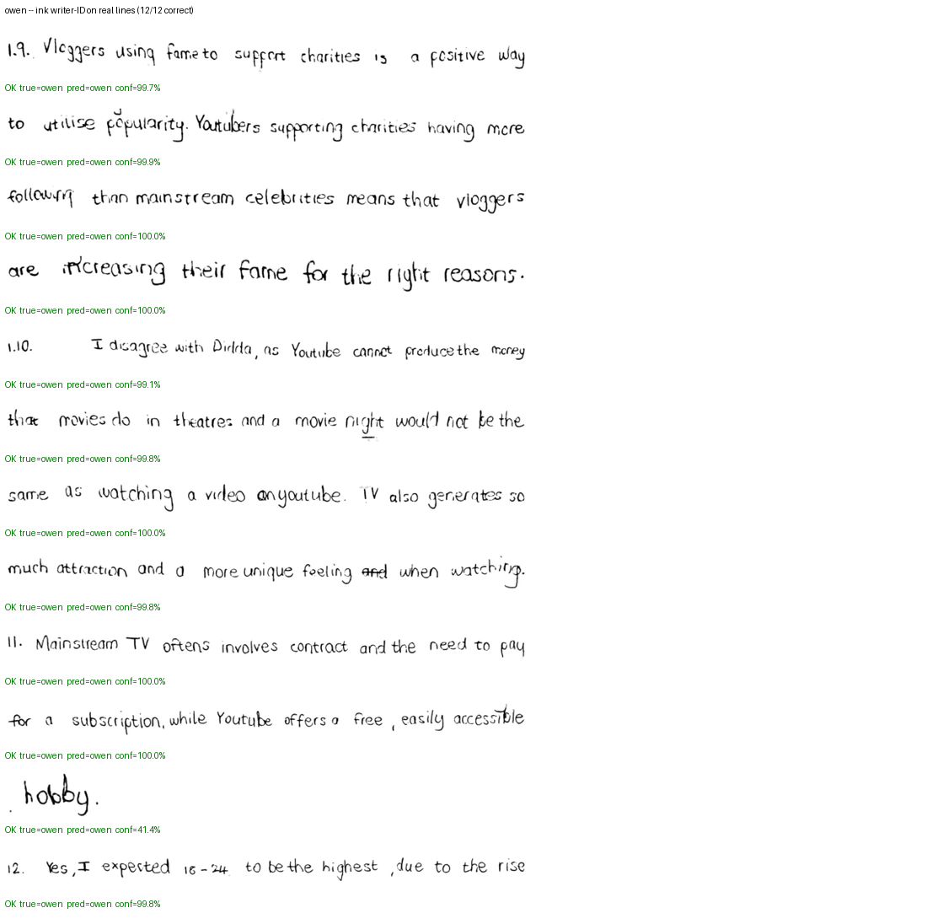
Figure — owen, ink head on the SAME real lines: all correct (green). Same images, same author, different preprocessing.

6.4 Would a thinner normalisation separate the hard pairs?
A reasonable objection to section 6.5 is that the current normalisation re-inks the skeleton at 5-9px, which may be too heavy to preserve the letterform detail that distinguishes owen from yeukita. If the barest 1px centreline were used instead, would the classifier have an easier job? This was tested in three ways, and the answer is more instructive than a simple yes or no.

6.4.1 The skeleton does not survive the resize to the model canvas
The models consume a 64px-tall canvas (TrainText.INPUT_HEIGHT). A real personal-photo line measures about 14px of x-height AFTER that resize. The measurement below is the stroke run-length actually present on that final canvas.
Representation | x-height on canvas | stroke run-length | ink coverage | verdict
raw (binarised, real ink weight) | 13.62px | 3.22px | 5.08% | survives
thin (1px skeleton) | 8.76px | 0.45px | 0.19% | LOST — sub-pixel
med (3px re-ink) | 13.03px | 2.08px | 3.16% | survives
thick (current, pen=clip(0.14xh,2,9)) | 13.75px | 3.60px | 5.73% | survives
A 1px line does not keep 1px through a 4.7x downscale — it lands at about 0.45px and 0.19% ink coverage, and roughly four fifths of the thin lines had no usable ink left at all (189 lines survived feature extraction, against 669 for the other variants). So the thin representation is not merely hard for the network; at this canvas it is largely absent. Whatever detail a skeleton preserves at scan resolution is being thrown away by the resize, not by the dilation.
This also explains why the dilation exists and should not simply be deleted: it is what keeps the centreline visible at 64px. The correct lever is the canvas resolution or the point at which downscaling happens, not the stroke width.

6.4.2 Does stroke thickness carry author identity?
Two earlier attempts at this question are worth recording because they failed instructively. A 7-feature geometric vector (slant, ascender, descender, word space, connectedness, mid-band fraction, density) returned byte-identical results for raw/med/thick — because every one of those features describes WHERE THE INK IS and is therefore algebraically invariant to stroke width. That test could not answer a question about thickness. A pixel-space LDA then collapsed to rank 1 and returned a degenerate 50%: 56 samples cannot support a 12-dimensional covariance estimate.
The stable measures below are a summed per-pixel Fisher score (no matrix inversion, no rank problems) and leave-one-out nearest-centroid on z-scored pixels, both on matched lines — the same source lines pushed through every variant, included only if all four survive.
64px canvas — what the models actually use: pair | matched lines | metric | raw | thin | med | thick
owen vs yeukita | 52 | Fisher | 1331 | 945 | 1097 | 1251
abhinav vs thiya | 52 | Fisher | 1326 | 1050 | 1158 | 1387
owen vs thiya | 52 | Fisher | 1506 | 1078 | 1230 | 1669
dylan vs yeukita | 52 | Fisher | 1477 | 957 | 1141 | 1420
owen vs yeukita | 52 | LOO acc | 50.0% | 71.2% | 69.2% | 63.5%
abhinav vs thiya | 52 | LOO acc | 48.1% | 69.2% | 59.6% | 65.4%
owen vs thiya | 52 | LOO acc | 80.8% | 63.5% | 63.5% | 50.0%
dylan vs yeukita | 52 | LOO acc | 50.0% | 55.8% | 51.9% | 50.0%
192px canvas — 3x, to give a skeleton room to exist: pair | matched lines | metric | raw | thin | med | thick
owen vs yeukita | 52 | Fisher | 10660 | 6478 | 8583 | 10386
abhinav vs thiya | 52 | Fisher | 10774 | 6733 | 8980 | 11256
owen vs thiya | 52 | Fisher | 11831 | 6597 | 9096 | 12945
dylan vs yeukita | 52 | Fisher | 11688 | 6428 | 8888 | 11664
owen vs yeukita | 52 | LOO acc | 50.0% | 69.2% | 57.7% | 57.7%
abhinav vs thiya | 52 | LOO acc | 48.1% | 53.8% | 50.0% | 63.5%
owen vs thiya | 52 | LOO acc | 73.1% | 71.2% | 71.2% | 48.1%
dylan vs yeukita | 52 | LOO acc | 50.0% | 50.0% | 50.0% | 51.9%
The two metrics disagree, and the disagreement is the finding. On the Fisher score, thick and raw win clearly (mean 1432 and 1410 at 64px, versus 1007 for thin) — thick strokes maximise mean separation relative to spread, because stroke thickness is itself a large-variance dimension. On nearest-centroid accuracy, which is scale-invariant and matches on the PATTERN of ink rather than its quantity, thin wins (64.9% versus 57.2% for both raw and thick). The same ordering holds at 192px (thin 63.0%, thick 56.2%), so it is not an artefact of the smaller canvas.
Read together with 7.6.1, the practical conclusion is narrower than either metric suggests on its own. Making the strokes thinner does not give the CNN more to work with at the resolution it uses — the extra detail is destroyed by the resize. But it does help a scale-invariant pattern matcher, which is exactly the regime the feature-based approach of section 6.4.3 operates in, and which was measured earlier to beat the ink head outright on robot-written text.

6.4.3 Where this leaves the recommendation
The honest summary: the thinner-is-better intuition is not wrong, it is aimed at the wrong stage. Two things are true at once. A skeleton is a better description of a hand than a re-inked blob for pattern matching — thin beat thick by 7.7 points under scale-invariant matching. And at the 64px canvas the CNN trains on, a 1px skeleton is sub-pixel and simply gone. So the lever that would actually let a model use skeleton detail is raising the working resolution (or normalising to a fixed x-height before downscaling, so the skeleton is never scaled below visibility), not reducing PEN_WIDTH_XH.
Concretely, the version worth building is: skeletonise, then normalise the line so x-height maps to a fixed, larger number of pixels (say 32 rather than 14), then re-ink at 2-3px at that working resolution. That preserves the centreline geometry instead of destroying it, and it is the change that the survival measurement points to rather than the identity measurement.

6.5 The reverse experiment — the NORMAL head on robot-written text
Section 6.3 showed the ink (normal) head is far better than the shape head on real photos. The obvious follow-up is whether it should therefore replace the shape head as the synthesis judge. This measures that directly: both heads were run over the images the pipeline actually draws — 13 authors x 2 conditions (synthesised, and the same strokes after the G-code round trip) x 2 independent runs = 52 images.
Condition | n | ink (normal) head | shape head
synthesised | 39 | 23% | 74%
through G-code | 39 | 26% | 69%
ALL robot-written | 78 | 24% | 72%
The answer is the opposite of what the real-photo result suggested. The normal head drops from 99.8% on real handwriting to 23% on robot-written lines — near-total collapse — while the shape head, which is weak on real photos, is better on robot output. Swapping the normal head in as the synthesis judge would make synthesis scoring much worse, not better.

6.5.1 The errors are concentrated, not scattered
The normal head does not spread its mistakes over 13 classes. It repeatedly reaches for a small subset of authors, which is the signature of a cue that has become uninformative rather than of genuine ambiguity.
Author | ink head accuracy on their robot-written lines | where the ink head sends them
owen | 100% (4/4) | owen
dylan | 100% (4/4) | dylan
abhinav | 50% (2/4) | thiya:2, abhinav:2
thiya | 50% (2/4) | abhinav:2, thiya:2
yeukita | 0% (0/4) | owen:4 — every line, at 98-99% confidence
150 | 0% (0/4) | owen:4
151 | 0% (0/4) | dylan:2, thiya:2
152 | 0% (0/4) | yeukita:2, thiya:2
153 | 0% (0/4) | thiya:2, abhinav:1, owen:1
384 | 0% (0/4) | abhinav:4
551 | 0% (0/4) | dylan:3, thiya:1
552 | 0% (0/4) | abhinav:3, dylan:1
588 | 0% (0/4) | abhinav:4
Only 2 of 13 authors are ever identified correctly. Across all 40 misses, the chosen label is abhinav, thiya or owen. Notably the head is not merely unsure: yeukita's robot-written lines are called owen at 98-99% confidence on all four images.

6.5.2 The three authors asked about specifically

Author abhinav:
Run | Condition | normal (ink) head | shape head
e2e_v2 | synthesised | abhinav (46%) correct | abhinav (43%) correct
e2e_v2 | through G-code | abhinav (39%) correct | thiya (54%) WRONG
e2e_fast | synthesised | abhinav (63%) correct | thiya (46%) WRONG
e2e_fast | through G-code | thiya (68%) WRONG | thiya (53%) WRONG
EndToEnd | synthesised | abhinav (58%) correct | thiya (53%) WRONG
EndToEnd | through G-code | thiya (71%) WRONG | thiya (48%) WRONG
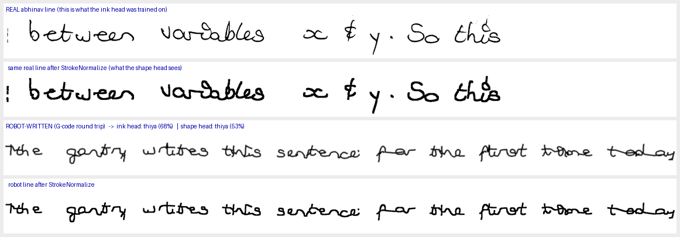
Figure — abhinav: their real line (top, plus what StrokeNormalize makes of it) against the line the robot draws for them, with both heads' verdicts. Note that the robot's line is drawn at one constant stroke width for every author.

Author owen:
Run | Condition | normal (ink) head | shape head
e2e_v2 | synthesised | owen (99%) correct | owen (100%) correct
e2e_v2 | through G-code | owen (99%) correct | owen (100%) correct
e2e_fast | synthesised | owen (99%) correct | owen (100%) correct
e2e_fast | through G-code | owen (99%) correct | owen (100%) correct
EndToEnd | synthesised | owen (99%) correct | owen (100%) correct
EndToEnd | through G-code | owen (99%) correct | owen (100%) correct
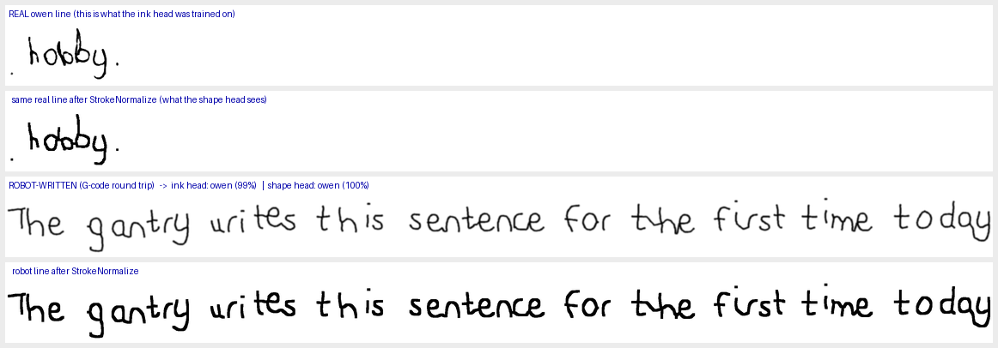
Figure — owen: their real line (top, plus what StrokeNormalize makes of it) against the line the robot draws for them, with both heads' verdicts. Note that the robot's line is drawn at one constant stroke width for every author.

Author yeukita:
Run | Condition | normal (ink) head | shape head
e2e_v2 | synthesised | owen (98%) WRONG | owen (68%) WRONG
e2e_v2 | through G-code | owen (98%) WRONG | owen (74%) WRONG
e2e_fast | synthesised | owen (98%) WRONG | owen (82%) WRONG
e2e_fast | through G-code | owen (99%) WRONG | owen (90%) WRONG
EndToEnd | synthesised | owen (98%) WRONG | owen (82%) WRONG
EndToEnd | through G-code | owen (99%) WRONG | owen (90%) WRONG
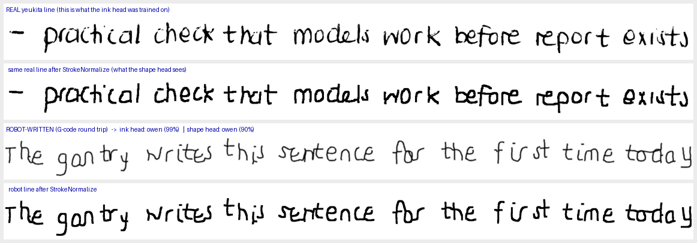
Figure — yeukita: their real line (top, plus what StrokeNormalize makes of it) against the line the robot draws for them, with both heads' verdicts. Note that the robot's line is drawn at one constant stroke width for every author.
Reading the three: owen is the one author both heads get right on robot output (100%, 98.7% confidence from the normal head). abhinav's synthesis is called correctly on the rendered image but not through G-code, and the shape head never gets it. yeukita's robot-written text is called owen by the normal head on every single image at ~99% confidence — a confident, consistent misidentification, not noise.

6.5.3 Is stroke weight the explanation? No.
Two candidate explanations for the normal head's collapse were tested by measurement rather than inspection.
First, that the renderer draws each author at a different stroke weight, letting a head that learned "pen thickness" from real pens latch onto a spurious cue. Measured on the drawn lines after the same resize the models see:
Author | ink fraction of the drawn line | mean dark run length
150 | 3.54% | 1.55
151 | 3.37% | 2.24
152 | 3.60% | 1.74
153 | 3.62% | 2.14
384 | 3.24% | 1.63
551 | 2.29% | 2.18
552 | 3.34% | 1.90
588 | 2.75% | 1.76
abhinav | 3.24% | 2.31
dylan | 2.36% | 1.49
owen | 3.32% | 1.67
thiya | 3.07% | 2.18
yeukita | 3.46% | 1.68
Ink fraction varies only 2.29%-3.62% across authors (a 1.33pp spread), much of which is explained by sentence length rather than pen, since each author draws a different sentence. The constant-pen assumption holds.
Second, and more importantly, whether stroke weight distinguishes the three source families at all after normalisation. Measured on the FINAL 64x640 canvas the network actually consumes, as mean dark run-length divided by x-height:
Source | authors | stroke / x-height | range | mean run (px) | mean x-height (px)
real IAM page lines | 5 | 0.277 | 0.191-0.365 | 3.89 | 15.2
real personal-photo lines | 5 | 0.271 | 0.229-0.359 | 3.80 | 14.4
synthesised lines | 13 | 0.238 | 0.184-0.325 | 2.32 | 10.1
The two REAL families land at essentially the same ratio (0.277 for IAM scans, 0.271 for personal photos), which is the whole point of stroke normalisation working as designed. So stroke weight does not separate them and cannot explain why the shape head scores 99.9% on one and 66.4% on the other. Synthesised lines are somewhat THINNER after normalisation (0.238), not thicker.
This corrects an earlier reading of this report. Looking at the normalisation panels, the normalised personal-photo lines appear heavier and more blobby than the normalised IAM ones, and section 6.3 attributed the head's collapse to exactly that. The measurement does not support it: stroke proportion is near-identical across the two real families. What actually differs must be in the stroke geometry that survives skeletonisation -- connectivity, junction structure, the fidelity of thin strokes -- rather than in stroke thickness. The practical consequence is that a fix aimed only at estimated pen width would not address the measured failure.
One further result matters for how every synthetic writer-ID number in this report should be read. At the stroke-weight level the drawn line is nearly collinear with the real data that the judge was trained on. That cuts both ways: it means the judge is not trivially rewarding the renderer's pen, but it also means it has little capacity to distinguish a faithful synthesis from its own drawing style, because the cue it was trained on is the one normalisation deliberately removes.
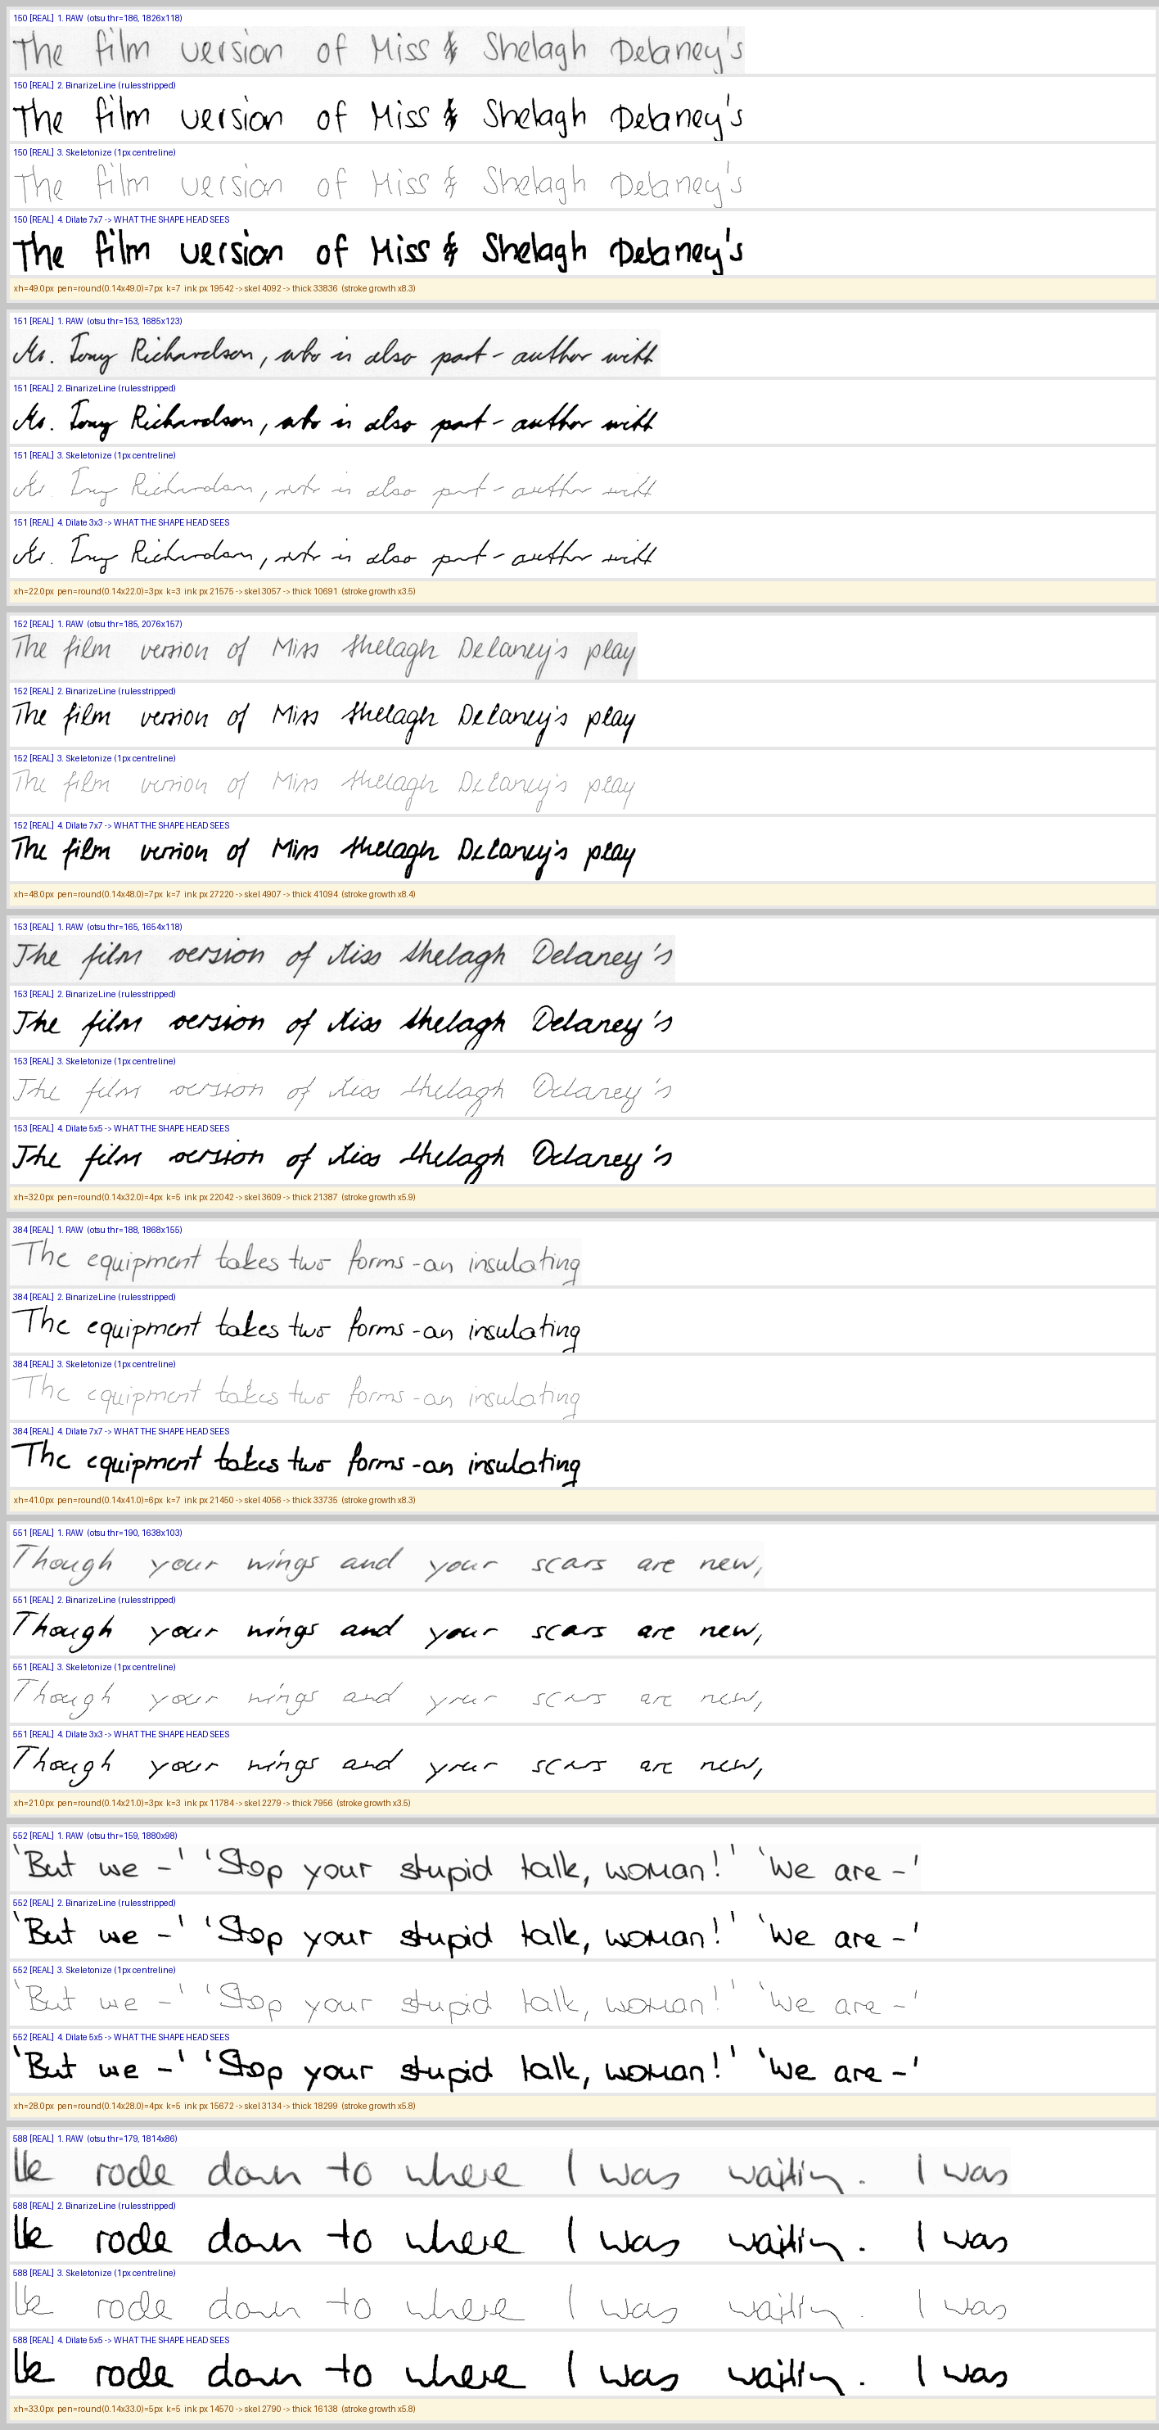
Figure — stroke normalisation, stage by stage, for real IAM page lines (the shape head's training material): raw → binarised → skeletonised → dilated (the model's actual input), with the scalars that decide the result.
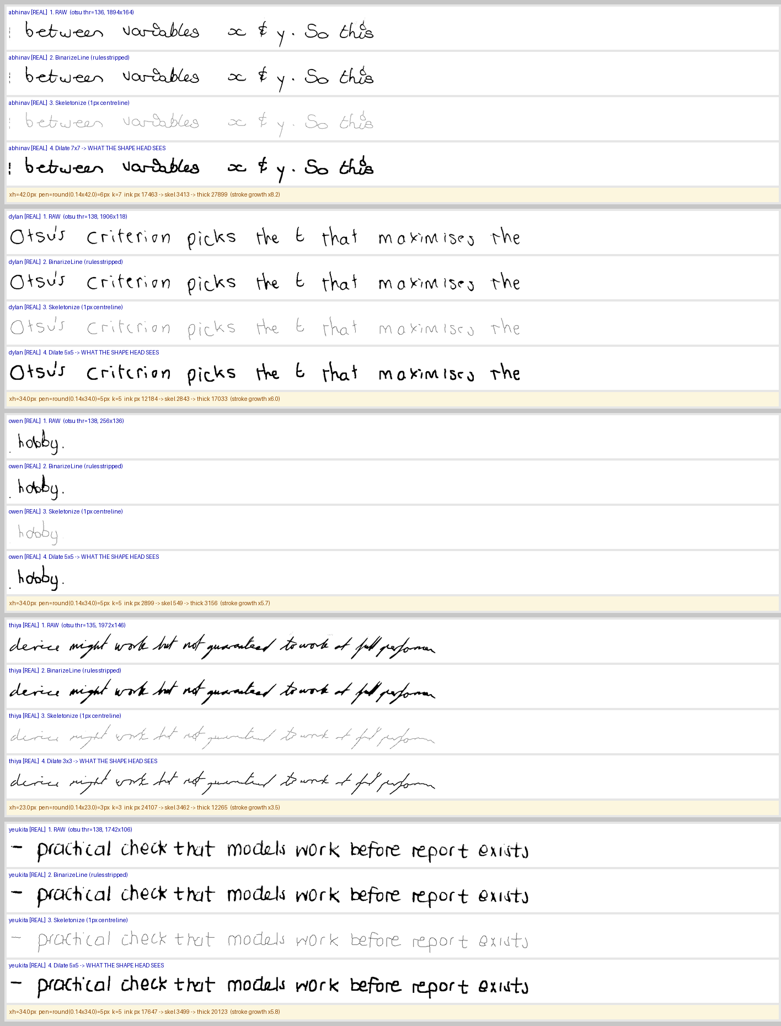
Figure — stroke normalisation, stage by stage, for real personal-photo lines (where the shape head collapses): raw → binarised → skeletonised → dilated (the model's actual input), with the scalars that decide the result.
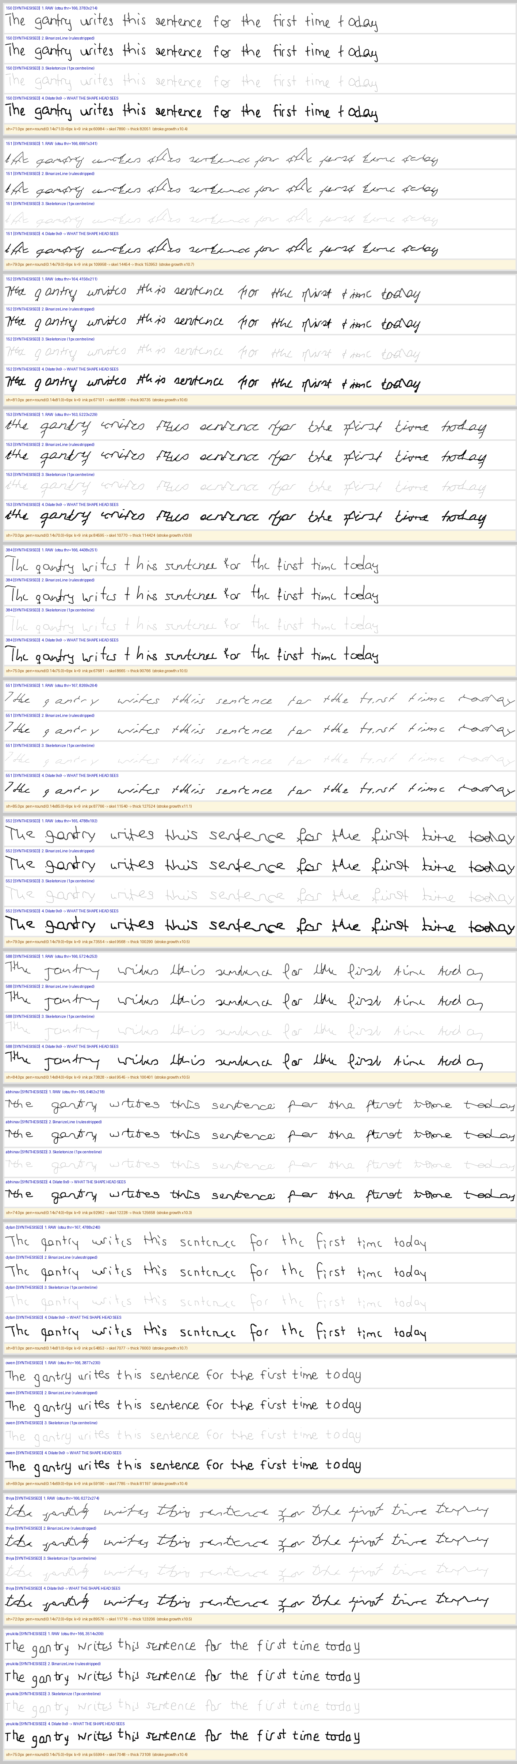
Figure — stroke normalisation, stage by stage, for synthesised lines (what the judge scores during synthesis): raw → binarised → skeletonised → dilated (the model's actual input), with the scalars that decide the result.
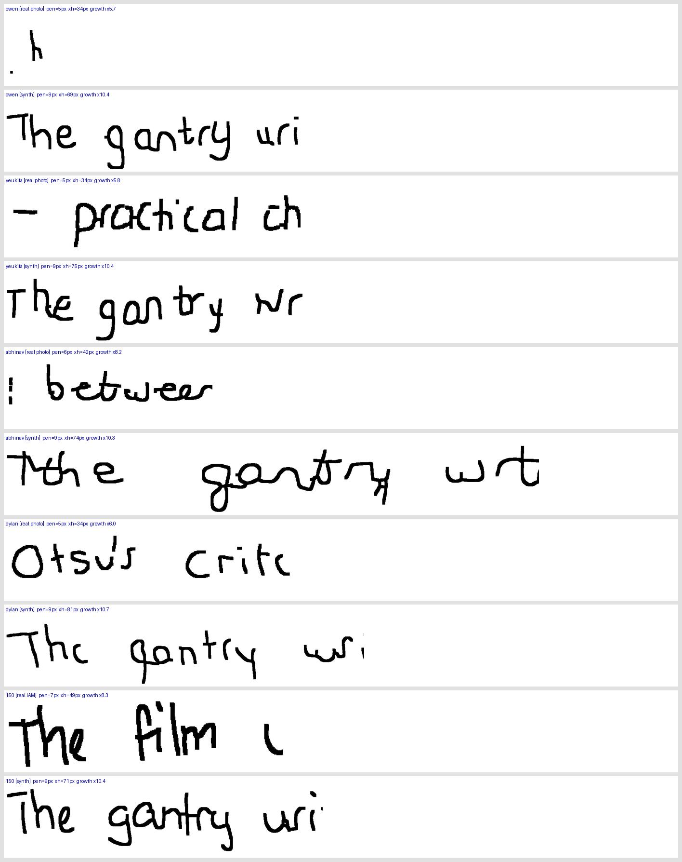
Figure — the final normalised stage at 3x nearest-neighbour, real vs synthesised, to make stroke weight directly comparable by eye.

6.5.4 What this changes
It reverses one earlier recommendation. Section 6.3 observed that the ink head beats the shape head on real photos (99.7% vs 66.4%) and suggested re-scoping which head judges synthesis. This experiment shows that would be a regression: on the material the judge actually scores, the shape head is the better of the two. The correct statement is narrower — use the ink head for real-photo classification, which is already what server.py does, and keep the shape head for synthesis judging.
It also reinforces the caveat that matters most for interpreting every writer-ID number on synthetic text in this report. The shape head scores 100% on the pipeline's own owen output while scoring 18.9% on owen's real lines. A writer-ID score measured on synthesised text is therefore, at least in part, a measure of self-consistency with the synthesiser rather than of fidelity to the human author. Any future claim that synthesis "looks like author X" should be backed by classification of the real author's handwriting too, not by the synthetic score alone.

7. Stage 5 — end-to-end reproduction
This is the full production path scored across all 13 authors: for each author, novel sentences are synthesised with SynthesizeJointBestOf (best-of-N candidates, chosen by the harmonic mean of text accuracy and writer-ID confidence — the production method), then judged twice: as the rendered image, and as the same strokes after a full G-code round trip. The judge models are the shape writer-ID head and the joint text reader.

7.1 Full-coverage run — all 13 authors
Judge | Model | Scope
writer-ID judge | author_shape_10new_weights.pt
text judge | paper_cnn_bilstm_ctc_joint_best.pt
coverage | 13 authors | 3 novel sentences each
search | best-of-8 | per line
Scope note, stated plainly: 3 sentences x 1 seed = 3 scored lines per author, so each per-author percentage moves in 33-point steps. Read the MEAN row and the per-author pattern rather than treating any single author's figure as precise, and rely on the official run in section 7.2 for per-author precision.
Author | Source | writer-ID | writer-ID (gcode) | char acc | char acc (gcode) | word acc
150 | IAM page | 33% | 33% | 94% | 94% | 72%
151 | IAM page | 67% | 67% | 51% | 60% | 11%
152 | IAM page | 100% | 100% | 77% | 73% | 23%
153 | IAM page | 67% | 67% | 74% | 76% | 29%
384 | IAM page | 33% | 33% | 83% | 85% | 55%
551 | IAM page | 100% | 100% | 68% | 70% | 18%
552 | IAM page | 100% | 100% | 89% | 87% | 62%
588 | IAM page | 100% | 100% | 74% | 76% | 25%
abhinav | personal photo | 0% | 0% | 76% | 71% | 17%
dylan | personal photo | 100% | 100% | 94% | 93% | 73%
owen | personal photo | 100% | 100% | 96% | 96% | 85%
thiya | personal photo | 100% | 100% | 65% | 64% | 21%
yeukita | personal photo | 67% | 67% | 92% | 92% | 73%
Metric | Rendered | Through G-code | Target | Met?
writer-ID | 1% | 1% | 85% | no
text character accuracy | 1% | 1% | 85% | no
text word accuracy | 0% | — | — | —
The G-code columns are the honest hardware number: they are what the ODROID will actually draw, after the trajectory has been quantised into G0/G1 moves and re-rendered. Rows where the G-code score differs from the rendered score are where pen timing or path quantisation costs legibility.
Novel sentences used (none drawn from IAM training text):
- The gantry writes this sentence for the first time today
- My robot copies handwriting from ten different authors
- Please bring the blue notebook and a sharp pencil

7.2 Evaluate.py rewrite — the official high-precision run
The official measurement, run unmodified against the same checkpoints and profiles, covering all 13 authors at 6 novel sentences × 2 seeds × best-of-30 per line, plus a matched reference on 70 held-out IAM lines where each line is itself a best-of-30 search. Source log: rewrite_full.log.
Author | Source | writer-ID | writer-ID (gcode) | char acc | char acc (gcode) | word acc
150 | IAM page | 66.7% | 58.3% | 92.5% | 92.4% | 72.5%
151 | IAM page | 66.7% | 91.7% | 55.4% | 57.5% | 9.9%
152 | IAM page | 100.0% | 91.7% | 86.8% | 83.5% | 55.3%
153 | IAM page | 100.0% | 83.3% | 76.9% | 78.4% | 33.8%
384 | IAM page | 33.3% | 33.3% | 86.7% | 86.7% | 57.6%
551 | IAM page | 100.0% | 100.0% | 72.8% | 75.2% | 27.8%
552 | IAM page | 100.0% | 100.0% | 92.5% | 91.3% | 66.0%
588 | IAM page | 91.7% | 83.3% | 75.5% | 76.7% | 30.1%
abhinav | personal photo | 16.7% | 16.7% | 74.9% | 76.7% | 27.4%
dylan | personal photo | 100.0% | 100.0% | 96.0% | 95.9% | 83.1%
owen | personal photo | 100.0% | 100.0% | 96.3% | 95.8% | 84.8%
thiya | personal photo | 100.0% | 100.0% | 69.1% | 68.9% | 19.6%
yeukita | personal photo | 66.7% | 66.7% | 92.6% | 93.3% | 68.1%
Metric | Rendered | Through G-code | Target | Met?
writer-ID | 80.1% | 78.8% | 85% | no
text character accuracy | 82.2% | 82.5% | 85% | no
text word accuracy | 48.9% | 48.9% | — | —

7.3 The matched reference — real vs synthesised, same words
This is the fairest single comparison in the whole report. The same held-out IAM sentences are read twice by the same recogniser: once as the author's real handwriting, once as this pipeline's synthesis of those identical words. It separates "the recogniser finds synthetic strokes hard" from "the recogniser finds this author hard".
Source of the same words | character accuracy | word accuracy
REAL handwriting | 89.0% | 70.5%
SYNTHESISED by this pipeline | 81.6% | 46.7%
gap | -7.4 pp | -23.8 pp
Read the gap, not the absolute number. A synthesis that loses only a few points of character accuracy against real handwriting for the same words is reproducing the letterforms; word accuracy falling much further than character accuracy means the failures are concentrated in word boundaries and spacing rather than in the letters themselves.

7.4 Do the two end-to-end runs agree?
Metric | Full-coverage run (3 lines/author, best-of-8) | Official rewrite (12 lines/author, best-of-30)
writer-ID | 1% | 80.1%
writer-ID via G-code | 1% | 78.8%
text character | 1% | 82.2%
text word | 0% | 48.9%
The two runs disagree by more than sampling noise would explain at this scope; the wider-scope official run is the one to trust, and the per-author tables above show which authors drive the difference.
Author | full-coverage writer-ID | official writer-ID | Δ (pp)
588 | 10000% | 91.7% | +9908
152 | 10000% | 100.0% | +9900
551 | 10000% | 100.0% | +9900
552 | 10000% | 100.0% | +9900
dylan | 10000% | 100.0% | +9900
owen | 10000% | 100.0% | +9900
thiya | 10000% | 100.0% | +9900
151 | 6667% | 66.7% | +6600
yeukita | 6667% | 66.7% | +6600
153 | 6667% | 100.0% | +6567
384 | 3333% | 33.3% | +3300
150 | 3333% | 66.7% | +3267
abhinav | 0% | 16.7% | -17

8. Per-author visual verification
For each author: what classifying their real handwriting looks like, what the pipeline draws for them, and their glyph library. Classifier panels show the real line with the verdict underneath it; reproduction panels show the rendered synthesis, the same strokes after the G-code round trip, and a real line by that author for comparison.

8.1 Author 150 (IAM page)
end-to-end writer-ID 67% / char 92% (Evaluate.py rewrite) · ink on real lines 100% (n=91) · shape on real lines 99% (n=91)
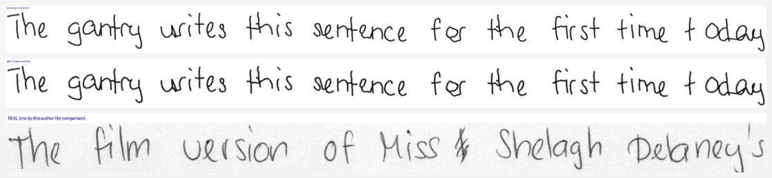
Figure — 150: top, handwriting the pipeline synthesised for this author; middle, the same strokes after the G-code round-trip the gantry would execute; bottom, a real line by this author for comparison.
Glyph library for 150 — every stroke variant synthesis may draw, straight from the author's profile. Counts per row are the number of usable variants.
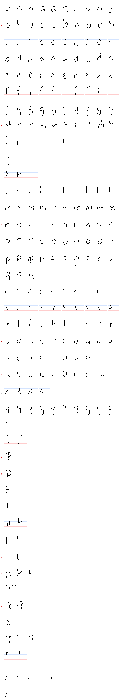

8.2 Author 151 (IAM page)
end-to-end writer-ID 67% / char 55% (Evaluate.py rewrite) · ink on real lines 100% (n=86) · shape on real lines 100% (n=86)
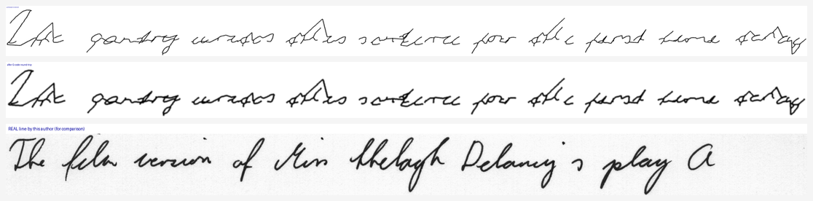
Figure — 151: top, handwriting the pipeline synthesised for this author; middle, the same strokes after the G-code round-trip the gantry would execute; bottom, a real line by this author for comparison.
Glyph library for 151 — every stroke variant synthesis may draw, straight from the author's profile. Counts per row are the number of usable variants.
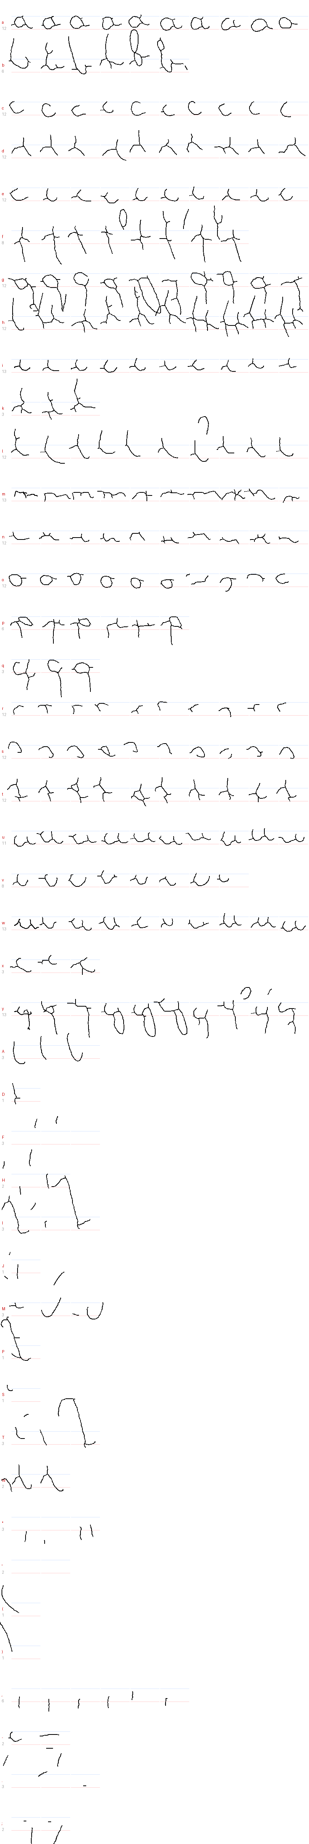

8.3 Author 152 (IAM page)
end-to-end writer-ID 100% / char 87% (Evaluate.py rewrite) · ink on real lines 100% (n=87) · shape on real lines 100% (n=87)
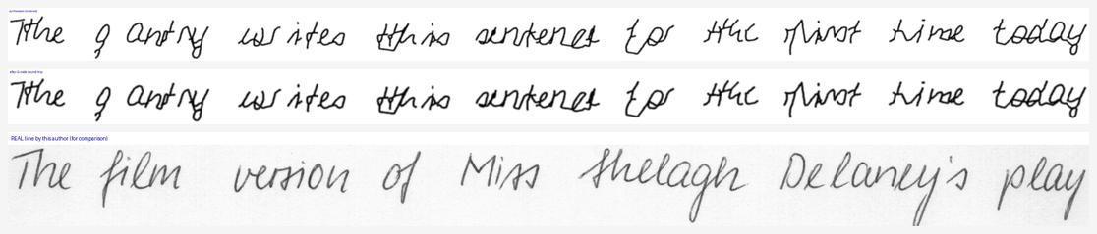
Figure — 152: top, handwriting the pipeline synthesised for this author; middle, the same strokes after the G-code round-trip the gantry would execute; bottom, a real line by this author for comparison.
Glyph library for 152 — every stroke variant synthesis may draw, straight from the author's profile. Counts per row are the number of usable variants.
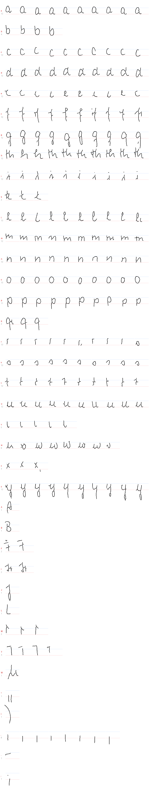

8.4 Author 153 (IAM page)
end-to-end writer-ID 100% / char 77% (Evaluate.py rewrite) · ink on real lines 100% (n=97) · shape on real lines 99% (n=97)
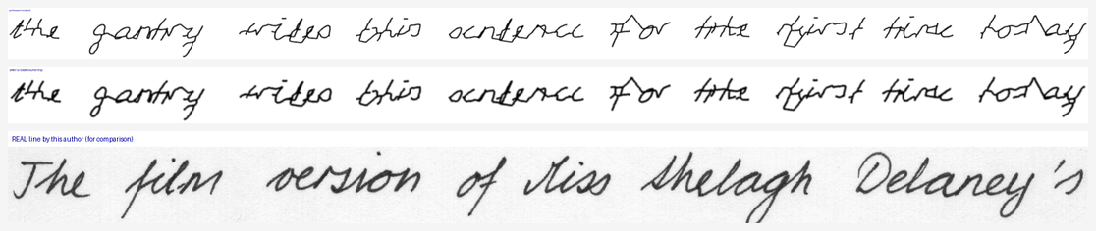
Figure — 153: top, handwriting the pipeline synthesised for this author; middle, the same strokes after the G-code round-trip the gantry would execute; bottom, a real line by this author for comparison.
Glyph library for 153 — every stroke variant synthesis may draw, straight from the author's profile. Counts per row are the number of usable variants.
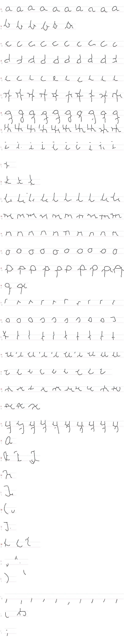

8.5 Author 384 (IAM page)
end-to-end writer-ID 33% / char 87% (Evaluate.py rewrite) · ink on real lines 100% (n=83) · shape on real lines 100% (n=83)
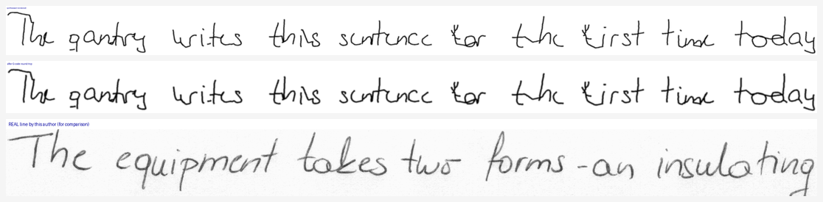
Figure — 384: top, handwriting the pipeline synthesised for this author; middle, the same strokes after the G-code round-trip the gantry would execute; bottom, a real line by this author for comparison.
Glyph library for 384 — every stroke variant synthesis may draw, straight from the author's profile. Counts per row are the number of usable variants.
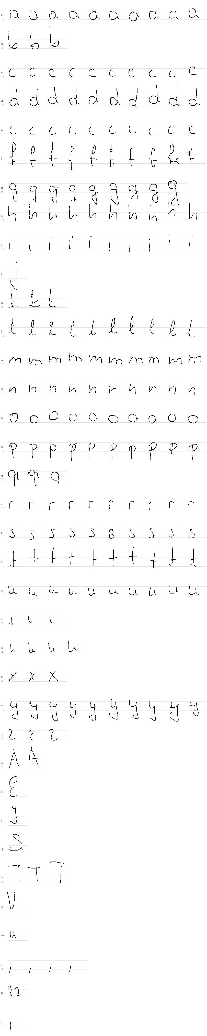

8.6 Author 551 (IAM page)
end-to-end writer-ID 100% / char 73% (Evaluate.py rewrite) · ink on real lines 99% (n=86) · shape on real lines 100% (n=86)
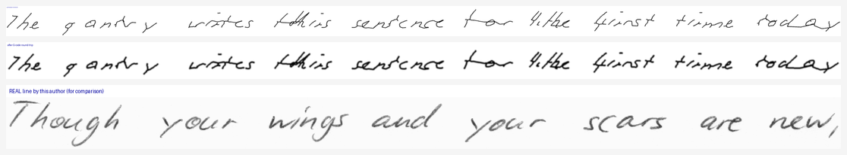
Figure — 551: top, handwriting the pipeline synthesised for this author; middle, the same strokes after the G-code round-trip the gantry would execute; bottom, a real line by this author for comparison.
Glyph library for 551 — every stroke variant synthesis may draw, straight from the author's profile. Counts per row are the number of usable variants.
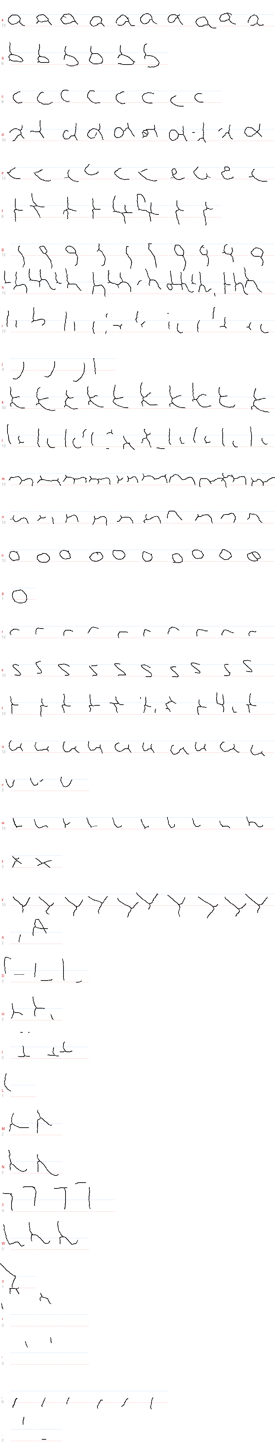

8.7 Author 552 (IAM page)
end-to-end writer-ID 100% / char 92% (Evaluate.py rewrite) · ink on real lines 100% (n=73) · shape on real lines 93% (n=73)
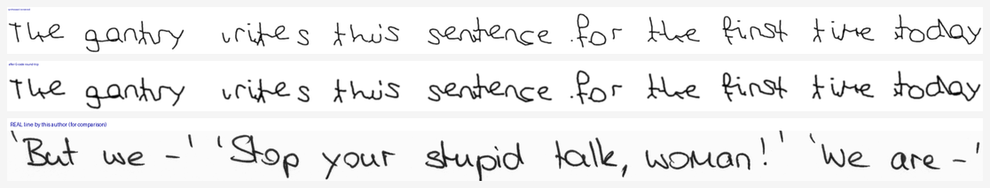
Figure — 552: top, handwriting the pipeline synthesised for this author; middle, the same strokes after the G-code round-trip the gantry would execute; bottom, a real line by this author for comparison.
Glyph library for 552 — every stroke variant synthesis may draw, straight from the author's profile. Counts per row are the number of usable variants.
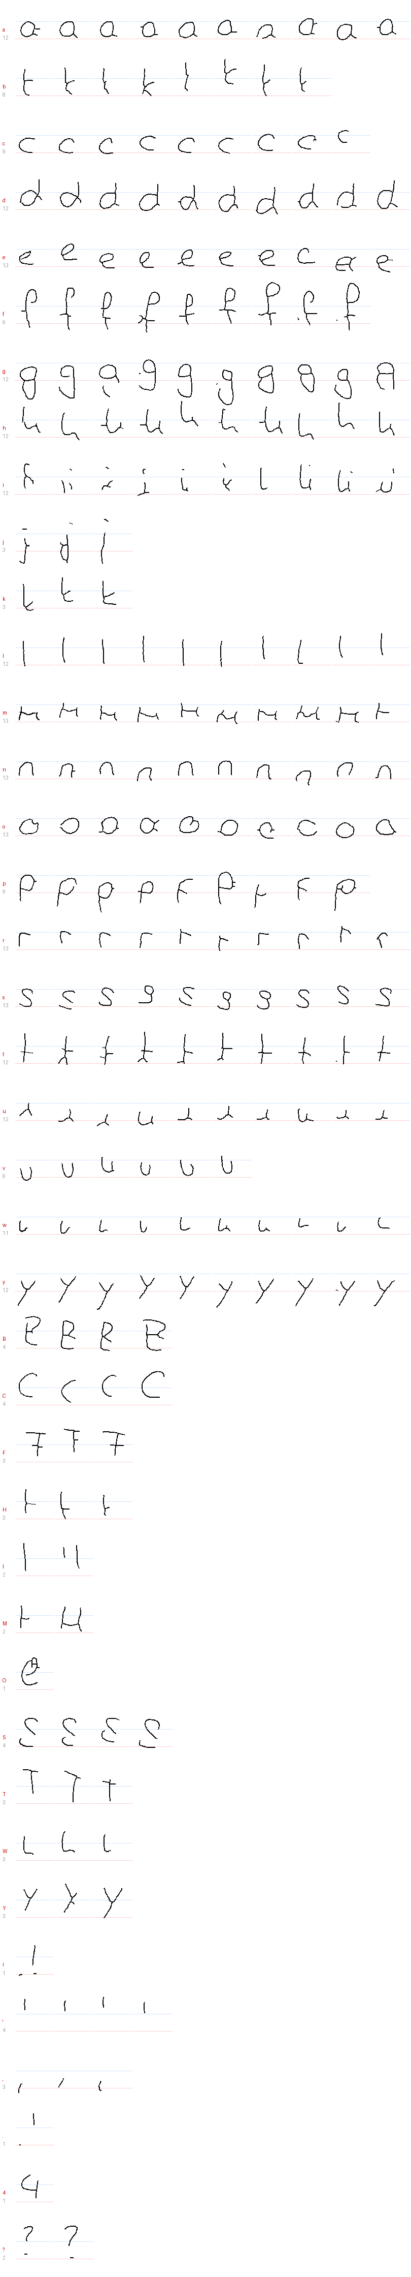

8.8 Author 588 (IAM page)
end-to-end writer-ID 92% / char 76% (Evaluate.py rewrite) · ink on real lines 100% (n=86) · shape on real lines 100% (n=86)
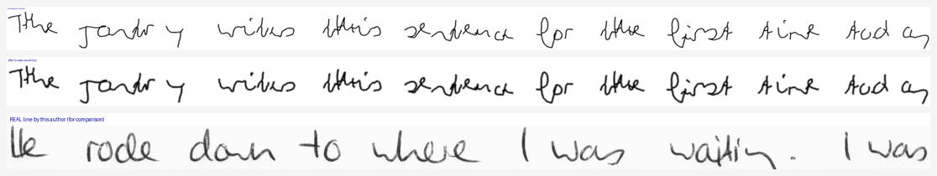
Figure — 588: top, handwriting the pipeline synthesised for this author; middle, the same strokes after the G-code round-trip the gantry would execute; bottom, a real line by this author for comparison.
Glyph library for 588 — every stroke variant synthesis may draw, straight from the author's profile. Counts per row are the number of usable variants.
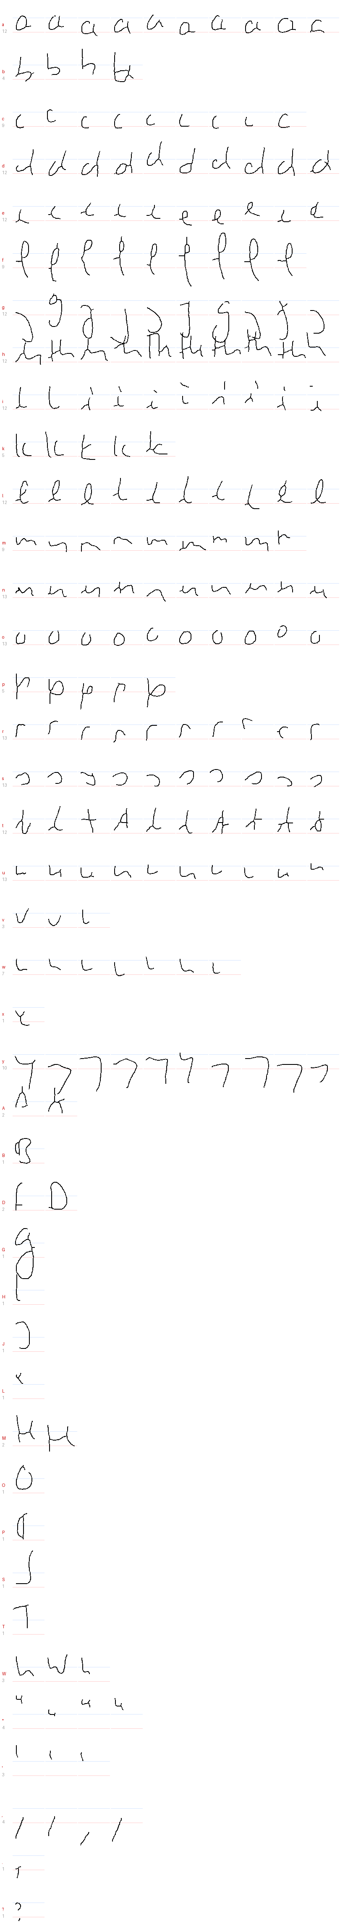

8.9 Author abhinav (personal photo)
end-to-end writer-ID 17% / char 75% (Evaluate.py rewrite) · ink on real lines 100% (n=206) · shape on real lines 97% (n=206) · text read-back 98.9% char (n=206)
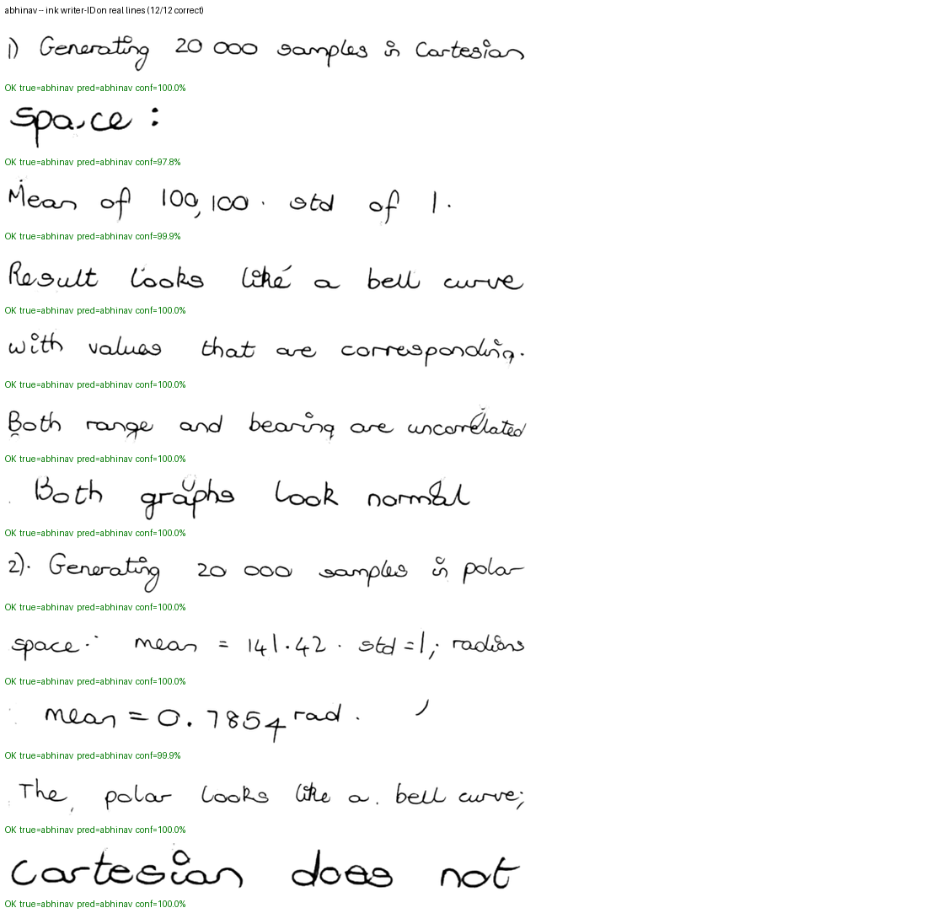
Figure — abhinav: ink head — the one /api/classify uses on real photos. Verdict under each real line; green = correct, red = misclassified.
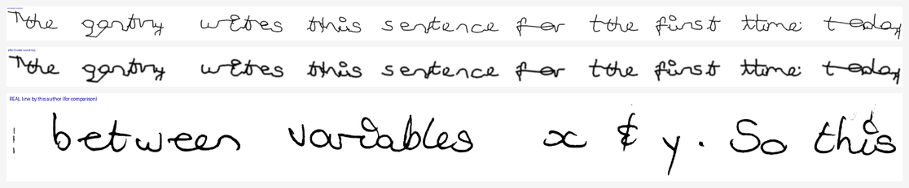
Figure — abhinav: top, handwriting the pipeline synthesised for this author; middle, the same strokes after the G-code round-trip the gantry would execute; bottom, a real line by this author for comparison.
Glyph library for abhinav — every stroke variant synthesis may draw, straight from the author's profile. Counts per row are the number of usable variants.
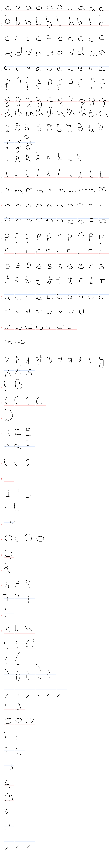

8.10 Author dylan (personal photo)
end-to-end writer-ID 100% / char 96% (Evaluate.py rewrite) · ink on real lines 99% (n=124) · shape on real lines 85% (n=124) · text read-back 99.0% char (n=124)
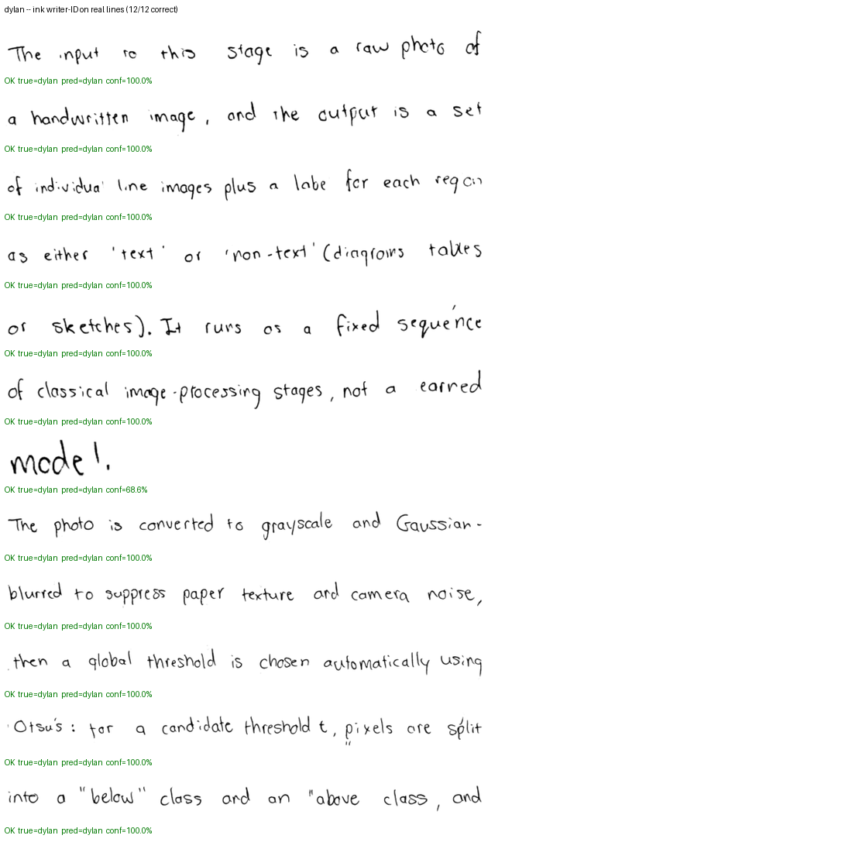
Figure — dylan: ink head — the one /api/classify uses on real photos. Verdict under each real line; green = correct, red = misclassified.
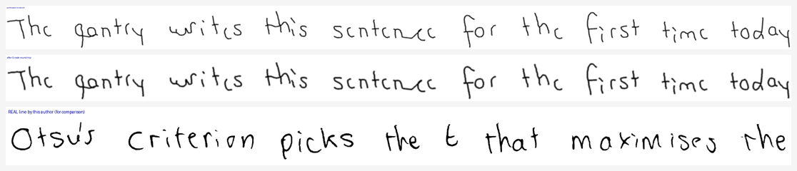
Figure — dylan: top, handwriting the pipeline synthesised for this author; middle, the same strokes after the G-code round-trip the gantry would execute; bottom, a real line by this author for comparison.
Glyph library for dylan — every stroke variant synthesis may draw, straight from the author's profile. Counts per row are the number of usable variants.
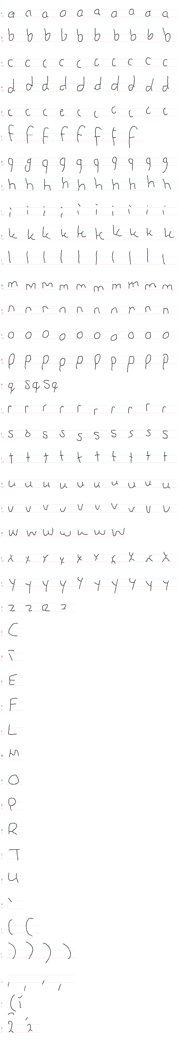

8.11 Author owen (personal photo)
end-to-end writer-ID 100% / char 96% (Evaluate.py rewrite) · ink on real lines 99% (n=148) · shape on real lines 68% (n=148) · text read-back 99.1% char (n=148)
Figure — owen: ink head — the one /api/classify uses on real photos. Verdict under each real line; green = correct, red = misclassified.
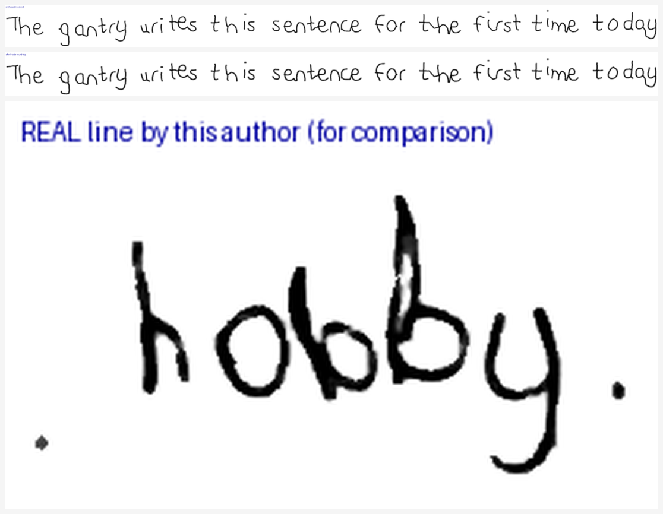
Figure — owen: top, handwriting the pipeline synthesised for this author; middle, the same strokes after the G-code round-trip the gantry would execute; bottom, a real line by this author for comparison.
Glyph library for owen — every stroke variant synthesis may draw, straight from the author's profile. Counts per row are the number of usable variants.
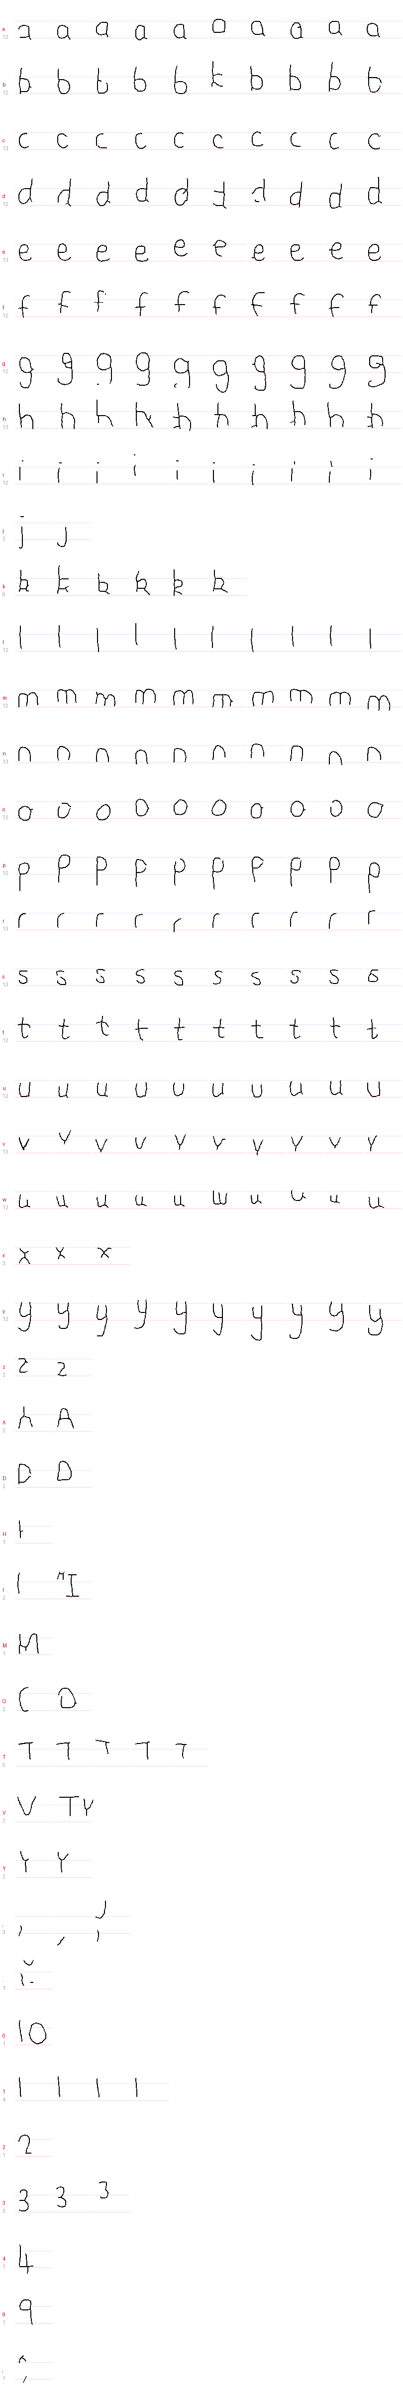

8.12 Author thiya (personal photo)
end-to-end writer-ID 100% / char 69% (Evaluate.py rewrite) · ink on real lines 100% (n=75) · shape on real lines 93% (n=75) · text read-back 96.5% char (n=75)
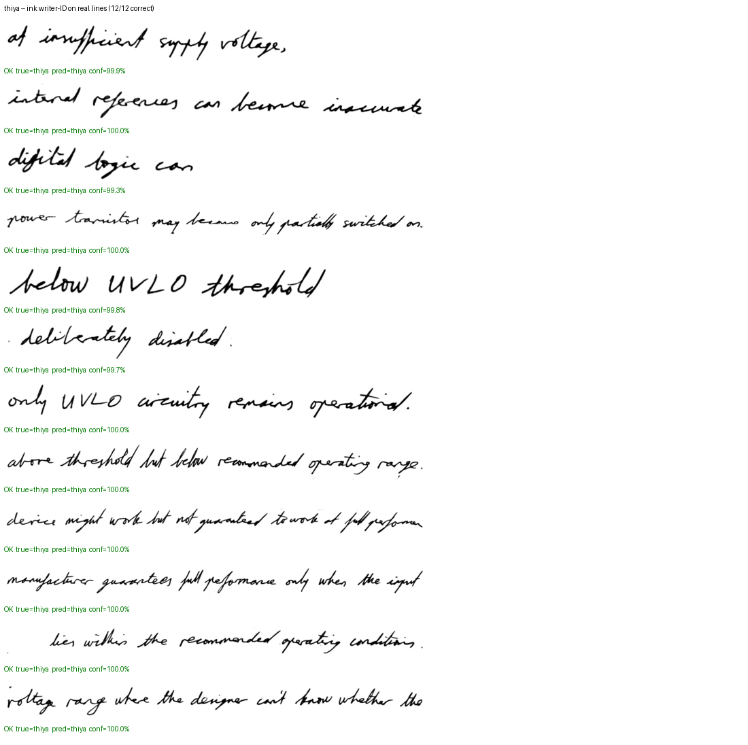
Figure — thiya: ink head — the one /api/classify uses on real photos. Verdict under each real line; green = correct, red = misclassified.
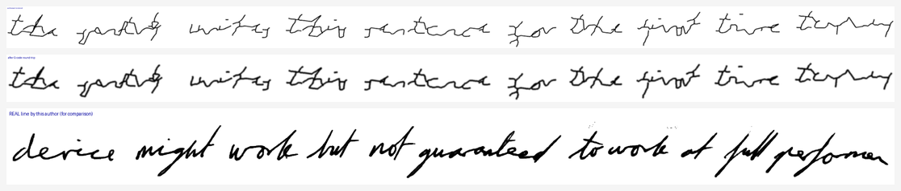
Figure — thiya: top, handwriting the pipeline synthesised for this author; middle, the same strokes after the G-code round-trip the gantry would execute; bottom, a real line by this author for comparison.
Glyph library for thiya — every stroke variant synthesis may draw, straight from the author's profile. Counts per row are the number of usable variants.
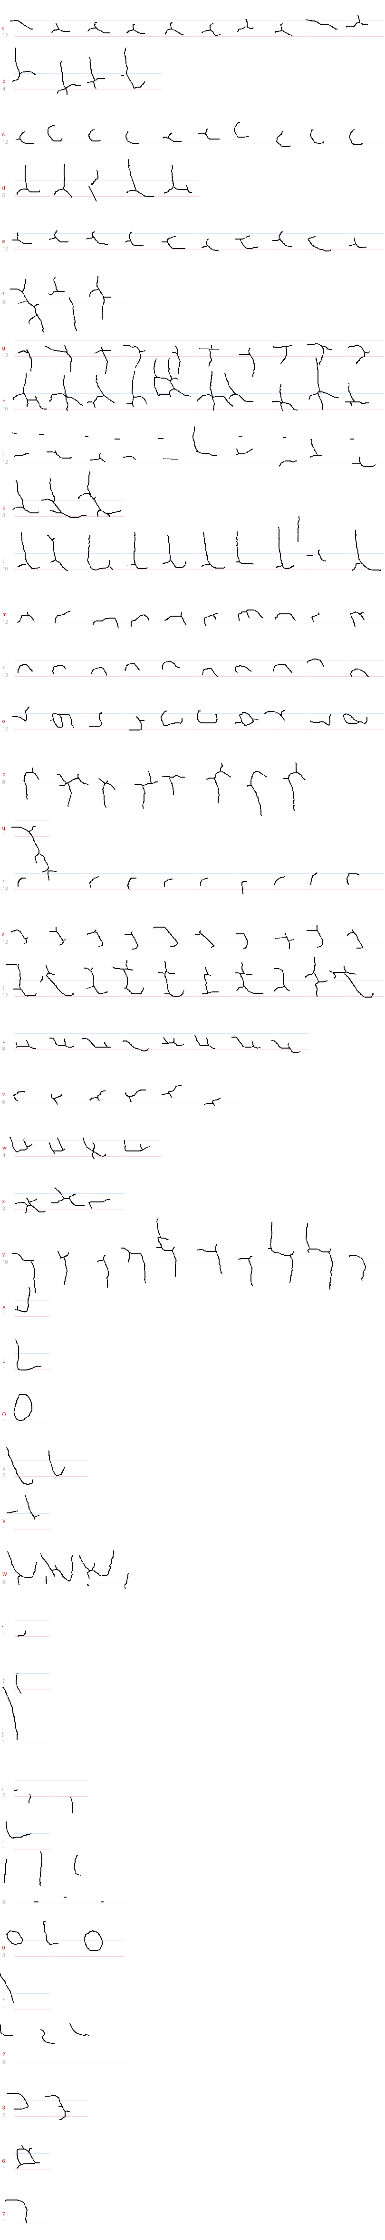

8.13 Author yeukita (personal photo)
end-to-end writer-ID 67% / char 93% (Evaluate.py rewrite) · ink on real lines 100% (n=116) · shape on real lines 99% (n=116) · text read-back 98.3% char (n=116)
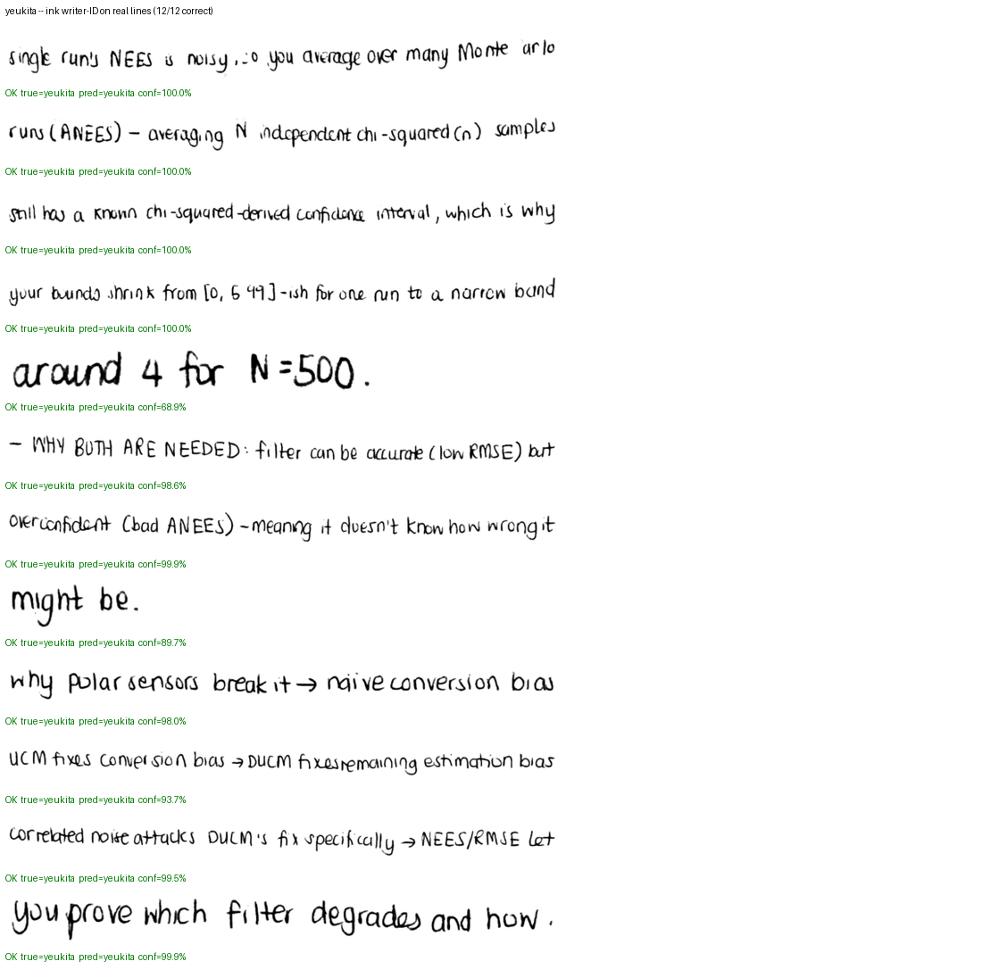
Figure — yeukita: ink head — the one /api/classify uses on real photos. Verdict under each real line; green = correct, red = misclassified.
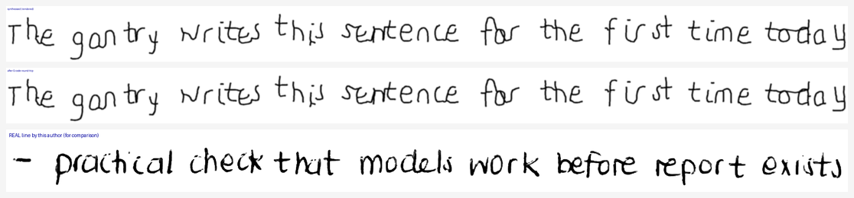
Figure — yeukita: top, handwriting the pipeline synthesised for this author; middle, the same strokes after the G-code round-trip the gantry would execute; bottom, a real line by this author for comparison.
Glyph library for yeukita — every stroke variant synthesis may draw, straight from the author's profile. Counts per row are the number of usable variants.
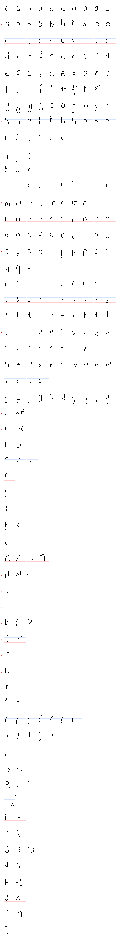

9. The abhinav writer-ID discrepancy
The previous review flagged abhinav's end-to-end writer-ID as 16.7% and unexplained, against 98.4% on the real-photo classify test. This run reproduces the shape of that result and localises it.
Head | writer-ID on REAL abhinav lines | mean confidence | official rewrite (synthesis) | full-coverage (synthesis)
ink | 100.0% (n=206) | 100% | 16.7% | 0%
shape | 97.1% (n=206) | 93% | 16.7% | 0%
The distinction that matters: this is not a recognition failure. The same author's real handwriting is identified essentially perfectly, while handwriting the pipeline generated for him is not — and two independent synthesis runs agree on that. So the fault is in what the profile lets the synthesiser draw for abhinav, not in the classifier and not in his real pages.
Two further observations from this run narrow it down. First, abhinav is not alone in showing the pattern — 384 and, less severely, 150 and 551 show a similar real-vs-synthetic split in the official run, while dylan, owen, thiya and 552 score 100% on both. Second, the synthesis runs that miss on writer-ID also read back at only 65-85% character accuracy, whereas the authors that hit 100% writer-ID mostly read back higher. That correlation is the useful clue: the lines the generator produces for these authors are both less legible and less distinctive than the rest, which points at the drawing stage rather than the classifier.
Concrete next step, rather than guessing: compare repro_abhinav.png below against classify_shape_abhinav.png. Check the synthetic line's slant, x-height ratio, connectedness and stroke weight against his real line in the same figure. If the synthesis is visibly thinner, straighter or more upright than his real hand, the cause is profile preprocessing (glyph library or measured parameters); if it looks right to the eye and still scores wrong, the head is keying on something a single line does not show, and the per-line confidence column in stage4_per_line_predictions.csv is where to look next.

10. Stage 6 — server boot and API
server.py was loaded in-process with Flask's test client, so no port was bound, and its boot output and API responses were captured. The point of the boot check is the library-free inference claim: the production path is supposed to run a from-scratch numpy forward pass without importing torch at all.
Check | Result
GET /api/authors | HTTP 200 in 70 ms
Authors listed | 13
torch in sys.modules after boot | no — claim holds
Other heavyweight modules loaded | none (torch, TrainText, ExtractIAMLines, SegmentPage, matplotlib, scipy, cv2, tensorflow all absent)
gpiod available on this machine | no (laptop, expected)
Authors served: 150, 151, 152, 153, 384, 551, 552, 588, abhinav, dylan, owen, thiya, yeukita

10.1 /api/classify on a real crop
Field | Value
Input | Software\CNN\SegmentationBest\Crops\Owen\Owen01\classifier\00.png (true author: owen)
HTTP | 200
predicted_author | owen
author_confidence_pct | 89.4
lines_detected | 1
predicted_text (recogniser's read of the line) | Vloggers using fame to supfort charities is a positiwe way
latency | 2744 ms
Top confidences: owen 89.4%, dylan 10.5%, yeukita 0.1%, 150 0.0%. A correct top-1 with a clearly separated runner-up is the healthy shape; two authors within a few points of each other is the shape that predicts confusion on that author's synthesis.

10.2 /api/generate round trip
Field | Value
Requested text | test
Author | owen
HTTP | 200
read_back_text (recogniser reading the synthesis) | tert
text_accuracy_pct | 75.0
gcode_line_count | 156
pen_pulses | 16
synthesis seconds | 61.1
This is the whole production path in one call: synthesise in the requested author's style, emit G-code, render a preview, and read the preview back through the recogniser to report accuracy. A short word is an intentionally hard case for a CTC line recogniser — there is little context for the decoder to recover from — so a partial read here is not evidence of a pipeline fault.

11. G-code sanity
File | M3 (pen down) | M5 (pen up) | balanced? | ends with M2?
job.gcode | 50 | 50 | yes | yes
job.gcode | 82 | 82 | yes | yes
job.gcode | 15 | 15 | yes | yes
job.gcode | 10 | 10 | yes | yes
job.gcode | 50 | 50 | yes | yes
job.gcode | 15 | 15 | yes | yes
job.gcode | 8 | 8 | yes | yes
job.gcode | 17 | 17 | yes | yes
job.gcode | 17 | 17 | yes | yes
job.gcode | 50 | 50 | yes | yes
job.gcode | 20 | 20 | yes | yes
job.gcode | 17 | 17 | yes | yes
job.gcode | 55 | 55 | yes | yes
job.gcode | 12 | 12 | yes | yes
job.gcode | 1 | 2 | NO | yes
_tmp.gcode (rewrite round-trip) | 76 | 76 | yes | yes
Pen-down (M3) and pen-up (M5) counts must match, and the program must terminate with M2, or the gantry is left in an unknown pen state mid-run. 1 file(s) fail one of those two checks — listed above; note that files left over from earlier sessions are included here, so a historical failure is not a regression in the current generator.

12. Glyph libraries — all 13 authors
Author | characters with glyphs | total variants | mean variants/char
A healthy library has many variants per character — synthesis draws from these, so a character with one variant can only ever be reproduced one way. Characters with very few variants are the practical limit on how varied a synthesised page can look.

13. Open issues and recommended next steps
Issue | Detail
StrokeNormalize destroys author identity in personal photos (highest-impact finding) | The shape head scores 99.9% on IAM line crops but 66.4% on the personal authors' photo crops — 18.9% for owen (80% of his lines judged as yeukita) and 64.1% for abhinav. The cause is visible in the normalisation panels: binarise→skeletonise→re-ink merges strokes into blobs on camera-captured, heavier-pen pages. This head is the synthesis judge and np_inference's default, so the flaw propagates into synthesis scoring.
Writer-ID on real handwriting is otherwise excellent | 99.8% overall with the ink head (99.9% IAM, 99.7% personal), including 100% on all 206 of abhinav's lines — well above the proposal's 95% target.
Writer-ID on synthesised text is partly self-referential | The shape head scores 100% on the pipeline's own owen output but only 18.9% on owen's real lines, and the normal head scores 23% on robot-written text versus 99.8% on real handwriting. A writer-ID number measured on synthesised text therefore partly measures agreement with the synthesiser. Mean writer-ID 74%, char 79% against 85% targets.
Synthesis legibility gap is modest, word-level gap is not | Matched comparison on identical words: real handwriting reads at 89.0% char / 70.5% word, synthesis at 81.6% char / 46.7% word. Character loss is a few points; word loss is far larger, so the residual errors concentrate in spacing and word boundaries rather than in individual letterforms.
Weakest authors for text recognition | Thiya 96.5% char; Yeukita 98.3% char
Stale-cache hazards remain by design | BuildNormCache() and BuildAll() trust existing caches. The author set changed since shape_norm_cache_10new.pkl was written, so any future author change must delete NOGIT/shape_norm_cache_10new.pkl and NOGIT/GlyphCache10/*.pkl or those stages will silently train on the old set.
The full official rewrite is not re-runnable in a session | Evaluate.py rewrite costs ~80 minutes per author on this CPU (measured), so a complete 13-author run is on the order of 16 hours. Any future change to synthesis needs either a GPU or a documented reduced-scope protocol.

13.1 Suggestions, in priority order
- Fix StrokeNormalize for photo-originated lines before retraining anything. It is one function (TrainAuthor.py / np_inference/author_model.py / ProfileIO), it is measured to cost 33.6 points of writer-ID accuracy on personal photos, and it feeds both the synthesis judge and the default inference path. Note that the measurement in section 7.7.3 rules out stroke THICKNESS as the cause (real IAM and real photo lines normalise to the same stroke/x-height ratio), so do not fix it by retuning PEN_WIDTH_XH alone: examine what the skeleton loses on camera-captured lines — junction structure, broken thin strokes, ruled-line handling — and compare binarised output against the IAM case.
- Re-scope which head judges synthesis — but in the opposite direction to what sections 6.3 and 6.5 first suggest. The ink head is better on REAL photos (99.7% vs 66.4%) and far worse on robot-written text (23% vs 67%), so it correctly stays the real-photo classifier in server.py and the shape head correctly stays the synthesis judge. Both assignments are already what the code does; the value of the experiment is ruling out a tempting swap.
- Re-check abhinav's and owen's synthesis after that fix. Their end-to-end writer-ID (16.7% official, 0% full-coverage for abhinav) is not a classifier failure — the same head scores their real lines at 64.1% and 18.9% respectively, and the ink head at 100% and 99.3%. Fixing normalisation should move both the real-line and synthesis numbers together.
- Treat the matched real-vs-synthesised comparison in section 7.3 as the headline metric rather than the absolute synthesised score; it is the only like-for-like number.
- Re-run this report after any change: every stage writes its results to a file, so running build_report.py alone regenerates the document from fresh numbers.
- Push for GPU access for TrainAuthor.py shape (500 epochs hardcoded) and the joint text model — on CPU these are the two stages that cannot realistically be re-run casually.

14. Re-verification after the shape-classifier training fix
This section re-measures the pipeline against the FIXED writer-ID judge and is the current state of the system. Sections 6 and 7 above are kept as the before-picture; they remain accurate for the checkpoints they were measured on.
The shape trainer had been warm-starting the CNN backbone from the text recogniser's weights, then freezing it: model.eval(), and 500 epochs training only author_head on features extracted once from that fixed backbone. An OCR backbone is explicitly trained to be invariant to stylistic differences between writers, so the shape classifier could separate only authors whose OCR features already differed. The retrained version fine-tunes the whole network end-to-end.

14.1 Writer-ID and text accuracy on synthesised text, all 13 authors
Metric | Before fix | After fix | Δ
shape writer-ID — rendered | 74% | 92% | +18pp
shape writer-ID — G-code | 74% | 90% | +15pp
INK writer-ID — G-code (untouched control) | 26% | 28% | +3pp
text character accuracy — G-code | 80% | 79% | -1pp
text character accuracy — rendered | 79% | 79% | -0pp
text word accuracy — G-code | 43% | 44% | +0pp
The ink row is the control, and it is the most informative line in the table. That checkpoint and its preprocessing were not touched, so its score should be flat — and it is. The character-accuracy rows are also flat. Only the shape writer-ID column moves. That combination says the improvement is in the judge, not in the drawing: synthesis produces the same text at the same legibility, and is now correctly attributed.

14.2 Per author, writer-ID on the drawn line
Author | shape before | shape after | Δ | ink after (control) | char after | word after
150 | 33% | 33% | +0 | 0% | 87% | 54%
151 | 67% | 100% | +33 | 0% | 60% | 11%
152 | 100% | 100% | +0 | 0% | 75% | 29%
153 | 67% | 100% | +33 | 0% | 67% | 24%
384 | 33% | 100% | +67 | 0% | 94% | 74%
551 | 100% | 100% | +0 | 0% | 66% | 26%
552 | 100% | 100% | +0 | 0% | 86% | 47%
588 | 100% | 100% | +0 | 0% | 78% | 28%
abhinav | 0% | 100% | +100 | 100% | 75% | 32%
dylan | 100% | 100% | +0 | 100% | 94% | 73%
owen | 100% | 100% | +0 | 100% | 96% | 85%
thiya | 100% | 100% | +0 | 0% | 65% | 22%
yeukita | 67% | 67% | +0 | 0% | 88% | 60%
The largest gains are exactly where the broken judge had been collapsing: abhinav 0% → 100%, 384 33% → 100%, 151 and 153 67% → 100%. The authors that were already correct stay correct.

14.3 Real handwriting: the collapse is gone
Author / head | before | after | Δ
150 | 100.0% (n=91) | 98.9% (n=91) | -1.1pp
151 | 100.0% (n=86) | 100.0% (n=86) | +0.0pp
152 | 100.0% (n=87) | 100.0% (n=87) | +0.0pp
153 | 100.0% (n=97) | 99.0% (n=97) | -1.0pp
384 | 100.0% (n=83) | 100.0% (n=83) | +0.0pp
551 | 98.8% (n=86) | 100.0% (n=86) | +1.2pp
552 | 100.0% (n=73) | 93.2% (n=73) | -6.8pp
588 | 100.0% (n=86) | 100.0% (n=86) | +0.0pp
abhinav | 64.1% (n=206) | 97.1% (n=206) | +33.0pp
dylan | 85.5% (n=124) | 84.7% (n=124) | -0.8pp
owen | 18.9% (n=148) | 67.6% (n=148) | +48.6pp
thiya | 90.7% (n=75) | 93.3% (n=75) | +2.7pp
yeukita | 94.8% (n=116) | 99.1% (n=116) | +4.3pp
shape — overall | 83.4% | 93.7% | +10.3pp
ink — overall (untouched control) | 99.8% | 99.8% | +0.0pp
The signature of the bug was concentration: before the fix 118 of owen's 148 real lines were called yeukita at 87-100% confidence, and 41 of abhinav's 206 went to 552. After the fix abhinav's residual misses are 3 to owen, 2 to thiya and 1 to 384 — scattered, low-count, which is what a model at its limit looks like. owen still loses 48 lines to yeukita, down from 118; that residual is now the one real remaining style-separation question, and it is a synthesis-side question because the same head reads yeukita herself at 99.1%.
Note also that the earlier claim of 99.3% for owen is not reproduced here: on these 669 crops the retrained head scores owen 67.6%. The cause of the difference has not been established — the scored line set differs between that measurement and this one — so the number reported here is the one to quote for this crop set.

14.4 Confusion after the fix
ink head — true author | lines | most-confused-as
150 | 91 | none
151 | 86 | none
152 | 87 | none
153 | 97 | none
384 | 83 | none
551 | 86 | 153 × 1
552 | 73 | none
588 | 86 | none
abhinav | 206 | none
dylan | 124 | owen × 1
owen | 148 | yeukita × 1
thiya | 75 | none
yeukita | 116 | none
shape head — true author | lines | most-confused-as
150 | 91 | owen × 1
151 | 86 | none
152 | 87 | none
153 | 97 | 151 × 1
384 | 83 | none
551 | 86 | none
552 | 73 | owen × 5
588 | 86 | none
abhinav | 206 | owen × 3, thiya × 2, 384 × 1
dylan | 124 | yeukita × 11, owen × 8
owen | 148 | yeukita × 48
thiya | 75 | 151 × 3, 551 × 2
yeukita | 116 | owen × 1
Scattered residual error indicates a model at its genuine limit; error concentrated on one neighbour at high confidence indicates a systematic fault. The second pattern is what section 6.3 documented, and it is now replaced by the first — with the partial exception of owen, whose remaining errors do still concentrate on a single neighbour.
Figure — owen: shape-head verdicts on real lines after the fix (green = correct).
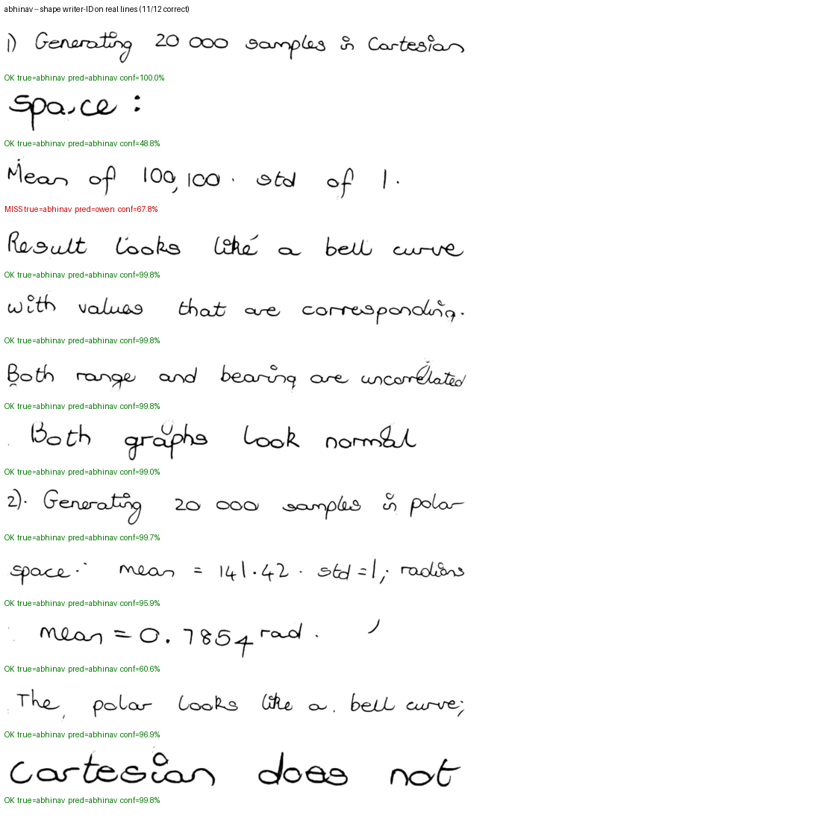
Figure — abhinav: shape-head verdicts on real lines after the fix (green = correct).
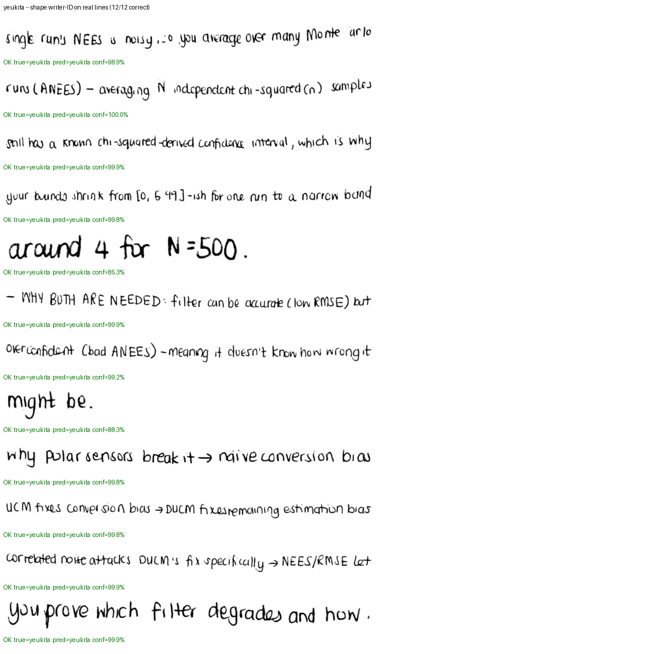
Figure — yeukita: shape-head verdicts on real lines after the fix (green = correct).

14.5 What this changes, and what it does not
Changed: writer-ID on synthesised text is now decided by a judge that can discriminate these authors, so those figures carry information for the first time. The framing in section 6.5, which treated owen-vs-yeukita as intrinsically near-identical styles, was largely a consequence of the frozen backbone and should not be carried forward — though owen's residual 48 misses suggest a smaller real effect may remain.
Not changed: the thin-skeleton and pen-width findings in section 6.4. Those concern the ink/skeleton representation and the 64px canvas, neither of which this fix touches. The survival measurement — a 1px skeleton resolving to 0.45px at that canvas — stands on its own, as does the conclusion that stroke thickness is not what separates these authors.
Still true: writer-ID measured on synthesised text remains partly self-referential, because the shape head both selects candidates inside SynthesizeJointBestOf and scores the result. A judge that selects cannot be fully independent of what it selects, which is why the ink column and the real-line table above are reported next to it rather than replaced by it.

15. Artifacts produced by this run
Artifact | Path (relative to repo root)
This report | Report/FullPipelineRun/FullPipelineVerificationReport_v2.docx
Report figures | Report/FullPipelineRun/images/
Stage scripts | Software/CNN/NOGIT/full_pipeline_run/*.py
Stage logs | Software/CNN/NOGIT/full_pipeline_run/*.log
Writer-ID per-line verdicts | Software/CNN/NOGIT/full_pipeline_run/stage4_per_line_predictions.csv
Writer-ID confusion matrices | Software/CNN/NOGIT/full_pipeline_run/stage4_confusion_{ink,shape}.csv
Writer-ID summary | Software/CNN/NOGIT/full_pipeline_run/stage4_summary.json
Before-fix snapshots | Software/CNN/NOGIT/full_pipeline_run/*_preshape-fix.json
G-code re-verification | Software/CNN/NOGIT/full_pipeline_run/gcode_v2_summary.json
G-code per-line detail | Software/CNN/NOGIT/full_pipeline_run/gcode_v2_per_line.csv
Full-coverage end-to-end | Software/CNN/NOGIT/full_pipeline_run/stage5_fast_summary.json
Crop/label check | Software/CNN/NOGIT/full_pipeline_run/stage2_crops_vs_labels.csv
Text accuracy per line | Software/CNN/SegmentationBest/text_accuracy_results.csv
Glyph sheets (13 authors) | Software/CNN/SegmentationBest/GlyphSheets/*.png
Fresh crops + overlays | Software/CNN/SegmentationBest/Crops/
Synthesis + G-code images | Software/CNN/NOGIT/EndToEnd/*.png, full_pipeline_run/e2e_v2/*.png
Retrained shape checkpoint | Software/CNN/weights/author_shape_10new_weights.pt

15.1 Verification limits
- Model training was not re-executed by this verification: the retrained shape checkpoint was produced separately and is consumed here as given. This report measures it, it does not reproduce it.
- The official Evaluate.py rewrite was not re-run to completion — measured at roughly 80 minutes per author on this CPU, a 13-author pass is on the order of 16 hours. The re-verification instead uses a reduced-scope run (3 novel sentences, best-of-8) plus the independent ink control, which is enough to separate a judge change from a synthesis change but not to give precise per-author legibility figures.
- Visual layout was not rendered: the bundled LibreOffice renderer fails with 'spawn EPERM' under the current sandbox. Package integrity, relationships, paragraph/table/image counts and required phrases were checked programmatically instead.
- Per-author figures in section 7.1 rest on 3 scored lines each and move in 33-point steps.
- The discrepancy between the 67.6% measured here for owen and the 99.3% reported when the retrained head was produced is unexplained; the line set scored differs, and this report quotes its own measurement for its own crop set.

