Project EPR400/402  First semester report | 24 July 2026 | Note:

Student to complete this section
Pike | C. | Mr. | 23111111
Design of a magnetic levitation system |  |  | Study leader:  Prof. M. Forrest
Degree programme enrolled for:  (e.g. Electrical Engineering) | Project number: |  |  |  | Revision number: | 0
Student declaration:  I understand what plagiarism is and that I have to complete my project on my own. I am fully aware of the University’s policy in this regard. I have not used another student’s past or present written work to submit as my own. I declare that this report is my own original work. Where other people’s work has been used (either from a printed source, internet or any other source), this has been properly acknowledged and referenced in accordance with departmental requirements. | The student MUST sign here  _______________ _____________  Student signature Date

Declaration by language editor
I have been allowed adequate time to read this document carefully and to make corrections where necessary (date received indicated below).
To the best of my knowledge, correct formatting, spelling and grammar are used throughout the document.
Language editor MUST sign.
Alternatively: attach email proof of language editing, and then indicate here:
"Proof of language editing is attached". (Attach after last page).
_______________________________  A.N. Example (language editor) (use the correct name here) | ___________  Date

Table of contents

1. Literature study | 1
2. Work breakdown and first semester progress | 3
3. Project plan (second semester) | 6
4. References | 8

1. Literature study

- Existing Concepts
A need exists to be able to decode the writer’s style and written text from an image:
The ability of a computer or system to identify written text after being trained on large amounts of data is known as HWR (Handwritten recognition) or HTR (handwritten text recognition). [ref 1] One type of handwritten text recognition is offline recognition, which means the data being identified by the system is static and post-completion of the page of handwritten text. This is ideal for identifying the text from a fixed image of handwritten content by utilizing image processing techniques and algorithms to identify the text that was written. [ref 3] The other type is online recognition, which is a more dynamic process, which identifies text during the creation of the handwriting, adding the variable of time to the classification of text.

These are two previous examples of processes used for offline handwritten character recognition, one with a single CNN (convolution neural network) for classification [ref 4], and the other with a combined CNN and RNN (recurrent neural network) classifier [ref 6]

Every stage of the process to achieve accurate handwritten text recognition requires a deep understanding of the different techniques available:

Datasets and resolution: Multiple datasets have been typically used for training handwritten text recognition modules, for example the EMNIST and IAM datasets. The EMNIST (Extended Modified National Institute of Standards and Technology) dataset consists of approximately 814255 handwritten characters and numbers each being 28 by 28 pixels in size. [ref 1] There is only a single, disconnected character per image which is used in many existing HTR models, but these models cannot effectively decipher connected handwritten words, like cursive words. The IAM handwriting dataset provides much more variety as it consists of 5685 complete sentences, with a total of 115320 words, gathered from 627 different authors, consisting of 26 letters and 27 punctuation marks [ref 3]
The images from the IAM dataset were scanned at 300 dpi, with 8 bits per pixel, scanned in grey scale. [ref 10]
The dataset used influences the accuracy of the classification for classification of text with higher variation, as well as defines the resolution of the camera required to capture the handwritten text to classify.

Pre-processing: The pre-processing of handwriting includes multiple techniques to be performed on the handwritten text before being passed into the classification and feature recognition algorithms. This is used to account for dimensional adjustments, removal of inconsistencies, and normalization of the data, to make the images more appropriate for text separation and classification. [ref 6] Normalization is used to increase the accuracy of HTR models by reducing the effect that unwanted features of the data could have on the performance of the model, with different techniques used such as min-max scaling, z-score normalization and log-scaling. Encoding techniques are also used in HTR model preprocessing to get rid of unintentional biases. [ref 1]
Text Separation: Text separation is the process of breaking up a page of handwritten text into smaller segments or blocks that can be used in feature extraction and neural network classifiers. There are two methods that existing models employ to separate text: either individual character separation, or word separation. Both methods involve breaking down the paragraphs of handwritten text into smaller segments. The accuracy of the extraction of smaller segments influences the effectiveness of the classifier heavily. Some existing techniques for this are classic dissection techniques, recognition-based segmentation, hysteresis thresholding and bounding box techniques. [ref 1] To achieve either word or character separation, the page must still be broken up into individual lines and then into separate words. Line separation is sometimes done by converting images to greyscale, obtaining inverted binary images, and then drawing bounding boxes over each line. [ref 6] Character separation just goes one step further and splits the word into individual characters.

Types of Neural Networks: Many different types of neural network models have been implemented in previous papers, including ANNs (artificial neural networks), CNNs (convolutional neural networks), RNNs (recurrent neural networks), and also various combinations of them to achieve the best accuracy. ANNs are created from the standard neural network architecture consisting of multiple neurons, weights, hidden layers and biases etc. and can accurately perform pattern recognition for handwritten text. CNNs are built off the architecture of ANNs but also facilitate feature extraction and identifying smaller, more important information in text. This leads to a reduction of necessary learnable parameters, and streamlines model training. [ref 3] RNNs also contain the same fundamental structure as CNNs, but also have the capabilities to consider sequential and dependent data. The ability to capture time dependent patterns is useful for deciphering various handwritten fonts, and because RNNs can consider dependencies in the data, this can improve accuracy of handwritten text recognition when considering common linguist dependencies in language. [ref 3]

A combination of both CNNs and RNNs can significantly enhance feature extraction by using the CNN’s pattern recognition and ability to identify diverse handwriting styles, and the RNN’s ability to use textual dependencies for improved contextual understanding. [ref 4]

Two baseline models have been primarily considered in existing research papers, the LeNet-5 CNN model and the ResNet-34 CNN model. The LeNet-5 is the most common of the two, and was created by Yann LeCun in 1988. It is a CNN structure that consists of 8 layers, including 3 convolutional layers, 2 pooling layers and lastly two fully connected layers. A fully connected layer refers to a portion of a typical ANN model, while the convolutional layers and pooling layers will be discussed later in this literature study. The input size to the model is 32 by 32 pixels, and uses a hyperbolic tangent activation function in the fully connected layers, and a softmax activation function in the output layer. This model is popular for use in object detection and image classification. [ref 1]
ResNet-34 is also a popular CNN model known for its residual architecture. This model uses a concept known as transfer learning to retain its existing weights, which forms the foundation of the feature extraction in this model and allows for fast and efficient training from limited datasets. [ref 3]

Feature extraction: The convolutional layers of a CNN are used to perform feature extraction, which means it can capture subtle patterns in different areas of a segment of text by sliding a convolutional kernel over the character or word image. Translation invariance is created by the convolution kernel sliding, which allows consistent patterns to be extracted from images [ref 3]. The N by N input layer is convolved with a f by f kernel, and returns a N-f+1 by N-f+1 output. Feature maps are created by applying the convolutions to different sections of the image being classified. By identifying common features the kernel sliding convolutional technique can produce more accurate classification. Each extracted feature is multiplied with a corresponding kernel value to produce a weighting, then a bias and activation function is applied until an output feature map is obtained. [ref 7]

An extended version of the standard CNN is the deep CNN which just refers to a CNN which can extract higher complexity features like handwritten strokes. The problem is a larger, deeper CNN creates a ‘vanishing gradient’ problem where there are so many layers that during backpropagation, some layers never get their weightings changed, so there is a limit to the number of layers a standard CNN could have before adding more layers becomes ineffective. This is why a residual network is used to implement a deep CNN by using residual blocks and skip connections across various layers, so that all layers will still update their weightings during back propagation regardless of the amount of layers. [ref 3]

After a singular round of feature selection, many parameters are still required to classify text with these high level features. Max-pooling is used to down sample these feature maps until only the essential features are remaining, to minimize the number of parameters needed to classify handwritten characters and prevent overfitting. [ref 7]

A need exists to reproduce text on paper accurately and fast in any writer’s style:
There are various existing methods of text reproduction methods and linear actuation techniques which can influence the accuracy and speed of text reproduction.
Method of reproduction: There are three main methods to reproduce handwritten text on paper: cartesian systems, serial chain robots and parallel chain robots. A cartesian system consists of a gantry with x-y movement. It has restricted movement in only 2 directions using linear actuation. Serial chain robots are most common in industrial settings for automated movement. It consists of multiple linkages chained together, one component connected to the next in a single chain, like a typical robot arm. The third method is parallel chain robots which consist of multiple serial chain linkages that can precisely control automated movement. [Ref 2]
Pen mapping techniques: The method of pen trajectory mapping for text reproduction influences the accuracy and speed of reproduction. A popular algorithm for pen mapping is the Douglas-Peucker algorithm, which takes a sequence of points and creates an estimation of the sequence by drawing points from the beginning to the end. The algorithm produces one of the highest accuracy estimations when compared to similar algorithms yet is not completely optimal. [ref 2]

Linear actuation types: there are multiple methods of linear actuation which could be considered for a cartesian plotting system. Some popular examples of linear actuation methods are electric, pneumatic, belt drive, rack and pinion, and ball screw. Electric and pneumatic methods are often used for more industrial cases, but the belt drive, rack and pinion and ball screw linear actuators have been used in multiple handwriting reproduction systems due to their durability, reliability and cost-effectiveness.

- The existing literature that has been discussed forms the foundation for the handwriting recognition and recreation system that must be created. Extensive knowledge of all the types of neural networks and techniques that must be used is needed to meet the accuracy and speed requirements for the classifier of this project. A deep understanding of the methods of text reproduction and pen mapping is also needed to ensure the accuracy and speed requirements for the reproduction part of the project. A pitfall of most research done on these areas is that they only focus on individual elements of the full system, and also make use of many online libraries for example tensor and opencv [REFERENCE]. Therefore the main contribution made to existing research will be the full integration of the system with the dataset creation, text classification and text reproduction from first principles. The system will also focus on classifying various authors of the text as well as classifying the text that was written.

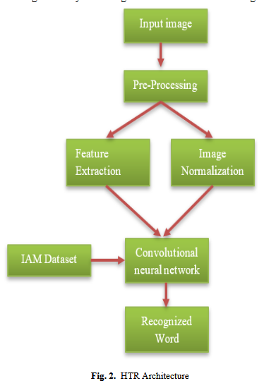4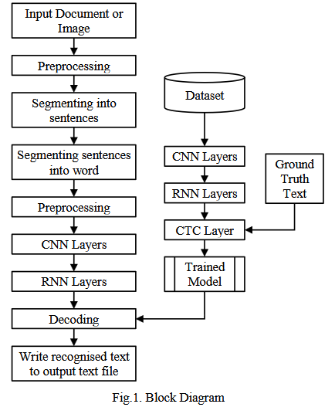6

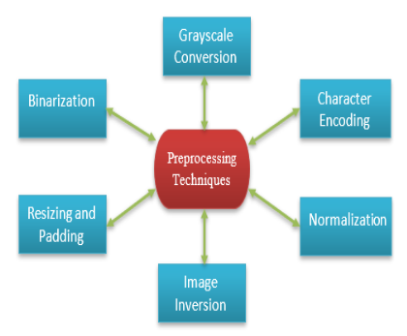
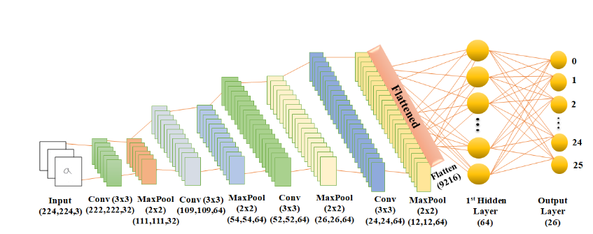
convolutional layers Ref 5

3. Work breakdown and first semester progress

Table 1. Project work breakdown and current completion

Task | Progress  (% complete) | Brief description
Finish project proposal | 100% | Revision 1 was approved.
Research neural networks in depth | 100% | All aspects of neural networks have been researched and documented.
Full conceptual understanding of the system | 100% | A full understanding of the overall flow and the method to achieve the requirements has been achieved.
CAD design of gantry | 100% | A full gantry has been modelled from first principles using good practice and tolerances in Autodesk Fusion 360.
Obtaining parts and 3D printing components | 50% | Local parts have been acquired and printed, but some parts including the camera module have been ordered but must still be delivered.
Neural network design and implementation | 0% | The classifier and deep learning model must be designed (preprocessing techniques and layers etc. ) and code must be written to be used in the single board computer.
Simulation and training of classifier | 0% | The classifier must be run on a PC with available datasets to verify accuracy of various model approaches to determine the best one.
Design and print PCB | 0% | The circuitry for the gantry and power supply must be designed using KiCad and printed locally on PCB.
Construction and testing of gantry | 0% | The gantry must be fully assembled and tested for speed and accuracy with simple pen mapping commands.
Integration with camera, SBC and gantry | 0% | The full system must be assembled ensuring the correct power is supplied to each subsystem.
Validate requirements through testing | 0% | The system must be fully tested in the specified field conditions to check if requirements are met, otherwise changes must be made.
Write final report | 0% | The final design report must be written and submitted before the deadline

3. Project plan (second semester)

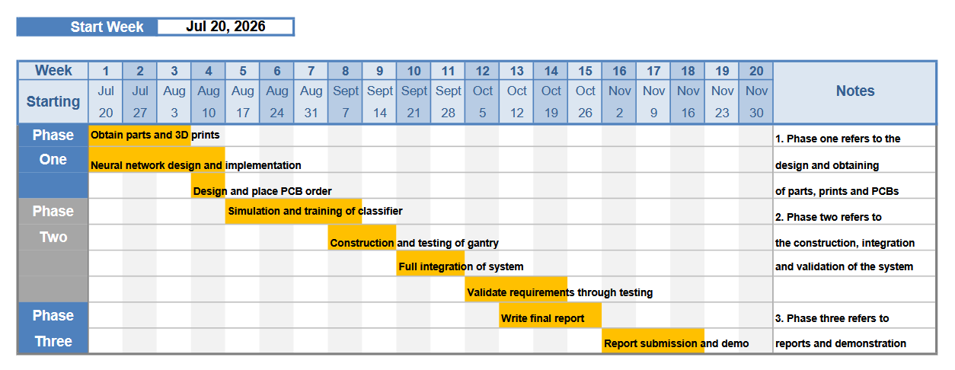
Figure 1. Second semester project plan, split into 3 stages of work to be completed.

Obtaining parts and 3D printing components | 50% | 21 July - 9 August
Neural network design and implementation | 0% | 21 July – 16 August
Design and place PCB order | 0% | 10 August – 16 August
Simulation and training of classifier | 0% | 17 August – 13 Sept
Construction and testing of gantry | 0% | 7 Sept – 20 Sept
Integration with camera, SBC, gantry and PCB | 0% | 21 Sept – 5 Oct
Validate requirements through testing | 0% | 5 Oct – 26 Nov
Write final report | 0% | 12 Oct – 1 Nov

4. References

Ref 1: (PDF) Handwritten Text Classification Based on Convolutional Neural Network. Available from: https://www.researchgate.net/publication/369471914_Handwritten_Text_Classification_Based_on_Convolutional_Neural_Network [accessed Jul 15 2026].

Ref 2: https://trepo.tuni.fi/bitstream/handle/123456789/24419/Teikari.pdf;jsessionid=4420C6BCD8D70909D9CD43262F832236?sequence=3

Ref 3:
https://www.scitepress.org/Papers/2023/128010/128010.pdf

Ref 4:
https://www.ijisae.org/index.php/IJISAE/article/view/7443/6436

Ref 5:
https://arxiv.org/pdf/2406.04511
Ref 6:
https://ictactjournals.in/paper/IJSC_Vol_12_Iss_1_Paper_1_2457_2463.pdf

Ref 7:
https://www.mdpi.com/1424-8220/21/18/6273
Ref 8:
https://dl.acm.org/doi/fullHtml/10.1145/3495018.3501199

Ref 9:
https://www.iqsdirectory.com/articles/linear-actuator/types-of-linear-actuators.html

Ref 10:
https://helios2.mi.parisdescartes.fr/~vincent/siten/Publications/theses/pdf/Siddiqi.pdf

