Hunt For the Wumpus

Dylan Clarry

Overview

You are stuck in a cave with a vicious creature called the Wumpus! You must hunt it down before if gets you, but you can’t see anything and need to rely on your handy Wumpus Detector. Be careful not to get too close to the Wumpus or he’ll eat you, but if you shoot it before you run out of ammo you’ll make it out alive.

Controls

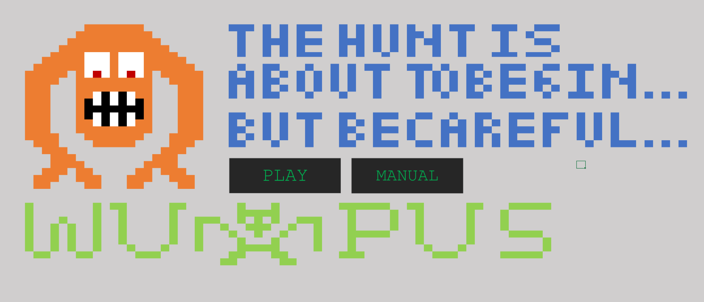

This is the main menu. Press play to start the game. Press Manual for a manual.

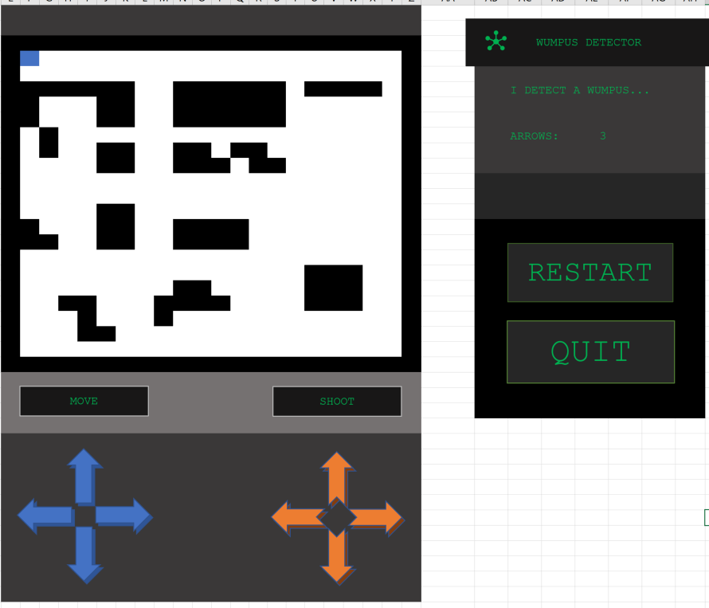

This is the game board.

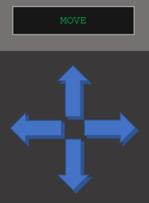

Blue arrows control your movement.

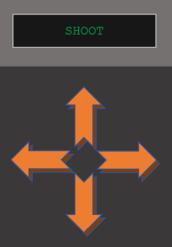

Orange arrows let you shoot an arrow in a one block radius.

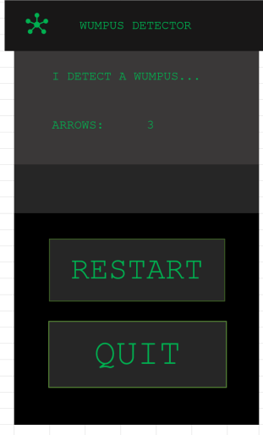

This is your Wumpus Detector. It lets you know what it detects, how many arrows you have, and if you hit anything. Restart will load a new map and reposition you. Quit will go back to the main menu.

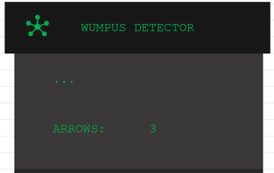

Nothing nearby.

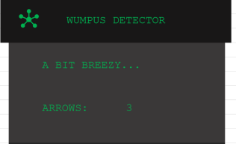

Near a hole.

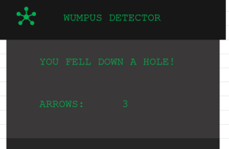

Fell down a hole.

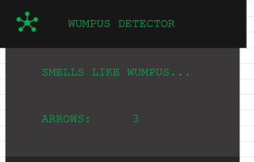

Near a Wumpus.

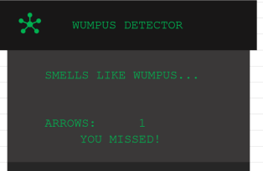

Arrow misses.

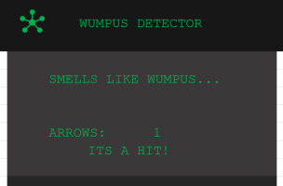

Arrow hits.