Problem: AutoStore users will sometimes delete bins from the AutoStore without deleting the corresponding TU in SynQ. If there is a task for the bin in SynQ, the system will reportedly come to a complete stop until the discrepancy is corrected.

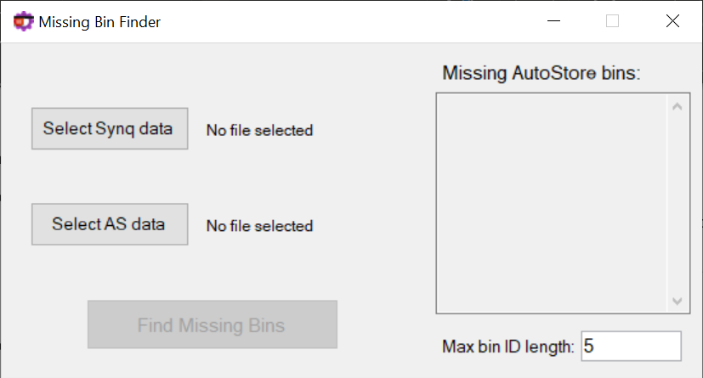App Description: The AutoStore Missing Bin Finder allows a user to compare two data files – one for SynQ TUs and one for AutoStore bins – in order to quickly determine which bins are missing in the AutoStore.

Data requirements:

* SynQ data
  + The SynQ data must be in **.xlsx** (Excel) format. This is the default export format for SynQ.
  + **The SynQ TU data must have a column which is headed by “TU” in the first row**. The app uses this header to identify the column with the TU data, as the column index of the TU data may be different depending on the user.
  + The TU column may have empty cells. The application should ignore them.
* AutoStore data
  + The AutoStore data must be in **.csv** format. This is the default export format for the AutoStore console. The AutoStore console data unfortunately does not translate well when converting to **.xlsx** format.
  + **The AutoStore bin data must have a column which is headed by “Bin” in the first row**. The app uses this header to identify the data, as the column index of the TU data may be different depending on the user.
  + The Bin column may have empty values (though there shouldn’t be any by default). The application should ignore them.

Instructions for use:

1. Export the TU data using SynQ’s Excel export tools highlighted below. It is recommended to export data from the “Tasks” screen in SynQ, rather than the “TU” screen.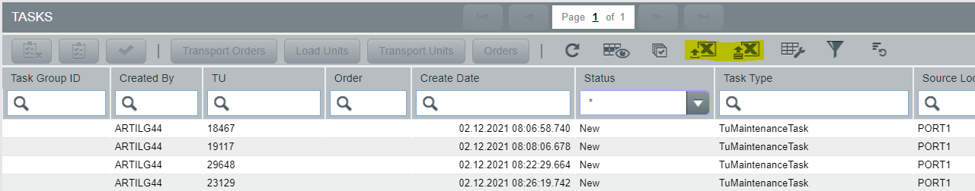
2. Export the Bin data using the export features of the AutoStore Console. Navigate to the Bin tab and use the hotkey for exporting (CTRL-E by default).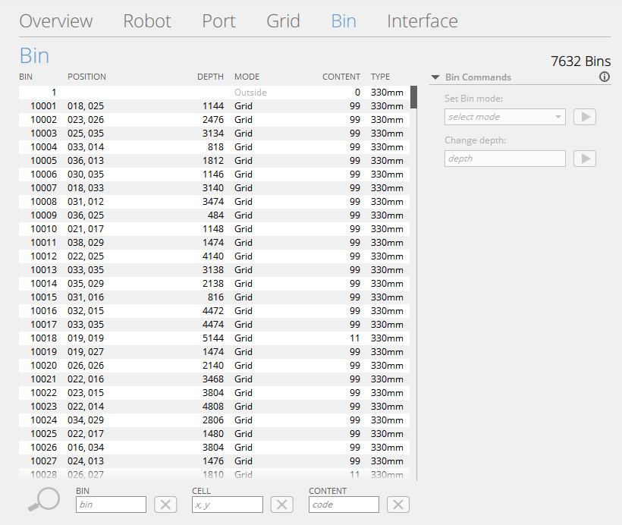
3. Use the “Select SynQ data” button to select the SynQ TU data file to use. Select the file created in step 1.



1. Use the “Select AS data” button to select the AutoStore Bin data file to use. Select the file created in step 2.



1. Once both files have been selected, the “Find Missing Bins” button should enable. Press this button to compare the two files for missing AutoStore bins.

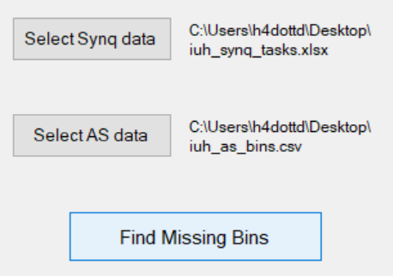

1. The following window will be displayed during processing.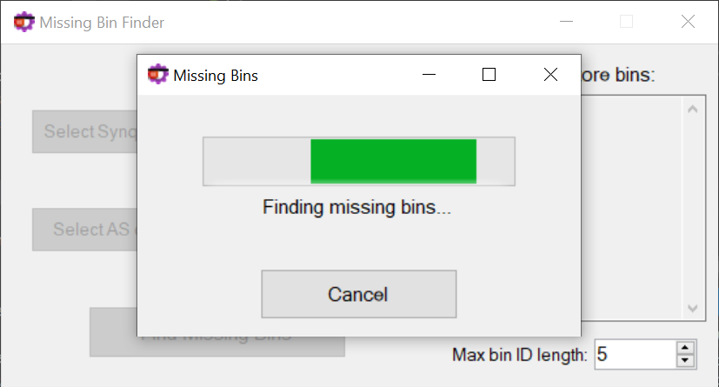
   1. You can use the “Cancel” button to cancel the operation. It may take a few seconds to cancel while the background thread is cleaned up. You can use the “X” button to cancel the operation without waiting for the thread cleanup.
   2. Any exceptions encountered during processing should be displayed in a popup window.

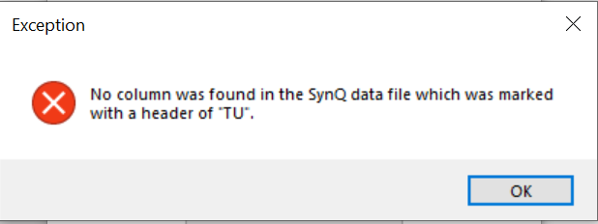

1. After processing is complete, the results will be displayed in the “Missing AutoStore Bins” table.

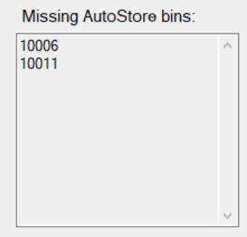

1. 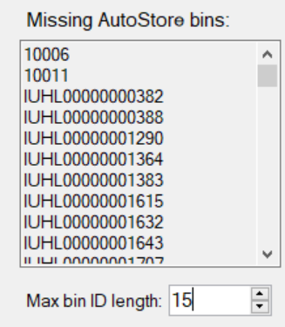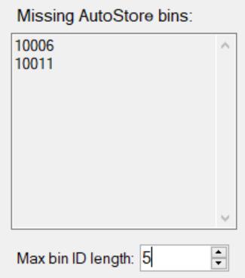You can use the “Max bin ID length” input field to specify the maximum bin ID length. Bin IDs are most likely 5 characters or less, but this feature is present in the event a site has 100,000 bins or more.