**SYSTEMS ENGINEERING MANAGEMENT PLAN FOR THE**

Multi-Modal Intelligent Traffic Signal System

Deployment Readiness Enhancements

(Phase III)

**Version 1.0**

**June 2018**

University of Arizona (Lead)

University of California PATH Program

**PREFACE**

This Systems Engineering Management Plan (SEMP) is intended to supplement the details of the Project Management Plan (PMP) and focuses on the technical plan of the project and the systems engineering processes to be used for the Pool Fund: Multi-Modal Intelligent Traffic Signal System (MMITSS) project.

The plan has been tailored from the US Department of Transportation, Federal Highway Administration – California Division Systems Engineering Guidebook for Intelligent Transportation Systems, November 2009. This document has been modified to meet the needs and expectations of the Multi-Modal Intelligent Traffic Signal System (MMITSS) project

The MMITSS Principal Investigator (Professor Larry Head) assumes responsibility for this document and updates it as required to meet the needs of the Sponsor. Updates to this document are performed in accordance with the MMITSS Configuration Management Process.

**RECORD OF CHANGES**

*A - ADDED M - MODIFIED D – DELETED

|  |  |  |  |  |
| --- | --- | --- | --- | --- |
| VERSION NUMBER | DATE | NUMBER OF FIGURE, TABLE OR PARAGRAPH | TITLE OR BRIEF DESCRIPTION | CHANGE REQUEST NUMBER |
| 1.0 | 6/2018 | - | Draft | - |

**TABLE OF CONTENTS**

**Section Page**

SECTION 1.0 PURPOSE OF DOCUMENT 5

SECTION 2.0 SCOPE OF PROJECT 5

2.1 Project Summary 5

2.2 Program Organization and Stakeholders 5

SECTION 3.0 TECHNICAL PLANNING AND CONTROL 7

3.1 Open Source Project 7

SECTION 4.0 SYSTEMS ENGINEERING PROCESS 8

3.3 Work Breakdown Structure 9

4.2 Work Description 10

4.3 Schedule 12

4.4 Configuration Management 13

SECTION 5.0 TRANSITIONING CRITICAL TECHNOLOGIES 15

SECTION 6.0 INTEGRATION OF THE SYSTEM 15

6.1 Integration 15

6.2 Field Test and Demonstration 16

6.2.1 Testing Enhancements from Task 3 16

6.2.2 Testing Updates to System Performance Measures 16

6.3 Deployment of the System 16

6.4 Training and Support 17

SECTION 7.0 APPLICABLE DOCUMENTS 17

**LIST OF FIGURES**

**Figure Page**

Figure 1 Systems Engineering Management Planning on the Systems Engineering Life Cycle Line 9

Figure 2 Phase III Project Schedule 13

**LIST OF TABLES**

**Table Page**

Table 1 Program Roles and Responsibilities 6

Table 2 Open Source Development Tools 7

Table 3 Project Deliverables By Task 9

Table 4 Work Description By Task 10

Table 5 Phase III Work Product Identification 14

# SECTION 1.0 PURPOSE OF DOCUMENT

This Systems Engineering Management Plan [SEMP] is an extension of the Project Management Plan. The SEMP focuses on the technical tasks and is a repository for project technical plans. The SEMP identifies what items are to be developed, delivered, integrated, installed, verified, and supported. It identifies when these tasks will be done, who will do them, and how the products will be accepted and managed. Finally, it defines the technical processes to be used to produce each of the project’s products.

# SECTION 2.0 SCOPE OF PROJECT

## 2.1 Project Summary

The proposal for this project was developed in response to the request for proposal (RFP) from the Connected Vehicle Pooled Fund Study (CV PFS) to improve deployment of the MMITSS prototypes to address needs identified by the Pooled Fund Members, stakeholders, and the MMITSS developers (University of Arizona and California PATH program).

In order to make the MMITSS bundle and associated applications readily deployable, the goals of this project are to enhance the existing MMITSS prototypes that were developed and field tested in Anthem, AZ, and Palo Alto, CA and to make the MMITSS software code widely deployable with as little code customization as possible.

The objectives of this project are:

* To prioritize the enhancement components based on the USDOT’s preliminary research plan, high-level gap analysis document, and feedback from past stakeholder engagement activities.
* To enhance the existing MMITSS prototypes to expedite the deployment, which includes, but not limited to, control interface, message standard version, security, control logic and generic application algorithm.
* To work, coordinate and collaborate with other deployers (including CV Pilots and Smart Cities) / standard groups / CAMP / OEMs to build on existing research and avoid duplication where possible.
* To conduct field testing/demonstration of the enhanced components of the Multi-Modal Intelligent Traffic Signal System (MMITSS).

Improvements in Phase III include creating a more robust and maintainable application code that is hardware agnostic and interoperable or transferable regardless of the hardware vendors or products.

## 2.2 Program Organization and Stakeholders

The structure of the organizations that create and maintain this project are the Connected Vehicle Pooled Fund Study (CV PFS) Pooled Fund Members, the MMITSS developers (University of Arizona and California PATH program) and other stakeholders including a newly formed working group called the MMITSS Development Group (MDG).

Table 1 Program Roles and Responsibilities

|  |  |
| --- | --- |
| **POSITION** | **ROLES/RESPONSIBILITIES** |
| CV PFS  (Virginia Lingham, VDOT) | Project Manager for the Connected Vehicle Pooled Fund Study |
| CV PFS PI  (Brian Smith, UVA) | Principal Investigator for the Connected Vehicle Pooled Fund Study which is the overall project tasked to develop infrastructure based connected vehicle applications |
| CTS PFS Project Manager  (Hyungjun Park, UVA) | Responsible for Project Management and Oversight |
| CV PFS Project Panel   * Champion: Greg Larson (CalTrans), Faisal Saleem (MCDOT), Gene McHale (FHWA) * Members: Blaine Leonard (Utah), Chuck Felice (Utah), Virginia Lingham (Virginia), Jianming Ma (Texas), Raj Ponnaluri (Florida), Hua Xiang (Maryland), Govind Vadakpat (FHWA), Debora Curtis (FHWA), Vanloan Nguyen (Virginia), Michael Clements (Virginia), Ahmad Jawad (Oakland County), Reza Karimvand (Arizona); * References: Ray Derr (TRB) | Provides direction, review, and input to the Project Manager and Project team |
| Project Team  PI: Larry Head, UA  Co-PI: Kun Zhou, PATH | Responsible for the management and technical leadership of the project. |
| Project Team | Team members are responsible for contribution to technical execution of the project plan. PI for each Team organization is responsible for the team members at that organization.  UA:  Sherilyn Keaton, Senior Software Engineer  Niraj Altekar, Graduate Research Assistant  Debashish Das, Graduate Research Assistant  Jane Gatzemeier, Undergraduate Research Assistant  Drake Sitaraman, Undergraduate Research Assistant  PATH:  John Spring, R&D Engineering 4  Huadong Meng, Research Engineer  David Nelson, , R&D Engineering 4 |

The MDG includes key development members from each of the projects shown in the bulleted list above, along with identified individuals that are actively using one of the MMITSS prototypes from the FHWA Open Source Application Development Portal (OSADP) where each prototype deployment has been submitted. Each of these organizations will be able to assign a designated individual to the MDG who can provide technical input on development planning decisions and priority establishment. The Pooled Fund Panel members will have “final voting” rights on these decisions.

The MMITSS Phase I and Phase II projects resulted in the development of two (2) prototype software systems referred to as MMITSS-AZ and MMITSS-CA. These prototypes have been submitted to the FHWA Open Source Application Development Portal (OSADP) and there are several teams using the source code to develop systems for projects. These projects include:

* THEA Connected Vehicle Pilot Deployment (MMITSS-AZ),
* Utah DOT Connected Vehicle Deployment (MMITSS-AZ),
* San Diego Port Tenants Association (via Peloton) (MMITSS-AZ),
* Columbus Smart City (via Peloton) (MMITSS-AZ),
* V2I-Hub Integration Project (MMITSS-AZ, Battelle, UA),
* VTA, SamTrans and MTC for CV-based Transit Signal Priority along El Camino Real (MMITSS-CA),
* LADOT (MMITSS-CA), and
* Potential MMITSS implementation with other interested agencies.

# SECTION 3.0 TECHNICAL PLANNING AND CONTROL

This section lays out the plan for the systems engineering activities and is written in close synchronization with the Project Management Plan (PMP) for Phase III. Although duplication between the PMP and SEMP has been minimized, further expansion of the systems engineering effort in this document will rely on similar high level descriptions that may appear in both documents.

## 3.1 Open Source Project

This project includes software development and documentation creation and updates. This project is also intended to produce Open Source Software. All software will be delivered to the FHWA Open Source Application Development Portal (OSADP) to support further development outside of this systems engineering process.

In order to maintain an environment conducive to ongoing open source development, an open source repository will be used (e.g., GitHub, GitLab, and / or Bitbucket). Software and document change requests will be handled via issue trackers built in to the repository platform. That means that all change tracking will be open for view and maintained at the repository level. Consideration of the tools to be used in this project included review of the tools being used in the USDOT Open Data Environment (ODE) project. Table 1 shows the open source tools proposed for the USDOT ODE and for the MMITSS the project. Any of these tools may be replaced by another tool if necessary.

Table 2 Open Source Development Tools

|  |  |  |
| --- | --- | --- |
| **Tool** | **USDOT ODE \*** | **MMITSS** |
| **Version Control System** | GitHub Open Source Repository | GitHub Open Source Repository |
| **Agile Process Management** | Jira by Atlassian (Agile Process assumed) | GitHub Issues (Agile not built in, but can be used in an Agile Process environment) |
| **Project Wiki Page** | Confluence by Atlassian | GitHub Wikis |
| **Continuous Integration and Delivery** | Travis | TBD (Travis is the current choice when we get to this capability) |
| **Static Code Analysis** | SonarQube / SonarCloud | TBD |

# SECTION 4.0 SYSTEMS ENGINEERING PROCESS

This is the third phase of the MMITSS project and the Systems Engineering “V” Process has been followed for each phase. **Error! Reference source not found.** below shows the documents that are relevant for this SEMP document. The following documents already exist for MMITSS:

* Concept of Operations
* System Requirements
* High Level Design
* Detailed Design

These documents will not be updated for this phase, however the changes made to the system are reflected in the MMITSS Phase III Development Plan, MMITSS Phase III Project Management Plan, and in this SEMP. These documents will serve as the basis for new documentation developed during the software design and development process.

This systems engineering process will be used to construct, test, validate, and accept the MMITSS Phase III development readiness project components. All software delivered to the OSADP is available to external developers and any future development, by necessity, falls outside of this systems engineering process.

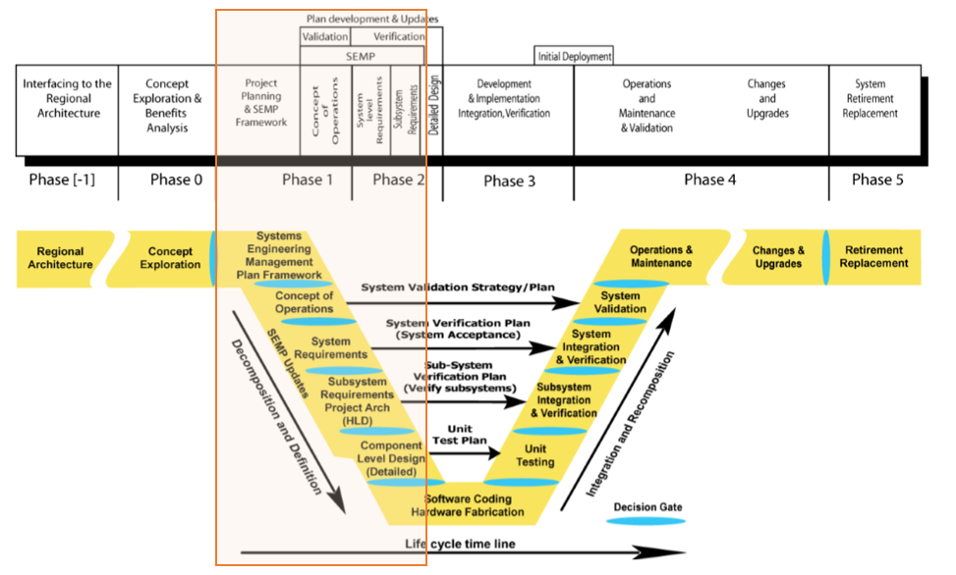

Figure 1 Systems Engineering Management Planning on the Systems Engineering Life Cycle Line

## 3.3 Work Breakdown Structure

The deliverables created in this project are intended to investigate the enhancement of existing MMITSS prototypes to make the system readily deployable. The deliverables are summarized in **Error! Reference source not found.** below with a project start date of February 1, 2018 as denoted in the Project Plan shown in Figure 2Figure 2 Phase III Project Schedule. The Tasks in this table are referred to throughout this document.

Table 3 Project Deliverables By Task

|  |  |
| --- | --- |
| **Task Name and Deliverable** | **Project Relative Date** |
| **Task 1 – Project Management and Systems Engineering Management** | |
| Briefing Materials, Kick-Off Meeting | Within 4 weeks |
| Draft PMP | 2 weeks |
| Draft SEMP | 2 weeks |
| Draft Project Schedule | 2 weeks |
| Final PMP | 6 weeks |
| Final SEMP | 6 weeks |
| Final Project Schedule | 6 weeks |
| Monthly Progress Reports | Monthly |
| Team Meetings Summaries | Within 1 week of Monthly |
| Briefing Materials, Closeout Meeting | 78 weeks |
| **Task 2 – Cross Cutting Activities** | |
| Quarterly reports of the cross cutting activities | Every quarter |
| Meeting Minutes | Within 1 week of Meeting |
| **Task 3 - Enhancement of Existing MMITSS Prototypes** | |
| Draft Deployment Readiness Development Plan and Briefing | 8 weeks |
| Final Deployment Readiness Development Plan | 10 weeks |
| Draft Task 3 Report | 35 weeks |
| Final Task 3 Report | 40 weeks |
| Public Briefing/Presentation Materials | 45 weeks |
| Public Briefing | 45 weeks |
| Code to the OSADP | 50 weeks |
| Updated MMITSS Systems Engineering Documents | 50 weeks |
| **Task 4 – Field Test and Demonstration** | |
| Draft Deployment and Field Test Plan | 48 weeks |
| Final Deployment and Field Test Plan | 52 weeks |
| Field Demonstration | 65 weeks |
| Data and Test Results to the RDE | 72 weeks |
| Draft Task 4 Report | 72 weeks |
| Final Task 4 Report | 78 weeks |
| **Task 5 – Technical Assistance to Deploy MMITSS** | |
| Select MMITSS Technical Support Recipient (new MMITSS deployment site) | 20 weeks |
| Draft MMITSS Deployment Guidance document | 68 weeks |
| Final MMITSS Deployment Guidance document | 70 weeks |
| MMITSS Results and Guidance meeting/webinar | 72 weeks |
| Draft MMITSS Deployment Lessons Learned report | 4 weeks from installation |
| Final MMITSS Deployment Lessons Learned report | 12 weeks from installation |

## 4.2 Work Description

The following work description provides an overview of each activity in the Work Breakdown Structure above.

Table 4 Work Description By Task

|  |  |
| --- | --- |
| **Task Name and Deliverable** | **Task Description** |
| **Task 1 – Project Management and Systems Engineering Management** | |
| Briefing Materials, Kick-Off Meeting | PM, Pooled Fund Study Group, PIs conducted via remote conferencing service. The purpose of the meeting will be to review the approach to the project including work activities. |
| Project Management Plan | MMITSS PI and Project Management Team will create the Project Management approach for the project in that both development teams (MMITSS-­AZ and MMITSS-­CA) will support. |
| Systems Engineering Management Plan | MMITSS PI and Project Management Team will create the SEMP that describes an overall system engineering management approach for the project in which both development teams (MMITSS-­AZ and MMITSS-­CA) will support. |
| Project Schedule | MMITSS PI and Project Management Team will create a detailed project schedule will be prepared that lists tasks, meetings, deliverables, and major milestones. The project schedule will be submitted electronically in Microsoft Project Plan (.MPP) format (MS Project 2010 or higher). |
| Monthly Progress Reports | Monthly progress conference calls will be held throughout the project. |
| Team Meetings Summaries | Meeting minutes, including action items will be submitted in PDF format within one week after the meeting. |
| Briefing Materials, Closeout Meeting | Larry Head (PI) will attend a project closeout meeting to be held during the last week of the project. During this meeting, they will present a summary of the work performed under each task, an overview and status of each deliverable, and total funds expended. |
| **Task 2 – Cross Cutting Activities** | |
| Quarterly reports of the cross cutting activities | MMITSS Project Management Team via the Monthly Progress Report. |
| Meeting Minutes | Contained in the Meeting Minutes from the Monthly Progress Report. |
| **Task 3 - Enhancement of Existing MMITSS Prototypes** | |
| Draft Deployment Readiness Development Plan and Briefing | MMITSS Team creates a Development Plan detailing the enhancements to be made to the software. |
| Final Deployment Readiness Development Plan | MMITSS Team updates the plan based on comment. |
| Draft Task 3 Report | MMITSS Team assesses the existing prototypes and other related research, describe the enhancement components and summarize the test results. |
| Final Task 3 Report | MMITSS Team updates the report based on comment. |
| Public Briefing/Presentation Materials | MMITSS Team creates materials for a presentation or public briefing. |
| Public Briefing | MMITSS coordinates with the CV PFS members and USDOT coordinator to host a public event (a webinar or a presentation in a conference) to present the enhanced MMITSS components and test results. |
| Code to the OSADP | MMITSS Team delivers the lasts code to the OSADP repository. |
| Updated MMITSS Systems Engineering Documents | Delivery to include updated documents. |
| **Task 4 – Field Test and Demonstration** | |
| Draft Deployment and Field Test Plan | MMITSS Team will develop a plan covering the test objectives, detailed test procedures, collected data, performance measures, and reporting outlines. |
| Final Deployment and Field Test Plan | MMITSS Team updates the Test Plan based on comment. |
| Field Demonstration | MMITSS Team demonstrates the MMITSS application in the Anthem, AZ, and Palo Alto, CA testbeds and document the results into a final assessment report. |
| **Task 5 – Technical Assistance to Deploy MMITSS** | |
| Draft MMITSS Deployment Lessons Learned report | MMITSS Team will produce a document capturing the key lessons learned, including perspectives of participating stakeholders. |
| Final MMITSS Deployment Lessons Learned report | MMITSS Team will update and submit the document based on review comments. |

## 4.3 Schedule

The project schedule in Figure 2 shows the duration and dates for each Task in the project. The schedule will be updated monthly to track task progress, for cost estimation monitoring, and to reflect and changes in start/end dates.

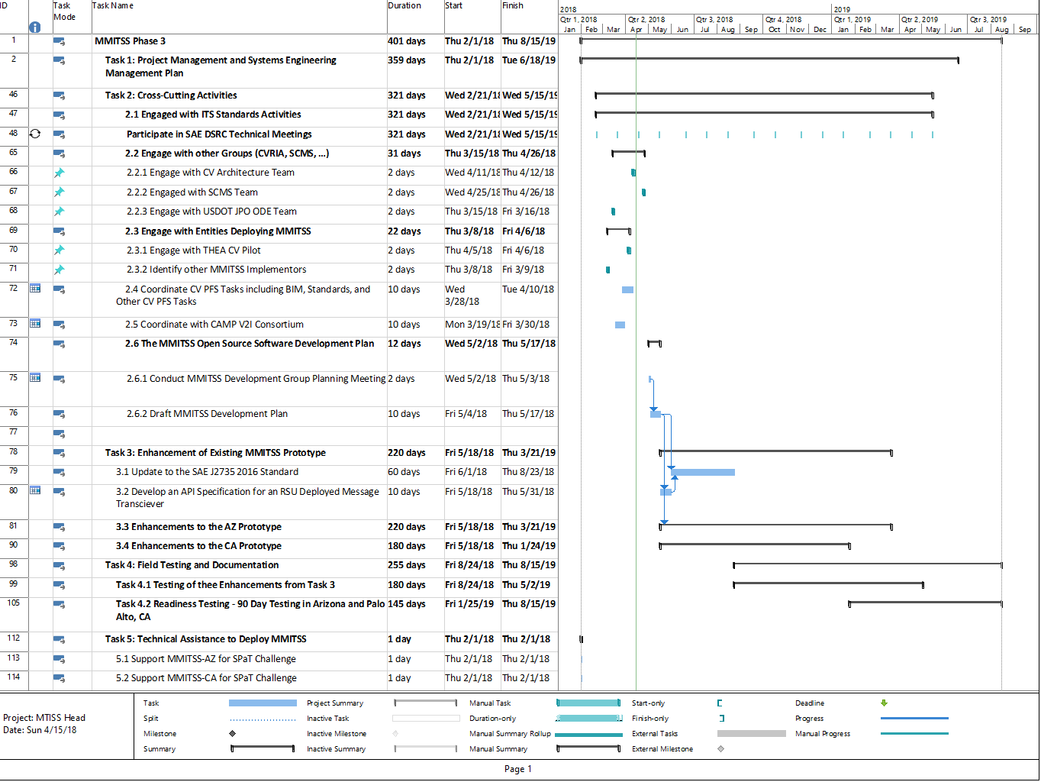

Figure 2 Phase III Project Schedule

## 4.4 Configuration Management

It is intended that each document and each element of non-proprietary, deliverable software is to be maintained under an electronic configuration management system that includes issue tracking as part of the Open Source Software Environment.

As stated previously in 3.1 , software and document change requests will be handled via issue trackers built in to the repository platform. That means that all change tracking will be open for view and maintained at the repository level.

Although relevant software and documents from this project are to be delivered to the OSADP environment, that environment is not considered a change management system for the purpose of collaborative, ongoing maintenance and development.

The evaluated metrics under configuration management include the proper work product identification, change control, records management, and change reports. Identification of work products is achieved through the establishment, adoption, and use of naming conventions.

Table 5 Phase III Work Product Identification

|  |  |
| --- | --- |
| Item | Filename |
| Project Plan | Source: MMITSS_ProjectPlan_PhaseIII.mpp  Distribution: MMITSS_ProjectPlan_PhaseIII.pdf |
| Monthly Briefings | Source: Phase3.*MonthYear*Update.pptx  Distribution: Phase3.*MonthYear*Update.pdf |
| Monthly Briefings Meeting Minutes | Source: MMITSS_*MonthYear*MonthlyMeetingMinutes.docx  Distribution: MMITSS_*MonthYear*MonthlyMeetingMinutes.pdf |
| MMITSS Development Plan | Source: MMITSS3_DevelopmentPlan.docx  Distribution: MMITSS3_DevelopmentPlan.pdf |
| MMITSS Development Group Monthly Meetings | Source: MMITSS.DevGroup.MM.DD.YYYY.pptx  Distribution: MMITSS.DevGroup.MM.DD.YYYY.pdf |
| MMITSS Source Code | Source: MMITSS GIT Repository  Distribution: via OSADP |
| System Integration and Laboratory Testing Notebook | Source: MMITSS3 MMITSS3_DevelopmentPlan _SILT.docx  Distribution: MMITSS3_STP.pdf, MMITSS3 MMITSS3_DevelopmentPlan _STPMatrix.pdf |
| Limited Simulation Experiment Report | Source: MMITSS3_SimExpReport.docx  Distribution: MMITSS3_SimExpReport.pdf |
| AZ Field Test Procedures | Source: MMITSS3_AZFieldTestProcedure.docx  Distribution: MMITSS3_AZFieldTestProcedure.pdf |
| CA Field Test Procedures | Source: MMITSS3_CAFieldTestProcedure.docx  Distribution: MMITSS3_CAFieldTestProcedure.pdf |
| AZ MMITSS System Performance Document | Source: MMITSS3_AZPerformance.docx  Distribution: MMITSS3_ AZPerformance.pdf |
| CA Test Results | Source: MMITSS3_CATestResults.docx  Distribution: MMITSS3_CATestResults.pdf |
| CA MMITSS System Performance Document | Source: MMITSS3_CAPerformance.docx  Distribution: MMITSS3_CAPerformance.pdf |
| Final Documentation | Source: MMITSS3_FinalReport.docx  Distribution: MMITSS3_FinalReport.pdf |

# SECTION 5.0 TRANSITIONING CRITICAL TECHNOLOGIES

*Risks come in many forms. They usually involve products that have not been built before. These might include novel hardware applications [e.g., new vehicle detector technology], novel software algorithms [e.g., a new approach to adaptive signal control], or challenging performance requirements [e.g., response times, and bandwidth]. Each must be identified as a risk. The technical tasks necessary to address that risk must be included in the SEMP.*

The technologies used in the MMITSS Phase III project are one generation newer than the technologies used in the MMITSS Phase II Field Test and Demonstration in the Anthem, AZ and Palo Alto, CA testbeds. The newer generation hardware includes the Roadside Units (RSU), Onboard Units (OBU), and MMITSS Roadside Processors (MRP). Both the AZ and CA testbeds are using RSUs manufactured by Savari. These units were developed based on the FHWA RSU 4.1 specification. However, preliminary testing has revealed some issues (risks) associated with the RSU 4.1 interface (Appendix C) that will require special consideration. Also, during the procurement process, two hardware/firmware issues were discovered that required Savari to provide rework. Savari continues to support the devices.

The OBUs are also of a new generation, but since there is no specification similar to the RSU 4.1 specification, there is no defined interface to the OBUs. The MMITSS Team is using some Savari IOBUY devices, but is also considering using devices from other manufacturers. Each device will require a custom interface built using a vendor supplied Integrated Development Environment (IDE). The team has the Savari IDE and won’t use other vendor’s OBUs if they don’t provide the IDE. The differences will be addressed in the OBU Interface design effort.

The MRPs to be used in CA are the same as in Phase II, so it is known that they will meet the project needs. AZ will use the Econolite CVCP board for the MRP. This board was developed to be field hardened so that it can survive the hot temperatures in Maricopa County. The board uses a standard Linux operating system and openly available took chain. The AZ team has already tested and demonstrated the use of the board.

# SECTION 6.0 INTEGRATION OF THE SYSTEM

*This section describes the methods to be used to integrate the developed components into a functional system that meets the system requirements and is operationally supportable. The systems engineering process steps to be detailed here include: integration, verification, deployment, and the training necessary to support operations & maintenance. Plans for validation of the system should also be covered. For each step, the resources [tools and personnel] are identified and products and criteria for each step defined.*

## 6.1 Integration

System integration is addressed at the development stage, in the laboratory, in local field testing facilities, and in the testbeds. The MMITSS-CA system is integrated throughout the software development process using software and laboratory hardware testing of the interfaces between devices and applications. In addition, PATH operates the Richmond Field Station test intersection where field testing can be executed before transitioning new versions of the system to the California testbed.

The MMITSS-AZ system is integrated throughout the software development process using software, software-in-the-loop, and laboratory hardware testing of the interfaces between devices and applications. In addition, the University of Arizona utilizes a test intersection at the corner of Speedway and Mountain in Tucson, AZ where field testing can be executed before transitioning new versions of the system to the California testbed.

## 6.2 Field Test and Demonstration

A Test Plan will provide the test objectives, detailed test procedures, collected data, performance measures, and reporting outlines. The plan will outline methods to collect and evaluate both baseline data (MMITSS turned off) and operating MMITSS traffic control strategies. As part of the test preparation, connected vehicle based performance metrics identified in the MMITSS Phase I project will be selected for characterizing the system performance. With the infrastructure-based detection system, each performance measure will be implemented using both actual BSMs from vehicles and emulated BSMs based on data from the SMS radars, so that we will be able to compare calculated performance metrics with observation (measurements of actual traffic). As an example, MMITSS performance measures will estimate the queue length based on connected vehicle data at different penetration rates. This estimated queue length will be compared with the observed (Through SMS radar data) distance of the last stopped vehicle from the stop bar for each lane, and / or the queue in terms of the number of stopped vehicles at each lane.

## 6.2.1 Testing Enhancements from Task 3

The Task 3 enhancements are to be field tested prior to the start of the 90-day Readiness Test (Task 4.2). A test plan will be defined and executed for each enhancement. Any issues or problems will be corrected and retested, if needed. An iterative and incremental approach to design, development, and testing will be used to ensure a stable and operating system is maintained throughout the project.

## 6.2.2 Testing Updates to System Performance Measures

The Task 3 enhancements are to be field tested prior to the start of the 90-day Readiness Test (Task 4.2). The system performance measures will be updated to collect data to support the 90-day Readiness Testing, including collection of system uptime (i.e.  System Availability), number of messages (vehicles) processed, and other system performance data identified to support evaluation of the system performance over the 90-day Readiness Test.

The updated performance measure will support future deployments. Ensuring the additional performance measures provide the desired characterization of system performance is essential to assessing the success of this project.

## 6.3 Deployment of the System

Both testbeds, CA and AZ, are continuously operating testbeds and have been so for over 5 years. As such, the implementation for the MMITSS Phase III effort is considered a deployment as well. The testbeds host demonstrations for national, regional, and local groups throughout the year. They serve as testbeds for other applications and other projects. Each testbed is supported through a partnership with the championing agency: Caltrans and MCDOT.

## 6.4 Training and Support

The MMITSS team recognizes the challenges that agencies face when considering utilizing new technologies, such as connected vehicles and MMITSS. To estimate a reasonable level of effort for this task, the MMITSS team will plan to support two SPaT Challenge projects that want to include MMITSS in the deployment corridor. One of the SPaT Challenge projects will want to use the MMITSS-CA system and one the MMITSS-AZ system. Support will include the following activities:

1. Provide an overview of MMITSS, in the context of the SPaT Challenge,
2. Discussion of the MMITSS architecture, including selecting the hardware vendors that the project chooses to install,
3. Support for the configuration of MMITSS for each of the 20 SPaT Challenge intersections including explanation of the configuration data required, MAP data, networking, etc.,
4. Support during integration and testing to answer questions and address issues identified, and
5. Support during a 90-day operation period including addressing questions or issues identified.

# SECTION 7.0 APPLICABLE DOCUMENTS

The applicable documents which are inputs to this Systems Engineering Management Plan are:

* Systems Engineering Guidebook for Intelligent Transportation Systems, Version 3, Sponsoring Agencies: US Department of Transportation, Federal Highway Administration – California Division California Department of Transportation, <http://fhwa.dot.gov/cadiv/segb>.
* Project Management Plan for the Multi-Modal Intelligent Traffic Signal System Deployment Readiness Enhancements (Phase III), University of Arizona (Lead) University of California PATH Program
* Multi-Modal Intelligent Traffic Signal System Phase III: Development Plan, University of Arizona (Lead) University of California PATH Program