

**Multi Modal Intelligent Traffic Signal System**

**Build Docker Image – User Manual**

Revision 0.1

(Initial Release)

July 13, 2020

**Table of Contents**

1. Purpose of Document 3

2. Systems Requirements 3

3. Build Docker Image 3

**List of Figures**

Figure 1: Snapshot of the dockerfile for base image (arm) 4

Figure 2: Snapshot of the dockerfile for base image (x86) 4

Figure 3: Snapshot of the dockerfile for the VSP image 5

Figure 4: Snapshot of the dockerfile for the MRP image 5

# Purpose of Document

This document is a guide for building docker images to deploy Multi-Modal Intelligent Traffic Signal System (MMITSS) software components in docker containers. The base image contains the source code, libraries, dependencies, tools, and other files which are required to run the applications. The vehicle side processor (VSP) image or mmitss roadside processor (MRP) image can be built by extending the base image. The VSP image contains only those applications which are required from the connected vehicle perspective and or MRP image contains only those applications which are required from the intersection perspective.

# Systems Requirements

To build docker image for deploying MMITSS in the docker container, following requirements are required to meet:

1. MMITSS roadside software components can be run in the Connected Vehicle Co-Processor (CVCP). To build the docker image and run the MMITSS roadside software components in the CVCP, install Ubuntu Bionic 18.04.3 operating systems. The operating systems can be installed by following the instructions found in [https://boundarydevices.com/ubuntu-bionic-18-04-3-lts-for-i-mx6-7-boards-august-2019-kernel-4-14-x/#](https://boundarydevices.com/ubuntu-bionic-18-04-3-lts-for-i-mx6-7-boards-august-2019-kernel-4-14-x/)
2. MMITSS vehicle side software components are run on a Raspberry Pi. Building the docker image and running the MMITSS vehicle software components on the Raspberry Pi, Ubuntu 18.04 Server operating systems must be installed.
3. Both roadside and vehicle side applications can be run on the x86 platform. Building the docker image and running the MMITSS software components on the x86 platform require that the Ubuntu 18.04.4 operating systems is installed.
4. Install docker and supervisor and clone the mmitss repository.
5. If MMITSS path is not set already, set the MMITSS path in the .bashrc file by executing the following command:

Export /MMITSS_ROOT=<mmitss directory>

For example if mmitss is cloned on home/user directory then the command will be:

Export /MMITSS_ROOT=/home/user

# Build Docker Image

Docker images for VSP and MRP are available on Docker Hub. However, if you wish to build your own images then the following applies.

To build the docker image for deploying the MMITSS software components requires the following:

**Step 1:** Define a Dockerfile for the base image

The base image can be built for an arm or a x86 machine. The dockerfile for the base image is located in the root level of the mmitss repository. An example of the base image of a Dockerfile for an arm or x86 machine is as follows. The only difference between the architectures would be the naming of the base image and libraries i.e. arm or x86.

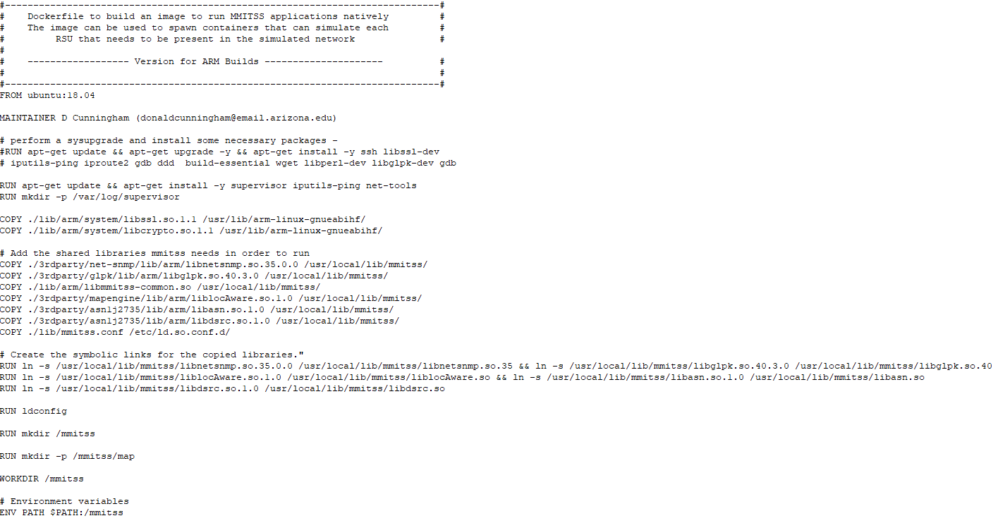

**Figure 1:** Snapshot of the dockerfile for base image (arm)

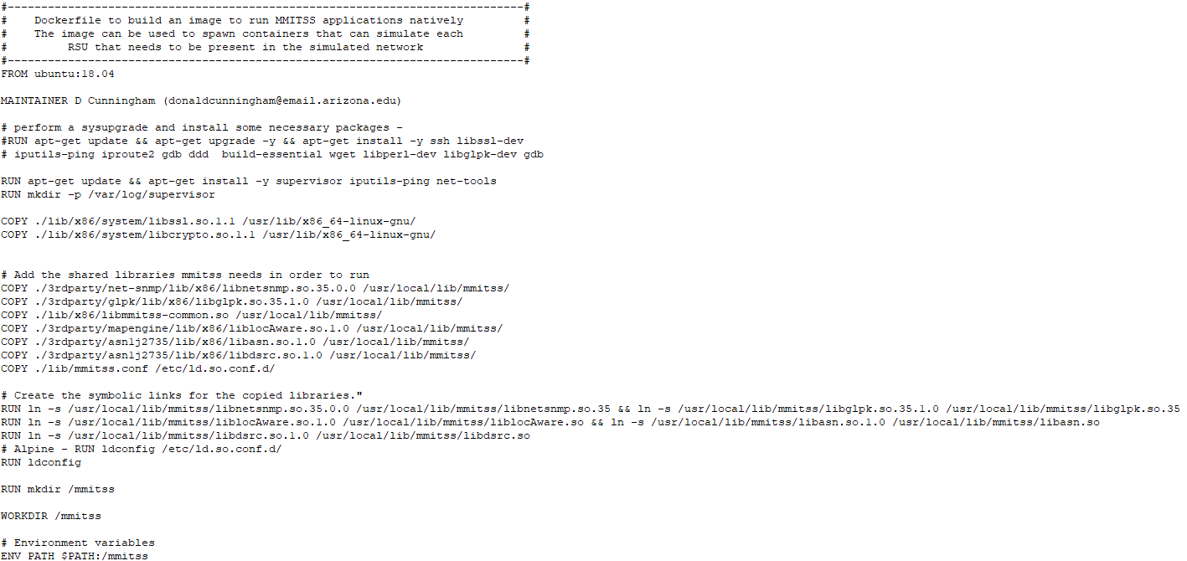

**Figure 2:** Snapshot of the dockerfile for base image (x86)

**Step 2:** Define Dockerfile for VSP/MRP

The applications for VSP and MRP are different. From the base image, it is required to create VSP docker image and MRP docker image. To create docker image for VSP and MRP, it is required to define to new dockerfiles. In the docker file, the name of the base image has to be defined correctly. Example of dockerfile for the VSP and the MRP are following:

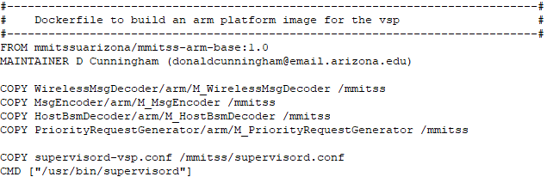

**Figure 3:** Snapshot of the dockerfile for the VSP image

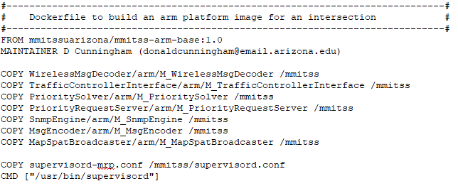

**Figure 4:** Snapshot of the dockerfile for the MRP image

**Step 3:** Build the docker image

To build the docker image for VSP and MRP following commands can be executed sequentially:

1. Go to the directory where base image dockerfile is located. For example:

cd /home/user/mmitss

1. Build the base docker image.

docker build –t <name of the image>:<tag> -f <path to dockerfile> .

For example, to build the base image for the arm box following command can be executed:

docker build –t mmitss-arm-VSP-base:1.0 -f /home/user/mmitss/Dockerfile.arm_base .

1. Go to mmitss/scripts directory and make all the applications For example to make all the applications for the arm box, execute the following:

cd /home/user/mmitss/scripts

./mmitss_docker_make_all_for_arm.sh

To make all the applications for the x86 box, run the following script:

mmitss_docker_make_all_for_x86.sh

1. Build VSP or MRP image by executing the following command

docker build –t <name of the image>:<tag> -f <path to dockerfile> .

For example to build the VSP docker image for the arm box, following command can be executed:

docker build –t mmitss-arm-VSP:1.0 -f /home/user/mmitss/bin/dockekerfiles/arm/Dockerfile-VSP.arm .