實驗12-new：Finite State Machine Application
一、實驗目的： 串列信號產生器及偵測器
學習Verilog code 去design state machine (Mealy machine)

題目: 學習Verilog code 去design state machine (digital design Lab 12 and Lab 13)
- 串列信號產生器: 請用學號後8碼, 模擬的時脈產生電路 其中 1<= 號碼 <=2 的為”1”其它為”0”， 例如: C108110101, 取 08110101 產生 -> 00110101
- 偵測器: 學號後2碼 mod 4, “餘數” 當pattern, Ex: 108110101, (01 mod 4) = 01
二、 HDL code and testbench code for the above circuits:
// Code your design here
// Lab 12-new: serigen
module lab12new(out,clk, reset,seriout);

//input [3:0] sel;
input clk, reset;
output seriout;
output out;

//input In3;
//input In4;
//output out1;
reg [2:0] count; // 8 states, 3-bits
reg seriout;

reg out;
parameter hight=1,low=0; // parameter for define the states
parameter s0=3'd0,s1=3'd1,s2=3'd2;
reg [2:0] state;
reg [2:0] next_state;

// 3-bit counter
//
always @(posedge clk or negedge reset)
begin
if (~ reset)
count =0;
else
count=count+1;
end

// Current sate
always @(posedge clk or negedge reset)
begin
if (~reset)
state = s0;
else
state = next_state;
end

always @(count)
begin
case (count) // MUX based combinational ckt
0: seriout=0;
1: seriout=0;
2 : seriout=1;
3 : seriout=1;
4 : seriout=0;
5 : seriout=1;
6 : seriout=0;
7 : seriout=0;

default : seriout=0;
endcase
end

always @(state or seriout )
begin

case (state)
s0: if (seriout==1 )
next_state = s0;
else
next_state = s1;
s1: if (seriout==1 )
next_state = s2;
else next_state = s1;
s2:next_state = s0;

endcase

end
// output stage
//

always @(state)
begin
case (state)
s0: out=low;
s1: out=low;
s2: out=hight;

default: out=low;

endcase
end

endmodule================= Testbench==================
// Code your testbench here
// or browse Examples
// Verilog test

`timescale 1ns / 1ns

module lab12newtestbench;

// Inputs
reg clk, reset;
//
// output
wire seriout;
wire out;

// Bidirs
lab12new u1(out,clk, reset,seriout);

// Initialize Inputs
initial
clk=0;
always
#5 clk=~ clk;

initial
begin
reset=0;
#20 reset=1;
#400 $finish;

end
initial begin

$dumpfile("dump.vcd");
$dumpvars(1);
end

endmodule

三、Simulation Waveform in EDAPlayground
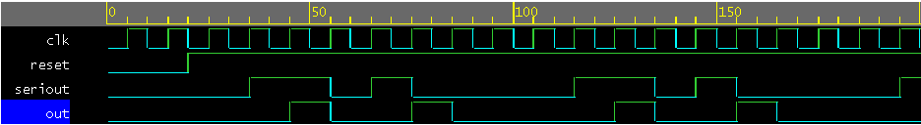
學號後兩碼49/4=1 =>01
偵測到串列輸出01後out出現1

