實驗九：Finite State Machine using Verilog
題目: 學習Verilog code 去design state machine
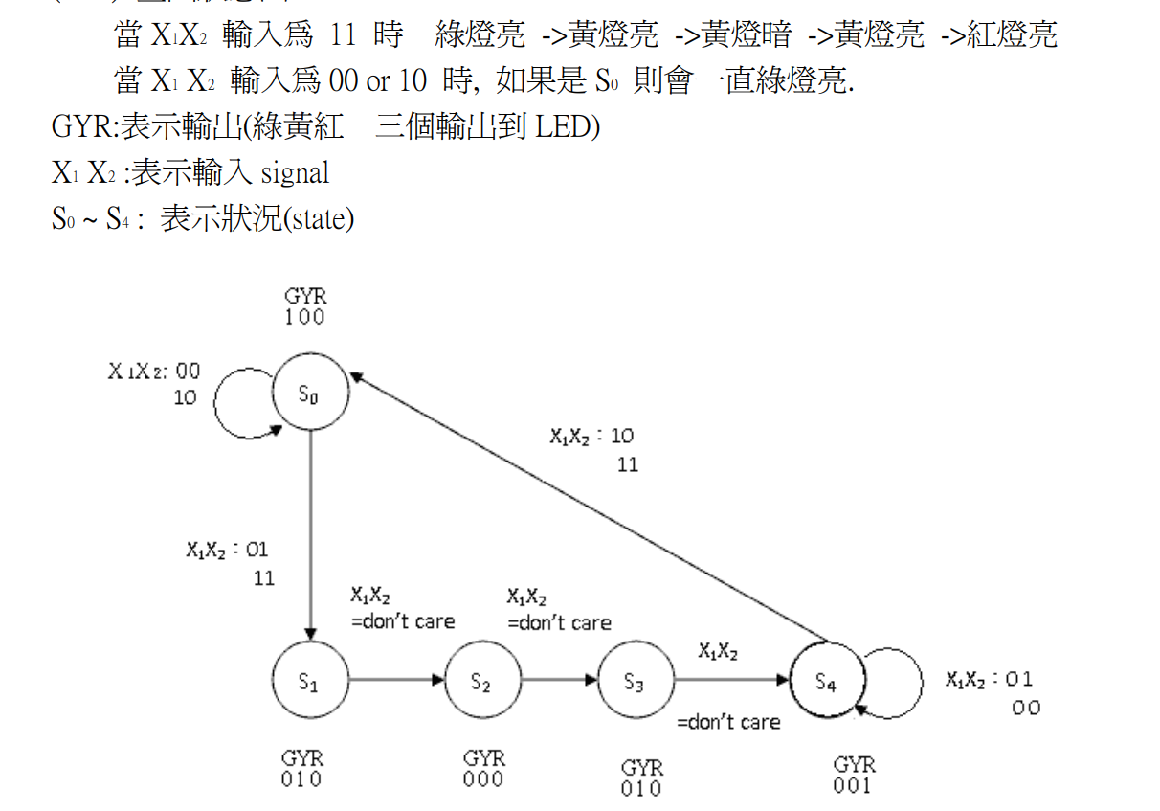
自己學號後兩碼，分成 5 大組，將自己學號(偶數)後 2 碼除以 2 選尾數 : 分成 5 大組
(如果學號是奇數者, 請用最後一碼) Ex: 9751020 → 20/2 =10 選(E), 9751088 → 88/2 =44
選(D) 請詳細看 Lab 11_補充資料.
(A) 1, 6：在 S0 後, 增加一個 state S1, (X1X2 = xx, GYR= 000), 原先 S1 S2 S3 S4 變成
S2 S3 S4 S5 state (其輸入/輸出條件不變).
(B) 2, 7：在 S3 後, 增加一個 state S4, (X1X2 = xx, GYR= 000), 原先 S4 變成 S5 state
(其輸入/輸出條件不變).
(C) 3, 8：在 S0 後, 將 state S1 刪除, 原先 S2 S3 S4 變成 S1 S2 S3 state (其輸入/輸出
條件不變).
(D) 4,9：在 S1 後, 將 state S2 刪除, 原先 S3 S4 變成 S2 S3 state (其輸入/輸出條件不
變).
(E) 5,10：在 S2 後, 將 state S3 刪除, 原先 S4 變成 S3 state (其輸入/輸出條件不變)

一、實驗目的：
學習Verilog code 去design state machine

第D組
二、 HDL code for the above circuit:

// Code your design here
module state_machine(gry,clk,x,reset);
input [1:0] x; // input for cotrol
output [2:0] gry; // output led lights
input clk,reset;
reg [2:0] gry;
parameter Green=3'b100,Yellow=3'b010,Red=3'b001,black=3'b000; // parameter for define the states
parameter s0=3'd0,s1=3'd1,s2=3'd2,s3=3'd3,s4=3'd4;
reg [2:0] state;
reg [2:0] next_state;
//reg [15:0]count1=0;
//reg [15:0]count2=0;
reg divclk=1;

reg [31:0] count=0;
always @(posedge clk)
begin
count=count+1;
// divclk=count[0];
end

// Current sate
always @(posedge clk or negedge reset)
begin
if (~reset)
state = s0;
else
state = next_state;
end

// Next state

always @(state or x )
begin

case (state)
s0: if (x==2'b00 || x==2'b10)
next_state = s0;
else
next_state = s1;
s1: next_state = s3;
//s2: next_state = s3;
s3: next_state = s4;
s4: if (x==2'b10 || x==2'b00)
next_state = s4;
else
next_state = s0;
endcase

end
// output stage
//

always @(state)
begin
case (state)
s0: gry=Green;
s1: gry=Yellow;
//s2: gry=black;
s3: gry=Yellow;
s4: gry=Red;
default: gry=black;

endcase
end

endmodule

====================================================================

// Code your testbench here
// or browse Examples
// Code your testbench here
// or browse Examples
// Verilog test
// Verilog test

module lab08testbench;

// Inputs
reg clk;
reg reset;
reg [1:0] x; // for control signals

// Output
wire [2:0] gry; // output from lab07
// wire counterdiv;

// Call the module of lab 07
//
state_machine u1(gry,clk,x,reset);

// Initialize Inputs

initial
clk=0;
always
#2 clk=~clk; // t=2 ns , 500 mhz

initial
begin
x=2'b00;
#0 reset=0; // reset the signal
#20 reset=1;
#100 x=2'b11;
#100 x=2'b10;
#2000 $finish;

end

initial begin

$dumpfile("dump.vcd");
$dumpvars(1);
end

endmodule

三、Simulation Waveform in EDAPlayground



