實驗八：Seven Segment using Verilog
題目: C108110249

一、實驗目的：
練習Verilog 設計sequential circuit, 控制 seven segment.

二、實驗步驟與結果：
請先download the 範例 to verify the Seven Segment
1: 是否可download 到FPGA 板

2: Seven Segment 功能是否正常?

三、a: HDL code for the above circuit:
// Start of main code
//
module sevensegment(clk,rst,led, SSCom, DisOut);
input clk, rst;
output [3:0] led;
output [3:0] SSCom;
output [7:0] DisOut; // Output to seven segment
//
led u1(clk, rst, led, SSCom);
hextoseg u2(led, DisOut);

endmodule
//

//

module led(clk, rst, led, SSCom);
//
input clk, rst; // input to the led module
output [3:0]led; // led output with 8 bits
output [3:0]SSCom; // this is the com enable signal for seven segment
reg [3:0]led; // define the led register with 8 bits
reg [3:0]SSCom; // define the SSCom register
reg [23:0]count; // The count register is for dealy
reg [4:0]count_no;
reg state;
//

always @(posedge clk ) // at the rising edge
begin
state=0;
if(rst) // the rst is high
begin // most of the time will enter this begin - end
//////////////up////////////
if(count_no<3 && state==0) // test for the delay

begin
if(count == 24'hEB8D80)
begin
count_no = count_no+1; // clear the count, re-start
led = led + 1; // shift right one bit of the led rgister

if(count_no==3)
begin
count=0;
count_no=0;
state=1;
end
end
else
begin
count = count + 1; // delay time + 1
end
end
//////down///////////
if(count_no<2 && state==1) // test for the delay
begin
if(count == 24'hEB8D80)
begin
count_no = count_no+1; // clear the count, re-start
led = led - 1; // shift right one bit of the led rgister

if(count_no==2)
begin
count=0;
count_no=0;
state=0;
end
end
else
begin
count = count + 1; // delay time + 1
end
end
end
////////////////////////
else
begin // rst =0 , initail setting
count = 0;
led = 4'h0;
SSCom = 4'hE; // disable the SSCom
end
end

endmodule

//
// HEX convert to seven segment
//
//
module hextoseg(din, seven_seg);
input [3:0]din;
output [7:0] seven_seg;
reg [7:0] seven_seg;

// dot h g f e d c b a
// low: led on
//hexadecimal code converter seven segment code
always @(din)
begin
case (din)
0: seven_seg<=8'b11000000;
1: seven_seg<=8'b11111001;
2: seven_seg<=8'b10100100;
3: seven_seg<=8'b10110000;
4: seven_seg<=8'b10011001;
5: seven_seg<=8'b10010010;
6: seven_seg<=8'b10000011;
7: seven_seg<=8'b11111000;
8: seven_seg<=8'b10000000;
9: seven_seg<=8'b10011000;
10: seven_seg<=8'b10001000;
11: seven_seg<=8'b10000011;
12: seven_seg<=8'b11000110;
13: seven_seg<=8'b10100001;
14: seven_seg<=8'b10000110;
15: seven_seg<=8'b10001110;

endcase
end
endmodule

B: ise 14.1 Synthesis的schematic：
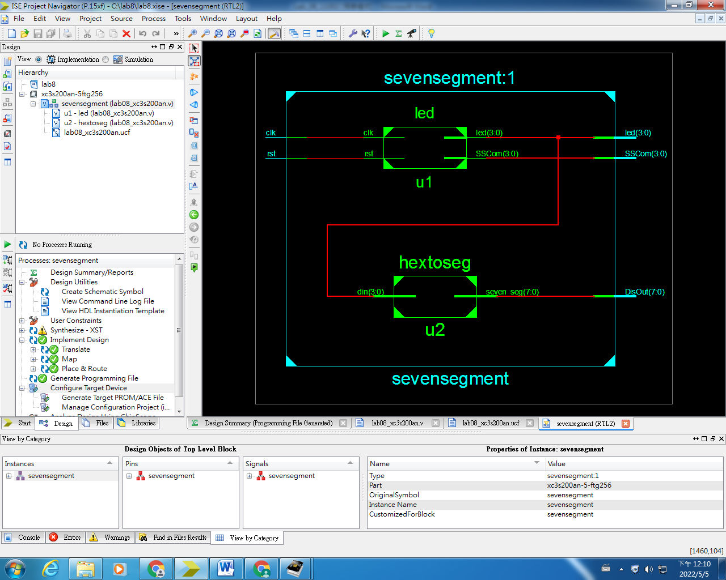
四、ise 14.1 顯示出的resource 使用情形
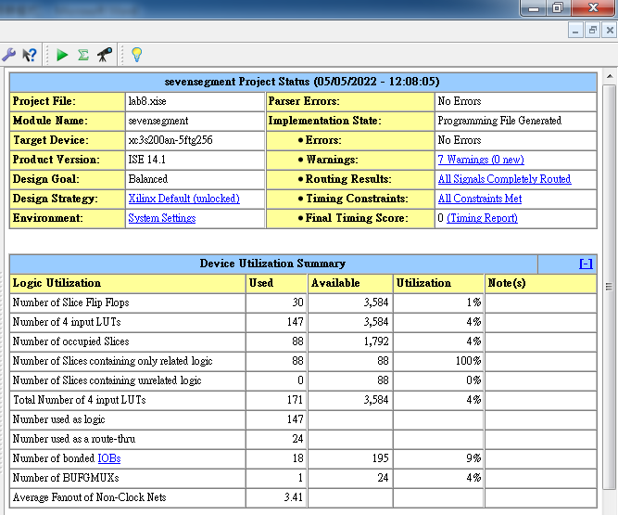

五、拍照ise 14.1 七段顯示出的情形(1 picture)


