FORMA BATHROOMS
Meta Ads — Static Creative & Copy

Three production-ready static ads built to drive traffic to formabathrooms.com/funnel.html. Each concept hits a distinct audience angle — putting-it-off, water damage urgency, and pre-sale renovation — with full A/B-ready copy variations.

# | CONCEPT | AUDIENCE | HOOK
01 | The Putting-It-Off Homeowner | Melbourne homeowners 35-65 who have been in the home 5+ years and have an outdated bathroom they keep meaning to do something about. | Pain + identity
02 | Water Damage / Mould Urgency | Melbourne homeowners with active water damage or mould — more urgent, higher-intent. | Urgency + cost-of-delay
03 | Pre-Sale Renovation / ROI | Melbourne homeowners planning to list their home in the next 3–12 months. | ROI + opportunity cost

How to use this
Drop the three PNGs into Meta Ads Manager (one per ad). For each concept, paste the corresponding Variant A primary text and Headline A as your launch creative; load Variants B and C as additional ads in the same ad set so Meta can test them against each other.

Recommended campaign structure
- Campaign objective: Leads (or Conversions if your pixel is firing the Lead event reliably).
- One ad set per audience angle — keeps learning clean and lets you scale winning angles independently.
- Ad set 1: Putting-it-off → Concept 1 + 3 primary text variants. Audience: Melbourne homeowners 35–65, interest: home improvement / renovation, behaviour: home owners. Exclude renters.
- Ad set 2: Water damage → Concept 2. Same demographic. Layer interests: mould, water damage, plumbing repair.
- Ad set 3: Pre-sale → Concept 3. Layer interests: real estate, property selling, downsizing. Behaviour: likely to move.
- Placements: Auto Placements with the 4:5 creatives — Meta will scale to feed, Reels and Stories. For maximum polish on Stories/Reels, also build a 9:16 (1080×1920) version using the same Concept HTML (request that and I’ll generate them).
- Daily budget: start at $30–$50/day per ad set; let each run 4–7 days before judging.
- Conversion event: Make sure your Meta Pixel “Lead” event is firing on funnel.html submission. The funnel HTML already has the // PIXEL // commented placeholders — they need to be replaced with your actual fbq init + Lead event.

What to swap if/when you have hero photography
These ads are typography-led so they work on day one. When you have a strong before/after photo or a hero shot of a finished bathroom, the highest-leverage version of the same ad is: dim the background to ~65% black, place the same brass eyebrow + bold headline over it, keep the bottom promise strip + CTA. Same composition, dramatically more thumb-stopping in feed.

Concept 01 · The Putting-It-Off Homeowner
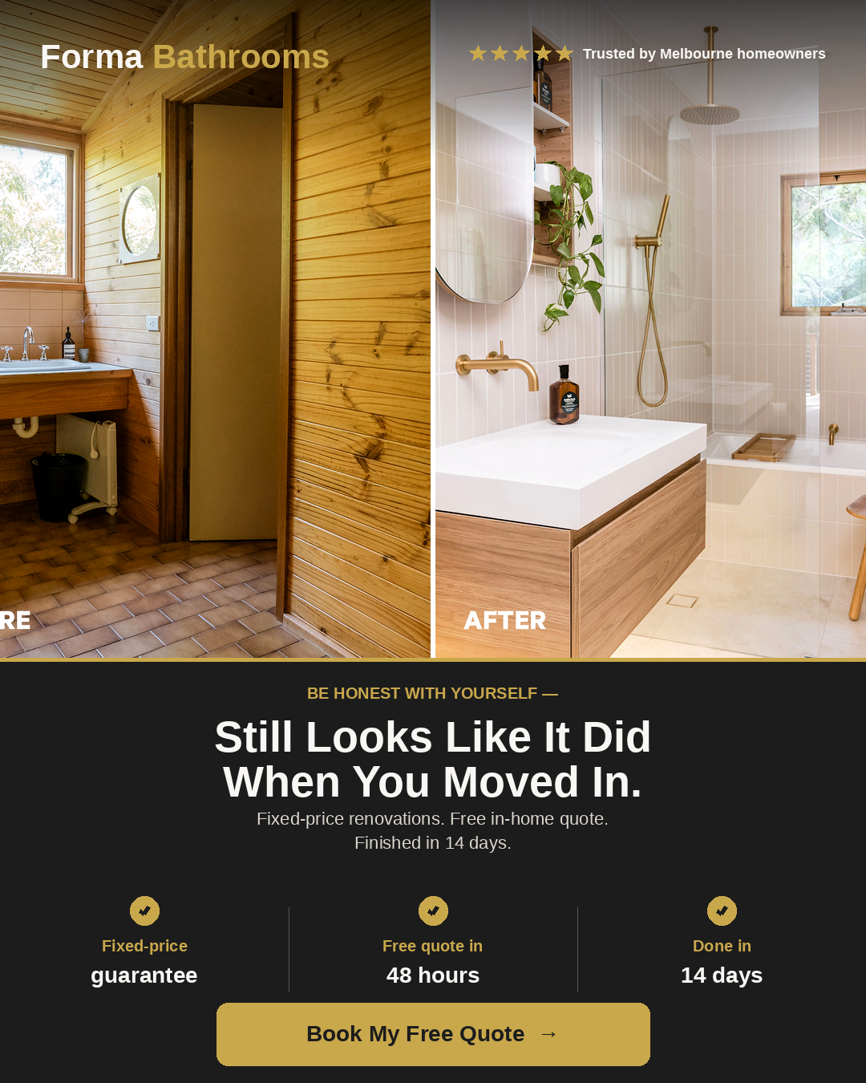
forma_ad_01_putting_it_off_4x5.png
CONCEPT BRIEF
AUDIENCE | Melbourne homeowners 35-65 who have been in the home 5+ years and have an outdated bathroom they keep meaning to do something about. Highest-volume audience.
HOOK | Direct-call-out emotional pain. The bathroom hasn’t changed since you moved in. You've been meaning to. Stop putting it off — it's easier than you think.
CTA BUTTON | Book Now
DESTINATION | https://formabathrooms.com/funnel.html
IMAGE FILE | forma_ad_01_putting_it_off_4x5.png
SIZE | 1080 × 1350 (Meta 4:5 feed — recommended)
PRIMARY TEXT — 3 VARIATIONS TO A/B TEST
Goes above the image in feed. Meta truncates at ~125 chars on mobile (“See more”).
Variant A
Be honest — when was the last time you actually felt good walking into your bathroom?

For most of the homeowners we meet across Melbourne, it’s been years.

Forma Bathrooms gives you a fixed-price written quote within 48 hours and finishes the full reno in 14 working days — site cleaned every evening, no blow-outs, no mess.

Free in-home consultation. Zero obligation.
👉 Tap below to book yours.
Variant B
That bathroom isn’t going to renovate itself.

You’ve been meaning to deal with it for — how long now? Two years? Five?

Forma Bathrooms makes it embarrassingly simple: we come to you, give you a fixed-price written quote in 48 hours, and finish the job in 14 working days flat.

If we go over budget, we cover the difference. If we run late, we discount $500/day.

Book your free in-home quote 👇
Variant C
Stop avoiding that one room when guests come over.

We’re Forma Bathrooms — Melbourne’s fixed-price renovation specialists. Free in-home consult. Quote in 48 hours. Finished in 14 days. Site cleaned at the end of every working day.

No high-pressure sales. No surprise costs. Just a beautiful bathroom you’re actually proud of.

Tap below to book 👇
HEADLINES — SITS BELOW THE IMAGE, MAX 27 CHARS IN FEED
A. It’s time. Book your free quote. (32 chars)
B. Fixed price. 14 days. Done. (27 chars)
C. Melbourne’s fixed-price bathroom reno (37 chars)
DESCRIPTIONS — ONLY SHOWN ON SOME PLACEMENTS (MAX 27 CHARS)
A. Free quote within 48 hrs (24 chars)
B. Melbourne · Fixed price (23 chars)

Concept 02 · Water Damage / Mould Urgency
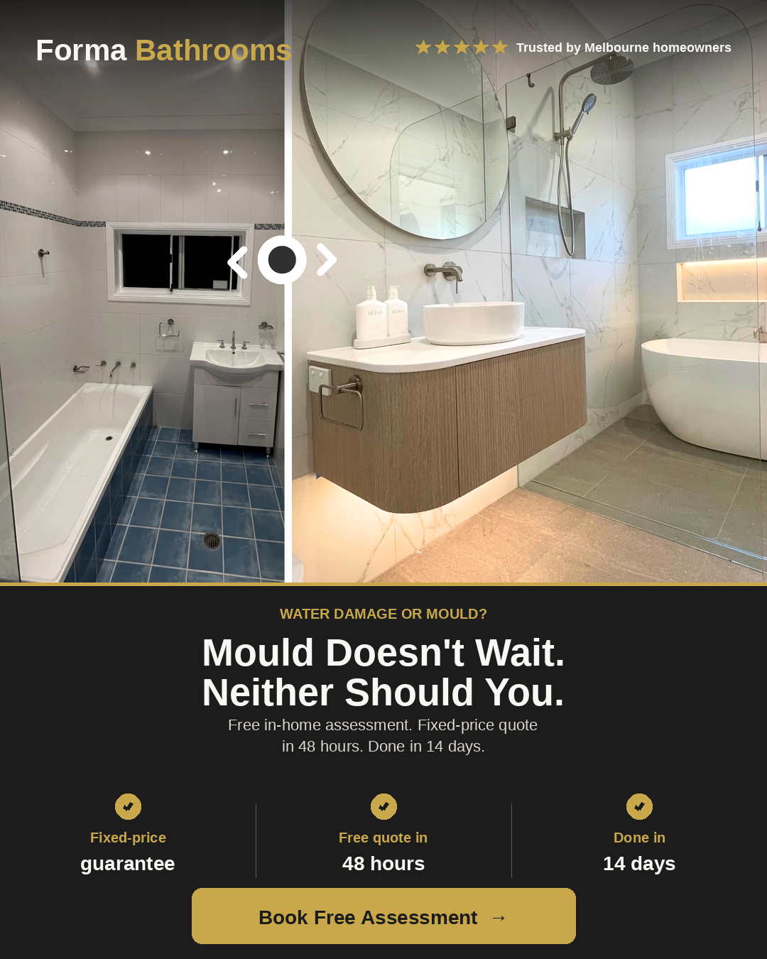
forma_ad_02_water_damage_4x5.png
CONCEPT BRIEF
AUDIENCE | Melbourne homeowners with active water damage or mould — more urgent, higher-intent. Typically converts faster but smaller absolute audience size.
HOOK | Urgency / damage-prevention. Mould doesn’t fix itself. The longer you wait, the bigger the bill.
CTA BUTTON | Get Offer
DESTINATION | https://formabathrooms.com/funnel.html
IMAGE FILE | forma_ad_02_water_damage_4x5.png
SIZE | 1080 × 1350 (Meta 4:5 feed — recommended)
PRIMARY TEXT — 3 VARIATIONS TO A/B TEST
Goes above the image in feed. Meta truncates at ~125 chars on mobile (“See more”).
Variant A
That spot in the corner you keep noticing? It’s not getting better.

Water damage and mould don’t fix themselves — and the longer you wait, the more expensive the rebuild becomes.

Forma Bathrooms can be at your home this week. Free in-home assessment. Fixed-price quote within 48 hours. Full renovation completed in 14 working days.

Don’t wait until water hits the joists.
👉 Book a free assessment now.
Variant B
Water-damaged bathroom? Mould creeping behind the tiles?

This is the cheap end of the problem. Get it looked at now, before it becomes a structural job.

Forma Bathrooms does fixed-price renovations across Melbourne — start to finish in 14 working days, with the site cleaned every evening. No surprises. No blow-outs.

Free in-home assessment 👇
Variant C
Behind every patch of bathroom mould is a bigger bill waiting to happen.

Damp walls, peeling silicone, tiles that shift — they’re early warnings. Sort it now while the fix is still a renovation, not a structural job.

Forma Bathrooms. Free in-home assessment. Fixed-price quote in 48 hours. Done in 14 days, site cleaned every evening.

Book yours 👇
HEADLINES — SITS BELOW THE IMAGE, MAX 27 CHARS IN FEED
A. Don’t let it get worse. (23 chars)
B. Free in-home assessment (23 chars)
C. Fix it before the joists go (27 chars)
DESCRIPTIONS — ONLY SHOWN ON SOME PLACEMENTS (MAX 27 CHARS)
A. Free quote within 48 hrs (24 chars)
B. Melbourne · Fixed price (23 chars)

Concept 03 · Pre-Sale Renovation / ROI
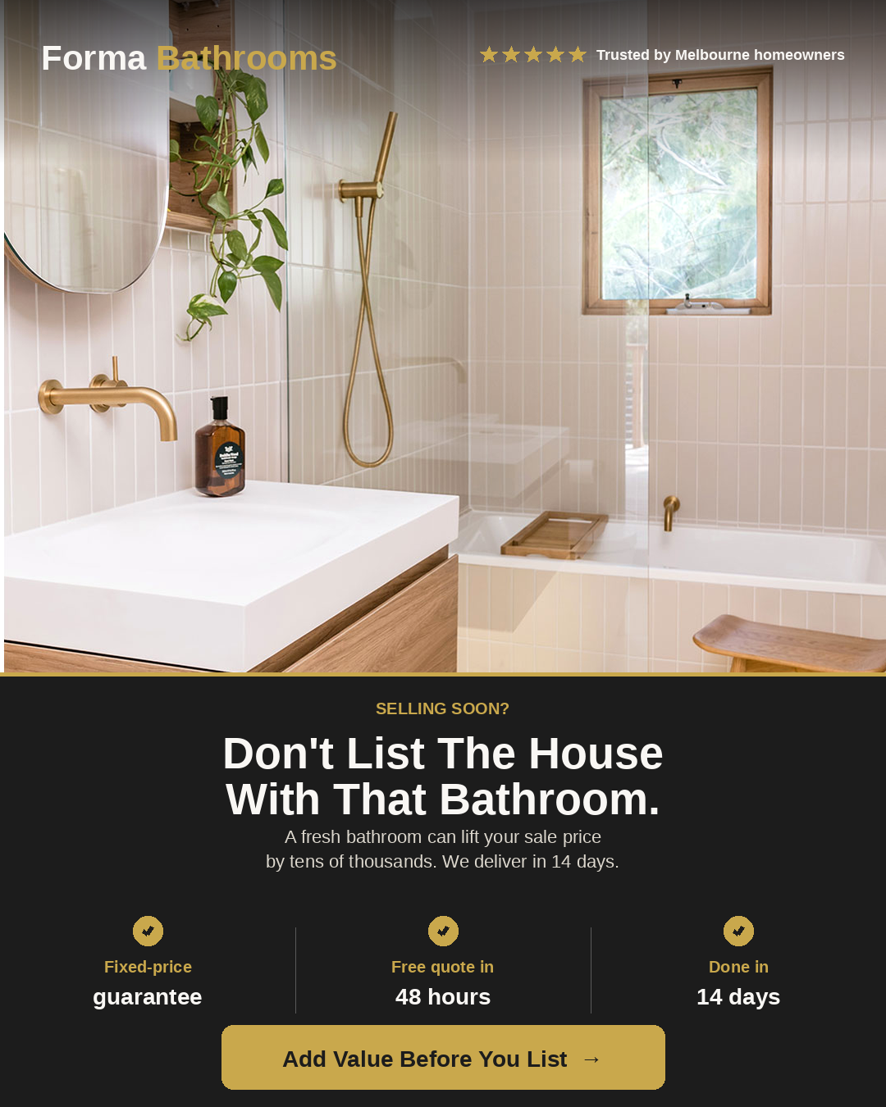
forma_ad_03_pre_sale_4x5.png
CONCEPT BRIEF
AUDIENCE | Melbourne homeowners planning to list their home in the next 3–12 months. Higher-budget, value-driven, decisive. Often investors or downsizers.
HOOK | Property-value / ROI angle. The bathroom is the room buyers fixate on. Don’t list until it’s done.
CTA BUTTON | Get Quote
DESTINATION | https://formabathrooms.com/funnel.html
IMAGE FILE | forma_ad_03_pre_sale_4x5.png
SIZE | 1080 × 1350 (Meta 4:5 feed — recommended)
PRIMARY TEXT — 3 VARIATIONS TO A/B TEST
Goes above the image in feed. Meta truncates at ~125 chars on mobile (“See more”).
Variant A
A dated bathroom is the single biggest reason buyers walk away on inspection day.

Before you list, talk to Forma Bathrooms.

Fixed-price renovations, completed in 14 working days, cleaned up every evening — built specifically for Melbourne homeowners who want to add real value before going to market.

👉 Free in-home quote. Book yours below.
Variant B
Selling soon? The bathroom’s where buyers decide.

A fresh, modern bathroom can lift your sale price by tens of thousands — but only if it’s done well, on time, and without nightmare blow-outs.

Forma Bathrooms: fixed price, 14-day completion, 48-hour written quote.

Book a free in-home consultation 👇
Variant C
Smart sellers renovate the bathroom first.

It’s the highest-ROI room in the house — and the one buyers fixate on at inspection.

Forma Bathrooms gives you a fixed-price quote in 48 hours and finishes the job in 14 days, cleanly. Most clients see the spend back in the sale price.

Tap to book your free, no-pressure home visit 👇
HEADLINES — SITS BELOW THE IMAGE, MAX 27 CHARS IN FEED
A. Add value before you list (25 chars)
B. 14 days to a higher sale price (30 chars)
C. Buyers fixate on the bathroom (29 chars)
DESCRIPTIONS — ONLY SHOWN ON SOME PLACEMENTS (MAX 27 CHARS)
A. Free quote within 48 hrs (24 chars)
B. Melbourne · Fixed price (23 chars)

Notes & next steps

14-day vs 10-day completion promise
Heads up: your live site (index.html, booking.html sidebar) currently states a 10-Day Completion Promise with a $500/day late discount. The ads use 14 days as you specified. Before launch, either:
- Update the index.html and booking.html copy from “10-Day Completion Promise” to “14-Day Completion Promise” to match the ads (recommended — message-match boosts conversion), or
- Switch the ads to say 10 days (drop me a note and I’ll regenerate).
Inconsistent claims between ad and landing page increase bounce rate and can occasionally trigger Meta ad disapproval for misleading content, so this is worth fixing before scaling.

Tracking checklist
- Install Meta Pixel base code on index.html, funnel.html and thankyou.html.
- Fire fbq('track', 'Lead') on funnel form submit (the funnel.html submitForm function already has a commented stub at line ~1141).
- Configure “Lead” as your custom-conversion event for the campaign.
- Set up a Conversion API (server-side) event from your GHL webhook for iOS-deduplicated tracking.

Files included with this brief
- forma_ad_01_putting_it_off_4x5.png — Concept 1, 1080×1350
- forma_ad_02_water_damage_4x5.png — Concept 2, 1080×1350
- forma_ad_03_pre_sale_4x5.png — Concept 3, 1080×1350
- Forma_MetaAds_Brief.docx — this document

