# Chapter1

1. What is a digital image?A two-dimensional function f(x, y) where x and y are spatial coordinates, and f at any pair of coordinates has a specific intensity value.
2. Which of the following is NOT a component of a typical digital image processing system?image reconstruction
3. What is the primary purpose of image sampling and quantization in digital image processing?to convert a continuous image into a digital form
4. In the context of digital image processing, what does the term "gray level" refer to?the intensity value of a pixel in a grayscale image
5. What is the main difference between analog and digital images?Analog images are made up of continuous signals, while digital images are made up of discrete signals.
6. Which stage of a digital image processing system deals with improving the appearance of an image for human perception?image enhancement
7. A digital image is composed of a finite number of elements, each having a particular location and value.T
8. In digital image processing, the term "gray level" refers to the color of a pixel.F
9. Digitizing a digital image  is responsible for reducing the size of the digital image file.F
10. Common applications of digital image processing include medical imaging, remote sensing, industrial inspection, and artistic creation.T
11. A digital image is(一幅数字图像是):An 2D entity arranged by pixels 一个有许多像素排列而成的二维实体
12. Which of the following is not a medical image? 以下哪一项不属于医学图像?Ultraviolet image 紫外图像
13. In the following image techniques, the technique doesn’t belong to the image processing is:Image seal 图像塑封

# Chapter2

1. Which of the following best describes the concept of spatial resolution in a digital image?the number of pixels per unit of an image
2. What is the dynamic range of a digital image?the range of brightness values the image can represent
3. A system has a 3 × 3 sensor array, and each sensor captures a 640 × 480 pixel image. If there is a 20-pixel overlap between adjacent sensors in both horizontal and vertical directions, what is the final image resolution after composing all sensor outputs?1880x1380pixels
4. What is the relationship between the sampling rate and the image resolution?higher sampling rates result in higher image resolution
5. If an image is sampled at a rate of 300 dots per inch(dpi),and the image dimensions are 8 inches by 10 inches,what is the resulting spatial resolution in pixel?2400x3000pixels
6. Spatial resolution refers to the number of distinct gray levels in a digital image.F
7. The process of sampling involves converting a continuous image function into a grid of pixels.T
8. Quantization is the process of mapping a large number of continuous values to a smaller set of discrete levels.T
9. An image with a higher number of pixels has better spatial resolution than an image with fewer pixels.T
10. What is a key difference between a sensor array and a single sensor for image acquisition?Single sensors capture one pixel at a time, while sensor arrays capture an entire image at once
11. What is the approximate intensity on a clear sunny day in the snow?85000
12. An image is quantized using 7 bits per pixel. How many different gray levels can be represented in this image?128
13. A 256*256 image, if the number of gray levels is 16, the number of bits needed to store it is （ 256K ）
14. What typically happens if the spatial resolution of an image increases?The image looks clearer
15. The following statements are correct ( )Increasing the resolution of the gray level of the image will increase the file size of the image Increasing the spatial resolution of an image will increase the file size of the image.
16. Which of the following statements is true about m-adjacency?Two pixels are m-adjacent if they are 8-connected, but only if their shared 4-adjacent pixels are not part of the same connected region
17. What is the Euclidean distance, D4 distance, and D8 distance between A(1, 2) and B(4, 6)?5；7；4
18. Consider the two image subsets S_1和 S_2, shown in the following figure. For  v={1}, determine whether these two subsets are (a) 4-adjacent, (b) 8-adjacent, or (c) m-adjacent.
19. Consider the image segment shown. （1）Let v={0,1}，and compute the lengths of the shortest 4-, 8-, and m-path between p and q. If a particular path does not exist between these two points, explain why. （2）Repeat for v={1,2}.

# Chapter3

1.In power-law transformation, what is the role of the constant c？To control the scaling of the output image

1. Typical applications of power-law transformation include:Enhancing details in medical images,Making night-time photographs clearer,Improving color accuracy in images,All of the above
2. If you want to compress the bright regions of an image and expand the details in the dark regions using power-law transformation, which γ value should you choose?0.5
3. Piecewise-linear transformation is commonly used in image processing for which purpose?Enhancing contrast in specific regions of an image
4. In a piecewise-linear transformation, how many linear segments are usually used?two or more
5. What is the main advantage of using a piecewise-linear transformation?it allows for selective enhancement and control over different regions of the intensity range
6. In a piecewise-linear transformation, if you want to enhance the contrast of low-intensity values and compress high-intensity values, what should the shape of the transformation function look like?A curve bending upwards at the start and flatting at the end
7. 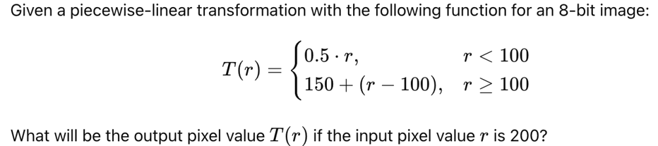250
8. Consider an 8-bit grayscale image with a pixel value of 175. If we want to extract the 3rd bit plane (counting from 0 as the least significant bit), what would be the value of the bit in that plane?1
9. Histogram shows how many pixels occur at ().each gray level
10. Suppose an image has 256 pixels with the following histogram distribution:· Pixel value 0: 64 pixels· Pixel value 1: 64 pixels· Pixel value 2: 64 pixels· Pixel value 3: 64 pixelsWhat is the effect of histogram equalization on this image?the histogram will remain the same
11. A 5x5 averaging filter is applied to an image. If the center pixel of the filter window has a value of 100 and all other pixels have a value of 20, what is the output of the filter at the center pixel?24
12. Consider applying a 3x3 median filter to the following section of an image: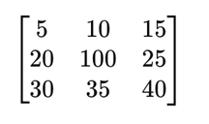What is the resulting value of the center pixel after applying the median filter?25
13. Contrast stretching belongs to Point based image enhancement
14. For an 8-bit grayscale image, if the original pixel's grayscale value is 200, what will be the grayscale value of this pixel after applying the negative transformation?55
15. Log transformation is mainly used for which type of image enhancement?Expanding the details in the dark regions of the image.Compressing the details in the bright regions of the image
16. In the power-law transformation formula how does the value of γ affect the image?γ =1 leaves the image unchanged
17. Consider a piecewise-linear transformation where the transformation function T(r) is defined as follows for an 8-bit grayscale image:If the input pixel value r is 90, what will be the output pixel value T(r)?80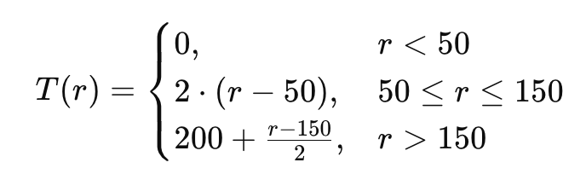
18. For an 8-bit grayscale image with a pixel value of 220, what is the binary representation, and what value would the pixel have in the 7th bit plane?Binary: 11011100, Value: 1
19. The corresponding relations between an image and its gray histogram is ( ).Many to one
20. What is the primary purpose of histogram equalization in image processing?To enhance contrast
21. What’s the value in the read circle?4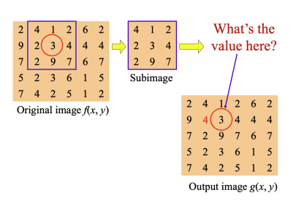
22. How does an averaging filter operate on an image?By replacing each pixel with the average of its neighbors
23. How does a median filter function?It sorts the intensity values of neighboring pixels and selects the middle value.
24. What is a common result of applying the Laplacian operator to an image?Detection of regions of rapid intensity change
25. Which operator is typically associated with second-order derivatives?Laplacian operator
26. What kind of values is the power γ ?Smaller than 1
27. 1.Suppose a 3-bit image (L = 8) of 100*100 pixels (MN=10000) has the intensity distribution (nk) shown in the following table, where the intensity levels are integers in the range [0, L-1] = [0, 7]Implement the Histogram equalization on the given image. You must evaluate the procedure of calculating the final mapping results. Directly listing the final results is not acceptable. Plot the histograms of the original image and the processed image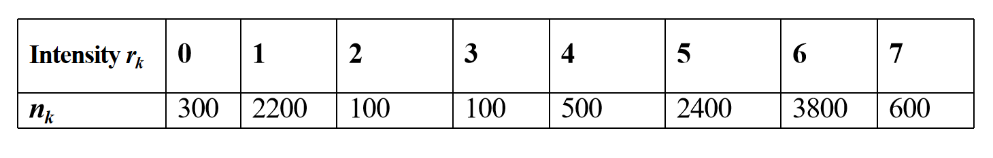
28. 2. 下图所示：(a) A 3-bit image segment f (x, y) with size of 5×5（with intensities 0～7）(b) A Laplacian filter with size of 3×3Work out： (1)The histogram of the given image segment.(2) Work out the response of the average filter. (3) Work out the response of the Laplacian filter.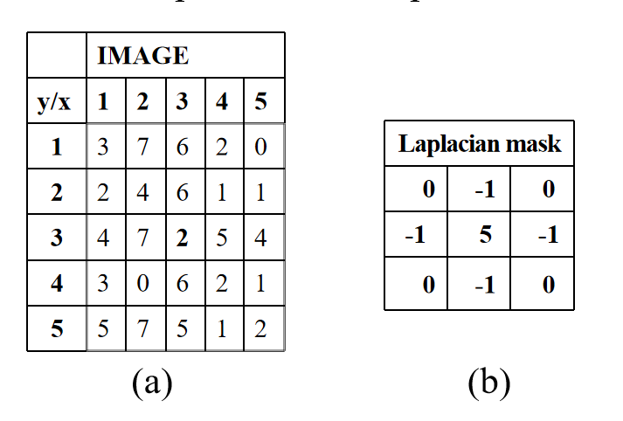

# Chapter5

1. Which type of noise is best reduced using the arithmetic mean filter? Gaussian noise
2. What is the primary purpose of the arithmetic mean filter in image processing?To reduce noise
3. How does the geometric mean filter calculate the new value of a pixel?By multiplying the pixel values in the neighborhood and taking the Nth root
4. What happens if Q = 0 in the contra harmonic mean filter?The filter behaves like an arithmetic mean filter
5. How does the contra harmonic mean filter handle salt-and-pepper noise?It eliminates sat noise when Q>0 and pepper noise when Q<0
6. What is a potential limitation of the harmonic mean fter?It cannot handle pepper noise (black pixels) effectively
7. Which type of noise is the harmonic mean filter particularly effective at reducing?Impulse noise (especially salt noise)
8. Which of the following filters is NOT a type of mean filter?Median filter
9. Which of the following is an order-statistics filter?Median filter
10. What is the main purpose of the median filter in image processing?To reduce noise,especially salt.and-pepper noise
11. How does the median filter calculate the output pixel value?By taking the middle value of the sorted neighborhood pixels
12. What is the midpoint filter best suited for?Removing salt-and-pepper noise and Gaussian noise
13. How does the midpoint filter compute the value of a pixel?By averaging the minimum and maximum pixel values in the neighborhood
14. Which of the following statements is true about the alpha-trimmed mean filter ?It removes both the smallest and largest values in the neighborhood before averaging
15. When would you prefer to use an alpha-trimmed mean filter instead of a median filter?When the image contains a mix of Gaussian noise and impulse noise
16. Which filter is best suited to reduce salt-and-pepper noise?Median filter
17. Which type of noise is the adaptive median filter particularly effective at reducing?Salt-and-pepper noise
18. What happens if the adaptive median filter reaches the maximum window size and still cannot find a suitable median?The pixel is replaced with the central pixel value of the window
19. Which type of noise looks like random white and black pixels in an image?Salt-and-pepper noise
20. How does the arithmetic mean filter modify a pixel in an image?By averaging the pixel value with its neighbors
21. What is the main advantage of the contraharmonic mean filter over the harmonic mean filter?It can selectively remove salt or pepper noise based on the value of Q
22. What is the main purpose of a mean filter in image restoration?To smooth the image and reduce noise
23. In the alpha-trimmed mean filter, what is the role of the parameter α?It determines how many of the smallest and largest pixel values are removed
24. Which of the following is a key difference between a regular median filter and an adaptive median filter?The adaptive median filter can change the window size to handle different levels of noise.
25. Which of the following best describes the difference between a bandreject filter and a bandpass filter?A bandreject filter removes frequencies in a specific range, while a bandpass filter allows frequencies in a specific range to pass
26. The following noised images show an 8-bit image of size 5-by-5 image in the square, with x and y coordinates specified.(1) Using the 3 × 3 median and averaging filter to restore the above image respectively. (Please always leave the boundary pixels unchanged since no center point will cover them.) (2) Using the 3 × 3 adaptive median filter to restore the above image where the maximum size of the mask subwindow is 5*5

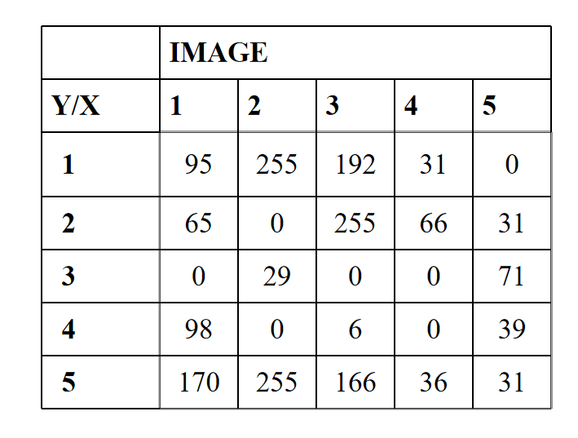

# Chapter6

1. Which of the following is NOT a primary color in the RGB color model?Yellow
2. Which of the following statements best defines the HSI color model?A color model that represents colors in terms of hue, saturation, and intensity.
3. What is the primary purpose of intensity slicing in image processing?To segment an image into regions based on pixel intensity values.
4. Which of the following correctly describes the use of HSI compared to RGB?HSI simplifies the representation of colors based on hue, saturation, and intensity, making it easier for human interpretation.
5. In the context of color image smoothing, what does applying a Gaussian kernel to an image primarily aim to achieve?Remove random noise and reduce minor details

**Why do images often be expressed as the form: 512*512, 1024*1024 ect?**

Image dimensions like 512×512 or 1024×1024 are commonly used because they are powers of 2, which align with how computers process data. Binary systems handle these sizes efficiently, simplifying memory allocation and processing.

Many algorithms for compression, scaling, and rendering are optimized for these dimensions. For example, resizing a 1024×1024 image to 512×512 preserves quality without artifacts. Additionally, GPUs and other hardware are designed to handle power-of-2 textures efficiently, ensuring smooth performance in graphics-intensive tasks.

Using power-of-2 sizes ensures compatibility, scalability, and processing efficiency, making them a standard in digital imaging.

**What is the basic idea of histogram equalization?**

Histogram equalization enhances image contrast by redistributing pixel intensities to span the entire range (e.g., 0–255 for an 8-bit image).

It calculates the image's histogram, determines its cumulative distribution function (CDF), and normalizes the CDF to map original intensity levels to new, evenly spread values. This process makes dark areas brighter and bright areas darker, improving detail visibility in under- or overexposed regions. It is widely used in image enhancement for applications like medical imaging and photography.

**For salt-and-pepper noise,why is median filtering better than average filtering?**

Median filtering is better than average filtering for removing salt-and-pepper noise because it effectively handles outliers and preserves image details. Salt-and-pepper noise consists of extreme pixel values (black and white), which heavily skew the average in an averaging filter, leading to incomplete noise removal and image blurring.

In contrast, median filtering replaces the central pixel with the median of its neighborhood, a value unaffected by extreme noise. This method removes salt-and-pepper noise without introducing new artifacts or blurring edges, maintaining image sharpness and detail. Thus, median filtering is more effective and reliable for this specific type of noise.

**What are the differences and relations between image sharpening and image smoothing?**

Image smoothing and sharpening serve opposite purposes but are complementary in image processing.

**Smoothing** reduces noise and softens details by averaging pixel values, often using filters like Gaussian or median, resulting in a cleaner but blurrier image. In contrast, **sharpening** enhances edges and fine details by increasing contrast at intensity transitions, using methods like high-pass filters or unsharp masking.

They are related as complementary techniques: smoothing removes noise to prevent artifacts, while sharpening restores clarity to important features. Smoothing suppresses high frequencies (noise), while sharpening amplifies them (details), balancing noise reduction and detail enhancement in an image.

**Impulse noise, such as salt-and-pepper noise, is commonly encountered in digital images. Among the median filter, alpha-trimmed mean filter, and adaptive median filter, which one is generally most effective at removing impulse noise without overly blurring the image? Explain why.**

The **adaptive median filter** is generally the most effective at removing impulse noise, like salt-and-pepper noise, without overly blurring the image. Unlike the standard median filter, the adaptive version adjusts its window size dynamically based on noise density. This allows it to handle varying levels of noise effectively while preserving edges and fine details.

The **median filter** works well for moderate noise but struggles with high-density noise or fine details. The **alpha-trimmed mean filter**, while reducing extreme outliers, may blur edges by averaging values. The adaptive median filter balances noise removal and detail preservation, making it superior overall.

**How do the arithmetic mean, geometric mean, harmonic mean, and contraharmonic mean filters differ in their approach to noise reduction? Discuss specific types of noise that each filter is best suited to handle.**

1. **Arithmetic Mean Filter**: Computes the average of pixel values in the neighborhood. It reduces Gaussian noise effectively but can blur edges and fails against impulse noise (e.g., salt-and-pepper noise).

2. **Geometric Mean Filter**: Uses the geometric mean of pixel values, preserving detail better than the arithmetic mean. It’s effective for Gaussian noise but struggles with high-intensity noise or zeros in the image.

3. **Harmonic Mean Filter**: Focuses on low-intensity values, making it effective against salt noise (bright pixels) but not pepper noise (dark pixels).

4. **Contraharmonic Mean Filter**: Adjusts sensitivity based on the order (Q). Positive Q targets salt noise; negative Q targets pepper noise, making it versatile for impulse noise.

**Discuss the relationship between color image enhancement and gray image enhancement**

Color and gray image enhancement share the goal of improving image quality but differ in complexity. Gray enhancement focuses solely on intensity, applying techniques like histogram equalization or filtering to a single channel. Color enhancement, however, involves multiple channels and must balance improved visibility with maintaining natural hues.

Color methods often work in perceptual color spaces (e.g., HSV, LAB) to enhance luminance without distorting chromaticity, unlike gray images where only intensity is processed. While gray image techniques form the foundation, color enhancement adapts them to handle color data, addressing challenges like hue preservation and multi-channel processing for realistic results.

**Comparing the strategy difference while smoothing in RGB color model and HSI color model.**

Smoothing in the RGB and HSI color models differs in strategy due to how color information is represented.

In the **RGB model**, smoothing is applied independently to the red, green, and blue channels. This approach may lead to color distortions since each channel is processed separately, potentially altering hue and saturation.

In contrast, the **HSI model** separates color into intensity (I), hue (H), and saturation (S). Smoothing is applied primarily to the intensity channel, preserving the original hue and saturation. This ensures better retention of natural colors while reducing noise, making the HSI model more effective for perceptually consistent smoothing.