1.2.1

#24

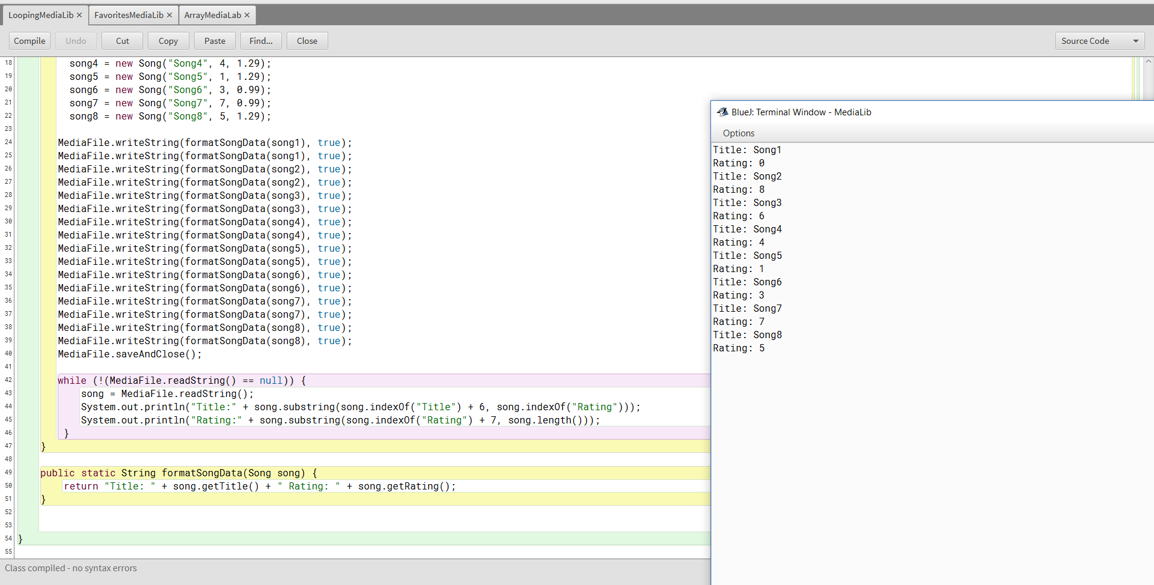

#30

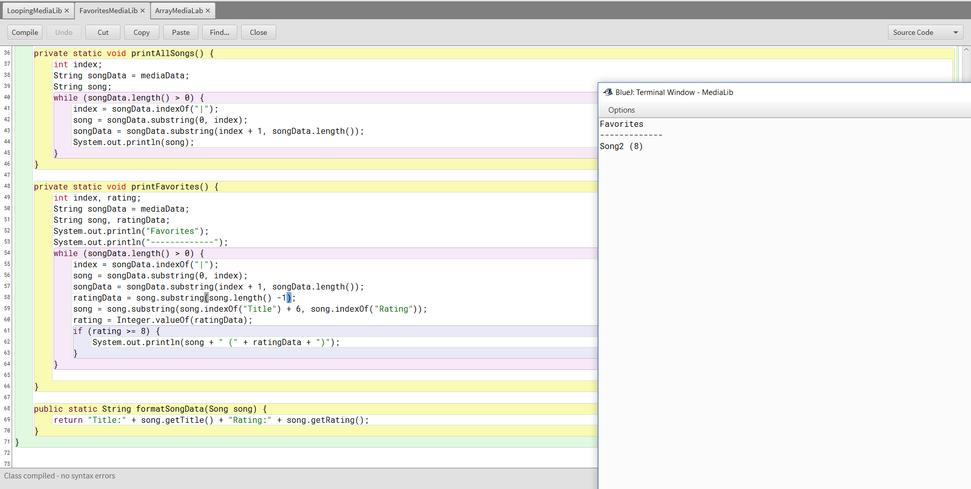

Conclusion

1. Give two iteration examples, one where a for loop would be a good construct to use, and another where a while loop would be preferred. Explain why each iteration construct is best in each example.

A good use of a for loop would be to go through a list of numbers in order. This is good if the counter in the for loop is being used, such as when accessing an array by index. A good use of a while loop would be to iterate through an array until a desired value was found because the loop can continue as long as the desired value being found is not true.

1. What major change in hardware prompted the development of Android OS 3.0, Honeycomb, and why did maintaining older versions like Gingerbread become extra cumbersome?

The development of Android 3.0 was because newer tablets didn’t have hardware buttons. The new operating system allowed software home and back buttons to be put at the bottom of the screen. Maintaining older versions became cumbersome because older Android versions lacked newer features and were unsupported by manufacturers.