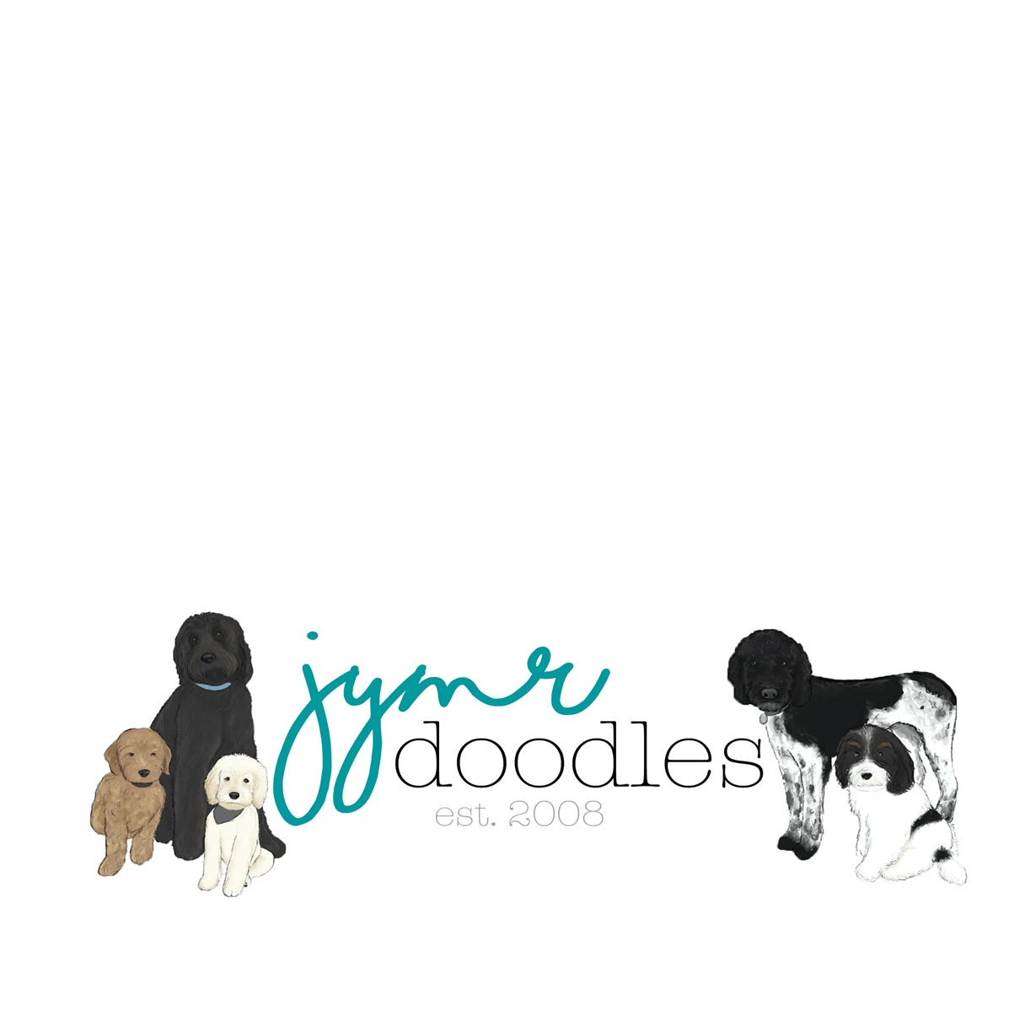

**JYMR Doodles Dog Ownership Agreement**

This Dog Ownership Agreement (“**Agreement**”) is made and entered into as ______, 20__ (“**Effective Date**”) by and between Michelle Ramirez with JYMR Doodles, a Utah business (“**Breeder**”) and ______________ (“**Buyer**”). The Breeder and the Buyer may be referred to individually as a “**Party**” or collectively as the “**Parties**.”

**STATEMENT OF PURPOSE**

Breeder is in the business of breeding Goldendoodle, Labradoodle and Poodle Dogs and desires to sell a puppy out of the breeding line of Breeder to Buyer. The Buyer is willing to buy puppy from Breeder under the terms and conditions set forth in this Agreement.

Breeder and Buyer, intending to be legally bound, agree as follows:

**Identity of Dog**

The “**Dog**” subject to this Agreement will be identified on the “**Identity of Dog Form**” attached hereto and by reference made a part hereof. Breeder will complete the attached form after the puppies are born and once the Buyer has chosen which puppy he or she wants. The Buyer will review and confirm that the information correctly identifies the puppy Buyer has chosen by signing and dating the Identity of Dog Form.

**Consideration**

Breeder agrees to sell to the Buyer the Dog for ______________ Dollars ($0000) Buyer will secure a hold for the Buyer’s choice of puppy upon execution of this Agreement along with a deposit of Five Hundred Dollars ($500) of which Three Hundred ($300) is non-refundable. The deposit can be paid with cash or Venmo @jymrdoodles. The non-refundable deposit can be applied to another puppy if the Buyer changes mind on the choice of puppy. The remaining balance of _______________Dollars ($0,000) must be paid in full prior to the puppy leaving the Breeder’s or as otherwise stated in the Installment Agreement. Breeder accepts Cash, Zelle or Venmo for final payment.

**Terms and Conditions**

The Buyer agrees to the following:

i. Buyer agrees to provide a life-long commitment, comfortable and safe environment, prompt medical attention, and responsible care for the Dog. This includes keeping the Dog parasite free and up to date with inoculations, proper nutrition, which consists of a good quality professional feed given at regular intervals, and fresh water available at all times when outside and offered frequently when kept inside.

ii. Buyer understands that the Dog **MUST** be groomed and brushed regularly and agrees to upkeep the grooming at regular intervals.

iii. Buyer agrees to provide a safe environment for the Dog and will never allow the Dog to roam freely without proper fencing or supervision.

iv. Buyer agrees and promises to house the Dog indoors only. The Dog is not an outdoor dog.

v. Buyer agrees to contact the Breeder immediately if any questions or concerns arise about the Dog, such as housing, diet or health.

vi. Buyer understands the Dog is a **“pet quality”** dog and it is a representation of its breed.

vi. Buyer understands that Breeder **highly** recommends training classes for a happy

relationship the dog and family. [www.baxterandbella.com](http://www.baxterandbella.com) is a wonderful online puppy course and buyer will receive a 25% discount with the code JYMR at checkout.

**Breeder**: The Breeder includes a microchip with the dog in order to facilitate the Dog’s return if lost or stolen. The Breeder will register the microchip number and the Breeder will be listed as second or third on the contact list.

**Breeder Guarantee: Health of Dog**

The Breeder guarantees the Dog to be of sound health and temperament at the time of sale The Breeder will take the Dog to have a vet check with a fecal screening after 7 weeks of age and The Breeder will provide all findings from the Health Exam along with the current health record of all shots and worming.

***Condition****:* The Buyer agrees to take the Dog to a licensed veterinarian (“**Vet**”) of their choice within 72 hours of possession for a physical examination with Fecal Screening. Should the Dog be determined to be of ill health, the cause of which the Breeder is clearly to blame, the Dog may, upon a signed written diagnosis from the Vet, be returned for refund of the purchase price or choose another puppy if available for replacement. The Breeder is not responsible for any fees associated with the initial vet visit or care of the Dog.

**Breeder’s Five-Year Genetic Health Guarantee**

Buyer understands and agrees that Breeder’s **Five Year** “Genetic Health Guarantee” is strictly based on the items below. The below items are not mandatory; however, if not followed by the Buyer, the Five Year Genetic Health Guarantee is considered VOID.

A. Nutrition is such an intricate part of the health and development of a puppy,

Buyer will **ONLY** feed the Dog the “pawTree” brand dog food.

Buyer **must** enroll as a pawTree Customer through **www.pawtree.com/jymrdoodles** and order pawTtree brand dog food setting it up on ezship. Breeder is able to track Buyer’s purchases of pawTree food and will **VOID** this 5- year guarantee if there is no record of buyer placing regular orders with pawTtree through the above link.

B.  During first year of the Dog’s life the Dog cannot be run on asphalt or cement (grass and dirt is ok.) If the Dog is run on asphalt or cement, this will void the guarantee against hip dysplasia.

If the Dog is found to have a genetic disease substantiated by a written report from

a licensed Vet, then the Buyer has the option of surrendering the Dog to the Breeder

and receiving a new puppy from the Breeder **Or** the Buyer may keep the Dog and still acquire a new puppy the Breeder. Breeder will **NOT** be responsible for any on going medical expenses.

**Breeding Rights**

As stated above, the Dog is a “pet quality” Dog and **under no circumstances may the Buyer use this Dog for breeding**. Buyer agrees to have the Dog spayed or neutered at the appropriate age recommended by the Vet (usually 6-10 months of age for mini and medium breeds and 8-12 months for large standard breeds). Please ask what size group you puppy will fall under and then consult with your Vet. Should the Vet feel it appropriate to sterilize your puppy at an earlier age, ensure they have educated you on all the benefits and risks.

**Repossession**

If at any time the Buyer can no longer retain possession of the Dog, the Breeder must be notified immediately and have all rights to immediately resume full ownership of the Dog or be involved in the placement of the Dog in a new home. **NO REFUND WILL BE GIVEN**. In the event Breeder resumes ownership of the Dog, it is the responsibility of the Buyer to:

1. Arrange for the return of the Dog

2. Pay for any travel expenses or costs associated with returning the Dog; and

3. Provide all CKC papers and medical records to the Breeder upon return.

Should any circumstance arise that affects the quality of life of the Dog, the Breeder is to be informed to help participate in determining the future of the Dog. The Breeder reserves the right to approve or prohibit any transfer of the Dog to a third party. Under no circumstances will this Dog be sold, leased, traded or given away to any pet store, research laboratory, animal shelter, rescue or similar facility.

**Assignment of Contract**

Neither this Agreement nor any duties or obligations under this Agreement may be assigned by either party without the prior written consent of the other.

**Indemnification**

Each party shall insure that its employees, agents, family members or those residing with each Party, present in either Party’s residence, or present near the Dog (“**Affiliates**”), if any, take all actions necessary to comply with the terms and conditions set forth in this Agreement and all applicable laws, regulations, rules and/or contractual duties either party may be subject to. Buyer agrees that Breeder and Affiliates are not responsible or liable for any laws broken, fines or penalties incurred, accidents, damage to property, injury to person, claims for intentional infliction of emotional distress, nuisance, assault, battery, or damage to property whether unintentional or intentional by the Dog once Buyer takes possession of the Dog.

Buyer acknowledges responsibility and assumes all liability for all actions by the Dog. Buyer warrants and represents that it’s care of the Dog and those who come in contact with the Dog will not: (1) violate any federal, state or local law or regulations; (2) in any way violate or infringe upon any party’s privacy right or any other right of any person or entity. Buyer shall specifically indemnify Breeder and Affiliates against any loss, claims, demands, action, proceedings, damages, costs, charges, and expenses, which may be made or brought or commenced against Buyer for the Dog’s actions. Buyer will further indemnify and hold Breeder and Affiliates harmless from any damage to Buyer’s personal or real property, harm or any other type injuries to persons, etc. resulting from the Dog’s actions.

**Dispute Resolution**

**No Jury Trial**. You and We waive, to the fullest extent permitted by law, all rights to trial by jury in any action or claim, whether at law or in equity, brought by either party.

**Manner of Handling Disputes**

i. Face to Face Meeting. First, discussed in a face-to-face meeting between you and us or via videoconference at our election, and within 30 days after either you or we give written notice to the other proposing such a meeting. We have the right, in our sole discretion, to waive this requirement.

ii. Mediation. If, in the opinion of either you or us, the meeting has not successfully resolved such matters and if desired by either you or us, the matters will be submitted to non-binding mediation. On election by either party, arbitration as provided below may proceed forward at the same time as mediation. The mediator will be disqualified as a witness, consultant, expert or counsel for any party with respect to the dispute and any related matters. The mediation will be conducted exclusively in Utah.

iii. Arbitration. If the parties are unable to reach a resolution through mediation, the Dispute may be submitted for arbitration to the American Arbitration Association in accordance with its commercial arbitration rules. All arbitration hearings must be conducted in Utah as the exclusive venue and jurisdiction, and the laws of the State of Utah shall govern. The arbitrator will have the power and jurisdiction to decide such Dispute solely in accordance with the express provisions of this Agreement. Both parties to the Dispute shall share in the upfront cost of the arbitrator and arbitration fees. If a party is unable or unwilling to pay its share of the upfront cost of the mediation or arbitration, the other party has the right to cover those costs; however, the prevailing party in any arbitration suit or action to enforce this Agreement, shall be entitled to recover the administrative costs of the arbitration proceeding and the fee for the arbitrator from the non-prevailing party. The parties agree that any claim hereunder shall result in an award not more than 180 days from the date of the statement of claim filed with the American Arbitration Association, unless otherwise waived by the parties. The Arbitrator’s decision shall be put in writing. The award and findings of the arbitrators shall be conclusive and binding upon all parties hereto and the judgment upon the award may be entered in any court of competent jurisdiction. Any Dispute and any arbitration, will be conducted and resolved on an individual basis only and not on a class-wide, multiple plaintiff or similar basis between You and Us and will not be consolidated with any other arbitration proceeding involving Us and any other person, except that with respect to a Dispute involving You and Your affiliate, You and Your affiliate may both be parties to the arbitration.

**Attorneys Fees**

In the event any action in law or equity or any arbitration, mediation or other proceeding is brought for the enforcement of this Agreement or in connection with any of the provisions of this Agreement, the successful or prevailing party or parties shall be entitled to reasonable attorney’s fees and other costs reasonably incurred in such action or proceeding. Reimbursement is due within 30 days of written notice after prevailing. For purposes of this Agreement, “prevailing party” Includes the party which obtains a judgment in their favor or agrees to dismiss an action or proceeding upon the other’s payment of sums allegedly due or performance of the covenants allegedly breached, or which obtains substantially the relief sought.

**Amendment**

No modification of or amendment to this Agreement, nor any waiver of any rights under this Agreement, will be effective unless in writing signed by the party to be charged. No oral statement to either Party may alter the terms of this Agreement.

**Severability**

If any provision(s) of this Agreement shall be held to be invalid or unenforceable for any reason, the remaining provisions shall continue to be valid and enforceable. If a court finds that any provision of this Agreement is invalid or unenforceable, but that by limiting such provision it would become valid or enforceable, then such provision shall be deemed to be written, construed, and enforced as so limited.

**No Waiver of Contractual Right**

The failure of either party to enforce any provision of this Agreement shall not be construed as a waiver or limitation of that party’s right subsequently to enforce and compel strict compliance with every provision of this Agreement.

**Governing Law**

The parties agree that this Agreement shall be governed by, and construed in accordance with, the laws of the State of Utah.

**Consent to Personal Jurisdiction**

The Parties hereby expressly consent to the personal jurisdiction of the state and federal courts located in Utah for any lawsuit filed there by either Party arising from or relating to this Agreement.

**Notices**

Any notice or other communication provided for herein or given to a party shall be in writing and shall be given in person, by email, or by mail (registered or certified mail, postage prepaid, return receipt requested) to the respective party.Notices sent in accordance with this Section shall be deemed effective on the date of dispatch. Any change in the information set forth in this Section shall be upon notice to the other party delivered in the manner set forth in this Section. Both parties agree to keep each other informed as to current mailing addresses, telephone numbers and email addresses.

**Entire Agreement**

This Agreement constitutes the entire understanding between the parties, and supersedes all prior agreements and negotiations, whether oral or written. There are no other agreements between the parties, except as set forth in this Agreement. No supplement, modification, waiver, or termination of this Agreement shall be binding unless in writing and executed by the parties to this Agreement.

IN WITNESS WHEREOF, the parties have executed this Agreement in the state of Utah the day and year set forth below.

**BREEDER:**

**JYMR Doodles**, a Utah Business

________________________________________ **Date**:_________________________

Michelle Ramirez, Breeder

**BUYER:**

________________________________________ **Date**:_________________________

, Buyer