**Adaptateur 4/20 mA**

La carte :

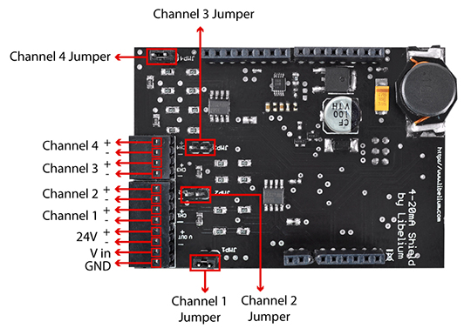

Mise en place sur une Arduino :

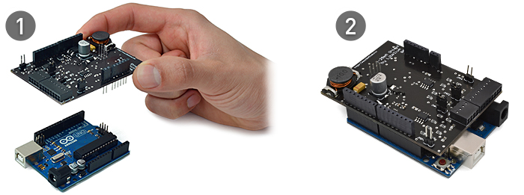

Code pour la Arduino (currentLoop.cpp) :

#include "Arduino.h"

#include "currentLoop.h"

currentLoop::currentLoop() {}

void currentLoop::ON(){

pinMode(5, OUTPUT);

digitalWrite(5, HIGH);

delay(1000);

digitalWrite(5, LOW);

}

void currentLoop::OFF(){

digitalWrite(5, HIGH);

}

int currentLoop::readChannel(uint8_t channel){

long analogValue = 0;

for (int i = 0; i < 50 ; i ++){

analogValue = analogValue + analogRead(channel);

}

return (analogValue / 50);

}

float currentLoop::readVoltage(uint8_t channel){

return (readChannel(channel) * 5.0 /1023);

}

float currentLoop::readCurrent(uint8_t channel){

return (readVoltage(channel) / 165.0 * 1000);

}

float currentLoop::readCurrent(uint8_t channel, float offSet){

return ((readVoltage(channel) / 165.0 * 1000) - offSet);

}

uint8_t currentLoop::isConnected(uint8_t channel){

if (readVoltage(channel) < 0.6)

return 0;

else

return 1;

}

currentLoop sensorBoard = currentLoop();

Code pour la Arduino (currentLoop.h) :

#ifndef currentLoop_h

#define currentLoop_h

#include <inttypes.h>

#define CHANNEL1 0

#define CHANNEL2 1

#define CHANNEL3 4

#define CHANNEL4 5

class currentLoop{

public:

//! The constructor of the class

currentLoop();

//! Powers ON the 4-20mA 24V Supply

void ON(void);

//! Powers OFF the 4-20mA 24V Supply

void OFF(void);

//! Get the sensor value in integer format

int readChannel(uint8_t channel);

//! Get the sensor value as a voltage in Volts

float readVoltage(uint8_t channel);

//! Get the sensor value as a current in mA

float readCurrent(uint8_t channel);

//! Get the sensor value as a current in mA and introduce

//! a correction offSet factor

float readCurrent(uint8_t channel ,float offSet);

//! It checks if the current loop is well connected

uint8_t isConnected(uint8_t channel);

};

extern currentLoop sensorBoard;

#endif

Code pour capteur  :

// Include this library for using current loop functions.

#include <currentLoop.h >

#define CHANNEL CHANNEL4

void setup(){

// Switch ON the 24V DC-DC converter

sensorBoard.ON();

// Inits the Serial for viewing data in the serial monitor

Serial.begin(115200);

delay(100);

Serial.println("Arduino 4-20mA board switched ON...");

}

void loop(){

// Get the sensor value in int format (0-1023)

int value = sensorBoard.readChannel(CHANNEL);

Serial.print("Int value read from channel 1 : ");

Serial.println(value);

// Get the sensor value as a voltage in Volts

float voltage = sensorBoard.readVoltage(CHANNEL);

Serial.print("Voltage value rad from channel 1 : ");

Serial.print(voltage);

Serial.println("V");

// Get the sensor value as a curren in mA

float current = sensorBoard.readCurrent(CHANNEL);

Serial.print("Current value read from channel 1 : ");

Serial.print(current);

Serial.println("mA");

Serial.println("***************************************");

Serial.print("\n");

delay(2000);

}