Technological Design Document Autumn 2020

By Dylan Curran

CRC Cards

Architecture

Features

Feature Name : Movement

Feature Task

Feature Name: Obstacles

Feature Name: Platforms

# CRC Cards

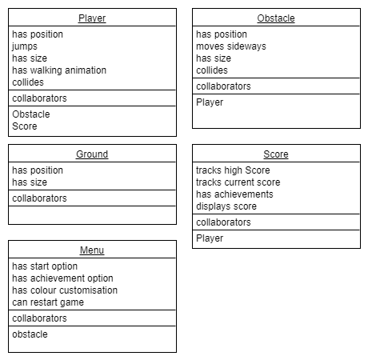

# Architecture

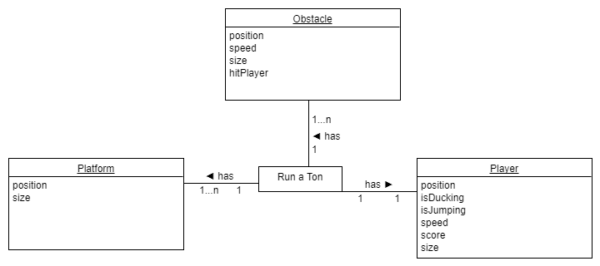

# Features

## Feature Name : Movement

### Feature Task

For this feature if the player is using the W key to jump, these movements will be used to ensure the player can avoid obstacles as they appear.

## Feature Name: Obstacles

### Feature Task

For the obstacles in this game they will appear from the right side of the screen and move left. The player has to react to them as the player sees them. The further the player gets in the game the more frequently the obstacles appear, thus making the game harder for the player.

## Feature Name: Platforms

### Feature Task

The platforms will be what the player is allowed to jump on, there will be one constinuously under the player so they have somewhere to run but there will be gaps so the player has to react by jumping also.