**Lab: Bikeshare data using SQL and Excel**

**Data source selection**

As different countries and cities have different factors impacting business performance, it’s hard to make comparison across business using count of trips and growth rate only.

In this instance, I choose Citybike - New York because it has sufficient fields of data including gender, age, bike for each trip etc.

**Trends and descriptive analytics**

1. **How many trips were there in each month of each year? How many different bikes were there in each month of each year?**

WITH summary AS

(SELECT * FROM citibike_2016

UNION

SELECT * FROM citibike_2017

UNION

SELECT * FROM citibike_2018

UNION

SELECT * FROM citibike_2019)

SELECT DATE_TRUNC('month',start_time),

COUNT(*) AS trips,

COUNT(DISTINCT bike_id) AS bikes

FROM summary

GROUP BY DATE_TRUNC('month',start_time);

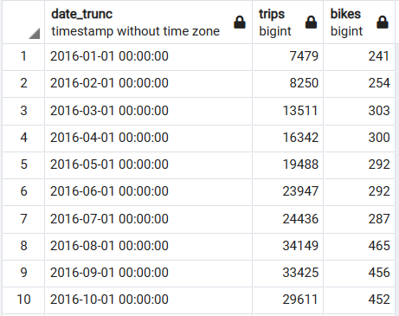

1. **Is the subscription side of these businesses growing? (In absolute terms; and also as a proportion of the sharing).**

**SQL:**

WITH summary AS

(SELECT * FROM citibike_2016

UNION

SELECT * FROM citibike_2017

UNION

SELECT * FROM citibike_2018

UNION

SELECT * FROM citibike_2019)

SELECT DATE_TRUNC('month',start_time),

user_type,

COUNT(*)

FROM summary

WHERE user_type IS NOT NULL

GROUP BY DATE_TRUNC('month',start_time),

user_type

ORDER BY DATE_TRUNC('month',start_time);

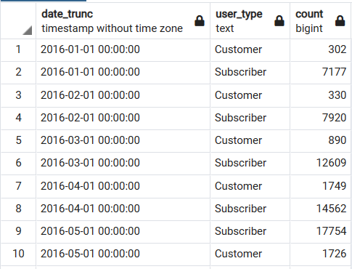

1. **If 2020 hadn’t been, well, 2020, what would you expect to have seen?**

Workings in excel file.

**Geospatial**

1. **What was the longest journey? What do we know about it?**

The longest journal was from Bergen Ave to Amsterdam Ave of 14.03km.

WITH summary AS

(SELECT * FROM citibike_2016

UNION

SELECT * FROM citibike_2017

UNION

SELECT * FROM citibike_2018

UNION

SELECT * FROM citibike_2019)

SELECT c1.name AS "From", c2.name AS "To",

CALCULATE_DISTANCE(c2.latitude, c2.longitude, c1.latitude, c1.longitude, 'K')

FROM summary

JOIN citibike_stations AS c1

ON start_station_id=c1.id

JOIN citibike_stations AS c2

ON end_station_id=c2.id

ORDER BY CALCULATE_DISTANCE(c2.latitude, c2.longitude, c1.latitude, c1.longitude, 'K') DESC

LIMIT 10;

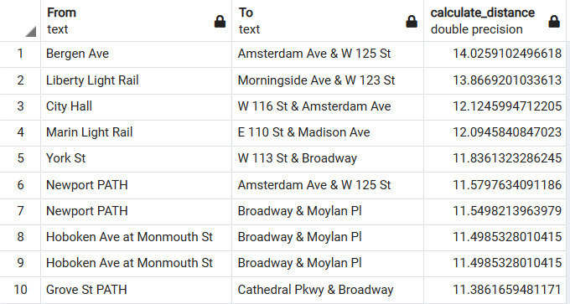

1. **What was the furthest relocation?**

The relocation from Amsterdam Ave to McGinley St was the longest of 13.54km.

WITH summary AS

(SELECT * FROM citibike_2016

UNION

SELECT * FROM citibike_2017

UNION

SELECT * FROM citibike_2018

UNION

SELECT * FROM citibike_2019)

SELECT c2.name AS "From",

c1.name AS "To",

CALCULATE_DISTANCE(c2.latitude, c2.longitude, c1.latitude, c1.longitude, 'K')

FROM

(SELECT *, LAG(end_station_id,1)OVER(PARTITION BY bike_id ORDER BY start_time) AS prev_id

FROM summary) AS window_table

JOIN citibike_stations AS c1

ON start_station_id=c1.id

JOIN citibike_stations AS c2

ON prev_id=c2.id

WHERE window_table.prev_id!=start_station_id

ORDER BY CALCULATE_DISTANCE(c2.latitude, c2.longitude, c1.latitude, c1.longitude, 'K') DESC

LIMIT 10

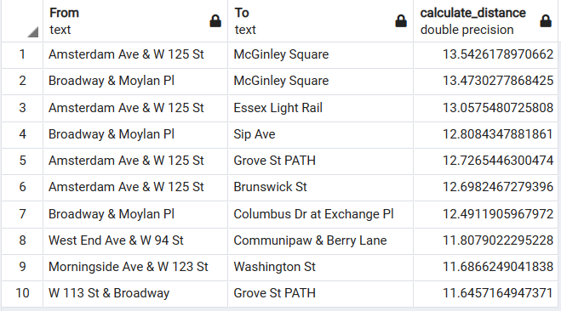

1. **How far is a typical journey?**

Typical journey is 0.97km.

WITH summary AS

(SELECT * FROM citibike_2016

UNION

SELECT * FROM citibike_2017

UNION

SELECT * FROM citibike_2018

UNION

SELECT * FROM citibike_2019)

SELECT AVG(CALCULATE_DISTANCE(c2.latitude, c2.longitude, c1.latitude, c1.longitude, 'K'))

FROM summary

JOIN citibike_stations AS c1

ON start_station_id=c1.id

JOIN citibike_stations AS c2

ON end_station_id=c2.id

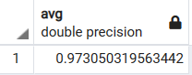

**Business and Commercial**

1. **What sort of people use these bikes, and when do they use them?**

**Trip by age groups:**

WITH summary AS

(SELECT * FROM citibike_2016

UNION

SELECT * FROM citibike_2017

UNION

SELECT * FROM citibike_2018

UNION

SELECT * FROM citibike_2019)

SELECT CASE WHEN birth_year<=2003 AND birth_year>1993 THEN '1994-2003'

WHEN birth_year<=1993 AND birth_year>1983 THEN '1984-1993'

WHEN birth_year<=1983 AND birth_year>1973 THEN '1974-1983'

WHEN birth_year<=1973 AND birth_year>1963 THEN '1964-1973'

WHEN birth_year<=1963 AND birth_year>1953 THEN '1954-1963'

WHEN birth_year<=1953 AND birth_year>1943 THEN '1944-1953'

WHEN birth_year<=1943 AND birth_year>1933 THEN '1934-1943'

WHEN birth_year<=1933 THEN 'Others'

END AS age_group,

COUNT(birth_year)

FROM summary

GROUP BY age_group

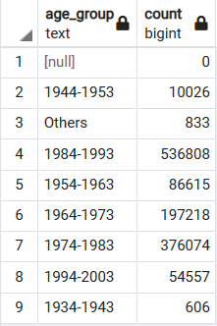

**Trip by time period:**

WITH summary AS

(SELECT * FROM citibike_2016

UNION

SELECT * FROM citibike_2017

UNION

SELECT * FROM citibike_2018

UNION

SELECT * FROM citibike_2019)

SELECT CASE WHEN DATE_PART('hour',start_time)>0 AND DATE_PART('hour',start_time)<=2 THEN '00-02'

WHEN DATE_PART('hour',start_time)>2 AND DATE_PART('hour',start_time)<=4 THEN '02-04'

WHEN DATE_PART('hour',start_time)>4 AND DATE_PART('hour',start_time)<=6 THEN '04-06'

WHEN DATE_PART('hour',start_time)>6 AND DATE_PART('hour',start_time)<=8 THEN '06-08'

WHEN DATE_PART('hour',start_time)>8 AND DATE_PART('hour',start_time)<=10 THEN '08-10'

WHEN DATE_PART('hour',start_time)>10 AND DATE_PART('hour',start_time)<=12 THEN '10-12'

WHEN DATE_PART('hour',start_time)>12 AND DATE_PART('hour',start_time)<=14 THEN '12-14'

WHEN DATE_PART('hour',start_time)>14 AND DATE_PART('hour',start_time)<=16 THEN '14-16'

WHEN DATE_PART('hour',start_time)>16 AND DATE_PART('hour',start_time)<=18 THEN '16-18'

WHEN DATE_PART('hour',start_time)>18 AND DATE_PART('hour',start_time)<=20 THEN '18-20'

WHEN DATE_PART('hour',start_time)>20 AND DATE_PART('hour',start_time)<=22 THEN '20-22'

WHEN DATE_PART('hour',start_time)>22 AND DATE_PART('hour',start_time)<=24 THEN '22-24'

END AS time_group,

COUNT(start_time)

FROM summary

GROUP BY time_group

