Dylan Johnson

Professor Treanor

Game Programming – One Pager

12/12/2015

**Gotta Get to Class**

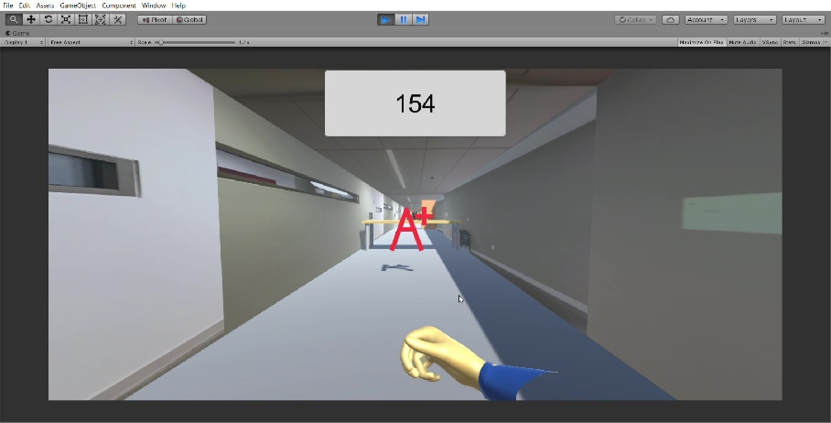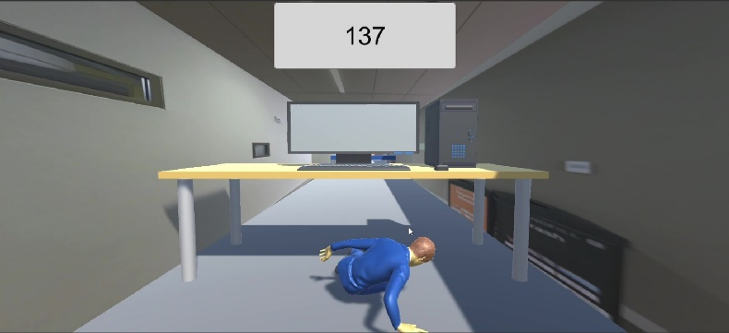 Do you remember how in high school there was always that one kid who always would run to their next class? You and your friends may have mocked them because you were too insecure to see the joy in running down a crowded hallway dodging obstacles, like your school was your own private obstacle course. Well now, you can correct the folly of your ways in a collegiate environment by playing Gotta Get to Class, an endless runner with endless fun. On your way through the hallways you can strafe side to side to avoid doors and people in your path, slide or vault over desks, collect books and earn good grades to increase your score. As your score increase so does your speed making the game more challenging and more fun.

Pseudorandom generated hallways always provide for a new experience every time you hit play, while at the same time always giving you a Don Myer’s texture to put you in the spirit of running through a school hallway. Moreover, with simple WASD controls and smooth movement across random terrain (yes, this is a BRINK reference get over it) the game is immersive yet simple to play. As you run through the hallways you may notice at the end you can see the glass double doors exiting the Don Myer’s building, but much like in real life you may never be able to reach the exit. Maybe this could be equated to a life long pursuit of learning, feeling trapped the experience is up to you, or just a chosen end of hallway screen so you weren’t just looking at a skybox or canvas, the choice is really up you. But one thing is certain, you Gotta Get to Class.