# README

This document provides an outline of the prototype file structure.

## Client File Structure

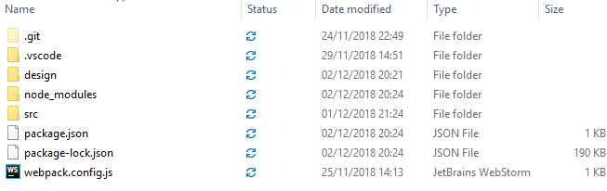

**.git**

Contains settings for GitHub repository.

**.vscode**

Contains settings for Visual Studio Code

**design**

Contains high fidelity prototype screenshots.

**node_modules**

Contains node modules that are generated when initiating the project with Node.js as well as additional modules used for the prototype such as googleapis, node-fetch and querystring.

**src**

Contains source code and image assets used in the making of the prototype.

**package.json**

This file holds metadata about the project including name, repository and project dependencies.

**package-lock.json**

This file is automatically generated for any operations where Node Package Manager (npm) modifies node_modules tree or package.json files. It describes the exact tree that was generated so that subsequent installs can generate identical trees.

**webpack.config.js**

This file contains the config for webpack initialisation.

## Client Source Code

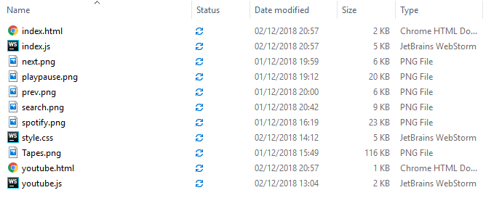

Index.html

Contains html layout for home screen of prototype

Youtube.html

Contains html layout for YouTube screen of prototype

Style.css

Contains CSS for design of both index.html and youtube.html.

Index.js

This file contains Spotify API functionality.

Youtube.js

This file contains YouTube API functionality.

## Server File Structure and Source Code

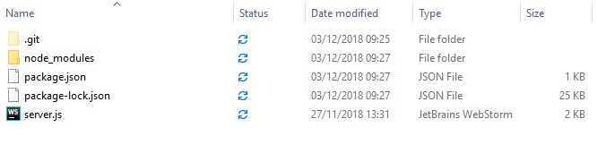

.git, node_modules, package.json and package-lock.json are the same as previously stated.

Server.js

Contains a backend server that allows for users to authorize Spotify API. This was built using express, request and querystring modules for Node.js.