Web Page Layout and Nielsen’s heuristics

1. Home Page

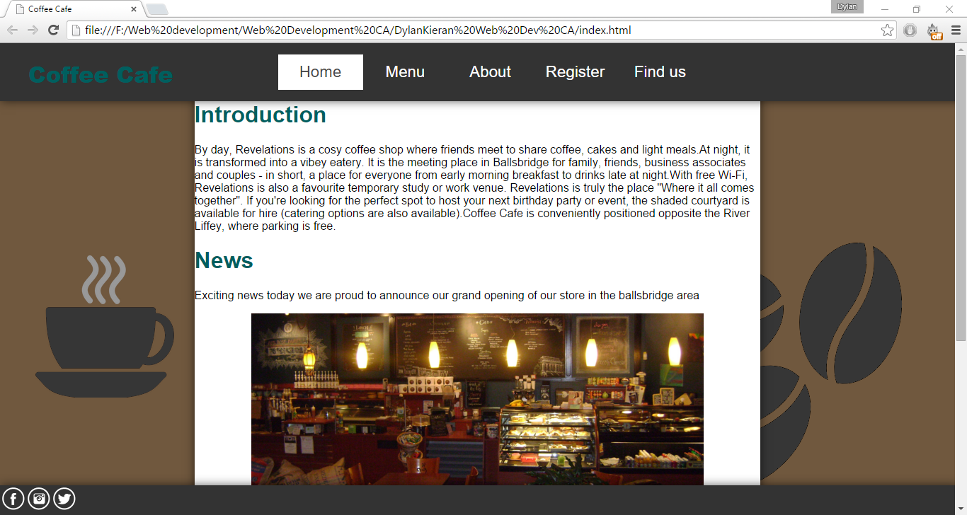

1. Menu Page

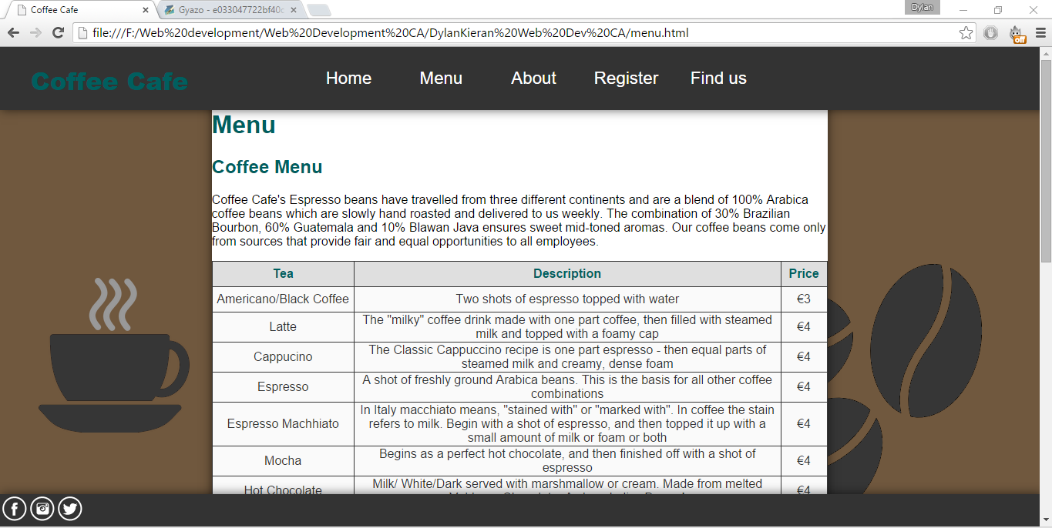

1. About Page

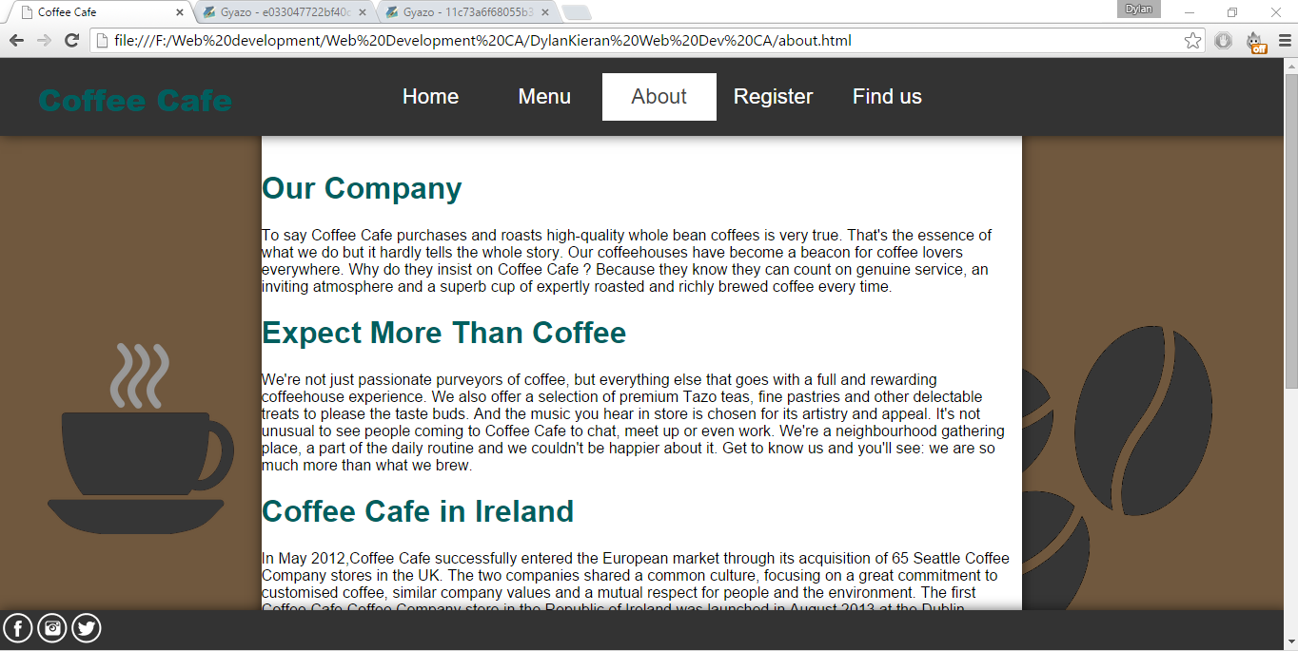

1. Register Page

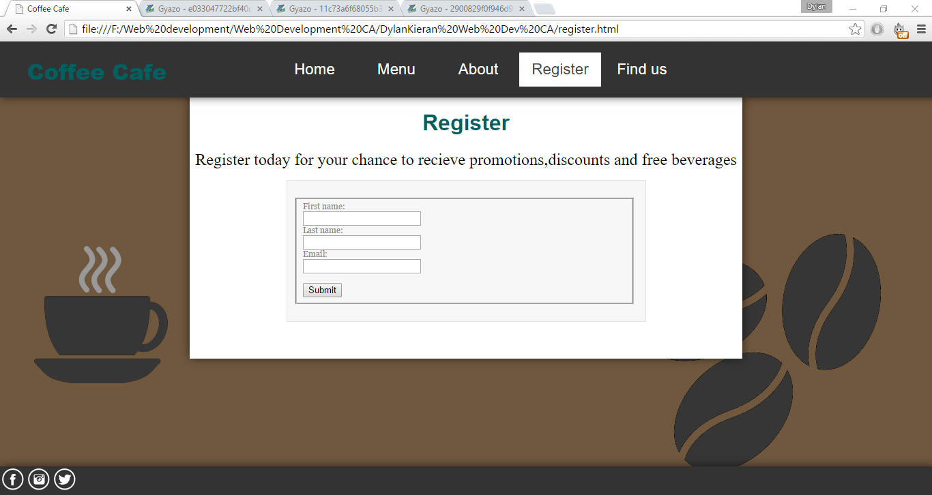

1. Find Us Page

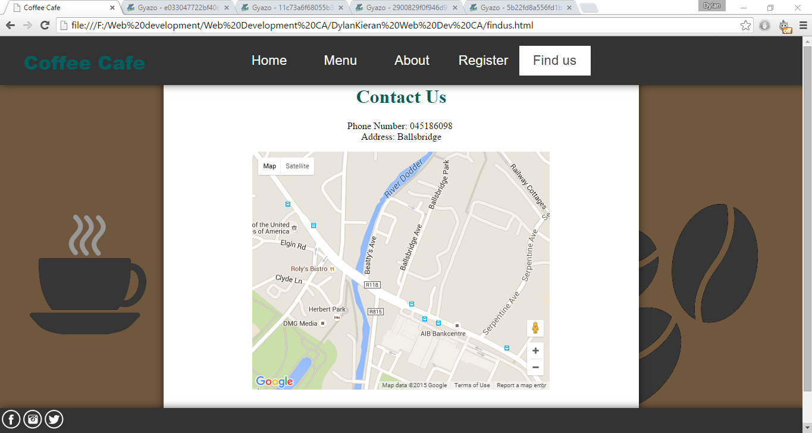

# Nielsen’s heuristics

In my opinion my website applies to all Nielsen’s heuristics the website is clean and simple and very user friendly with all Nielsen’s heuristics applied to it.