--- layout: default ---

## Information

[](%7B%%20link%20information_patient_involvement.md%20%%7D)

### Patient involvement

We involve patients in the design and application of our research project to ensure their opinions are included and to better understand their needs and experiences.

* [More](%7B%%20link%20information_patient_involvement.md%20%%7D)

[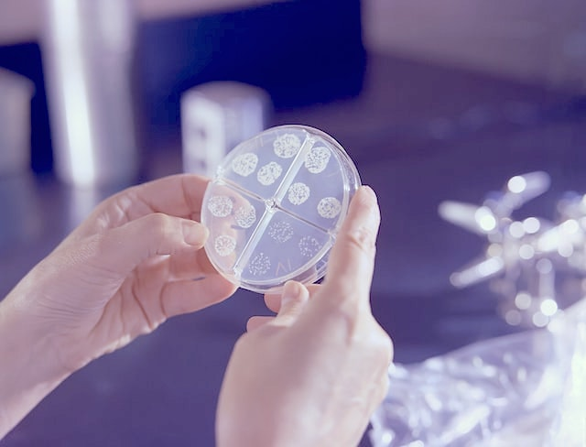](%7B%%20link%20information_personalised_health.md%20%%7D)

### Personalised health

We tailor treatments based on scientific evidence using genomics, multi-omics, and other forms of analysis to provide personalized health care to our patients.

* [More](%7B%%20link%20information_personalised_health.md%20%%7D)

[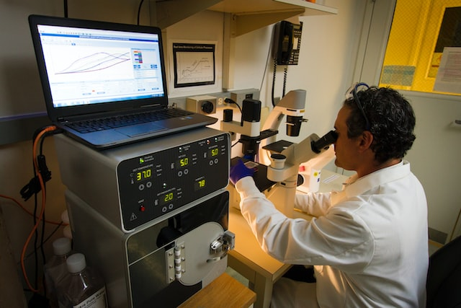](%7B%%20link%20information_modern_technology.md%20%%7D)

### Modern technology

We rely on modern technology such as DNA analysis, proteomics, statistics, high-performance computing, and medical knowledge interpretation to develop new medical systems.

* [More](%7B%%20link%20information_modern_technology.md%20%%7D)

[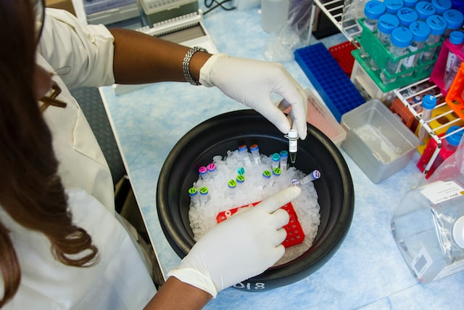](%7B%%20link%20information_basic_science.md%20%%7D)

### Basic science

We focus on basic science research to understand the fundamental mechanisms underlying disease and to develop new diagnostic tools and treatments based on this knowledge.

* [More](%7B%%20link%20information_basic_science.md%20%%7D)

[](%7B%%20link%20information_cross_collaboration.md%20%%7D)

### Cross collaboration

We collaborate between multiple university hospitals and university research groups to combine resources, expertise, and knowledge for cutting-edge medical research.

* [More](%7B%%20link%20information_cross_collaboration.md%20%%7D)

[](%7B%%20link%20information_how_your_contribution.md%20%%7D)

### How your contribution is used

Your contribution to our hospital research project will be used to improve how we diagnose patients, make research breakthroughs, and develop new treatments for diseases.

* [More](%7B%%20link%20information_how_your_contribution.md%20%%7D)

## Projects

### Summary of major projects

Our work is demonstrated by a number of Lighthouse and Nested projects, with an emphasis on patient and public involvement. [➔ Read more](%7B%%20link%20study_overview.md%20%%7D)

### Patient and public involvement

SwissPedHealth places major importance on the involvement of all patients, family, and the public. Openness and fairness is a key requirement to build a productive and functional personalised health network. Learn how your involvement can help us to deliver world-class treatments, today and into the future. [➔ Read more](%7B%%20link%20nested_project_ppi.md%20%%7D)

### Multi-omic diagnosis of for children with rare disease

By harnessing cutting-edge scientific methods we can detect the causes of illness with better precision and make new discoveries for all society in the future. [➔ Read more](%7B%%20link%20lighthouse_project.md%20%%7D)

### Basic anthropometric information from all children

Several national registries are used to study birth records (height, weight, head circumference, gestational age) alongside electronic health records to understand and improve our detection and treatment of disease. [➔ Read more](%7B%%20link%20nested_project_1.md%20%%7D)

### Oncology patients

By modernising our monitoring process, we can improve the detection of illness and standard of care. This is achieved by linking electronic health records with our national cancer registries. [➔ Read more](%7B%%20link%20nested_project_2.md%20%%7D)

### Outpatients with respiratory problems

We are developing national-scale analysis of essential diagnostic data for outpatients with respiratory problems to improve interpretation, quality control, and reporting for patients. [➔ Read more](%7B%%20link%20nested_project_3.md%20%%7D)

### Antibiotics use

We monitor infectious diseases and antibiotic utilization patterns to inform regulatory and strategic trials. With this data we are transforming the evidence-base for antibiotic selection, duration, and route of administration. [➔ Read more](%7B%%20link%20nested_project_4.md%20%%7D)

## News

### [ETH Zurich - Hope for patients with a severe rare disease.](%0A%20%20%20%20%20%20%20%20%20%20%20%20%20%20%20%20https://ethz.ch/en/news-and-events/eth-news/news/2023/01/hope-for-patients-with-a-severe-rare-disease.html%0A)

26.01.2023

Combining the results of multiple molecular analyses could lead to improved diagnosis of the rare and severe hereditary metabolic disease, methylmalonic aciduria. The new research offers potential benefits for affected individuals and could also pave the way for improved treatment options in the future.

### [The first SwissPedHealth publication - Nature Metabolism.](%0A%20%20%20%20%20%20%20%20%20%20%20%20%20%20%20%20https://www.nature.com/articles/s42255-022-00720-8%0A)

26.01.2023

Integrated multi-omics reveals anaplerotic rewiring in methylmalonyl-CoA mutase deficiency. Nature Metabolism, 26 January 2023, doi: [10.1038/s42255-022-00720-8](https://www.nature.com/articles/s42255-022-00720-8). Forny P, Bonilla X, Lamparter D, Shao W, Plessl T, Frei C, Bingisser A, Goetze S, van Drogen A, Harshman K, Pedrioli PGA, Howald C, Poms M, Traversi F, Buerer C, Cherkaoui S, Morscher RJ, Simmons L, Forny M, Ioannis Xenarios, Aebersold R, Zamboni N, Rätsch G, Dermitzakis E, Wollscheid B, Matthias R. Baumgartner MR, Froese DS.

## Get in touch

### Contact

For clinic appointments please consult your physician. For research inquiries please use the contact information provided. For patient involvement please contact xyz@email.

* {{ site.email }}
* {{ site.phone }}
* {{ site.street_address }}  
  {{ site.city }}, {{ site.state }} {{ site.zip_code }}  
  {{ site.country }}

### SPHN

SwissPedHealth is part of the Swiss Personalized Health Network (SPHN). You can read more about SPHN on their website [sphn.ch](https://sphn.ch).

### PHRT

SwissPedHealth is part of Personalized Health and Related Technologies (PHRT). You can read more about SPHN on their website [sfa-phrt.ch](https://www.sfa-phrt.ch).