**Mobile App Development 2**

Project Document

Dylan Loftus

G00347849

**Brief Description**

For my app this year I would like to design an app that will provide the user with food recipes and tutorials on how to cook said recipe. The UI will be simplistic to make the app user friendly. The app will show recipes depending on the time of day the user logs into the app for example if the user opens the app at 5PM they will receive recipes of dishes that would be typically eaten at that time.

**Features**

The main features of the app will be as follows.

* Provides users with recipes depending on time for example at 9AM breakfast recipes will be shown.
* Each recipe page will provide a button labelled “Buy Ingredients” which will navigate the user to a retailer to buy the ingredients for the recipe page they are on.
* An embedded YouTube tutorial will appear on each recipe page.
* Detailed instructions on each page to make the recipe.
* Ability to sign up and log in
* Ability to view saved recipes

**User interface**

The user interface will look simplistic to be user friendly.

The Initial page would look something like this.

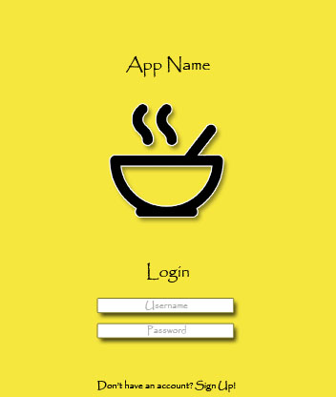

After the user logs in they are greeted by a page that will look something like this.

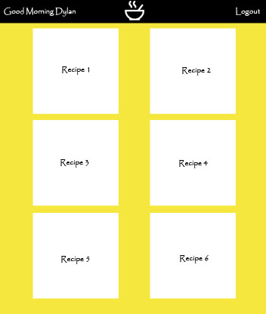

When the user clicks on a recipe they then will be greeted with the recipe page for the recipe they clicked on. It will look something like this.

