Part 1. Updating AgResource Map.

1.1.First we'll grab the coordinates for each of the farms.

Trip 1:
A: 901-999 E 2300 North Rd, Danforth, IL 60930
B: 330-332 County Road 500 N, Buckley, IL 60918
C: 1601-1627 E 100N Rd, Paxton, IL 60957
D: 2122-2198 County Road 1200 E, Champaign, IL 61822
E: 553-589 Co Road 950 N, Tuscola, IL 61953
F: 951-999 N Co Road 450E, Atwood, IL 61913

1.2. You can get quick Lat & Long coordinates from quite a few sites. For this I'm using http://www.findlatitudeandlongitude.com/batch-geocode/.

1.3. Now let's add it to our dataset. Open up the CSV (comma separated values) in your favorite spreadsheet software (Excel is great).

We numerate the locations with an id, and then just need to paste the lat & long in the appropriate places.

1.4 Next we can fill out the source column. All you need do here is put A if it's a picture AgResource took, or P for public. This determines which icon is displayed.

1.5 Now you can go ahead and add the name of the farm (if you have it) and date of the picture taken. The number at the end of the date_ corresponds to the image number. So, date_1 should be the date that picture 1 was taken. Date_2 should correspond to picture 2.

1.6 For each farm, put in how many images have been taken at that location.
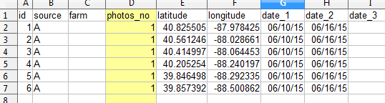

1.7 Now that it's updated, save the file as a CSV and convert it to a

