|  |  |  |  |  |
| --- | --- | --- | --- | --- |
|  | **Item** | **Assignment details** | | |
| 1 | Names and ID numbers of Group Members | Dylan Cross - 15219491  Nate Fort - 123  Tom Sloman - 123 | | |
| 2 | Operating System | Windows 10 | | |
| 3 | Compiler used | GCC 4.8.1 | | |
| 4 | IDE used | Atom (Text Editor) | | |
| 5 | Required Functionalities |  | **Parameter Settings** | |
| Implementation level | **CLIENT** | **SERVER** |
| Full | 01 | 00 |
| Full | 00 | 01 |
| Full | 01 | 01 |
| Full | 10 | 00 |
| Full | 00 | 10 |
| Full | 10 | 10 |
| Full | 11 | 11 |
| 6 | Snap shots of sample interactions: | Yes | | |
| 7 | Extra work done (Bonus): | Implemented Selective Repeat | | |

Screen shot of results:

00:

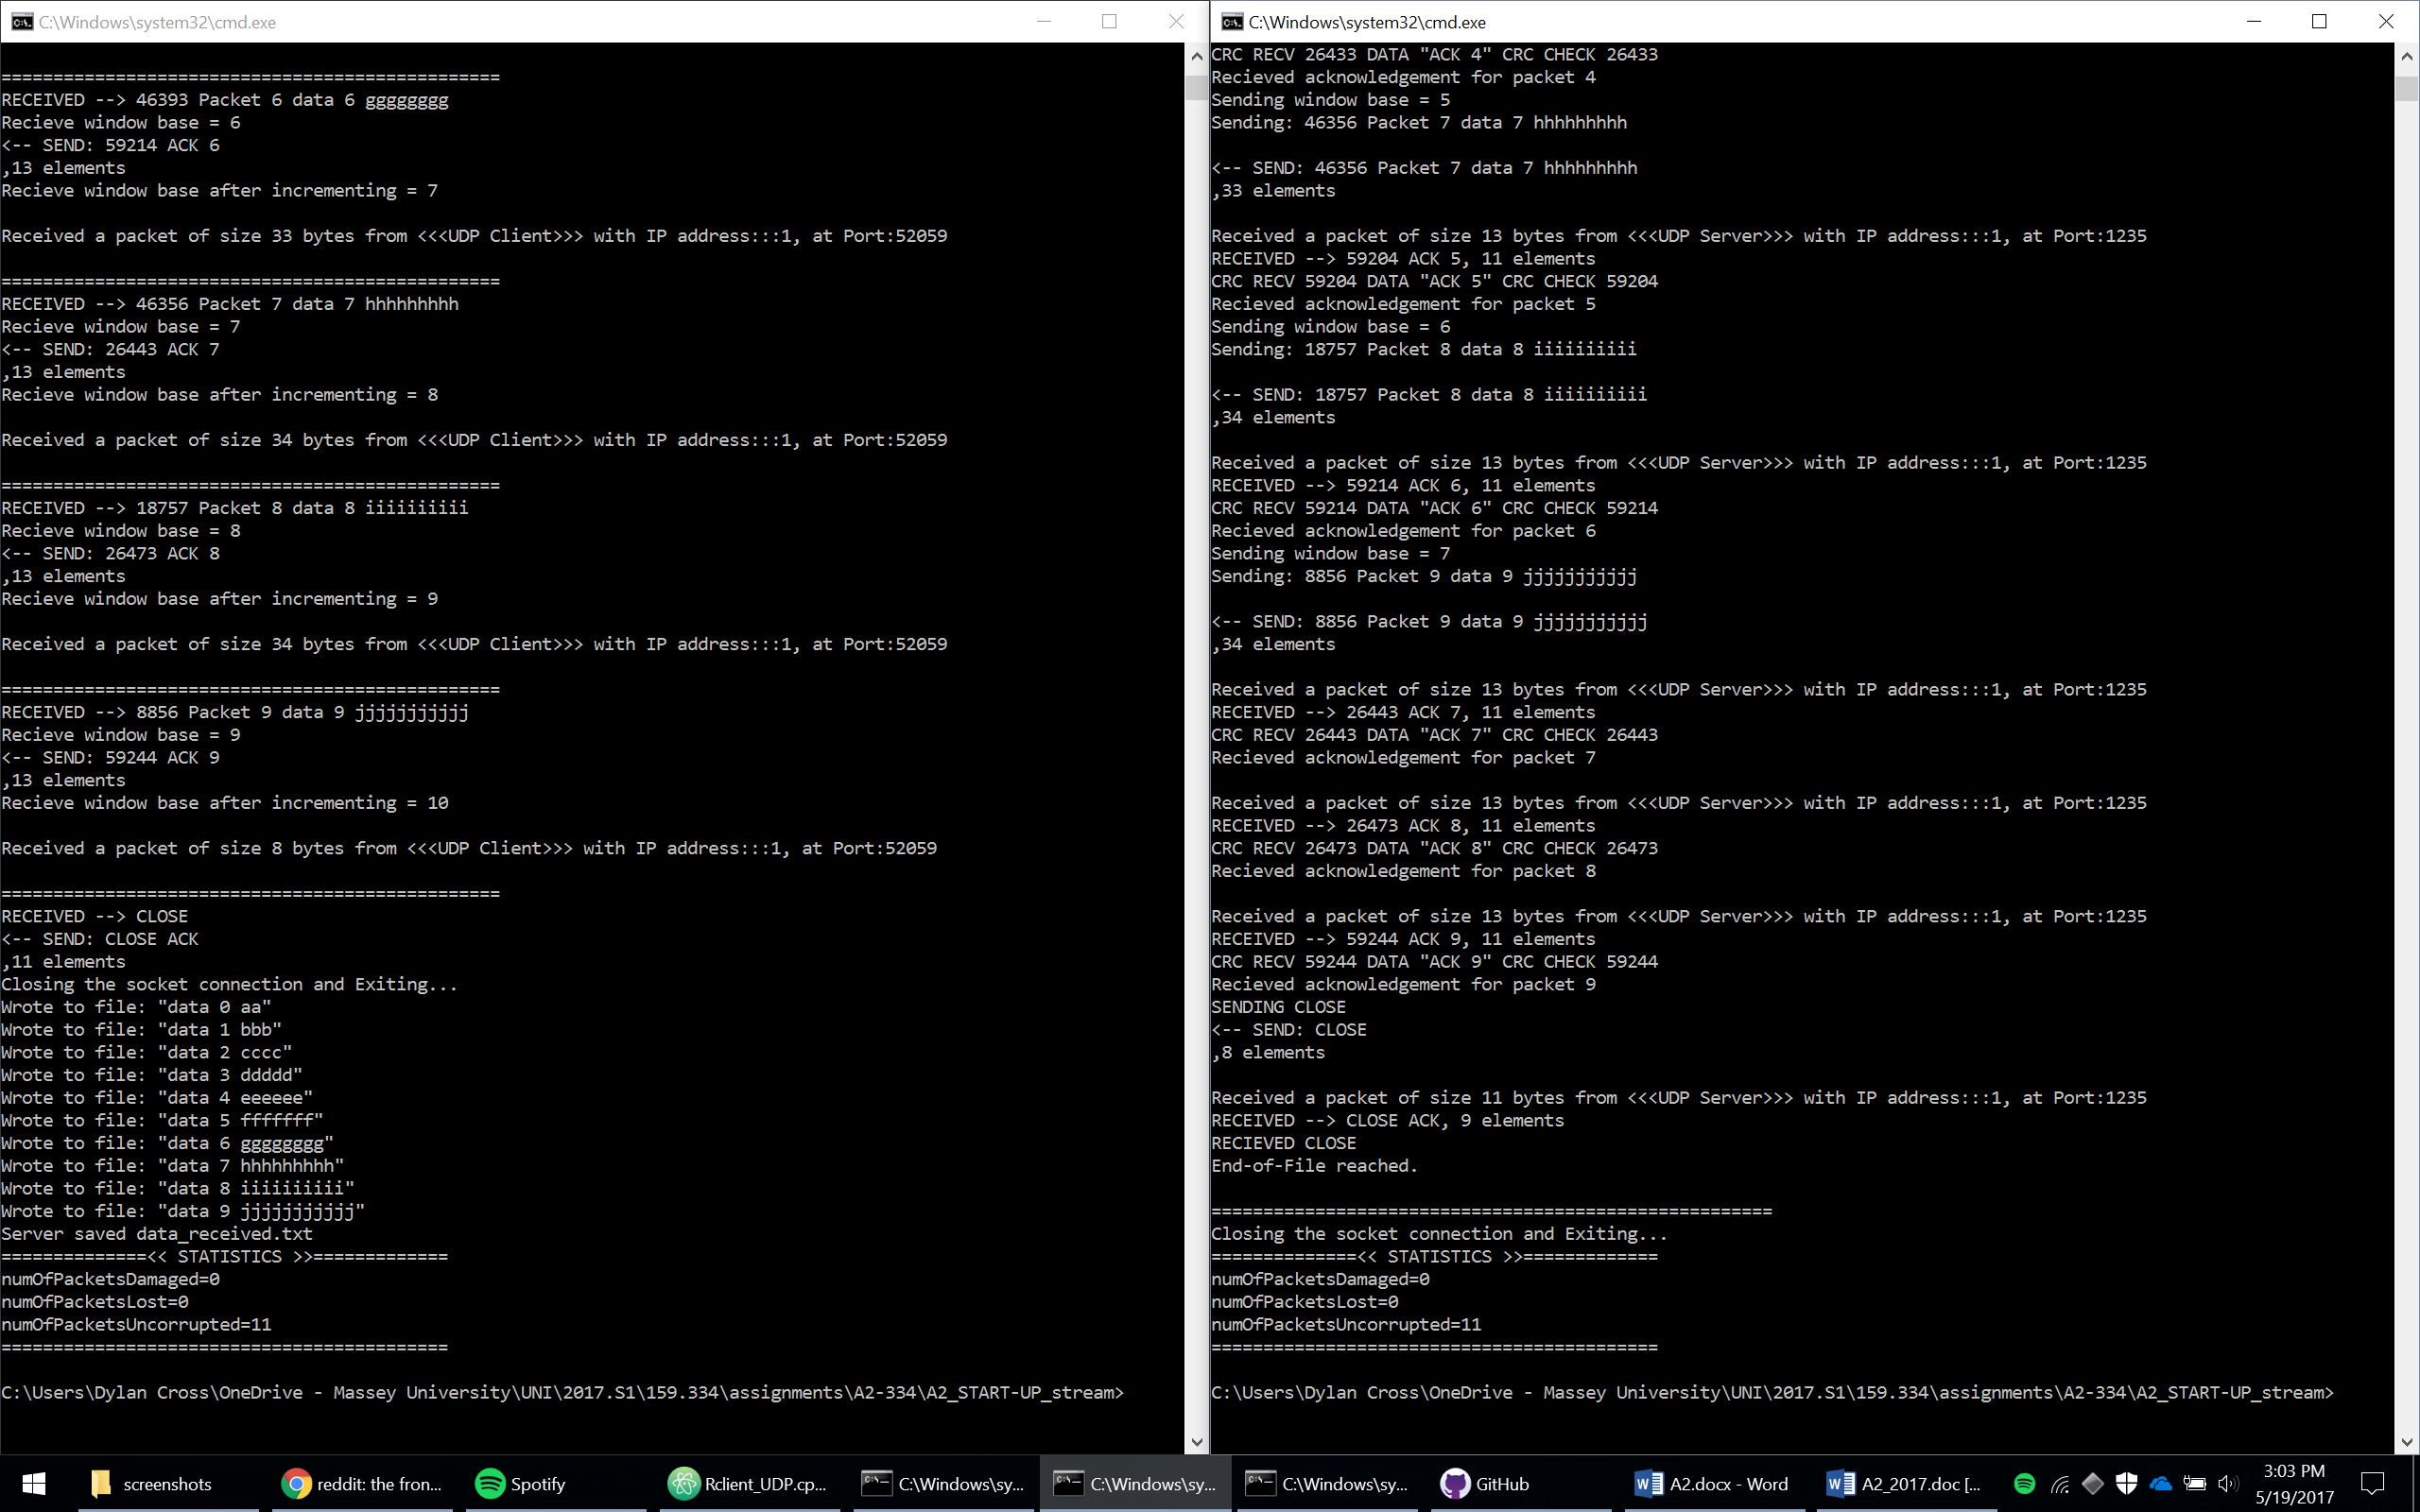

10:

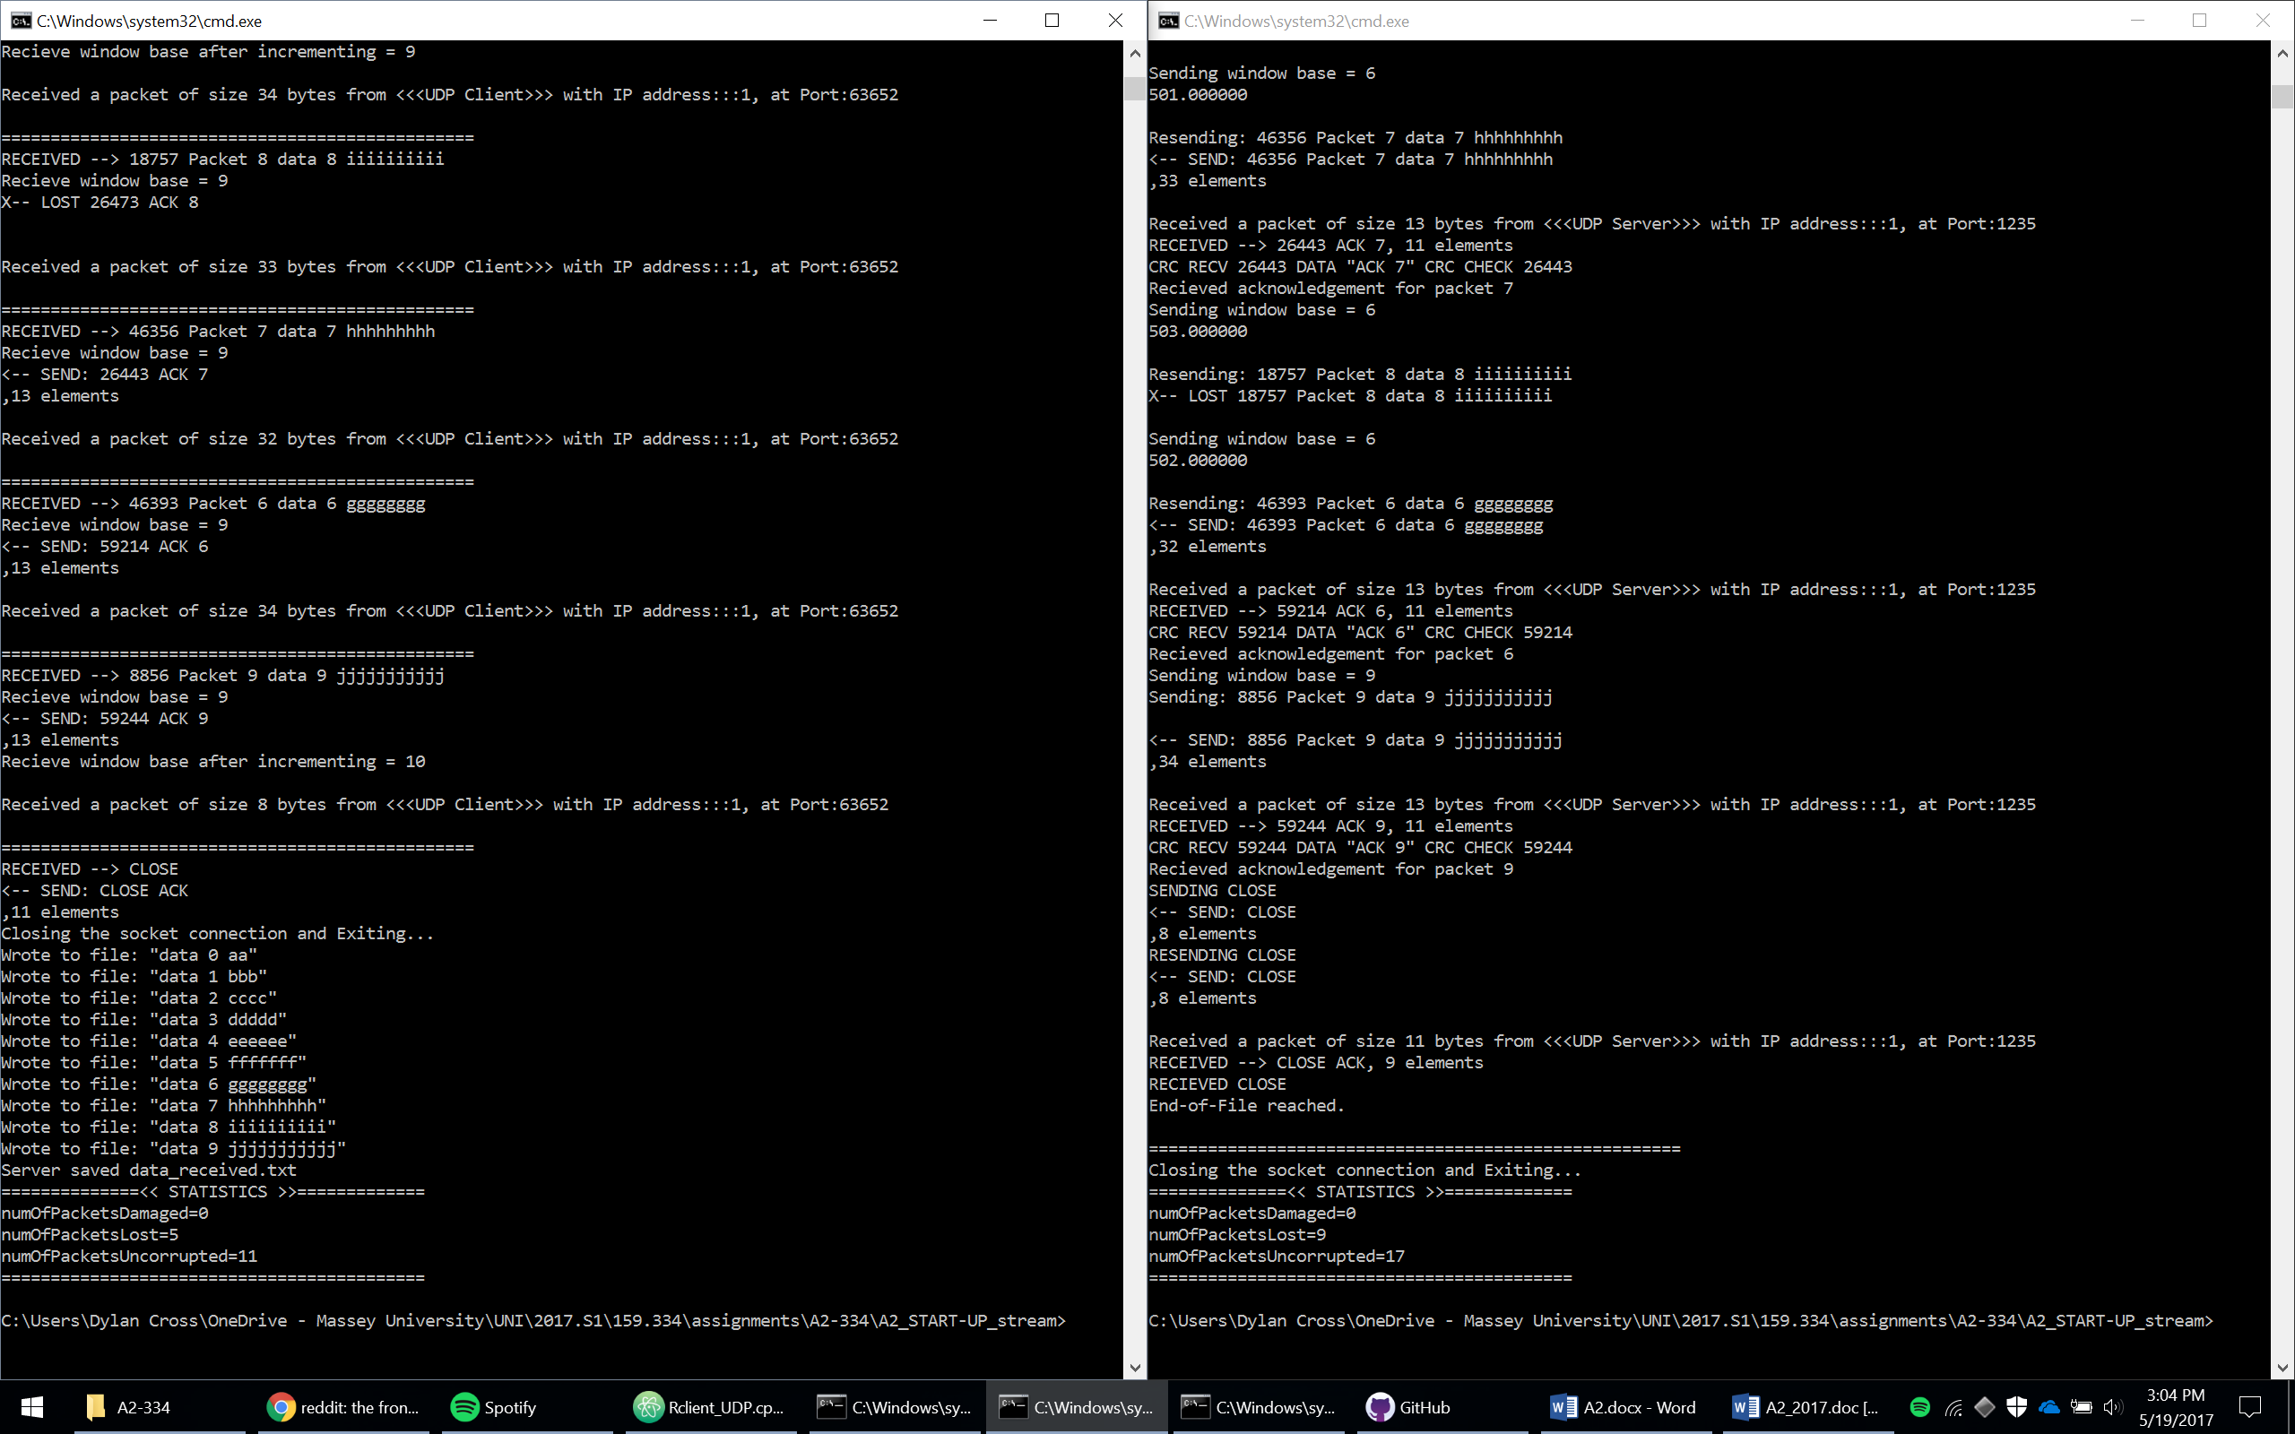

01:

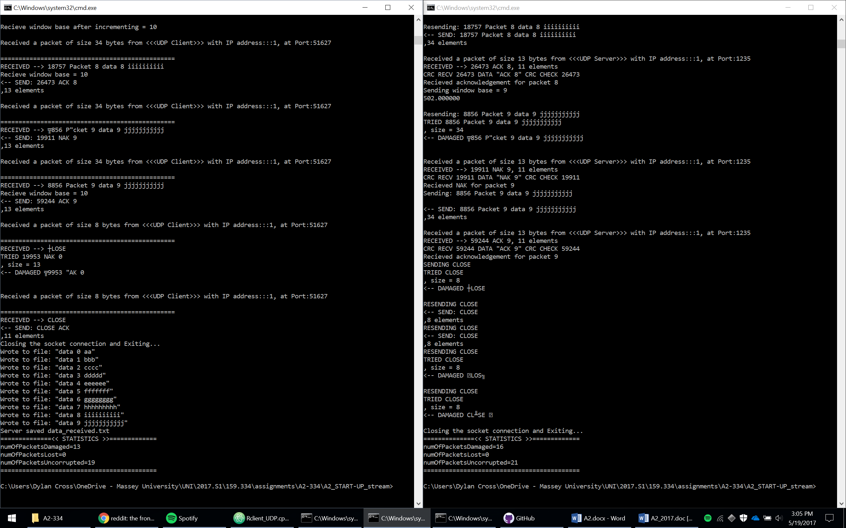

11:

