Computer Networks 159.334 Assignment 3 due 11/June/2017

Cryptography: the RSA algorithm with Cipher Block Chaining

Introduction
In this assignment your task is to implement a hybrid encryption algorithm called RSA with Cipher Block Chaining in a client/server application using TCP sockets. In the TCP client/server example, as you might remember, a client types a message, and then sends it to a server. In turn, the server echoes back the message. In this assignment, you have to modify the client so that it encrypts all communication sent to the server. In addition, you also have to modify the server, so that it decrypts the encrypted message locally.
Create a fixed RSA private (dCA) and public key (eCA) for a CA (certification authority). Assume that the server knows the private key (dCA) of the certification authority (the server is also the certification authority), while the client knows the public key of the certification authority, eCA.
The first time a connection is established, the server will have to send the client its encrypted public key for the current session dCA(e,n). In turn, the client ACKs the receipt of the key, then it extracts the public key using eCA(dCA(e,n)). Next, the client informs the server of the random number (nonce) that will be used for the initial encryption and decryption operations. This nonce is sent encrypted using e(nonce). Successive messages coming from the client will then be encrypted accordingly using RSA-CBC, and the server will decrypt the received messages using RSA-CBC. The server may also echo back to the client the decrypted messages (this is optional - not required).
The client/server should be able to show the original, encrypted and decrypted messages, as seen in the example below:

- The client types: hello

- The server prints locally: The received encrypted message was: 10898 15630 8308 321 13772 22674 22040
After decryption, the message found is: hello
Implementation details
There are many details in the implementation of a real RSA with Cipher Block Chaining that might have to be left out in order to keep it under the scope of an assignment. You have to ask the following questions regarding some decisions about the implementation:
a) What are the sizes of the keys? (aim for a big number(in the thousands) for the variable n in RSA)
b) Should the encryption be done character by character, or by block of characters?
c) Should padding be used?
d) Do you need an arbitrary precision library, or the keys are small enough to use a simple exponential code?
e) How are the keys sent to the client (your protocol design should specify: format, message order, etc).

The answers to these questions will establish how your own “encryption protocol” works.
Follow the following instructions:
1) The details of the core algorithm that should be implemented can be found in “Lecture-14-Network Security_Implementing RSA_CBC_2017.pptx” You are allowed to use relatively small prime number pairs, but do not use pairs that will generate the same original message after encryption.
2) Use the TCP_server_client_CrossPlatform_IPv6 codes as start-up codes (found in our 159334 Stream website). Modify these source codes for your implementation of the encryption protocol.
Testing the assignment:
For quickly testing the assignment, use the batch file, run.bat provided.
The assignment is going to be marked based on functionality and design. The marks are distributed as follows:
- 3 marks: for the successful sending of the encrypted RSA public key to the client, and decryption of the public key by the client.
- 3 marks: for correctly sending the encrypted random number (encrypted(nonce)) to the server. That also includes the server decrypting and extracting the nonce correctly.
- 6 marks: for the correct implementation of RSA with Cipher Block Chaining. The encryption/decryption results should be always correct for any ASCII characters. Make sure that the combination of the selected RSA keys and nonce will not have any problem encrypting and decrypting messages.
- 3 marks: Documentation (MS Word). Write a pseudocode of your system (i.e. specify the message format, encoding, decoding scheme, how keys are sent, generation of keys, etc.). Provide a snapshot of one complete client/server interaction. For testing, use the message “the quick brown fox jumps over the lazy dog.” Also, indicate if you have implemented the Extended Euclidean Algorithm, to get some bonus marks.
*2 Bonus marks will be given to those who can implement correctly the Euclidean Algorithm and the Extended Euclidean Algorithm (make a note in your assignment submission if you did this). Include simple test functions to prove that your implementations are correct.
Notes:
1 - Submit your files electronically via Stream, in zip format. Submit everything, including the folders and the batch file.
2 - This assignment is worth 15 marks (+ bonus, if your submission qualifies).
3 - Marks will be subtracted for obvious copying and/or for delays without justification.

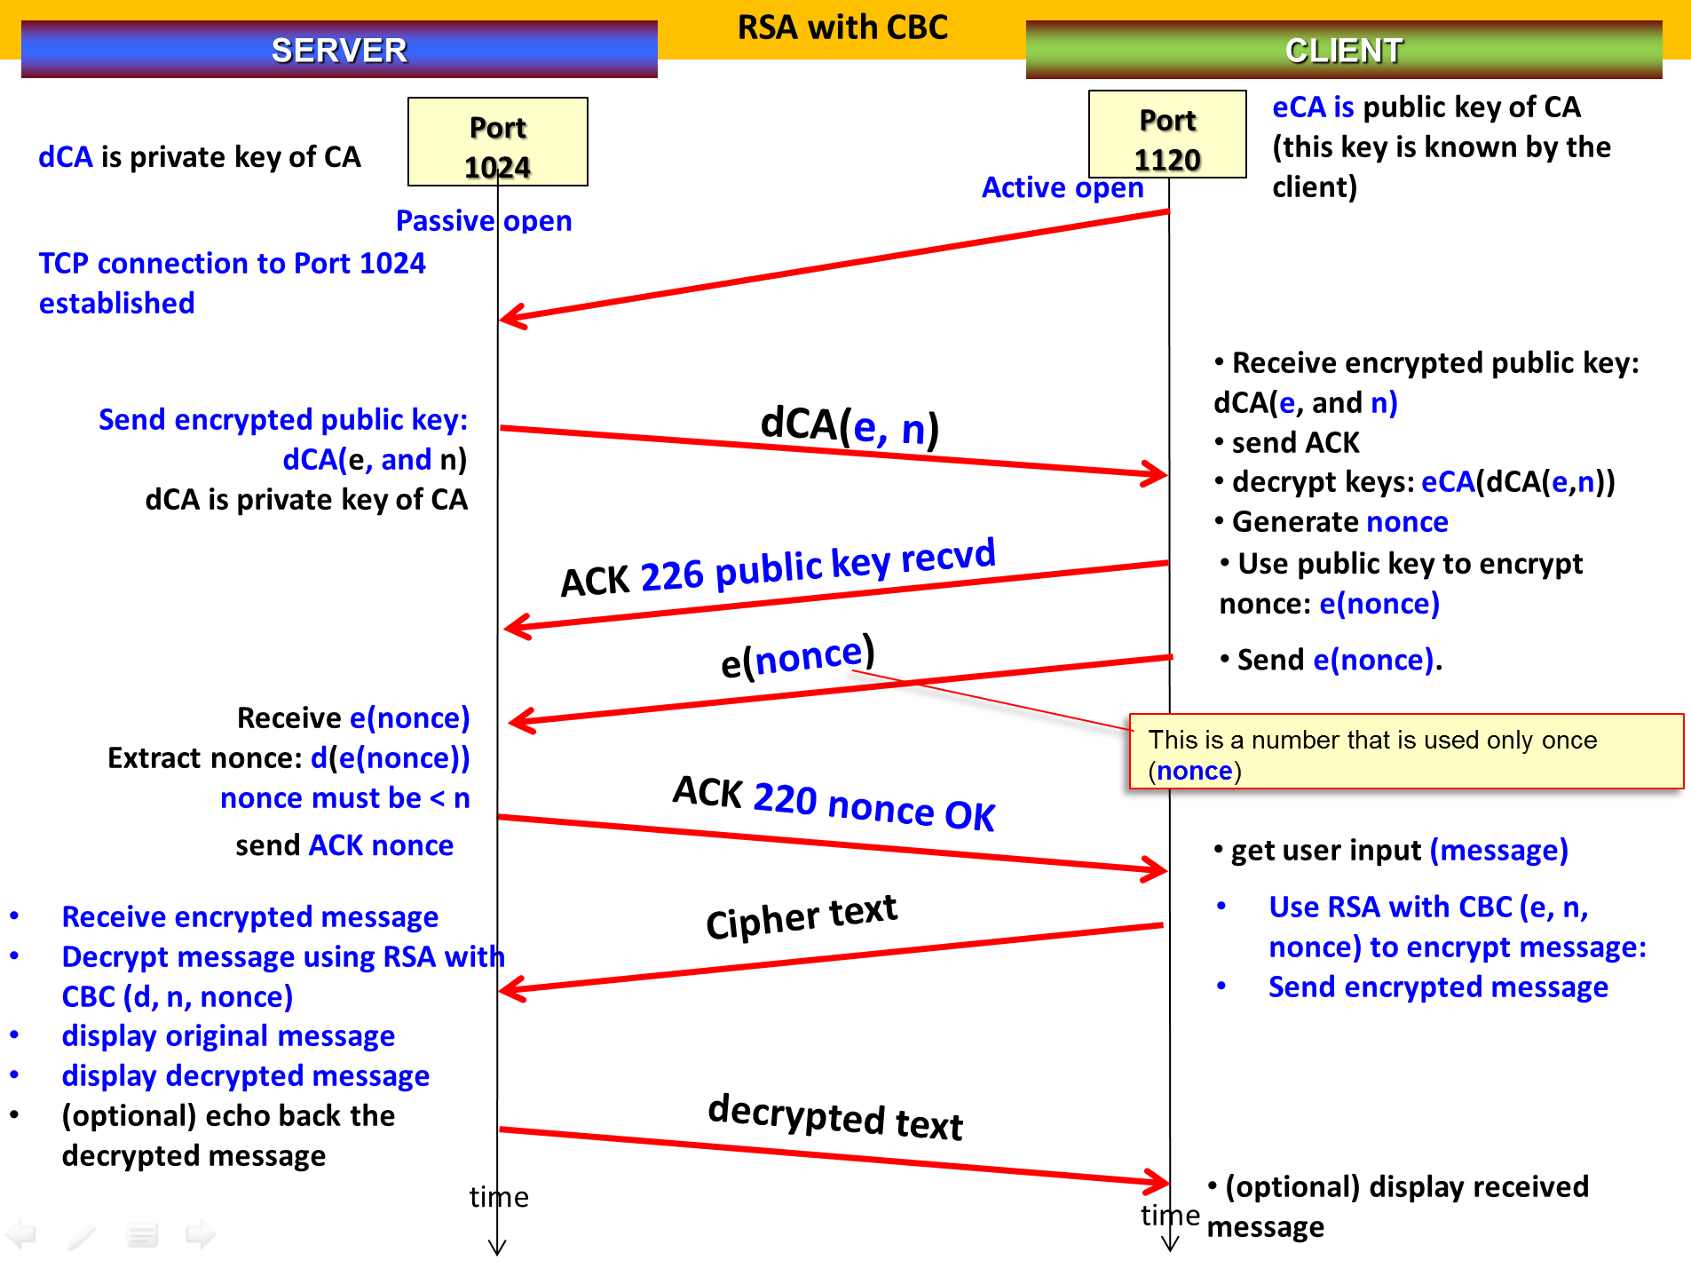

---
Nothing follows.

