Dylan Phoutthavong
February 16th, 2025
CSCI 3287
HW 4
- Using the database described in figure 1.2 (page 8 from the textbook), specify the following queries as relational algebra expressions:
  - Retrieve the transcript—a list of all courses and grades—of ‘Smith’
    - Find ‘Smith’ in STUDENT:
      - σName=’Smith’(STUDENT)
      - ‘Smith’ is associated with Student_number 17
    - Join with GRADE_REPORT to get tupples associated with ‘Smith’:
      - σStudent_number=17(GRADE_REPORT)
    - Join with COURSE to get Course_number:
      - σStudent_number=17(GRADE_REPORT)⋈SECTION
    - Join with COURSE to get Course_name:
      - (σStudent_number=17(GRADE_REPORT)⋈SECTION)⋈COURSE)
    - Projection: Retrieve Course_name and Grade:
      - πCourse_n​ame,Grade​((σStudent_n​umber=17​(GRADE_R​EPORT)⋈SECTION)⋈COURSE)

  - List the names of students who took the section of the ‘Database’ course offered in fall 2008 and their grades in that section
    - Find Course_number of ‘Database’ in COURSE:
      - σCourse_name=’Database’(COURSE)
    - Extract Course_number (CS3380) and find any sections that match:
      - σCourse_number=’CS3380’∧Semester=’Fall’∧Year=08(SECTION)
    - Extract Section_identifier (135) and find matching students in GRADE_REPORT:
      - σSection_identifier=135(GRADE_REPORT)
    - Join with STUDENT to get Name:
      - (σSection_identifier=135(GRADE_REPORT)⋈STUDENT)
    - Projection: Retrieve Name and Grade:
      - πName,Grade​(σSection_i​dentifier=135​(GRADE_R​EPORT)⋈STUDENT)

  - List the prerequisites of the ‘Database’ course
    - Find Course_number of ‘Database’ (CS3380):
      - σCourse_n​umber=′CS3380′​(PREREQUISITE)
    - Projection to get Prerequisite_number:
      - πPrerequisite_n​umber​(σCourse_n​umber=′CS3380′​(PREREQUISITE))

  - Display the content of the RESULT relation for query “b” above
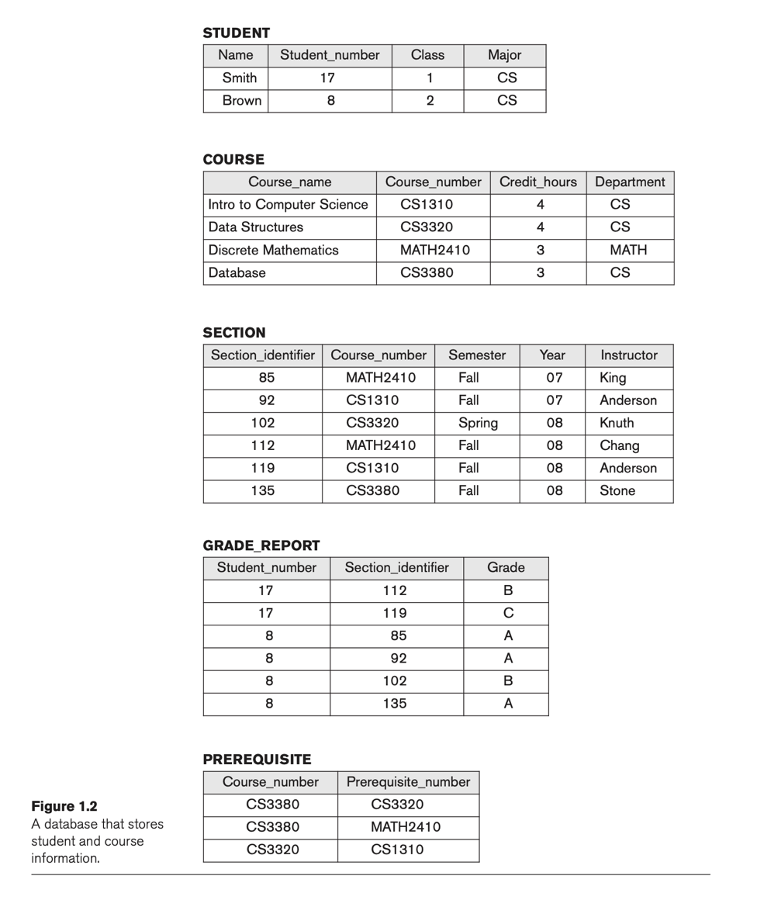
    - Brown, A
- Using the database below, specify the following queries as relational algebra expressions:
  - List of products (id, name and quantity) to be delivered to stores/clients in Colorado
    - Find clients in Colorado:
      - σState=′CO′​(CLIENT)
    - Extract Client_id:
      - πClient_i​d​(σState=′CO′​(CLIENT))
    - Find the invoices for these clients:
      - INVOICE⋈πClient_i​d​(σState=′CO′​(CLIENT))
    - Extract Invoice_number:
      - πInvoice_n​umber​(INVOICE⋈πClient_i​d​(σState=′CO′​(CLIENT)))
    - Find the products and quantities from ITEM:
      - ITEM⋈πInvoice_n​umber​(INVOICE⋈πClient_i​d​(σState=′CO′​(CLIENT)))
    - Join with PRODUCT to get product descriptions:
      - (ITEM⋈πInvoice_n​umber​(INVOICE⋈πClient_i​d​(σState=′CO′​(CLIENT))))⋈PRODUCT
    - Projection to get Product_id, Description, and Quantity:
      - πProduct_i​d,Description,Quantity​((ITEM⋈πInvoice_n​umber​(INVOICE⋈πClient_i​d​(σState=′CO′​(CLIENT))))⋈PRODUCT)

  - List product description and category name of products that are not part of any invoice
    - Find all Product_id in ITEM:
      - πProduct_i​d​(ITEM)
    - Find products not in invoices:
      - PRODUCT−πProduct_i​d​(ITEM)
    - Join with CATEGORY to get Category_name:
      - (PRODUCT−πProduct_i​d​(ITEM))⋈CATEGORY
    - Projection to get Description and Category:
      - πDescription,Category​((PRODUCT−πProduct_i​d​(ITEM))⋈CATEGORY)
  - Total amount (quantity * price) of all electronics listed in an invoice
    - Find Category_id for Electronic:
      - σCategory=′Electronic′​(CATEGORY)
    - Extract Category_id (1):
      - πCategory_i​d​(σCategory=′Electronic′​(CATEGORY))
    - Find Product_id for Electronics:
      - σCategory=1​(PRODUCT)
    - Join with ITEM to get quantities:
      - ITEM⋈σCategory=1​(PRODUCT)
    - Compute Quantity * Price:
      - ∑(Quantity×Price)(πQuantity,Price​(ITEM⋈σCategory=1​(PRODUCT)))
  - Display the content of the RESULT relation for query “c” above
    - Total_amount = (3 * 250) + (10 * 900) + (10 * 250) = 750 + 9000 + 2500 =
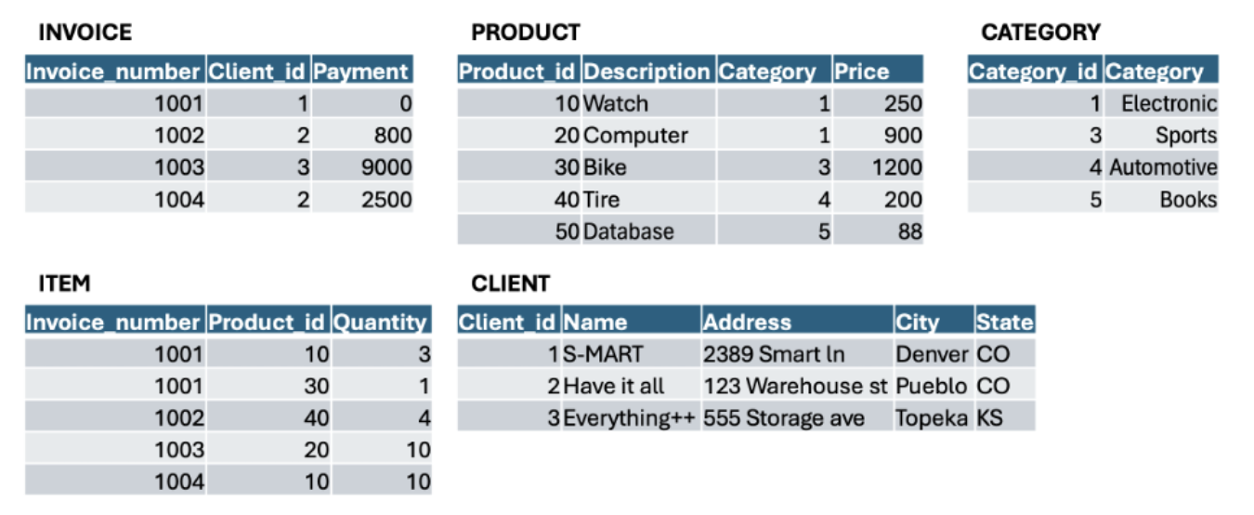
    - 12250

