Total Points: 100

Languages C++, C#, Java and Python.

You will be implementing Feistel for two block sizes, both will use Galois Fields for their calculations. It is possible to start this without knowing Galois Fields. You can implement Feistel with a template function (i.e. F = RH) and add the function later on.

For those operations requiring a Galois Field, over GF(2⁸) use m(x) = x⁸ + x⁴ + x³ + x + 1 (otherwise known as 0x11B)
For those operations requiring a Galois Field over GF(2⁴) use m(x) = x⁴ + x + 1 (otherwise known as 0x13)

WARNING: Modulo over a Galois Field is NOT the same as an arithmetic modulo.

Chapter 4 Feistel
Q-1: Implement the Feistel Cypher to encrypt and decrypt a file using a block size 16-bits per block. 16-bits mean two characters form a single block and R₀ = 8bits (one input character) and L₀ = 8bits (the other input character in the 16 bit block)
Implement the function F = (R_{n-1} * key_{n}) mod 0x11B)₁₆ over GF(2⁸) and a_{i} ∈ GF(2) with m(x) = x⁸ + x⁴ + x³+ x¹ + 1 (0x11B).
R_{n-1} is the right-hand round input for round n.
L_{n-1} is the left-hand round input for round n.
R_{n} and L_{n} are the round outputs for round n.
key_{n} is the key input to F for round n.

The routine will accept four arguments:
- a text file name of a file containing the text to be encrypted (or decrypted).
- an output file name to store the result
- an argument for key values in ASCII (this will also determine # of rounds)
you can pass binary values as well but that depends on your development environment or you can opt to read a file instead so long as the user can specify a key somehow.
- The ascii inputs “e” / “d” for encrypt or decrypt.

You can write any argument handler [or IDE interface, it is to make it easier for you not for me necessarily] but it should minimally report an error and show how to use your program and report errors if arguments are incorrect (no keys, no choice of “e” or “d” … etc.)

EXAMPLE argument inputs to execute[ if using a command line interface]:
./feistel plain.txt cypher.txt R2 e
Will create a file cypher.txt with encrypted cyphertext.
./feistel cypher.txt recover.txt R2 d
Will create a file output.txt with recovered plaintext.

If you have spaces or other weird characters you may need to enclose the arguments in quotes (“ – double quotes).

In this case each round key will require a one byte which equals a single ASCII character i.e. ‘R’ or ‘2’. If the number of rounds is 16, R2 will be repeated eight times with
Round 1 = R, Round 2 = 2, Round 3 = R again, Round 4 key = 2 again … etc. until you run out of keys.

./feistel
ERROR, too few arguments
Usage: feistel <input_filename> <keys> <“e” | “d”>

./feistel plain.txt cypher.txt KeNnEsSaWr23626Z e
In this case round 1 key = ‘K’ then 2 = ‘e’, 3 = ‘N’, 4 = ‘n’, 5 = ‘e’ up to 16 rounds to encrypt to the file encrypt.txt

./feistel plain.txt .txt R2R2R2R2 e
In this case it will go 8 rounds but round 0,2,4,6 will use ‘R’ as a key, 1,3,5,7 using ‘2’ as a key to encrypt to the file cypher.txt

./feistel cypher.txt recover.txt R2R2R2R2 d
In this case it will go 8 rounds but round 0,2,4,6 will use ‘R’ as a key, 1,3,5,7 using ‘2’ as a key to decrypt to the file recover.txt

If you are using an IDE it will also accept arguments on a built-in command line, its usage varies from IDE to IDE. If you prefer it can prompt the user for these arguments before beginning.

Write a complete program. Use only standard libraries and data structures (i.e. no “import encrypt.class” or whatever). Include code in submission file as a text readable form as a separate text file in D2L. See below regarding languages.
Implemented in the code.

50 points

Q-2: Feistel with 8bit blocksize. Modify the above to include an 8-bit blocksize, this means LH and RH are each 4-bit halves of each block which is a single 8-bit ASCII character.
Add a fifth argument for block size in bits (i.e. <8 | 16> bits)

Implement the function F = (R_{n-1} * key_{n}) mod 0x13)₁₆ over GF(2⁴) and a_{i} ∈ GF(2) with m(x) = x⁴ + x¹ + 1 i.e. 0x13)₁₆ .
R_{n-1} is the right hand round input for round n.
L_{n-1} is the left hand round input for round n.
R_{n} and L_{n} are the round outputs for round n.
key_{n} is the key input to F for round n.

Implemented in the code.
20 points

Q-3: Test your implementations, the following tests are offered:

16 BIT TESTS
File: AM_Meaning.txt
Encrypted with key = “Secret”, blocksize = 16bits
Test Result: AM_Meaning_cypher.txt (use hexdump or hexeditor to see hex values to compare file with your outputs)
My Output:
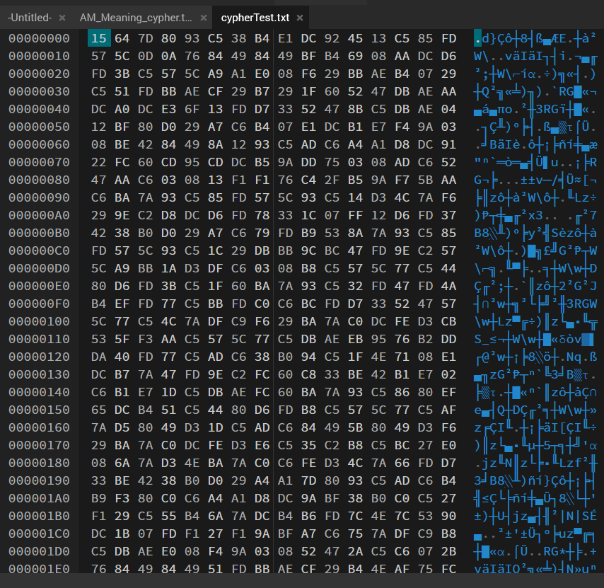

Correct output:
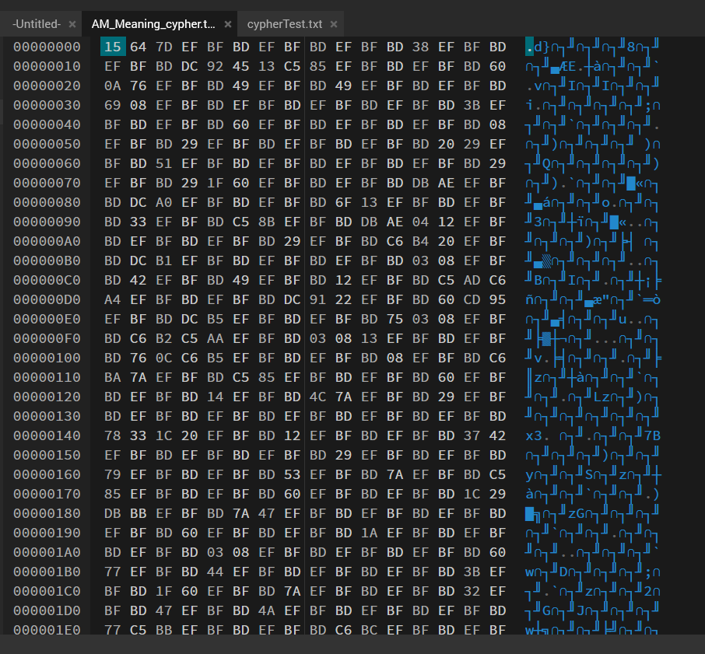
File: cypher.txt
Decrypted with key = “R2R2R2”, blocksize = 16bits
Test Result: recover.txt (does your output equal this text) Yes, it does.
My output:
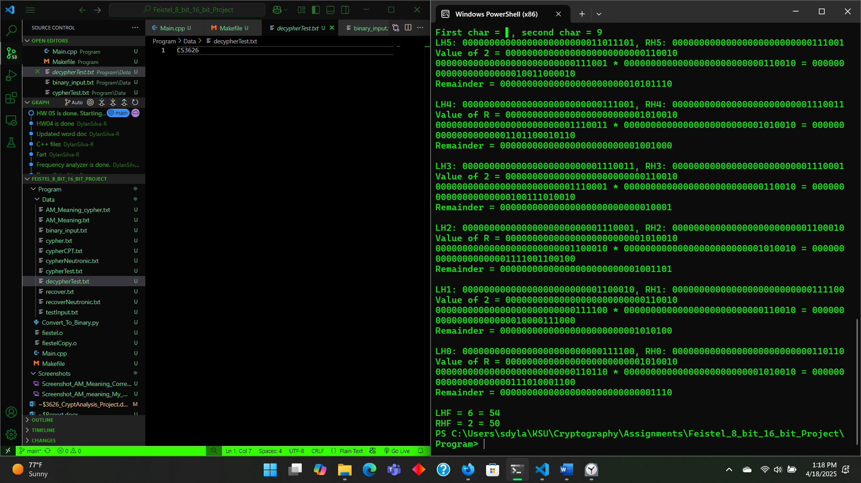

8 BIT TESTS
File : plainCPT.txt (plainCPT.txt was not included)
Decrypted with key “CPT3000”, blocksize = 8bits
Test Result: cypherCPT.txt

File: cypherNeutronic.txt
Decrypted with key “MITMITMIT”, blocksize = 8bits
Test Result: recoverNeutronic.txt
Output:
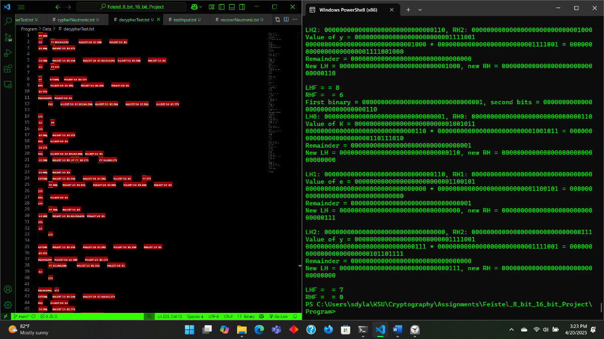

SUBMISSION DOCUMENTS:

Supply source code files as an ASCII text document (See EXCEPTION section below) along with instructions on how to compile.
Submit screenshot showing the execution of the encryption and decryption operations on an 8-bit block and 16-bit block.
Encrypt a plaintext message which includes your name somewhere in it and submit the resulting cyphertext only here along with the keys used, blocksize used.

Plaintext message = Hi, my name is Dylan Silva-Rivas
Key = Key
Block size = 16-bit
Cypher text = ���U��~�t\l���^#L��Tt�c���i
Screenshots:

Encryption
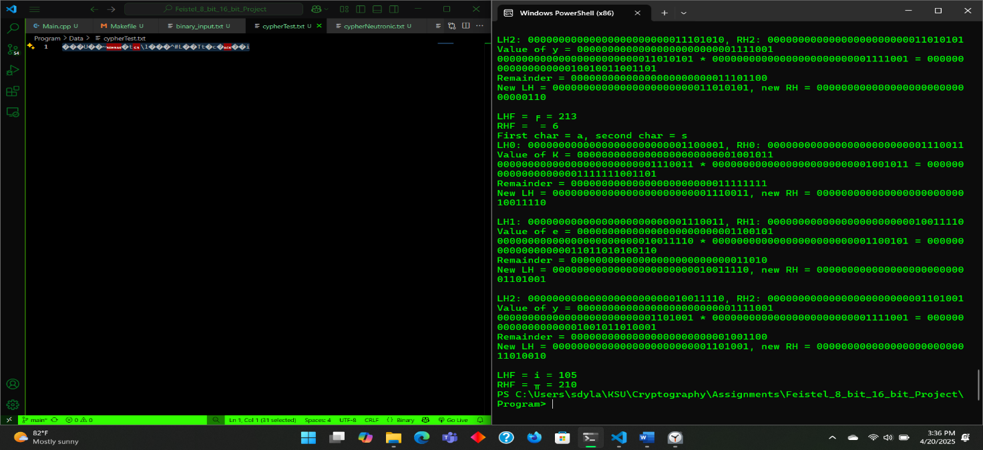

Decryption
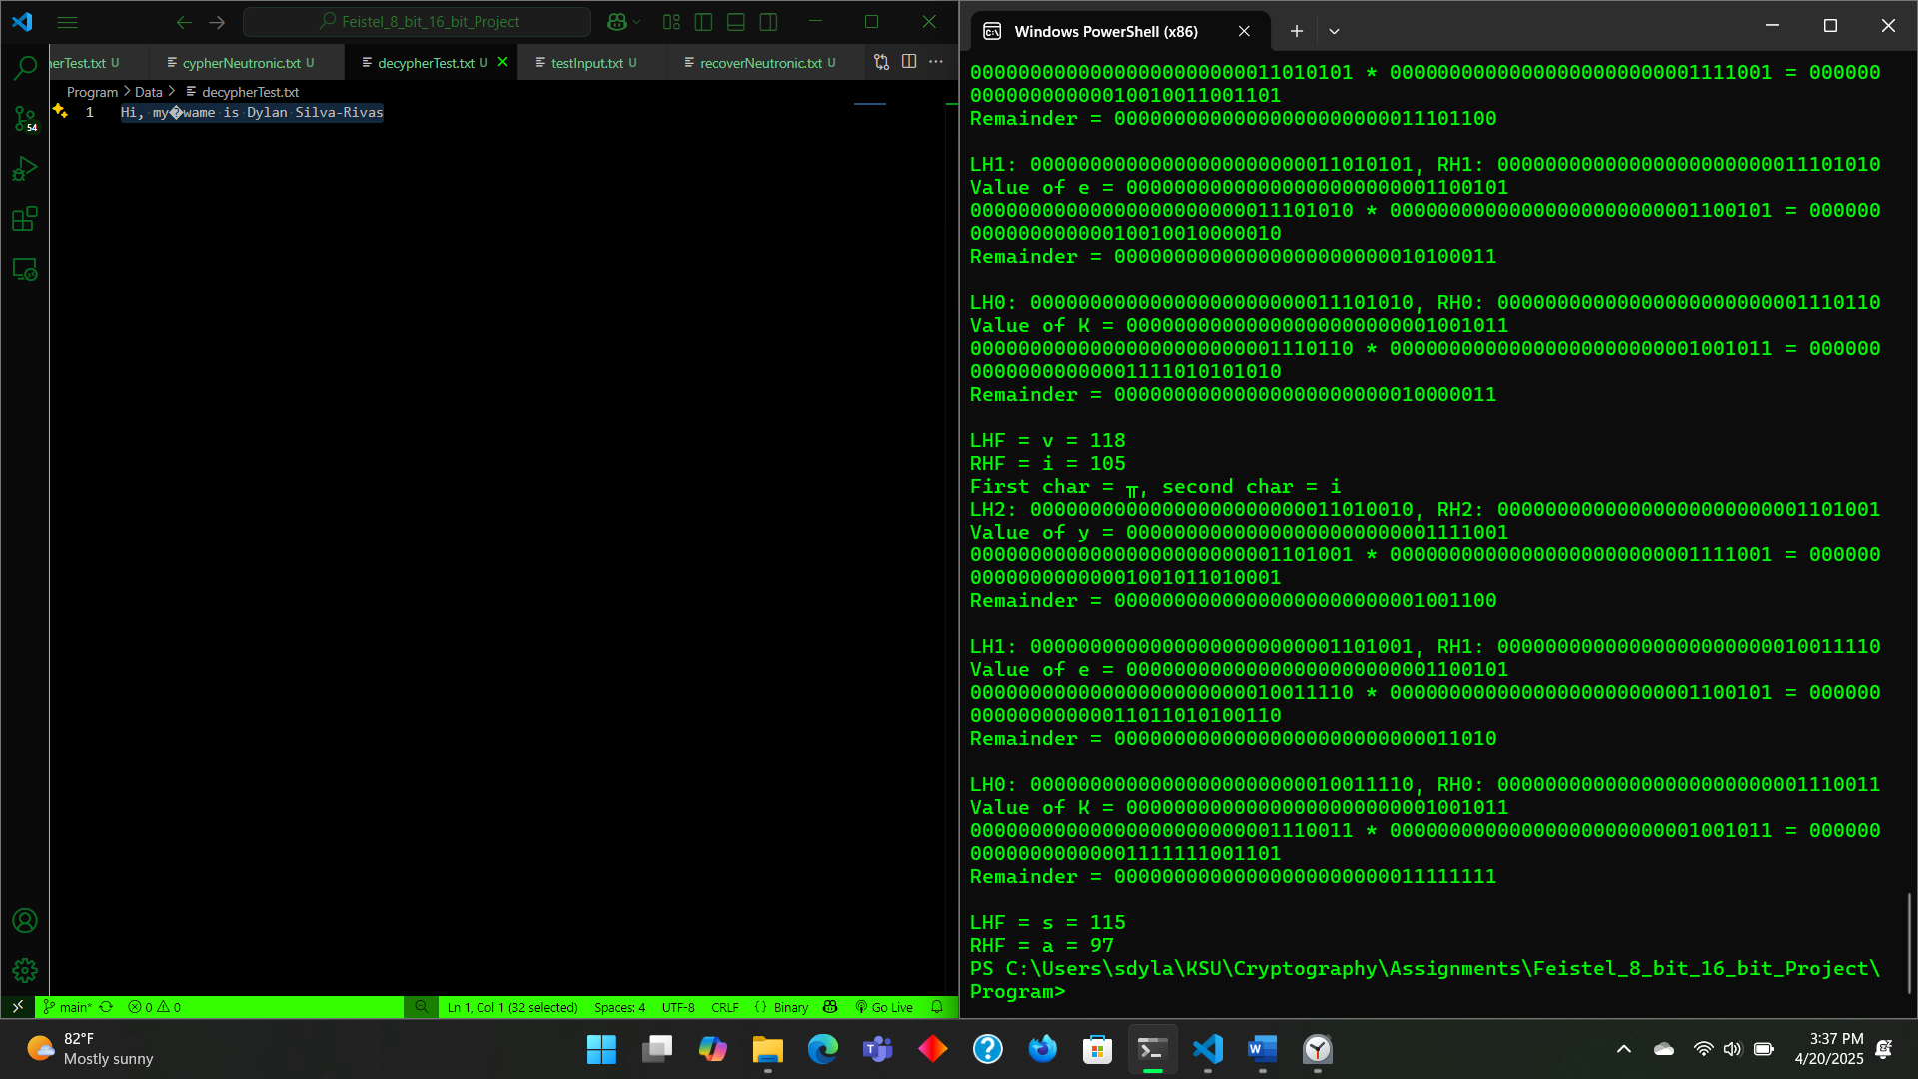

30 points

Submission Guidelines:
- No handwritten submission is accepted, always submit answers as text within this or similar document file with any support images (which may include handwritten answers in an image though) embedded in the file.
- EXCEPTION: If asked for source code implementation you can submit those individually and as separate files in ASCII format in their original file format .cpp, .java, .py, .cs etc. or even as a .txt file will be acceptable. Do not insert code into the submission document file. It ruins spacing which makes .python and some languages (perl, awk etc.) difficult to test build. Implementation languages preferred are C#, C/C++, Java and Python. If you plan to use another language please let me know.
- Do not submit ZIP files… ever… for anything in D2L. The system is extremely unhelpful with regards to those filetypes and grading.
- You may include your freehand drawing/image and handwritten scans in the submission. However, the writing and images must be clearly legible. Though, it is best to present non-handwritten submissions, generally, as is done in the professional setting.
- If asked, show all work/calculations/graphs etc. in the determination of the problem.
- Please complete your entire work in a single Word Document and Save the file as: yournetid_CS3502_Assignment01.docx (e.g. ogarcia5_CS3502_Assignment01.docx.) and upload your file in D2L.
- Please observe the submission due date and time. After the due date there is a 50% penalty for the next 24 hours. Any submission after 24 hours of the due date will be graded at 0%.
- If you include a reference or an image taken from other sources, please cite them appropriately. APA is preferred but cite them so they can be found. NOTE: verbatim copying or even paraphrasing is plagiarism so if the source used constitutes your answer rather than simply supporting the answer, it will be considered invalid. This is especially true of source code implementation answers.
- If you resubmit, please make sure to attach the file again. Your latest submission before the due date will be the one graded.

