Number of Units Sold by Month



The first table provides data on the number of units sold per month by model type. Overall it can be seen that road bikes perform the best, followed by mountain and touring bikes respectively. Road bikes outperform the sales of the other two model types in every month, usually by a factor of 1.5-2 for mountain bikes. However when compared to touring bikes we can see a much more varied number of purchases per month when compared to the other types. For example in February road bikes outperform touring bike sales by around twice the number or purchases, but for one month later in March road bikes outperform touring bikes by around 4.5 time the number of purchases. In addition a general trend of purchases for all models occurs between January to May before dropping off until August.

Based on this data I would recommend looking into how to boost sales for the few months that they drop off in the middle of the year in June and July. Having a summer sale of some sort and offering promotions in the months of June and July could be beneficial to boost sales number in these months, but further analysis would also need to be done into which types of promotions are effective and not only driving sales, but also ensuring that profit is made as there is a fine line when it comes to promotions and profit.

Number Sold by Promotion

This table provides data of the number of sales in each month per promotion. It can be seen that some promotions are much more effective than others, and some promotions do not even garner any sales at all and are completely ineffective. Since the data is categorized by month, it can also be seen which months have the greatest number of sales due to discounts. This can be combined with the general sales data for months to determine when sales should be taking place in order to maximize profit and the number of models sold. The highest number of promotional sales occur in December through February, and remain stable for the rest of the year.

Based off this data I would recommend focusing on running promotions in the summer in order to try and increase the number of sales in these months, and reduce the number of promotions in January through May since those are already high performing months that will not benefit as much from running promotions. I would also suggest running different promotion types in place of the ineffective ones in order to move inventory in a timely fashion.

Number of Units Sold by Model Size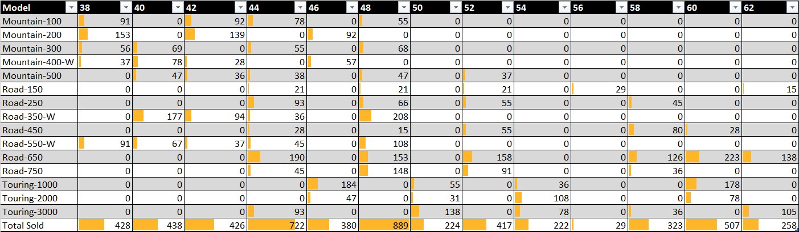

This table provides data on the number of units sold based on the size of the bike model. From this data we can see that the most popular size is 48, and the least popular is 56. This information is critical to understand when it comes to ordering stock from suppliers, as well as creating a re-order schedule that reduces the length of time that models are sold. Since the data specifically shows the number of units sold per model by size, it also shows which models do not need to be stocked at all since they do not generate any sales at all.

Based on this data I would recommend keeping no current stock for any models that have no sales, and a low inventory for models that do sell poorly in comparison to other models. The low selling models could not be kept in stock and strictly only available for purchase upon request where the model would then be shipped to the store and sold the customer at a premium instead of keeping it in stock and taking up space where a higher selling model could be. This data is useful for determining the general percent of which models and sizes should be ordered in order to keep up with customer demand.

Number of Units Sold per Color of Model

The final table shows the number of sales per color for each model of bike. From this data we an see that the most popular colors in general are black, then yellow, then red, then silver. We can also see that there are quite a few models that have no sales in certain colors. It is unclear from this data whether or not certain models are offered in those colors, and nobody is buying them, or the colors are unavailable for those models. In this case we will assume that those models are not available in those colors in the first place. Based on models that do have sales however, this data is useful in knowing consumer preferences for colors when multiple colors are offered so they know which colors of each model they need to stock relatively.

Based on this data I would recommend stocking bikes in the more popular color and less in the less popular colors. A simple ratio of which color to stock can be come up with by comparing the sales of each model per color available. While for most models it appears that the ratio is even per color, some models like the Road-650 should be stocked much higher in red than black as that fits consumer preference.

Appendix/Queries

Month:

USE AdventureWorksDW2014

SELECT \* FROM

(SELECT EnglishProductSubcategoryName

, OrderQuantity

, DATENAME(MONTH,OrderDate) AS [Month]

FROM FactResellerSales f

INNER JOIN DimProduct p

ON p.ProductKey = f.ProductKey

INNER JOIN DimProductSubcategory s

ON s.ProductSubcategoryKey = p.ProductSubcategoryKey

INNER JOIN DimProductCategory c

ON c.ProductCategoryKey = s.ProductCategoryKey

WHERE ProductSubcategoryAlternateKey IN ('1','2','3')

) AS MonthData

PIVOT

(SUM(OrderQuantity)

FOR [Month] IN(January, February, March, April, May, June, July, August, September, October, November,

December)

) AS PivotTable

Promotions:

USE AdventureWorksDW2014

SELECT \* FROM

(SELECT ModelName, EnglishPromotionName, OrderQuantity, Month(OrderDate) As [Month]

FROM FactResellerSales f

INNER JOIN DimPromotion as t

ON t.PromotionKey = f.PromotionKey

INNER JOIN DimProduct p

ON p.ProductKey = f.ProductKey

INNER JOIN DimProductSubcategory s

ON s.ProductSubcategoryKey = p.ProductSubcategoryKey

INNER JOIN DimProductCategory c

ON c.ProductCategoryKey = s.ProductCategoryKey

WHERE ProductSubcategoryAlternateKey IN ('1','2','3')

GROUP BY EnglishPromotionName, ModelName, OrderQuantity, Month(OrderDate)

) AS SKUData

PIVOT

(SUM(OrderQuantity)

FOR [Month] IN ([1], [2], [3], [4], [5], [6], [7], [8], [9], [10], [11], [12])

) AS PivotTable

Size:

USE AdventureWorksDW2014

SELECT \* From

(SELECT DISTINCT ModelName, Size, OrderQuantity

FROM FactResellerSales AS f

INNER JOIN DimProduct p

ON p.ProductKey = f.ProductKey

INNER JOIN DimProductSubcategory s

ON s.ProductSubcategoryKey = p.ProductSubcategoryKey

WHERE ProductSubcategoryAlternateKey IN ('1','2','3')

) AS SizeData

PIVOT

(SUM(OrderQuantity)

FOR Size IN ([38], [40], [42], [44], [46], [48], [50], [52], [54], [56], [58], [60], [62])

) AS PivotTable

Color:

USE AdventureWorksDW2014

SELECT \* FROM

(SELECT DISTINCT ModelName, Color, OrderQuantity

FROM FactResellerSales AS f

INNER JOIN DimProduct p

ON p.ProductKey = f.ProductKey

INNER JOIN DimProductSubcategory s

ON s.ProductSubcategoryKey = p.ProductSubcategoryKey

WHERE ProductSubcategoryAlternateKey IN ('1','2','3')

) AS RawData

PIVOT

(SUM(OrderQuantity)

FOR Color IN (Black, Red, Yellow, Silver)

) AS PivotTable