Spis treści
First run: 2
First opened 3
Top Menu 4
Visual options 5
Buttons Bar 5
New element 6
Template 7
Folders Structure 9
Optional Fields 9
Unique fields 10
Adventures 10

First run:
When first opening, it should display text:
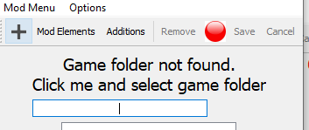
Do as it says.
Select folder with main exe.
If nothing broken, it should load all data from game files.
In future, if game is updated, it should automatically scan its content and gather new data.
This process might take some time.

First opened
Normally, when open, it be in shortened form. When editing, it will expand and stay expanded.

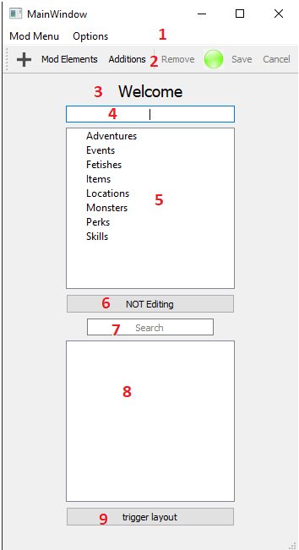 | - Main menu bar.  - Button bar. I don’t remember what “remove” should do, probably same as pressing “del” key when selecting stuff  - Main label. It shows if missing config file and when displaying any objects.  - Mod title field. Need it to save mod  - Mod view. It also displays addition files. Double click to expand, double click on lowest item to load its data. To Create new, select top item and press + in button bar(1).  - Button, but it does nothing. It’s purpose is to display when editing any field that require various game or mod items.  - Search bar for next field  - Main game items view. When editing field, it should display main game item and mod items to add.  - Testing button. Should show something in command window.

Top Menu
Lets start with menus at the top:
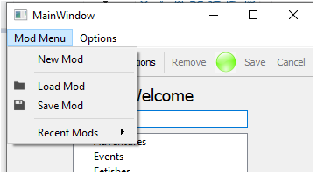 | - New mod: clear content in mod view and some other stuff.  - Load Mod – select folder with mod, preferably it should already be in game/mods  - Save Mod – VERY IMPORTANT – saves mod. Need mod title to work  Recent mods – to ease loading , will display last 3 mods loaded.
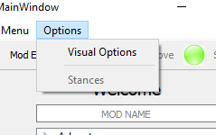 | Options:  Visual options Explained next  Stances – tried to make separate window, but did not work so added it to visual options.

Visual options

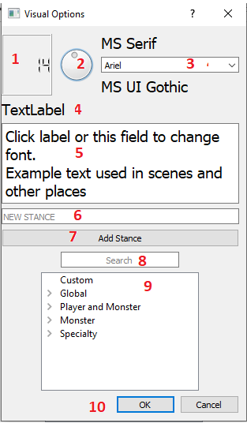 | - Display size of fonts  - Tried something cool – use to change font size  - Font selection. Above displayed font before, below next. Should work with arrow up and down. Mouse scroll should also work. Here and for size.  - Example label  - Example field with text. This is mostly for description and when writing scene texts  - Now starts part that should be in separate window. Input field for new stance.  - Button to add new stance. It is added to “Custom”  - Search bar for stances. ….Might remove it, don’t see is purpose here  - View of all stances, main and custom for mod. It should not be possible to remove game stances, only custom.  - Confirmation buttons

Buttons Bar

+ To add new items. When selected anything, it checks root item and based on prepare to add new
Mod elements – display mod view
Additions – Display additions view
Remove – probably simple “del” key does the same
Green sphere – Another attempt at something cool. Tried to make some kind of warning when something was edited. Should turn red when editing anything to show that it needs to be saved.
Save/Cancel - saves or cancel creation/edition

New element
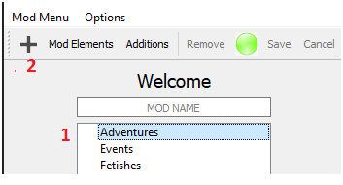 | To create element, select anything in mod tree and click + button. It will expand window showing correct template.
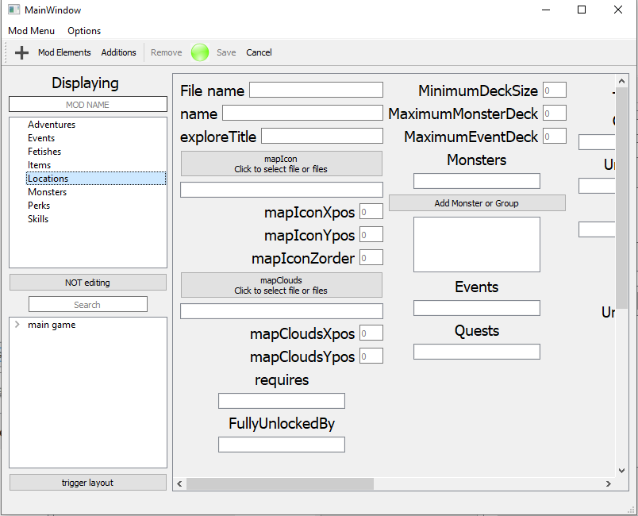
This is expanded view of main window.

Template
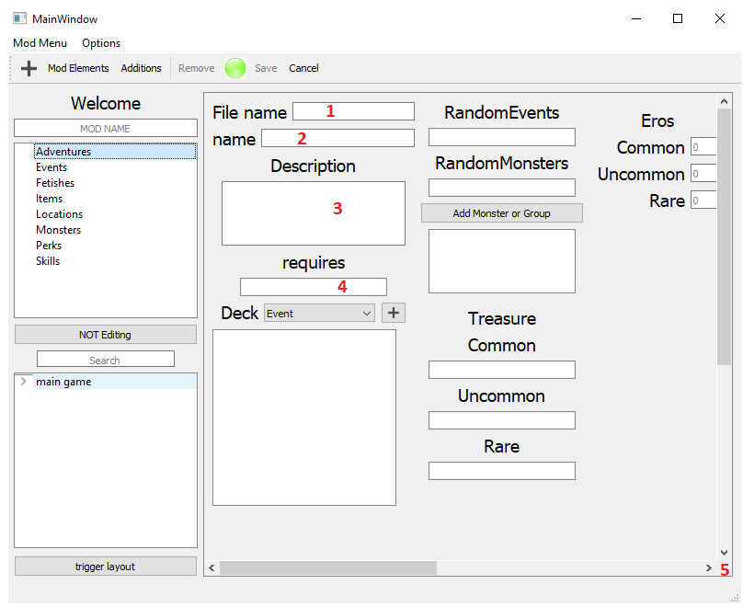
- File name. Except for Fetished, this is where you write….file name. If it’s same as name, it can stay empty, will copy from name. Also, to create folders, save specific template with only file name.
- Name of element, used in most places in game to identify
- Typical input field.
- Special input fields. Those fields, when clicked will change label “NOT Editing” into specific field, so you know where are you adding stuff. Then, main game view will display possible stuff to add. Double click any lowest level item to add to specific field.
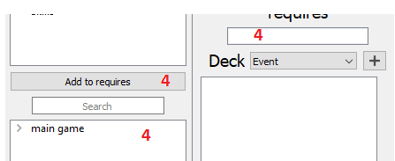
- Scroll bars. , in case not everything fits.

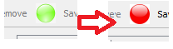 | Now, when you edit anything, warning icon should change to red. Then “SAVE” button should unlock.
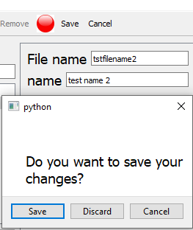 | If you try to load anything else while already editing, there should be a warning:
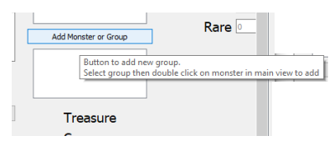 | If you hover mouse over most labels or button, tooltip should appear….I probably should add something to make it visible which label or button has a tooltip.

Folders Structure
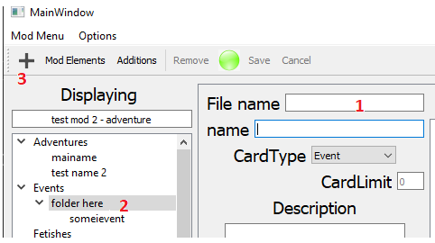  Also, to edit folder name, double click it. Cannot edit item name this way. | To create folders, provide only folder name in field (1) “File name” and nothing in field “Name”  Click save, then select folder(2), press +(3) to create new element.  !!  Even if template is shown, if you skip +, provide data and save again, it will save according to last selection, so not in folder.  !!

Optional Fields
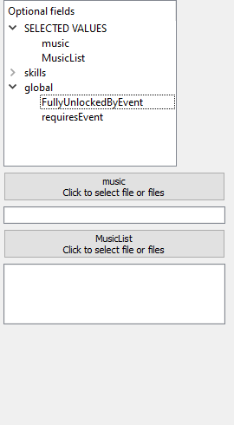 | Each template got optional fields display at far right.  Double click on any lowest element to add field below.  Delete any element from “SELECTED VALUES” to…delete optional field.  In most items, Global always work, Skill is, obvious, only for skills. There are all those optional stances, potencies and stuff.  I don’t have idea how to make it compact, for now it add field below, so in case of skills it might get rather long.

Unique fields
Lets go over special fields, that had me brainstorming and pot burning.

Adventures

Deck
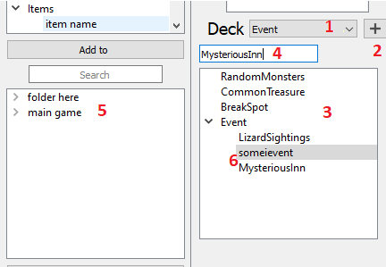 | - Drop down with options to select.  - Add buttons. Add selected option to list.  - List, or how I call it, treeview.  - If selected Event/Monster, another input field appears. Click it to load data into main game view(5). While you can type anything, it is advised to use (5)  - Main game view. Displays available selection, including new things from current mod.
- Neat logic. When adding more monster or event, when you select top item (here “Event”) and press add, it will add at the end of list. If you select item in the middle somewhere, it will add above. Click outside or press ESC on keyboard to cancel selection.

Monster Groups
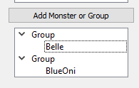 | First click button to add a group. Then in Main Game view you get all possible selections. Doubleclick lowet item to add to a group.  If nothing is selected, it will add to lowest group. If there is no group, it will NOT add. If group Is selected, it adds to selected group.  If monster is selected within group, it adds above it.

Events

Speakers
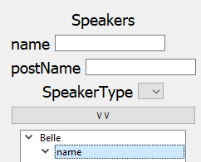 | Name will show avalable monster in Main Game view. Provide all data and click button to add to treeview. Data in treeview cannot be edited, to if something, remove and add again.

Scenes
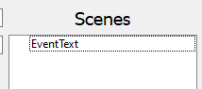 | Double click any scene to open ….text function editor..or functional text editor. This is extensive, will be explained later.

Fetishes
Only thing that does not create new files, so field is blocked.

Location
Special field is monster group, same as in Adventure.

Monsters

Fetishes
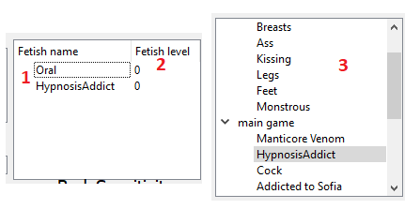
This is attempt at using 2 columns in treeview.
Click on (1)field to load available selection in(3) Main Game View. Double click any selection to load into (1)field view. Double click on (2)value column to edit it. If left with 0, it will be deleted when saving.

ItemDropList
Similar to speaker, button to add data to treeview. Cannot edit.
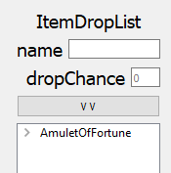

Scenes
Same as in event, double click to open Text and Function window.

combatDialogue
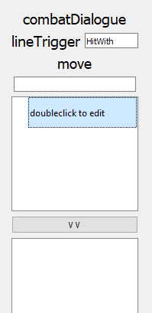 | Wooo boy.  Line trigger – simple field, load data in Main Game View.  Move – same as above.  Text treeview – as it says, double click to edit. When pressed ENTER, it should add another text field ready to edit.  IF you select “Music” line trigger, text treeview changes to a button to load file with music. It of course load only path.  And button to add all to treeview.

Pictures
Main template view:
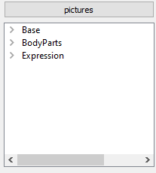 | - Label which is a button. Click it to open picture viewer  - Treeview display of pictures field

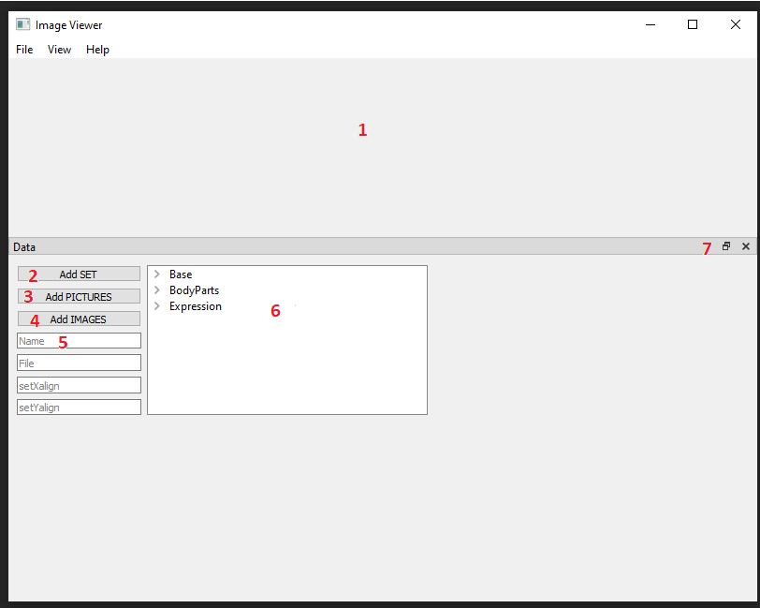
- Drag and drop picture display. Drop anything on it or use menu above to load picture. It’s name will appear in (5)
- Add sets. Only add to top level.
- Add pictures group. If nothing selected, add to top level. If selected a set, will add to set.
- Add image. Need to load image to add. Only adds to pictures.
- Field to single image data.
- Treeview displaying all data. It is same as treeview in template, so no need to have save buttons or stuff.
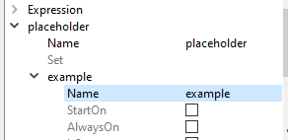 | Here is fresh set and pictures added.  Change data by double clicking in second column.  When name is changed, parent name will change too.  There is empty space after checkbox. Too difficult to get rid of it, just leave it empty.  Remove stuff with delete button on keyboard.  Also, double click on image file in treeview to load image to viewer.

- Perks

StatReq and PerkType
These are similar 1 and 2.
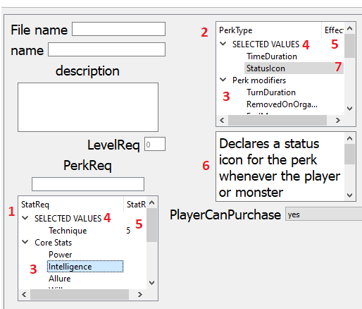
Double click on any (3) item to add it to (4) SELECTED VALUES. It should move, so you can’t add it twice. Select it in (4) SELECTED VALUES and press “DEL” on keyboard to put it back.
Double click in (5) second column to input value. In case of (7) “StatusIcon” it should open window to select file.
Perk type has addition (6) explanation field.

Skills
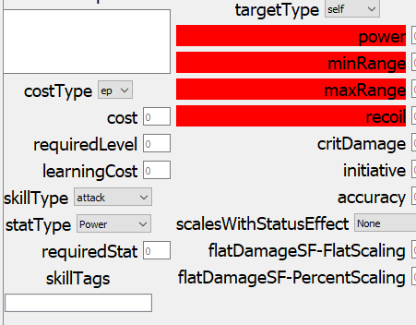
As you see, some labels are red. These are mandatory and change, depending on “SkillType” and later on “StatusEffect”. There should be warning if you try to save skill with empty mandatory field.

Others
With example of Fetish tags
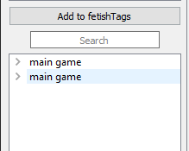
It recognizes by title, so Mod item are top level, rest is nested in “main game “ and since fetishes are as “Fetish” and “Addiction”, it lookes like this.
As mentioned before, I did not figure out how to place optional field, so if there are too many:
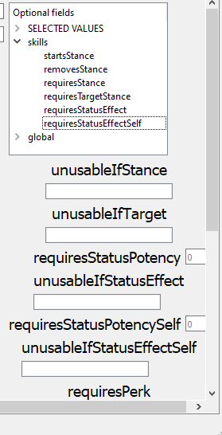

Additions
Click on „Additions” buttons in top bar to switch mod view to additions view.
Expand and double click any item to load it.
Save it and it should appear in your mod it appropriate type. Only field that are used by game are copied. Leave rest fields empty.
Edit is as normal item.

If you want to check which fields are used, switch to additions view, important labels will be marked. !!! remember to switch back before you save element.

Text Editor
Now, probably half of entire tool:
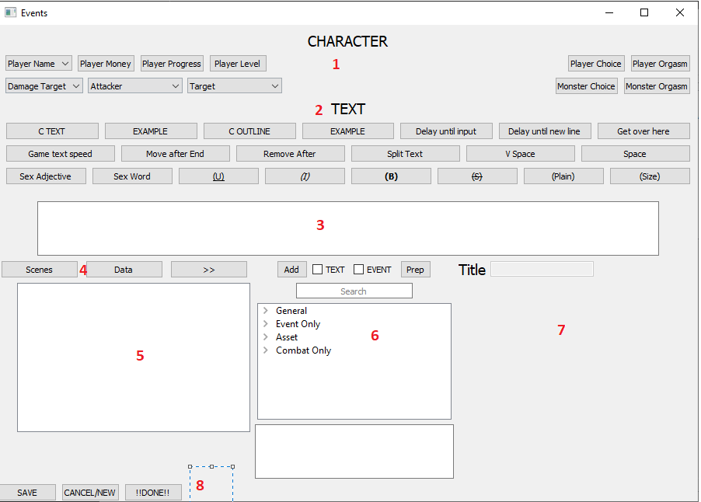
Starting at TOP (1) and (2) are obvious, tags for player and monster and general text markups. (3) is main text area. Press ENTER on keyboard to add text to scene.(4) are buttons to edit and view scene data.(5) is scene display, (6) is functionality part with (7) being where functions are displayed.

Character
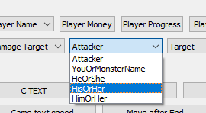 | Select any option besides top and it will be added to scene text

TEXT
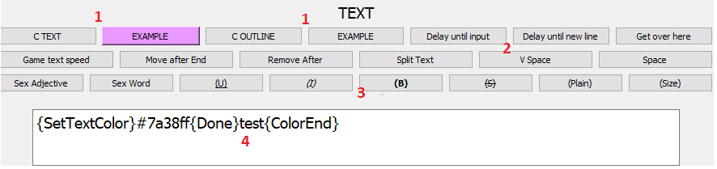
For coloring text (1) first click C button, select colour and Example shows. Click on example to apply it to text(4).
Buttons (2) without () are single character functions, button with () like (3) need to first select text(4) which you want to format

I guess if there will be a lot more markups in the future I could turn title into button to hide and show all markups.

Scene overalls
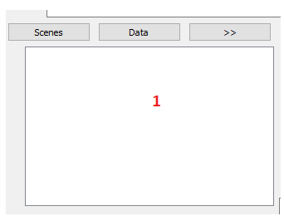 | This displayes all text from loaded scene. Double click any row to load it above to edit.
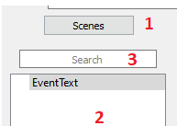 | Button (1) show and hide scene list. So user does not need to close window to check other scenes. Double click scene to load it to main display.  Scene list (2)  Search bar(3), might be useful or not, I don’t know.
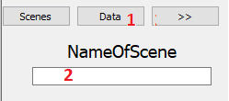  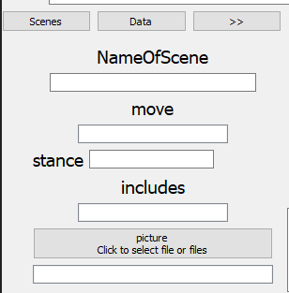 | Scene data. Click (1) to show and hide. Below shows fields (3). Name is needed to save scene. In case of monster there will be more, similar working to field in templates. Second picture shows how it looks for monster events. When click upon some fields, available options are displayed in function part of window.

Functions

Function Selector
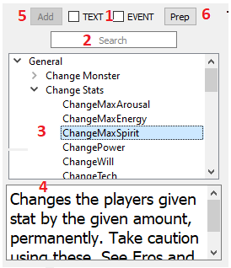 | First part.  - Here select how to add functions. TEXT adds it to text input, EVENT will add to scene text to the right. Should turn red if you forget to check one of them.  - Search bar.  - Functions list. I might add some filter later, when using this window to edit text for outcome field, that does not use all functions.  - Explanations  - Button to add. Disabled if there are more then just title, enabled once ready to add.  - Prep will show fields in function. Disable if it’s just one word.
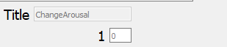
Simple example after clicking PREP…..ups, it should show “amount” instead of 1.
!!IMPORTANT!!
While you can select more fucntions at one, It will either load first selected function, or crash. So please don’t.

Edit function
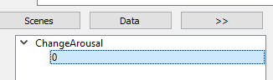 | Normally, editing text in scene throws it in text input field above, but if user click >> button when selected function, it should load into function display. Useful when need to edit bigger functions or some stats or skills. In case it does not overwrite when added/updated, please remove previous function with DEL key on keyboard

Special functions
Now another hard part.
First, functions options display:
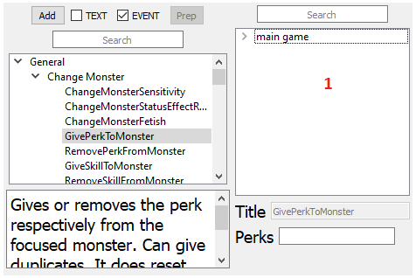
Many functions require you to provide other items, like Perks or Skills. In this case, treeview appears, similar to main game view in main window. Click appropiate field(Perks) and stuff from mod and game will load above. Double click to add it to field. This is also used when editing scene main elements, stances and move.

SwapLineIf
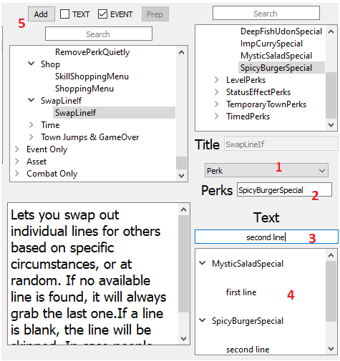 | - Select option from list.  - Input fields will appear. Provide data.  - Provide text for selected option and value and press ENTER key.  - It will appear in treeview.  - When done, click ADD button.  WARNING – probably option OtherEventChoice is not working. I don’t know why.  SECOND WARNING – for some reason, after using swaplineif, other functions are display at the bottom. Open window again to reset it.

Choices
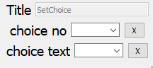 | Here, if you provide text and number and add it to scene, it should also record this choice for future use.  If you press X button when choice or number is selected, it will remove it from future use.

Menu
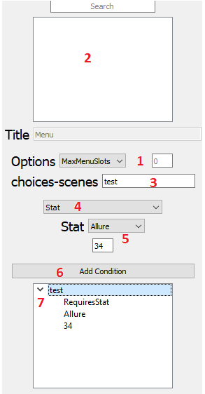 | - Options to select for menu.  - Main game items view  - Click here to load other scenes from current event. Double click on scene to load it here. Then press ENTER to add it as choice in (7) treeview  - Options for conditions to select.  - Field appear depending of choice in (4)  - Button to add conditions. It add at the end of selected choice in (7).  - Treeview to display all conditions for specific choice. Press DEL key to remove row or entire choice. Double click anything to edit that row. To update you have to remove choice and add it again.

Combat encounter
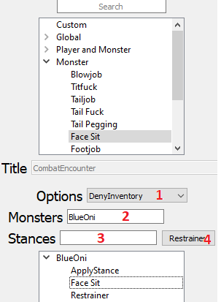 | - Basic options to select  - Click and add monster from main game treeview. Press ENTER key to add it as encounter to bottom treeview.  - When provided, button (4) turns to APPLY to add stance to selected monster. Remember to select to which monster you wish to apply.  - If (3) is empty, this button adds restrainer to selected encounter.  DEL key to remove rows as always.  I think there is also limit on how many encounter you can add here. So if adding does not work, you have to remove some.

StatCheck
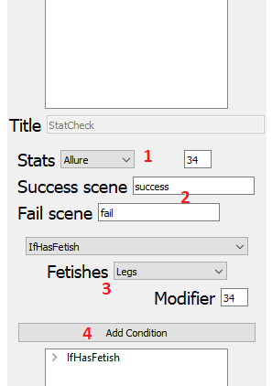 | - Basic stat selection with value  - Click to load scenes to add in both fields  - Condition to go to success scene  - Button to add condition. You can add as many conditions as you want.  When done, click ADD button to add single stat check.

ChangeImageLayer
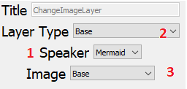 | - First select speaker. It load data from current event from SPEAKERS field.  - Then layer and image is loaded. When you change layer type  - Image is updated with data from layer.  In most cases like this, you need first select speaker.

AnimateImageLayer
Similar to above.

VFX
Are rather simple. Just saying, that in future I’ll try to combine it with image viewer where you can see how it will work in game.

Planned features
- Picture viewer for picture in monster files, should also work for locations. Will be used in functions for VFX with ability to show how different options affect picture in game.
- MAYBE some fight simulator to test statcheck fuctions.
- Maybe some algorithm to go over scenes and check for any inconsistencies.

Fun facts
- Not all of the are fun.
- I’ve been working on it alone for almost 3 years now. While working day job as well. And I have problem with STRESS
- First I tried some less good, easier libraries, then I made it in Tinker and it was mostly working, but move window around was lagging a bit. Then (addname of FeltculeMight…later) Mentioned other libraries and I switched and move to PyQt.
- I’ll make code for it public. So if someone know and loves to program, go ahead and fix it.
- It’s made so that simple fields and function can be added to files and should work right away. Only complex stuff are hardcoded.
- If I’m alive in the future, my contact information hardly changes, so if something happens I might fix it.
- Trivia time: - previous pictures fields
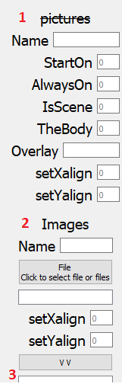 | This is current, probably working setup. It consist of 2 parts.  Main(1) is main picture data.  Images(2) is where you put single images with some info, press button to add them(3). When all images are added to treeview, below is another treeview, which belongs to (1) main pictures and a button to add all images.  I’m working on new super image viewer, so in future it will be replaces with just bottom main treeview with data and button to load images.  As Mentioned above, it might actually be still working as is it based on simple logic of being a dictionary(images) withing dictionary(pictures) which was working before.

