Survey Application Database System

Requirement Analysis

What is the purpose of the database? What should it do?

* The main purpose of the database is to ask questions to users in order to achieve certain results through surveys, to get answers to the questions asked and store them in the online database.
* Our database will store users' data, surveys, questions in the survey and answers to questions, as well as organizer information.

Who are the users and what are their information needs?

* Our users are randomly selected people.
* Analysts and surveyors

What are the problems that the system should solve?

* Traditional surveys are usually carried out face-to-face or over the phone, which causes great difficulties in storing data and using this data. With the system we have established, the data of the users and their answers to the surveys will be stored in the database, so that the data can be easily processed and used.
* One of the biggest problems in traditional surveys is keeping the stored information up to date. With the online survey system, this problem can be easily overcome.

What input data is available to the database?

* Users’ information, surveys, questions, responses
* What kind of information should be stored in the database?
* Users' data, users' answers, survey data, questions, information of questions, organizer information

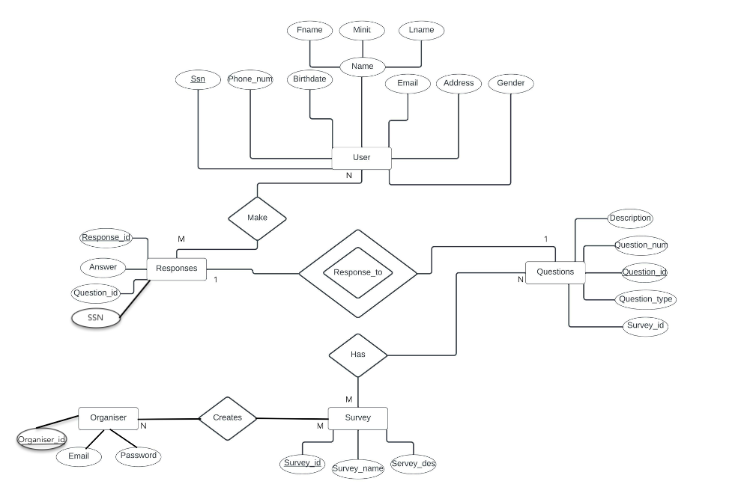

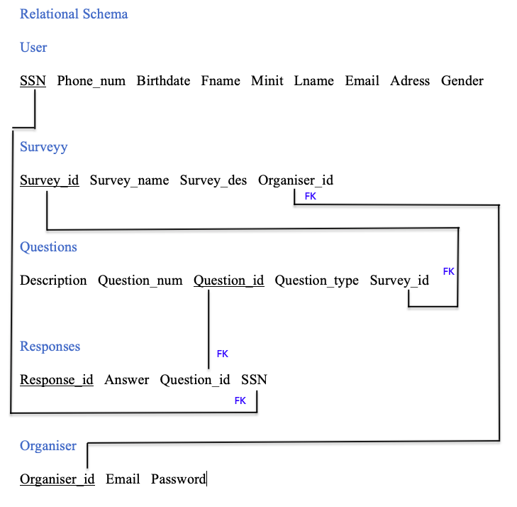

Database Schema

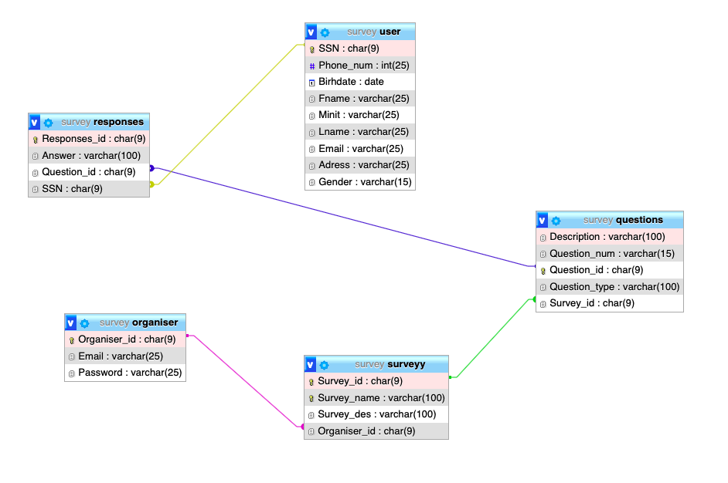

**Organizer username and password:**

[organiser1@mail.com](mailto:organiser1@mail.com)

1234

Screenshots

Here we have the option to sign-in as an organizer or a user.

Clicking “I am Organizer” will lead you to the sign-in page for the organizer of the application.

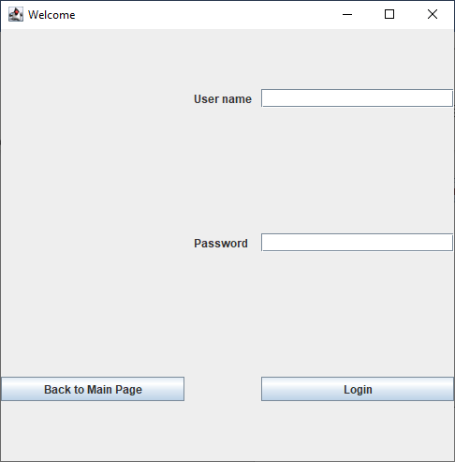

Signing in as an organiser will let you display the statistics and there is a button to display response statistics as well.

The response statistics page looks like this:

Users are greeted with a warning when they first click on “I am a user”

Here they have a form to fill in

After the form is filled another pop up follows to greet the user

There the users have two options to choose from: questions about the product and branding survey

The format for the two pages is the same but as an example let’s look at the questions about the product page

After the form is filled and the user hits send, there will be a pop up message to tell the process was successful

After the form is sent, both the user statistics and the responses will now show up in the database the organiser can access to.

