Máy ubuntu
sudo apt-get update
sudo apt-get install snort -y (ens33, ip may mik(192.168.1.0/24 ubun tu)
Sai ip cài lại snort
sudo apt-get purge snort -y (xoa)
sudo apt-get install snort -y
sudo ip link set ens33 promisc on
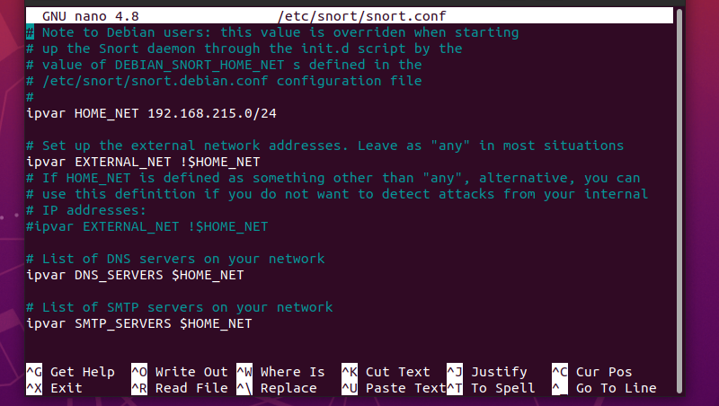
sudo nano /etc/snort/snort.conf
(sữa y như này, ip may ubuntu)
sudo snort -i ens33 -A console -c /etc/snort/snort.conf
cd /etc
ls
cd snort
cd rules
ls
sudo nano icmp.rules
alert icmp any any -> any any (msg:”Co ai do dang PING”; sid: 1000001; rev:1;)
sudo snort -i ens33 -A console -c /etc/snort/snort.conf (run)

may kali
test ping
ping 192.168.1.11 (ip may ubuntu)
wa máy ubuntu xem ket qua

sudo nano /etc/snort/snort.conf (kiem tr )
ctrl+w
icmp.rules
enter
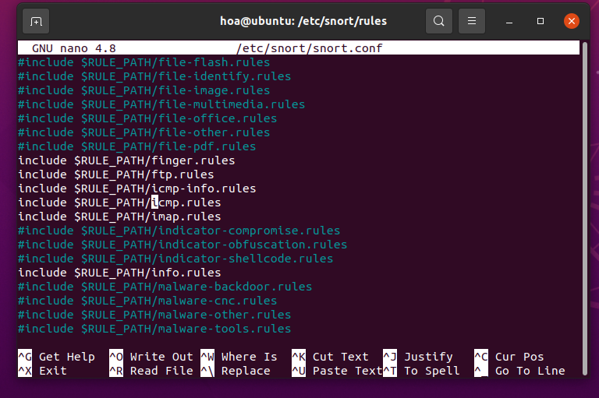
kiem tra xem co bi an khong

DDOS
cd /etc/snort/rules
ls
sudo nano dos.rules
alert tcp any any -> $HOME_NET 80 (msg:"TCP SYN Flood"; flags:S; threshold:type threshold, track by_src, count 100, seconds 10; sid:1000005;)
sudo snort -i ens33 -A console -c /etc/snort/snort.conf (run)

may kali test DDOS
sudo hping3 -S --flood -p 80 192.168.1.11

Dừng tất cả Snort đang chạy:
sudo pkill snort

sudo nano /etc/snort/snort.conf
ctrl+w: icmp.rules, enter
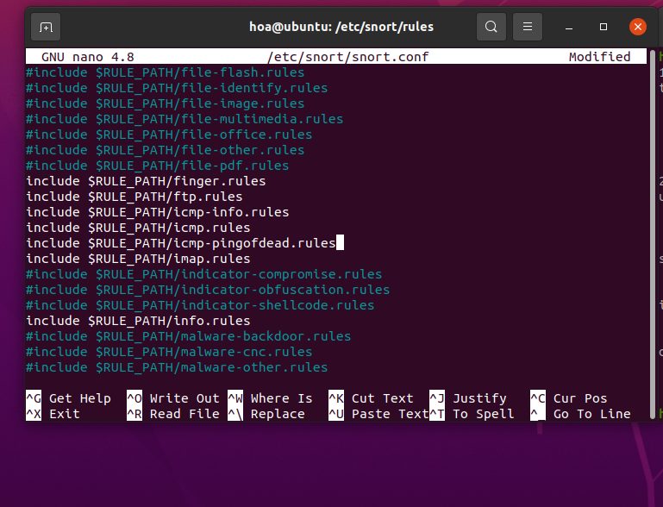
include $RULE_PATH/icmp-pingofdead.rules

cd /etc/snort/rules
sudo touch icmp-pingofdead.rules
ls
sudo nano icmp-pingofdead.rules
alert icmp any any -> $HOME_NET any (msg:"ICMP PING OF DEATH ATTACK"; itype:8; dsize:>1000; detection_filter:track by_src, count 10, seconds 5; classtype:denial-of-service; sid:1000003; rev:1;)
sudo snort -i ens33 -A console -c /etc/snort/snort.conf (run)

may kali
ping 192.168.1.135 -s 65500 (test 4,5 terminal)
công cụ hping 3
sudo hping3 -S --flood -p 80 192.168.1.135 ( tấn công tcp ddos )

Xem co snort nao chay ko (nen dừng snort trước đó mik đã test)
ps aux | grep snort
Dừng tất cả Snort đang chạy:
sudo pkill snort
sudo pkill -f snort
sudo pkill snort
sudo snort -A console -q -c /etc/snort/snort.conf -i ens33

HYDRA
sudo apt-get update
sudo apt-get install vsftpd -y
sudo systemctl start vsftpd
sudo systemctl enable vsftpd
sudo systemctl status vsftpd

sudo nano /etc/snort/rules/ftp.rules
alert tcp any any -> 192.168.1.135 21 (msg:"FTP Brute Force Attack Detected"; flow:to_server,established; content:"USER "; nocase; threshold:type threshold, track by_src, count 5, seconds 10; sid:1000101; rev:1;)
or
alert tcp any any -> any 21 (msg:"FTP Brute Force Attack Detected"; content:"USER "; nocase; sid:1000102; rev:1;)

sudo nano /etc/snort/snort.conf
search: ftp.rules, local.rules
sudo snort -i ens33 -A console -c /etc/snort/snort.conf (run)

may kali test ftp
cd /usr/share/wordlists
ls
sudo gzip -d /usr/share/wordlists/rockyou.txt.gz (giai nen file)
hydra -l testuser -P /usr/share/wordlists/rockyou.txt ftp://192.168.1.135

TELNET
+ alert tcp any any -> 192.168.1.135 23 (msg:"Telnet Brute Force Attack Detected"; flow:to_server,established; content:"login:"; nocase; threshold:type threshold, track by_src, count 5, seconds 10; sid:1000002; rev:1;)
Or
alert tcp any any -> 192.168.1.135 23 (msg:"Telnet Brute Force Attack Detected"; flow:to_server,established; content:"testuser"; threshold:type threshold, track by_src, count 3, seconds 10; sid:1000004; rev:1;)
+ hydra -l testuser -P /usr/share/wordlists/rockyou.txt telnet://192.168.1.135

HTTP
+ alert tcp any any -> 192.168.1.135 80 (msg:"HTTP Brute Force Attack Detected"; flow:to_server,established; content:"Authorization: Basic"; nocase; http_header; threshold:type threshold, track by_src, count 5, seconds 10; sid:1000003; rev:1;)
+ hydra -l admin -P /usr/share/wordlists/rockyou.txt 192.168.1.135 http-get /protected

SQL INJECTION
sudo apt-get update
sudo apt install -y docker.io
sudo systemctl status docker
sudo usermod -aG docker $USER
shutdown -r now

docker pull vulnerables/web-dvwa
docker pull santosomar/mutillidae_2
docker run -d -p 80:80 --name web-dvwa vulnerables/web-dvwa
ko run dc thi:
sudo lsof -i :80
sudo systemctl stop apache2
docker stop web-dvwa
docker rm web-dvwa
docker run -d -p 80:80 --name web-dvwa vulnerables/web-dvwa

firefox: localhost
low
SQL Injection 1

cd /etc/snort/rules
sudo nano local.rules
alert tcp any any -> any 80 (msg: "AND SQL Injection Detected"; content: "and" ; nocase; sid:100000060; )
alert tcp any any -> any 80 (msg: "OR SQL Injection Detected"; content: "or" ; nocase; sid:100000061; )
sudo snort -i ens33 -A console -c /etc/snort/snort.conf

lay cookie: F12 Network User ID: 1 Submit cookie
PHPSESSID=u9kn07k3ildkqvouc90siclbd3; security=low
may kali test SQL
sqlmap -u "http://192.168.1.135/vulnerabilities/sqli/?id=1&Submit=Submit" -cookie="PHPSESSID=abc123; security=low" --batch
rmhdn68oug1uq5ve7r7epvd0m3

